

Cuireadh chun Tairisceana/Invitation to Tender

Invitation to Tender for the disposal of a site to an Approved Housing Body for the potential delivery, construction and sale and lease of affordable residential accommodation for Irish Speakers at Doirí Beaga (Gaoth Dobhair), Co. Dhún na nGall for Údarás na Gaeltachta.
Residential Development at Doirí Beaga (Gaoth Dobhair), Co. Dhún na nGall

Closing date: 12pm, 4th December 2026

Contents
Part 1: Introduction 5
1.0 Instructing Authority 5
Part 2: Instructions to Respondents 10
3.0 Questionnaire 13

Work area | Disposal of Land for the potential delivery of residential development.
Name of Contracting Authority | Údarás na Gaeltachta
Title | Invitation to Tender for the disposal of a site to an Approved Housing Body for the delivery, construction, and sale and lease of Affordable Residential Accommodation for Irish Speakers at Doirí Beaga (Gaoth Dobhair), Co. Dhún na nGall, for Údarás na Gaeltachta, in close collaboration with Donegal County Council.
Background | Údarás na Gaeltachta na Gaeltachta is not a housing authority within the meaning of the Housing Acts. The delivery, construction, management and letting of residential accommodation falls outside its statutory functions and in-house capacity.  However, Údarás na Gaeltachta na Gaeltachta plays a secondary role in providing housing, as outlined in the Údarás na Gaeltachta na Gaeltachta (Amendment) Act 2026, which is described in greater detail below.  Section 8 of the Principal Act is amended by inserting the following subsection after subsection (7).  “(7A) An tÚdarás na Gaeltachta may sell or otherwise dispose of land to an approved housing body (within the meaning of the Housing (Regulation of Approved Housing Bodies) Act 2019 ) or to a housing authority (within the meaning of the Housing (Miscellaneous Provisions) Act 1992 ) for the provision of housing in the Gaeltacht”  This Act was signed into law on the 1st July 2026.  It must therefore partner with an AHB operator with the relevant housing-delivery capability to satisfy the requirement to provide long-term affordable residential accommodation in Gaeltacht areas.
Description | Údarás na Gaeltachta wishes to identify an Approved Housing Body (“AHB”) with a view to progressing the disposal of a site from its portfolio to facilitate the delivery of affordable residential accommodation for Irish speakers at Doirí Beaga (Gaoth Dobhair), Co. Dhún na nGall.  The appointed AHB, will become the owner of the site and shall assume full responsibility for the delivery of the project, including site design, planning, construction, and the letting and/or sale of all residential units, and shall act as long-term owner and landlord.  The successful AHB shall secure all statutory approvals, certifications, and compliance sign-offs. For the avoidance of doubt, Údarás na Gaeltachta is not funding the development and is not seeking the delivery of social housing as there are sufficiently social units under construction by Donegal County Council (Social Housing Development at Machaire Gathlán/Ard na gCeapairí, Doire Beag, Dún na nGall | Donegal County Council's Online Consultation Portal).  Údarás na Gaeltachta is seeking an AHB that will take control of the Site, with an initial investment from Údarás na Gaeltachta limited to enabling planning permission only.  All other risks and development finance are a matter for the AHB.
Procurement Type | Works Related Services with Disposal of site
Directive | 2014/24/EU (Classic)
Procedure | Open
CfT Involves | A Public Contract
CPV Codes | 70110000 Development services of real estate; 70111000 Development of residential real estate; 70121000 Building sale or purchase services; 45000000 Construction work; 45211100 Construction work for houses
Contact Point | Údarás na Gaeltachta
NUTS Code | IE
Time-limit for receipt of Invitation to Tender | 12pm, 4th December 2026
Allow suppliers to make an online Invitation to Tender | Yes
EU funding | No
Date of Publication | Wednesday 4th November 2026
Language of Publication | EN / GA

Part 1: Introduction

1.0 Instructing Authority
  - About the Contracting Authority
Údarás na Gaeltachta is the regional development authority with responsibility for the economic, social and cultural development of the Gaeltacht with the overall objective of maintaining Irish as the communal language of the region. The organisation, which has a staff complement of circa 100 people, has its Headquarters in Na Forbacha, County Galway and regional offices in Gaoth Dobhair, Contae Dhún na nGall, An Daingean Uí Chúis, Contae Charraí, Beal an Mhuirthead, Contae Mhaigh Eo, Baile Mhic Íre, Contae Chorcaí. It also has a substantial portfolio of industrial and office properties and business parks throughout the Gaeltacht regions. Further information can be obtained on our website (www.udaras.ie).

  - Irish Language
As Irish is the administrative language of the organisation, it is a requirement that Tenderers have the capability to deliver the service through both the Irish as well as the English language as required. Údarás na Gaeltachta will provide advice and support in this regard to the successful Tenderer.

  - Rationale for the Project Procurement
Údarás na Gaeltachta (the 'Contracting Authority') holds land at Doirí Beaga (Gaoth Dobhair), Co. Dhún na nGall, and wishes to identify an Approved Housing Body to dispose of the site with a view to progressing the delivery of affordable residential accommodation for Irish speakers at this location, following this tender process.
This Invitation to Tender follows, and builds on the outcome of, a Prior Market Consultation which closed on 31 July 2026.

Accordingly, and by means of this exercise, Údarás na Gaeltachta is inviting tenders from Approved Housing Bodies under an open procedure, for the purpose of identifying an AHB with the capability to take control of the site and to design, plan, construct, let and/or sell the Development, on the basis set out in this document (“the Competition”).

Basis of Engagement: For the avoidance of doubt, Údarás na Gaeltachta is not funding the development or seeking the delivery of social housing. Údarás na Gaeltachta is seeking an Approved Housing Body that will take control of the Site, with an initial investment from Údarás na Gaeltachta limited to enabling planning permission only (further detail at Part 1, Section 5 below).

All other risks and development finance, including site investigations beyond that initial investment, design development, construction, sales and/or letting, and ongoing asset management, are a matter for the appointed AHB. All units are to be for Irish Language Speakers only, and all methods of delivering affordable residential accommodation must be explored, i.e., rental and purchase. Please also note that further consultation with Donegal County Council for the provision of affordable housing will be required.
Respondents' attention is drawn in particular to the basis of engagement set out below and the terms in the Draft Heads of Terms Document included in the tender package. Participation in the Competition will not oblige Údarás na Gaeltachta to conclude any contract, and Údarás na Gaeltachta reserves the right not to proceed with the project, in whole or in part, at any stage. Separately, and irrespective of the final contractual structure adopted, the development of any housing on the identified lands will require planning permission under the Planning and Development Act 2000/24/26, under which any grant of permission must be consistent with the relevant local authority development plan (including its rural, Gaeltacht, language and zoning objectives) and with any applicable environmental assessment requirements under the EU Environmental Impact Assessment and Habitats Directives.

  - About the Project
The subject site is located along Bóthar Ard na gCeapairí (Ard na gCeapairí Road, L1373), Doirí Beaga, within the Limistéar Pleanála Teanga of Gaoth Dobhair, Rann na Feirste, Anagaire agus Loch an Iúir, Co. Dhún na nGall.
The proposed development is conceived as a phased regeneration scheme for the Gaeltacht, to be delivered by the appointed AHB as long-term owner and landlord. The principal elements comprise the following:
- Approximately 2 hectares / 4.94-acre site
- Phase 1 – Refurbishment and deep retrofit of 4 no. existing vacant 3-bedroom bungalows to provide 8 no. 2-bedroom dwellings, together with associated car parking and private open space, as a pilot under the Secure Tenancy Affordable Rental (STAR) scheme.
- Phase 2 – Construction of 6–12 no. new residential units for affordable purchase, together with associated car parking, private open space, and compliance with all statutory design standards now and at the planning stage.
- Provision of new vehicular and pedestrian access, public open space, landscaping, drainage infrastructure and all associated ancillary works.
- Provision of infrastructure to allow future residential development
All 4 no. dwellings are accessed separately via Bóthar Ard na gCeapairí (L1373). The extent of these 4 no. dwellings is outlined below.

- 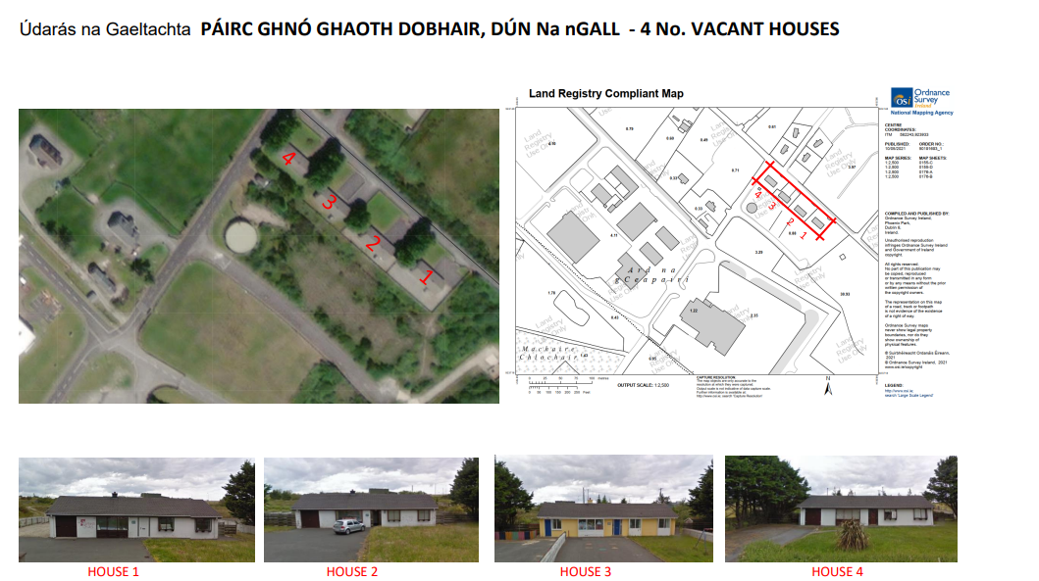
Figure 1 – Dwellings on Subject Site
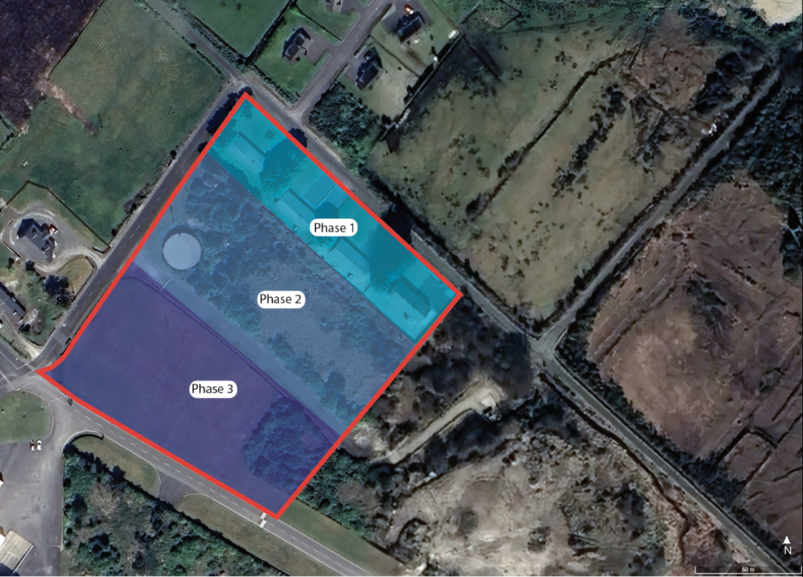
Figure 2- Aerial Map with subject site outlined in Red and phasing concept

The development has the potential to deliver a total of 8 – 20 no. Residential dwellings over the short to medium term (along with further future residential potential), at a residential density of approximately 10 units per hectare, subject to appropriate planning permission. This density is considered appropriate, having regard to the edge-of-settlement, semi-rural character of the site and its Gaeltacht context.

The phasing outlined above is indicative only, and it will be a matter for an AHB to plan accordingly to ensure commercial viability.

  - Basis of Engagement – Commercial Terms

The AHB appointed following this process will be expected to enter into Heads of Terms (see attached proposed terms), and subsequently a Planning Agreement and Land Transfer, with Údarás na Gaeltachta on substantially the following basis. Respondents should read this section carefully before completing the questionnaire at Part 3:
- Development Commitment: The AHB will be required to submit a feasibility study, and thereafter enter into a Planning Permission Agreement, to advance the Development. Financial Accounts of the AHB (audited, for the last three financial years) will be required prior to signing of the Heads of Terms. This timeline is expected of a successful AHB no later than 30 days after
- Údarás na Gaeltachta Equity Funding (Planning Only): Údarás na Gaeltachta will fund to the AHB to enable the obtaining of planning permission, together with the initial site outlay; this is to comprise design team and planning outlay, site investigations, and head office overhead (payable in monthly increments of over seven months). This funding is strictly limited to enabling planning permission and the initial site outlay; it is not development finance. An AHB submitting a tender should detail the amount of investment they require together with noting their matched investment.
- Community Engagement: The AHB will be expected to meet with the local community ahead of planning to inform them of their proposal, and experience of community engagement will be evaluated.
- Planning Target: Planning permission is targeted for approval by January 2027 or earlier. If no decision has been issued by then, the application is to be lodged by that date and, in any event, with a decision awaited in Q1 2027.
- Letter of Consent: For the purpose of obtaining planning permission, Údarás na Gaeltachta, as landowner, will provide a letter of consent to the AHB to enable the planning application to be lodged.
- Land Transfer: The grant of planning permission for the Development will be the milestone triggering Údarás na Gaeltachta's obligation to sell the Site to the AHB, subject to a covenant on title restricting occupation of the accommodation to Irish speakers. Completion of the land transfer must occur within 2 months of the grant of planning.
- AHB's Role and Risk: As the long-term owner and landlord, the AHB will act as client throughout the Development, entering into contractual agreements with the contractor, funders, and any prospective purchasers or tenants, and will retain ongoing liability for major external and structural maintenance following handover and building compliance to ensure sales completion.
Save for the planning-stage funding set out above, all development risk and development finance, including design development, construction costs, sales and/or letting, and ongoing asset management, will be borne by the AHB.
- Indicative Milestones:
    - Q4 2026 – feasibility study and pre-planning consultation;
    - Q1 2027 – planning submission to Donegal County Council;
    - Q1/2 2027 – grant of planning and tender process; application for STAR scheme
    - Q3 2027 – commencement of construction, in accordance with the phasing set out in this document or such other phasing as may emerge during the planning process.
The indicative development is proposed to be delivered in the following phases (subject to change in consultation with the successful party):
- Phase 1: Refurbishment and deep retrofit of 4 no. existing vacant 3-bedroom bungalows to provide 8 no. 2-bedroom dwellings for affordable rental, together with associated car parking and private open space, as a pilot under the Secure Tenancy Affordable Rental (STAR) scheme (subject to further discussion with the Housing Agency).
- Phase 2: Construction of 6–12 no. new residential units for affordable purchase, together with associated car parking, private open space and compliance with all statutory design standards (subject to further discussion with Donegal County Council).
- Phase 3: Subject to the successful delivery and occupation of Phases 1 and 2, further residential development brought forward in a planned and integrated manner consistent with an approved site masterplan (subject to further discussion with Donegal County Council and the appointed AHB).
  - Purpose of the Competition
The purpose of the Competition is to identify and shortlist an Approved Housing Body with the capability to take control of the Site and deliver appropriate and suitable affordable housing for the population of Limistéar Pleanála Teanga Ghaoth Dobhair, Rann na Feirste, Anagaire agus Loch an Iúir, on the basis of engagement set out in Section 1.5 above.
The strategic necessity of this project is underscored by the acute housing need within the Gaeltacht. The population of Limistéar Pleanála Teanga Gaoth Dobhair, Rann na Feirste, Anagaire agus Loch an Iúir increased by 256 persons between 2016 and 2022, rising from 5,895 to 6,151. Notwithstanding this population growth, only 57 private housing units were constructed in the area from 2016 onwards, representing a significant and sustained shortfall in housing supply relative to demand.
This development is intentionally designed to address the identified deficit by providing quality housing for daily Irish speakers within the Donegal Gaeltacht, in alignment with the statutory objectives of the Contracting Authority, and to serve a secondary function in the provision of housing. It is acknowledged, however, that Donegal County Council serves as the administrative authority for housing in the region and has made significant progress in providing social housing. Nonetheless, the lack of access to affordable housing is further evidenced by responses in the LPT for this region, from the housing survey commissioned by Údarás na Gaeltachta, where respondents identified access to affordable housing as the primary reason for Irish speakers relocating from the Gaeltacht.

This tender is being carried out in accordance with the open procedure under Article 27 of Directive 2014/24/EU, as transposed into Irish law by Regulation 27 of the European Union (Award of Public Authority Contracts) Regulations 2016 (S.I. No. 284 of 2016)
The key objectives of this exercise are to identify and shortlist an Approved Housing Body that:
- has experience of residential development in rural and/or Gaeltacht contexts, with particular reference to the Gweedore / Bun Beag area;
- can deliver affordable housing and long-term affordable rental solutions (such as the STAR scheme or other) appropriate to the site and its Gaeltacht context and meet the timelines identified;
- can meet Údarás na Gaeltachta's requirements, including housing for Irish speakers;
- has the pipeline, capacity and financial standing to deliver this project;
- has knowledge of, and the ability to comply with, the planning, environmental and language conditions applicable to Gaeltacht developments;
- will apply appropriate construction approaches, including Modern Methods of Construction (MMC);
- has the appetite and capability to fund development finance for the project, on the basis that Údarás na Gaeltachta's own funding is limited to enabling planning permission only;
- understands the potential risks and constraints, including wastewater infrastructure, environmental designations and Language Impact Assessment requirements, and is capable of managing them.

Part 2: Instructions to Respondents
2.1 General
This is a formal Invitation to Tender, issued as an open procedure for the appointment of an Approved Housing Body to deliver the Development described in Part 1 of this document. Responses will be evaluated against the criteria set out in Part 3 of this document. Based on the responses received, Údarás na Gaeltachta may invite one or more respondents to proceed to the next stage of the process, which may include direct engagement on Heads of Terms with a preferred respondent.
The Contracting Authority reserves the right not to progress the project, or any part of it, at its absolute discretion.
  - Queries
The material in this document is intended to provide sufficient background information for respondents to present details about their offerings.
Notwithstanding this, the Contracting Authority encourages respondents to seek clarification on this notice and the questionnaire where needed. All clarifications regarding the Competition must be submitted through eTenders (www.etenders.gov.ie).http://www.etenders.gov.ie/
Queries should be submitted prior to the closing date stated on the front cover.
The details of persons who make a query will not be disclosed when the response is circulated.
All queries must be submitted before the query deadline to enable the issuance of responses to all interested parties.
  - Closing Date for Submissions
The closing date for submissions is specified on the title page.
It is the responsibility of interested parties to ensure that their submission is complete and is uploaded by the designated deadline. Submissions that are received late or via other means will not be considered in this public procurement competition.
It is important to note that only persons who have downloaded and accepted a document can upload a submission.
  - Submission Guidance
The Contracting Authority is using the postbox facility on eTenders, and responses must be submitted electronically via the eTenders postbox facility on www.etenders.gov.ie only. Only submissions sent via the electronic postbox will be accepted. Submissions via any other means (including but not limited to by email, post or hand delivery) will not be accepted.
Interested parties must ensure that they give themselves enough time to upload and submit all required documentation before the closing date/time noting the use of the new eTenders platform. Please consider the fact that upload speeds vary. In order to submit a response to the electronic post-box, please note that you must ensure you have submitted the response completely. It is advisable to familiarise yourself with the new platform prior to the closing date.
If in doubt, please ensure you contact the eTenders helpdesk as follows:
European Dynamics - Short User Guides
Accessing Documents
It is important to note that you must ensure you ASSOCIATE your company with this competition in the first instance. To do this you must do the following:
(a) Log-in to the system
(b) Locate the competition using the Advanced Search by Contracting Authority or Resource ID
(c) Click on the hyperlink for the competition which will bring you to the CfT Workspace
(d) In the Show CfT Menu for the competition click on the “Invitation to Tender” in the drop down menu
(e) Complete the “Association with the CfT” tab.
(f) This will then provide you with a link to “Tender” under the Show CfT Menu

  - Submitting your Response
In responding to a competition please click on Proposals and attach your response on the Send Proposal tab.
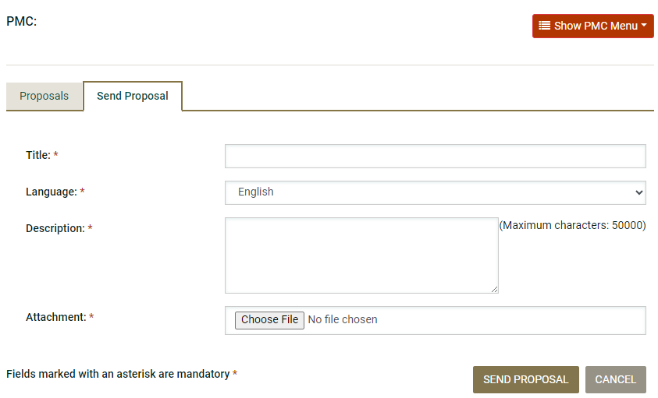
Please upload your response as a ZIP FILE to protect the integrity of the file names.
  - Confidentiality
All responses will be treated in strictest confidence, but respondents should note that under the Freedom of Information Act 2014 and the European Communities (Access to Information on the Environment) Regulations 2007 to 2014, information provided by them during this Competition may be liable to be disclosed. Respondents are asked to consider if any of the information supplied by them should not be disclosed because of its confidentiality or commercial sensitivity. If respondents consider that certain information is not to be disclosed because of its confidentiality or commercial sensitivity, they must, when providing such information, clearly identify the specific sections of their response containing such information and specify the reasons for its confidentiality or commercial sensitivity. Please note, the Contracting Authority is not inviting pricing information at this time.

  - Forms to be Submitted
In addition to the completed questionnaire at Part 3, respondents must complete and submit the forms set out at Appendix 1 (Forms & Declarations), as follows. This Invitation to Tender is below the relevant EU procurement threshold; accordingly, a European Single Procurement Document (ESPD) is not required.
- Applicant Cover Letter
- Applicants Information
- Bona Fide Submission
- Conflicts of Interest
- Eligibility
- Data Sharing Agreement Form
- Data Protection Statement
- Declaration in relation to Financial & Economic Standing
Incomplete submissions, or submissions missing any of the forms listed above, may be deemed non-compliant and excluded from further consideration, at the discretion of Údarás na Gaeltachta.
Incomplete submissions, or submissions missing any of the forms listed above, may be deemed non-compliant and excluded from further consideration, at the discretion of Údarás na Gaeltachta.
  - Evaluation Methodology
The Competition is below the relevant EU procurement threshold. Nonetheless, in keeping with the general principles of transparency, equal treatment and proportionality, responses will be evaluated as set out below.
Suitability Assessment (Pass/Fail)
Respondent Information, including the required financial statements and the Confirmation of Basis of Engagement, and all of the forms at Appendix 1 (Forms & Declarations) will be assessed on a Pass/Fail basis only. Respondents who do not meet this minimum standard will not proceed to evaluation.
Quality and Funding Evaluation (Scored)
Respondents who meet the minimum requirements will be evaluated against the criteria in Sections A, B and C of the questionnaire, scored out of a total of 100 marks, weighted as follows:
- Section A – Funding Required from Údarás na Gaeltachta (20 marks). Respondents who submit a higher value will not proceed to the next stage and their submission not considered.
- Section B – Delivery Model, AHB Capability and Procurement Approach (40 marks):
- Section C – Community / Social Cohesion (40 marks):
The amount requested under Section A is treated as a final figure for evaluation purposes only; it does not commit Údarás na Gaeltachta to fund any amount in excess of €150,000, nor does it vary the basis of engagement set out at Part 1, Section 1.5. Any tender which contains a figure greater than €150,000 under Section A, will be deemed non-compliant.
Section A, B and C will be scored by reference to the scale below:
- 0 – no response, or response is non-compliant;
- 1–2 – limited evidence provided, with significant gaps or concerns;
- 3 – satisfactory response, meets the requirement;
- 4 – good response, clearly evidenced;
- 5 – excellent response, fully and convincingly demonstrated. Terms and conditions of the Tender fully understood.
A minimum combined score of 50 marks (out of 100) is required for a respondent to proceed to evaluation. Údarás na Gaeltachta reserves the right, at its absolute discretion, to seek clarifications from any respondent prior to finalising scores, and not to proceed with awarding a contract to any respondent if, in its opinion, no response adequately addresses the requirements of this Invitation to Tender.

3.0 Questionnaire (Section A -C)
Respondents are requested to complete all sections (A - C) of this questionnaire. Responses should be clear, concise and based on demonstrable experience relevant to the project described in this Invitation to Tender.
Section A
Question 1: Please submit your funding criteria breakdown. (20 marks)
- Marks will be awarded based on the understanding of the tender

[Respondent Input] limit to 750 words

Section B

Question 2 (a): Delivery Model, AHB Capability and Procurement Approach (30 marks)
Describe how your organisation, as the appointed Approved Housing Body (AHB), would deliver this scheme from land transfer through to completion and handover based on your professional experience from managing risk, delivery and market fluctuations. Your response should cover:
- your proposed delivery model ;
- your procurement approach, including how you would engage local suppliers, contractors and relevant state agencies;
- how you would fund development after land transfer
- Identify potential risk and your approach to risk management
[Respondent Input] limit to 2,000 words

Question 2 (b): Previous project experience - evidence previous experience in delivering a project similar in nature. (20 marks)
[Respondent Input] limit to 1,000 words

Section C
Question 3: Section C: Community Engagement and Social Cohesion (30 marks)
How would your organisation engage the local community of Limistéar Pleanála Teanga Ghaoth Dobhair, Rann na Feirste, Anagaire agus Loch an Iúir to promote social cohesion, both in advance of and during the planning and construction phases?
Your response should include:
Identification of key stakeholders
Communication procedures
Problem resolution and escalation process
Draw on your previous experience to explain your approach.

[Respondent Input] limit to 2,000 words

Thank you for your time and effort in completing this Invitation to Tender
Responses should be submitted via eTenders at www.etenders.gov.ie

Appendix 1

Forms & Declaration

Appendix 1

Forms To Be Completed and Submitted PASS/ FAIL Basis ONLY

The forms contained in this Appendix must be completed in full and returned by Applicants.

  - Applicant Cover Letter (Sign and return)

  - Applicants Information (Sign and return)

  - Bona Fide Submission (Sign and return)

  - Conflicts of Interest (Sign and return)

  - Eligibility (Sign and return)

  - Data Sharing Agreement Form (Sign and return)

  - Data Protection Statement (Sign and return)
  - Declaration in relation to Financial & Economic Standing (Sign and return)

FORM 1 - APPLICANTS’S STATEMENT

[to be completed by the Applicant on its headed notepaper]

To: Údarás na Gaeltachta

Re: Invitation to Tender for the disposal of a site to an Approved Housing Body for the potential delivery, construction and sale and lease of affordable residential accommodation for Irish Speakers at Doirí Beaga (Gaoth Dobhair), Co. Dhún na nGall for Údarás na Gaeltachta.

Having examined your Invitation to Tender competition, we hereby include our Submission and agree and declare the following on or own behalf (and where we are a Group, on behalf of all members of our Group):

We understand the nature and extent of the Works required to be provided under the Contract, and the risks associated therewith, and we have carried out all necessary due diligence in relation to same.

We confirm that we have made our Submission in accordance with the instructions set out in the Invitation for Tender.

We understand that Údarás na Gaeltachta does not bind itself to accept the lowest or any Submission made in response to the documents for this procurement competition.

We understand Údarás na Gaeltachta reserves the right to discontinue the award procedure in the event of irregular Submissions or in the absence of appropriate Submissions and in such circumstances it may use the negotiated procedure without a further call for competition.

We warrant and represent that we have all the requisite corporate authority to make this Submission.

We undertake to ensure that all appropriate technical and organisational resources shall be taken to prevent the unauthorised or unlawful processing of personal data and to prevent accidental loss or damage or destruction of personal data entrusted to us in the course of the Competition.

If applicable, we enclose with this Statement any relevant letters of support from parent companies or third parties whose resources we intend to rely on in order to perform the Contract. These letters confirm that any such third party:

- will make its relevant resources available to the Applicant in the event that the Applicant is successful in this Competition and is awarded the Contract; and

- it will enter into a contractual commitment with Údarás na Gaeltachta or a guarantee in favour of Údarás na Gaeltachta in respect of such relevant resources at the same time as any Contract is entered into with the Applicant

We acknowledge that the documents for this Competition do not constitute an offer to enter into a contract and should not be regarded as a commitment or representation on the part of Údarás na Gaeltachta to enter into a contractual arrangement. No commitment of any kind, contractual or otherwise, binding Údarás na Gaeltachta shall exist unless and until a formal written contract is executed by or on behalf of Údarás na Gaeltachta. We understand that Údarás na Gaeltachta may, at its absolute discretion, terminate this Competition at any time prior to a formal written contract being executed on behalf of Údarás na Gaeltachta.
Dated this day of 2026
Signed by or on behalf of the Applicant:
Print Name of Signatory:
Name of Applicant³:
Registered Address:

FORM 2 - CORPORATE INFORMATION

Applicant (or lead entity only in case of Group)

Full Name
Address
Previous Name(s) if applicable
Registered Address if different
Registration Number (if applicable)
Telephone
Fax
Contact Name & Details
E-mail address:
Website address
Year Established
Legal Form  (Tick One) |  |  | Company |  | Joint Venture
Legal Form  (Tick One) | Partnership Other (specify)
VAT Registration Number (if applicable)
Directors’ names and titles
Parent Company
Ownership (Ultimate Beneficial)

Applicant’s authorised representative (or lead member’s representative in case of Group)

Name:
Contact Name & Details:
Address:
Telephone:
Facsimile:
Email Address:

Group Members (if applicable)

We, the other members of the Applicant’s Group, confirm that the Applicant’s authorised representative named above is authorised to act on behalf of the Applicant and as the principal contact for the Applicant in dealings with the Authority. (If not applicable, state ‘n/a’).

Group Member | Name and Title | Signature

Status of Applicant
Single Bidder
Partnership
Group
Other Type of Joint Venture
If other type of joint venture, please specify:
Please confirm whether the Applicant is a single bidder, a partnership, a Group or other type of joint venture.

FORM 3 - BONA FIDE SUBMISSIONS

[to be completed by the Applicant]

The essence of competing for the above response is that the client (Údarás na Gaeltachta), shall receive bona fide competitive Applicants from all firms competing. In recognition of this principle, we certify that we are submitting a bona fide submission which is intended to be competitive and we have not fixed or adjusted any amount specified in our Submission by or under or in accordance with any agreement or arrangements with any other person.

We also certify that we have not:

- Communicated to a person other than Údarás na Gaeltachta the amount or approximate amount of any pricing in our Submission, except where the disclosure, in confidence, of such pricing was necessary to obtain insurance premium quotations required for the preparation thereof;

- enter into any agreement or arrangement with any other person that he shall refrain from competing or as to the amount or pricing to besubmitted; and

- offered or paid or given or agreed to pay or give any sum of money or valuable consideration directly or indirectly to any person for doing or having done or causing or having caused to be done in relation to any other submissions for the said work any act or thing of the sort described above.

We undertake that we will not do any of the acts mentioned in sections (a), (b) or above at any time before the acceptance or rejection of our Submission.

In this certificate, the word “person” includes any persons and anybody or association, corporate or unincorporated and “any agreement or arrangement” includes any such transaction, formal or informal and whether legally binding or not.

Signed by or on behalf of the Applicant
(and the Applicant’s Group, if applicable):

Printed:

Name of Applicant⁴:

FORM 4 - CONFLICT OF INTEREST

[to be completed by the Applicant]

With reference to Section 4.6 (Conflict of Interest) of the documents for this procurement competition, please complete where appropriate.
We warrant that: -

- There would be no conflict of interest in relation to the personnel or type of work involved in the Applicant Contract.

No Conflict

- There could be a possible conflict of interest in relation to [enter the name(s) of the individual(s) concerned] and their involvement in the Applicant Contract.

Possible Conflict

- Please explain what the possible conflict or perceived conflict of interest may be and who it relates to and how it could have an adverse effect on the Applicant Contract(s).

Any registrable interest involving the Applicant’s or any sub-contractors and any of the members of the board of Údarás na Gaeltachta, members of the Government, members of the Oireachtas, or employees or officers of Údarás na Gaeltachta or their relatives must be fully disclosed.

The terms 'registrable interest' and 'relative' shall be interpreted as per Section 2 and Schedule 2 of the Ethics in Public Office Act 1995 a copy of which is available to download at www.finance.gov.ie.
We wish to notify Údarás na Gaeltachta of the following registrable interests:

Signed by or on behalf of Applicant5
(and the Applicant’s Group, if applicable):

Printed:

Name of Applicant:

Registered Address:

FORM 5 - ELIGIBILITY

[to be completed by the Applicant]

Section 1

Applicant’s will be automatically excluded from the Competition if, to the knowledge of Údarás na Gaeltachta, the Applicant (or any member of an Applicant’s Group) has been convicted of an offence involving the:

- participation in a prescribed criminal organisation;

- corruption;

- fraud;

- money laundering; or

- any other offence within the meaning of Regulation 57(1) of the European Union (Award of Public Authority Contracts) Regulations 2016 (S.I. No. 284 of 2016), as defined by the national law of any relevant State.

Are any of the conditions referred to in sub-paragraphs (a) to (e) above applicable to the Applicant or any Group member? (Please tick relevant box).

YES | NO

If “yes” please give details.

Section 2

In addition, Applicant’s may be automatically excluded from the Competition where any of the conditions in sub-paragraphs (a) to (g) inclusive below apply to the Applicant or any of its Group members:

- they are subject to any of the following bankruptcy or insolvency procedures:

  - the person is bankrupt or the subject of a bankruptcy petition

  - the person, being a body corporate, is being wound up or the subject of proceedings for compulsory winding up, or

  - the person's affairs are being administered by a court, or the person is the subject of proceedings in which it is sought to have the person's affairs so administered or
  - the person has entered into an arrangement with creditors, or

  - the person has suspended business activities, or

  - the person is, in the opinion of Údarás na Gaeltachta concerned, in any situation analogous to any of those mentioned in subparagraphs (i) to (v) under a law of the State, another Member State or a third country relating to bankruptcy or insolvency.

- they have been found guilty of professional misconduct by a competent authority that is authorised by law to hear and determine allegations of professional misconduct against persons that include the operator; or

- they have committed grave professional misconduct provable by means that the authority can demonstrate;

- they have not fulfilled an obligation to pay a social security contribution as required by a law of the country or territory—

  - where the person ordinarily resides or carries on business, or

  - where the authority is established, or

- they have not fulfilled an obligation to pay a tax or levy imposed by or under a law of the country or territory—
  - where the person ordinarily resides or carries on business, or

- where the authority is established, or they have provided a statement or information to the authority or another contracting authority knowing it to be false or misleading, or has failed to provide to the authority or another such authority a statement or information that is reasonably required by the authority for the purpose of awarding the public contract concerned;

- they are subject to any other ground stated in Regulation 57(2) and (4) of the European Union (Award of Public Authority Contracts) Regulations 2016 (S.I. No. 284 of 2016), as defined by the national law of any relevant State.

Are any of the conditions (a) to (g) applicable to the Applicant or any of its Group members? (Please tick relevant box).

YES | NO

If “yes” please give details.

Signed by or on behalf of Applicant
(and the Applicant’s Group, if applicable):

Printed:

Name of Applicant⁶:

Registered Address:

FORM 6 - DATA SHARING AGREEMENT FORM
General Data Protection Regulation (EU) 2016/679 Data Protection Act (IE), 2018
Details of Company / Individual Sole trader:

Company Name: Company Address:

Chief Executive / Sole Trader Name:

Declaration:

This Company/ Individual Sole Trader, as joint controller and/or processor of data with Údarás na Gaeltachta, declares the following:
- It has a competent working knowledge of GDPR requirements, and has taken the necessary measures to ensure that it is compliant with the General Data Protection Regulation, 2018.
- All data received from Údarás na Gaeltachta will be used for the sole purpose of providing the service / carrying out duties attached to this job.
- All data received from Údarás na Gaeltachta will only be available to staff assigned to this project, who are aware of GDPR responsibilities.
- When in the possession of this Company / Individual Sole Trader, all hard copies and electronic copies will be stored securely and only accessible to staff assigned to this project.
- In the event of a breach under GDPR regulations, this Company / Individual Sole Trader will immediately notify the Údarás na Gaeltachta.

I have signed this declaration as Chief Executive of this company / or Individual Sole Trader.

Signed: Date:

(Block):

Noted: Date:

Údarás na Gaeltachta

(Please return completed and signed form to Údarás na Gaeltachta).

FORM 7 - DATA PROTECTION STATEMENT

[to be completed by the Applicant]

I/We confirm that I/we:

- We agree that, if awarded any Contract, we shall, in the performance of such contract, comply with all applicable obligations in the field of environmental, social and labour law.

- We confirm that all Data Subjects whose Personal Data is provided in our Tender have consented to the processing of such Personal Data by us, the Contracting Authority, the Evaluation Team and the supplier of the etenders.gov.ie website, for the purposes of our participation in this Competition or that we otherwise have a legal basis for providing such Personal Data to the Contracting Authority for the purposes of our participation in this Competition and that we will provide evidence of such consent and/or legal basis to the Contracting Authority upon request.

Signed by or on behalf of Applicant

Signed:
Name (in Capital Letters):
Position / Authorised Person:
On behalf of:
Address:
Telephone: |  | Fax:
Email: |  | Date:

FORM 8 - DECLARATION IN RELATION TO FINANCIAL & ECONOMIC STANDING

[On the AHB's letter-headed paper - to be completed by the Applicant]
]

Declaration that Applicant can meet Minimum Standard for Economic and Financial Criteria in the Invitation for Invitiation to Tender document
To: Údarás na Gaeltachta

Regarding: Invitation to Tender for the disposal of a site to an Approved Housing Body for the potential delivery, construction and sale and lease of affordable residential accommodation for Irish Speakers at Doirí Beaga (Gaoth Dobhair), Co. Dhún na nGall for Údarás na Gaeltachtafor Affordable Residential Accommodation for Irish Speakers at Doirí Beaga (Gaoth Dobhair), Co. Dhún na nGall
Date: [dd/mm/yyyy]

Suitability criteria: Financial and Economic Standing

A Dhaoine Uaisle

I declare that as an Applicant interested in being assessed for suitability for Affordable Residential Accommodation for Irish Speakers at Doirí Beaga (Gaoth Dobhair), Co. Dhún na nGall I have the financial capacity to meet the minimum standards set down for economic and financial standing in the Invitation for Tender document.
Furthermore, WE HAVE provided the required evidence within seven calendar days to support this declaration when requested to do so during the Competition.

Is mise, le meas

Financial Director
[Name of AHB]

