

Marine Institute, Rinville, Oranmore, Co. Galway

REF: MI-CFT26-044

Request for Tenders for the provision of General Maintenance Services at Marine Institute, Rinville, Oranmore, Co. Galway, H91 R673

Tender procedure: Open procedure

Tender Deadline no later than 10:00am on Wednesday the 25th of November 2026

Contents
__________________________________________________
Part 1: Introduction
Part 2: Instructions to Tenderers
Part 3: Selection and Award Criteria

Appendix 1: Requirements and Specifications
Appendix 2: Pricing Schedule
Appendix 3: Tenderers Statement
Appendix 4: Declaration as to Personal Circumstances of Tenderer
Appendix 5: Marine Institute Service Desk
Appendix 6: Draft Services Contract

Part 1: Introduction
__________________________________________________
The Marine Institute is Ireland’s scientific agency responsible for supporting the sustainable development of the state’s maritime area and resources. We do this through conducting applied research and providing scientific knowledge, advice and services to government, industry and other stakeholders and users.
The Institute was set up under the 1991 Marine Institute Act with the following general functions:
“to undertake, to co-ordinate, to promote and to assist in marine research and development and to provide such services related to marine research and development, that in the opinion of the Institute will promote economic development and create employment and protect the environment.” – Marine Institute Act, 1991
General information on the Marine Institute is also available at www.marine.ie
  - The Marine Institute invites tenders (“Tenders”) to this request for tenders (“RFT”) from economic operators (“Tenderers”) for the provision of the services as described in Appendix 1 to this RFT (the” Services”).

  - In summary, the Services comprise: General maintenance services for Oranmore HQ.

  - “Not used”

  - This public procurement competition (the “Competition”) will be conducted in accordance with the open procedure under the European Union (Award of Public Authority Contracts) Regulations 2016 (Statutory Instrument 284 of 2016) (the “Regulations”). Any contract that may result from this Competition (the “Services Contract”) will be issued for a term of two (02) years (“the Term”).

  - The Marine Institute reserves the right to extend the Term for a period or periods of up to twelve (12) months with a maximum of one (01) such extension on the same terms and conditions, subject to the Marine Institute’s obligations at law.

  - “Not used”
1.7 Marine Institute policy seeks to encourage participation on a fair and equal basis by Small and Medium Enterprises (“SME” s) in this Competition. SME’s that believe the scope of this Competition is beyond their technical or business capacity are encouraged, subject to paragraph 2.5, to explore the possibilities of forming relationships with other SMEs or with larger enterprises. Through such relationships they can participate and contribute to the successful implementation of any Services Contract that may result from this Competition and therefore increase their social and economic benefits.

Larger enterprises are also encouraged, subject to paragraph 2.5, to consider the practical ways that SMEs can be included in the proposals to maximise the social and economic benefits of any Services Contracts that may result from this Competition.
Part 2: Instructions to Tenderers
2.1 IMPORTANT NOTICES
2.1.1 While every effort has been made to provide comprehensive and accurate information in all notices and documents prepared for the purposes of this Competition, the Marine Institute does not accept any liability or provide any express or implied warranty in respect of any such information. Tenderers must form their own conclusions about the solution needed to meet the requirements set out in the RFT and may wish to consult their legal advisers.
2.1.2 The Marine Institute does not bind itself to accept the lowest priced or any Tender. This RFT does not constitute an offer or commitment to enter into a Services Contract.
No contractual rights in relation to the Marine Institute will exist unless and until a formal written Services Contract has been executed by or on behalf of the Marine Institute.
Any notification of preferred bidder status by the Marine Institute shall not give rise to any enforceable rights by the Tenderer.
The Marine Institute may cancel this Competition at any time prior to a formal written Services Contract being executed by or on behalf of the Marine Institute.
The award of a Services Contract does not confer exclusivity on the successful Tenderer.
2.1.3 This RFT supersedes and replaces any and all previous documentation, communications and correspondence between the Marine Institute and Tenderers, and Tenderers should place no reliance on such previous documentation and correspondence.
2.1.4 In this clause 2.1.4, “Data Protection Laws” means all applicable national and EU data protections laws, regulations and guidelines including but not limited to Regulation (EU) 2016/679 on the protection of natural persons with regard to the processing of personal data and on the free movement of such data, and repealing Directive 95/46/EC (the “General Data Protection Regulation”), and any guidelines and codes of practice issued by the Office of the Data Protection Commission or other supervisory authority for data protection in Ireland from time to time.
The Marine Institute will be a Data Controller (where Data Controller has the meaning given under the Data Protection Laws) in respect of any Personal Data (where Personal Data has the meaning given under the Data Protection Laws) required to be provided by the Tenderer in response to this RFT.
The Tenderer, as Data Controller in respect of any Personal Data provided by it in its Tender, is required to confirm in the statement required under paragraph 2.4 below that all Data Subjects (where Data Subject has the meaning given under the Data Protection Laws) whose Personal Data is provided by the Tenderer have consented to the processing of such Personal Data by the Tenderer, the Marine Institute, the Evaluation Team and the supplier of the etenders.gove.ie website, for the purposes of the participation of the Tenderer in this Competition or that the Tenderer otherwise has a legal basis for providing such Personal Data to the Marine Institute for the purposes of its participation in this Competition.
2.2 COMPLIANT TENDERS
2.2.1 If a Tenderer fails to comply in any respect with the requirements of this paragraph 2.2.1, the Marine Institute reserves the right to reject the Tenderers Tender as noncompliant or, without prejudice to this right and subject to its obligations at law, to take any other action it considers appropriate including but not limited to:
- Seeking written clarification from the Tenderer;
- Seeking further information from the Tenderer; or
- Waiving a requirement, which in the Marine Institute’s view, is non-material or procedural.
Tenders are required:
- To submit all documentation which this RFT requires to be submitted with their Tender;
- To follow the format of this RFT and respond to each element in the order as set out in the RFT;
- To conform to and comply with all instructions and requirements set out in this RFT;

2.2.2 Without prejudice to the generality of paragraphs 2.2.1, failure to comply with paragraphs 2.6.1, 2.6.2 or 2.6.3 below will render the Tender non-compliant and it will be rejected.

2.3 SERVICES CONTRACT
2.3.1 Tenderers should note the terms and conditions of the Services Contract at Appendix 6 to this RFT. Tenderers may not amend the Services Contract.
2.3.2 Tenderers are required to confirm their acceptance of the terms and conditions of the Pricing Schedule by signing the Pricing Schedule Appendix 2.

2.4 ACCEPTANCE OF RFT REQUIREMENTS
Each Tenderer is required to accept the provisions of this RFT.

2.5 CONSORTIA AND PRIME/SUBCONTRACTORS
Where a group of undertakings (in whatever form and regardless of the legal relationship between them) come together to submit a Tender in response to this RFT, the Marine Institute will deal with all matters relating to this Competition through a single nominated entity authorised to represent all members of the group of undertakings. The Tenderer must provide details of all members of the group of undertakings and their role in the Tender and clearly set out the contact details including name, title, telephone number, postal address, facsimile number and e-mail address of the nominated entity authorised to represent the Tenderer and to whom all communications shall be directed and accepted until this Competition has been completed or terminated. Correspondence from any other person will NOT be accepted, acknowledged or responded to.
Prior to and as a condition of award of any Services Contract, the successful Tenderer shall be required to designate a single entity who will carry overall responsibility for the Services Contract (the “Prime Contractor”), irrespective of whether or not tasks are to be performed by a subcontractor or other consortium member (the “Subcontractor”).

2.6 TENDER SUBMISSION REQUIREMENTS
2.6.1 Tenders must be submitted via the electronic postbox available of www.etenders.gov.ie
Only Tenders submitted to the electronic postbox will be accepted. Tenders submitted by any other means (including but not limited to by email, fax, post or hand deliver) will NOT be accepted.

Tenderers must ensure that they give themselves sufficient time to upload and submit all required tender documentation before the Tender Deadline (as defined in paragraph 2.6.2). Tenderers should take into account the fact that upload speeds vary. There is a maximum of 4GB for the total (combined) documents sent to the electronic postbox.
In order to submit a document to the electronic postbox, please note that you must click “Submit Response”. After submitting you can still modify and re-send your response up until response deadline. Tenderers should be aware that the “Submit Response” button will be disabled automatically upon the expiration of the response deadline.
2.6.2 Tenders must be received not later than 10:00am on Wednesday the 25th of November 2026 (the “Tender Deadline”). Tenders that are received late WILL NOT be considered in this Competition
2.6.3 Tenders must be submitted in English,
2.6.4 Subject to paragraph 2.14 and 2.18, each Tenderer is limited to submitting one Tender in its own capacity and Tender as part of a consortium/group of undertakings under this RFT.
2.6.5 All Tenders submitted in soft copy must be compiled such that they can be read immediately using Word or Excel where appropriate. The Marine Institute is not responsible for corruption in electronic documents. Tenderers must ensure electronic documents are not corrupt.

2.7 QUERIES AND CLARIFICATIONS
2.7.1 All queries relating to any aspect of this Competition or of this RFT must be directed to the messaging facility on www.etenders.gov.ie . Queries will be accepted no later than five (05) working days before the deadline for tender submissions unless otherwise published by the Marine Institute. For the avoidance of doubt, Tenderers may not contact the Marine Institute directly regarding any aspect of this Competition.
2.7.2 All responses to queries will be issued by the Marine Institute via the messaging facility on www.etenders.gov.ie. Where appropriate, queries may be amalgamated. Tenderers should note that the Marine Institute will not respond to individual Tenderers privately.
2.7.3 The Marine Institute reserves the right to issue or seek written clarifications.
2.7.4 The Marine Institute reserves the right up to three (03) working days before the closing date of the Tender Deadline, to update or amend the information contained in this document. The Marine Institute may notify tenderers of an extension to the Tender Deadline up to one working day before the closing date. Participating Tenderers will be informed of any such amendments or extension through the eTenders website.
2.7.5 Tenderers should ensure that they register their interest in this Competition, by clicking on the “Accept” button on www.etenders.gov.ie , in order to receive all responses to queries and other updates in relation to this Competition.

2.8 TENDERING COSTS
2.8.1 All costs and expenses incurred by Tenderers relating to their participation in this Competition including, but not being limited to, site visits, field trials, demonstrations and/or presentations shall be borne by and are a matter for discharge by the Tenderers exclusively.

2.9 CONFIDENTALITY
2.9.1 All documentation, data, statistics, drawings, information, patterns, samples or material disclosed or furnished by the Marine Institute to Tenderers during the course of this Competition:
(a) are furnished for the sole purpose of replying to this RFT only;
(b) may not be used, communicated, reproduced or published for any other purpose without the prior written permission of the Marine Institute
(c) shall be treated as confidential by the Tenderer and by any third parties (including subcontractors) engaged or consulted by the Tenderer; and
(d) must be returned immediately to the Marine Institute upon cancellation or completion of this Competition if so requested by the Marine Institute.

2.10 PRICING
2.10.1 All Tenderers must complete the Pricing Schedule at Appendix 2 to this RFT.
2.10.2 All prices quoted must be all-inclusive (i.e. including but not being limited to delivery, ancillary costs and all other costs/expenses), be expressed in Euro only and exclusive of VAT. The VAT rate(s) where applicable should be indicated separately.
2.10.3 Tenderers must confirm that all prices quoted in the Tender will remain valid for 120 days from the Tender Deadline. NOTE: This validity period may be extended by agreement between the Marine Institute and awarded / participating tenderers.
2.10.4 Any currency variations occurring over the term of the Services Contract shall be borne by the Tenderer.
2.10.5 Payments for Services provided pursuant to this RFT shall be subject to and made in accordance with the Services Contract at Appendix 6 to this RFT.
2.10.6 “Not used”

2.11 ENVIRONMENTAL, SOCIAL AND LABOUR LAW
2.11.1 In the performance of any Services Contract awarded, the successful Tenderers and their Subcontractors (if any), shall be required to comply with all applicable obligations in the field of environmental, social and labour law that apply at the place where the services are provided, that have established by EU law, national law, collective agreements or by international, environmental, social and labour law listed in Schedule 7 of the Regulations.
2.11.2 Tenderers shall be required to include an undertaking to comply fully with the provisions of Council Directive 2001/23/EC of 12 March 2001 on the approximation of the laws of the Member States relating to the safeguarding of employees’ rights in the event of transfers of undertakings, business or parts of undertakings or business and as implemented in Irish law by Statutory Instrument No.131 of 2003, the European Communities (Protection of Employees on Transfer of Undertakings) Regulations 2003 and to indemnify the Marine Institute for any claim arising or loss or costs incurred as a result of its failure or incapacity to fulfil its obligations under the said Directive and Statutory Instrument.
2.11.3 The Protection of Employees (Temporary Agency Work) Act 2012 (the “2012 Act”) provides that an Agency Worker (as defined in the 2012 Act) is entitled to the same basic working and employment conditions as those which apply to employees recruited directly by the Hirer (as defined in the 2012 Act) to do the same or a similar job. Where the provision of the Services will involve the provision to the Marine Institute of Agency Workers (within the meaning of the 2012 Act), Tenderers should ensure that they consider their obligations under the 2012 Act when pricing their Tender. The Marine Institute shall have no liability for any increase in salaries that may be payable as a result of the application of the 2012 Act to the provision of the Services.

2.12 PUBLICITY
No publicity regarding this Competition or any Services Contract pursuant to this Competition is permitted unless and until the Marine Institute has given its prior written consent to the relevant communication.

2.13 REGISTRABLE INTEREST
Any Registrable interest involving any Tenderer or Subcontractor and the Marine Institute, members of the Government, members of the Oireachtas, or employees and officers of the Marine Institute and their relatives must be fully disclosed in the Tender or, in the event of this information only coming to the notice of the Tenderer or Subcontractor after the submission of a Tender, just be communicated to the Marine Institute immediately upon such information becoming known to the Tenderer or Subcontractor.
The terms “Registrable Interest” and “Relative” shall be interpreted as per Section 2 of the Ethics in Public Office Acts 1995 and 2001, copies of which are available at www.irishstatutebook.ie. The Marine Institute will, at its absolute discretion, decide on the appropriate course of action, which may in appropriate circumstances include eliminating a Tenderer from this Competition or terminating any Services Contract entered into by a Tenderer.

2.14 ANTI-COMPETITIVE CONDUCT
Tenderers’ attention is drawn to the Competition Act 2002 (as amended, the “2002 Act”). The 2002 Act makes it a criminal offence for Tenderers to collude on prices or terms in a public procurement competition.

2.15 INDUSTRY TERMS USED IN THIS RFT
Where reference is made to a particular item, source, process, trademark, or type in this RFT then all such references are to be given the meaning generally understood in the relevant industry and operational environment.

2.16 FREEDOM OF INFORMATION
2.16.1 Tenderers should be aware that, under the Freedom of Information Act 2014 and the European Communities (Access to Information on the Environment) Regulations 2007 to 2014, information provided by them during this Competition may be liable to be disclosed.
2.16.2 Tenderers are asked to consider if any of the information supplied by them in their Tender should not be disclosed because of its confidentiality or commercial sensitivity. If Tenderers consider that certain information is not to be disclosed because of its confidentiality or commercial sensitivity, Tenderers must, when providing such information, clearly identify the specific sections of their Tender containing such information and specify the reasons for its confidentiality or commercial sensitivity. For the avoidance of doubt Tenderers may not assert confidentiality or commercial sensitivity over the entire Tender but must clearly identify the specific section containing such information. If Tenderers do not identify information as confidential or commercially sensitive, it is liable to be released in response to a request under the above legislation without further notice to or consultation with the tenderer. The Marine Institute will, where possible, consult with Tenderers about confidential or commercially sensitive information so identified before making its decision on a request received. The Marine Institute accepts no liability whatsoever in respect of any information provided which is subsequently released (irrespective of notification) or in respect of any consequential damage suffered as a result of such obligations.
2.17 TAX CLEARANCE
It will be a condition of any Services Contract pursuant to this Competition that the successful Tenderer(s) shall, for the term of such contract(s), comply with all applicable EU and domestic tax laws. Tenderers are referred to www.revenue.ie for further information. Prior to the award of any Services Contract arising out of this Competition the successful Tenderer shall be required to supply its Tax Clearance Access Number and Tax Reference Number to facilitate online verification of their tax status by the Marine Institute. By supplying these numbers, the successful Tenderer acknowledges and agrees that the Marine Institute has the permission of the successful Tenderer to verify its tax cleared position online.

2.18 CONFLICTS OF INTEREST
Any conflict of interest or potential conflict of interest on the part of a Tenderer, Subcontractor or individual employee(s) or agent(s) of a Tenderer or Subcontractor(s) must be fully disclosed to the Marine Institute as soon as the conflict or potential conflict is or becomes apparent. Tenderers are required to declare that the preparation of their Tender was carried out independently. In the event of any actual or potential conflict of interest, the Marine Institute may invite Tenderers to propose means by which the conflict of interest might be removed and in circumstances where there are links between Tenderers, the Marine Institute may seek further information to confirm the Tenders have been prepared independently. The Marine Institute will, at its absolute discretion, decide on the appropriate course of action, which may in appropriate circumstances include eliminating a Tenderer from this Competition or any Mini-Competition or terminating any Framework Agreement or Services Contract entered into by a Tenderer.

2.19 WITHDRAWAL FROM THIS COMPETITION
Tenderers are required to notify the Marine Institute immediately via the e-tenders website, if at any stage they decide to withdraw from this Competition.

2.20 SITE VISIT
2.20.1 The Marine Institute will facilitate Tenders by permitting an inspection of the Marine Institute’s premises. A site visit to view the Marine Institute’s facilities at Rinville, Oranmore, Co. Galway, H91 R673 shall be organised on Monday the 9th November 2026 between the hours of 10:00am and 13:00pm. Tenderers wishing to make an appointment to avail of this opportunity must confirm their attendance through the etenders messaging portal no later than 12:00 on Friday the 6th of November 2026.
Late requests may not be accommodated.
No more than two representatives per company may attend.
Attendance at the Marine Institute’s premises will be subject to compliance with local security and health and safety arrangements.
2.20.2 “Not used”

2.21 INSURANCE
2.21.1 The successful Tenderer shall be required to hold for the term of the Services Contract the following insurances:

Type of Insurance Indemnity Limit

Employers Liability | €12.7 million
Public Liability | €6.5million

2.21.2 By submitting a response to this competition, Tenderers confirm that, if awarded a Services Contract under this Competition, (i) they will, from the Effective Date of the Services Contract (as defined in the Services Contract), obtain and hold the types and levels of insurance as specified in the Selection Criteria, (ii) the territorial limits and jurisdiction of its insurance policies include Ireland and (iii) they are not aware of any exclusions, restrictions, conditions or warranties or, in the case of policies with an aggregate limit of indemnity, any outstanding claims, which could have a material adverse impact on the level of coverage specified above. A formal confirmation from the Tenderer’s insurance company or broker to this effect will be requested from the successful Tenderer(s) prior to the award of (and shall be a condition of) any Services Contract.

2.21.3 The successful Tenderer will during the term of the Services be required to:
(a) immediately advise the Marine Institute of any material change to its insured status;
(b) produce proof of current premiums paid upon request;
(c) produce valid certificates of insurance upon request.

Part 3: Selection and Award Criteria
__________________________________________________
3.1 COMPLIANT TENDERS
3.1 Only those Tenderers who have:-
(a) Submitted compliant Tenders pursuant to paragraph 2.2 above, and
(b) Meet all Pass/Fail Selection Criteria outlined below
If a Tenderer does not, upon request by the Marine Institute, provide evidence which is considered by the Marine Institute as sufficient to demonstrate (i) its fulfilment of the Selection Criteria (or any one of them) in accordance with this RFT, it shall be excluded from further participation in this Competition.
If a Tenderer does not, upon request by the Marine Institute, provide evidence which is considered by the Marine Institute as sufficient to demonstrate (i) the fulfilment by any Subcontractor on whose capacity the Prime Contractor relies of the Selection Criteria (or any one of them) in accordance with this RFT in respect of any Subcontractor, or the reliability of any Subcontractor, it shall be excluded from further participation in this Competition unless it replaces the Subcontractor with one which meets all relevant requirements of this RFT.

3.2 SELECTION CRITERIA
3.2 Tenderers will either pass OR fail each of the Selection Criteria in this part 3.2. A Tenderer who fails a selection criterion will be excluded from participating in this Competition.
3.2.A Not Used
3.2.B Technical and Professional Ability
Tenderers must declare that they satisfy the technical and professional requirement(s) set out below and that they are able, upon request and without delay, to provide the supporting documentation specified below to the Marine Institute in each case.

No | Quality Criteria | Maximum  Score  Available
1 | Confirmation of previous experience delivering commercial contracts of a similar nature and scale.  Please provide details of one (01) relevant commercial contract undertaken for clients/organisations other than the Marine Institute.  Details should include the client/organisation name, scope of services provided, approximate contract value (where applicable), contract duration, and key outcomes achieved. | Pass/Fail
2 | A minimum of three (03) years commercial general maintenance experience in a live environment (such as office, educational facility, laboratory) for the person/s proposed to work onsite for this contract. | Pass/Fail
3 | Certification that the personnel working onsite for this contract has (or will have) for Working at Heights certification. | Pass/Fail
4 | Call out emergency response time to Rinville, Oranmore, Co. Galway of no more than one (01) hour | Pass/Fail
Tenderers must provide the supporting documentation specified above without delay when requested by the Marine Institute.

3.3 Awards Criteria
3.3.1 The Services Contract will be awarded on the basis of the most economically advantageous tender(s) as identified in accordance with the tender criteria.

IMPORTANT NOTICE – Tenderers should read Appendix 1 (Requirements and Specifications) when responding to this section of the CFT. A total of 60 marks will be awarded in this phase. Please note respondents may only proceed to Financial Evaluation if they:

Obtain 60% or more of the total available marks in this section; AND
Obtain 50% or more of the marks available for each individual criterion listed below.
If fewer marks than specified above are obtained, tenders will be eliminated.

No | Quality Criteria | Maximum  Score  Available | Minimum  Score Required
5 | Operational/Service Management  Clearly outline how you propose to manage this contract, to include but not limited to;  - How the 30hrs per week will be allocated  - Scheduling of routine scheduled PPM works  - Details of how the day-to-day general maintenance programme and works will be managed and undertaken (non-scheduled work) - from receipt of Marine Institute inhouse service desk call to sign off and completion of tasks. (see Appendix 6 Service desk).  - How periods of planned & unplanned leave will be managed  - Procedures for responding to emergency/out of hour call outs | 20 | 10
6 | Contract Management  Tenderers must provide details of:  - Complaint handling procedures  - Details of Contract/Account Manager  - Provision of reports and programme updates  - Frequency of review meetings and general account management | 10 | 5
7 | Technical Expertise  Please clearly demonstrate that all personnel assigned to this contract will have the technical experience and capability to fulfil the tender requirements as set out in Appendix 1.  The table in Appendix 1 must be completed.  Responses must include the CV of the proposed individual(s) providing the onsite service as above and completion of Table 1 in Appendix 1.  Provide details of qualifications, IT skills and training/certification relevant to the contract. Ongoing training and development (where relevant) must be outlined. | 15 | 7.5
8 | Compliance with Health & Safety  Please demonstrate your understanding of and commitment to Health and Safety relevant to this contract.  Confirmation of training and the provision of PPE, tools and equipment relevant to this contract. | 10 | 5
9 | Environmental considerations  Provide details of your practical application of sustainability, energy & environmental considerations within a general maintenance contract of this type.  Outline strategies that could be implemented to improve sustainability and energy reduction within the contract. | 5 | 2.5
 | MAXIMUM SCORE | 60 | 36 (60% overall)

Financial Evaluation:
If tenderers achieve sufficient scores in the criteria above, they will then be evaluated based on cost.
IMPORTANT NOTICE – Tenderers should read Appendix 1 (Requirements and Specifications) and Appendix 2 (Pricing Schedule) carefully when responding to this section of the RFT.
A total of forty (40) marks is available in this phase. The lowest total price will be awarded full marks for this criterion. The other tenders will be assessed relative to the lowest priced tender using the following formula:
Cost Score = (Lowest Evaluated Price ÷ Tenderer's Evaluated Price) × 40
No | Criteria | Maximum Score
10 | Pricing  Complete Appendix 2 Pricing Schedule – Form 1A Pricing Schedule and Form 1B Cost Evaluation Scenario  Please note the price MUST be a fixed cost for three (03) years. Cost accounts for 40% of the total points available.  The Pricing Forms 1A & 1B provided must be completed by all tendering companies. This is the only format acceptable for evaluation purposes.  Form 1B is an annual service provision scenario which shows how the cost evaluation will be calculated. This is indicative only and is not a guarantee of service requirements of the contract. | 40
 | Total Marks for Cost Criteria | 40
 | Overall Total Marks | 100

3.4 PRESENTATION OF PROPOSALS
Tenderers may be required to make a presentation of the proposal contained in their Tender. The Marine Institute will not be responsible for the cost of such presentations (in accordance with paragraph 2.8). This meeting will be used to clarify submissions only, and no additional new information will be sought. Tenderers must be available to attend such a meeting if requested on Monday the 30th of November 2026. No other date will be available. Companies will be contacted by the Marine Tender Office if attendance is required. Failure to attend this phase may result in rejection from the competition.

3.5 STANDSTILL PERIOD
3.5.1 Not applicable

3.6 RETURN OF SIGNED CONTRACTS
3.6.1 The successful Tenderer must sign and return the Services Contract to the Marine Institute. A signed Services Contract returned by the successful Tenderer is not binding on the Marine Institute until the Marine Institute has signed the Services Contract in accordance with paragraph 2.1.2 above.

Appendix 1: Requirements and Specifications
_______________________________________________________________
Tenderers must address each of the issues and requirements in this part of the RFT and
submit a detailed description in each case which demonstrates how these issues and
requirements will be dealt with/met and their approach to the proposed delivery of the
Services. A mere affirmative statement by the Tenderer that it can/will do so or a
reiteration of the tender requirements is NOT sufficient in this regard.

SERVICE REQUIREMENT
The principle function of the contract is to carry out general maintenance work. The main duties required include, but are not limited to:
- Maintenance of internal walls, floors
- Hanging fixtures such as electronic screens/wall planners/whiteboards/notice boards
- Furniture and laboratory equipment removals – inter-site relocations
- Assembling, dismantling & relocating furniture
- Office moves and changes
- Cleaning and power hosing paved areas
- Assisting onsite Mechanical and Electrical engineer with minor repairs & carry out visual electrical faults to advise electrician
- Working from heights externally to include Roof repairs & Gutter clearance using MEWP & fall arrest system
- Remove and de-scale all site hot water boilers, located in the tea stations/coffee docks, this is to be carried out on a two monthly cycle
- Joinery work making bespoke solutions for units/equipment
- Maintaining external woodwork – primarily doors and windows & frames
- Checking and adjusting door hinges and hydraulic arm fittings
- Checking and adjusting window levers and hinges
- Contact suppliers for materials where relevant & liaise with general service providers (painter’s/furniture suppliers)
- Working from a Service desk/online system for fault logging and reporting. Updating calls and checking daily
- To maintain written records of all works undertaken on site, these records to be signed off by the Facilities Manager and retained on file
- Any other duties appropriate to the maintenance position
*Please note order does not indicate importance
Details of the experience of the personnel proposed for the contract MUST be completed using Table 1.
The contract will commence on 7th February 2027 and will run for a two-year period, with the option to extend for a further twelve (12) months.
It is anticipated that this contract will require an onsite presence of thirty (30) hours per week Monday - Friday. There may be circumstances when planned out of hours work is required and this will be scheduled accordingly with the contractor.
The Institute requires an emergency call out option for this contract in the event of unforeseen general building emergencies, e.g. doors/windows blown out by storms. A response time of one (01) hour is stipulated.
This contract requires the individual/s carrying out the work to have a good knowledge of the facility so it is envisaged the same person will attend site for efficiency and familiarity purposes. Where this is not proposed full details of all personnel fulfilling the services must be provided.
A basic level of electrical and plumbing knowledge is required to perform some of the maintenance duties, however works will only be carried out and certified by qualified personnel. Visual checks and assistance in these instances is required by the General Maintenance person.
Good communication and I.T. skills are essential to both communicate with the Marine Institute personnel and facilities manager, and to be able to use the in-house Service Desk system to track open jobs, priorities and close when work completed (see Appendix 6). It is the responsibility of the onsite maintenance person to log onto the Service desk and prioritise calls within the facility. All service desk items must be updated and logged, and this will be the responsibility of the maintenance person.
It is essential the onsite maintenance person is able to work on their own and have the ability and competence to prioritise all work calls. They must be capable of completing and signing off on all general maintenance tasks under this contract. The Facilities Manager (FM) will meet the onsite maintenance contractor once a week for updates and issues to be reported, however the FM will not be responsible for scheduling the service desks calls under this contract.
Personnel undertaking the work onsite will report directly to the tenderer. It is expected there will be liaison between the Facilities Manager, onsite person and account manager (where relevant) to ensure all deliverables are met and that the work is being completed to an appropriate standard.
Contractors must provide their own communication devices such as laptop and/or mobile phone. It is essential the maintenance person has access to a mobile phone for ease of contact whilst on site. They must also provide all safety equipment (PPE), tools and ensure ongoing training is completed.
Principle Routine Tasks
Please provide details of where these duties or similar have been previously undertaken by the proposed individual(s) performing this contract onsite in Oranmore HQ. Table 1 below MUST be completed.

Duties | Details
Maintenance of internal walls, floors

Cleaning and power hosing external paved areas
Hanging fixtures such as electronic screens/wall planners/ whiteboards/notice boards
Furniture and laboratory equipment removals – inter-site relocations
Assembling, dismantling & relocating furniture
Office moves and changes
Event set up – furniture and equipment
Working from Heights internally & externally
Working from Heights for External Roof repairs and gutter clearance – MEWP and fall arrest system
Assisting onsite Mechanical and Electrical engineer with minor repairs & carry out visual electrical faults to advise electrician
Joinery work making bespoke solutions for units/equipment
Remove and de-scale all site hot water boilers, located in the tea stations/coffee docks, this is to be carried out on a two monthly cycle
Maintaining external woodwork – doors & windows & frames
Checking and adjusting door hinges and hydraulic arm fittings
Checking and adjusting window levers and hinges
Contact suppliers for materials where relevant & liaise with general service providers (painter’s/furniture suppliers)
Working from a Service desk/online system for fault logging and reporting. Updating calls and checking daily
To maintain written records of all works undertaken on site, these records to be signed off by the Facilities Manager and retained on file
Table 1 Onsite personnel experience

Appendix 2: Pricing Schedule
To: The Marine Institute

From (Name of Tenderer): _____________________________________________________

I/We have reviewed the Invitation to Tender for the provision of General Maintenance Services, Rinville, Oranmore, Co. Galway tender and do hereby offer to provide the services set out therein, as may be required by the Marine Institute, in exchange for the following fee, which is inclusive of all costs, overheads and expenses:

Form 1A – Pricing Schedule

Pricing Schedule Service Type | COST € (EXC. VAT) – FIXED FOR CONTRACT TERM
SERVICE TYPE | YEAR 1 | YEAR 2 | YEAR 3 (optional extension)
Standard Cost per Hour  8:00am – 6:00pm  Blended rate to cover all grades of qualifications | € | € | €
Cost per Hour for Out of Hours Work (Blended rate)  Outside of Monday to Friday 8am to 6pm | € | € | €
Cost per Hour for Office hours additional to the 30hrs contracted hours
Within office hours of Monday to Friday 8am to 6pm
Emergency Call Out Rate  This is a once off call out cost for out of hours response to attend site | € | € | €
Minimum call out rate  This is the minimum call out cost for first hour of emergency response. | € | € | €
Other Expenses – please specify  Insert additional lines as required. | € | € | €

Form 1B – Pricing Evaluation scenario

Pricing Evaluation scenario  this is an example of services required for evaluation only. It is NOT a guarantee of service needs. | Annual Scenario for evaluation purposes Only | COST € Please Insert total scenario cost based on Year 1 charges in Form 1A
Standard Cost per Hour  8:00am – 6:00pm  Blended rate to cover all grades of qualifications | Example: 30hrs per week x 50 weeks | Insert Total cost per year (50 weeks)  €
Cost per Hour for Out of Hours Work  Outside of Monday to Friday 8am to 6pm | Example: 15 hrs in total | Insert cost of 15 hours  €
Cost per Hour for Office hours additional to the 30hrs contracted hours  Within office hours of Monday to Friday 8am to 6pm | Example: 20 hrs in total | Insert cost of 20 hours  €
Emergency Call Out Rate  This is a once off call out cost for out of hours response to attend site | Example: 3 call outs | Insert total cost for 3 call outs  €
Minimum call out rate  This is the minimum call out cost for first hour of emergency response. | Example: First hour of 3 call outs | Insert Total cost of first hour of 3 call outs  €
Other Expenses – please specify  Insert additional lines as required. | Example: Health & Safety, PPE, Training | Insert annual cost per expense
TOTAL COST |  | Insert total SCENARION Cost €

Fee is to be quoted in Euro (€), excluding VAT
- If awarded this contract, the Tenderer accepts the terms of the General Maintenance Services Contract.
- The Tenderer agrees to keep this offer open for acceptance by the Marine Institute for a period of 90 days from the deadline date for receipt of Tenders.
- The Tenderer has read and confirms its acceptance of the Instructions to Tenders.
- The Tenderer agrees to treat the details of this offer, together with any subsequent correspondence or contract, as private and confidential.
- The Tenderer acknowledges that the Marine Institute shall not be responsible for any costs incurred by in the preparation of its Tender or any associated work effort, howsoever arising.
- The Tenderer acknowledges that the essence of the public procurement process is that the Marine Institute shall receive bona fide competitive tenders from all Tenderers. In recognition of this principle, the Tenderer certifies that this is a bona fide tender, intended to be competitive, and that it has not fixed or adjusted the amount of the tender by or under or in accordance with any agreement or arrangement with any other Tenderer. The Tenderer is aware of the prohibitions contained in Article 101 of the Treaty on the Functioning of the European Union (TFEU) and the Competition Act 2002.

Dated this ________ day of November 2026

Signature: _____________________________________

Print Name: _____________________________________

Address: _____________________________________

Contact No: ____________________

Appendix 3: Tenderers’ Statement
Tenderers shall complete and return the following form of Tenderers’ Statement printed on
the Tenderers’ headed notepaper (where applicable) and signed by the Tenderer.

TENDERERS’ STATEMENT
TO: Marine Institute
RE: MI-CFT26-044 Call for Tenders for the provision of General Maintenance Services at Marine Institute, Rinville, Oranmore, Co. Galway, H91 R673
Having examined your Request for Tenders (the “RFT”) including the instructions to Tenderers, the Selection and Award Criteria, the Requirements and Specifications and the Terms and Conditions of the Services Contract we hereby agree and declare the following:
- We understand the nature and extent of the Services required to be delivered as described in Requirements and Specifications at Appendix 1 to the RFT.

- We accept all of the Terms and Conditions of the RFT.

- We accept all the Selection and Award Criteria as set out in Part 3 of the RFT.

- We agree to provide the Marine Institute with the Services in accordance with the RFT and our Tender.

- We agree that, if awarded any Services Contract, we shall, in the performance of such contract, comply with all applicable obligations in the field of environmental, social and labour law.

- We confirm that we have complied with all requirements as set out at Part 2 of the RFT.

- We confirm that all prices quoted in our Tender will remain valid for the period of time commencing from the Tender Deadline, as specified at paragraph 2.10.3 of the RFT.

- We shall, if awarded any Services Contract under the RFT, have in place on the Effective Date of the Services Contract all insurances (if any) as required by paragraph 2.21.1 of the RFT.

- We confirm that all Data Subjects whose Personal Data is provided in our Tender have consented to the processing of such Personal Data by us, the Marine Institute, the Evaluation Team and the supplier of the etenders.gov.ie website, for the purposes of our participation in this Competition or that we otherwise have a legal basis for providing such Personal Data to the Marine Institute for the purposes of our participation in this Competition and that we will provide evidence of such consent and/or legal basis to the Marine Institute upon request.

SIGNED __________________________
(Authorised Signatory)

Print name __________________________

Company __________________________

Address _____________________________________________________________________

Date __________________________

Appendix 4: Declaration as to Personal Circumstances of Tenderer

Re: MI-CFT26-044 Call for Tenders for General Maintenance Services at Marine Institute, Rinville, Oranmore, Co. Galway, H91R673
NAME: [Click here and insert name] ADDRESS: [Click here and insert address]
I, [Click here and insert name of Declarant], having been duly authorised by [Click here and insert name of entity] sincerely declare that [Click here and insert name of entity] itself or any person who has is a member of the administrative, management or supervisory body of [Click here and insert name of entity] or has powers of representation, decision or control in [Click here and insert name of entity]:
- Has never been the subject of a conviction for participation in a criminal organisation, as defined in Article 2 of Council Framework Decision 2008/841/JHA.
- Has never been the subject of a conviction for corruption, as defined in Article 3 of the Convention on the fight against corruption involving official of the European Communities or official of Member States of the European Union and Article 2(1) of Council Framework Decision 2003/568/JHA as well as corruption as defined in the national law of the Marine Institute or [Click here and insert name of entity].
- Has never been the subject of a conviction for fraud within the meaning of Article 1 of the Convention on the protection of the European Communities’ financial interests.
- Has never been the subject of a conviction for terrorist offences or offences lined to terrorist activities, as defined in Articles 1 and 3 of Council Framework Decision 2002/475/JHA respectively, or for inciting or aiding or abetting or attempting to commit an offence, as referred to in Article 4 of that Framework Decision.
- Has never been the subject of a conviction for money laundering or terrorist financing, as defined in Article 1 of Directive 2005/60/EC of the European Parliament and of the Council.
- Has never been the subject of a conviction for child labour and other forms of trafficking in human beings as defined in Article 2 of Directive 2011/36/EU of the European Parliament and of the Council.
- Is not in breach and has not breached its obligations relating to the payment of taxes or social security contributions.
- That the preparation of the tender was carried out independently.
- Has, in the performance of all public contracts, complied with applicable obligations in the field of environmental, social and labour law that apply at the place where the works are carried out or the goods provided, that have been established by EU law, national law, collective agreements or by international, environmental, social and labour law listed in Schedule 7 of the European Union (Award of Public Authority Contracts) Regulations 216 (Statutory Instrument 284 of 2016).
- Is not bankrupt or the subject of insolvency or winding-up proceedings, its assets are not being administered by a liquidator or by the court, it is not in an arrangement with creditors, its business activities are not suspended nor is it in any analogous situation arising from a similar procedure under national laws and regulations.
- Is not guilty of grave professional misconduct.

- Has not entered into agreements with other economic operators aimed at distorting competition.
- Is not aware of any conflict of interest due to its participation in the Competition.
- Has not had any prior involvement in the preparation of the Competition
- Has not shown significant or persistent deficiencies in the performance of a substantive requirement under a prior public contract, a prior contract with a contracting entity, or a prior concession contract, which led to early termination of that prior contract, damages or other comparable sanctions.
- Is not guilty of serious misrepresentation in supplying the information required for the verification of the absence of grounds for exclusion or the fulfilment of the Selection Criteria for this Competition and did not withhold such information and did not fail or is not able to submit supporting documents in respect of this Competition as required under Regulation 59 of the European Union (Award of Public Authority Contracts) Regulations 2016 (Statutory Instrument 284 of 2016).
- Has not undertaken to unduly influence the decision-making process of the Marine Institute in respect of the Competition or obtain confidential information that may confer upon it undue advantages in respect of the Competition; or negligently provided misleading information that may have a material influence on decisions concerning exclusion, selection or award.

I understand and acknowledge that the provision of inaccurate or misleading information in this declaration may lead to my business/firm/company/partnership being excluded from participation in this or future tenders, and I make this solemn declaration conscientiously believing the same to be true and by virtue of the Statutory Declarations Act, 1938. This declaration is made for the benefit of the Marine Institute.

________________________________ _______________________________
Signature of Declarant Name of Declarant in print or block capitals

Appendix 5: Marine Institute Service desk (fault logging)
Service desk – Facilities maintenance requests
Self-Serve – log a call for any faulty/damaged item that falls within the Facilities remit.
Select Type – complete the form and it will be sent to the Facilities team for follow up action
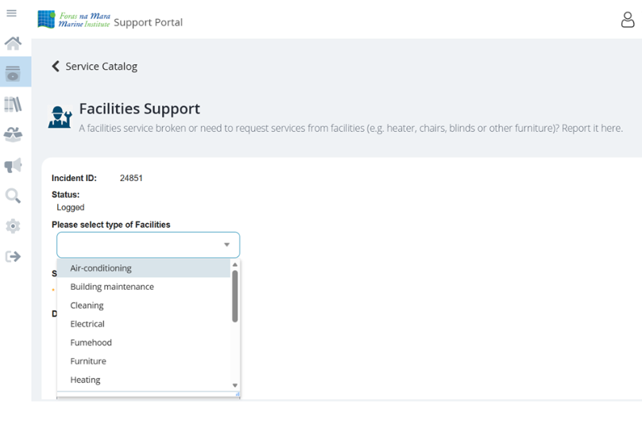

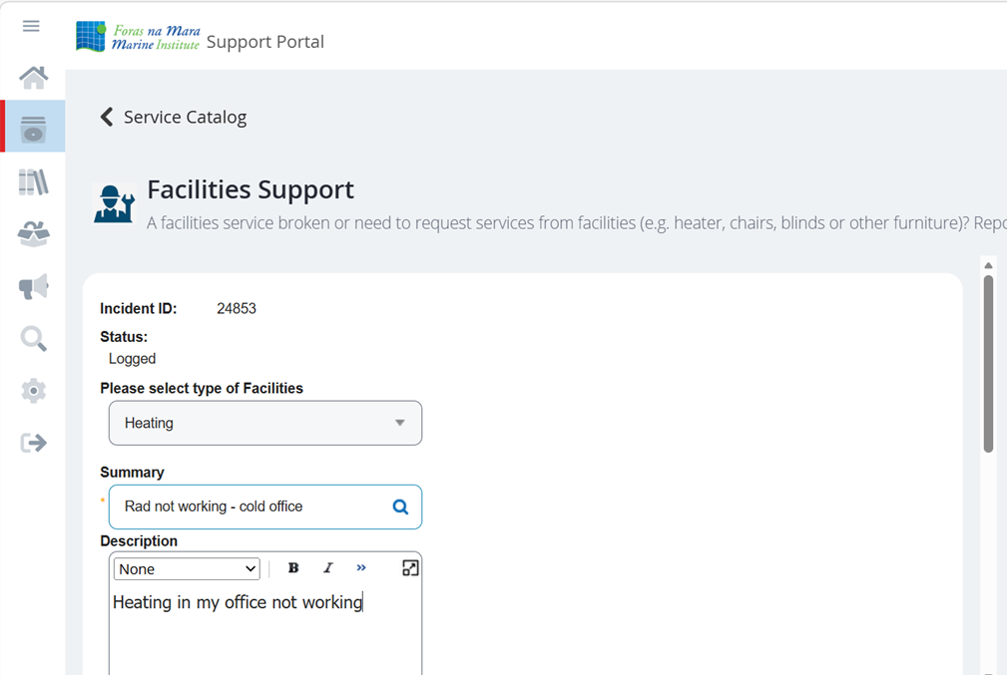

FAC team view
Dashboard – call information, owner, type of call.
Follow up actions, updates, resolution. Email generated to owner when closed out.
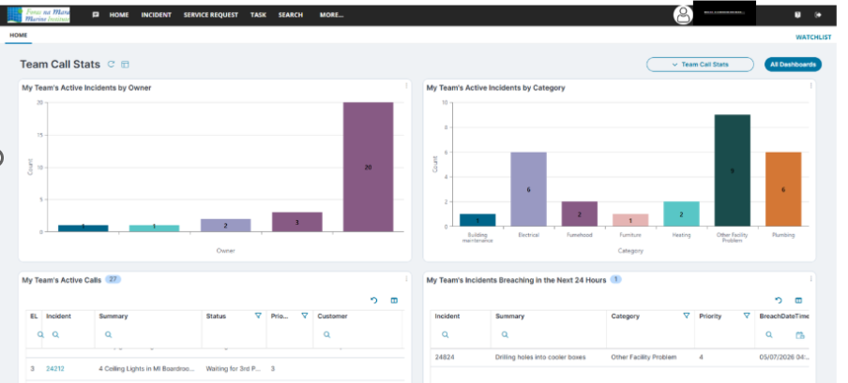

Appendix 6: Services Contract
See additional document

