ELIGIBILITY AND AWARD CRITERIA

Eligibility Criteria and Associated Rules
The Contracting Authority is using the Open Procedure. In the first instance, tenderers are requested to review the Selection Criteria and confirm using the self-declaration sheet attached at Appendix 3 – Form Of Self Declaration that they meet the minimum rules as set out below. This Selection Criteria will be assessed on a pass/fail basis. In the case of a grouping, this requirement will need to be completed by all group members.
The tenderer with the most economically advantageous tender will be requested to submit evidence in order to be validated against the Eligibility Criteria and rules contained in this Section 6 of the ITT document. Failure to achieve the required ‘pass’ mark on any of the Eligibility Criteria will result in the tenderer’s elimination from the competition. In the event that this verification process reveals that misleading or inaccurate information has been provided, the tender in question will be rejected from further consideration. Moreover, tenderers may be precluded, at the discretion of the Contracting Authority, from participating in future competitions. In the event that, following a request from the Contracting Authority, tenderers are not in a position to provide the required evidence within three (3) working days, their tender submission will be eliminated from further consideration.
For the avoidance of doubt, there is no requirement to complete Section 4.1 of the ITT document at this stage. Tenderers are requested to review the selection criteria and confirm using the self-declaration sheet attached at Appendix 3 – Form of Self Declaration that they meet the minimum rules as set out in below.
Alternatively, tenderers can avail of the option of submitting the European Single Procurement Document (ESPD) Article 59, confirming they meet the minimum rules as set out below.

ELIGIBILITY CRITERIA |  | MARKING SCHEME
4.1 (a) | Contact Details | For information only
4.1 (b) | Insurances | Pass / Fail
4.1 (c) | Financial Capacity | Pass / Fail
4.1 (d) | Tax Compliancy | Pass / Fail
4.1 (e) | Declaration of Bona Fides | Pass / Fail
4.1 (f) | Previous Experience | Pass / Fail
4.1 (g) | Quality Assurance | Pass / Fail

- Please complete the table below, providing contact details for your organisation. The table may be expanded as required.
4.1(a) – CONTACT DETAILS
Name of Organisation
Company Registration Number
Date of Establishment
Address of Organisation
Contact Person
Position of Contact Person
Telephone Number
E-mail Address
Information regarding partnership or subcontracting arrangements.

RULE: Tenderers must complete this table. If the tender concerns a grouping or a partnership, each group member or subcontractor must answer each criterion below.

- Please provide evidence (e.g., certificates of insurance) indicating that you possess the forms and levels of insurance specified. Alternatively, please provide a broker’s letter indicating that the forms and levels of insurance specified can be put in place if you are successful in this competition.
4.1(b) – INSURANCES
INSURANCE | LEVEL |  | APPENDIX AT WHICH EVIDENCE IS ATTACHED
Employer’s Liability | €13m in any one occurrence |  | Insert
Public / Product Liability | €6.5m in any one occurrence |  | Insert
Professional Indemnity | €2.6m |  | Insert
Cyber Risk Insurance including Third Party Liability | Please specify limits currently arranged |  | Insert
ALTERNATIVELY
Broker’s letter indicating that the forms and levels of insurance required can be put in place if the tenderer is successful in this competition |  | Insert

Liability policies should extend to provide a specific indemnity to the Contracting Authority

RULE: Tenderers must provide evidence that they possess the forms and levels of insurance specified. Alternatively, tenderers must provide a broker’s letter indicating that the forms and levels of insurance specified can be put in place if the tenderer is successful in this competition.

- Please provide appropriate certified evidence defining your turnover for each of the three previous financial years (2023, 2024, and 2025 if available).

4.1(c) – FINANCIAL CAPACITY
TYPE OF CERTIFIED EVIDENCE PROVIDED | APPENDIX AT WHICH EVIDENCE IS ATTACHED
Insert | Insert

RULE: Tenderers must provide evidence that they attained a turnover of at least €75,000 in any one of the three (3) previous financial years.

- Please provide your companies Tax Reference number and Access number for the Contracting Authority to verify your tax compliancy through Revenue’s online facility (ROS).
4.1(d) – TAX COMPLIANCE
Tax Reference Number | Insert
Access Number | Insert
Do you grant the Contracting Authority permission to verify your tax position online? | Insert
Signature | Insert

Alternatively, attach a current and valid Tax Clearance Certificate to your submission, specifying here the Appendix number or page at which it is contained:
Appendix No. / Page

RULE: Tenderers must demonstrate that they are fully tax compliant.

- Please complete and sign the Declaration of Bona Fides contained in Appendix 2 – Declaration Of Bona Fides of this ITT document.
RULE: Tenderers must complete, date and sign this declaration. Provision of inaccurate or misleading information in this declaration may lead to my organisation being excluded from participation in this and future competitions.
Any -tenderer that cannot meet the requirements as prescribed in Appendix 2 – Declaration Of Bona Fides may provide evidence to the effect that measures taken by the tenderer are sufficient to demonstrate its reliability despite the existence of a relevant ground for exclusion.

- Please provide information regarding your previous experience by completing the tables below. The tables may be expanded as necessary.
RULE: Tenderers must detail two (2) projects delivered during the previous three (3) years that are of comparable nature and scale to the Contracting Authority’s requirements under this competition. Tenderers are advised that the projects listed must demonstrate capability to deliver the various supply / service aspects to meet the Contracting Authority’s requirements.
4.1(f) – PREVIOUS EXPERIENCE – PROJECT ONE

Client Name
Client contact details | Contact name
Client contact details | Contact e-mail address
Client contact details | Contact telephone number
Approx. annual value
Start date |  | End date
1. Please outline the range of services carried out over the course of this contract.
Insert, expanding this table as necessary

2. Please indicate how the contract is comparable with the subject matter of this competition.
Insert, expanding this table as necessary.

3. Please detail how any urgent requests were dealt with.
Insert, expanding this table as necessary.

4.1(f) – PREVIOUS EXPERIENCE – PROJECT TWO

Client Name
Client contact details | Contact name
Client contact details | Contact e-mail address
Client contact details | Contact telephone number
Approx. annual value
Start date |  | End date
1. Please outline the range of services carried out over the course of this contract.
Insert, expanding this table as necessary

2. Please indicate how the contract is comparable with the subject matter of this competition.
Insert, expanding this table as necessary.

3. Please detail how any urgent requests were dealt with.
Insert, expanding this table as necessary.

Quality Assurance
Please outline your organisations quality assurance policy. Tenderers must detail their methodology for ensuring quality and must provide details of any Quality Management System that they have in place.
If your organisation has any third-party accreditations, please provide details below:

Date of original accreditation
Date of most recent audit
Scheduled date for next audit
Name of accreditation body
Scope of accreditation
Name of person responsible for quality management

Certification
Tick if attached
Appendix number

Award Criteria and Weightings
A framework agreement will be established with the tenderer submitting the most economically advantageous tender, identified following application of the Award Criteria and weightings detailed hereunder. It is emphasised that the Contracting Authority is not bound to accepting the most economically advantageous tender or any tender submissions received and reserves the right to accept or reject in whole or in part any or all tender submissions received.
Award Criteria | Percentage | Max. points available | Min. points required
- Ultimate Cost | 40% | 4,000 | N/A
- Proposed Team and Creative Capability | 30% | 3,000 | 1,500
- Understanding of Requirements and Contract Management | 25% | 2,500 | 1,250
- Environmental and Social Considerations | 5% | 500 | 250
Totals | 100%

NB: Tenderers should ensure in their submissions that they provide detailed information in respect of all aspects of the Award Criteria as stated below. Failure to provide detailed responses to the Award Criteria may result in elimination from the competition.

Minimum Qualitative Score Required
Tenderers should note that they must achieve a minimum rating of “minimum mark” or 50% of the total marks available, the qualitative Criterion B and C to avoid elimination from the competition.

Verification And Clarification Meetings
Meetings for the purpose of verification / clarification may be carried out with appropriate tenderers as a facet of the evaluation process in order to identify the most economically advantageous tender submission, prior to the establishment of the Framework Agreement. Such meetings may be required in order to verify the scores achieved by tenderers in respect of their tender submissions. For the avoidance of doubt, tenderers should note that mere performance at interview will not of itself be evaluated. In the event that such meetings are required, information regarding location and times will be communicated to the chosen tenderers. In order to ensure the optimum effectiveness of such meetings, it is strongly recommended that the key personnel proposed to manage this Framework Agreement on the part of the tenderer in question should attend.
If necessary, please complete the separate sheet and return it with your tender submission.

Criterion A – Ultimate Cost (40%)
Tenderers are required to complete in full the Form Of Tender contained in Appendix 1 – Form Of Tender. The lowest notional ultimate cost tender submission that also meets all minimum requirements described in this document will attain the highest score available under this criterion. The scores of all other valid tender submissions will be calculated as follows:
Points awarded = (the maximum score achievable) multiplied by (the cost of the lowest-cost valid tender) divided by (the cost of the valid tender in question).
Prices shall be fixed for the first two (2) years of the Framework Agreement. Any price changes for subsequent years of the Framework Agreement must be detailed and confirmed in writing to the Contracting Authority’s Contract Manager / Procurement Manager for review and discussion at least three (3) months prior to any acceptance.

TABLE A - RATES - DESIGNER
Rate | Rate in € ex VAT | Notional number of hours for evaluation purposes | Sub Total in €
Senior Designer Hourly Rate | €, Please insert | 10 hours | €, Please insert
Senior Designer ½ Daily Rate | €, Please insert | 10 days  (3.75 hours per day) | €, Please insert
Senior Designer Full Daily Rate | €, Please insert | 10 days  (7.5 hours per day) | €, Please insert
Junior Designer Hourly Rate | €, Please insert | 10 hours | €, Please insert
Junior Designer ½ Daily Rate | €, Please insert | 10 days  (3.75 hours per day) | €, Please insert
Junior Designer Full Daily Rate | €, Please insert | 10 days  (7.5 hours per day) | €, Please insert
TOTAL |  |  | €, Please insert

TABLE B – ADDITIONAL SERVICES
ADDITIONAL SERVICES | NOTIONAL NUMBER | RATE | TOTAL COST (€) (Ex VAT)
Cost per social media graphic | 10 | Insert (€) | Insert (€)
Cost per A4 poster / flyer | 10 | Insert (€) | Insert (€)
Cost per page for booklet/report design | 10 | Insert (€) | Insert (€)
Cost per PowerPoint infographic or slide design | 10 | Insert (€) | Insert (€)
Rates for motion graphics / video editing / studio time | Hourly rate  10 | Insert (€) | Insert (€)
Rush job cost – on the day turn around for ad hoc needs | 5 | Insert (€) | Insert (€)
TOTAL |  |  | €, Please insert

TABLE C – TOTALS FOR EVALUATION PURPOSES
TABLE A Total Fixed Price | Insert (€)
TABLE B Total Additional Hours | Insert (€)
Total TABLE A + TABLE B for the purpose of Evaluation | Insert (€)

The rates proposed must be inclusive of fuel costs, out of pocket expenses, including travel, subsistence and ancillary expenses or costs of every description, including costs relating to the production of documentation, production of quotes and any administrative surcharges or expenses. Any additional rates/costs will not be considered a render your submission invalid.
The contracting authority reserves the right to request a breakdown of the above prices.
- Pricing must be:
  - Transparent and itemised
  - Pricing outside of agreed hours for amends must be signed off
  - Sufficiently detailed to allow like-for-like comparison across bidders
  - Valid for the duration of the contract (or clearly indexed if subject to change)

Criterion B – Proposed Team and Creative Capability (30%)
Tenderers are required to provide a comprehensive, up-to-date portfolio demonstrating the overall capability, expertise, and suitability of the proposed resource to deliver a range of creative services. This should include named team members, details of their roles and relevant experience. Tenderers must provide 3-5 examples of similar projects, outlining the scope of work and key responsibilities undertaken, demonstrating creative quality, brand consistency and suitability.

Expand as required.

If necessary, please complete the separate sheet and return it with your tender submission.

Criterion C – Understanding of Requirements and Contract Management (25%)
Tenderers are required to outline how they plan to meet HRI’s requirements and describe any potential risks, concerns and requirements that they envisage arising based on industry experience. This response is required to include in detail the methodology to undertaking work with HRI including the proposed steps to undertake and the outputs that would emerge.
Tenderers are required to detail:
  - Handling of urgent requests, concurrent projects and peak periods
  - Direct access to designers, continuity and absence cover
  - Briefing, approvals, revisions and budget control
  - Quality checks, including current platform safe zones
  - Source-file handover, reporting and escalation
Tenderers are also asked to provide adequate detail to inform the Contracting Authority as to how the relationship would be managed on a day-to-day basis including communication, meetings, administration and invoicing.

Expand as required.

If necessary, please complete the separate sheet and return it with your tender submission.

Criterion D – Environmental and Social Considerations (5%)
Tenderers are required to outline how environmentally and socially responsible practices will be applied when delivering multimedia design services to HRI. Tenderers are asked to provide any certificates, policies, practices and considerations relevant to the requirement that integrate principles of Green and Socially Responsible Public Procurement, that outline any of the following that contribute to the reduction of the Tenderer’s Carbon Footprint and promoting fair working conditions and community engagement (this list is not exhaustive):
- Commitment to the use of Energy-Efficient Equipment, e.g. Energy-efficient computers, monitors and other production equipment, renewable energy where available, responsible reuse, recycling and disposal of equipment;
- Sustainable Design and Production, e.g. digital proofing and approval processes, minimising unnecessary print, and recommending resource-efficient formats and responsibly sourced materials where print production forms part of the brief;
- Low Impact Travel, e.g. remote collaboration and meetings where appropriate, lower emission travel options for necessary site visits;
- Fair Working Practices, e.g. fair working conditions, reasonable workloads, responsible engagement and payment of employees, freelancers and subcontractors;
- Accessibility and Inclusion, e.g. Accessible and inclusive design practices, together with relevant training, mentoring or community initiatives connected to the delivery of the contract;
- Responsible Resourcing, e.g. consideration of environmental and social standards when selecting suppliers and subcontractors engaged on HRI projects.
Tenderers should outline how these measures will be implemented and monitored throughout the contract, including any relevant targets or performance measures. Supporting policies or certificates may be provided, but responses should focus on practical actions relevant to HRI’s outlined requirement.

Expand as required.

APPENDIX 1 – FORM OF TENDER
This Form of Tender must be completed, signed and returned by tenderers. Any amendment to the structure of this document, or any qualification of financial offers, may, at the sole discretion of the Contracting Authority, result in the elimination of the tender submission in question.

Contracting Authority: Horse Racing Ireland & Subsidiaries
Competition: Single Party Framework for the Provision of Multi-Media Design Services
From (Tenderer):

The cost proposals must be inclusive of all out-of-pocket expenses, travel, subsistence and ancillary expenses or costs of every description, including costs relating to the production of documentation, production of quotes and any administrative and assembly supervision surcharges or expenses.
The Contracting Authority reserves the right to request a breakdown of the above prices.

I/We, having read the full ITT Document and associated Appendices, do hereby offer to provide the whole of the supplies / services described all to the entire satisfaction of the Contracting Authority, for the above prices, and enter into a framework agreement accordingly.
I/We confirm that I/we:
- Understand the nature and extent of the Supplies / Services required to be delivered as described the ITT document.
- Accept all of the Terms and Conditions of the ITT document and the Framework Agreement and agree if awarded a Framework Agreement to execute the Framework Agreement appended at Appendix 4 – Terms & Conditions to the ITT document.
- Agree to provide the Contracting Authority with the Services / Supplies in accordance with the ITT document and our tender submission.
- Have examined the ITT documentation and hereby offer to provide the Supplies / Services above in accordance with the specification and terms set out in the ITT document.
- Will keep this offer open for acceptance by the Contracting Authority for a period of twelve (12) months from the date of deadline for submission of tender.
- Agree that the Contracting Authority are not bound to accept the most economically advantageous tender submission or any tender submission that may be received by the Contracting Authority.
- Have read and thoroughly examined the ITT document and fully understand the ITT document and the Contracting Authority’s requirements.
- Undertake to perform and complete the Supplies / Services in accordance with the terms and conditions of the ITT document General Specification Of Requirements (Section 4).
- Acknowledge that all costs and expenses incurred by us in producing and submitting this tender submission will be borne by us in full.
- Certify that the information provided in this tender submission is accurate and complete to the best of our knowledge and belief.
- Understand that the provision of inaccurate or misleading information in this Form of Tender may lead to my organisation being excluded from participation in this and future competitions.
- Undertake to treat the details of this ITT document, the resulting tender submission and any subsequent clarifications as private and confidential.
- Acknowledge that acceptance by the Contracting Authority of a tender submission will not constitute a binding and enforceable agreement and that a legally enforceable agreement will not exist until and unless the Framework Agreement has been established by the Contracting Authority;
- Have availed of all offers for additional information or have otherwise satisfied ourselves as to conditions that may in any manner affect the performance of the Framework Agreement awarded under it.
- Have included everything necessary for the performance of the Supplies / Services required under the Framework Agreement which are either expressly stated in the ITT document or contained in any supplementary information or which could reasonably be inferred therefrom.
- Have found no errors, omissions, conflicts or ambiguities in the ITT document, except those which I/We have brought to the attention of the Contracting Authority before the latest date for submitting queries.
- Have included for compliance with all statutory requirements applicable in the Republic of Ireland and those applicable in any country where parts of the contract may be performed that are in force seven (7) days prior to the deadline for receipt of tender responses.
- Will not, if awarded a Framework Agreement , employ labour in a manner that is discriminatory in relation to gender, race, religious beliefs, age, etc., or source any part of any Framework Agreement awarded in countries subject to official international trading sanctions.
- Understand the nature and extent of the requirements as described in Section 4 – General Specification of Requirements of this ITT document.
- Have reviewed Appendix 4 – Terms and Conditions of the ITT document and Framework Agreement and either (a) have no queries / issues and if awarded will execute the requirements to these terms OR (b) confirm that we have submitted our queries relating to these Terms and Conditions either via the ITT clarification question and answer process or along with our tender submission.
- Accept all the Eligibility and Award Criteria as set out in the ITT document.
- Agree to execute the requirements to the Contracting Authority in accordance with the ITT document and our tender submission.
- Agree that, if awarded any Framework Agreement , we shall, in the performance of such , comply with all applicable obligations in the field of environmental, social and labour law.
- Confirm that we have complied with all requirements as set out in Section 5 – Instructions to Tenderers within this ITT document.
- Confirm that all prices quoted in our tender submission will remain valid for the period of time commencing from the ITT Deadline, as specified within at Clause 5.11 of this ITT document.
- Shall, if awarded any Framework Agreement under this competition, have in place on the Effective Date of the Framework Agreement, all insurances (if any) as required, outlined in Section 6 – Eligibility Criteria.
- Confirm that all Data Subjects whose Personal Data is provided in our tender submission have consented to the processing of such Personal Data by us, the Contracting Authority, the Evaluation Team and the supplier of the www.etenders.gov.ie website, for the purposes of our participation in this competition, or that we otherwise have a legal basis for providing such Personal Data to the Contracting Authority for the purposes of our participation in this competition and that we will provide evidence of such consent and / or legal basis to the Contracting Authority upon request
SIGNATURE | (Insert) | Date | (Insert)
Name | (Insert) | Phone | (Insert)
Position | (Insert) | Email | (Insert)

A Tenderer’s failure to sign and date this Form of Tender and to complete all sections will invalidate the tender submission.

APPENDIX 2 - DECLARATION OF BONA FIDES
I, having been duly authorised by the economic operator, sincerely declare that itself or any person who has is a member of the administrative, management or supervisory body of the economic operator or has powers of representation, decision or control in the economic operator:
- Has never been the subject of a conviction for participation in a criminal organisation, as defined in Article 2 of Council Framework Decision 2008/841/JHA.
- Has never been the subject of a conviction for corruption, as defined in Article 3 of the Convention on the fight against corruption involving officials of the European Communities or officials of Member States of the European Union and Article 2(1) of Council Framework Decision 2003/568/JHA as well as corruption as defined in the national law of the Contracting Authority.
- Has never been the subject of a conviction for fraud within the meaning of Article 1 of the Convention on the protection of the European Communities’ financial interests.
- Has never been the subject of a conviction for terrorist offences or offences linked to terrorist activities, as defined in Articles 1 and 3 of Council Framework Decision 2002/475/JHA respectively, or for inciting or aiding or abetting or attempting to commit an offence, as referred to in Article 4 of that Framework Decision.
- Has never been the subject of a conviction for money laundering or terrorist financing, as defined in Article 1 of Directive 2005/60/EC of the European Parliament and of the Council.
- Has never been the subject of a conviction for child labour and other forms of trafficking in human beings as defined in Article 2 of Directive 2011/36/EU of the European Parliament and of the Council.
- Is not in breach of its obligations relating to the payment of taxes or social security contributions.
- Has, in the performance of all public contracts, complied with applicable obligations in the field of environmental, social and labour law that apply at the place where the works are carried out or the services provided, that have been established by EU law, national law, collective agreements or by international, environmental, social and labour law listed in Schedule 7 of the European Union (Award of Public Authority Contracts) Regulations 2016 (Statutory Instrument 284 of 2016).
- Is not bankrupt or the subject of insolvency or winding-up proceedings, its assets are not being administered by a liquidator or by the court, it is not in an arrangement with creditors, its business activities are not suspended nor is it in any analogous situation arising from a similar procedure under national laws and regulations.
- Is not guilty of grave professional misconduct.
- Has not entered into agreements with other economic operators aimed at distorting competition.
- Is not aware of any conflict of interest due to its participation in the Competition.
- Has not had any prior involvement in the preparation of the Competition.
- Is not guilty of significant or persistent deficiencies in the performance of a substantive requirement under a prior public contract, a prior contract with a contracting entity, or a prior concession contract, which led to early termination of that prior contract, damages or other comparable sanctions.
- Is not guilty of serious misrepresentation in supplying the information required for the verification of the absence of grounds for exclusion or the fulfilment of the Selection Criteria for this Competition and did not withhold such information and did not fail or is not able to submit supporting documents in respect of this Competition as required under Regulation 59 of the European Union (Award of Public Authority Contracts) Regulations 2016 (Statutory Instrument 284 of 2016).
- Has not undertaken to unduly influence the decision-making process of the Contracting Authority in respect of the Competition or obtain confidential information that may confer upon it undue advantages in respect of the Competition; or negligently provided misleading information that may have a material influence on decisions concerning exclusion, selection or award.
- I understand and acknowledge that the provision of inaccurate or misleading information in this declaration may lead to my business/firm/company/partnership being excluded from participation in this or future tenders, and I make this solemn declaration conscientiously believing the same to be true and by virtue of the Statutory Declarations Act, 1938. This declaration is made for the benefit of the Contracting Authority.
THIS FORM MUST BE COMPLETED AND SIGNED BY A DULY AUTHORISED OFFICER OF THE TENDERER
I certify that the information provided above is accurate and complete to the best of my knowledge and belief. I understand that the provision of inaccurate or misleading information in this declaration may lead to my organisation being excluded from participation in this and future competitions.
SIGNATURE | (Insert) | Date | (Insert)
Name | (Insert) | Phone | (Insert)
Position | (Insert) | Email | (Insert)

APPENDIX 3 – SELF DECLARATION
SELF DECLARATION – SELECTION CRITERIA
To | The Contracting Authority
Competition | Single Party Framework for the Provision of Multi-Media Design Services for HRI & Subsidiaries
Name of Organisation | Insert
Address of Organisation | Insert
Contact Person and Position: | Insert
Telephone Number | Insert
E-mail Address | Insert
Information regarding partnership or subcontracting arrangements. | Insert
4.1 (b) Insurances |  | Please confirm
I confirm possession of the required forms and levels of insurance and will provide insurance certificates as evidence of this fact promptly following receipt of a request from the Contracting Authority or I undertake to put the required forms and levels of insurance in place if successful in the competition and will provide a broker’s letter indicating my capacity to do so promptly following receipt of a request from the Contracting Authority. |  | (Insert)
4.1 (c) Financial Capacity |  | Please confirm
I confirm that I have adequate financial capacity to meet the turnover requirements specified in respect of Eligibility Criterion 4.1(c) and will provide appropriate evidence to this effect promptly following receipt of a request from the Contracting Authority. |  | (Insert)
4.1 (d) Tax Clearance |  | Please confirm
I confirm that my tax affairs are up to date and that I am fully tax compliant, or I confirm that I have applied for a Tax Clearance Certificate, which will be made available promptly following receipt of a request from the Contracting Authority. |  | (Insert)
4.1 (e) Declaration of Bona Fides |  | Please confirm
I confirm that I fully meet the requirements as set out the Declaration of Bona Fides as set out in Appendix 2 – Declaration Of Bona Fides and will promptly supply a signed copy following receipt of a request from the Contracting Authority. |  | (Insert)
4.1 (f) Previous Experience
I confirm that I have delivered two (2) projects of a similar nature and scale within the past three (3) years and will promptly supply sufficiently annotated details following receipt of a request from the Contracting Authority.
4.1 (g) Quality Assurance |  | Please confirm
I confirm that I have a Quality Assurance Policy / Quality Management System / Quality Accreditation in place, and will promptly provide evidence of such following receipt of a request from the Contracting Authority. |  | (Insert)

I certify that the information provided above is accurate and complete to the best of my knowledge and belief. I understand that the provision of inaccurate or misleading information in this declaration may lead to my organisation being excluded from participation in this and future competitions.

THIS FORM MUST BE COMPLETED AND SIGNED BY A DULY AUTHORISED OFFICER OF THE TENDERER’S ORGANISATION

SIGNATURE | (Insert) | Date | (Insert)
Name | (Insert) | Phone | (Insert)
Position | (Insert) | Email | (Insert)

APPENDIX 4 - TERMS AND CONDITIONS
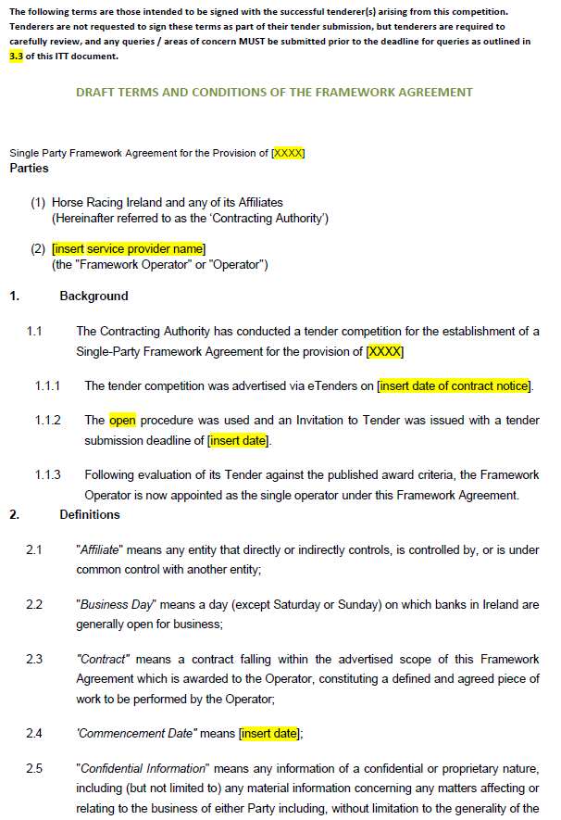

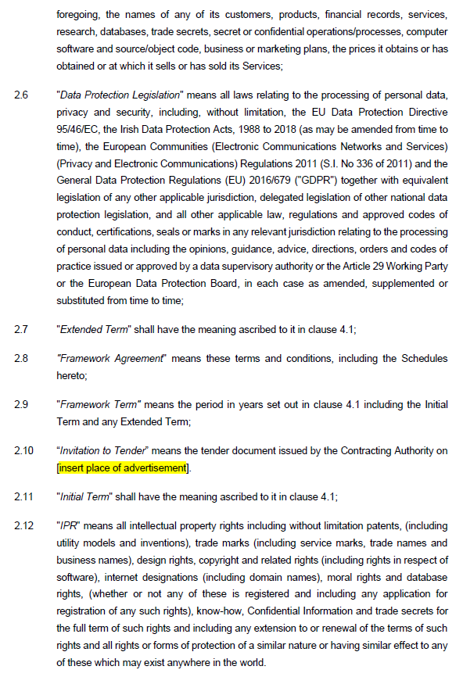

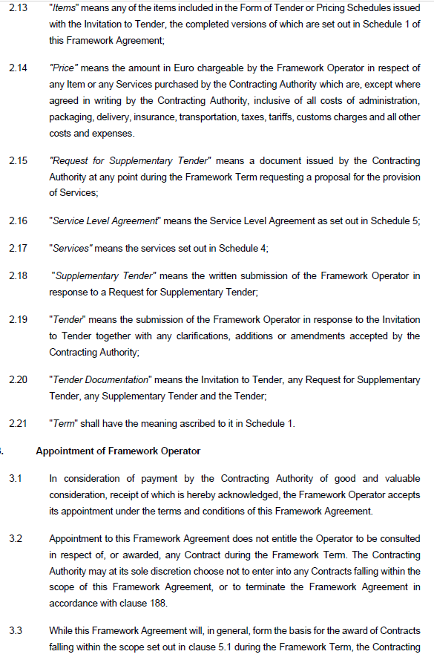
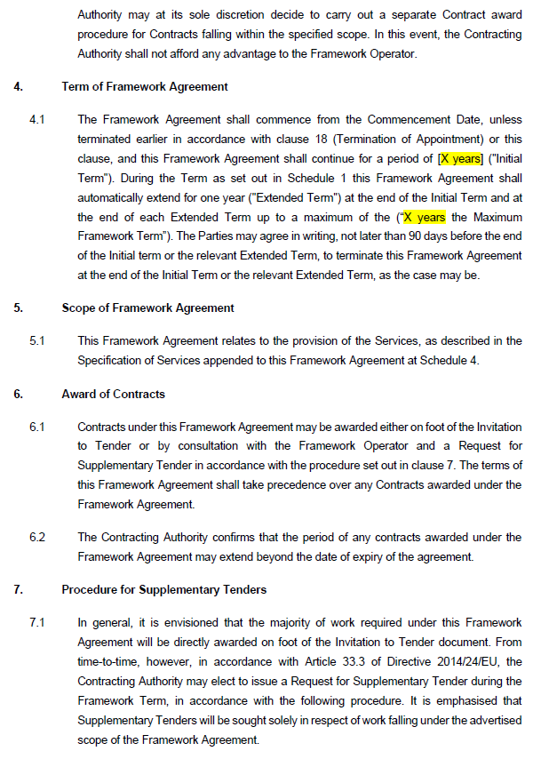
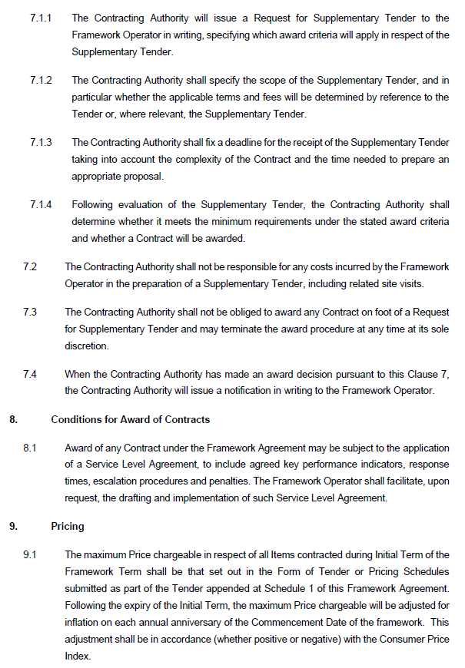
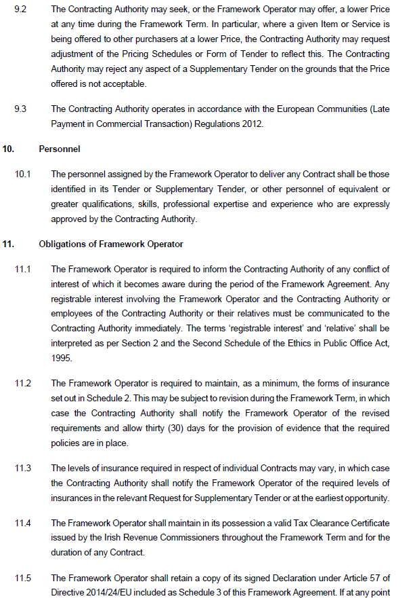
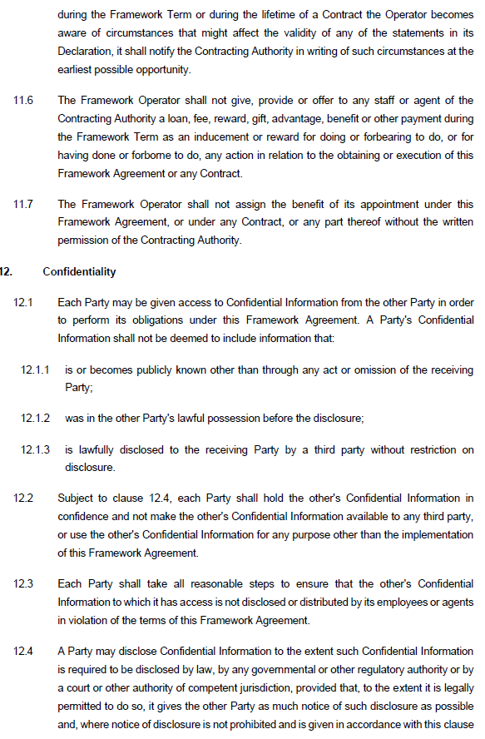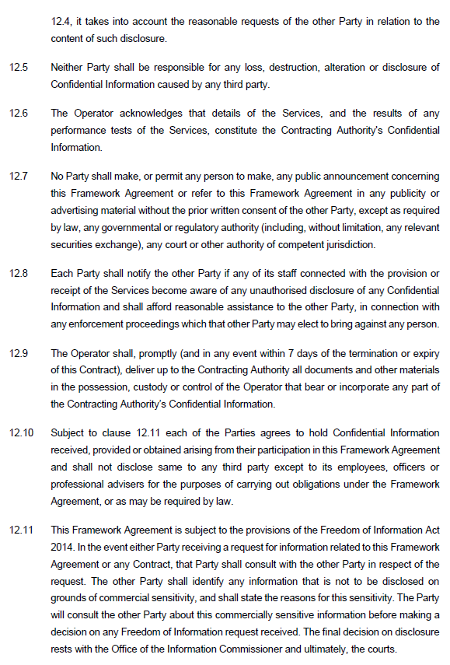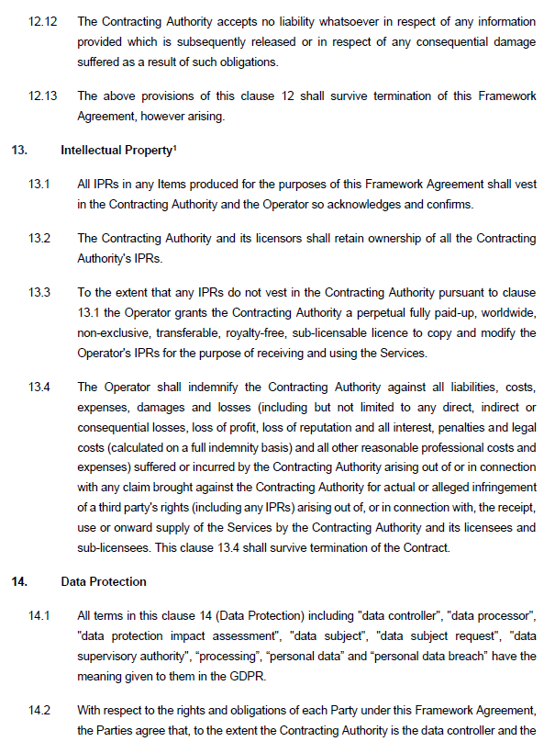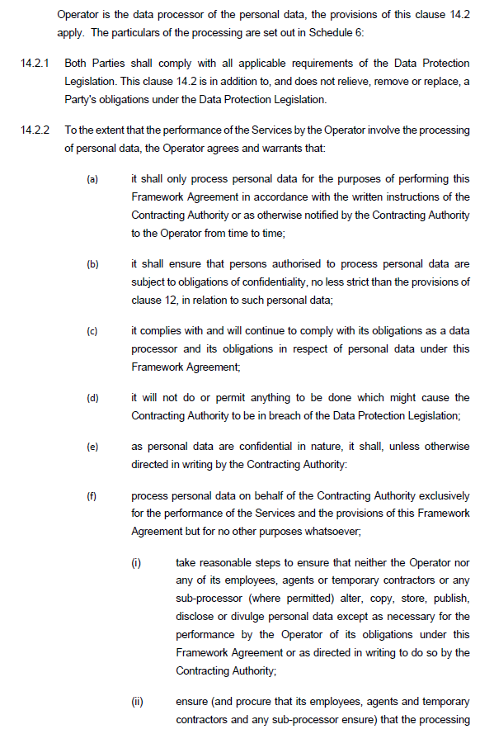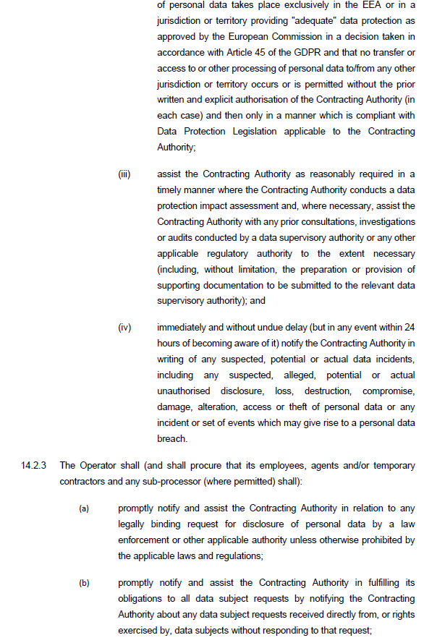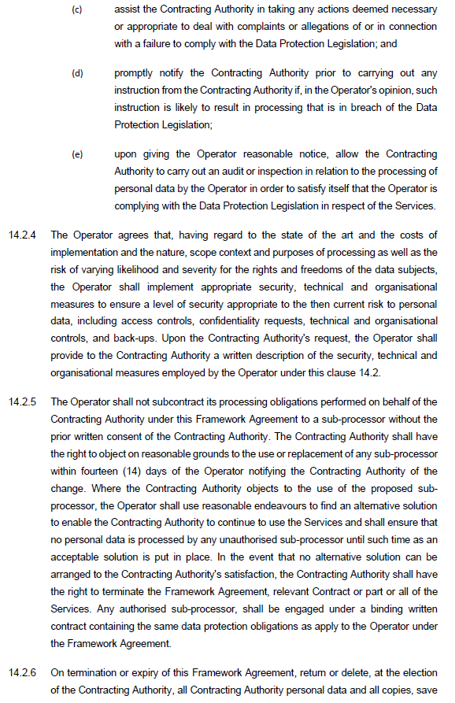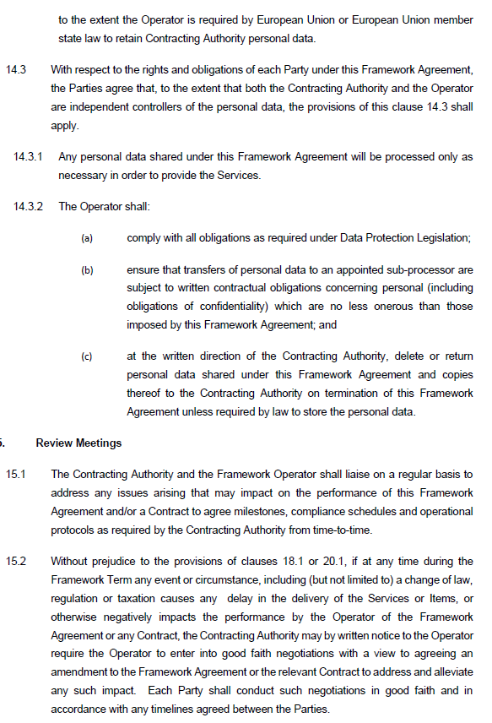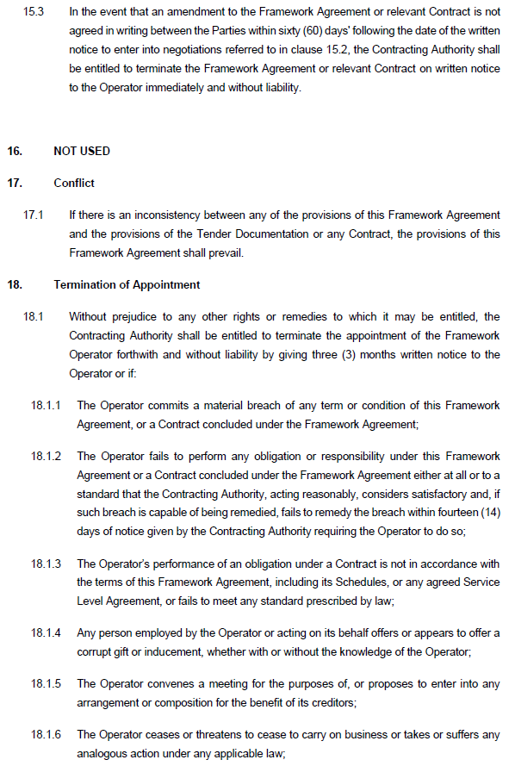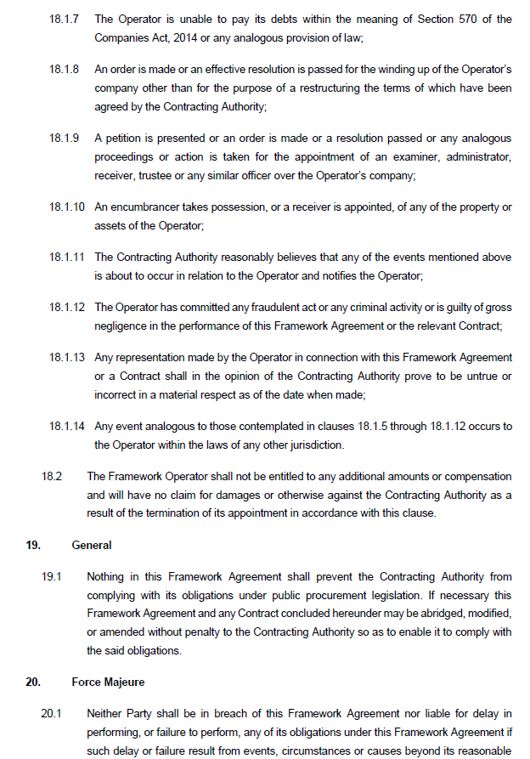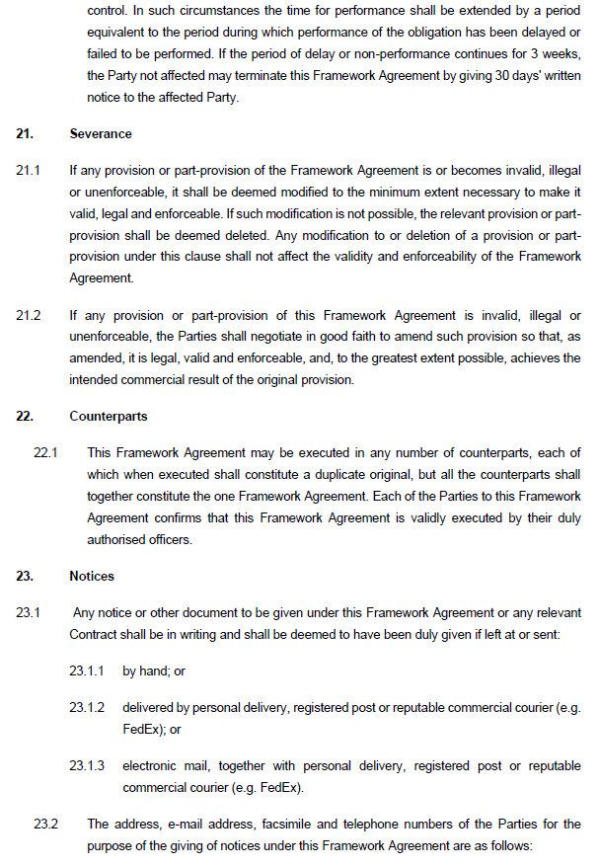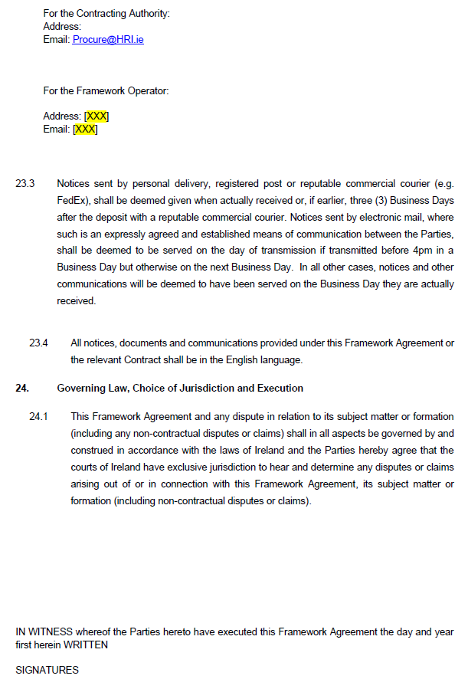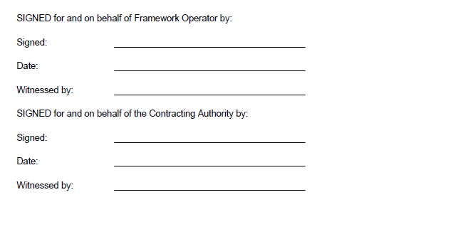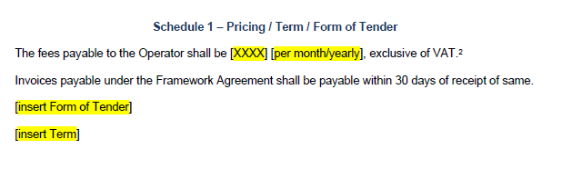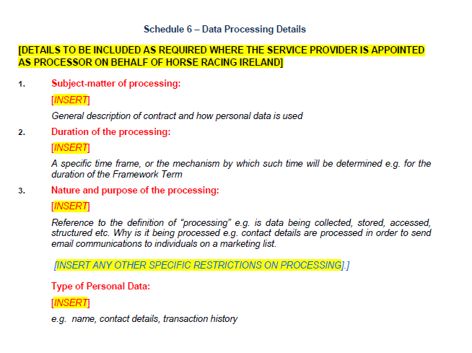

HORSE RACING IRELAND
DATA PROCESSING AGREEMENT

THIS AGREEMENT is dated [ ● ] (the “Agreement”)
PARTIES
- [Horse Racing Ireland and its Subsidiaries], a company incorporated in Ireland [with company number [ ● ] and having its registered office at [Ballymany, The Curragh, County Kildare, R56 XE37, Ireland] (“HRI”); and
- [ ● ] with company number [ ● ] and having its registered office at [ ● ] (“Processor”),
(each a “Party”, together the “Parties”).
BACKGROUND
  - HRI has appointed Processor to carry out [ ● ] (the “Services”)
  - The Parties have agreed the following terms and conditions in order to ensure compliance with Article 28 of the GDPR.
AGREED TERMS
The Parties agree the following:
- Definitions & Interpretation
  - Definitions
In this Agreement, the following terms shall have the following meanings:

- “Adequacy Decision” means a decision adopted by the European Commission that a relevant third country, territory or one or more specified sectors within such third country or international organisation ensures an adequate level of protection within the meaning of Article 45 of the GDPR;
- “Appropriate Safeguards” the appropriate safeguards provided for in Article 46 of the GDPR;
- “Appropriate Technical and Organisational Measures” the appropriate technical and organisational measures referred to in Data Protection Law (including, as appropriate, the measures referred to in Article 32(1) of the GDPR);
- “Applicable Data Protection Law” means any law and regulatory requirements relating to the Processing of Personal Data and to privacy as such may be supplemented, amended, revised or replaced from time to time:
  - the Irish Data Protection Acts 1988 to 2018,
  - the Directive (EU) 2016/680,
  - the General Data Protection Regulation (EU) 2016/679 (the “GDPR”),
  - the Directive on privacy and electronic communications 2002/58/EC,
  - any successor or replacement to the laws set out above, and
  - all other industry guidelines (whether statutory or non-statutory) or applicable codes of practice and guidance notes relating to the processing of Personal Data or privacy issued from time to time by a relevant supervisory authority, such as the DPC, and which are applicable to a party;
- “Authorised Person(s)” the persons specified in Schedule 1, as amended from time to time in accordance with this Agreement;
- “Business Day” means a day other than a Saturday, Sunday or public holiday in Ireland;
- “Delete” to remove or obliterate personal data such that it cannot be recovered or reconstructed;
- “DPC” means the supervisory authority in Ireland for the purposes of Article 51 of the GDPR whose principal administrative offices are at 21 Fitzwilliam Square South, Dublin 2, D02 RD28, Ireland, or any replacement supervisory authority under the Applicable Data Protection Law, appointed from time to time in Ireland;
- “EEA” means the European Economic Area, comprised of those states that are contracting Parties to the Agreement on the European Economic Area from time to time;
- “Losses” has the meaning given to such term in Clause 13.1;
- “Normal Business Hours” means 9.00 am to 5.00 pm Irish Standard Time on a Business Day;
- “Personal Data” has the meaning given to such term in Article 4(1) of the GDPR and means any information relating to an identified or identifiable natural person (the “Data Subject”); and relates only to personal data, or any part of such personal data, in respect of which HRI is the controller, and in respect of which Processor is the processor under this Agreement;
- “Personal Data Breach” means any “personal data breach” as defined in the GDPR including a breach of security leading to the accidental or unlawful destruction, loss, alteration, unauthorised disclosure of, or access to, personal data transmitted, stored or otherwise processed;
- “Personnel” means the employees, agents and/or contractors of Processor;
- “process”, “processed” or “processing” means any operation or set of operations which is performed on Personal Data or on sets of Personal Data, whether or not by automated means, such as collection, recording, organisation, structuring, storage, adaptation or alteration, retrieval, consultation, use, disclosure by transmission, dissemination or otherwise making available, alignment or combination, restriction, erasure or destruction;
- “Restricted Transfer” any transfer of Personal Data to countries outside of the EEA which are not subject to an Adequacy Decision, where such transfer would be prohibited by Data Protection Law;
- “Security Features” any security feature, including any encryption, pseudonymisation, key, PIN, password, token or smartcard;
- “Sensitive Data” means personal data set out in Articles 9(1) and 10 of the GDPR such as personal data revealing racial or ethnic origin, political opinions, religious or philosophical beliefs, or trade union membership, genetic data or biometric data for the purpose of uniquely identifying a natural person, data concerning health or a person’s sex life or sexual orientation, or data relating to criminal convictions and offences;
- “Services” has the meaning given to that term in Recital (A), in the course of which the Processing of Personal Data as described in Schedule 1 shall occur;
- “Standard Contractual Clauses” means the contractual clauses dealing with the transfer of Personal Data to a Third Country, which have been approved by (i) the European Commission under Applicable Data Protection law, or (ii) by the DPC or an equivalent competent authority under Data Protection Law;
- “Specific Instructions” has the meaning given to that term in Clause 2.2;
- “Sub-processor” has the meaning given to that term in Clause 9; and
- “Term” has the meaning given to that term in Clause 17.1.
  - Interpretation
    - References to Clauses and Schedules are to the Clauses and Schedules of this Agreement and references to paragraphs are to paragraphs of the relevant Schedule.
    - Clause, Schedule and paragraph headings shall not affect the interpretation of this Agreement.
    - The Schedules form part of this Agreement and shall have effect as if set out in full in the body of this Agreement. Any reference to this Agreement includes the Schedules.
    - A person includes a natural person, corporate or unincorporated body (whether or not having separate legal personality).
    - A reference to a company shall include any company, corporation or other body corporate, wherever and however incorporated or established.
    - Unless the context otherwise requires, words in the singular shall include the plural and in the plural shall include the singular.
    - Unless the context otherwise requires, a reference to one gender shall include a reference to the other genders.
    - A reference to a statute or statutory provision is a reference to it as amended, extended or re-enacted from time to time.
    - A reference to a statute or statutory provision shall include all subordinate legislation made from time to time under that statute or statutory provision.
    - Any words following the terms “including”, “include”, “in particular” or “for example” or any similar phrase shall be construed as illustrative and shall not limit the generality of the related general words.
    - For the avoidance of doubt, in the event of any conflict or ambiguity between the provisions of this Agreement and/or the Standard Contractual Clauses (if applicable), the following order of precedence shall apply:
      - the Standard Contractual Clauses (if applicable); and
      - this Agreement.
- Services
  - Processor agrees that to the extent that it processes Personal Data for or on behalf of HRI, it is subject to, and agrees to comply fully with Applicable Data Protection Law.
  - Processor shall not act on any Specific Instructions given by HRI from time to time for the duration of the Term in respect of Processing unless they are:
    - in writing (including by electronic means); and
    - given by an Authorised Person.
  - Processor shall Process the Personal Data for the performance of the Services only and in compliance with HRI’s instructions from time to time, which may be:
    - Specific Instructions; or
    - the general instructions set out in this Agreement.
unless required to do otherwise by law, in which case, where legally permitted, Processor shall inform HRI of such legal requirement before Processing.
  - Processor shall cooperate with HRI and take all reasonable steps requested by HRI where required for HRI to comply with any notification or other obligations applicable to HRI under Applicable Data Protection Law.
- Processor’s Obligations
  - Processor shall:
    - only make copies of the Personal Data to the extent reasonably necessary for the performance of its obligations under this Agreement (which, for clarity, includes back-up, mirroring (and similar availability enhancement techniques), security, disaster recovery and testing of the Personal Data);
    - not extract, reverse-engineer, re-utilise, use, exploit, redistribute, re-disseminate, copy or store the Personal Data other than for the performance of its obligations under this Agreement;
    - At HRI’s request, provide to HRI such information and such assistance as the it may reasonably require, and within the timescales reasonably specified by HRI, to allow HRI to comply with its obligations under Applicable Data Protection Laws, including but not limited to assisting HRI to (i) comply with its own security obligations with respect to the Personal Data; (ii) discharge its obligations to respond to requests for exercising Data Subjects’ rights with respect to the Personal Data; (iii) comply with its obligations to inform Data Subjects about serious Personal Data Breaches; (iv) carry out data protection impact assessments and audit data protection impact assessment compliance with respect to the Personal Data; and (v) consult with the DPC following a data protection impact assessment, where a data protection impact assessment indicates that the Processing of the Personal Data would result in a high risk to Data Subjects;
    - notify HRI immediately if it receives any complaint, notice or communication which relates directly or indirectly to the processing of Personal Data or to either party’s compliance with Applicable Data Protection Law and provide HRI with full co-operation and assistance in relation to any such complaint, notice or communication;
    - not do anything that may materially damage the reputation of HRI;
    - notify HRI in writing without delay of any situation or envisaged development that shall in any way influence, change or limit the ability of the Processor to Process the Personal Data as set out in this Agreement;
    - promptly comply with any request from HRI requiring the Processor to amend, transfer or Delete any of the Personal Data;
    - at HRI’s request, provide HRI with a copy of all Personal Data held by the Processor in the format and on the media reasonably specified by HRI; and
    - adhere to the terms of any approved code of conduct under Article 40 of the GDPR or any approved certification mechanism under Article 42 of the GDPR, where applicable.
  - Processor shall notify HRI in writing without delay of any situation or envisaged development that shall in any way influence, change or limit the ability of Processor to Process the Personal Data as set out in this Agreement.
  - At HRI’s request, Processor shall provide to HRI a copy of all Personal Data held by Processor in the format and on the media reasonably specified by HRI.
  - At HRI’s request, Processor shall provide to HRI such information and such assistance as HRI may reasonably require, and within the timescales reasonably specified by HRI, to allow HRI to comply with its obligations under Applicable Data Protection Law, including but not limited to assisting HRI to:
    - comply with its own security obligations with respect to the Personal Data;
    - discharge its obligations to respond to requests for exercising Data Subjects’ rights with respect to the Personal Data;
    - comply with its obligations to inform Data Subjects about serious Personal Data Breaches;
    - carry out data protection impact assessments and audit data protection impact assessment compliance with respect to the Personal Data; and
    - consult with the DPC following a data protection impact assessment, where a data protection impact assessment indicates that the Processing of the Personal Data would result in a high risk to Data Subjects.
  - Any proposal by Processor to in any way use or make available the Personal Data other than as provided for pursuant to this Agreement shall be subject to prior written approval of HRI.
- Data Subject Rights
  - Processor shall co-operate with and assist HRI, including but not limited to employing Appropriate Technical and Organisational Measures and with any assessment, enquiry, notice or investigation under Applicable Data Protection Law, in respect of the fulfilment of HRI’s obligations to respond to requests from a Data Subject exercising his/her rights under Applicable Data Protection Law.
  - Processor shall notify HRI within twenty four (24) hours if it receives:
    - a request from a Data Subject for access to that person’s Personal Data;
    - any communication from a Data Subject seeking to exercise rights conferred on the Data Subject by Applicable Data Protection Law in respect of the Personal Data; or
    - any complaint or any claim for compensation arising from or relating to the Processing of the Personal Data.
  - Processor shall not disclose the Personal Data to any Data Subject or to a third party other than at the request of HRI or as provided for in this Agreement, or as required by law, in which case Processor shall to the extent permitted by law inform HRI of that legal requirement before Processor discloses the Personal Data to any Data Subject or third party.
  - Processor shall not respond to any request from a Data Subject except on the documented instructions of HRI or Authorised Person or as required by law, in which case Processor shall to the extent permitted by law inform HRI of that legal requirement before Processor responds to the request.
- Audit
  - HRI shall have the right to examine and review the use by Processor of the Personal Data provided to Processor by HRI for the purposes of ascertaining that such Personal Data has been used and Processed in accordance with the terms of this Agreement.
  - Processor shall grant to HRI (or Authorised Representatives of HRI) on reasonable advance notice a right of access to Processor’s premises during Normal Business Hours for the purposes of such examination and review, and Processor shall give all necessary assistance to the conduct of such examinations/audits during the Term. The requirement to give reasonable advance notice will not apply if HRI believes that Processor is in breach of any of its obligations under this Agreement.
  - The examination and review by HRI of the use by Processor of the Personal Data may include, but shall not be limited to, a review of the existing internal compliance regime of Processor in relation to:
    - business processes and nature of interactions with customers;
    - existing audit procedures on business activities and financial reporting, and the governance of such procedures;
    - staff vetting, hiring and training procedures;
    - data access requests and the purpose/duration for which Personal Data is Processed/kept; and
    - reporting of data breaches.
  - After each audit, HRI may (but shall not be obliged to) provide a report to Processor detailing the extent of compliance with the provisions of this Agreement. Processor shall respond as required to the findings and recommendations of any HRI audit report and shall provide information requested by HRI on the implementation by Processor of any required actions.
  - In the event that the audit process determines that Processor is non-compliant with the provisions of this Agreement, HRI may, by notice in writing, deny further access to the Personal Data and the provisions of Clause 17 (Term and Termination) may, by notice in writing, be invoked.
  - Without prejudice to HRI’s right of audit under this Clause, to the extent permitted under Applicable Data Protection Law, Processor may demonstrate its and, if applicable its Sub-processors’, compliance with its obligations under this Agreement through its compliance with a certification scheme or code of conduct approved under Applicable Data Protection Law.
- Processor’s Personnel
  - Processor shall ensure that access to Personal Data is limited to: (a) those Personnel strictly necessary to meet Processor’s obligations under the Agreement; and (b) in the case of any access by any Personnel, such part or parts of the Personal Data as is strictly necessary for performance of such Personnel’s duties; and ensure that all Personnel: (x) are informed of the confidential nature of the Personal Data being processed for or on behalf of HRI; (y) have undertaken training in the laws relating to handling of Personal Data; and (z) are aware both of Processor’s duties and their personal duties and obligations as Processors under such laws and the Agreement.
  - Processor shall have in place procedures so that personnel of Processor, will respect and maintain the confidentiality and security of the Personal Data. Any person acting under the authority of Processor shall be obligated to process the Personal Data only on instructions from Processor. This provision does not apply to persons authorised or required by law or regulation to have access to the Personal Data.
  - Processor shall ensure that all personnel that have access to the Personal Data:
    - are informed of the confidential nature of the Personal Data and are subject to an appropriate statutory obligation of confidentiality or have committed themselves to a binding duty of confidentiality in respect of such Personal Data;
    - have undertaken training in the laws relating to handling Personal Data; and
    - are aware both of Processor’s duties and their personal duties and obligations under Applicable Data Protection Law and this Agreement.
  - Processor shall take reasonable steps to ensure the reliability of any of Processor’s employees (or approved agents/contractors) who have access to the Personal Data.
- Records
  - Processor shall keep at its normal place of business detailed, accurate and up-to-date records (including in electronic form) to demonstrate compliance with this Agreement and relating to all categories of Processing activities carried out on behalf of HRI containing:
    - details of the purposes of such processing;
    - a general description of the security measures taken in respect of the Personal Data, including details of any Security Features and the Appropriate Technical and Organisational Measures;
    - the name and contact details of Processor; any sub-processor; where applicable, Processor’s representatives; and where applicable any Data Protection Officer appointed by Processor;
    - the categories of Data Subjects and categories of Personal Data Processed by Processor on behalf of HRI;
    - the time limits for erasure of the Personal Data; and
    - details of any Restricted Transfers, and the safeguards in place in respect of such transfers.
- Data Protection Officer
Each Party shall appoint a Data Protection Officer, if required to do so pursuant to Applicable Data Protection Law, and provide the other Party with the contact details of such Data Protection Officer.
- Sub-processors
  - Processor may only authorize a third party (including any third party, affiliate or contractor of Processor, but excluding Processor employees) (a “Sub-processor”) to process the Personal Data being processed for or on behalf of HRI with the prior written consent of HRI and provided that:
    - Processor shall provide reasonable notice to HRI of any intended changes concerning the addition or replacement of other Sub-processors, thereby giving HRI the opportunity to revoke its consent in respect of such changes. The list of Sub-Processors authorised pursuant to this Clause 9.1 as at the date of this Agreement are detailed in Schedule 2.
    - the Sub-processor’s contract is on terms which are substantially the same as those set out in this Agreement (in particular, providing sufficient guarantees to implement Appropriate Technical and Organisational Measures in such a manner that the Processing will meet the requirements of Data Protection Law);
    - the Sub-processor will be subject to the same obligations as those which Processor is subject to under this Agreement; and
    - the Sub-processor’s contract will terminate automatically on termination of the Agreement for any reason.
  - With respect to each approved Sub-processor, Processor shall, before the Sub-processor first Processes Personal Data, carry out adequate due diligence to ensure that the Sub-processor is capable of providing the level of protection for Personal Data required by this Agreement.
  - Where Processor appoints or otherwise uses the services of a Sub-processor, Processor shall be fully liable to HRI for the performance, acts and omissions of Sub-processor. Nothing in this Agreement shall relieve Processor of any liability for the acts or omissions of its staff, employees or contractors in relation to the Personal Data.
- Security
  - Processor shall at all times have Appropriate Technical and Organizational Measures, including any Security Features, in place to protect and secure any Personal Data which it holds for or on behalf of HRI against accidental or unlawful destruction or accidental loss, alteration, unauthorized disclosure or access, and that having regard to the state of technological development and the cost of implementing any measures, such measures shall provide a level of security appropriate to the risk represented by the processing and the nature of the Personal Data to be protected. Processor shall, at the request of HRI, provide a detailed, written explanation and full details of the Appropriate Technical and Organizational Measures taken by or on behalf of Processor to demonstrate compliance with Applicable Data Protection Law.
  - Processor agrees and warrants that the Appropriate Technical and Organisational Measures referred to in this Agreement are appropriate to protect Personal Data against accidental or unlawful destruction or accidental loss, alteration, unauthorised disclosure or access, in particular where the processing involves the transmission of data over a network, and against all other unlawful forms of processing, and that these measures ensure a level of security appropriate to the risks presented by the processing and the nature of the Personal Data to be protected having regard to the state of the art.
  - Processor shall ensure that the Personal Data provided by HRI can only be accessed by persons and systems that are authorised by Processor and necessary to provide the Services, and that all equipment used by Processor for the Processing of Personal Data shall be maintained by Processor in a physically secure environment.
  - Processor further agrees and warrants that the processing of the Personal Data has been and will continue to be carried out in accordance with the Applicable Data Protection Law.
- Breach Reporting
  - Processor shall promptly inform HRI if any Personal Data is copied, modified, lost or destroyed or becomes damaged, corrupted, or unusable, or if there is any accidental, unauthorised or unlawful disclosure of or access to the Personal Data. In such case, HRI will restore such Personal Data at its own expense, and will comply will all of its obligations under Data Protection Laws in this regard.
  - Processor must inform HRI of any Personal Data Breaches, or any complaint, notice or communication in relation to a Personal Data Breach, without undue delay, provide sufficient information and assist HRI in ensuring compliance with its obligations in relation to notification of Personal Data Breaches (including the obligation to notify Personal Data Breaches to the DPC within seventy two (72) hours), and communication of Personal Data Breaches to Data Subjects where the breach is likely to result in a risk to the rights of such Data Subjects. Processor shall co-operate with HRI and take such reasonable commercial steps as are directed by HRI to assist in the investigation, mitigation and remediation of each such Personal Data Breach.
  - In the event of a Personal Data Breach or any data breach involving the Services, Processor shall not make any announcement to the media in respect of such breach without first consulting with HRI.
  - Processor agrees not to use any Personal Data which it processes on behalf of HRI for direct marketing purposes without the prior written authorisation of HRI.
- Restricted Transfers
  - A Restricted Transfer may not be made by Processor without the prior written consent of HRI, and if such consent has been obtained, such Restricted Transfer may only be made where there are Appropriate Safeguards in place with regard to the rights of Data Subjects (including but not limited to the Standard Contractual Clauses, binding corporate rules, or any other model clauses or transfer mechanism approved by the DPC).
  - Any Party which is entering into the Appropriate Safeguards with a data importer shall comply with the guidance of any relevant regulatory authority, such as the DPC, on Restricted Transfers in particular with respect to the use of Standard Contractual Clauses and any additional or supplementary measures required to be taken in the context of any such Restricted Transfers, including but not limited to the requirement to carry out risk assessments and to adopt supplementary measures to ensure essentially equivalent protection for Data Subjects in the jurisdiction of the data importer.
  - Clauses 12.1 or 12.2 shall not apply to a Restricted Transfer if other compliance steps (which may include, but shall not be limited to, obtaining explicit consents from Data Subjects) have been taken to allow the relevant Restricted Transfer to take place without breach of Applicable Data Protection Law.
- Liability and Indemnity
  - Processor shall immediately notify HRI of any breach of its data protection obligations under this Agreement and/or any Applicable Data Protection Law. Processor hereby indemnifies HRI against all claims, liabilities, costs, expenses, damages and losses (including but not limited to any direct, indirect or consequential losses, loss of profit, loss of reputation and all interest, penalties and legal costs (calculated on a full indemnity basis) and all other reasonable professional costs and expenses) suffered or incurred by HRI arising out of or in connection with any breach by Processor of any terms of this Agreement or the Processing of the Personal Data by Processor, its employees or agents in breach of this Agreement, contrary to the instructions of HRI or in contravention of Applicable Data Protection Law (including but not limited to claims by Data Subjects relating to loss of control over Personal Data or limitation of rights, discrimination, financial loss, damage to reputation, loss of confidentiality of Personal Data and any other significant economic or social disadvantage) (the Losses).
  - This Clause 13 is intended to apply to the allocation of liability for losses relating to Data Protection Law as between the Parties, including with respect to compensation to Data Subjects, notwithstanding any provisions under Data Protection Law to the contrary, except:
    - to the extent not permitted by applicable law (including Data Protection Law); and
    - that it does not affect the liability of either Party to any Data Subject.
  - Where requested by HRI, Processor shall provide the other party with evidence of financial resources to confirm it has sufficient such resources to fulfil its responsibilities under Clause 13.1 as appropriate (which may include proof of insurance cover).
- Limitation of Liability
  - To the extent permitted by law, HRI shall not under any circumstances be liable to Processor for any costs or losses of Processor relating to this Agreement.
  - Unless required to do so by the DPC or any other competent supervisory authority, Processor shall not make any payment or any offer of payment to any Data Subject in response to any complaint or any claim for compensation arising from or relating to the Processing of the Personal Data, without the prior written agreement of HRI.
- Warranties
  - Processor warrants, represents and undertakes to HRI that:
    - Processor will Process Personal Data in compliance with all applicable laws, enactments, regulations, orders, standards and other similar instruments (including Applicable Data Protection Law);
    - Processor will maintain Appropriate Technical and Organisational Measures against the unauthorised or unlawful Processing of Personal Data and against the accidental loss or destruction of, or damage to, Personal Data; and
    - Processor will discharge its obligations under this Agreement with all due skill, care and diligence.
  - HRI does not warrant that the Personal Data:
    - is or are accurate, complete, reliable, secure, useful, fit for purpose or timely;
    - has or have been tested for use by Processor or any third party; or
    - will be suitable for or be capable of being used by Processor or any third party.
- Rights and Remedies
Except as expressly provided in this Agreement, HRI’s rights and remedies provided under this Agreement are in addition to, and not exclusive of, any rights or remedies provided by law (including Applicable Data Protection Law).
- Term and Termination
  - This Agreement shall commence on [the date at the beginning of this Agreement] and, subject to Clauses 17.2 and 17.4, shall continue in force until the earlier of the date on which the Parties have discharged their obligations under or the termination of the Agreement (the “Term”).
  - This Agreement may be terminated by written agreement of both Parties.
  - Without prejudice to Applicable Data Protection Law, in the event that Processor is in breach of its obligations under this Agreement, HRI may instruct Processor to suspend the Processing of Personal Data until Processor rectifies the breach of the Agreement. Processor shall within twenty four (24) hours inform HRI in case it is unable to comply with these Clauses, for whatever reason.
  - HRI shall be entitled to terminate this Agreement insofar as it concerns Processing of Personal Data in accordance with this Agreement if:
    - the Processing of Personal Data by Processor has been suspended by HRI pursuant to Clause 17.1 and if compliance with this Agreement is not restored within a reasonable time and in any event within one (1) month following suspension;
    - Processor is in substantial or persistent breach of this Agreement or its obligations under Applicable Data Protection Law; or
    - Processor fails to comply with a binding decision of a competent court or the DPC regarding its obligations pursuant to this Agreement or to Applicable Data Protection Law.
  - Upon termination or expiry of this Agreement, Processor shall, at the choice of HRI, Delete all Personal Data processed on behalf of HRI and certify to HRI that it has done so, or, return all the Personal Data to HRI and Delete existing copies unless legally required/entitled to retain the Personal Data for a period of time.
- Allocation of Cost
Each Party shall perform its obligations under this Agreement at its own cost.
- Variation
No variation of this Agreement shall be effective unless it is in writing and signed by the Parties (or their authorised representatives).
- Waiver
A failure to exercise or delay in exercising a right or remedy provided by this Agreement or by law does not constitute a waiver of the right or remedy or a waiver of other rights or remedies. No single or partial exercise of a right or remedy provided by this Agreement or by law prevents further exercise of the right or remedy or the exercise of another right or remedy.
- Severance
  - If any provision or part-provision of this Agreement is or becomes invalid, illegal or unenforceable, it shall be deemed modified to the minimum extent necessary to make it valid, legal and enforceable. If such modification is not possible, the relevant provision or part-provision shall be deemed Deleted. Any modification to or deletion of a provision or part-provision under this Clause 21 shall not affect the validity and enforceability of the rest of this Agreement.
  - If any provision or part-provision of this Agreement is invalid, illegal or unenforceable, the Parties shall negotiate in good faith to amend such provision so that, as amended, it is legal, valid and enforceable, and, to the greatest extent possible, achieves the intended commercial result of the original provision.
- Changes in Law
If during the Term, Applicable Data Protection Law and/or other applicable laws change in a way that the Agreement is no longer adequate for the purpose of governing lawful data sharing exercises, the Parties agree to negotiate in good faith to review the Agreement in light of the new legislation.
- Relationship of the Parties
Nothing in this Agreement is intended to, or shall be deemed to, establish any partnership or joint venture between the Parties, constitute any Party the agent of another Party, or authorise any Party to make or enter into any commitments for or on behalf of any other Party.
- [Entire Agreement
This Agreement constitute[s] the entire agreement and understanding of the Parties, and any and all other previous agreements, arrangements and understandings (whether written or oral) between the Parties with regard to the subject matter of this Agreement (save where fraudulently made) are hereby excluded.]
- Further Assurance
At its own expense, each Party shall, and shall use all reasonable endeavours to procure that any necessary third party shall, execute and deliver such documents and perform such acts as may be required for the purpose of giving full effect to this Agreement.
- Dispute Resolution
  - If any dispute arises in connection with this Agreement, the Parties (or directors or other senior representatives of the Parties with authority to settle the dispute) will, within fourteen (14) days of a written request from one Party to the other Party, meet in a good faith effort to resolve the dispute.
  - If the dispute is not resolved at the meeting referred to in Clause 26.1, the Parties will attempt to settle it by mediation in accordance with the CEDR Model Mediation Procedure. The Parties shall submit the dispute to mediation by a person agreed by the Parties, or in the event that they are unable to agree on a mediator, the mediator shall be nominated by CEDR Ireland. To initiate the mediation, a Party must give notice in writing (“ADR Notice”) to the other Party requesting a mediation. The mediation will start not later than thirty (30) days after the date of the ADR Notice.
  - No Party may commence any court proceedings in relation to any dispute arising out of this Agreement until it has attempted to settle the dispute in accordance with this Clause 26, and either the mediation has terminated or the other Party has failed to participate in the mediation, provided that the right to issue proceedings is not prejudiced by a delay. Nothing in this Clause shall prevent any Party seeking a preliminary injunction or other judicial relief at any time if, in its judgement, such an action is necessary to prevent irreparable damage.
  - The Parties agree that in order to make the mediation process as effective as possible, they shall endeavour in good faith to resolve the disagreement through mediation, to abide by all procedural requirements established by the mediator, and to respond to requests by the mediator to appear before him and present arguments and evidence bearing upon and supporting the position of each Party with respect to the particular matter in dispute.
- Counterparts and Electronic Signature
  - This Agreement may be executed in any number of counterparts, and by different Parties on separate counterparts, each of which, when executed and delivered will constitute a duplicate original of this Agreement, but all of which together will constitute one and the same instrument.
  - The Parties consent to the execution by or on behalf of each other Party to the Agreement by electronic signature, provided that such manner of execution is permitted by law and that an executed copy of the Agreement may be retained in electronic form. The Parties acknowledge that such electronic form shall constitute an original of the Agreement and may be relied upon as evidence of the Agreement.
- Governing Law and Jurisdiction
  - This Agreement and any dispute or claim arising out of or in connection with it or its subject matter or formation (including non-contractual disputes or claims) shall be governed by and construed in accordance with the laws of Ireland.
  - Each Party irrevocably agrees that the courts of Ireland shall have exclusive jurisdiction to settle any dispute or claim arising out of or in connection with this Agreement or its subject matter or formation (including non-contractual disputes or claims).

Description of the Processing

Authorised Person

- [Details to be inserted]

Categories of data subjects whose personal data is processed

- [Details to be inserted]

Purpose(s) for which the personal data is processed on behalf of the controller

- [Details to be inserted]

Duration of the processing

- [Details to be inserted]

Categories of personal data processed

- [Details to be inserted]

Sensitive Data (if applicable) and applied restrictions or safeguards that fully take into consideration the nature of the data and the risks involved, such as for instance strict purpose limitation, access restrictions (including access only for staff having followed specialised training), keeping a record of access to the data, restrictions for onward transfers or additional security measures.

- [Details to be inserted]
Contact point(s) for data protection enquiries for Processor

Name:
Role:
Email Address:

Authorised Sub-processors

Name of Sub-processor | Address and location | Description of the processing
[ ]
[ ]

ENTERED INTO by the parties on the date appearing at the top of page.

SIGNED by

for and on behalf of ______________________________

Horse Racing Ireland

In the presence of:

Witness:

Address:

Date:

SIGNED by [ ]

for and on behalf of

[ ] _______________________________

In the presence of:

Witness:

Address:

Date:

Drafting note: Special category data and data relating to criminal matters are subject to strict conditions prior to processing. If any Sensitive Data is being processed, please also see Schedule 1 where details of the processing, and safeguards applicable are to be described.
Drafting note: Complete in accordance with the definition of “Services” in the Agreement. Please also see Schedule 1 where details of the processing are to be described (subject-matter and duration of the processing, the nature and purpose of the processing, the type of personal data and categories of data subjects involved).
Drafting note: This Agreement is intended for intra-EEA transfers only. Where the personal data processing requires access to/transfers of personal data outside the EEA to countries not subject to an adequacy decision under Article 45 of the GDPR then further measures are required in order to ensure compliance with Chapter V of the GDPR (such as Standard Contractual Clauses).
Drafting note: This processor indemnity is not mandated by the GDPR, but should be sought by HRI where possible to obtain from its third party processors.
Drafting note: If the commencement date differs, delete the text between the brackets and insert the specified date.
Drafting note: This Clause may need to be amended to the extent that this Data Processing Agreement forms part of a larger contract (e.g. MOU, SLA or service provider agreement).
Drafting note: Preferred approach on dispute resolution to be confirmed. This ADR clause can be removed if preferred.
Drafting note: Where processing special category data or data relating to criminal prosecutions or convictions (as defined under “Sensitive Data” in Clause 1), consider including description of any restrictions or safeguards in place re the nature of the data and the particular risks involved, e.g. strict purpose limitation, access restrictions (including access only for staff having followed specialised training), keeping a record of access to the data, restrictions for onward transfers or additional security measures).
Drafting note: Insert details of sub-processor(s) where relevant.
Drafting note: Entity to be confirmed/details provided.

