Clarifications

Ref | Query | Teagasc Response
1 | Pricing Document – Appendix 1, Element 60: Site Services  Item 60.3, “Amount for disconnection and removal of existing site lighting” – Could you please clarify what works are required under this item?. | N/A
2 | Pricing Document – Appendix 1, Element 61: Electrical Centre  Item 61.1, “Amount for hire of temporary 300kVA continuously rated generator and all associated sundries for 2-week period” – Could you please confirm which board the temporary generator is to be connected to? | Its to be connected to SDB 1 as per the electrical schematic.
3 | Electrical Drawing 1881-E300  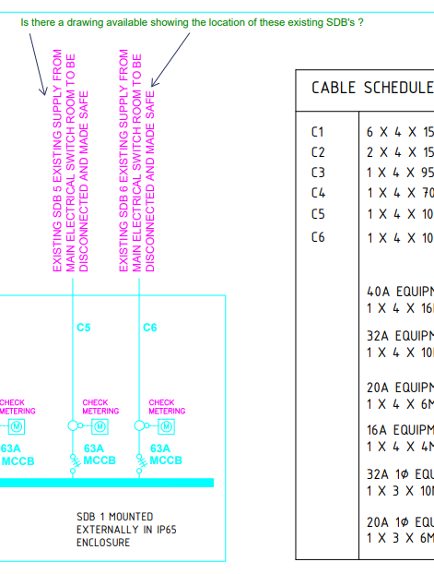. | These locations are indicated on drawing reference no. 1811 - E100
4 | could we clarify the following please:  type of containment ie- galvanised or stainless | For the main distillery, its stainless the requirements are set out on page 10 of the Electrical Specification, outside of this area e.g. containment requirements for SDB 3 / SDB 5 / SDB 6 etc it can be galvanised.
5 | can ducting runs be altered to ensure less cutting of roads etc | Yes, within reason & without compromising circuit design including voltage drop etc. This will have to be demonstrated by the contractor to the Engineer / Client before any solution can be accepted. Outside of Engineering matters, the Client shall ultimately reserve the right to approve the route.
6 | do we need to include costs of an earthing bar in quotation | Yes as per requirements set out on Page 16 of the Electrical Services Specification document.
7 | is generator hire inclusive in quote or added under the line as an extra | Included in quote & coset to be entered under Item 61.1
8

