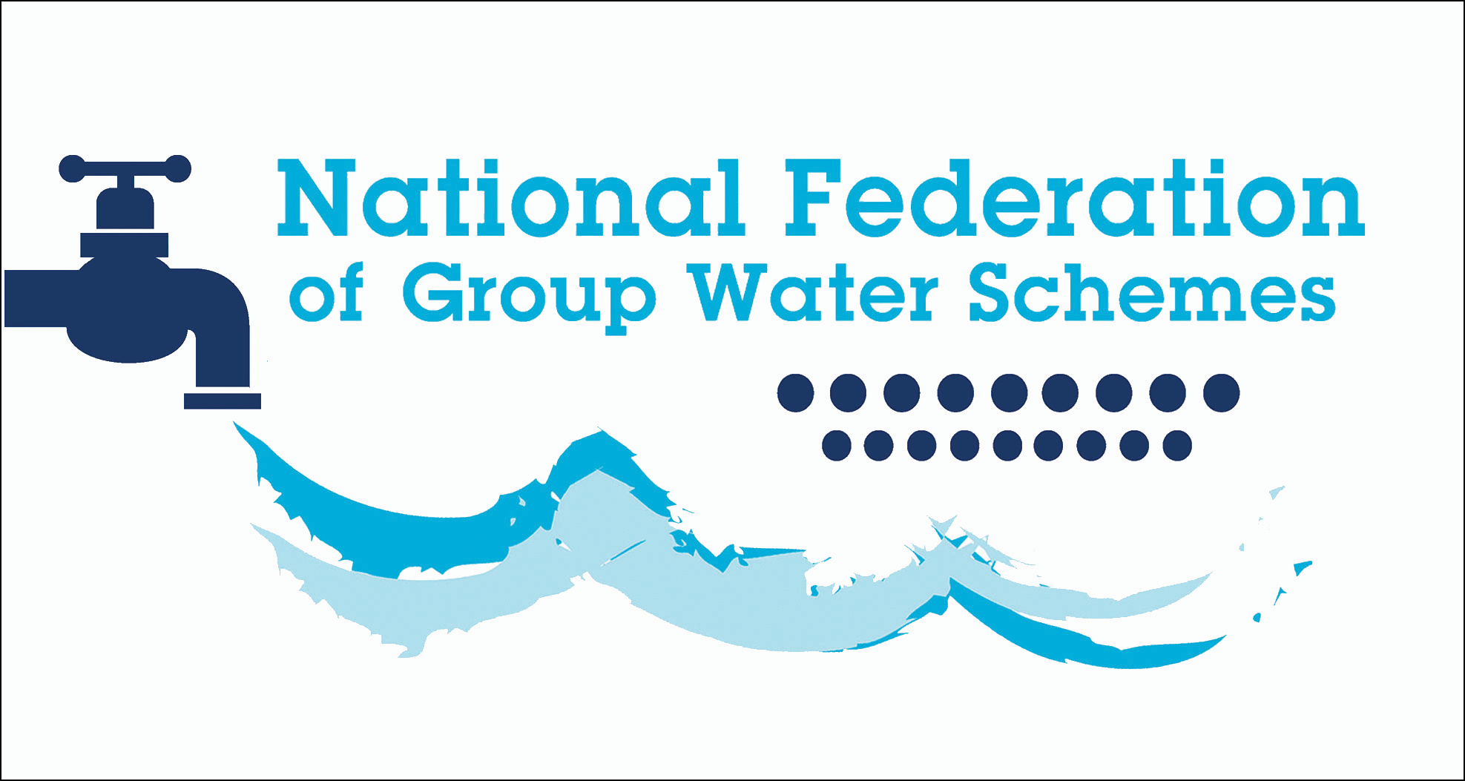

REQUEST FOR QUOTATION

Subject of Quotation
Provision of Services for Preparation of Integrated Source Protection Plan for Mountain Lodge Water Scheme Co-Operative Society Limited (Mountain Lodge GWS)

Key Dates
Issue Date | Thursday 15th October 2026
Closing Date for Queries | Thursday 29th October 2026 – 5pm
Closing Date for Quotations | Thursday 12th November 2026 – 3pm
Contact for Queries
Josephine Ryan jryan@nfgws.ie Or VIA www.etenders.gov.ie ONLY
Format for submission of quotations – use the Quotation Response Document provided
Josephine Ryan jryan@nfgws.ie Or VIA www.etenders.gov.ie ONLY

CONTENTS
REQUEST FOR QUOTATION 1
Key Dates 1
CONTENTS 2
1. ABOUT THE CONTRACTING AUTHORITY 1
1.1 Introduction 1
2. SCOPE OF REQUIREMENT 4
2.1 Specification of Requirements 4
2.1.1 Desk-based Assessment 5
2.1.2 Field-based Assessment 7
2.1.3 Catchment Areas/ZOC Final Story 7
2.1.4 Preliminary Risk Assessment 7
2.1.5 Evaluation of Mitigation Options 7
2.1.6 Future Monitoring and Investigations 8
2.1.7 Prioritised Recommended Actions 8
2.2 Water Quality Data Sources 8
2.3 Deliverables 9
2.4 Stakeholder Engagement 10
2.5 Review of Performance 10
2.5.1 Account Management 10
2.5.2 Invoicing 11
2.6 Award to Runner Up 11
3. EVALUATION CRITERIA 12
3.1 Suitability 12
3.2 Award Criteria 12
3.3 Selection Criteria 15
4. FORMAT OF RESPONSE 16
5. INSTRUCTIONS FOR ECONOMIC OPERATORS QUOTING 17
(a) Closing Date 17
(b) Submission of Quotations 17
(c) Queries 17
(d) Currency and Payments 17
(e) Confidentiality 17
(f) Conflict of Interest 17
(g) Freedom of Information Acts 18
(h) Data Protection 18
(i) Tax Clearance Certificate 19
(j) Withholding Tax 19
(k) Interference and Inducement to Purchase 19
(l) Notification of Evaluations 19
(m) Replacement Personnel 19
(n) Copyright 19
(o) Responsibility of Successful Party 20

1. ABOUT THE CONTRACTING AUTHORITY

1.1 Introduction
The delineation of drinking water source catchments/zones of contribution (ZOC) across the Group Water Scheme (GWS) sector was completed in recent years as preliminary source protection reports. The National Federation of Group Water Schemes (NFGWS) is currently encouraging GWSs to develop Integrated Source Protection Plans (ISPPs) based on the learnings and processes developed during the Source Protection Pilot Project Phase 2. These pilots were progressed in collaboration with the Department of Housing Local Government and Heritage (DHLGH) and a range of other key stakeholders.
The aforementioned pilot project established a framework for the development of ISPPs, largely based on drinking water source quality and catchment characterisation. If source water quality is good (i.e. within the guide values specified in the framework), protective actions should be developed and implemented. Should source water be in an unsatisfactory condition (i.e. above the guide values specified), an improvement will be required. Appropriate source protection actions should be targeted and established within the catchment’s critical source areas (CSAs). To aid this process, the project has also overseen the completion of a handbook document helping identify actions to prevent or mitigate source water contamination from agricultural sources.
With the transposition of S.I. No. 99/2023 – European Union (Drinking Water) Regulations 2023 - there is now a requirement for risk assessment and risk management of the catchment areas for abstraction points of water intended for human consumption. Arising from this, drinking water source protection guidance has been published by the Department of Housing, Local Government and Heritage. In addition, implementation guidance has been published by the EPA.The completion of an Integrated Source Protection Plan is the most scientifically detailed means for a GWSs to fulfil the requirements of both documents for drinking water sources and catchment areas.
The contracting authority Mountain Lodge GWS, wishes to appoint a suitably qualified professional/service provider to develop an Integrated Source Protection Plan (ISPP) for their drinking water catchments (Lough Naglare – Figure 2 and Lough Asturrall – Figure 3), following the process outlined in both the NFGWS framework document and the Drinking Water Source Protection Guidance, and which is summarised in Figure 1. Mountain Lodge GWS is primarily supplied by Lough Naglare and is almost continually supplemented by Lough Asturrall.
At present, both Lough Naglare and Lough Asturrall are estimated to be classified as IMPROVE drinking water sources. However, this classification is based on limited water quality data and will need to be confirmed following a review of more recent results.

- This RfQ is for surface water (river and lake) drinking water sources that have an Improve objective.

- In undertaking an ISPP, account should be taken of the NFGWS ‘Guidance on the Content and Format of Integrated Source Protection Plans’ document.

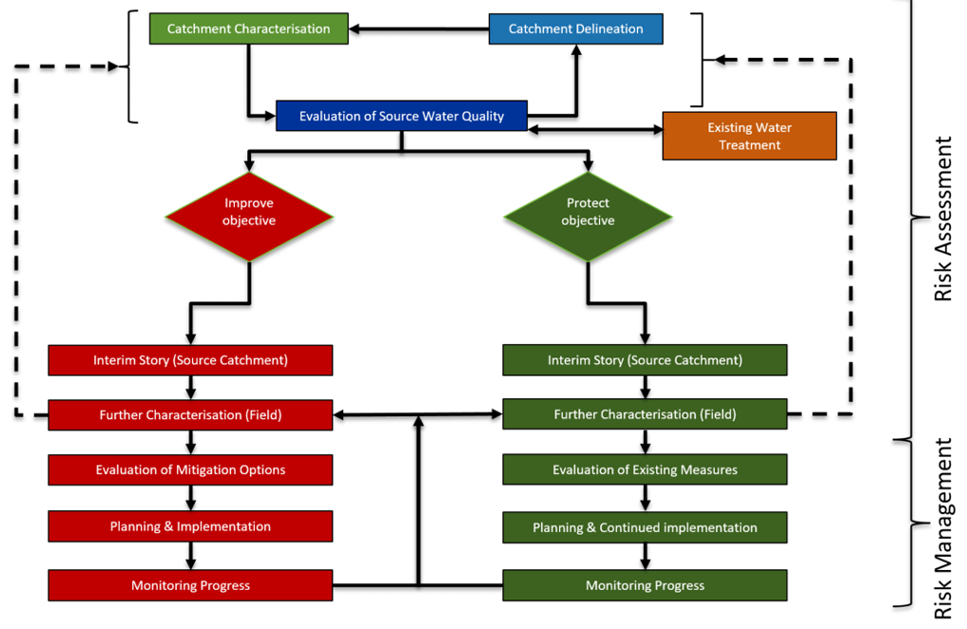
Figure 1: Recommended drinking water source protection framework

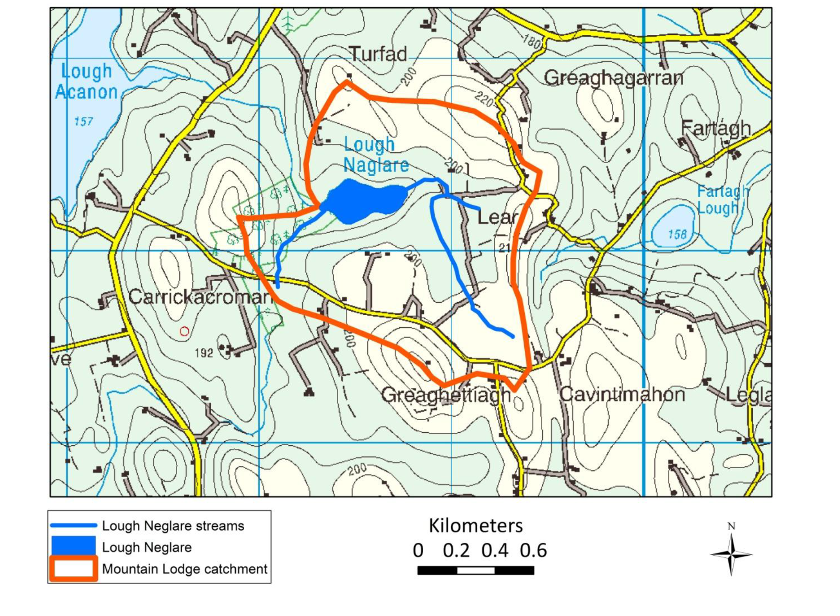
ITM: 658445, 802329
Figure 2 – Image of Lough Naglare delineated catchment.

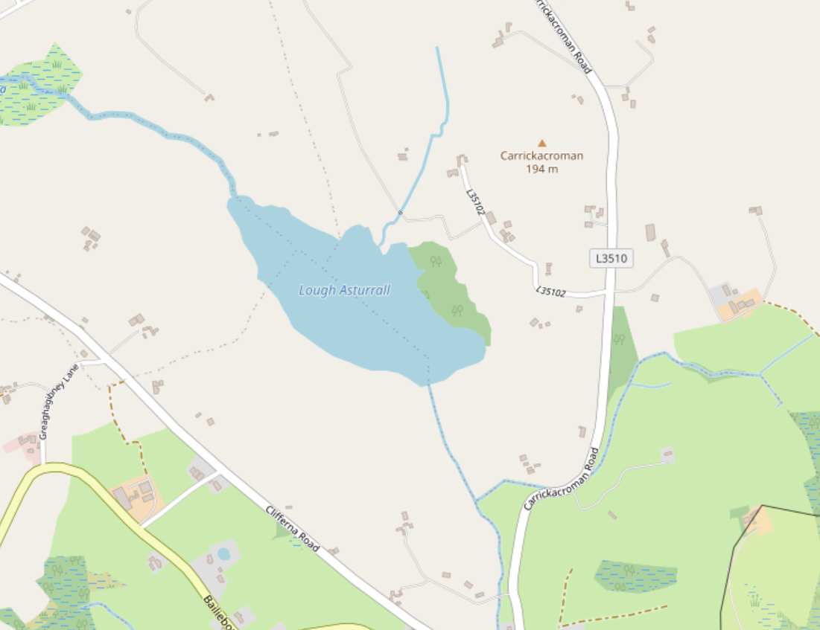
ITM: 656985, 800480
Figure 3 – Image of the location of Lough Asturrall (approximately 2km south-west of Lough Naglare).

2. SCOPE OF REQUIREMENT

2.1 Specification of Requirements
The appointed consultant/consultancy will develop an ISPP structured in accordance with the NFGWSs ‘Guidance on the Content and Format of Integrated Source Protection Plans’ document, which is included with this RfQ. Brief details on the required work for the ISPP recommended report headings are given below.

2.1.1 Desk-based Assessment
GWS Details
- Include a description of the scheme, for instance, details on sources, number of people supplied, treatment facilities, historical background, etc.
Evaluation of Untreated Water Quality
- Review, evaluate and graph available water quality data for both GWS sources and catchments.
Note: The Protect or Improve classification is determined based on the quality of the water pre-treatment (or parameters unimpacted by the treatment process). However, a review of the treated water quality data should also be undertaken to ascertain if any drinking water compliance failures have occurred in the preceding years. Section 2.2 outlines the different water quality data sources and approx. quantity of data which should be included in the assessment.
- Visit to GWS treatment plant to establish the water treatment system in place and gain an understanding of any previous pressures relating to water treatment at the plant.
- Conclude on the significant pollutants (hazards) causing unsatisfactory water quality. (Note: this assumes that certain pollutant concentrations exceed the Guide Values.)
- Produce the Evaluation of the Water Quality Section.
- See Section 5.3.2 of the NFGWS ISPP Guidance for further details.

Delineation of both Source Catchment Areas
- It should be noted that the GWS ZOC (for Lough Naglare) has previously been delineated for the GWS. A copy of this report (referred to as ‘Phase one’ preliminary source protection report) accompanies this RFQ. Information regarding Lough Asturrall is not included in this report as the GWS was not supplementing its supply with Lough Asturrall at this time. The successful tenderer will be required to review this report and
  - Confirm that the current delineation of the ZOC (for Lough Naglare) is sufficiently accurate for the purposes of this study.
  - Outline any modifications if required.
  - Delineate the ZOC for Lough Asturrall.

- Undertake a desk-based review of both catchment areas for the sources (i.e. comparison between existing shapefile boundary and other datasets e.g. OSI historic mapping, EPA HydroTool, FSU dataset and OSI Height/LIDAR data if available.
Note: Ground proofing of findings should be undertaken as part of Further Catchment Characterisation.
- Produce the Catchment Delineation section.

Evaluation of water quality data within both catchments
- Review, evaluate and graph available water quality data for the watercourses/waterbodies within both source catchment areas.
- Write subsection on all catchment wide water quality data for both catchments and, if relevant and achievable, undertake phosphate or nitrate loadings analysis.
Note: In the absence of hydrometric data or EPA HydroTool flow estimates, a more simplistic/indicative loading analysis may only be achievable.
Pathway information and analysis
- Review the datasets and maps relevant to determining possible pathways within both catchments (e.g., National Soils Hydrology Maps, Aquifer maps, PIP-P flow delivery paths and points, Recorded Discharge Locations, Groundwater Vulnerability maps etc).
- Assess the identified pathways within both source catchments and complete the pathways subsection.
Note: In rural catchments the PIP flow path and delivery points maps are likely to be an important data source.
Pressure information and analysis
- Review the datasets relevant to determining possible pressures within both catchment areas (e.g. PIP maps, Discharge Licence information, SANICOSE risk mapping, forestry felling licence applications etc.).
- Assess the identified pressures (hazardous events) within both source catchment areas and complete the pressures subsection.
Note: In rural catchments the PIP-P and/or PIP-N mapping is likely to be an important information source.
Ecological and heritage considerations
- Identify any important ecological or heritage sites in both catchments, such as SACs.
Interim ‘story’
- Complete the ‘Interim Story’. This section should summarise the findings of the previous sections. At this juncture, conclude on whether the assumptions that these are ‘improvement objective’ sources are justifiable. In addition, a workplan must be included detailing what further investigative works within both source catchments are recommended. It should include maps of areas identified for further assessment in addition to details on proposed tasks (e.g. ground proofing of previously identified overland flow paths during wet weather events, consultation with landowners, additional sampling as agreed with the GWS etc.
- Where relevant, include details on the ecological and heritage aspects of both catchment areas.
- See Section 5.4 of the NFGWS ISPP Guidance for further details.

At this stage, consultation with the NFGWS should be undertaken to discuss and agree the field-based assessment.

2.1.2 Field-based Assessment
- Additional water quality monitoring may be needed. See Section 5.5.1 of the NFGWS ISPP Guidance.
- Details on the catchment walks are given in Section 5.5.2 of the NFGWS ISPP Guidance.

2.1.3 Catchment Areas/ZOC Final Story
- Update the desk-based Interim Story using the information from the field-based assessment (see Section 5.6 of the NFGWS ISPP Guidance).

2.1.4 Preliminary Risk Assessment
- Prepare the Preliminary Risk Assessments as the final step in the characterisation of both sources and the source catchment areas, as shown in Figure 1.
- See Section 5.7.2 of the ISPP Guidance for further details on undertaking this preliminary risk assessment.

2.1.5 Evaluation of Mitigation Options
- The overall approach to selecting mitigation measures is given in Section 5.8.2 of the NFGWS ISPP Guidance.
- Sources of information on mitigation measures are given in Box 3 in the ISPP Guidance. Particular attention should be given to the Waters of Life, Farming for Water EIP, NFGWS and Stranooden GWS publications when recommending measures.
- Field scale maps for the locations of the proposed mitigation measures are required.

2.1.6 Future Monitoring and Investigations
- Outline recommended future monitoring and further investigations (see Sections 5.8.3.1 and 5.8.3.2 in the ISPP Guidance), with explanations, that would benefit the understanding and protection of the source.

2.1.7 Prioritised Recommended Actions
- Produce a table of prioritised recommended actions (see Section 5.8.4 in the ISPP Guidance).
- Present the draft ISPP to the GWS Committee.
- Include relevant and agreed outcomes from the presentation meeting in the final ISPP.

2.2 Water Quality Data Sources
The following data sources are known to the NFGWS and an assessment of such for the previous 5 years should be included:
Water Quality Data – Lake Sources
- Weekly/monthly untreated and treated water service provider results on both sources. Parameters typically include, iron, manganese, aluminium, colour, pH, alkalinity, turbidity.
- Local Authority treated water check and audit sampling (4 check samples and 1 audit sample per annum but can vary depending on GWS volume of water distributed each day).
- Mountain Lodge GWS sampling programme results for both sources (monthly samples which typically includes parameters such as pH, alkalinity, conductivity, nutrients, metals, chlorophyll a, microbiological parameters and acid herbicides).
- A check and submit review/analysis of sampling completed by Local Authority, LAWPRO, EPA or other agencies on both sources should also be completed.
- Any Water Quality data available from the WFD App on EDEN https://www.edenireland.ie/. The NFGWS can assist with accessing this information.

Untreated Water Quality Data (Catchments)
- Mountain Lodge GWS sampling programme results (typically monthly samples at various locations in both source catchments) which typically includes parameters such as pH, alkalinity, conductivity, nutrients, metals, and microbiological parameters.
- A check and submit review/analysis of sampling completed by Local Authority, LAWPRO, EPA or other agencies in both source catchments should also be completed.
- Any Water Quality data available from the WFDApp on EDEN https://www.edenireland.ie/. The NFGWS can assist with accessing this information.
The evaluation of the water quality data should distinguish between the various data sources.
A comparison between the water data quality previously mentioned and that included in the GWS’s Phase 1 Preliminary Source Protection Report (attached) should also be carried out.
The appointee is encouraged to include any other relevant water quality data that is available and collated by them during the project.

2.3 Deliverables
The final ISPP must be completed within 6 months of the award of this contract. Tenders should only be submitted where bidders are in a position to meet this strict deadline. The following outputs must be provided as part of the contract:
- Submission of ‘Evaluation of Water Quality’ Section, for both source catchments, for review.
- Upon acceptable completion of ‘Evaluation of Water Quality’ section, submission of ‘Catchment Characterisation/Interim Story’ section for both source catchments.
- Upon agreement on the workplan proposed as part of the ‘Interim Story’ submission of the remaining sections for review by an appointed peer review committee.
- In person PowerPoint presentation of the draft ISPP to GWS and audience identified by GWS and NFGWS (it is envisaged that the audience will be principally comprised of GWS staff/committee members and NFGWS staff and held at a venue local to the GWS).
- Incorporation of amendments arising from presentation meeting in ISPP Final report;
- 1 x electronic copy of the final ISPP including maps and any CSAs and proposed mitigations at appropriate field scale following the processes outlined in this RFT;
- Excel files of water quality analysis and trending
- 2 x hard copies of the final report in colour.
- GIS shapefiles of any mapping produced (e.g. any new catchment boundaries, CSAs etc.). and
- Complete a table of proposed recommended actions for both source catchments.
Following the award, an initial virtual ‘kick off’ meeting will be held between the service provider and the GWS/NFGWS/Other Stakeholders within 1 week of the contract award. Thereafter, progress meetings will be held (virtually) between the winning tenderer and the GWS/NFGWS. It is planned that these meetings will take place following the completion of each step of the project (as per Figure 1). Thus, the tenderer should include in their price a fee for the attendance to 4 virtual meetings and 1 in person presentation. Please note that the NFGWS will also endeavour to meet with the tenderer virtually upon request to discuss any matters that may arise (please note that any meetings requested by the tenderer will not be financially covered).
Please note that the tender price should allow for a cost to incorporate any revisions/amendments of the various sub-sections requested by the peer review committee.
Each submitted sub-section should be provided in both Microsoft Word (i.e. to allow for track changes) and PDF format.

2.4 Stakeholder Engagement
In order to develop a satisfactory ISPP, there will be a requirement to engage with third parties. Below is a list of stakeholders in which information should be sought. Please note that the following list is non-exhaustive. Other parties should be contacted where they have relevant information that can be used in the development of the ISPP.
- LAWPRO (e.g. information relating to the SANICOSE model for the catchments, additional water quality monitoring results/assessments completed within the catchments);
- EPA (e.g. information on watercourse flows within the catchments/data from the QUBE hydrological assessment model).
- ASSAP (e.g. consultation on possible mitigation measures proposed).
- Local Authority Environment Section/Biodiversity Officer (e.g. check for previous/ongoing environmental projects in the catchments).
- GSI (e.g. information which could enhance the catchments conceptual model).
Correspondence with the GWS / NFGWS staff will be required in order to gain permission for access to private lands during the ‘Further Catchment Characterisation’.

2.5 Review of Performance

2.5.1 Account Management
Tenderers submitting a quotation are required to nominate a dedicated account manager who will act as the main point of contact for the duration of the contract. This person shall have the authority to deal with all matters in relation to the contract and be responsible for the satisfactory delivery of the services required.

2.5.2 Invoicing
Invoices shall be submitted by the awarded contractor on stage basis. An invoice for 50% of the total cost should be submitted upon successful completion of the ‘Interim Story’ section of the ISPP. An invoice for the remaining 50% shall be submitted upon completion of the final draft of the ISPP report. All official invoices must quote a Contracting Authority purchase order number. The stage of payment (e.g. first 50% / second 50%) must also be clearly stated on the invoice. All invoices which do not quote the relevant order number(s) will be returned to the service provider.

2.6 Award to Runner Up
If for any reason, it is not possible to award the contract to the successful economic operator emerging from this competitive process, or if having awarded the contract, the Contracting Authority considers that the successful economic operator has not met its obligations, the Contracting Authority reserves the right to award the contract to the next highest scoring economic operator on the basis of the terms advertised, at any time during the quotation validity period of 6 months.

3. EVALUATION CRITERIA

3.1 Suitability
The Contracting Authority will only consider quotations from competent and financially sound and compliant economic operators. To this end, you are required to confirm the following by completing the self-declaration contained in the separate Quotation Response Document (QRD).
- General economic operator information.
- Confirmation of tax compliance.
- Confirmation that the economic operator is appropriately insured.
- Confirmation via declaration that the economic operator is not bankrupt, guilty of corruption, fraud, money laundering, membership of a criminal organisation, not involved in child labour and/or human trafficking and is fully compliant with all its statutory obligations.

3.2 Award Criteria
The contract will be awarded on the basis of the Most Economically Advantageous Tender. The following criteria will apply:

Criterion A |  | Weighting | Maximum Marks
Qualifications |  | Pass / Fail
Description | See minimum requirements outlined in Section 3.3
Criterion B |  | Weighting | Maximum Marks
Quality of Methodology Proposed |  | 40% | 400
Description | Methodologies will be assessed against suitability to deliver ISPP in accordance with the NFGWS’s A Framework Drinking Water Source Protection (2019) and tasks described in Section 2.
Criterion C |  | Weighting | Maximum Marks
Expertise of Consultant/Team Proposed |  | 30% | 300
Description | See description included in Section 3.3
Criterion D |  | Weighting | Maximum Marks
Cost of Tender |  | 30% | 300
Description | Lowest cost achieves highest marks

- Tenders will be evaluated against the quality criteria set out in the Particulars. Any Tender:
- Not passing on a ‘pass / fail’ criterion,
- achieving less than 40% of the maximum marks on an individual ‘quality’ criterion or
- achieving less than 50% of the total available quality marks

will be excluded from further consideration.
- Those Tenderers whose tender submissions have not been excluded following the evaluation against the criteria at (a) above will then have their tender assessed.

(c) Marks will be awarded for the cost of tender based on the following formulas:
- Lowest price tendered divided by the Tenderer’s price (net of VAT) multiplied by the number of marks available for price.

The lowest price offered will receive the maximum score for that criterion and all other prices offered will be scored relative to this lowest price using the above formula.
Price marks for Tenderer = A x (B/C)
Where:
A = Total marks available for price
B = Tender price of tenderer
C = Lowest eligible tender price
(d) In the quality assessment, the Tenderer(s) considered to have the highest technical merit in each criterion being assessed (or sub-criterion, where used) will be given the maximum marks available for that criterion (or sub-criterion, where used). All other Tenders will be marked for each criterion (or sub-criterion (where used)) relative to the tender(s) assessed as having the highest technical merit for that criterion (or sub-criterion, where used). Each Tenderer’s quality marks for each criterion shall be totalled at the end of the assessment process. The highest scoring Tenderer eligible for appointment will then be awarded 100% of the available marks for quality and all others will be awarded a proportion of the total available marks equal to the proportion that their quality score represents of the highest scoring Tenderer. Fractions of points shall be rounded to the nearest whole unit.
Quality marks for Tenderer = A x (B/C)
Where:
A = Total marks available for quality
B = Total marks awarded to Tenderer for all quality criteria
C = Total marks awarded to highest scoring Tenderer for all quality criteria.
(e) The quality and price marks for the Tenderers which have not been excluded must have regard to the Quality: Price Ratio set out in the Particulars. The Tenderer with the highest final score as determined by the formula below will be the Most Economically Advantageous Tender. In the event of a tie between Tenderers, the Tenderer with the highest marks for quality will be the Most Economically Advantageous Tender.
Final score = (A/B x C) + (D/E x F)
Where:
A = Tenderer’s total quality marks as determined
B = Total marks available for quality
C = Quality Ratio as set out in Quality : Price Ratio in the Particulars
D = Tenderer’s total price marks as determined
E = Total marks available for price
F = Price Ratio as set out in Quality : Price Ratio in the Particulars
The contract will be awarded on the basis of a quality and cost evaluation as assessed by the Contracting Authority, who is not obliged to accept the lowest or indeed any quotation.
Tenderers should also complete the Hourly Rates table included on Page 9 of the Quotation Response Document (QRD). Should additional services outside the scope of this tender be requested off the successful tenderer during the project, the hourly rates specified will apply. No additional services should proceed prior to a final agreement from each party (i.e. successful tenderer, Mountain Lodge GWS and NFGWS).

3.3 Selection Criteria
The qualifications and expertise criteria set out below will apply.
Criterion A - Qualifications
Tenderers must demonstrate in their tender the following minimum qualifications criteria for the individual(s) responsible for delivering the project:
- A level of at least QQI level 9 (post-graduate masters degree) or equivalent, in environmental science or closely related discipline attained from an accredited academic institution, in addition to a minimum of 5 years’ practical expertise in the area of catchment science;
Or
- A level of at least QQI level 8 (degree level), or equivalent, in environmental science or closely related discipline attained from an accredited academic institution in addition to a minimum of 10 years’ demonstrated expertise in the area of catchment science.
Criterion C - Expertise of Consultant/Team Proposed
Tenderers must demonstrate in their tender their expertise/proven track record among individual(s) responsible for delivering the project in the following areas:
- Catchment Science/Drinking Water Source Protection.
- Agricultural Science/Design of Mitigation/Source Protection Actions.
- Ecology.
- Water Treatment.
- Project Management demonstrating ability to deliver similar sized projects.
- Demonstrated expertise of effective community engagement.
- Working knowledge of GIS software.
A sound understanding of the above areas of expertise will be required to undertake this contract effectively. Where it is proposed to engage external expertise to assist with the preparation of the ISPP, this should be clearly demonstrated.

4. FORMAT OF RESPONSE
Service Providers are required to complete the separate Quotation Response Document which contains:
    - General Economic operator Information
    - Information regarding compliance with the Suitability Criteria – tax, insurances and declarations; and
    - The Quotation Form;

Service Providers are also required to provide a relevant response to the Qualitative Award Criteria (i.e. Criterion A, B & C). This should include:
- CVs of personnel involved in the project (i.e. including subcontractors/external experts);
- Methodology on how it is proposed to complete the various tasks associated with the ISPP as per Section 2;
- Examples of previous relevant projects undertaken by the tenderer in order to demonstrate the expertise requested in Section 3.3

Please ensure you read the Instructions to Economic operators Quoting as detailed in Section 5.

5. INSTRUCTIONS FOR ECONOMIC OPERATORS QUOTING

Closing Date
The closing date for receipt of quotations is Thursday 12th November 2026 – 3pm of this document.
Quotations that are received late will not be considered in this competition.

Submission of Quotations
Quotations should be submitted via email only – jryan@nfgws.ie
Clearly marked Quotation for preparation of Integrated Source Protection Plan for Mountain Lodge Water Scheme Co-Operative Society Limited

Queries
All queries regarding this quotation should be submitted to the following email address: jryan@nfgws.ie, clearly marked Query for Quotation for preparation of Integrated Source Protection Plan for Mountain Lodge Water Scheme Co-Operative Society Limited
Queries should be raised as soon as possible and in any case on or before Thursday 29th October 2026 – 5pm.
For the purpose of circulating responses, queries will be edited to avoid disclosing the identity of the querist, and any sensitive information included in the query should be clearly indicated.

Currency and Payments
The currency and invoices in which all prices and rates shall be quoted, and which payments under the contract will be paid, shall be Euros (€). All prices and rates quoted should be exclusive of VAT.
A schedule of payments will be agreed with the successful economic operator. The Contracting Authority operates in accordance with the European Communities (Late Payment in Commercial Transactions) Regulations 2012.
The standard method of payment used is Electronic Funds Transfer.

Confidentiality
The distribution of the quotation documents is for the sole purpose of obtaining offers. The distribution does not grant permission or licence to use the documents for any other purpose. Economic operators are required to treat the details of all documents supplied in connection with the quotation process as private and confidential.

Conflict of Interest
Any conflict of interest involving an economic operator (or economic operators in the event of a consortium bid) must be fully disclosed to the Contracting Authority. Any registrable interest involving the economic operator and The Contracting Authority or employees of the Contracting Authority or their relatives must be fully disclosed in the quotation submission or should be communicated to the Contracting Authority immediately upon such information becoming known to the economic operator, in the event of this information only coming to their notice after the submission of a bid and prior to the award of the contract. The terms ‘registrable interest' and 'relative' shall be interpreted as per Section 2 of the Ethics in Public Office Act, 1995. Failure to disclose a conflict of interest may disqualify an economic operator or invalidate an award of contract, depending on when the conflict of interest comes to light.

Freedom of Information Acts
Economic operators should be aware that, under the Freedom of Information Act 2014 and the European Communities (Access to Information on the Environment) Regulations 2007 to 2014, information provided by them during this Competition may be liable to be disclosed.
Economic operators are asked to consider if any of the information supplied by them in their Quotation should not be disclosed because of its confidentiality or commercial sensitivity. If economic operators consider that certain information is not to be disclosed because of its confidentiality or commercial sensitivity, economic operators must, when providing such information, clearly identify the specific sections of their quotation containing such information and specify the reasons for its confidentiality or commercial sensitivity. For the avoidance of doubt economic operators may not assert confidentiality or commercial sensitivity over the entire quotation but must clearly identify the specific section containing such information. If economic operators do not identify information as confidential or commercially sensitive, it is liable to be released in response to a request under the above legislation without further notice to or consultation with the economic operator. The Contracting Authority will, where possible, consult with economic operators about confidential or commercially sensitive information so identified before making its decision on a request received. The Contracting Authority accepts no liability whatsoever in respect of any information provided which is subsequently released (irrespective of notification) or in respect of any consequential damage suffered as a result of such obligations.

Data Protection
“Data Protection Laws” means all applicable national and EU data protection laws, regulations and guidelines including but not limited to Regulation (EU) 2016/679 on the protection of natural persons with regard to the processing of personal data and on the free movement of such data, and repealing Directive 95/46/EC (the “General Data Protection Regulation”), the Data Protection Act, 2018 and any guidelines and codes of practice issued by the Data Protection Commission or other supervisory authority for data protection in Ireland from time to time.
The Contracting Authority will be a Controller (where Controller has the meaning given under the Data Protection Laws) in respect of any Personal Data (where Personal Data has the meaning given under the Data Protection Laws) required to be provided by the Tenderer in response to this Request for Quotation.
The Tenderer, as Controller in respect of any Personal Data provided by it in its Tender, is required to confirm by way of statement in the “Declarations” section of the accompanying Quotation Response Document (QRD) that all Data Subjects (where Data Subject has the meaning given under the Data Protection Laws) whose Personal Data is provided by the Tenderer have consented to the processing of such Personal Data by the Tenderer, the Contracting Authority, the Evaluation Team and the supplier of the etenders.gov.ie website, for the purposes of the participation of the Tenderer in this Competition or that the Tenderer otherwise has a legal basis for providing such Personal Data to the Contracting Authority for the purposes of its participation in this Competition.

Tax Clearance Certificate
It will be a condition of award of this contract and any subsequent contract that the successful economic operator(s) comply with all EU and national tax laws. Economic operators are referred to the Irish Revenue web site http://www.revenue.ie/. Non-resident economic operators should apply to the Office of the Revenue Commissioners, Non-Resident Tax Clearance Unit, Office of the Collector General, Sarsfield House, Francis Street, Limerick, Ireland; e-mail: nonrestaxclearance@revenue.ie.

Withholding Tax
Relevant payments shall be subject to Irish ‘Professional Services Withholding Tax’ at the prevailing rate (currently at 20%) as laid down by the Revenue Commissioners in Ireland. Non-residents may be able to reclaim such deducted Tax from the Office of the Revenue Commissioners in Ireland, International Claims Section located currently at Government Buildings, Nenagh, Co. Tipperary, Ireland (Tel: +353-67-63400).

Interference and Inducement to Purchase
Any effort by the economic operator to unduly influence the Contracting Authority, relevant agency personnel or any other relevant persons or bodies in the process of examination, clarification, evaluation and comparison of quotations and in decisions concerning the Award of Contract shall have their quotation rejected. In accordance with Section 38 of the Ethics in Public Office Act 1995 any money, gift or other consideration from a person holding or seeking to obtain a contract will be deemed to have been paid or given corruptly unless the contrary is proved.

Notification of Evaluations
All parties will be informed of the outcome of their proposals following evaluation and any necessary clarifications.

Replacement Personnel
Notification must be sent in writing (by post or electronic means) as soon as possible to the Contracting Authority on any proposed change of nominated personnel, such change to be subject to the written approval of the Contracting Authority. Replacement personnel must be of equal or better standing that the existing personnel in terms of qualifications and experience.

Copyright
The Contracting Authority will have copyright ownership of any material developed for use by the Contracting Authority under the terms of this quotation. The service provider may have a non-exclusive licence to use such material but only for its own purposes (to be agreed with the successful economic operator).

Responsibility of Successful Party
As a condition of award, it shall be the sole responsibility of the tenderer (in the event of success in this competition) to fulfill the obligations under the Contract, notwithstanding any changes in circulars, laws, regulations, taxation, duties or other factors which might arise following the withdrawal of the United Kingdom from membership of the EU.

https://nfgws.ie/wp-content/uploads/2019/06/NFGWS-A-Framework-for-Drinking-Water-Source-Protection.pdf
https://nfgws.ie/wp-content/uploads/2019/06/Handbook-mitigation-actions-November-2020.pdf
https://www.gov.ie/en/publication/411f4-drinking-water-source-protection/
https://www.epa.ie/publications/compliance--enforcement/drinking-water/advice--guidance/guidance-and-reporting-templates-for-risk-assessment-and-risk-management-of-public-and-private-supplies-at-source.php
The EPA Implementation Guidance requires that a risk assessment process be undertaken based on the methodology in the Guidance. This will be prepared by the NFGWS after the ISPP is completed.

