Requirements & Response Document
Call for Tender for the Provision of: | Provision of Sludge dewatering and disposal services at Teagasc, Moorepark, Fermoy, Co Cork
Procedure | Open (OJEU)
eTenders CFT ID | P4910 - 9297441
Issue Date | 15th October 2026
Closing Date for Queries | 13th November 2026 @ 14:00hrs
Contact for Queries | Via eTenders messaging facility
Closing Date / Time for receipt of Completed Questionnaires | 27th November 2026 @ 14:00hrs
Site Visit (Optional) | The Contracting Authority will facilitate a site visit to view the Contracting Authority’s premises or facilities at Teagasc, Moorepark, Fermoy Co. Cork before the 31/10/2026 between the hours of 10:00am and 15:00pm. Tenderers wishing to make an appointment to avail of this opportunity must confirm their attendance in advance, by contacting Kealan O’Toole at kealan.otoole@teagasc.ie by 5pm on 28/10/2026 at the latest. Attendance at the Contracting Authority’s premises will be subject to compliance with local security and health and safety arrangements.



- Table of Contents
1 Introduction 3
2 Requirements 4
2.1 Scope 4
2.2 Service Requirements 4
2.2.1 General Requirements: 5
2.2.2 Site Entry/Exit Procedures 5
2.2.3 Health & Safety, Risk Assessments and Method Statements 5
2.2.4 Equipment 6
2.2.5 Contract Management 6
2.2.6 Invoicing 7
2.2.7 Environmental and Sustainability Requirements 7
2.3 Pricing Requirements 7
3 Response Document 7

SECTION A:

Introduction

Teagasc – the Agriculture and Food Development Authority, (www.teagasc.ie ) is the national body responsible for providing integrated research, advisory and training services for the agriculture and food industry in Ireland. It is a semi-state organisation established under legislation enacted by the Irish government.

Teagasc is a client-based organisation and operates in partnership with all sectors of the agriculture and food industry and with rural development agencies. The organisation has approx. 1,600 staff (including contract staff), 3,500 full and part time students, and close to 500 PhD and MSc Walsh Scholars working with research staff. Teagasc is based at over 50 locations dispersed throughout Ireland. See http://www.teagasc.ie for some background information about Teagasc
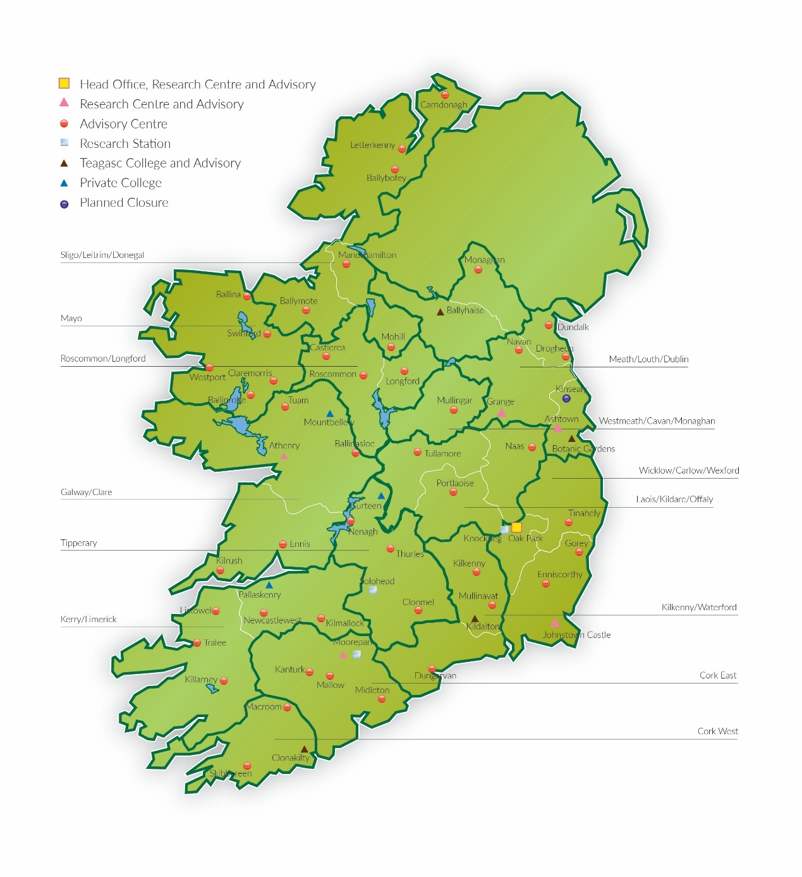

Requirements

Scope

Teagasc – the Agriculture and Food Development Authority, wishes to seek tenders from suitably qualified and experienced suppliers for the provision of Sludge dewatering and disposal services for its campus at Moorepark, Fermoy, Co Cork

Service Requirements

General Requirements:
Teagasc, the contracting authority, operate a WWTP under license from Cork County Council, at their Moorepark campus. The contracting authority are dewatering sludge on site and sending the concentrated sludge for composting. Teagasc are seeking tenders for the de-watering and composting operation as required, approx. 6-10 times per annum depending on sludge disposition and activity levels within the WWTP
- Dewatering – Average 10 days dewatering per annum - an anticipated dewatering unit of capacity 15 m³ -50 m^{3/}hr will be required with a final sludge cake of 25-30% DS. Your price must include for all costs including set up, travelling, cost per hour / day / tonne and polymer etc.
- Sludge cake disposal: In strict accordance with all environmental regulations with certification for every load. Average of 20 loads per annum. Your price must include for all costs e.g. composting or other removal costs including skip hire, transport etc. Note, sludge weight referred to in this document is taken to mean the dry matter weight having undergone a dewatering process.
- Vacuum and Transport of Grease Trap waste.
The contracting authority confirms that there is a water source on site.
Volume of grease anticipated is approximately 20 cubic metres per year. However, there is variance depending on the requirement to use fats to feed the WWTP.
Please note that the service requirements and frequency of same must be mutually agreed with the local Teagasc point of contact on commencement of the contract and may vary over the term of the contract subject to site requirements.
As part of their tender submission, tenderers are required to submit details of their proposed Service Level Agreement, which will ensure that the standards of service are monitored and effective corrective action is taken when necessary.

Site Entry/Exit Procedures
The Contractor is required to sign-in on arrival and again at departure. Any other specific site related procedures will be notified by the local Teagasc point of contact to the Contractor.

Health & Safety, Risk Assessments and Method Statements
To comply with all applicable H&S legislation, Teagasc has an online Contractor Management System called Flex. Teagasc is committed to providing a safe place of work for everybody and managing contractors on site plays an important role. Contractors are required to provide the required resources, training and expertise to conduct their activities safely on site.
The Flex system used by Teagasc requires some input from the Contractor and is designed so that the Contractor can upload the necessary health and safety documentation (e.g. Safety Statement, Insurance Certificates, PSA licences etc.) when needed and will generate notifications if required, e.g. expiring insurance certificates. To be granted access to Teagasc sites, the successful applicant must comply with and maintain the online Teagasc Contractor Management System (Flex). The following details must be provided/ or made available on request and confirmed prior to work commencing:
• Safety Statement;
• Valid Insurance Certificates confirming adequate Public Liability & Employer’s Liability cover and any other Insurance cover as specified;
• Health & Safety Training (e.g. CSCS Cards, Manual Handling, safe pass, etc.);
• Online Induction (all personnel (including subcontractors) attending a Teagasc Site must complete the Teagasc online health & safety induction and any other deemed applicable by Teagasc);
• A Method Statement for any scheduled works (submitted in advance), outlining the personnel involved, the sequence of works and applicable risk assessments;
• Any other relevant safety documentation, e.g. disposal licences
The successful Contractor must commit to updating documents on the Flex System in a timely manner.

Equipment
The Contractor will be responsible for providing all equipment required to carry out the provision of services as part of any awarded contract. Equipment is to be included in pricing provided. The Tenderers should clearly detail specific equipment used by them to carry out their duties and any innovations in the provision of equipment to enhance service delivery.

Contract Management
Teagasc requires the Contractor to provide a dedicated Key Account Manager, and they shall attend annual meetings (as required) in person/online as mutually agreed with the Teagasc account manager. There will be no additional costs for this service. The duties of the Key Account Manager will include the following:
- Overall responsibility for a good working relationship with Teagasc;
- Be responsible for the day-to-day management of any Services Contract awarded;
- Meet as and when required to review the relationship and examine performance;
- Deal with disputes, complaints or concerns that cannot be adequately resolved;
- Regularly give and receive both formal and informal feedback on the relationship, workloads, processes, areas & suggestions for improvement and cost savings;
- Proactively discuss with Teagasc ways of improving efficiency regarding service delivery and cost minimisation in general;
- Provide Management information reports as required. Please note that all report requirements and frequency of same must be mutually agreed with the local Teagasc point of contact on commencement of the contract and may vary over the term of the contract subject to site requirements.

Invoicing
All invoices must quote a valid Teagasc PO number provided by the local Teagasc point of contact for each site. Invoices should be issued in a timely manner and within 30 days for services being completed. All invoices/credits/statements are to be submitted electronically to accounts.payable@teagasc.ie
Invoices not quoting a valid PO number will be returned unpaid. All invoices should provide clear details of services provided to include Qty/No of hours (where applicable) , description of service provided etc.

Environmental and Sustainability Requirements
Teagasc is fully committed to adhering to both national and European Union policies regarding Green Public Procurement (GPP) and sustainable procurement practices.
The Contractor is expected to demonstrate environmental awareness and cooperate fully with Teagasc staff to uphold the Contracting Authority’s sustainability commitments

Pricing Requirements
All costs excluding VAT MUST be included in pricing section below. The tender response must include all costs associated to ensure the continuous operation of the Teagasc WWTP

Response Document
All Sections must be completed in full
SECTION A: Pass/Fail Criteria
REF | PASS/FAIL CRITERIA | PASS REQUIREMENT
A1 | Tenderer Summary | Tenderers must complete this section. If the Tenderer is a consortium, then a separate questionnaire must be completed for each consortium member.
A2 | Financial | Tenderers are required to self-declare compliance with the requirements.  Applicants should note that if awarded contract, they will be required to provide the evidence self-declared prior to receipt of contract.
A3 | Tax Compliance
A4 | Insurance
A5 | Health and Safety | Applicants must demonstrate operation of health & safety systems and procedures in line with the Safety Health & Welfare at Work Act 2005
A6 | References | Tenderers must provide acceptable evidence of having successfully carried out at least 2 previous contracts of a similar nature and scale over the past 3 years, by providing a description of the contract.
SECTION B: Award Criteria
REF | WEIGHTED CRITERIA | WEIGHTING | MAX POINTS | MIN POINTS REQUIRED
B1 | Contract Management | 25% | 2,500 | 1,500
B2 | Methodology for Service Delivery | 25% | 2,500 | 1,500
B3 | Sustainability & Environmental Considerations | 10% | 1,000 | 600
B4 | Overall Costs (all costs excluding VAT). | 40% | 4,000 | N/A
TOTAL |  | 100% | 10,000

PLEASE NOTE
In the first instance, all submissions will be verified to ensure they meet the mandatory pass/fail requirements in Section A in order to determine compliancy and responsiveness. All submissions which meet the mandatory pass/fail criteria will be deemed to be compliant and responsive and will be assessed under the weighted criteria set out in Section B. Any submission which does not meet the mandatory pass/fail requirements will be deemed to be non-compliant and non-responsive and will be eliminated.
Note: Tenderers must achieve the minimum marks allocated to each of the individual qualitative criteria. Failure to achieve the minimum mark in any one of the qualitative criteria will result in the elimination of the Tender Response from the Competition
If an item is Mandatory, tenderers must be able to provide this requirement.
Scoring of the Qualitative Award Criteria will be based on an assessment of the information provided by the Tenderers in their completed Tender Response Document (“TRD”). The Evaluation Panel will assess the information provided for each criteria and marks will be awarded using the following scoring methodology:
Weighting Range | Scoring Methodology  Meaning
90-100% | Excellent response that meets or exceeds all elements of the stated requirement and demonstrates an excellent level of quality, detail, and clarity, such that it provides convincing assurance that the Tenderer will deliver to an excellent standard.
80-89% | A very good response that meets all elements of the stated requirement and demonstrates a high to very high level of quality, detail, and clarity, providing convincing assurance that the Tenderer will deliver to a very good or high standard.
60 - 79% | A satisfactory response that addresses all elements of the stated requirement and gives reasonable assurance of delivery to an adequate standard but is lacking in some elements of quality, detail, or clarity to award a higher mark.
40 - 59% | A response that addresses the majority, but not all, of the elements of the stated requirement or is lacking in some elements of quality, detail, and clarity such that it does not provide confidence to the Contracting Authority that the requirement will be successfully delivered.
20 - 39% | A response that addresses only some of the elements of the stated requirement, which may be due to for example, insufficient detail or quality or a response which is seriously inadequate, such that there is a high risk of failure to deliver the requirement
0 - 19% | A response that fails to appropriately meet any or only a small proportion of the elements of the stated requirement.

Formula for cost criteria:
Lowest price divided by price being evaluated multiplied by mark allocated for cost.
The following section describes the detailed Qualification Criteria for the CFT. Note that only compliant tenders may be evaluated for qualification.
In order to qualify, tenderers must meet the qualification criteria outlined in the response tables below. Tenderers that do not meet all criteria will not qualify. Please complete the tables as follows:
Further information should be inserted to demonstrate your ability to meet the qualification criteria. A max of 400 words unless otherwise stated per criterion will be accepted.
Notes:
- The responses to these tables of requirements will form part of the contract between Teagasc and any selected Tenderer.
- In evaluating the responses to these tables of requirements, the only information which Teagasc will review during the selection process (unless specifically stated) are the responses in the Y/N and Further Information columns. Additional material in the form of sales brochures, specification documents or links to online information will NOT be reviewed as part of the evaluation process.
- Teagasc reserves the right to disqualify any organisation if Teagasc feels that they do not have sound financial standing.
Tie Break: If the evaluation results in a tie between two or more Tenders, then the Tender with the highest score for non-cost award criterion shall be deemed the Most Economically Advantageous Tender.
In the event of a tie and there being no difference in the above scores, then the Tender with the highest score for the criterion ‘Cost’ shall be deemed the Most Economically Advantageous Tender.
Right to runner-up clause
If for any reason it is not possible to award the contract to the designated successful tenderer emerging from this competitive process, or if having awarded the contract, Teagasc considers that the successful tenderer has not met its obligations, Teagasc reserves the right to award the contract to the next highest scoring tenderer on the basis of the terms advertised, at any time during the tender validity period. This shall be without prejudice to the right of Teagasc to cancel this competitive process and/or initiate a new contract award procedure at its sole discretion.

SECTION A: PASS/FAIL CRITERIA

A1.1 TENDERER SUMMARY / COMPANY INFORMATION Weighting: Pass/Fail only
Pass requirement: Tenderers must complete this section.
Tenderers must demonstrate that they operate within the field of the contract in question by providing sufficient details of the organisation and company profile, including the range of services provided, history, major clients, etc.
Tenderer details
Organisation Legal Name
Contact Person
Organisation Business Address

Organisation website:
Telephone number
Email contact details:
Legal Status (if any) (e.g. Company, Partnership, Sole Trader, etc.)
Year Established
Outline of Range of Services Provided
Staff Numbers, both permanent & contract
Tax Clearance Access Number and Tax Reference Number:
Company registered number (where applicable):
Vat Registration Number:

A1.2 Sub-contractor details – to be completed where sub-contracting work
Organisation Legal Name
Organisation Business Address
Telephone
Organisation website:
Email contact details:
Legal Status (if any) (e.g. Company, Partnership, Sole Trader, etc.)
Year Established
Outline of range of services provided
History of Tenderer working with Sub-Contractor
Description of the role to be fulfilled by the sub-contractor
Nominated contact personnel authorised to represent the Subcontractor (name, title, telephone number, postal address and e-mail address)
Insert additional tables for each sub-contractor as required

A2/A3/A4/A5/A6 FINANCIAL/ TAX COMPLIANCE / INSURANCE/HEALTH & SAFETY/REFERENCES Weighting: Pass/Fail only
Pass requirement: Tenderers must confirm that they meet the following minimum rules

A2. Financial Summary
Requirement | Yes / No
The company is solvent and of good economic standing and can if requested supply evidence of Turnover for last 3 years (by way of audited accounts or by statement from Company auditor). Tenderers must demonstrate a turnover of at least €100,000 p.a. for the past 3 years | Choose an item.

A3. Tax Compliance
Requirement | Yes / No
The Candidate holds a current and valid TCAN (Tax clearance access number) /Tax Clearance Certificate(s) from the Revenue Commissioners or in the case of a Candidate outside of the Republic of Ireland hold or can provide an equivalent statement from the relevant taxation authority. | Choose an item.

A4. Insurances
Requirement | Yes / No
That the Candidate holds, or will hold should they be successful, the following insurances. Teagasc reserves the right to amend the requirements before a Contract is issued.
Employer’s Liability - €13 million limit for any one claim or series of claims arising out of a single occurrence | Choose an item.
Public Liability - €6.5 million limit for any one claim or series of claims arising out of a single occurrence | Choose an item.

Documentary evidence of economic and financial standing is not required at this stage of the Competition. Instead, Candidates are asked to declare that they meet the minimum standards required by the Contracting Authority and will be in a position to produce the necessary documentation (e.g. bank statements, audited accounts, proof of insurance, etc.) prior to any award of contract.
Teagasc also reserves the right to make enquiries with commercial credit rating agencies in order to evaluate or confirm that tenderer’s have sufficient financial and economic capacity to undertake the obligations arising under the Contract.

A5. Health & Safety
Requirement
Applicants must demonstrate operation of health & safety systems and procedures in line with the Safety Health & Welfare at Work Act 2005.
Do you comply with the Safety Health & Welfare at Work Act 2005 | Choose an item.
Name of Manager responsible for Health & Safety | Insert Response
NB. The contracting authority will be required to satisfy itself of the declared capacity before awarding the contract. Therefore, the relevant evidence to satisfy the minimum requirements stated below must be submitted promptly on request by the contracting authority.
I hereby declare that the applicant has a Safety Statement in the format outlined at https://www.hsa.ie/eng/Topics/Managing_Health_and_Safety/Safety_Statement_and_Risk_Assessment/ which will be provided on request and that all of the requirements listed below are addressed in the Safety Statement, as is the evidence relating to the minimum standards also listed below which have been met. If the requirements and minimum standards have not been addressed in the Safety Statement, separate evidence is to be provided on request which demonstrates that such requirements and minimum standards have been met.
Requirements
A copy of your company’s current general health and safety policy;
An outline of your management organisational structure with regard to allocation of duties, delegation of responsibilities, etc.
Copies of standard forms used for method statements and risk assessments as part of your duties under the Safety, Health and Welfare Act 2005
Details of arrangements for ongoing training of personnel in Health and Safety, including personnel who would be employed on the project;
Details of the company’s procedures for disseminating and implementing up-to-date developments on health and safety issues;
Once a contract is awarded, the following will be required by the successful applicant.
To comply with all applicable legislation, Teagasc has an online Contractor Management System called Flex. Teagasc is committed to providing a safe place of work for everybody and managing contractors on site plays an important role. Contractors are required to provide the required resources, training, and expertise to conduct their activities safely on site.
The Flex system requires some input from the Contractor and is designed so that the Contractor can upload the necessary health and safety documentation (e.g. Safety Statement, Insurance Certificates etc.) when needed and will generate notifications if required, e.g. expiring insurance certificates. To be granted access to Teagasc Sites, the successful applicant must comply with and maintain the online Teagasc Contractor Management System (Flex).
To be provided/ or made available on request and confirmed prior to work commencing;
- Safety Statement
- Valid Insurance Certificates confirming adequate Public Liability & Employer’s Liability cover and any other Insurance cover as specified.
- Health & Safety Training (e.g. CSCS Cards, Manual Handling, safe pass etc.)
- Online Induction (all personnel (including subcontractors) attending a Teagasc Site must complete the Teagasc online health & safety induction and any other deemed applicable by Teagasc)
- A Method Statement for any scheduled works (submitted in advance), outlining the personnel involved, the sequence of works and applicable risk assessments.
- Any other relevant safety documentation, e.g. equipment certification.

Documents must be updated in a timely manner.

Please confirm your agreement to satisfy all requirements outlined in Section A.5 Health & Safety above | Please choose Yes or No
Signature |  | Date

A6. References
Requirement
Weighting: Pass/Fail only Applicants must supply contact details and information on services provided for two referees to whom you have provided similar services to the requirements of this CFT over the past 3 years.
The reference contracts must :
- have delivered some or all of the same contract requirements as the proposed contract requirements specified in Appendix 1 of the CFT
and
- include services of a similar scale and nature;
and
- be of similar value to the contract being tendered for.
Tenderers must ensure they provide sufficient information to allow the Contracting Authority to judge the similarity of these contracts to the Tender Requirements as specified.
Tenderers must provide two (2) satisfactory customer references confirming the information provided in the previous contracts in the tables below.
Referees may be required to confirm that the information submitted by the Tenderer in response to ‘Experience of Previous Contracts’ above is true, accurate and not misleading in any way.
Please indicate clearly where sub-contractors were used on any of these contracts provided as references.
Note: Teagasc reserves the right to contact the referee on a confidential basis without reference back to the Tenderer.
Failure to provide the required documentation may result in the Tenderer being eliminated from the Competition.
Reference 1
Client Name
Client Contact Details | Contact Name
Client Contact Details | Email
Client Contact Details | Phone Nr.
Details including description of Services Provided including relevance to the requirements described in the CFT.
Start and End dates of contract
Total Contract Value (EURO) ex vat
Reference 2
Client Name
Client Contact Details | Contact Name
Client Contact Details | Email
Client Contact Details | Phone No.
Details including description of Services Provided including relevance to the requirements described in the CFT.
Start and End dates of contract
Total Contract Value (EURO) ex vat

SECTION B: AWARD CRITERIA
In evaluating the responses to Section B, the only information that Teagasc will review during the evaluation process is the responses in the response section. Any exceptions to this will be explicitly explained. Additional material in the form of sales brochures, specification documents or links to online information will NOT be reviewed as part of the evaluation process unless specifically requested.
Please feel free to add suggestions where you can provide an alternative or improved idea to the stated requirement.
Note that the responses will form part of the contract between Teagasc and any selected Tenderer.
Note: A max of 400 words will be accepted per question unless otherwise stated.
B1. Contract Management
Weighting: 25% (Maximum 2,500 marks, Minimum 1,500 marks)
Tenderers should describe the proposed methodology for managing the Teagasc account, delivery and handling complaints and contract management procedures. This should include, at a minimum, the following:
• An outline of how they propose to manage their ongoing relationship with Teagasc, including their method of handling complaints/disputes
- The tenderer shall nominate an Account Manager or Technical Account Manager who will act as the main point of contact with Teagasc. It is a requirement of the proposed contract that the Account Manager will have the necessary authority to take decisions and deal directly with all matters relating to this contract. It is important that Teagasc always have a point of contact, to ensure any issues which may arise are resolved in a timely manner. For this purpose, details of a nominated deputy, or other contacts, should also be supplied. Please provide details of the qualifications, expertise and experience of the proposed account manager.
Please also provide details of any additional services/add-ons/benefits that are included within the costs tendered.
Insert Response: Please outline here your proposal in relation to contract management, ensuring you cover, at a minimum, all the points listed above.

B2. Methodology for Service Delivery
Weighting: 25% (Maximum 2,500 marks, Minimum 1,500 marks)
Tenderers are required to describe their proposed methodology for delivering all contract requirements set out in the CFT. Consideration should be given to the following:
- How the tenderer proposes to meet the specification outlined, including response times to call outs where required
- Proposal to ensure the health & safety of the public and operatives
- Detail their compliance with waste management disposal
Please refer to all the above, at a minimum, when outlining your methodology for service delivery
Insert Response:

B3. Sustainability & Environmental Considerations
Weighting: 10% (Maximum 1,000 points, minimum 600 marks)
Tenderers must clearly demonstrate their commitment to Environmental and sustainability goals in their response
Tenderers should provide details of any proposed methodologies that demonstrate sustainable or environmentally advantageous practices they are currently involved in and demonstrate their commitment to sustainability and how this is incorporated in the performance of the contract.
Insert Response:

B4. COSTS Weighting: 40% (Maximum 4,000 points):
All costs are to be shown in EUROS and should be exclusive of VAT but the VAT rate applicable should be indicated also. Note that prices quoted constitute best and final offer. There are no opportunities at a later stage in the process to offer further financial incentives.
All rates quoted are to cover all costs associated with the provision of the Services. No additional charges to those outlined below will be entertained.
Rates for Dewatering must include all costs including but not limited to:
- Set-up costs,
- Travel costs
Rates for sludge cake disposal must include all costs related to disposal, including, but not limited to:
- Disposal facility
- Haulage costs
- Skip hire
- post dewatering
Ref # | Item Description | Price € (ex VAT) | Vat Rate%
B4.1 | Dewatering (Daily rate)
B4.2 | Sludge cake disposal (Disposal cost per tonne post dewatering)
B4.3 | Call out charge for Vacuum & transport of grease trap waste
B4.4 | Disposal per tonne for Vacuum & transport of grease trap waste
Please provide any further clarifications on pricing provided, where applicable below:
Insert Response:

Supplier CFT Checklist
Please confirm that the information in Sections 3.2.A and 3.2.B of the CFT have been completed and returned as requested |  |  |  | Choose an item.
Please confirm that Appendix 3 (Tenderer’s statement) of the CFT has been completed and returned as requested |  |  |  | Choose an item.
Please confirm that Appendix 4 (Declaration as to Personal Circumstances of Tenderer) of the CFT have been completed and returned as requested.  Please note, while all tenderers must compete and submit this declaration, only the successful tenderer will be required to have the Declaration of Personal Circumstances notarised by a practising Solicitor/Commissioner for Oaths. This will be requested after contract award |  |  |  | Choose an item.
Please confirm that all sections of this response document have been completed in full and returned as requested and that no alterations have been made to this document. |  |  |  | Choose an item.
 | Signed: |  | Position:
 | Print Name: |  | Phone No:
 | Company Name: |  | Date:
 | Address:
 | Email:

***********************************************END OF DOCUMENT********************************************************

