CALL FOR TENDERS (CFT) FOR THE PROVISON OF SOCIAL RESIDENTIAL AND SOCIAL AND COST RENTAL RESIDENTIAL HOUSING SCHEMES IN LOCAL AUTHORITY AREAS WITHIN THE CORK CITY & COUNTY REGION (40 to 100 UNITS)

TENDER RESPONSE DOCUMENT
This document must be completed and submitted in accordance with the requirements specified herein and in the CFT. The responses in this document will be evaluated in accordance with the methodology set out in the CFT.

SECTION 1
TENDERER NAME
TENDERER SUMMARY/CORPORATE INFORMATION

For information only – not evaluated

Where the Tenderer is a Tenderer Group, Section (a) must be completed in respect of each Tenderer Group Member.

Failure to provide the specified information in this Section 1 may result in elimination from the Competition.

(a) Corporate Information

Full Company Name (full legal name)
Previous Name (if applicable)
Incorporated under the laws of [please identify country of incorporation]
Company Registration Number
Registered Address/Registered Office
Contact details |  | Name
 |  | Position
 |  | Address
 |  | Telephone Office
 |  | Telephone Mobile
 |  | Email
Legal Status
(Company/Partnership/Sole Trader/Tenderer Group, etc)

Main business

Parent company (if any)

Beneficial ownership (if applicable)

Date of establishment
b) Tenderer Groups

Where the Tenderer is a Tenderer Group, Section (b) must be completed by the Lead Member.

The Tenderer is a Group: |  |  | Yes?__________________ (if Yes, complete the rest of this section 1(b)  No? __________________
Please identify the Lead Member for the Tenderer Group, including named contact, organisation, contact details (position; mobile no.; email)
Please also provide the following information: | Name and Address |  |  |  | Proposed Role
Tenderer Group Member #1
Tenderer Group Member #2
[Add More Rows if necessary]
Please confirm that a separate Section (a) is enclosed for each Tenderer Group Member |  |  | Confirm if enclosed:  Yes / No __________________
c) Building Contractor

Please identify the proposed Building Contractor below:

Name

Please specify whether the Building Contractor is a Tenderer Group Member or a subcontractor:

Please confirm that a separate Section (a) is enclosed for the Building Contractor |  |  | Confirm if enclosed:  Yes / No __________________
d) Relying on Resources of Other Entities

Where the Tenderer is a Tenderer Group, Section (d) must be completed by the Lead Member.

Is the Tenderer (or any member of a Tenderer Group) relying on an Other Entity (e.g. a parent company or third party)? |  |  |  | Yes? __________________ (if Yes, complete the rest of this section 1(d)  No? __________________
Please provide the following information: | Name and Address |  |  |  | Requirements third party is being relied upon to satisfy
Other Entity #1
Other Entity #2
[Add More Rows if necessary]
Please confirm that a separate Section (a) is enclosed for each Other Entity |  |  | Confirm if enclosed:  Yes / No __________________
Please confirm that a letter of support in the form attached at Annex 1 is enclosed for each Other Entity |  |  | Confirm if enclosed:  Yes / No __________________  [Insert File Name/Reference, where applicable]

Organisational Chart
For information only – not evaluated

An organisational chart showing the proposed structure of the Tenderer (including all Tenderer Group Members and Other Entities and their respective roles) must be provided | Please confirm that the required org chart is enclosed:  Yes / No __________________  [Insert File Name/Reference]

eESPD(s) and Declaration(s) as to Personal Circumstances
Refer to section 6.2 of the CFT for the approach to evaluation.
Completed eESPDs must be uploaded to eTenders for the Tenderer (and where relevant, each Tenderer Group Member / the Building Contractor / each Other Entity) | Please confirm that the required eESPDs have been uploaded:  Yes / No __________________  [Insert File Name/Reference]
Declaration of Personal Circumstances (Form 1, Annex 1) for each entity completing the eESPD must be provided | Please confirm that the required Declarations have been provided  Yes / No __________________  [Insert File Name/Reference]

SECTION 2 - MINIMUM PROJECT REQUIREMENTS
Please refer to section 3.2 of the CFT for more information.

Statement of Compliance with Minimum Project Requirements
We confirm that our Project meets the following requirements:
- It has a minimum of 40 Homes and a maximum of 100 Homes;
- We have obtained a final grant of Planning Permission by the Tender Submission Deadline (as specified in the CFT);
- Our Project is capable of complying with the conditions of the relevant Planning Permission;
- Our Project complies with the relevant Local Authority Development Plan and Housing Delivery Action Plan;
- Our Project meets the identified social housing needs of the relevant Local Authority;
- Our Project complies with the Respond Documents;
- Our Project is capable of connection to primary power, water, surface water and foul sewage and similar services;
- Our Project is close to Primary Services (as defined in the CFT) and has access to appropriate Public Services (as defined in the CFT);
- Our Project complies with all relevant housing guidelines and guidance issued by the Department of Housing, Local Government and Heritage, as more particularly described in Schedule 3A of the Development Agreement.
Tenderers whose Project does not meet these Minimum Project Requirements will not be eligible for the award of a Contract and will be eliminated from the Competition.

THIS STATEMENT MUST BE COMPLETED AND SIGNED BY A DULY AUTHORISED OFFICER OF THE TENDERER (OR WHERE THE TENDERER IS A GROUP, BY A DULY AUTHORISED OFFICER OF THE LEAD MEMBER)
Signature |  | Date
Print Name
Company

SECTION 3 - MINIMUM REQUIREMENTS
Please refer to section 6.3 of the CFT for more information.

Italicised text in the tables below is provided to identify specific requirements and should be deleted/overwritten when completing.
PROJECT INFORMATION

Approach to Evaluation: Information only

Please provide the information specified below.
Failure to provide the specified information may result in elimination from the Competition.
Project Name | [Development Name – ideally as agreed with Local Authority]
Address
Name of Local Authority
No of Homes
No of Homes to be acquired by Respond
Breakdown of Homes to be acquired by Respond | [Insert Number of Homes with breakdown of Tenures and Mix (Houses, Duplex, Apartments, etc) per Tenure]
Project Image | [Include key image of development; CGI preferable if available or confirm File Name if provided separately]
Website, FTP or similar Site | [Include details if available]

SITE LOCATION MAP

Approach to Evaluation: Information only

Please provide a site location map showing the location of the Project within the relevant Local Authority area. The site location map must be size A3, scale 1:1000, Ordnance Survey map or similar, with boundaries of the Site clearly marked in red.

Where the proposed Project is part of a larger scheme or development, the extent/boundaries of the Site should also be clearly marked on the site location map in a different colour.

Failure to provide the site location map as required may result in elimination from the Competition.

Please confirm that the required site location map has been uploaded | Yes / No __________________  [Insert File Name/Reference]

PLANNING PERMISSION AND OTHER CERTIFICATES

Approach to Evaluation: Information only

Please complete the table below and provide a copy of the Planning Permission granted in respect of the Project.
Where available, a copy of the planning pre-commencement conditions as well as the Fire Safety Certificate and disability access certificate must be provided. Where applications have been made in respect of such conditions or certificates but not yet granted, copies of the applications submitted must be provided.
At a minimum, a statement should be provided from the appropriate professionals confirming that the Project has been reviewed by them and that no material contraventions or issues exist which could result in the Project being deemed non-compliant with pre-commencement conditions and/or in a refusal of either/both of the Fire Safety Certificate and disability access certificate.

Failure to provide the information specified may result in elimination from the Competition.

Local Authority Region
Planning File Ref. No.
Date of Grant of Planning Permission
Date of Expiry of Grant of Planning Permission
Please provide a copy of the Full Planning Application Information Pack including any further Information or similar responses submitted | Confirm if enclosed:  Yes / No __________________  [Insert File Name/Reference]
Part V Requirements | [Include details if available; include details of any discussions/agreements with Local Authority]  [Confirm File Name/Reference, where applicable]
Please confirm that the required grant of Planning Permission has been uploaded and specify File Name/Reference | Yes / No __________________  [Insert File Name/Reference]
Please confirm that a copy of the planning pre-commencement conditions (or alternative information specified above) has been uploaded and specify File Name/Reference | Yes / No __________________  [Insert File Name/Reference, where applicable]
Please confirm that the required Fire Safety Certificate (or alternative information specified above) has been uploaded and specify File Name/Reference | Yes / No __________________  [Insert File Name/Reference, where applicable]
Please confirm that the required disability access certificate (or alternative information specified above) has been uploaded and specify File Name/Reference | Yes / No __________________  [Insert File Name/Reference, where applicable]
Please provide a copy of all other documents submitted/approved in respect of the Certificates outlined above | Confirm if enclosed:  Yes / No __________________  [Insert File Name/Reference, where applicable]
Please confirm that the Statement from the appropriate professionals confirming that the Project has been reviewed by them and that no material contraventions or issues exist has been uploaded and specify File Name/Reference | Confirm if enclosed:  Yes / No __________________  [Insert File Name/Reference, where applicable]

HOUSING QUALITY ASSESSMENT REPORT

Approach to Evaluation: Information only

Please provide a completed Housing Quality Assessment proforma summarising the key information regarding the proposed project. The proforma is included as Appendix 6 to this CFT pack and has been formatted such that the Tenderers are required to insert text in the boxes where Green font text is indicated.

Failure to provide the completed Housing Quality Assessment report as required may result in elimination from the Competition.

Please confirm that the required completed Housing Quality Assessment proforma has been uploaded | Confirm if enclosed:  Yes / No __________________  [Insert File Name/Reference]

ECONOMIC AND FINANCIAL STANDING

Please refer to Section 6.3 of the CFT for precise details of requirements and approach to evaluation.

This is a Pass/Fail criterion.

Please provide the information below. Where it is not possible to provide the documentation requested for any valid reason, alternative evidence may be provided, provided that the alternative evidence has previously been proposed to the Contracting Authority via the Clarification and Query process in section 4.4 of this CFT and has been approved by the Contracting Authority for submission. The Contracting Authority shall not be obliged to accept such alternative evidence.

Audited Accounts and/or Unqualified Audit Reports for each of the last 3 financial years
This information must be provided in respect of the Tenderer (and Tenderer Group Members where applicable) and in respect of the proposed Building Contractor.
Where the Tenderer or a Tenderer Group Member or the Tenderer's proposed Building Contractor is relying on the financial resources of an Other Entity (e.g., a parent company or a third party) to demonstrate that it has the necessary financial and economic standing to perform the Contract, the information set out above must also be provided in respect of that Other Entity.
Confirm name of entities for whom the above information is provided
Confirm all required information is enclosed | Yes/No
Confirm File Name/Reference

Turnover Information
This information must be provided in respect of the Tenderer (and Tenderer Group Members where applicable) and in respect of the proposed Building Contractor.
Where the Tenderer or a Tenderer Group Member or the Tenderer's proposed Building Contractor is relying on the financial resources of an Other Entity (e.g., a parent company or a third party) to demonstrate that it has the necessary financial and economic standing to perform the Contract, the required information must also be provided in respect of that Other Entity.
Please replicate the text boxes below as necessary.
Annual Turnover for [insert name of entity]
Year | 20[ ] | 20[ ] | 20[ ]
Month End (e.g. July)
Annual Turnover €
Auditor's letter confirming minimum annual turnover of €20,000,000 in any three of the last 5 financial years OR turnover of €70,000,000 in aggregate over the last five financial years  [Please confirm File Name/Reference] | Confirm if enclosed:  Yes / No __________________  [Insert File Name/Reference]
Confirm turnover stated above is derived from development / construction-related works | Yes/No
Net Asset Value, Statement of Going Concern, Letters of Good Standing, etc
This information must be provided in respect of the Tenderer (and Tenderer Group Members where applicable) and in respect of the proposed Building Contractor.
Where the Tenderer or a Tenderer Group Member or the Tenderer's proposed Building Contractor is relying on the financial resources of an Other Entity (e.g., a parent company or a third party) to demonstrate that it has the necessary financial and economic standing to perform the Contract, the required information must also be provided in respect of that Other Entity.
Certified Net Asset Value Statement/s demonstrating net assets greater than 10% of the value of the Tender Price (including VAT) proposed by the Tenderer as of a balance sheet within the six months prior to the Tender Submission Deadline. In the case of a Tenderer Group, the cumulative (combined) net asset values of the Tenderer Group Members should be greater than 10% of the value of the Tender Price (including VAT) proposed by the Tenderer Group as of balance sheets within the six months prior to the Tender Submission Deadline. All as described in CFT Document.
Confirm names of entities for whom the above information is provided

Confirm all required information is enclosed: | Yes / No __________________
Please confirm File Name/Reference | [Insert File Name/Reference]
Statement/s of Going Concern by Director as described in CFT Document.
Confirm names of entities for whom the above information is provided

Confirm all required information is enclosed: | Yes / No __________________
Please confirm File Name/Reference | [Insert File Name/Reference]
Letter/s of Good Standing from principal Banker dated within the 3 months prior to the Tender Submission Deadline as described in CFT Document.
Confirm names of entities for whom the above information is provided

Confirm all required information is enclosed: | Yes / No __________________
Please confirm File Name/Reference | [Insert File Name/Reference]
Confirmation of ability to procure Performance Bond as described in the CFT Document.
Confirm names of entities for whom the above information is provided

Confirm all required information is enclosed: | Yes / No ________________
Please confirm File Name/Reference | [Insert File Name/Reference]
Detailed statement of funding facilities and commitments as described in the CFT Document.
Confirm names of entities for whom the above information is provided

Confirm all required information is enclosed: | Yes / No __________________
Please confirm File Name/Reference | [Insert File Name/Reference]

TECHNICAL AND PROFESSIONAL ABILITY
Please refer to section 6.3 of the CFT for information on the requirements and approach to evaluation.

This is a scored criterion.

Tenderers must demonstrate that they have successfully developed and completed five (5) residential schemes within the last seven (7) years prior to the Tender Submission Deadline which are similar in nature, scale and complexity to the Project proposed to be developed for the Contracting Authority.

Responses must demonstrate the following:
- five (5) residential schemes must have been developed and completed within the last seven (7) years prior to the Tender Submission Deadline;
- a minimum of three (3) of the five schemes must have been delivered by the proposed Developer (Note: Where there are two or more proposed Developers as part of the Tenderer Group, at least one (1) scheme must have been delivered by each proposed Developer);
- at least one (1) of the five schemes must have been delivered by the proposed Building Contractor (Note: Where the Project will be delivered as a self-build by the Developer (i.e., there will be no separate Building Contractor), then five schemes completed by the Developer must be provided); and
- all five schemes must have delivered a minimum of 40 Homes.
Tenderers should note that the Contracting Authority may contact the referees identified below for verification purposes without prior notice to Tenderers.
Reference Project # [insert number e.g. 1,2,3,4,5]
Entity who Delivered the Reference Project
Role – Developer or Building Contractor
Name and Full Address of Reference Project
Total Number of Homes Delivered (must be a minimum of 200 units)
Types of Homes Delivered (house types, apartments, etc)
Value of the Contract
Outline of Architectural specification, materials and finishes
Photographs of Finished Homes – internal & external | [Please confirm File Name/Reference]
Name of Employer/Client/End User of Reference Project

Contact Number & Email of Employer/Client/End User
Details of Parties Delivering the Reference Project (developer, building contractor, design team members, Assigned Certifier, Project Supervisor Design Phase (PSDP), Project Supervisor Construction Stage (PSCS) and Fire Safety Consultant)
Date of Commencement of Construction
Date of Practical Completion
BER Rating Achieved
Describe how the reference project is similar in scale, nature and complexity to the Project proposed to be delivered for the Contracting Authority. The response should be limited to two A4 pages in Arial 10 font.
[Insert response here]

SECTION 4 - QUALITY SUB-CRITERIA
Please refer to section 6.4 of the CFT for information on the approach to evaluation of the Quality Sub-Criteria.

- Design Quality of the Development – 1600 marks (Minimum mark required – 800 marks)
Respond’s vision is that every individual in Ireland will have high quality housing as part of a vibrant community that meets their needs throughout their lifetime. Respond's design vision incorporates the principle of designing for longevity and future proofing for communities through Placemaking, reflecting Respond’s core values in every project and embedding Respond’s design approach, vision and aspirations.
With reference to the Respond Design Guide and the Respond Requirements documents, please describe how your proposed Project, development and design quality proposals reflect this vision and context.
Your response should address the following aspects of the Design Guide with respect to the proposed Project:
- Sustainable Communities;
- Placemaking;
- Transport;
- Designing Good Homes;
- Supporting Communities;
- Asset Management; and
- Value for Money
A page limit of either 6 No ISO A4 pages OR 3 No ISO A3 pages has been set for the response which includes for any graphics, photographs, diagrams or the like. Pages/text in excess of these limits will be ignored for assessment purposes. Please use Arial font 10.
Please also provide the information set out in Form 3 (Schedule of Minimum Design Information) at Annex 1. This information is to be provided in addition to the information requested above and is not covered by the page limit set out. In particular, the site and general arrangement plans, elevations and layouts of the units within the development together with the Design Statement included within the Planning Application Information will be of relevance and this information will be used in the evaluation of the response to this criterion.
The response to this question will be evaluated in the round using the scoring matrix at section 6.4 of the CFT and will take into consideration how the proposed Project aligns with Respond’s objectives as set out in the Respond Design Guide and the Respond Requirements.
[Please insert your response below]

- Location of the Development – 1600 marks (Minimum mark required – 800 marks)
Respond’s vision incorporates the principles of urban design, healthy placemaking and supporting communities to access physical and social infrastructure such as community buildings, creches, healthcare, retail outlets and other amenities.
With reference to the Respond Design Guide and the Respond Requirements, please describe how your proposed Project and its location is aligned with Respond's vision, with particular reference to the availability of suitable physical and social infrastructure and services within the locality.
Your response should address the following aspects with respect to the proposed Project:
- Location of the proposed development including, in particular, any interdependencies with neighbouring sites/infrastructure not transferring as part of this Tender;
- Proximity and adjacency of Primary Services and Public Services (as defined in the CFT), with details of proposed and planned upgrades to Primary Services and Public Services;
- Transport routes and connections with details of proposed and planned upgrades to same; and
- Local Area Development including:
  - Details of other similar developments in locality – including other social, affordable and cost rental schemes completed and planned for area;
  - Details of public housing providers and other providers' schemes – both complete and planned; and
  - Demand in area – consideration of location risk analysis and evidence of housing need and demand in area.
A page limit of either 6 No ISO A4 pages OR 3 No ISO A3 pages has been set for the response which includes for any graphics, photographs, diagrams or the like. Pages/text in excess of these limits will be ignored for assessment purposes. Please use Arial font 10.
As part of your response please also provide:
- the information set out in Form 3 (Schedule of Minimum Design Information) at Annex 1. This information is to be provided in addition to the information requested above and is not covered by the page limit set out. In particular, the site and landscaping plans and similar information provided within the Planning Application Information in respect of infrastructural elements within and adjacent to the development will be of relevance and this information will be used in the evaluation of the response to this criterion; and
- a 15-Minute Map for the proposed Project as per Form 4 (15 Minute Map - How to Guide) at Annex 1 of this Tender Response Document. The 15-Minute Map should be based on acceptable mapping tools such as Google Maps, Ordnance Survey or similar for consistency and accuracy. The page limit above does not include for the 15-Minute Map document which is in addition to the page limit specified;. The information included in this 15-minute map will be used in the evaluation of the response to this criterion.
The response to this question will be evaluated in the round using the scoring matrix at section 6.4 of the CFT and will take into consideration how the proposed Project aligns with Respond’s objectives as set out in the Respond Design Guide and the Respond Requirements].
[Please insert your response below]

- Technical Specifications & Schedule of Finishes 1200 marks (Minimum mark required – 600 marks)
Respond is committed to delivering high-quality energy-efficient homes that meet or exceed statutory requirements and internal design standards.
With reference to the aspirations of the Respond Design Guide and the specifications in the Respond Requirements, please describe how your proposed Project and the specification and finishes proposals align with the above commitment and requirements of Respond.
Your response should address the following aspects with respect to the proposed Project:
- Compliance with the specification requirements set out in the Respond Requirements;
- Building & Energy Performance;
- NZEB Compliance;
- Structural system and construction approach;
- Internal & External Finishes;
- Landscape and Boundary Treatments; and
- Asset Management and Life Cycle Considerations
A page limit of 4 No ISO A4 pages OR 2 No ISO A3 pages has been set for the response which includes for any graphics, photographs, diagrams or the like. Pages/text in excess of this limit will be ignored for assessment purposes. Please use Arial font 10.
Tenderers must also complete Form 5 (Specification Document) included in Annex 1 to this Tender Response Document. This information is to be provided in addition to the information requested above and is not covered by the page limit set out. Tenderers should note that the Specification Document must be completed in full and that if successful in the Competition, Tenderers will be required to deliver the Project in accordance with the tendered Specification Document. The information included in this Specification Document will be used in the evaluation of the response to this criterion.
The response to this question will be evaluated in the round using the scoring matrix at section 6.4 of the CFT and will take into consideration how the proposed Project aligns with Respond’s objectives as set out in the Respond Design Guide and Respond Requirements.
[Please insert your response below]

- Programme for Delivery 800 marks (Minimum mark required – 400 marks)
Please provide a programme (in Microsoft project format or similar) showing the timescales involved in developing the Project including key stages, dependencies, critical path, proposed project duration and potential completion date(s). Please indicate general durations/timeframes and when the Project is projected to reach Practical Completion.
The projected Date for Completion must be specified in the Programme – it is acknowledged that this date will ultimately be adjusted to accommodate the actual execution date of the Development Agreement which will be impacted by internal approvals and external funding processes. Please note that Respond will not accept later changes to the overall project duration as indicated in this programme.
In particular, allowance should be included in the programme for HFA shutdowns in respect of handovers sequences and the impact of same; details of HFA shutdown periods are included in the draft Development Agreement.
No page limit has been set for the programme.
Please also describe your proposed approach to the successful delivery of the Project. Your response should address the following aspects with respect to the proposed Project:
- Overall Programme Timeline – clear milestones, critical path identification, target Date for Completion(s);
- Buildability - including construction methodology, sequencing and site logistics to minimise delays and disruption;
- Supply Chain and Sub-Contractor Strategy – key partners and suppliers including demonstration of capacity and experience;
- Phasing Proposals – where relevant, how phased/sectional handovers could support early occupation or reduce operational risk; and
- Key Project Risks – identification of key project risks and proposed mitigation measures to eliminate/minimise impact. A key risk consideration will be the level of Part V negotiations undertaken with the relevant local authority.
A page limit of 4 No ISO A4 pages OR 2 No ISO A3 pages has been set for this element of the response which includes for any graphics, photographs, diagrams or the like. Pages/text in excess of this limit will be ignored for assessment purposes. Please use Arial font 10.
Tenderers should note that a more detailed and comprehensive building programme for the construction of the Works is to be provided by the Developer/s to Respond in accordance with the terms of the Development Agreement.
The response to this question will be evaluated in the round using the scoring matrix at section 6.4 of the CFT. Tenderers should note that higher marks may be awarded for Projects which are considered to be more advanced and more “shovel ready” in terms of earlier commencement and completion.
[Please insert your response below]

- Sustainability - 800 marks (Minimum mark required – 400 marks)
Respond is committed to building homes that are sustainable in design, construction, energy use and social impact. Please describe how your development and design proposals align with this commitment and the aspirations set out in the Respond Design Guide.
Your response should address the following aspects with respect to the proposed Project:
- Sustainable construction practices;
- Biodiversity enhancement;
- Low-carbon and energy-efficient design; and
- Whole-life cost and maintainability
and should include information on how the above aspects have been incorporated into the proposed project and other completed projects.
A page limit of either 4 No ISO A4 pages OR 2 No ISO A3 pages has been set for the response which includes for any graphics, photographs, diagrams or the like. Pages/text in excess of these limits will be ignored for assessment purposes. Please use Arial font 10.
The response to this question will be evaluated in the round using the scoring matrix at section 6.4 of the CFT.
[Please insert your response below]

TENDERER STATEMENT
Tenderers are required to sign the Tenderer Statement below. Tenderers may not amend the Tenderer Statement.
Failure to sign the Tenderer Statement will result in elimination from the Competition.
Section 1: Bona Fide Tender
Having examined the CFT and the Contract, we hereby agree and declare the following on our own behalf (and where we are a Tenderer Group, on behalf of all Tenderer Group Members):
- We confirm that we have full power and authority to submit the Tender. We confirm that we have read the CFT and accept all of the terms and conditions and the disclaimers set out in the CFT.
- We certify that the information supplied in our Tender is true, complete and accurate to the best of our knowledge. We understand and accept that the provision of false or misleading information could result in exclusion from the Competition. We undertake to notify the Contracting Authority of any changes to the information given in answer to questions in this Tender Response Document.
- We confirm that we have not, and will not, canvass or solicit any officer, employee or representative, of the Contracting Authority, its staff or any other relevant person or bodies in connection with the Competition and that no person employed by us or acting on our behalf has done, or will do, any such act. We understand that any person who unduly influences or attempts to unduly influence the Contracting Authority, its staff or any other relevant person or bodies involved in this Competition in relation to the conduct and outcome of this Competition will be excluded from this Competition.
- We confirm that this is a bona fide tender which is intended to be competitive and that we have not fixed or adjusted the amount specified in our Tender by or in accordance with any arrangement with another person or entered into any agreement or arrangement with any other person that he/she shall refrain from participating in the Competition.
- We undertake that we have not, and will not, at any time discuss with any other person any aspect of our Tender, save for the Tender Group Members, Other Entities or advisors to the extent required in order to complete our Tender and will procure this same undertaking from those entities.
- We confirm that we have read and understand all the documentation issued in relation to the Competition and that we have made our own investigations and undertaken our own research and due diligence in relation to the Competition and the Contract and the conditions under which the Contract is to be performed. We have taken account of our legal obligations in relation to this Competition and the provision of the Works, including all applicable obligations in the fields of environmental, social and labour laws, and we shall, in performance of the Contract, comply with all applicable obligations in the fields of environmental, social and labour laws.
- We confirm that we (or our subcontractors (if any)) will be solely responsible in law for the employment, remuneration, taxes, immigration and work permits of all personnel retained for the purposes of carrying out the Works.
- We accept all of the terms and conditions of the Contract (which includes both the Contract for Sale and the Development Agreement) and we agree that, if we are successful in the Competition and awarded a Contract, we will execute the relevant documents upon request by the Contracting Authority. We understand and accept that the Contract takes precedence over any previous communications or correspondence and any terms, conditions, stipulations or provisos which may appear on or be annexed to any correspondence submitted by us in connection with the Competition. We further understand that the Contracting Authority does not intend to enter into any negotiation or discussion in respect of the terms of the Contract, although the Contracting Authority has the right to consider project-specific amendments where necessary or non-material or clarificatory amendments.
- We understand the nature and extent of the Works required to be provided under the Contract, and the risks associated therewith, and we have carried out all necessary due diligence in relation to same.
- We confirm that we have highlighted any perceived shortcomings in this Competition to the Contracting Authority and that any part of the documentation, or any other aspect of this Competition, which we considered to be unclear or not compliant with relevant legislation, has been clarified.
- We acknowledge and confirm the requirement for our Tender to remain open for acceptance by the Contracting Authority for the Tender Validity Period as specified in the CFT.
- We confirm that we shall, if successful in the Competition, obtain and hold and procure that the proposed design team and sub-contractors (as applicable) will obtain and hold the Required Insurances as specified in the CFT.
- We confirm that all Data Subjects whose Personal Data is provided in our Tender have consented to the processing of such Personal Data by us, the Contracting Authority, the evaluation team and the supplier of the etenders.gov.ie website, for the purposes of our participation in this Competition or that we otherwise have a legal basis for providing such Personal Data to the Contracting Authority for the purposes of our participation in this Competition and that we will provide evidence of such consent and / or legal basis to the Contracting Authority upon request.
- We confirm that we do not come within the category of prohibited economic operators identified in Regulation (EU) No 833/2014 of 31 July 2014 (as amended by EU Regulation 2022/576 or any subsequent amendments to same).
- The origin of goods connected to our Tender, if any, are not subject to the prohibitions set out in Regulation (EU) No 833/2014 (as amended by EU Regulation 2022/576 and subsequent amendments to same).
- Any subcontractor, supplier or other entity on whose capacity we rely as part of our Tender does not come within the category of prohibited economic operators identified in Regulation (EU) No 833/2014 of 31 July 2014 (as amended by EU Regulation 2022/576 and subsequent amendments to same).
- We confirm that where requested by the Contracting Authority we will respond efficiently and within the specified timeframes to any requests for additional information and clarifications where same are considered necessary to ensure a complete and comprehensive assessment and evaluation of our Tender.
- We acknowledge that the CFT does not constitute an offer to enter into any contract and should not be regarded as a commitment or representation on the part of the Contracting Authority to enter into a contractual arrangement.
- No commitment of any kind, contractual or otherwise, shall exist unless and until a formal written Contract is executed by or on behalf of the Contracting Authority.
- We understand that the Contracting Authority may, at its absolute discretion, terminate this Competition at any time prior to a formal written Contract being executed on behalf of the Contracting Authority and without incurring any liability for the costs of our participating in the Competition.
Section 2: Conflict of Interest
If any conflict of interest or potential conflict of interest arises in respect of the Tenderer, any Tenderer Group Member, or Other Entity with regards to this Competition, it must be fully disclosed to the Contracting Authority. (See section 4.12 of the CFT).

We confirm that there is no level of conflict, or potential conflict of interest, that has not already been drawn to the attention of the Contracting Authority.
YES
NO
We believe that there is, or may be, a possible conflict of interest.
YES
NO
[If the answer is ‘yes’, please enter details of any possible conflict of interest, including who it relates to, and any safeguards you intend to put in place in relation to such a conflict.]
Section 2: Conflict of Interest
Section 3: Registrable Interests
We confirm that there is no registrable interest in relation to the Tenderer (including any sub-contractors) and any of the members of the board of Respond, members of Government, members of the Oireachtas, or employees or officers of Respond or their relatives. (‘Registrable interest’ and ‘relative’ are to be interpreted in accordance with the Ethics in Public Office Acts 1995 and 2001.)
YES
NO
[If the answer is ‘yes’, please enter details of any registrable interests.]

Section 4: Confidentiality
We confirm that our Tender contains commercially sensitive information.
YES
NO
We consider that the following information in the Tender is commercially sensitive for the following reasons and for the time period set out below:
Tender Reference | Reasons | Time Period
[If any information supplied in the Tender is considered commercially sensitive, please state clearly which information should not be disclosed] | [Please state clearly the reasons for the confidentiality] | [Please state the time period for which the information is considered to remain commercially sensitive]
[Insert other rows if necessary]

THIS TENDERER STATEMENT MUST BE COMPLETED AND SIGNED BY A DULY AUTHORISED OFFICER OF THE TENDERER (OR THE LEAD MEMBER WHERE THE TENDERER IS A TENDERER GROUP)

We certify that the information provided above is accurate and complete to the best of our knowledge and belief. We confirm that we accept that any circumstance confirmed above may result in our elimination from the Competition.
We understand that the provision of inaccurate or misleading information in this Tenderer Statement may result in our Tender being excluded from this Competition.
Signature |  | Date
Print Name
Company

ANNEX 1

Forms

Form 1 (Declaration of Personal Circumstances)
Form 2 (Letter of Support from Other Entity)
Form 3 (Schedule of Minimum Design Information Required)
Form 4 (15 Minute Map – How to Guide)
Form 5 (Specification Document)

Form 1

Declaration of Personal Circumstances

Re: Call for Tenders for the Provision of Social & Cost Rental Residential Housing Schemes in specified Local Authority areas within the Cork City & County Region (Greater than 40 and less than 100 Homes)
NAME: [Click here and insert name]
ADDRESS: [Click here and insert address]
I, [Click here and insert name of Declarant], having been duly authorised by [Click here and insert name of entity] sincerely declare that [Click here and insert name of entity] itself or any person who has is a member of the administrative, management or supervisory body of [Click here and insert name of entity] or has powers of representation, decision or control in [Click here and insert name of entity]:
- has never been the subject of a conviction for participation in a criminal organisation, as defined in Article 2 of Council Framework Decision 2008/841/JHA.
- has never been the subject of a conviction for corruption, as defined in Article 3 of the Convention on the fight against corruption involving officials of the European Communities or officials of Member States of the European Union and Article 2(1) of Council Framework Decision 2003/568/JHA as well as corruption as defined in the national law of the Contracting Authority or [Click here and insert name of entity].
- has never been the subject of a conviction for fraud within the meaning of Article 1 of the Convention on the protection of the European Communities’ financial interests.
- has never been the subject of a conviction for terrorist offences or offences linked to terrorist activities, as defined in Articles 1 and 3 of Council Framework Decision 2002/475/JHA respectively, or for inciting or aiding or abetting or attempting to commit an offence, as referred to in Article 4 of that Framework Decision.
- has never been the subject of a conviction for money laundering or terrorist financing, as defined in Article 1 of Directive 2005/60/EC of the European Parliament and of the Council.
- has never been the subject of a conviction for child labour and other forms of trafficking in human beings as defined in Article 2 of Directive 2011/36/EU of the European Parliament and of the Council.
- is not in breach of its obligations relating to the payment of taxes or social security contributions.
- has, in the performance of all public contracts, complied with applicable obligations in the field of environmental, social and labour law that apply at the place where the works are carried out or the services provided, that have been established by EU law, national law, collective agreements or by international, environmental, social and labour law listed in Schedule 7 of the European Union (Award of Public Authority Contracts) Regulations 2016 (Statutory Instrument 284 of 2016).
- is not bankrupt or the subject of insolvency or winding-up proceedings, its assets are not being administered by a liquidator or by the court, it is not in an arrangement with creditors, its business activities are not suspended nor is it in any analogous situation arising from a similar procedure under national laws and regulations.
- is not guilty of grave professional misconduct.
- has not entered into agreements with other economic operators aimed at distorting competition.
- is not aware of any conflict of interest due to its participation in the Competition;
- has not had any prior involvement in the preparation of the Competition.
- is not guilty of significant or persistent deficiencies in the performance of a substantive requirement under a prior public contract, a prior contract with a contracting entity, or a prior concession contract, which led to early termination of that prior contract, damages or other comparable sanctions.
- is not guilty of serious misrepresentation in supplying the information required for the verification of the absence of grounds for exclusion or the fulfilment of the Selection Criteria for this Competition and did not withhold such information and did not fail or is not able to submit supporting documents in respect of this Competition as required under Regulation 59 of the European Union (Award of Public Authority Contracts) Regulations 2016 (Statutory Instrument 284 of 2016).
- has not undertaken to unduly influence the decision-making process of the Contracting Authority in respect of the Competition, or obtain confidential information that may confer upon it undue advantages in respect of the Competition; or negligently provided misleading information that may have a material influence on decisions concerning exclusion, selection or award.
I understand and acknowledge that the provision of inaccurate or misleading information in this declaration may lead to my business/firm/company/partnership being excluded from participation in this or future tenders, and I make this solemn declaration conscientiously believing the same to be true and by virtue of the Statutory Declarations Act, 1938. This declaration is made for the benefit of the Contracting Authority.
________________________  Signature of Declarant | ___________________________________  Name of Declarant in print or block capitals
Declared before me by ___________________________________ who is personally known to me
(or who is identified to me by ______________________________who is personally known to me)
at ____________________________ this ___________ day of _______________ 20__

________________________________
(signed)
Practising Solicitor/Commissioner for Oaths

Form 2

Letter of Support
[On headed paper of Other Entity addressed to Respond]

Dear Sir/Madam,
Re: Call for Tenders for the provision of social and cost rental residential housing schemes in specified Local Authority areas the Cork City & County Region (Greater than 40 and less than 100 Homes)
eTenders Ref: [●]
I write in connection with the competition relating to the above Call for Tenders (the "Competition").

I am a director of [● insert name of supporting company/organisation] (the “Other Entity”).

I confirm that the Other Entity will provide [● Insert description of financial/technical resources being provided] if [● Insert name of entity that is relying on Other Entity] is successful in the Competition.

I further confirm that, in such circumstances, the above resources will be made available during the term of the Contract and the Other Entity will enter into a contractual commitment to this effect with Respond, if required.
Yours faithfully

[Name and Address of Other Entity]

Form 3

Schedule of Minimum Design Information

The following drawings and documents are to be provided to support the Tenderers responses to Quality Criteria 1 & 2:

Name | Scale | Notes
Site Layout Plan(s) | 1:250/1:1000 | Redline site layout drawing required including details of and interdependencies with neighbouring sites not transferring as part of this Tender.
General Arrangement Plans | 1:100 | With figured dimensions
General Arrangement Sections/Elevations | 1:200 | With figured dimensions
Schedules, Details or Typical Details where available | 1:50 or smaller | With figured dimensions
Landscape Plan | 1:200
3D Views |  | Where available
Existing Survey Information | As available | Survey information in respect of topography, existing buildings, etc
Copy of relevant planning grant and confirmation of any submissions pertaining to compliance and all agreed planning drawings and documents |  | To be submitted in separate folder
Apartment/House Type layouts | 1:50 | With Furniture, figured dimensions and room areas.
Layouts and schedule of Universally designed units | 1:50
For housing developments tenderers should include a floor area schedule for each house type |  | Floor area schedules should be measured overall to inside face of external walls
For apartment developments tenderers should include an overall floor area schedule to include circulation areas and individual apartment areas |  | Floor area schedules should be measured overall to inside face of external walls

Form 4

15-minute map – How to Guide

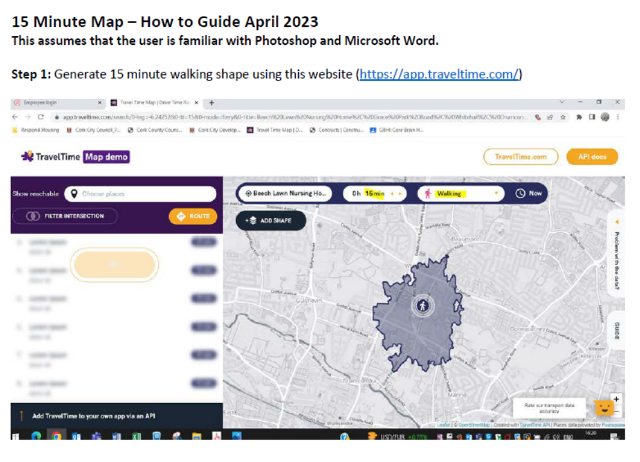
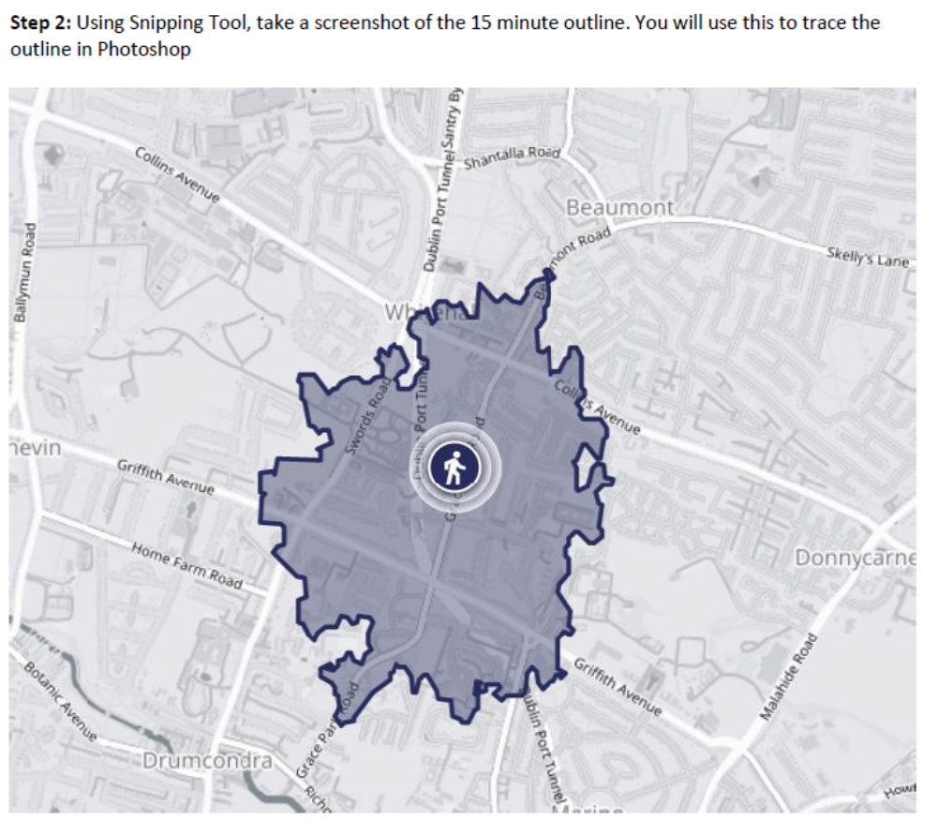

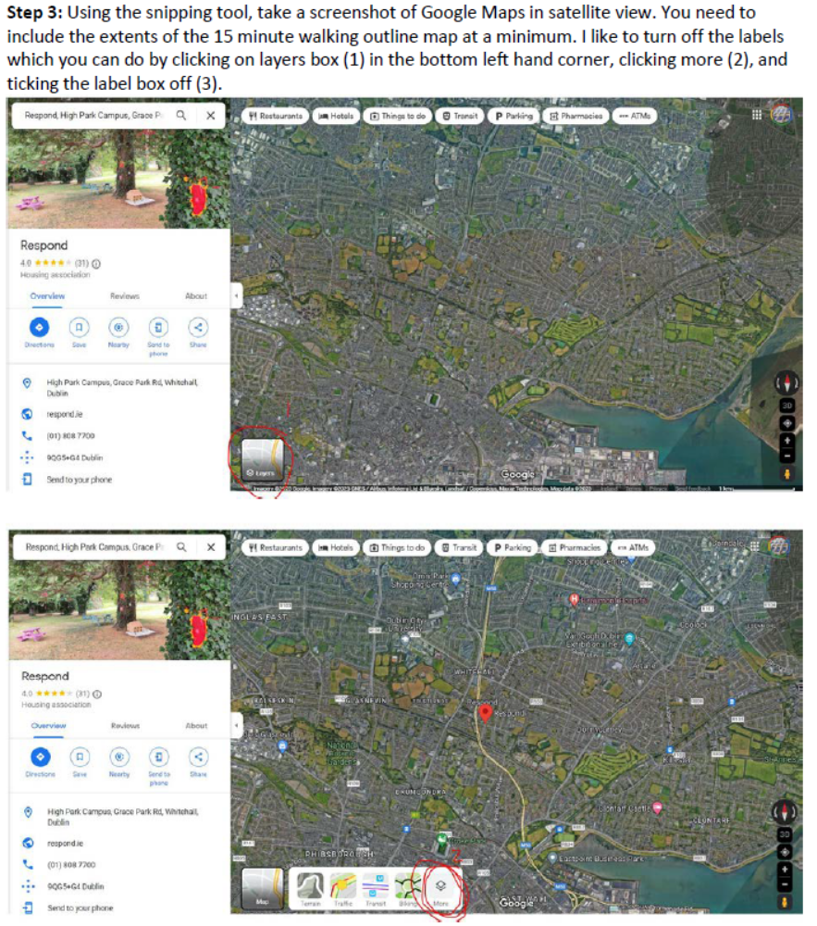

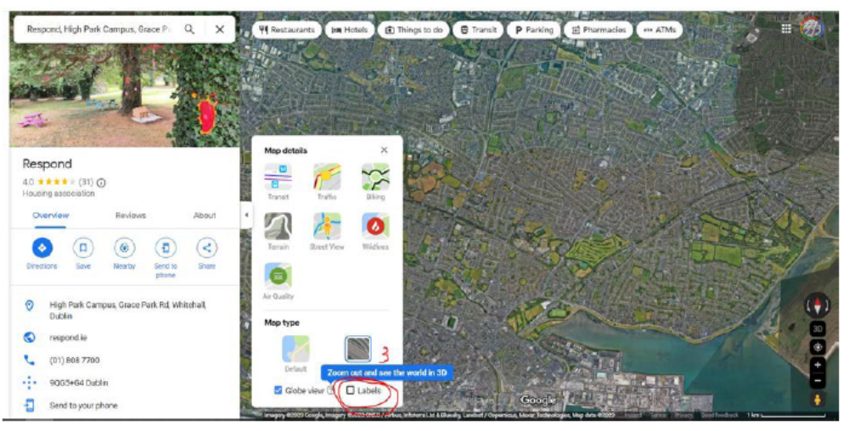

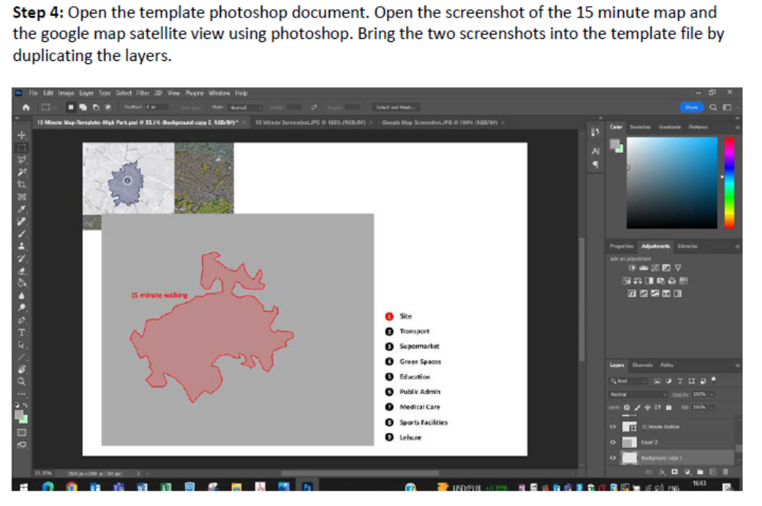

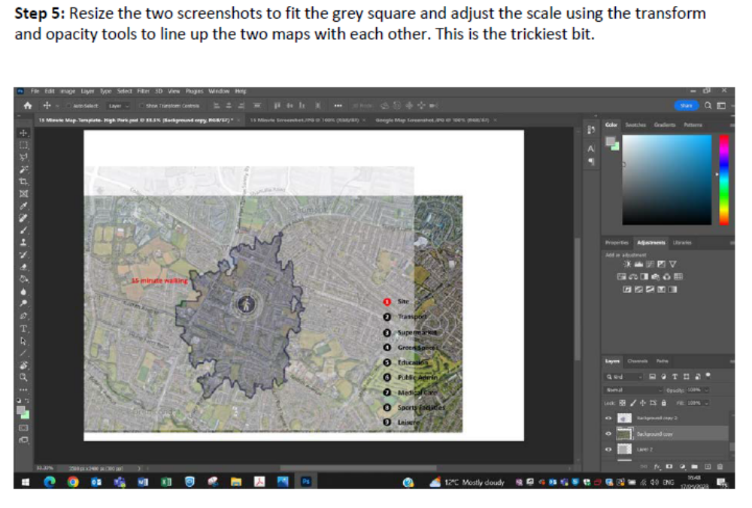
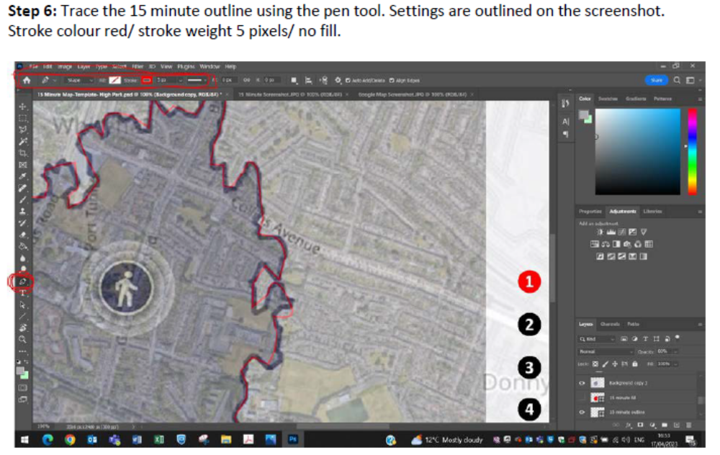
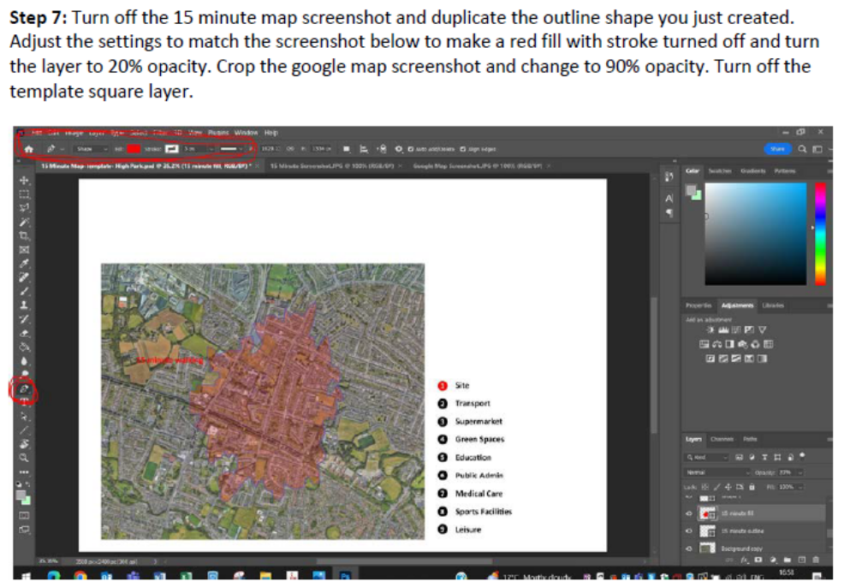
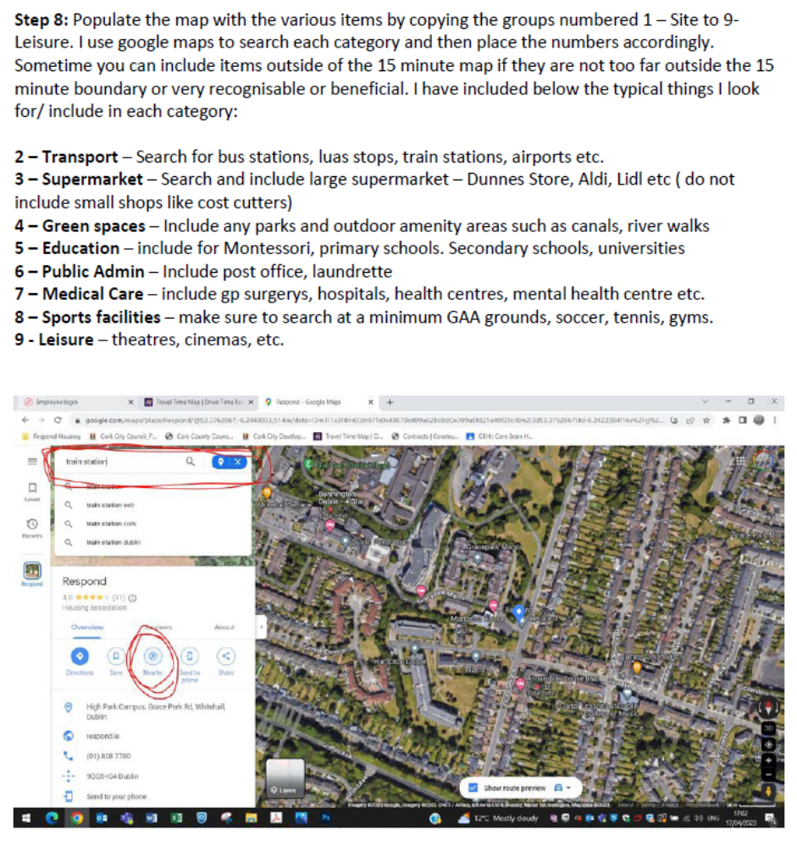
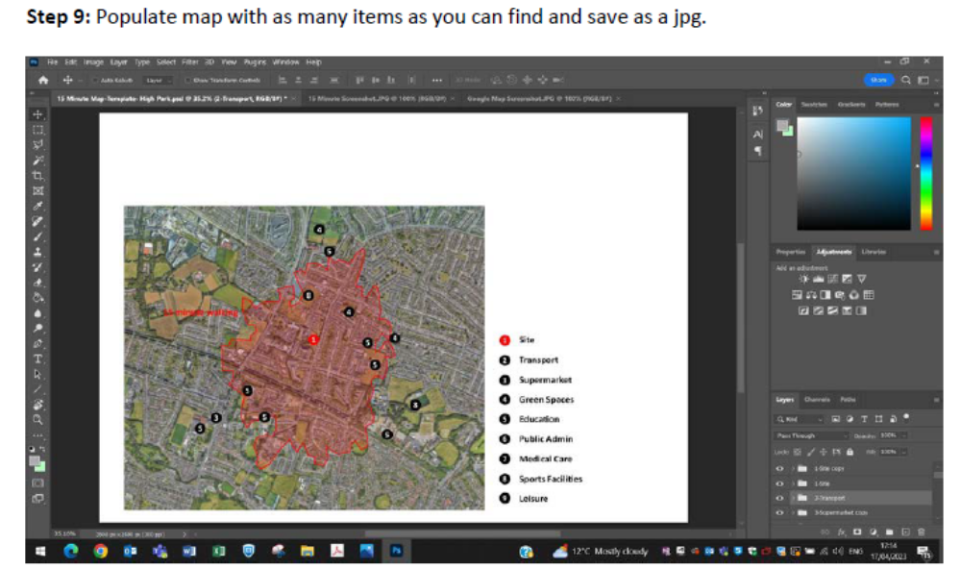

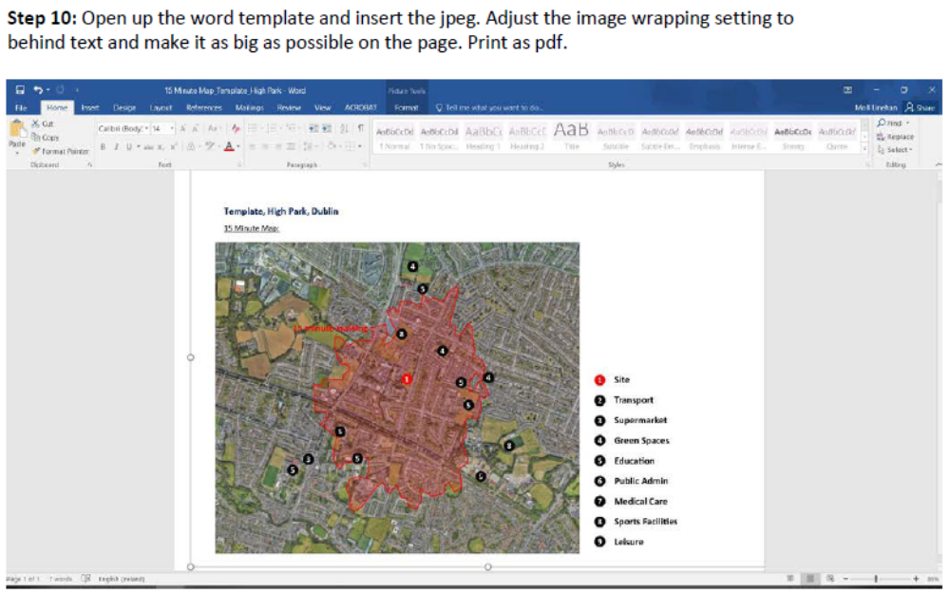

Form 5

Specification Document

[Also Provided Separately in Soft Copy]

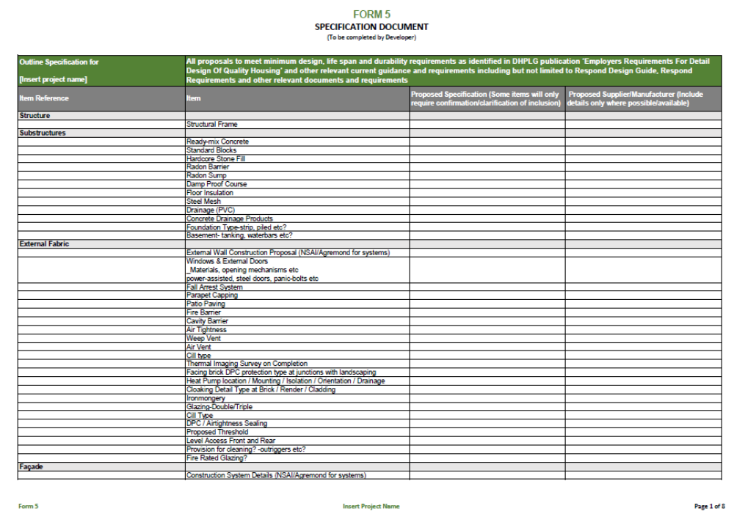
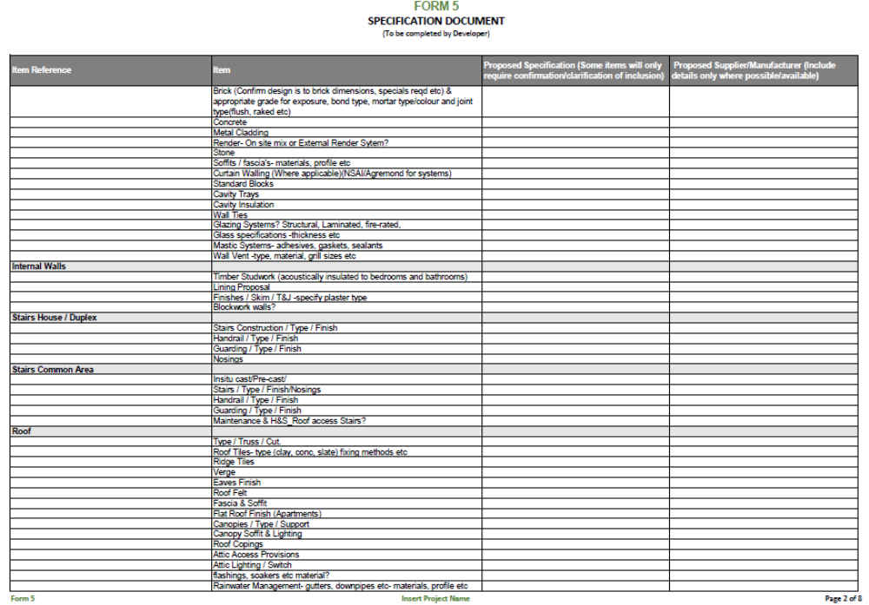
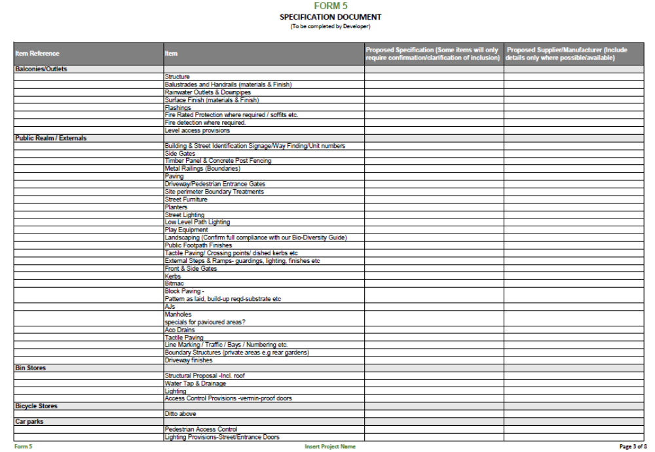
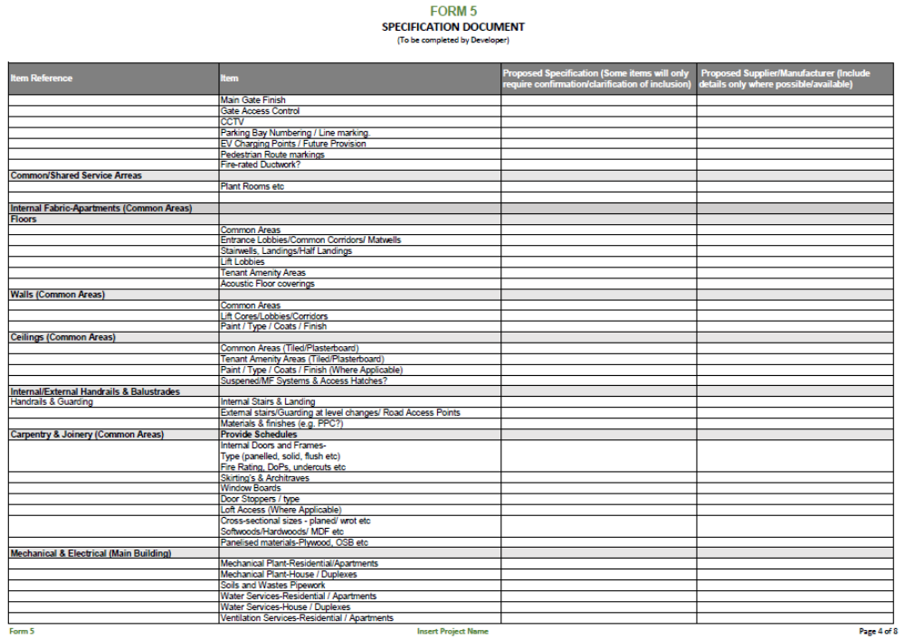
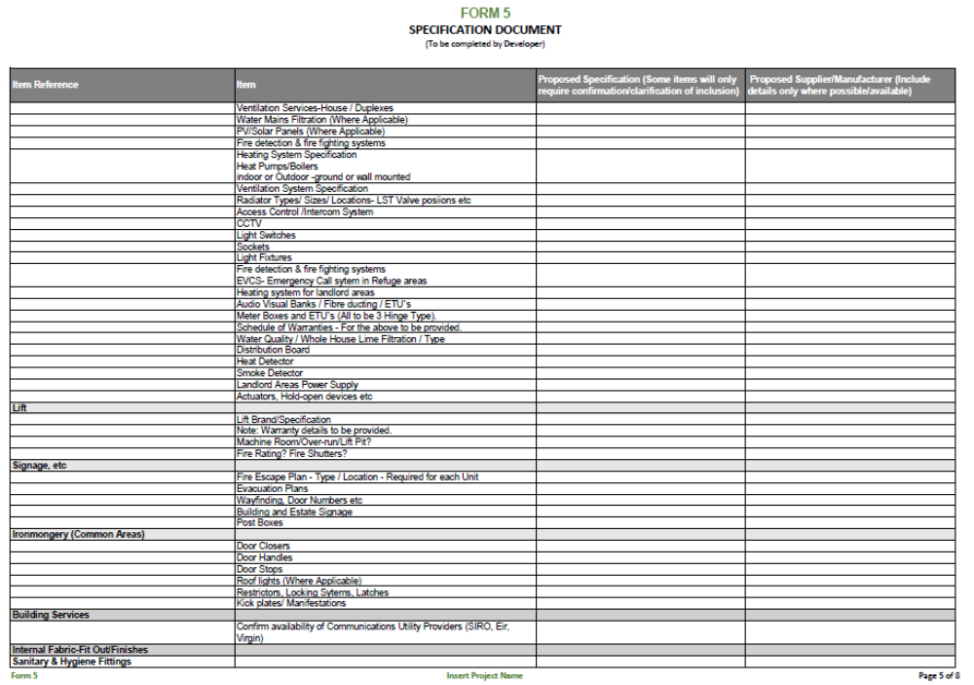
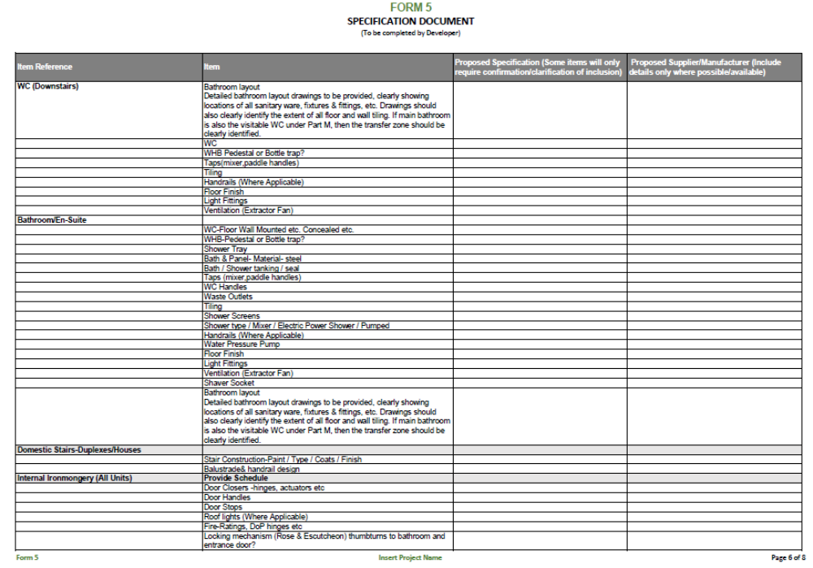
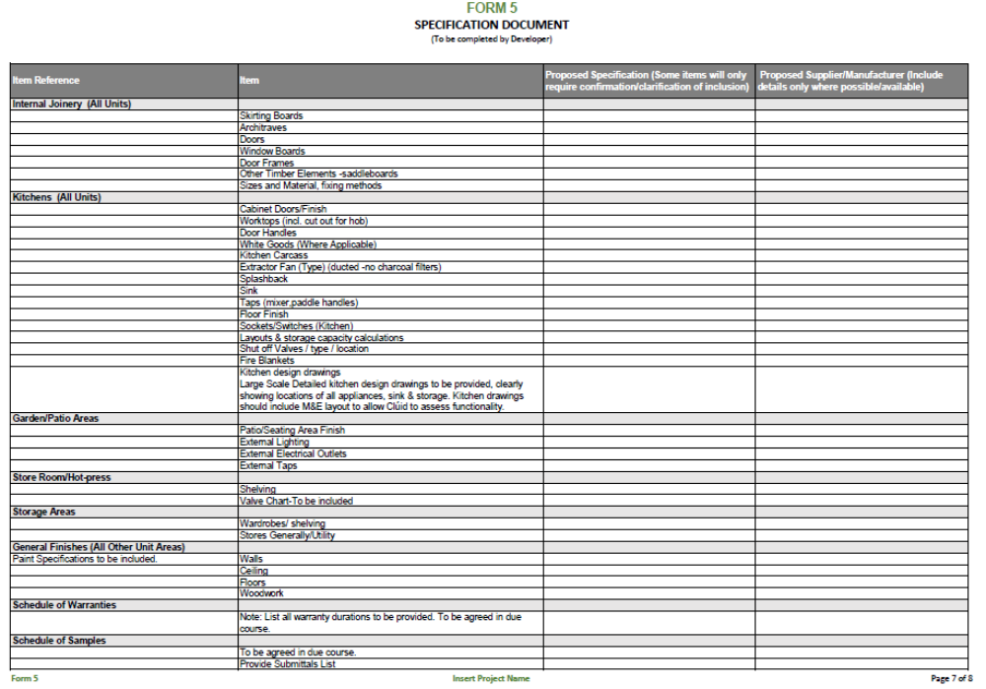
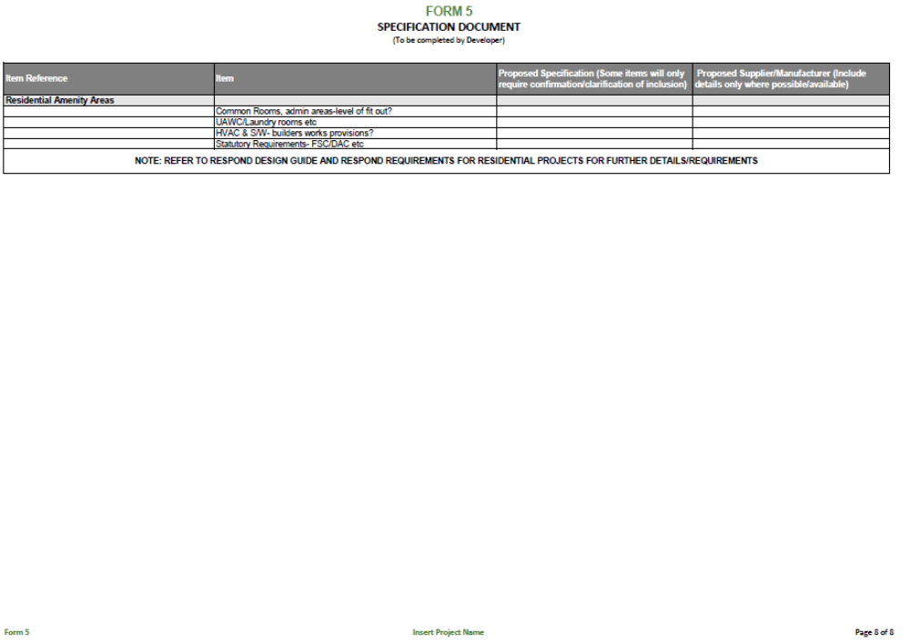

Note to Tenderers: Refer to Section 4.6 of the CFT, noting in particular the meaning of Tenderer Group Member.
Note to Tenderers: See footnote above.
Note to Tenderers: Refer to Section 4.7 of the CFT.
Note to Tenderers: Must be a minimum of 40 Homes and a maximum of 100 Homes.
Note to Tenderers: A copy of the Full Planning Application Information Pack is to be submitted to support the Tenderer’s response to Quality Criteria 1 & 2 as set out later in this Tender Response Document and this information will be referenced in the evaluation of the Quality Criteria
Note to Tenderers: Please replicate the table for each of the five (5) schemes.

