Portlaoise Cultural Quarter Regeneration
The Fort Museum and Event Centre
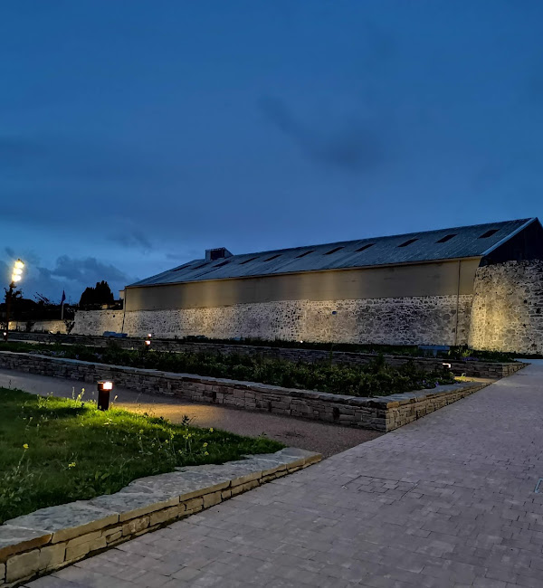
Project Brief for Appointment of Full Design Team Services
General Summary


September 2026

Appendix 1

General Summary

GENERAL SUMMARY OF LUMP SUM SUBMISSION

Reference | Project Section |  | Unit Price
Section 1 | The Fort Museum and Event Centre  Design Team | Item | €
Section 2 | Ancillary Associated Costs (Preliminaries, Expenses, Insurances etc.) | Item | €
Section 3 | Total Lump Sum Costs  (Excluding Value Added Tax)  Forward to Form of Tender | Item | €
Section 4 | Value Added Tax | Item | €
Section 5 | Total Lump Sum Costs  (Including Value Added Tax) | Item | €

