 | Provision and installation of parkland / woodland 6-8 cm trees at Cleveragh Regional Park Sligo.  Tree planting - DZ Scheme Cleveragh Regional Park Biodiversity and Nature Restoration Project  TENDER BRIEF (SPECIFICATION)

Introduction

Cleveragh Regional Park is located adjacent to Garavouge River, in Sligo town, an approximate 15-minute walk from the town centre. The area was originally developed in the 19th century by Colonel W G Woodmartin as an area of wetland on his estate. The Regional Park’s proximity to the town ensures it is a much-loved recreational amenity, popular with every age demographic.
Sligo County Council has received funding under the Decarbonising Zone scheme for Cleveragh Regional Park Biodiversity and Nature Restoration Project.

Part of the proposed Biodiversity and Nature Restoration Project works includes the provision of a biodiverse planted woodland areas in Zone B2 and B3 of the parkland (Refer Cleveragh Park – B1 Birch Forest, B2 Oak Forest zones below)

This procurement competition is to provide for the following items: -
- the supply and installation of a specified range of high-quality Irish provenance 6-8 cm native woodland trees as per specifications including supply, install, staking, 12-month maintenance.

Tenderers should provide all project costs in the attached Pricing Document and submit any additional relevant information, including experience history, pertaining to their proposals as part of their tender submission. Tenders should address all award criteria as outlined in Section 5.1 Award Criteria – basis of award.

Location Map Cleveragh Regional Park, Sligo
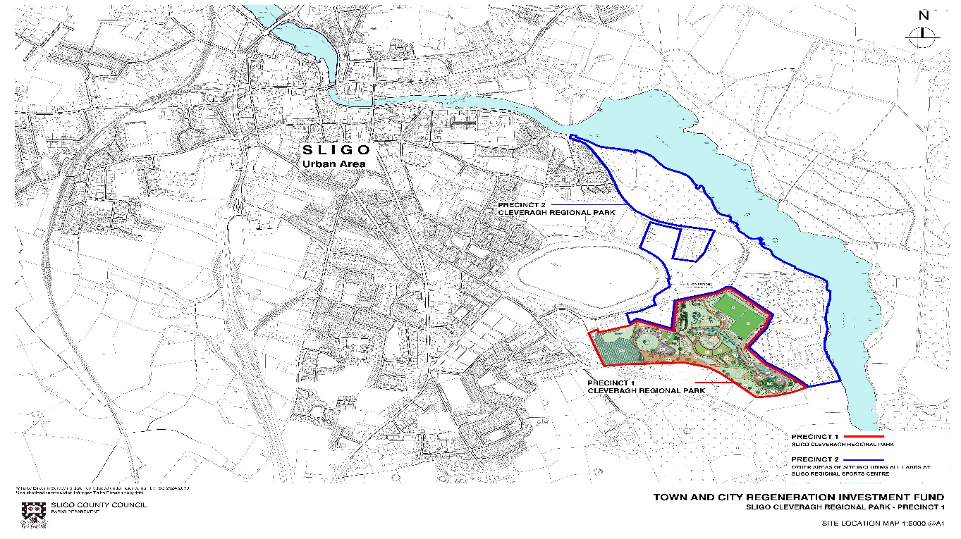

Cleveragh Park – B1 Birch Forest, B2 Oak Forest zones
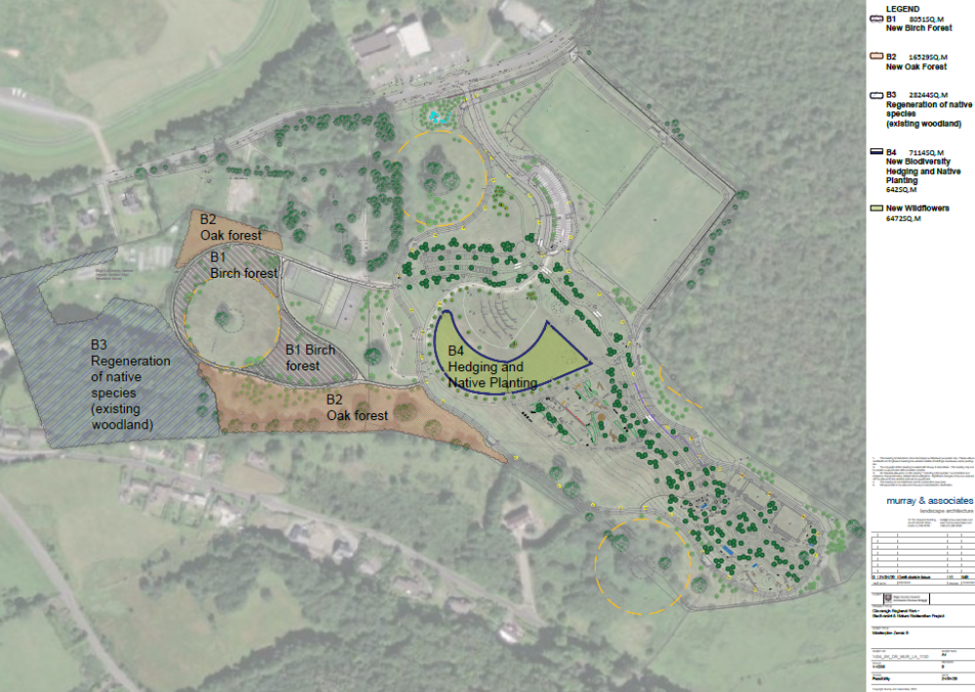

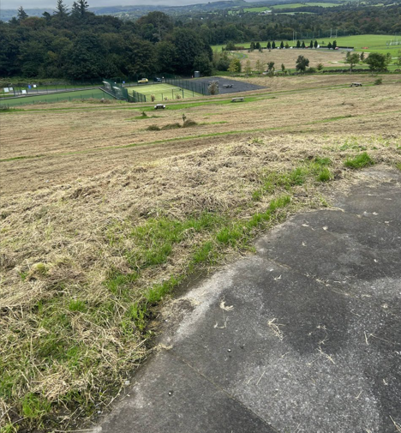
Cleveragh Regional Park – section of cleared area for B1 Birch Woodland Planting
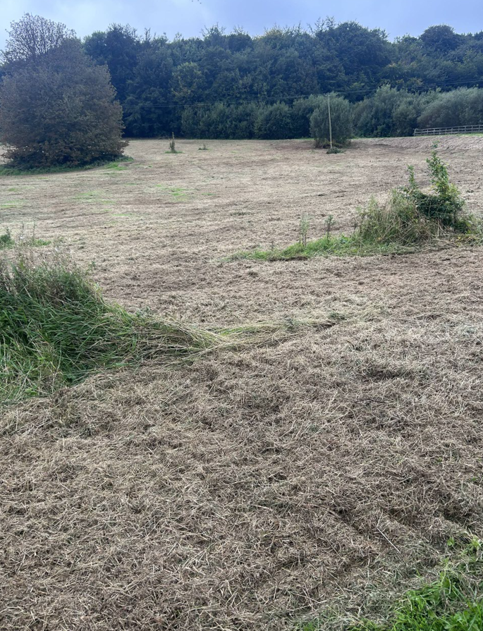
Cleveragh Regional Park – section of cleared area for B1 Birch Woodland Planting
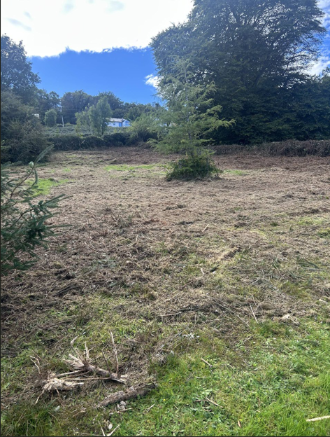
Cleveragh Regional Park – section of cleared area for B2 Oak Woodland Planting

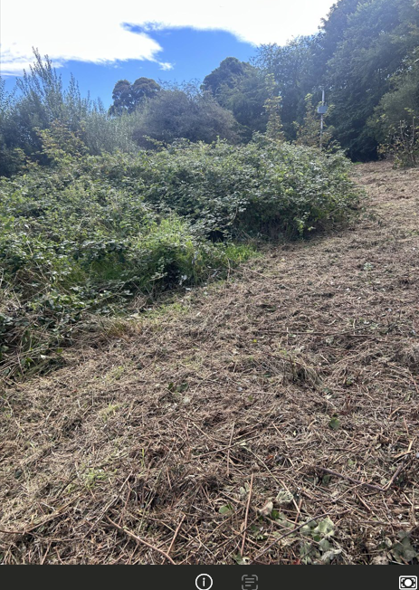

Cleveragh Regional Park – section of upper cleared area (Clearance work in progress) for B2 Oak Woodland Planting

2. Health & Safety
The Contractor will be aware of his/ her obligations and the obligations of the Contracting Authority under Health and Safety legislation and in particular the Safety, Health, and Welfare at Work (Construction) Regulations, 2013. These obligations include the preparation of appropriate safety plans to cover all activities involving the presence of labour, plant, or materials on the site/location of the works during the performance of the commission.
                - The contractor’s attention is drawn to the particular risk of Park users entering the works area during the proposed installation process. The site is located adjacent to adjacent to a walkway / cycleway and bounds a public open recreational green area. Public access to adjacent areas will be maintained during the contract works. Public car parking for the amenity is located close by. The adjacent areas will be subject to continuous use by the public and domestic pets for the duration of the works. The contactor shall be responsible for the Security of the Works area including (but not exclusively) any storage areas, any loading / off-loading area or operations necessary for the completion of the works.
                - No site compound, welfare facilities, temporary power or attendances of any kind will be provided by the Contracting Authority.
                - Council, if required, will allow (at contractor risk) storage of plant material in an adjacent Parks compound during the works.

2.1 Risk Assessment
The appointed Contractor shall conduct a detailed Risk Assessment of all works to be undertaken. The risks shall be identified and a qualitative and quantitative assessment conducted. Where possible the risks shall be eliminated and where elimination or avoidance is not possible, mitigatory measures shall be identified and procedures put in place to implement these measures.

2.2 Method statements / task specific risk assessments
In advance of appointment and or commencement on site, the appointed contractor will be required to provide a Site-Specific Method Statement for the Service Provision. All Contractors will be assessed as to their ability to conduct their work in a safe manner, in accordance with current safety legislation and codes of practice. Contractors works will be required to operate in line with the CIF – Construction Sector C19 Pandemic, Standard Operating Procedures (Current edition), or Government public health measures as applicable.
Method Statement shall clearly document:
- How the contractor will achieve the works within his scheduled time.
- The methodology, equipment and resources proposed to be used by the contractor for each specific element of the works.
- The contractor’s approach to Quality Control including the certification and commissioning of the equipment supplied.
- The contractor’s approach to maintaining and checking equipment for the duration of warranty periods.

2.3 Traffic management
The Contractor shall be responsible for the planning, design, implementation, maintenance and removal of any traffic safety and management measures required to facilitate the work.
The Contractor shall always comply with the requirements of ‘Chapter 8’ of the Department of Transport Traffic Signs Manual, current edition.
In the event of a traffic accident occurring adjacent to any of the Works, the Contractor shall immediately contact the Gardaí and the Contracting Authority informing them of the following:
- Location of the accident.
- The seriousness of the accident and whether any persons are trapped, whether the collision involves vehicles carrying inflammable, corrosive or hazardous substances, whether there is a possibility of ignition from leaking fuel or chemicals.

The Contractor shall provide telephone numbers of a minimum of three employees who can be contacted by the Gardaí and/or Employers Representative, both during and outside normal working hours, and who shall be responsible for initiating whatever action shall reasonably be required in the event of an emergency.

3.Scope of Works

3.1 Description
The Contractor shall supply, install and stake a range of 6-8 cm trees, to meet all specifications, forming part of the B1, B2 woodland Biodiversity Zone at Cleveragh Regional Park.

3.2 Scope of Works
- Supply and installation of a range of native tree species 6-8 cm within a biodiversity-led parkland environment (Refer to pricing document for numbers of trees, species variety, mix)

3.3 Tree Planting Specification

Supply of Trees
Provide approved native tree species as shown on the pricing document and indicative drawings

Tree Size
- Extra Heavy Standard trees.
- Girth: 6-8 cm measured at 1.0 m above ground level.
- Height typically 2.5-3.5 m depending on species.
- Well-branched crown with straight leading shoot.
- Root system to be container-grown, air-pot grown or regularly transplanted nursery stock.
- Trees to comply with:
  - BS 3936 Nursery Stock.
  - National Plant Specification (Horticulture Trades Association).
- Free from pests, diseases, defects and mechanical damage.

3.4 Planting Operations

Pit Formation -Excavate planting pit:
Minimum dimensions:
  - 900 mm diameter
  - 600 mm deep
or
- Three times root ball diameter, whichever is greater.
Pit sides and base to be loosened to prevent glazing and aid root penetration.
Any excavated rubble, stones greater than 50 mm or unsuitable material to be removed from planting hole and distributed on site in a safe manner.

Planting Medium
Backfill with:
- Existing topsoil
- Incorporate approved slow-release fertiliser and/ or mycorrhizal root treatment at planting.
Ensure root flare is positioned at finished ground level.
Firm soil around root ball to eliminate air pockets.
Fertiliser
Supply and incorporate slow-release granular tree fertiliser at a rate of 75 g per tree. Fertiliser shall be approved for use with newly planted trees and shall be evenly mixed through the backfill material during planting. Product: Controlled-release tree and shrub fertiliser, e.g. Osmocote Exact, Sierra Blen Tree & Shrub, or approved equivalent.

Fertiliser shall not be placed directly beneath or in contact with the root ball. Alternatively, where directed by the Senior Executive Parks, bonemeal may be substituted at a rate of 125 g per tree.
Water immediately after planting

3.5 Double Staking System

Stakes -Provide per tree:
- Two pressure-treated round timber stakes.
- Diameter: 75 mm minimum.
- Length: 1.8 m.
Install stakes outside root ball.
Drive stakes minimum 600 mm into firm ground.
Leave top of stake approximately: 600 mm above ground level.
This creates a low staking system which minimizes stem movement yet allows crown flexing.

Cross Rail
Provide: 75 mm × 38 mm treated timber crossbar fixed between stakes.
Secure using galvanized coach screws.

Tree Tie
Provide:
- Adjustable rubber tree tie.
- Arboricultural spacer block.
Install between tree stem and cross rail. Allow slight movement for trunk development. Inspect and adjust during maintenance period.

Mulch
Apply:
- 75 mm depth medium grade bark mulch.
Extent:
- 1.0 m diameter circle around each tree.
Keep mulch clear of stem by 75 mm.

Watering - At planting: Minimum 30 litres per tree.

Maintenance Period
Maintain for 12 months after practical completion. 2 x site visits
Include:
- Watering – 30 litres per visit
- Weed control around mulched areas
- Tie adjustment.
- Replacement of failed trees.
- Removal of litter and competing vegetation.
Replace dead, diseased or damaged trees with matching container grown stock

Restrictions
The following are not permitted:
- ❌ No cultivation beyond corridor
- ❌ No compost or soil improvers
- ❌ No imported soil

3.10 Maintenance
- 12-month establishment period
- Minimum 100% survival rate
- Failed plants replaced by Contractor
3.11 Biodiversity Requirements
Only Irish trees to be sourced and use – Irish grown or Irish seed source stock.

The Contractor shall:
- Minimise ground disturbance.
- Preserve soil structure and ecology.
- Deliver a woodland planting nicely integrated into the parkland environment.
Tree Installation
- Spacing at 7 m centres or as advised / agreed on site with Sligo County Council
- Planting mix distribution to be agreed on site. (very indicatively as shown on drawings but subject to onsite consideration and direction from Council)
Final Inspection
- Good specimen trees Height ≥1.5 m
- Adequately staked and tied to specification
- Stable and fit for dog containment
3.12 Form of Contract
Public Works Contract PW-CF5 (Minor Works) or similar.

All tendering contractors are, welcome if needed, to visit the site prior to submitting their tender to establish the extent of works involved in the removal of equipment and surfacing and the supply and installation of new equipment and surfacing.
Consideration must be given to the limited vehicular access to the works area and limitations presented by the proximity of public, accessible recreational areas. Public use of the overall parkland areas and walking trails will continue throughout the project.
The Contracting Authority offers no advice or direction regarding the suitability or otherwise of the existing soil. It is noted that the planting areas were formerly good quality agricultural grass land areas

4. Tendering Criteria

4.1 Contract Award
This contract will be awarded following the Contracting Authorities assessment of all tenders (fulfilling the tendering criteria) against criteria outlined in ‘Section 5 Award Criteria’. The contract will be awarded based on a Fixed Price Lump sum for the conducting of the specified works, tenders shall be itemised and outlined in the attached Pricing Document

4.2 Insurance Requirements
The successful Contractor shall indemnify Sligo County Council in respect of any legal liability, loss, claim or proceedings whatsoever arising out of or in connection with the death and/or bodily injury to any persons whomsoever and/or loss or damage to any property whatsoever which arises directly or indirectly out of (the carrying out of the Works) or (the Supply of Goods) or (the Provision of Services) by or on behalf of the Contractor.
In addition to the above, the successful Contractor shall provide evidence of insurance cover as follows:
Employers Liability Insurance: – an indemnity limit of not less than €13m and to include a notation of an indemnity to the Council or an Indemnity to Principal clause.
Public & Products Liability Insurance: - an indemnity limit of not less than €6.5m and to include a notation of an indemnity to the Council or an Indemnity to Principal clause.

4.3 Invoicing
Invoices shall be submitted by the appointed contractor on completion of both the removal of existing and installation of the new equipment or as otherwise agreed in writing by both parties.
All official invoices must quote a Sligo County Council purchase order number. All invoices which do not quote the relevant order number(s) will be returned to the service provider. Invoices for payment must be submitted online to supplierinvoices@sligococo.ie for processing

4.4 Tendering format
Tenderers are required to complete the following documentation:
    - Pricing Document

Tenderers must submit the fully completed Pricing Document / Bill of Quantities in the format provided as part of their tender. Failure to submit a fully completed pricing document in the prescribed format may result in your tender being deemed non-compliant and eliminated from the tender competition.
Tender Submission
Tenderers shall submit:
- Completed Pricing document.
- Programme of Works
- Details of relevant Experience
- Health & Safety documentation
Sligo County Council will only consider quotations from competent and financially sound and compliant economic operators. The successful contractor will be required to confirm and provide evidence of the following
- Confirmation of tax compliance.
- Confirmation that the economic operator is appropriately insured.
- Confirmation that the tenderer is not bankrupt, guilty of corruption, fraud, money laundering, membership of a criminal organisation, not involved in child labour and/or human trafficking and is fully compliant with all its statutory obligations.

4.5 Instructions for tenders

- Closing Date
The closing date for receipt of tenders is 12,00 noon on Friday 30 October 2026

Completed tenders should be submitted by email to Micheal Condren at mcondren@sligococo.ie

E tender return of tender as per advice on etender website

Tenders that are received at any time or date after this cut off time of 12.00 noon Friday 30 October 2026 will not be considered in this competition.

- Submission of queries and submission of Tender
All queries regarding this tender should be referred to Senior Executive Parks - Micheal Condren at mcondren@sligococo.ie .

Written email queries for record purposes are the preferred medium of contact for any tender queries or clarifications.

Micheal Condren can be contacted on mobile 0876386414 for general background or preliminary information.

The closing date for receipt of tender is 12.00 noon on Friday 30 October 2026

Completed quotations should be submitted by email to Micheal Condren at mcondren@sligococo.ie
E tender return of tender as per advice on etender website

It is intended that works will be completed by mid- April 2027 latest to meet funding criteria. Earlier completion if possible is preferred.
- Currency and Payments
The currency and invoices in which all prices and rates shall be quoted, and which payments under the contract will be paid, shall be Euros (€). All prices and rates quoted should be exclusive of VAT.

A schedule of payments will be agreed with the successful tenderer. The standard method of payment used is Electronic Funds Transfer.

- Confidentiality
The distribution of the quotation documents is for the sole purpose of obtaining offers. The distribution does not grant permission or licence to use the documents for any other purpose. Tenderers are required to treat the details of all documents supplied in connection with the quotation process as private and confidential.

- Cessation of tendering competition
Sligo County Council reserve the right to abandon this tender competition at any stage and will not be liable for any expenses incurred by tenderers in preparing tenders in response to this Contract notice.

- Conflict of Interest
Any conflict of interest involving a tenderer (or economic operators in the event of a consortium bid) must be fully disclosed to the Contracting Authority. Any registrable interest involving the tenderer and The Contracting Authority or employees of the Contracting Authority or their relatives must be fully disclosed in the quotation submission or should be communicated to the Contracting Authority immediately upon such information becoming known to the tenderer, in the event of this information only coming to their notice after the submission of a bid and prior to the award of the contract. The terms ‘registrable interest' and 'relative' shall be interpreted as per Section 2 of the Ethics in Public Office Act, 1995. Failure to disclose a conflict of interest may disqualify an economic operator or invalidate an award of contract, depending on when the conflict of interest comes to light.

- Freedom of Information Acts
Tenderers should be aware that, under the Freedom of Information Act 2014 and the European Communities (Access to Information on the Environment) Regulations 2007 to 2014, information provided by them during this Competition may be liable to be disclosed.
Tenderers are asked to consider if any of the information supplied by them in their Quotation should not be disclosed because of its confidentiality or commercial sensitivity. If economic operators consider that certain information is not to be disclosed because of its confidentiality or commercial sensitivity, tenderers must, when providing such information, clearly identify the specific sections of their quotation containing such information and specify the reasons for its confidentiality or commercial sensitivity. For the avoidance of doubt tenderers may not assert confidentiality or commercial sensitivity over the entire quotation but must clearly identify the specific section containing such information. If tenderers do not identify information as confidential or commercially sensitive, it is liable to be released in response to a request under the above legislation without further notice to or consultation with the economic operator. The Contracting Authority will, where possible, consult with tenderers about confidential or commercially sensitive information so identified before making its decision on a request received. The Contracting Authority accepts no liability whatsoever in respect of any information provided which is subsequently released (irrespective of notification) or in respect of any consequential damage suffered because of such obligations.

- Data Protection
Data Protection Laws” means all applicable national and EU data protection laws, regulations and guidelines including but not limited to Regulation (EU) 2016/679 on the protection of natural persons with regard to the processing of personal data and on the free movement of such data, and repealing Directive 95/46/EC (the “General Data Protection Regulation”), the Data Protection Act, 2018 and any guidelines and codes of practice issued by the Data Protection Commission or other supervisory authority for data protection in Ireland from time to time.

The Contracting Authority will be a Controller (where Controller has the meaning given under the Data Protection Laws) in respect of any Personal Data (where Personal Data has the meaning given under the Data Protection Laws) required to be provided by the Tenderer in response to this Request for Quotation.

The Tenderer, as Controller in respect of any Personal Data provided by it in its Tender, is required to confirm by way of statement in the “Declarations” section of the accompanying Quotation Response Document (QRD) that all Data Subjects (where Data Subject has the meaning given under the Data Protection Laws) whose Personal Data is provided by the Tenderer have consented to the processing of such Personal Data by the Tenderer, the Contracting Authority, the Evaluation Team and the supplier of the etenders.gov.ie website, for the purposes of the participation of the Tenderer in this Competition or that the Tenderer otherwise has a legal basis for providing such Personal Data to the Contracting Authority for the purposes of its participation in this Competition.

- Tax Clearance Certificate
It will be a condition of award of this contract and any subsequent contract that the successful tenderer complies with all EU and national tax laws. Tenderers are referred to the Irish Revenue web site http://www.revenue.ie/. Non-resident tenderers should apply to the Office of the Revenue Commissioners, Non-Resident Tax Clearance Unit, Office of the Collector General, Sarsfield House, Francis Street, Limerick, Ireland; e-mail: nonrestaxclearance@revenue.ie.

- Withholding Tax
Relevant payments shall be subject to Irish ‘Professional Services Withholding Tax’ at the prevailing rate (currently at 20%) as laid down by the Revenue Commissioners in Ireland. Non-residents may be able to reclaim such deducted Tax from the Office of the Revenue Commissioners in Ireland, International Claims Section located currently at Government Buildings, Nenagh, Co. Tipperary, Ireland (Tel: +353-67-63400).

- Interference and Inducement to Purchase
Any effort by the tenderer to unduly influence the Contracting Authority, relevant agency personnel or any other relevant persons or bodies in the process of examination, clarification, evaluation and comparison of quotations and in decisions concerning the Award of Contract shall have their quotation rejected. In accordance with Section 38 of the Ethics in Public Office Act 1995 any money, gift or other consideration from a person holding or seeking to obtain a contract will be deemed to have been paid or given corruptly unless the contrary is proved.

- Notification of Evaluations
All parties will be informed of the outcome of their proposals following evaluation and any necessary clarifications.

- Award to Runner-up
If for any reason, it is not possible to award the contract to the designated successful party emerging from this competitive process and assessment of submissions, or if having awarded the contract, the Contracting Authority considers that the successful party has not met its obligations, they reserve the right to award the contract to the next highest scored tender. This shall be without prejudice to the right of the Contracting Authority to cancel this competitive process and/or initiate a new contract award procedure at its sole discretion.

- Replacement Personnel
Notification must be sent in writing (by post or electronic means) as soon as possible to the client on any proposed change of nominated personnel, such change to be subject to the written approval of the client. Replacement personnel must be of equal or better standing that the existing personnel in terms of qualifications and experience.

- Copyright
Sligo County Council will have copyright ownership of any material developed for use by the client under the terms of this quotation. The service provider may have a non-exclusive licence to use such material but only for its own purposes (to be agreed with the successful tenderer).

5. Award Criteria

5.1 Basis of Award
The contract will be awarded on the basis of assessment by the Contracting Authority of completed tender proposals considering; criteria outlined in table 5.1 below.
(Table 5.1)
Criteria | Instruction | Weighting | Maximum Mark
Price | Complete Pricing Document Tree Planting DZ scheme Cleveragh Regional Park Biodiversity project. | 50% | 50
Type and provenance and assessed quality of trees | Provide details of the trees to be used, nursery or nurseries of origin  Only Irish grown native plant material to be used for this biodiversity project | 10% | 10
Maintenance, guaranteed service life | Outline maintenance approach and how the company will manage the maintenance of the tree planting for a 12-month establishment period. | 10% | 10
Quality of Service / Experience of tendering contractor | Provide details of 3 or more similar or relevant large scale tree planting projects (or landscape projects) completed by the tendering contractor within the past 5 years, include details of the awarding authority’s representative for consultation / referee. | 20% | 20
Timescale for delivery and completion of installation | Provide timescales for the delivery of the tree planting and period for completion of installation works  Works must be completed before mid-April 2027 | 10% | 10

Appendix _

Pricing document
Fill and complete pricing document and return. Supply evidence copies of insurance and tax clearance, Provide evidence of previous similar installations x 3. Address all award criteria as outlined in Section 5.1 Award Criteria – basis of award
- Cleveragh NWRA forest establishment regeneration areas
- Cleveragh NWRA outline planting schedules

