Great Sole Bank meeting room, Oranmore

Usage – Meeting room (up to 10 pax)
Room setup – Carpeted, fixed table, 75” mounted TV. Existing cabling in place used by Poly equipment
Natural Lighting – 3.7m high window running majority of bottom side of diagram. Blinds in place
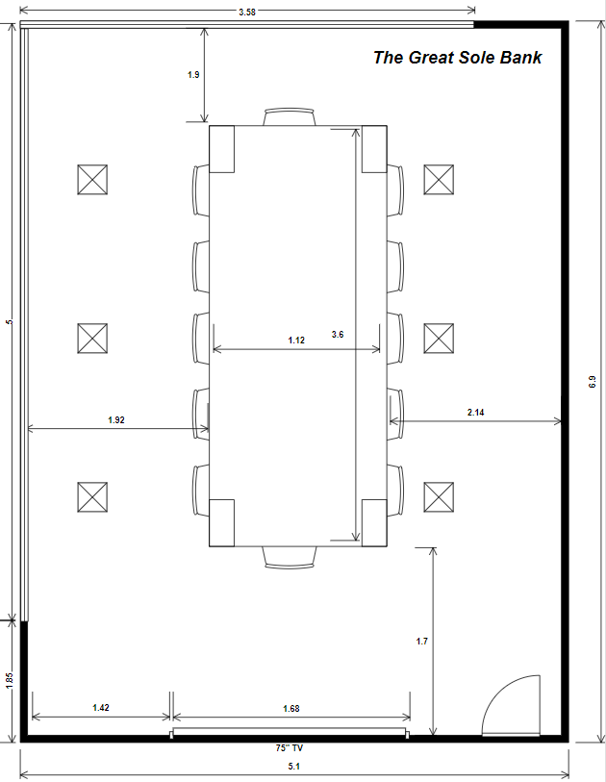

Dublin Primary meeting room

Usage – Meeting room (up to 10 pax)
Room setup – Carpet tiles, fixed table, Alcove unit at top of room with a 75” mounted TV. Raised floor in place, existing cabling in place used by Poly equipment
Natural Lighting –Window running the majority of the left side of the room looking out into an office space.

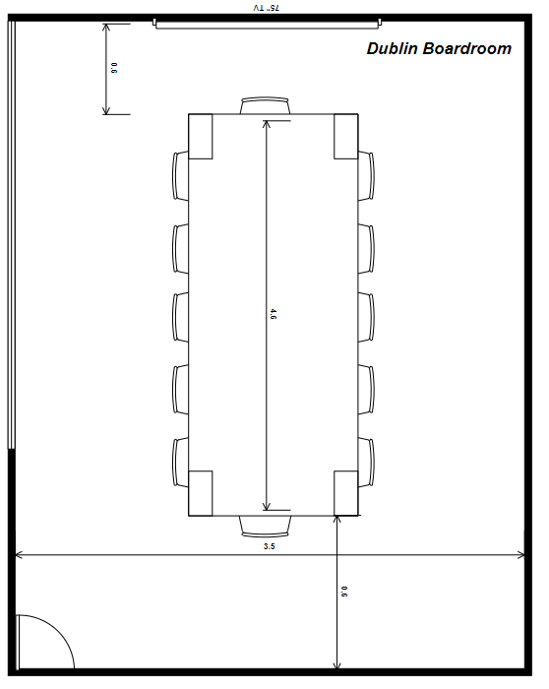

Newport Primary meeting room

Usage – Meeting room (up to 10 pax)
Room setup – Carpeted, fixed table. An alcove unit at the top of the room with a drop down projector screen & mounted 75” TV. Existing cabling in place used by Poly
Natural Lighting – 1.5m high window running majority of right side of diagram. There are shade blinds and blackout blinds on all windows.

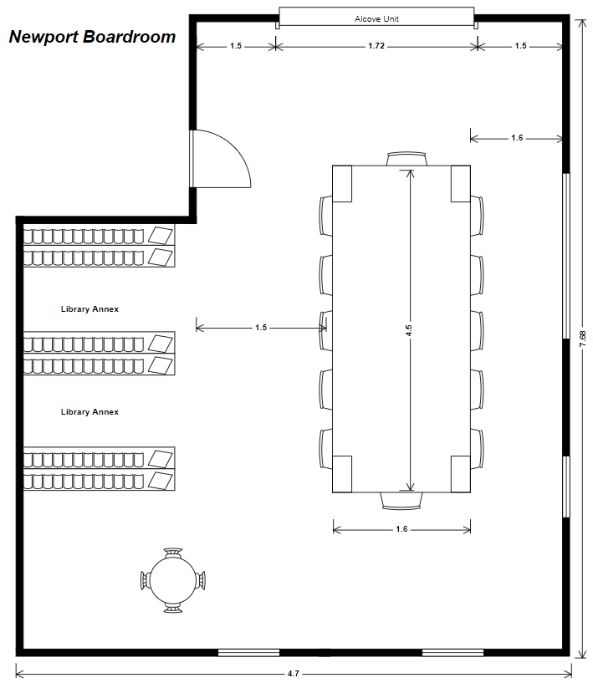

Office of CEO

Usage – Meeting room (up to 10 pax)
Room setup – Carpeted, fixed table & mounted 75” TV. Existing cabling in place used by Poly
Natural Lighting – 1.9m high window running width of room, blinds in place, frosted glass partition wall next to door
