

SPECIFICATION No. 2RN2626

Document Title
TECHNICAL SPECIFICATION
Section 2

Project Title
Ballydavid Tower

Project No. 2RN2626
Version 1

Technical Specifications

Table of Contents
- INTRODUCTION 1
- TOWER 1
- EARTHING 2
- EXTERNAL GANTRIES 3
- SITE WORKS 4
- CONCRETE FOUNDATIONS 5
- TESTING OF CONCRETE 6
- ACCESS ROADS 7
- ADDITIONAL DELIVERABLES 7
- ROHS AND WEE DIRECTIVES 8
Appendix A 9
Appendix B 32
Appendix C 33
Appendix D 38
Appendix E 39
Appendix F 40

- INTRODUCTION
1.1 SCOPE OF THIS DOCUMENT
1.1.1 The scope of this Specification details the requirements for the design, supply, construction of a new 54m self-supporting tower at Ballydavid, Co. Kerry (N52.195233° W-10.373784°). The scope of this tender includes foundation excavation and installation for the new structure which has suitable capacity to carry the proposed loading, supply of tower, construction of compound with palisade fence, access track and crane hard stand area any other civils requirement.
1.2 SCOPE OF SPECIFICATIONS
1.2.1 The Tenderer shall be responsible for the supply, delivery and offloading to Ballydavid of all the equipment supplied against this specification.
1.2.2 The Tenderer shall be required to deliver a solution for the design, supply, of a tower at Ballydavid , Co. Kerry.

    - As-built drawings shall be provided. Drawings shall also be submitted in editable electronic form, to AutoCAD 2010.
    - All text on drawings, and all other documentation, shall be in English.
    - Manufacturer’s test certificates shall be provided by the Contractor in accordance with the above standards.

- TOWER
2.1 TOWER FOUNDATION
The new tower shall be located North of the existing guyed mast location. Provisionally a base of 9x9x1.2m has been assumed. Geotech will be supplied with the tender to confirm suitability.
2.1.1
- The base is to be founded on a confirmed suitable soil stratum level. 100kPa or higher.
- A ground investigation to confirm the allowable bearing pressure of the substrate has been supplied.
- All concrete to be minimum C30/37 and meet the following Design Mix Criteria S2 – XC2. (Table NA. 5 of NA: 2015 to I.S. EN 206 2013)
- All rebar supplied must be 500MPa as per EN1992-1-1: 2004.

2.1.2 The Contractor shall ensure that the proposed foundations shall not interfere with existing buildings, foundations, roads or fences.
2.1.3 The Contractor shall check the setting out of all existing reference points, datum levels, foundations and other features to which the works are related. Any discrepancies shall be reported to the 2RN Engineer to obtain further instructions. The Contractor shall be responsible for the correctness of the position, level, dimension and alignment of all parts of the works to an accuracy within the specified tolerances.
2.1.4 Unless otherwise stated in the Specification the ordinary structural concrete shall conform to BS EN 1992-1-1:2004+A1:2014 and all relevant British Standards stated therein. The cement content shall not be less than 320 kg/m3 or exceed 380 kg/m3 of the finished concrete. The characteristic strength shall be 37 N/mm2 using ordinary Portland Cement to BS 12. The maximum acid-soluble alkali content of the mix shall not exceed 0.45 to provide durable concrete under severe conditions. Design Mix to be approved prior to pour.
2.1.5 All spoil be moved to a safe area during the works and shall be removed from the site to an approved location at the end of the excavation stage.
2.1.6 Any damage to adjacent land shall made good to the satisfaction of the landowner at the end of the works.
2.1.7 Appendix A contains the 2RN Earthworks specification. The applicable sections of this specification shall be met at all stages.
2.2 SUPPLY of tower
2.2.1 A 54m lattice tower shall be supplied. The tower shall be 54m in height and triangular in plan. This shall be minimum 1.1m wide at the top and maximum 3.5m at the base. The tower sections shall be delivered preassembled if possible. For sections too wide for transportation, they shall be flat-packed section-by-section with all members suitably marked for assembly, with detailed assembly drawings. The tower shall support the following loading:
- 2 No. Yagis (2m) from 51.5m to 54m, spaced equally
- 4 No Dipoles (2m) from 36m to 42m, spaced equally
- 1 No Omni Whip (2.1m) at 32.4m
- 3 No. GSM panels (2.7m) & 3no RRU’s at 29.5m c/c
- 3 No. GSM panels (0.7m) at 31.5m c/c
- 3 No. GSM panels (2.7m) & 3no RRU’s at 26.1m c/c
- 3 No. GSM panels (2.7m) & 3no RRU’s at 23.9m c/c
- 2 No. 0.9m dishes at 26.6m c/c
- 2 No. 0.9m dishes at 25m c/c
- 4 No. 0.9m dishes at 21m c/c

- Notes:
- All GSM panels are assumed to be 2.7m x 0.49m, with RRU fibre and DC
- All Broadband antennas assumed to be 0.7m x 0.4m with ½” feeders
- All other feeders are assumed to be 1 No. 12mm per antenna. (Assume a total of 60 No.).
- All standoffs shall be supplied with backing plates if required (not J-bolt solution will be rejected)
The following antenna support poles shall be supplied:
- 1 No. 3 sided face frame at 29m. Face frame to be stood off 300mm. 9 No. 3m CHS88.9x5mm pole supplied with all required U-bolts and clamps for face frame.
- 1 No. 3 sided face frame at 25m. Face frame to be stood off 300mm. 9 No. 3m CHS88.9x5mm pole supplied with all required U-bolts and clamps for face frame.
- 1 No. 8m long CHS88.9x4mm with 4 No. stand-off brackets
- 1 No. 5m long CHS88.9x4mm with 3 No. stand-off brackets
- 3 No 3m long CHS76x4mm with 2 No. standoff brackets per pole
- 3 No. 2.5m long CHS76x4mm with 2 No. standoff brackets per pole
- 4 No. 1.5m long CHS76x4mm with 2 No. standoff brackets per pole

All poles to be supplied with U-bolts, nuts, washers and backings plates.

2.2.2 The structure shall be analysed to EN 1993-3-1 (2006) (English): Eurocode 3: Design of steel structures - Part 3-1: Towers, masts and chimneys – Towers and masts
and members checked in accordance with the requirements of BS EN 10025: 1993 “Hot rolled products of non-alloy structural steels.” Or BS EN 1993-1-3:2006 Eurocode 3 “Cold formed Steel”

2.2.3 The structure shall be checked for a deflection criterion based on a maximum allowable rotation of the microwave dishes of 1.0 degrees, inside a 5-year return period, while the strength of the structure shall be analysed to a return period of 50 years.
2.2.4 The following wind loading values and factors shall be used based on the wind speed maps in the latest Eurocode and Irish Annex.:
2.2.5 Wind Speed
Mean hourly wind speed with return period of 50 years: 27.5 m/s
2.2.6 Partial Safety Factors (to Eurocode)
i. Reliability Class 2
ii. Gamma-m = 1.10
2.2.7 Altitude factor and hill slope:
i. Site level is 50m above sea.
ii Orography type is shallow slope with Min base of upwind orography 22m above sea level
2.2.8 Terrain Category 0/ II (EN 1991-1-4 A.1
2.2.9 Distance to the sea: Min distance to Sea can be taken as 400m

2.2.10 The following shall also be supplied and erected:
i) A ladder and Latchways fall-arrest system. The ladder shall be supported off a diagonal member across the centre of the tower at 3m vertical spacings.
ii) a vertical feeder cable system behind the ladder to cater for up to 40 No. antenna feeders. Minimum vertical spacing of vertical supports to be 0.50m.
iii) An enclosure-type anti-climbing frame around the tower. This should include; weldmesh panels 2.4m high around the perimeter of the Tower, bolted onto the tower legs, with double gates on one face.
iv) 1 No. face frames as shown above. Horizontals to be min. 80mm box section with allowance for standoffs to avoid clashing with the tower bracing.
v) Steel template and holding-down bolts within the foundation. These shall be supplied by the tower fabricator and be available for inspection by the 2RN Engineer before the base is poured.

The contractor shall issue a “Safe to Climb” cert at the end of the works and quality check the structure.

  - TOWER STEELWORK

2.3.1 The stress in the steelwork shall be in accordance with EN 1993-3-1 (2006) (English): Eurocode 3: Design of steel structures - Part 3-1: Towers, masts and chimneys – Towers and masts

2.3.2 All steel shall be in accordance with BS EN 10025 and BS EN 10219 or approved equivalent.

2.3.3 Bolts shall be Grade 8.8 or higher in accordance with EN 1993-1-8:2005. All bolts, nuts and washers shall be spun galvanised to EN ISO 1461. The edge and end distance for bolts shall comply with the EN1993-1-8 Table 3.3 / 3.4. All bolts shall have two flat washers and one spring washer under the nut. After final tightening, all bolts shall project through the nuts by not less than 3mm and shall not have any threads in the plies. Unless otherwise stated, holes shall be drilled 1.5mm larger than the nominal diameter of the bolt passing through them.

2.3.4 Bolts in main leg members and primary bracings shall be not less than 20mm diameter and in secondary members shall be not less than 12mm diameter. For angle bracing, there shall be a minimum of 2 No. bolts at each end.

2.3.5 All steelwork shall be galvanised to BS EN ISO 1461:1999. The hot dip galvanised coating shall have a minimum average coating of 125 mm, and a minimum local thickness of 100 mm. The tower contractor shall make known to 2RN the name and address of the galvanising contractor at the time of tender. Bolts and nuts shall have a coating with an average thickness of 40mm or more.

2.3.6 All welding shall be in accordance with BS 5135. Electrodes shall be in accordance with BS 639.

2.3.7 Drawings shall show steel grades of all members and sizes of all bolts.

2.3.8 Before fabrication all drawings shall be submitted in duplicate to 2RN for comment. Such comment shall not relieve the Contractor of the responsibility for the accurate detailing and fabrication of members and for proper assembly at the time of erection.

2.3.9 All plan bracing at the top of each tower section shall include internal diamond-shape arrangement.

  - CABLE MANAGEMENT
    - A cable management system shall be provided behind the ladder for the following feeders number and sizes:

    - 40 No 10mm, 40 No. 1/2”, 26 No. 7/8” feeders.

    - Non-structural horizontal flat bars as feeder management steelwork are required. The maximum spacing between each horizontal flat bar shall be no more than 500mm. These flat bars shall be drilled with holes at 100mm centres for threaded bars & Rem-Clamps. Details and drawings of the flat-bars being proposed shall be submitted in the tender response. All steelwork shall be in accordance with the specifications outlined in Clause 2.3 of this document.

3 Earthing
3.1 SPECIFICATIONS
3.1.1 The earthing system shall be designed to incorporate the tower.
3.1.2 The lightning protection system shall comply with IS EN 62305-2011“Protection against lightning. Physical damage to structures and life hazard”.
3.1.3 All earthing systems shall comply with BS 7430-2015 “Code of practice for protective earthing of electrical installations” and BS EN 62305-2011
3.2 REQUIREMENTS
3.2.1 The earth termination system shall be designed by the Contractor and shall have a resistance to earth not less than that required by BS EN 62305.
3.2.2 The entire system must be designed to ensure that no path to earth can be found through the tower equipment, and the Contractor shall supply technical information of the quality and design of the system to be supplied.
3.2.3 Earthing systems shall not be visible at ground surface except where the conductor emerges from the ground. The conductor shall be of tape form, 25mm x 3mm section, and shall contact the item being earthed only at the point of attachment. The tape shall enter the ground by the shortest route consistent with neatness and avoidance of personnel tripping hazards.
3.2.4 All conductor tape above ground level will be an aluminium tape with a PVC cover. All conductor tape below ground level shall be bare copper tape. All interconnections between copper and aluminium shall made with bi-metallic connectors.
3.2.5 All lightning protection and earthing work shall be carried out by an approved Contractor, experienced in this work. The pre-tender site visit by the Contractor shall include sufficient tests to indicate the soil resistivity.

QUALITY STANDARDS
4.2.1 All processes material must be finished according to the standards below or equivalent. In cases where these standards have been superseded, the most up to date is to be used.
BS EN ISO 1461:2009 Hot dipped metal coated steel.
BS EN 60529:1992+A2:2013 Degrees of protection of enclosures.
BS EN 1991-1-1:2002 Code of Practice for dead or imposed loads.
BS 5493-1997 Code of Practice for protective coating for steel which is especially for the marine environment and harsh weather conditions
BS EN ISO 1090-2:2018 Specification for material fabrication and erection of Hot rolled steel section. CE marking compliance Execution Class EXC2.
BS EN 1991-1-4:2005+A1:2010 Code of Practice for wind loads.
BS EN 1991-1-3:2003+A1:2015 Code of Practice for imposed roof loads.
BS EN ISO 10581:2013 Homogeneous flooring.
BS 6767-1:1999 Design and construction of transportable buildings.
BS 6767-2:1998 Transportable accommodation installation – transport
BS EN 1993-1-3:2006 Code of practice for design of steel sections
BS 7671:2008+A3:2015 IEE Wiring regulations
BS 5839-1:2017 Fire detection and alarm systems
PD 476-3:2012 External fire exposure roof test

5 SITE WORKS
5.1 REQUIREMENTS
5.1.1 Hours of Work, the work shall be carried out on consecutive normal working days without interruption, except as agreed by 2RN, until completion of contract.
5.1.2 Site Access 2RN utilise a web-based system “Siteshare” http://www.siteshare.ie/acms/users/login.aspx to book access to site. The contractor should follow all access requirements and any specified at the time of commencement of the works.
5.1.3 All contractors, sub-contractors and agents must have prior 2RN accreditation as well as SafePass and any other requirements under EU or Irish H&S regulations
5.1.4 The number and status of personnel together with equipment to be provided during the Works shall be detailed by the Contractor prior to work commencing.
5.1.5 Where appropriate all personnel used shall be sufficiently skilled and trained to complete the tasks they are employed to undertake
5.1.6 All personnel/ subcontractors shall be required to have prior approval by 2RN in advance of any work commencing. 2RN shall reserve the right to remove any personnel/ subcontractors from a site if the person is not deemed fit for the task. This person/ subcontractor must be replaced by the successful Tenderer without any cost or negative effect to 2RN or the project
5.1.7 Test Certificates
The Contractor shall be required to produce valid test certificates (or copies), for each item of lifting equipment to be used on the 2RN site. These certificates must be produced for inspection by the Site Supervisor when so requested. Crane plans must be available for inspection upon request if used on site.
5.1.8 Site Re-instatement
Before leaving site, the Contractor shall be responsible for the removal of all debris resulting from his work, and for restoring the working area, including all access roads, including the public road, as far as possible, to its original condition. For grassland, the surface shall be levelled, prepared with topsoil, and seeded.
5.1.9 Site Visits and presentation
To facilitate design and site work, the Contractor must visit the site in advance of the installation period, and due allowance shall be made for such visits in the tender. The Contractor shall ensure that he has made adequate provision for access to all parts of the site for plant and personnel. Site safety procedures may also be discussed during this visit and the Contractor shall be required to agree a safety procedure and comply with it during the work. The successful Contractor shall carry out a detailed presentation of his proposal at the 2RN offices in Dublin prior to work commencing. This presentation shall include a detailed method statement of how he intends to carry out all aspects of the work on site.
5.1.10 Setting Out
The Contractor shall check the setting out of all existing reference points, datum levels, foundations and other features to which the works are related. Any discrepancies shall be reported to the 2RN Engineer to obtain further instructions. The Contractor shall be responsible for the correctness of the position, level, dimension and alignment of all parts of the works to an accuracy within the specified tolerances.
6 CONCRETE FOUNDATIONS
6.1.1 Concrete Strength and Installation
i) Unless otherwise stated in the Specification the ordinary structural concrete shall conform to BS EN 1992-1-1:2004+A1:2014 and all relevant British Standards stated therein. The cement content shall not be less than 320 kg/m3 or exceed 380 kg/m3 of the finished concrete. The characteristic strength shall be 37 N/mm2 using ordinary Portland Cement to BS 12. The maximum acid-soluble alkali content of the mix shall not exceed 0.45 to provide durable concrete under severe conditions.
ii) The Contractor shall base his costs on the provision of concrete to the above characteristic strength. The requirement for 37 N/ mm² characteristic strength may be relaxed with the permission of the Engineer in certain circumstances, and with appropriate adjustment to costs. The aggregates shall comply with BS 882, the maximum size not exceeding 20mm.
iii) Only proprietary additives approved by the 2RN Engineer and conforming to BS 5057 shall be used in the mix, in approved quantities.
iv) The use of Ready-mix concrete to BS EN 206:2013+A1:2016 is preferred.
v) Site mixed concrete will only be permitted when specifically approved by the 2RN Engineer in writing. The requirements of BS EN 206:2013+A1:2016 shall also apply.
vi) Hand mixed concrete will not be allowed.
vii) It is preferred that construction joints are not used but if they are found necessary, approval of the joint details and procedures shall be obtained from the Engineer at the design stage.
viii) All concrete shall be compacted by vibration and the shuttering designed accordingly. The 2RN Engineer will reject any foundation not so compacted or whose shuttering deflects excessively during compaction.
ix) Precautionary measures shall be taken to prevent damage to the finished concrete by the heat of hydration of the cement. Precautions shall also be taken to ensure a reasonable surface finish by controlling the rate of loss of moisture from the surface.
x) Sawn timber finish will be acceptable for exposed concrete surfaces. Other exposed surfaces shall be wooden float finished. Steel floats or trowels shall not be used.
xi) A 75mm upstand, above ground level shall be provided for all foundation. The top surface shall be graded to prevent collection of water around steelwork members.
xii) Oversite concrete (Blinding) shall be used within excavations and shall not be less than 50mm thick and provide a flat working surface at the correct level.
xiii) The Contractor shall provide a rate /m³ for rock breaking by mechanical methods.
xiv) Any damaged concrete shall be cut out and replaced by the Contractor at his own expense.
7 TESTING OF CONCRETE
7.1 REQUIREMENTS
7.1.1 A slump test in accordance with BS 1881 shall be carried out on each delivery of concrete just prior to placing and the slump shall not exceed 75mm.
7.1.2 Cube Test. The Contractor shall be responsible for the making, storing and curing of all concrete cubes in accordance with BS 1881. Testing of cubes shall be carried out by an approved authority. The size of cubes shall be 150mm, and the Contractor shall supply all metal moulds and tamping rods. The cost of making the cubes and all charges in connection with the testing, storing and curing of the cubes shall be included in the Tender Price.
7.1.3 A minimum of three cubes shall be taken from the trial mix and the first 5m³ of lorry load of concrete from each batching plant used that day. One cube shall be tested at seven days and one cube tested at twenty-eight days, with one as a spare, by an independent testing laboratory. One cube shall be taken from each subsequent 5m³ or lorry load of concrete for testing at twenty-eight days.
7.1.4 A careful record should be kept of the exact spot for which the sample is representative, the date, time, temperature, weather conditions and identification for each sample.
7.1.5 The cube results should show clearly the date on which the cube was made, type of mix, water/cement ration, density and crushing strength and shall be forwarded immediately they are available.
7.1.6 In the case of and tower, base or anchor blocks, one additional cube shall be taken from each block for chemical analysis by an independent laboratory to determine the maximum acid-soluble alkali content of the mix.
7.2 Delivery of Concrete
7.2.1 No delivery of concrete to site will be permitted by the 2RN Engineer unless he is satisfied that the Contractor is equipped to carry out the required tests. The Contractor shall provide the 2RN Engineer with reasonable notice for these provisions to be checked.
7.3 Contractor Default
7.3.1 In the event that the Contractor fails to carry out the tests specified in 14.1.1 and 14.1.3, or fails to keep adequate records, or is unable to submit records, he will be deemed in default and the 2RN Engineer will be at liberty to request specialist tests on the completed works at the Contractors expense.
7.4 Failure of Tests
14.4.1 In the event that concrete fails any of the above tests, the 2RN Engineer may request its replacement at the Contractor’s expense.
7.5 Enhancement of the Specification
14.5.1 If, in the opinion of the Contractor, a significant improvement in performance, reliability or life expectancy could be achieved, albeit at some additional cost, the Contractor is invited to provide alternative tenders, one in accordance with this Specification and the other in accordance with the proposed improvements. The latter shall clearly identify the improvements offered relative to the former, together with the justification for each proposed improvement.
8 ACCESS ROADS
8.1 Preparation of Site
8.1.1 All topsoil and soft material shall be excavated to a minimum depth of 150mm or down to a solid stratum and the excavated material shall be suitably stored and shall be removed from the site at the end of the excavation stage.
8.1.2 Where slopes are unavoidable, they should be kept to a minimum and be as uniform as possible. Provisions shall be made for drainage of the site.
8.1.3 In the case of roads, such culverts and drains as may be required for the stability of the roadway or the drainage of adjacent land shall be provided.
8.2 Foundation
8.2.1 The foundation shall consist of 150mm of well-compacted hardcore gravel or dry filling, laid to produce a smooth surface, with gradients corresponding closely to those required in the finished roadway.
8.3 SAFETY CONSIDERATIONS
8.3.1 Entrance gates off a public road should open inward and should be recessed to an extent that permits the parking of vehicles and trailed equipment totally clear of the carriageway with the gate in the closed position.
8.3.2 Gradients of roadways should be kept to a minimum in the immediate vicinity of entrance.
8.3.3 Measures shall be taken to prevent the discharge of surface water run-off or the deposition of mud or other debris on public roads.
9 ADDITIONAL DELIVERABLES
9.1 Project Plan
9.1.1 Tenderers shall supply a detailed schedule for the Work.
9.1.2 2RN will look favourably at tender returns that offer an expedient schedule for the completion of the Works.
9.1.3 The Tenderer shall submit a “Project Plan” showing the proposed program of works, in weeks and days, the time required from receipt of a Contract for the design, building, works–testing, packing, delivery, unpacking on site, and include installation, Site Acceptance Tests and Final Acceptance Date as required by the Works.
9.1.4 The program of works shall exclude all allowances for inclement weather or waiting time.
9.1.5 The project plan shall be shown in Gantt chart format and shall be supported electronically in Microsoft Project format.
9.1.6 The “Project Plan” shall indicate milestones for activities such as completion of Works testing, delivery of equipment to site, completion of commissioning tests, completion of integration tests and completion of Site Acceptance Tests as required by the Works.
9.1.7 The successful Tenderer shall be required to issue equipment supply progress reports to the 2RN Engineer every week after the signing of contracts.

9.2 REQUIREMENTS
The tender price is to include supply of the following documents:
- Contractor’s Safety Policy, in accordance with the Safety, Health and Welfare at Work Regulations, 2013.
- Foundation installation method statement.
- List of Standard Terms and Conditions.
- Quality Plan.
- Approximate Program of Works.
- Personnel and Equipment list.
10 ROHS AND WEEE DIRECTIVES
18.1 The Tenderer shall be in full compliance with the EU RoHS and WEEE directives.

APPENDIX A
Earthworks

EARTHWORKS SPECIFICATION

Version: 1.0 01 May 2025

Author: D Nagle

Amended by:

SPECIFICATION FOR EARTHWORKS

CONTENTS

SECTION TITLE

1.0 GENERAL

2.0 WORKMANSHIP

3.0 EXCAVATION

4.0 FILLING AND BACKFILLING

5.0 LANDSCAPING - GRADING AND TOPSOILING

6.0 COMPACTION

TABLES

Table 1 - Compaction Requirements

1.0 GENERAL

1.1 Scope

This specification covers the requirements for earthworks including site
clearance, bulk excavation, excavation for foundations and roads, trenches for site services, removal of excess material from site and the placing and consolidation of fill for foundations, retaining walls and floor slabs. The works shall be in accordance with B.S. 6031 "Code of Practice for Earthworks".

1.2 Definitions

1.2.1 Engineer

The Engineer referred to in this specification means the Civil/Structural Engineer
stated in the Appendix to the Form of Tender or any other such Engineer appointed by the Employer or the Architect for the purposes of the Contract.

1.2.2 Topsoil

Topsoil shall mean soil which by its nutrient content is capable of supporting the growth of vegetation.

1.2.3 Obstructions

All obstructions shall mean rock, concrete, reinforced concrete, solid masonry, sheet piles etc. met within excavations. This excludes those met on the surface of the ground.

1.2.4 Formation

Formation shall mean the surface of the ground after completion of any excavation or filling operation.

1.3 Method Statement and Programme

The Contractor shall provide the Engineer with the following information:
- The type of plant he proposes for excavation and compaction.
- The method of excavation.
- The method of filling and compaction.
- The method of stopping and stockpiling of topsoil.
- The method of treating slopes.
- The method of supporting sides of trenches.
- The method of preparation and protection of formations.
- Details of wheel washing facilities for construction vehicles.
- The method of disposal of spoil.
- Method statement for keeping excavations and formations free of water.

1.4 Existing Ground Levels - Site Topography

The Contractor should satisfy himself that the existing ground contours and
levels, as indicated on the drawings are correct before the site is disturbed or excavation work commences.
Any discrepancy should be brought to the attention of the Engineer and the
correct site levels should be taken, recorded and agreed by both the Contractor and the Engineer before any site work commences.

1.5 Site Investigation - Geotechnical

When information from a site investigation report is made available to the Contractor by the Engineer, it is given only as a guide to the Contractor and the conditions described therein cannot be taken to apply during all seasons of the year to all areas of the site.
No responsibility is accepted by the Engineer for any opinions or conclusions drawn therein or therefrom.
The Contractor shall be deemed to have visited the site and, if necessary, by
trials to have satisfied himself as to the actual nature of the ground and the water table wherever work is to be carried out.
He shall not carry out trial excavations or boreholes without the prior written approval of the Engineer.
No claims will be allowed as a result of the Contractor having failed to make himself thoroughly acquainted with the site conditions.
The Contractor shall immediately notify the Engineer should conditions encountered on the site differ significantly from those generally described in the contract documents.

1.6 Existing Privately and Publicly Owned Services

The positions of all mains and services both underground and overground and all Local Authority sewers affected by the works shall be investigated and verified by the Contractor who shall satisfy himself as to the exact position of all such apparatus.
The Contractor shall liaise fully with and take all measures required by any Statutory Undertaker or Public Authority for the support and full protection of all pipes, ducts, cables, mains and other apparatus during the progress of the works. He shall keep the Engineer fully informed of any such liaisons and measures.
It will be the Contractors responsibility to ensure that Statutory Undertakers, Local or Public Authorities and authorised Contractors are organised in advance to be on site in time to carry out their works in order to facilitate the Contractor's programme.

The Contractor is responsible for making arrangements with the Statutory Undertakers, Local or Public Authorities and authorised Contractors, to ensure that all the work that they require and also that work which they carry out themselves or is carried out by authorised Contractors is allowed for in the programme of the Contractors works. The Contractor shall arrange to obtain any excavation/opening permits required.

All existing services within the site boundaries and/or affected by the works shall be carefully protected from damage by the Contractor. The Contractor shall make good by restoration to its original condition, at his own expense, any damage resulting from his operations and he shall indemnify the Employer against any claim for damage to drains, sewers, gas mains, water mains, cables for electricity, instrumentation, telecommunications, data highway, poles, pylons, drawpits, hydrants and sluice valves or their chambers, manholes, interceptors, culverts or any other property, supply or service, caused by his operations.

If any privately owned service as listed above and passing through the site will be affected by the works, the Contractor shall locate it and provide a satisfactory alternative service in full working order to the satisfaction of the Engineer and the landowner before cutting the existing service.

When archaeological objects are discovered during excavation, site work shall be stopped in the immediate vicinity of the find and the Engineer informed at once.

1.7 Inspection and Approvals

The Contractor shall comply with all the requirements of the Local Authority regarding the notification, inspection and approval of all excavations and formation levels for permanent works. The Contractor shall keep dated records of the inspections and any instructions which result in the defined limits of the excavation being exceeded.

The Contractor shall give the Engineer an agreed period of notice of the time at which each formation level will be exposed so that the Engineer may if he so wishes, inspect the formation. This period shall be a minimum of twenty four hours.

The Contractor shall maintain and copy to the Engineer at times to be agreed full records of notices, inspections and the time and duration of formation exposure prior to covering up.

The Contractor shall report any unforeseen obstructions or physical conditions immediately to the Engineer for his inspection.

Any changes in the defined limits of the excavation shall be measured, recorded and agreed by both the Contractor and the Engineer before work continues.

2.0 WORKMANSHIP

2.1 Site Clearance

Trees, shrubs, hedges and other vegetation shall be cleared from the site and roots grubbed up. Where specified or prescribed on the drawings, conserve
trees and bushes. Existing walls, fences and other obstructions shall be demolished and any foundations broken out.

Materials resulting from site clearance, demolition and excavations shall be removed off site by the Contractor unless it has been approved by the Engineer as suitable for re- use in which case it shall be laid aside in an agreed location and kept separate from other materials. Materials removed from site shall be disposed of at an approved tip as agreed with the Local Authority.

2.2 Top Soil

The Contractor shall take off all top soil from the required area taking due care not to contaminate same with material from other substrates. The top soil shall be kept separate from other materials and shall be either stock piled or spread in a designated location or disposed of by the Contractor.
Care must be taken to avoid consolidation of topsoil by vehicles. Precautions shall be taken to prevent stockpiled top soil from being contaminated by sub-soil, cement, lime, sand, broken concrete, aggregate, broken bricks or blocks, or other construction materials or by petrol, diesel, lubricating oil or any other matter likely to impair its horticultural value.
3.0 EXCAVATION

3.1 Classification of Excavation

Excavation shall be classified as:
a. Excavation in any material except solid rock i.e. common excavation.
b. Excavation in solid rock.

3.1.1 Common Excavation

For the purposes of measurement, common excavation shall mean excavation in clay, silt, gravel, sand, chalk, loam, mart, peat, filled material, broken rock and all other similar materials which can be excavated by mechanical excavator or by hand without preliminary drilling, wedging, ripping or equivalent preparation prior to excavation.

3.1.2 Excavation in Solid Rock

For the purposes of measurement, excavation in solid rock shall mean excavation in rock found in ledges or masses in its original position or any hard natural or artificial material which would normally have to be loosened either by ripping or by pneumatic tools for its removal or if excavated by hand, by wedges and sledge hammers.
All solid boulders or detached pieces of rock exceeding 0.2m³ in volume in trenches or exceeding 1 m³ in volume in general excavation, but not otherwise, shall be regarded as solid rock.
If during the course of excavation, the Contractor encounters what in his opinion i s rock, he shall notify the Engineer immediately so that an examination can be carried out.
If the Engineer agrees that the material is rock as defined above, all necessary dimensions and levels shall be taken, recorded and agreed before its removal is commenced.

3.2 Excavation - General

The Contractor shall carry out all excavations required for the permanent works in whatever material may be encountered. The Contractor shall provide all labour and plant including all necessary excavating, lifting, haulage and transport equipment to deal with every class of material.
Excavations and earthworks shall be carried out to the lines and levels or the widths, lengths and depths shown on the drawings or to such further lines and levels as may be directed by the Engineer.
All excavating and earth moving plant and machinery shall be of a type fit for the purpose, shall be agreed with the Engineer and shall be maintained throughout the contract in good working order.

3.2.1 Explosives

Where rock or any other hard natural or artificial material is met with in excavations and which is not readily removable by excavating plant, it is to be removed by means other than blasting.
The use of explosives for loosening or splitting up rock or any other hard natural or artificial material will not be permitted under any circumstances.

3.3 Classification of Excavated Materials

3.3.1 Unsuitable Excavated Materials

Excavated material shall be classified by the Engineer as unsuitable for filling if it is clay having a liquid limit exceeding 80% and/or a plasticity index exceeding 55% as defined in B.S. 1377, or if it has a moisture content greater than 2% above the plastic limit of the material, or if it contains any organic matter, peat, rubbish, mud, combustible material or any other matter considered by the Engineer to be unsuitable. All excavated material classified as unsuitable shall be removed from the site without delay to an approved tip as agreed with the Local Authority.

3.3.2 Suitable Excavated Materials

Common or rock excavation materials not classified as unsuitable as described in Section 3.3.1 shall be deemed suitable materials for fill subject to the requirements of Section 4.0.
Excavated materials which are to be used as fill or backfill at a later stage shall be selected and stock piled at locations agreed by the Engineer.

3.4 Limits of Excavation

3.4.1 Over Excavation - General

Any excavation below the required formation levels as shown on the drawings which is due to the Contractor's error, shall be filled in with approved material at the Contractor's expense. Precautions shall be taken to prevent erroneous over excavation.

3.4.2 Soft Areas

The Contractor shall advise the Engineer of any soft or unsuitable areas of formation.
Any excavation below the required formation levels as shown on the drawings which is due to adverse ground conditions and/or soft spots, shall be carried out with the Engineer's prior approval, in the most economical and suitable manner and backfilled to the Engineers instructions with concrete Grade 15 N 40 or with approved granular fill or other selected material as instructed by the Engineer.

3.5 Excavation Adjacent to Existing Buildings

Excavations adjacent to the foundations of, or any other permanent works
relating to, existing buildings shall be carried out in such a manner as to prevent damage to the existing building.
The Contractor shall make all necessary provision for shoring, strutting, underpinning or for the supporting of any walls, foundations or other built structures, the stability of which may possibly be endangered by the execution of the works.
He shall also make all necessary provision to prevent damage to adjacent property and to avoid adversely affecting the ground upon which it is intended to build. The Contractor shall submit details of his proposals for review by the Engineer.

3.6 Water in Excavations

All excavations shall be kept free of water at all times until completion of
construction and backfilling of the excavations. Whenever so directed by the Engineer, the Contractor shall excavate a trench or lay a temporary pipeline from the excavations to a natural water course. The Contractor shall provide all pumping equipment, temporary drains and sumps as may be necessary for this purpose. All such sumps shall be filled in with concrete or other selected material as instructed by the Engineer prior to backfilling.
Water pumped from excavations shall be directed either onto the adjoining ground without causing damage or into an adjacent permanent drainage system as directed by the Engineer. Adequate precautions shall be taken to ensure that water from trenches and excavations shall be disposed of in such a manner as to avoid damage to roads, public or private property, silting of drains or blocking of water courses, the work completed or in progress and it shall not cause unnecessary interference with the use of the roadworks or access ways by the public or become a public health hazard.

3.7 Method Statement

The Contractor shall provide the Engineer with a plan detailing the lengths and depths of cut to be open at any one time and with his proposed method of excavation, spoil disposal, pumping arrangements if required, angles of side slopes for open cuts and methods of supporting excavations.

Where necessary, guard railings and toe boards shall be provided for safety protection around excavations and all necessary ladders, stagings and walkways shall be provided for secure and safe access. All such safety apparatus shall be regularly inspected and maintained in a satisfactory condition and fit for its purpose. Extra precautions as directed by the Engineer may be required where excavations lie in the vicinity of pedestrian or vehicular traffic routes used by authorised personnel other than site personnel. All earthworks shall be properly protected against damage from any cause.

3.8 Support of Excavations

3.8.1 The sides of all excavations shall be adequately supported at all times or
battered to a safe angle where such battering is acceptable.
Where necessary, excavations shall be fully supported to prevent movement and to prevent materials from falling into them, by timbering, steel trench sheeting, steel sheet piling/, or other means. When directed by the Engineer the Contractor shall submit drawings and calculations with his proposals for supporting excavations.
Before the works commence, the Contractor shall submit details of his proposals for supporting the sides of all excavations which have slopes steeper than 1:2, or less if poor conditions exist, or exceeding 1.2m in depth which will be formed during the course of the works.
Pressure shall not be brought onto permanent works before it is capable of withstanding such pressure and the Contractor's design of temporary support shall accommodate removal of supports to make way for permanent work.

3.8.2 Supports Left in Trenches

The Contractor shall leave in position to be embedded either in the backfill of excavations or in the permanent works, all bracing, shoring, sheeting etc. not shown on the drawings which the Engineer may direct in writing to be retained.
All other shoring, bracing or other such supports to excavations shall be removed in such a manner that no damage is caused to any permanent works whether public or private.

All voids left or caused by the withdrawal of sheeting shall be immediately backfilled with approved fill material and compacted.
The right of the Engineer to instruct that sheeting and bracing be left in place
shall not be interpreted or construed as creating any obligation on his part to
issue such instructions and the omission of these instructions on the part of the Engineer shall not relieve the Contractor from liability for damages to persons or property arising from the work caused by negligence or failure on the part of the Contractor to provide sufficient sheeting and bracing in excavations to prevent any ground movement adjacent to the sides of the excavations, or any caving in of the excavations.

3.9 Protection of Adjacent Areas

3.9.1 Adjacent Paved Surfaces

The Contractor shall carry out excavation, disposal of spoil and construction of the temporary and permanent works in such a manner that adjacent paved and trafficked surfaces are not unduly damaged.
Any damage caused to such surfaces as a direct consequence of the construction works, shall be made good at the Contractors expense.
Any spillage of materials or deposition of mud and clay on roads shall be cleaned up immediately.
All paving flags, paviours, kerbs etc. likely to be damaged during the construction of the works shall be carefully removed and replaced at a later date.

3.9.2 Adjacent Fields and Open Areas

The Contractor shall carefully strip the topsoil over those areas likely to be disturbed during construction. The topsoil shall be stored in accordance with Section 2.2 and reinstated over the affected areas which are to be made good when the works are completed.

3.10 Formations

3.10.1 Preparation of Formations Other Than Rock

The bottom of all foundation excavations shall be carefully levelled and
accurately shaped to receive the structure to be placed upon them and all concrete shall be laid on an even and solid foundation.
The formation shall be well trimmed, cleared, free from mud and slurry and in respect of formations other than rock, shall be properly compacted by rolling to an even and uniform surface at the levels and gradients shown on the drawings.

All prepared formations and sub-grades shall be inspected by the Engineer and no sub-base materials shall be placed without the Engineer's approval.

3.10.2 Unsuitable Material at Formation Level

Any unstable, deleterious or otherwise unsuitable material encountered at formation level shall be removed and the excavations backfilled with lean mix concrete or suitably graded and compacted granular material to the approval of the Engineer.

3.10.3 Preparation of Rock Formations

Trimming of rock formations shall be carried out as near as possible to the required levels so that no projection of rock comes within:
- 50mm of the underside of a pad foundation.
- 100mm of the underside of ground floor slabs or other concrete
pavement.
- 100mm of the underside of a pipe barrel in a trench.

Excavate and remove all loose rock and boulders from rock formations before covering with permanent work. On removal, this material shall be prevented from failing onto working areas.
Rock faces shall be trimmed as near as practicable to the required profiles.

3.10.4 Protection of Formations

The Contractor shall ensure that the formation or sub-grade level under
foundations does not undergo deterioration from exposure to adverse weather conditions.
To avoid this, the final 150mm of excavation shall not be carried out until the Contractor is ready to place the concrete blinding, sub-base material or other such permanent construction work on the prepared formation and then only in suitable weather conditions. Care shall be taken in the final excavation to formation level to avoid using excavation methods which could adversely affect the sub-grade.
The Contractor shall avoid exposing the final formation level of the sub-grade in adverse weather conditions such as rain or frost which could render the formation unsuitable for compaction and affect its bearing capacity for the permanent works.
Care shall be taken when trimming formations to prevent any unnecessary disturbance of the sub-soil.
All formation other than rock shall be compacted to re-consolidate any soil disturbed or filled to the required level with lean mix concrete or suitably graded and compacted granular material to the approval of the Engineer.
If the Contractor allows deterioration of the formation level to occur by working in unsuitable weather, by employing adverse methods of excavation and compaction or any other means, he shall at his own expense and at the direction of the Engineer, remove all softened or otherwise damaged material from the site and re-instate formation levels to the satisfaction of the Engineer as described above.
If any areas of formation are damaged by conditions described above the Engineer shall be informed without delay.
Once the formation has been prepared, construction plant and other vehicular traffic shall not be operated upon-it except that required for the preparation of the formation, unless adequate protection is provided. The Contractors proposals for preparing the formation and in particular how he intends to traffic it, shall be agreed with the Engineer.

3.10.5 Sealing of Foundation Formations

A layer of blinding concrete, lean mix concrete, mass concrete or other specified sub-base material as detailed on the drawings, shall be placed on every foundation formation as soon as possible and not more than four hours after being uncovered and offered for inspection.

3.10.6 Formation Level - Tolerances

The permissible deviations of the formation levels in materials other than solid rock as defined in this specification from the positions shown on or calculable from the drawings and with reference to the nearest datum level shall be as follows:

Permissible Deviation of Formation Level

Beneath Mass Concrete Foundations | +/- 25mm
Beneath Ground - Bearing Slabs and R.C. Foundations | +/- 15mm
Beneath Road and Car-Park Construction | +/- 20mm
Slopes for Embankments and Cuttings | +/- 50mm
Beneath Topsoil | +/- 75mm

4.0 FILLING AND BACKFILLING

4.1 General

This section covers the requirements for backfilling of excavations for
foundations and retaining walls and for structural filling under ground floor slabs. The requirements for backfilling of pipe trenches, excavations for manholes and for structural filling under roads and paving shall comply with Document No. Specification for Drainage and Roads.
Unless otherwise directed, all excavations shall be backfilled as soon as the structures therein have acquired adequate strength or pipelines have been laid, tested and approved. On commencement, backfilling shall be carried out without delay.
The Contractor shall submit to the Engineer, proposals regarding the fill materials he intends to use, their sources and the plant for spreading, compacting, filling and backfilling. Imported filling shall only be used if suitable site excavated materials are not available.
Sample loads of the proposed imported material shall be delivered to the site for inspection, testing and compaction trials as required by the Engineer.
The Contractor shall carry out compaction trials, as required by the Engineer, using the approved proposed methods and plant and shall satisfy the Engineer that all the specified requirements regarding compaction can be achieved. All necessary compaction tests shall be carried out during these trials.
Compaction trials shall be completed and reviewed by the Engineer before the work of filling takes place. Trial areas satisfactorily filled and compacted shall be incorporated in the works.

4.2 Permitted Materials

4.2.1 Approved Backfill

Approved backfill shall consist of material as described in Section 3.3.2 "Suitable Excavated Materials". Earth backfilling shall consist of clean, easily
compactable, predominantly granular earth which shall be free of organic matter, debris and/or deleterious materials.
It shall exclude topsoil, unsuitable material as described both in Section 3.3.1 and in CL 601 of the Department of the Environment (D.O.E) Specification for Road Works.

4.2.2 Hardcore

Hardcore shall be 75mm crushed stone, of uniform quality and shall consist of sound, tough, durable, highly angular, 100 percent mechanically crushed fragments with at least two fractured faces having a rough surface texture.

It shall be free from an excess of thin or elongated particles, wood fragments, shells, coatings of clay or any other deleterious material. The grading limits shall be:

Sieve Size Percentage by Mass Passing

75mm 100
50mm 65 to 1 00
5mm 25 to 65
150μm 1 to 15
75μm 0 to 10

4.2.3 Granular Sub-Base Material Type A

Granular sub-base material Type A shall be material conforming to the requirements of CL 803 of the D.O.E Specification for Road Works, but with the additional requirement that the fines shall be non-plastic. The grading limits shall be.

BS Sieve Size Percentage by Mass Passing

75mm 100
37.5mm 85-100
l0mm 45-100
5mm 25-85
600μm 8-45
75μm 0-10

4.2.4 Granular Sub-Base Material Type B

Granular sub-base material Type B shall be material conforming to the requirements of CL 804 of the D.O.E Specification for Road Works. The grading limits shall be:

BS Sieve Size Percentage by Mass Passing

75mm 100
37.5mm 85-100
l0mm 40-70
5mm 25-45
600μm 8-22
75μm 0-10

4.2.5 Quarry Dust

The quarry dust shall be well-graded material, free from an excess of thin or elongated particles with a maximum size of 10mm and a minimum fines content
to the following grading limits:

B.S. Sieve Size Percentage by Mass Passing

l0mm 100
6.3mm 95-100
5mm 80-100
3.35mm 70-95
2.36mm 60-90
600μm 30-50
150μm 14-30
75μm 10-22

4.2.6 Sand Blinding

Sand for blinding hardcore fill material or structural filling under ground floor
slabs shall be clean washed sand and shall comply with the requirements of B.S. 882, Table 5, Type C or M or IS 5, Table 2, Zone 1 and Zone 2.

4.2.7 Frost Susceptibility

All permitted fill materials shall not be frost susceptible as defined by the test described in Transport and Road Research Laboratory Report LR 90 and Supplementary Report No. 318. The material shall be deemed to be frost susceptible if in the test the heave is greater than 13mm.

4.2.8 Sulphate Content

Fill materials shall not contain more than 0.5% by dry weight of sulphate measured as S03, determined in accordance with Part 3, Method 5 of B.S. 1377.

4.2.9 Plasticity of Fines

The material passing the 425 micron SS sieve, when tested in accordance with B.S. 1377, shall be non plastic for Type A granular material and shall have a plasticity index of less than 6% for Type B granular material. The amount of material retained on the sieve shall be reported for each test.

4.3 Excluded Materials

Fill material shall exclude the following:
- Material which is susceptible to attack from chemicals in the ground
or surface water giving rise to a health hazard or damaging the structure of the fill.
- Materials which in combination with the ground or surface water give rise to an aggressive environment for the building structure.
- Organic, chemically contaminated and noxious material.

4.4 Submission of Fill Material Samples

At least 21 days before any filling commences, the Contractor shall submit to the Engineer full details of the sources and types of his proposed filling materials together with 25Kg representative samples of each type from each source. On request from the Engineer these samples shall be collected and disposed of by the Contractor.

4.5 Backfilling

Backfilling operations shall be programmed to ensure that the specified compaction is attained throughout and that a reasonable time period is allowed
for such tests as may be required.
Unless otherwise directed all excavations shall be backfilled as soon as the structures contained therein have acquired adequate strength.
Once started, backfilling shall be carried out without delay.
No backfill shall be placed in water, nor shall any backfilling operations be carried out in freezing conditions. Any damage caused to structures during premature backfilling operations or resulting from the backfilling methods adopted, shall be rectified at the Contractors expense.

4.5.1 Backfilling Around Foundations

Excavations for pad foundations, strip footings, ground beams, pile caps, etc. within the building footprint shall be backfilled with hardcore as described in Section 4.2.2 or with granular sub-base material Type A or B as described in Sections 4.2.3 and 4.2.4 respectively, or as directed by the Engineer.

4.5.2 Backfilling Around Retaining Walls

Backfilling around retaining walls or any other earth retaining structures shall be well graded, free draining approved granular material, complying with the requirements of Sections 4.2.2, 4.2.3 or 4.2.4.
In the particular case of cantilevered earth retaining structures abutting ground floor slabs the Contractor shall provide all temporary support necessary to
ensure the stability of the structure during the backfilling operation.

4.5.3 Cold Weather Working

No frozen materials or material[s containing ice shall be used for filling. Fill shall not be placed on a frozen surface. Any material which has been affected by frost shall be removed and after thawing it shall be re-compacted as defined in this specification.

5.0 LANDSCAPING - GRADING AND TOPSOILING

5.1 Method of Work

No works in relation to grading and topsoiling to be carried out in conditions
where materials are wet.
Provide catchment drains or ditches to collect excess run-off and prevent water entering from adjacent land. Remove scrub as well as top growth by cutting and burning. Flail or swipe mowers can be used. Where turf is excessively thick, plough, disc harrow, and reduce vegetative content by weathering and cultivations.
When soil is in a condition for stacking, remove all topsoil to its full depth (see site conditions report) and place it in heaps either off site in a convenient position, or on the neutral line of-cut and fill. Strict precautions are essential to prevent loss or admixture with subsoil.
Soil heaps should be formed in positions which facilitate eventual re-spreading, reduce travel to a minimum and will not result in interference with subsequent major levelling and/or grading operations.
While topsoil is stacked, measures should be taken to ensure that weed control by spraying with total or appropriate selective weed killers is carried out during the growing season to prevent weeds seeding.
Subsoil should be placed in layers not exceeding 150mm thick; consolidation of fill may be accomplished by the use of special compacting machinery or by running over it with the next load; filling by tipping over an exposed face is not recommended because of the difficulty of consolidation.

5.2 Subsoil Cultivations

After completion of subsoil moving, the formation level should be graded with the box scraper to even, running contours and then, depending on the soil texture and degree of compaction, loosened with a subsoiler or ripper.

5.3 Topsoil

Topsoil to be of medium texture, pH slightly acid to neutral, pH 6.0-7.0, stone content not greater than 5%, and no stones greater than 30mm in any
dimension. Depth of topsoil to be as specified. To be free of perennial weed roots, i.e. couch grass, sticks, sub soil or any waste, toxic, putrescent or foreign matter.
After spreading, the soil should be cultivated to crumb size to a condition suitable for blade grading. Large stones and unwanted material 75mm and over should be picked off and carted away. Areas should then be blade graded to true flowing contours.
As topsoiling proceeds all consolidated wheel tracks shall be forked over.
Final grading of the top 150mm is to be carried out to ensure a true specified
level and slope to avoid dishing or other depressions where water may collect.
The use of a heavy roller to roll out humps will not be permitted and any area that becomes unduly compacted during the grading operation shall be loosened by forking or harrowing.

5.4 Protection of Existing Vegetation

Where work is carried out near existing vegetation which is to be retained it
should be protected from damage with 1.2m cleft chestnut fencing or similar.
This should be maintained in good effective condition until the work is completed. Fencing to protect trees should coincide, as far as is practicable with the spread of the branches, or in the case of fastigiate trees with a radius of half the height of the tree. Materials should never be stacked within the roof spread of the trees. Normal maintenance should be carried out within fenced areas during the execution of the work.

6.0 COMPACTION

6.1 General

Approved fill materials shall be compacted as soon as practicable after
deposition. All filling other than hardcore for structures and services shall be deposited in layers with a compacted thickness not exceeding 200mm. Compaction shall be carded out in accordance with the minimum requirements of Table 1, Appendix 1 of this specification. Earthmoving machines will not be accepted as compaction plant.

The Contractor shall carry out tests on the fill material to establish the maximum dry density and the optimum moisture content in accordance with the standard proctor test of B.S. 1377. The Contractor shall satisfy the Engineer by compaction trials supplemented by laboratory tests that the plant and machinery he proposes to use for spreading and compaction will be adequate to achieve the specified compaction without causing damage to the sub-grade.

6.2 Materials for Compaction

Materials for compaction as described in Section 4.2 shall have a moisture content within +/- 2% of the optimum value.
Granular sub-base material Type "A" shall be compacted to a minimum of 95% of the maximum dry density.
Granular sub-base material Type “B” shall be compacted to a minimum of 97% of the maximum dry density.
Approved backflll material (see Section 4.2.1) shall be compacted to a minimum of 90% of the maximum dry density.

6.3 Hardcore

Hardcore material as described in Section 4.2.2 shall be spread and levelled in layers not exceeding 150mm and thoroughly compacted with a vibratory roller, vibrating plate compactor, vibrotamper or power rammer to the requirements of Table 1, Appendix 1 of this specification.
The thickness of hardcore shall be not less than 150mm unless otherwise shown on the drawings. The top surface shall be blinded with sand (see Section 4.2.5) moistened as necessary, before the final rolling, to produce a flat smooth surface.

6.4 Quality Control

The Contractor shall carry out tests to B.S. 1377 to determine:
- The moisture contents of materials immediately prior to and during
compaction.
- The dry density/moisture content relationship.
- The insitu dry densities of compacted materials.
The Contractor shall carry out an adequate number of tests to control moisture conditioning and compaction operations in order to achieve the specified compaction requirements.

He shall satisfy the Engineer that such requirements have been achieved and shall allow in his rates for all expenses in connection therewith.
The average frequency of the tests shall be one for each 1,000 square metres of each layer in bulk filling. The frequency may be decreased when the required degree of compaction is consistently obtained. When the scope of work is small, the frequency of the tests may be increased at the Engineer's discretion.

6.4.1 Prevention of Settlement

The avoidance of settlement is especially important in fill placed under the
ground floor slab. The placing and compaction of such fill shall be executed with particular care so as to ensure a compaction of a minimum of 95% of the maximum dry density as determined by the standard proctor tests of B.S. 1377 throughout the full depth of the fill. Construction work on fill shall not be commenced until permission has been obtained from the Engineer.

6.4.2 Soft Areas

Soft areas which develop during compaction arising from the use of unapproved fill materials, compaction plant or methods of compaction, shall be removed to the full widths and depths affected and made good to the satisfaction of the Engineer at the Contractor's expense.

6.4.3 Protection of Work

The Contractor shall use all means necessary to prevent erosion of freshly graded areas during construction and until such time as permanent drainage and erosion measures have been installed.

TABLE 1

COMPACTION REQUIREMENTS
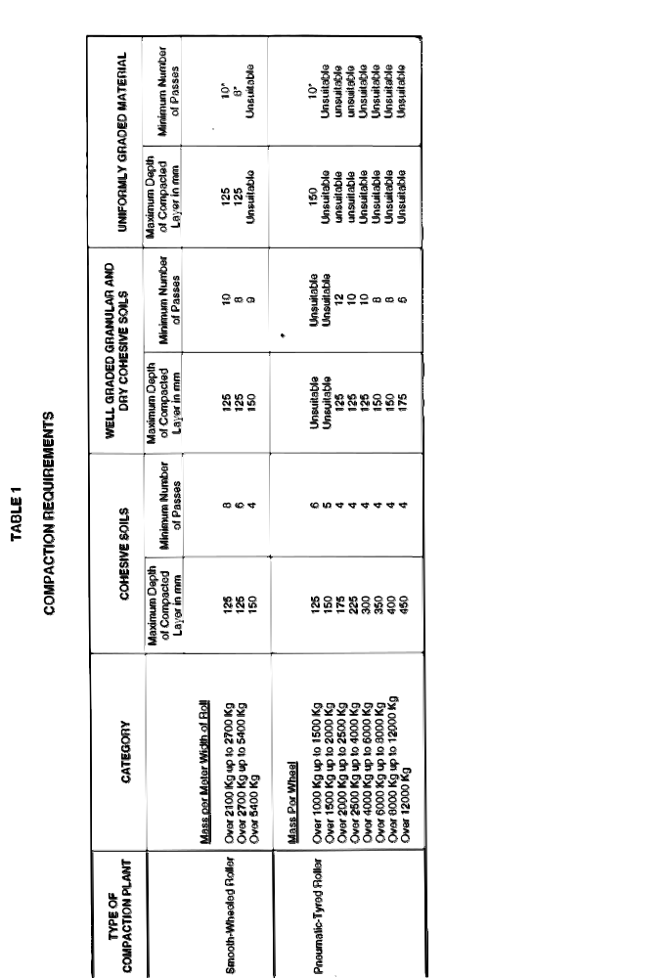

APPENDIX B
Locking System
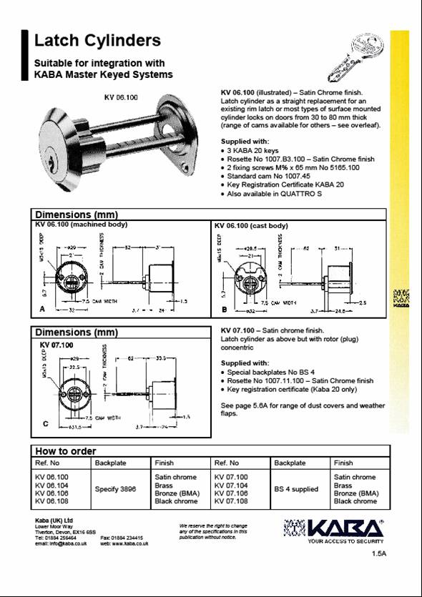

APPENDIX C
2RN Cable marking specification
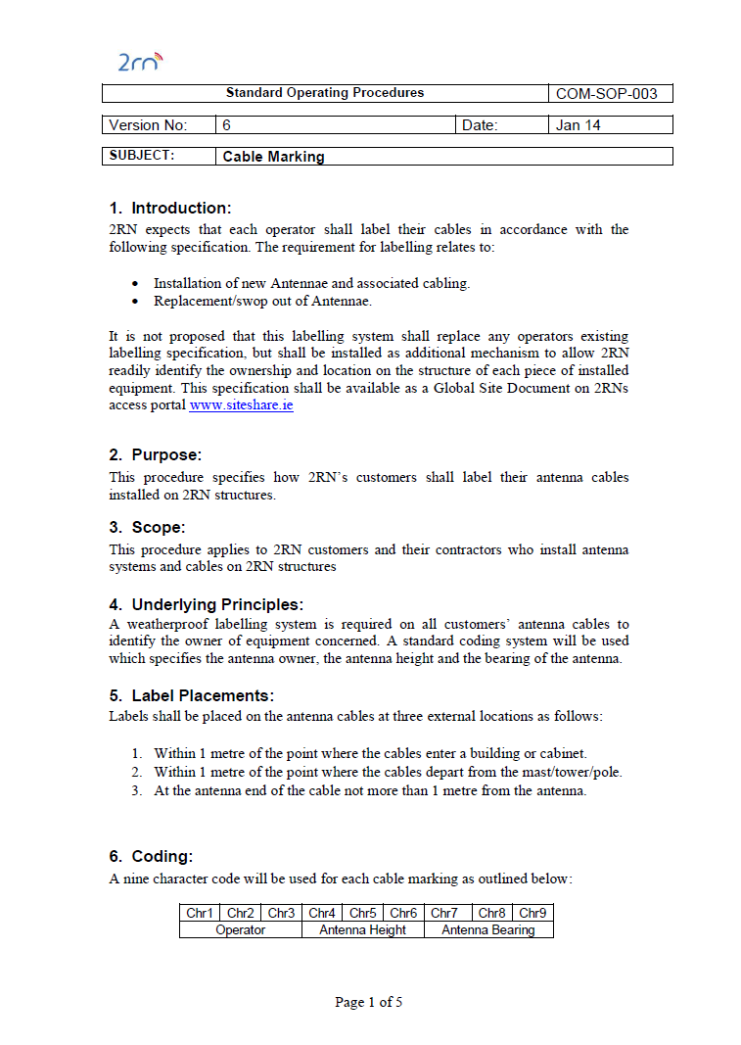
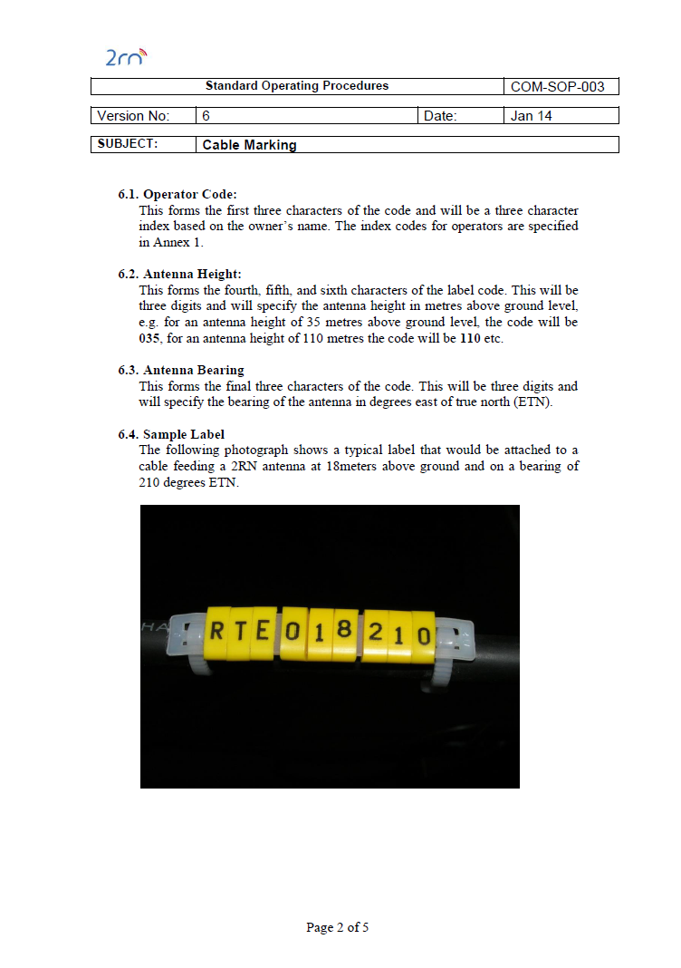

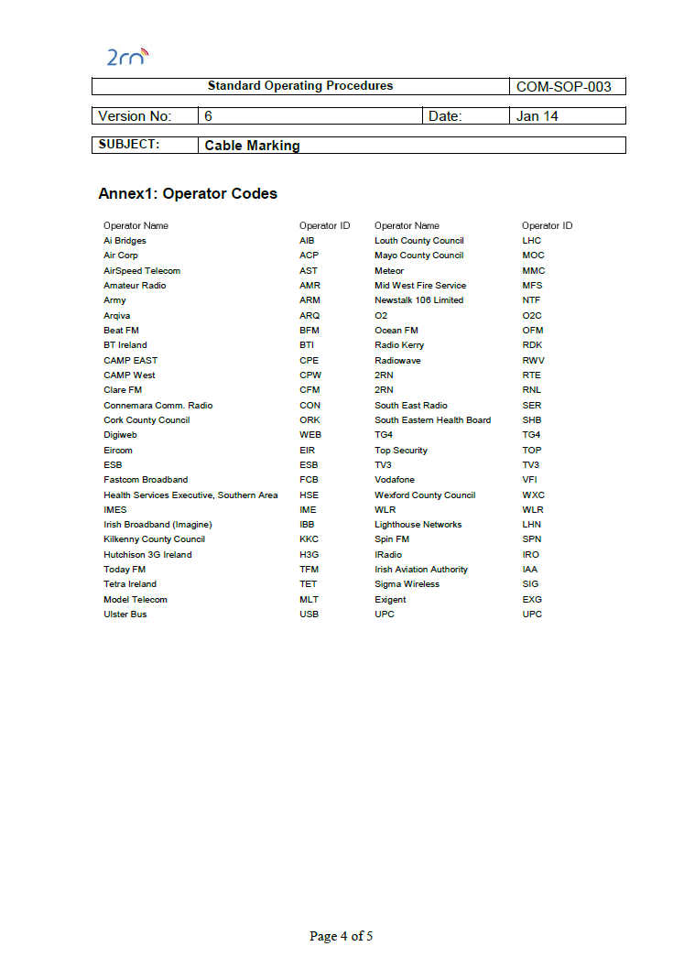
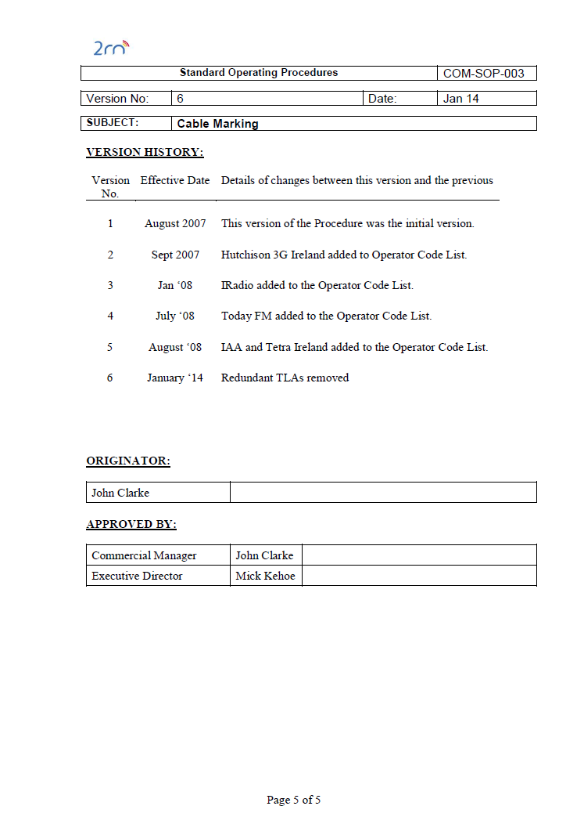
APPENDIX D
Drawings

Tower drawing shown shows a schematic of the required tower. All tenderers shall provide a similar drawing of their proposed tower”

APPENDIX E
Plinth Detail
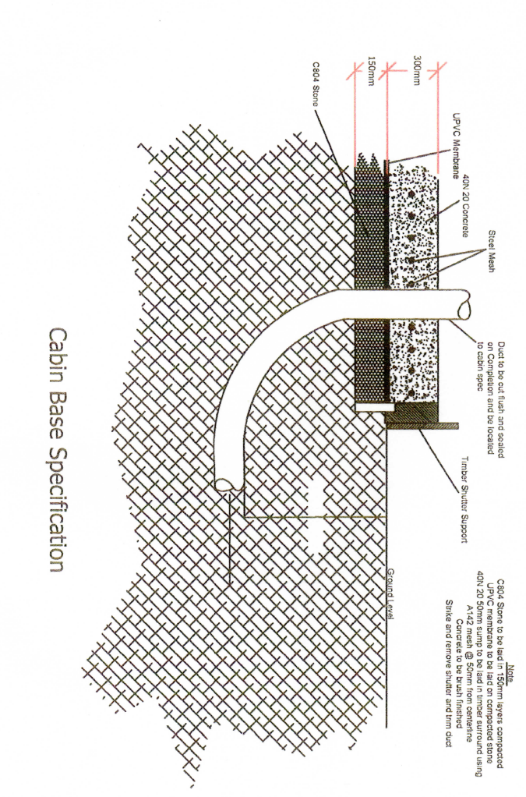

APPENDIX F – Handover Completion Pack

(required for final acceptance)

HANDOVER COMPLETION PACK

SITE NAME:

SITE NO:
SITE TYPE:
PROJECT NUMBER:

Handover Document Contents

Yes No N/A

1. Introductory Pages – Handover Completion Pack/Documents Contents

2. Site Details

3. Copy of Construction File
4. Preliminary Health & Safety Assessment (PSDS)
5. Safety and Health Plan Construction Stage (PSCS)
(Includes Site Specific Method Statement)

6. Site Register

7. Site Completion Checklist

- Safe to Climb Cert (if applicable)

- Earth Test Cert (if applicable)

10. Reci Test Cert (if applicable)

11. Duct Cert (if applicable)

12. Site Photographs
- Concrete Cube Test (if applicable)

- Site As Built Drawings

15. Operational Manual (if applicable)

16. Geotec Report (if applicable)

Section 2 – Site Details

Location/Directions

Site Co Ordinates Easting Northing

Site Provider Phone

Site Details/Structure type

Hazards

Section 3 - Copy of Drawings

Section 4 - Preliminary Health & Safety Assessment (PSDS)

Section 5 - Safety and Health Plan Construction Stage (PSCS)

Section 6 - Site Register

Section 7 - Site Completion Check List

Checklist Contents:

- Site Access/Surrounds
- Cabin – External Check
- Cable Trays/Ladders
- Tower/Structure
- Power Supply

1.0 | Compound, Site Access and Surrounds | Yes | No | Comments
1.1 | Site access complete and in good condition
1.2 | Fence/gate erected, secure and earthed
1.3 | Overall site secure
1.4 | Compound hardcore free from vegetation, debris etc.
1.5 | Special access keys required?
1.6 | Is site clear of all waste material

2.0 | Cabin – External check | Yes | No | Comments
2.1 | Concrete cabin base installed and well finished
2.2 | Cabin bolts in place
2.3 | Any external damage done to cabin before/during installation
2.4 | Is Anti-Oxide compound applied to external earthing points via visual check

3.0 | Cable Trays/Ladders | Yes | No | Comments
3.1 | State what cable tray ladder has been installed
3.2 | Are they installed in a neat manner
3.3 | Are the cables secure/neat
3.4 | Are bends greater than min radius
3.5 | Are the correct materials used  (i.e. remclamps, bolts etc)

4.0 | Tower/Structure | Yes | No | Comments
4.1 | Is there an anti-climb device fitted to the Tower/Structure
4.2 | Is the tower/Structure properly earthed?
4.3 | Is Anti Oxide Compound applied to earthing points
4.4 | Is there a lightening finial installed?  (where applicable)
4.5 | Is there an Aircraft Beacon Light installed and operative (If applicable)
4.6 | Are all bolts installed correctly and properly tightened
4.7 | Are any structural members damaged or missing
4.8 | Is the ladder/fall arrest secure
4.9 | Any damage to the ladder/ fall arrest

5.0 | Power Supply | Yes | No | Comments
5.1 | Is there a power supply?  ESB/Local/Generator  (Please specify in comments block)

Section 8 Safe to Climb Certificate

Section 9 Earth Test Certificate

Section 10 - Electrical Test Certificate

Section 11 - Duct Cert

Section 12 Site Photographs

Pre-Construction

Description

During Construction

Description

Completed Works

Description

Section 13 - Concrete Cube Test

Section 14 - Site As Built Drawings

Section 15 - Operational Manual

Section 16 - Geotec Report

