Document 3 - Specification
Contract for provision of a health coaching-aligned and physical activity coaching programme to people living with obesity complicated by diabetes for the PEACETIME research project

- Background

The Derry GP Federation are a partner in the cross-border PEACETIME project.
The overall objective of the PEACETIME research project focuses on ‘obesity management’ and the overall objective of PEACETIME is the develop and evaluation of a novel integrated cross-border clinical healthcare service model that will increase access to care for people living with obesity complicated by type 2 diabetes mellitus (OBDM).
The project will see Derry GP Federation work with project partners including.
- Ulster University – Lead Partner
- Atlantic Technological University.
- National Institute for Prevention and Cardiovascular Health
The project has also engaged the Irish Coalition for People Living with Obesity to ensure that patient voice and lived experience is reflected in the programme design and delivery. The project team will work with 19 further collaborators across the Island of Ireland including charities, government departments, community organisations, social enterprises and councils.
PEACETIME has been successful in securing grant funding from the European Union PEACEPLUS programme to deliver this cross-border initiative between September 2026 and September 2028.
The PEACEPLUS Programme under which the grant has been awarded is Theme 4 ‘Healthy and Inclusive’ communities.
The specific objective this project will directly contribute towards is IA4.1 ‘Collaborative health and social care – ensuring equal access to health care and fostering resilience of health systems, including primary care, and promoting the transition from institutional to family and community-based care.’
Providers will be appointed will be tasked with contributing towards the following output;
Output | Target | Result | Beneficiaries
Jointly developed solution | 1 | Beneficiaries of jointly developed and delivered health and social care solutions | 5,000 in The Derry GP Federation Area

2. Project overview
The challenge that the PEACETIME research project is addressing is the significant negative impact of the chronic disease of obesity on people, healthcare and societies.
Obesity causes suffering to the individual and poses a major financial burden to the healthcare system and society and the complications of obesity and the current inequitable access to care provides a barrier to people reaching their full potential.
The PEACETIME project is a collaborative cross border research project and the provider who will deliver health coaching aligned and physical activity coaching programmes will operate in this instance in the Derry GP Federation area to develop and evaluate a novel integrated cross border clinical service that will increase access to care for people living with OBDM (Obesity with Type 2 Diabetes Mellitus).
The Derry GP Federation spans Derry City and Strabane, Fermanagh and Omagh, and Causeway Coast and Glens (Limavady) council district. The project will be implemented across this area. Delivery will include a hybrid model of health coaching–aligned and physical activity interventions, comprising one-to-one support sessions and group-based sessions, all delivered through a multidisciplinary team approach.
The overall target of this project is for our multi-disciplinary team to deliver specialist obesity care to 9000 people. 5000 people living in Northern Ireland and 4000 living in the Republic of Ireland. Obesity care for people with OBDM will take place in exclusively in primary care and the community.
Lot1
The Derry GP Federation will manage a tender competition to appoint a provider for the delivery of a health coaching-aligned and physical activity programme that will assist with the delivery of the PEACETIME project in Northern Ireland.
Although the PEACETIME is a cross-border research project and will include work in Donegal, respondents to this tender competition are bidding for delivery of work in Derry GP Federation area only.
3. Tender Specification
The objective of this tender is to appoint an appropriate provider for the delivery of a health coaching-aligned and physical activity coaching programme that will be delivered in conjunction with a wider multi-disciplinary team.
The specification is designed to provide potential tenderers with clarity about the nature and quality of services the Derry GP Federation seeks to procure. Should a procured provider fail to have all necessary registrations in place or to otherwise meet any of the specification requirements at any time, the Derry GP Federation reserves the right to cancel any contract signed with or without notice as it deems necessary

The PEACETIME care pathway below is designed to improve health outcomes for patients living with OBDM through a coordinated, person-centred model of support. By providing timely access to targeted interventions and multidisciplinary support, the pathway aims to support sustainable behaviour change, improve OBDM management, enhance overall wellbeing, and reduce the risk of further health complications. This is a cross-border research programme. The intervention protocols have been co-designed and need to be aligned on both sides of the border.
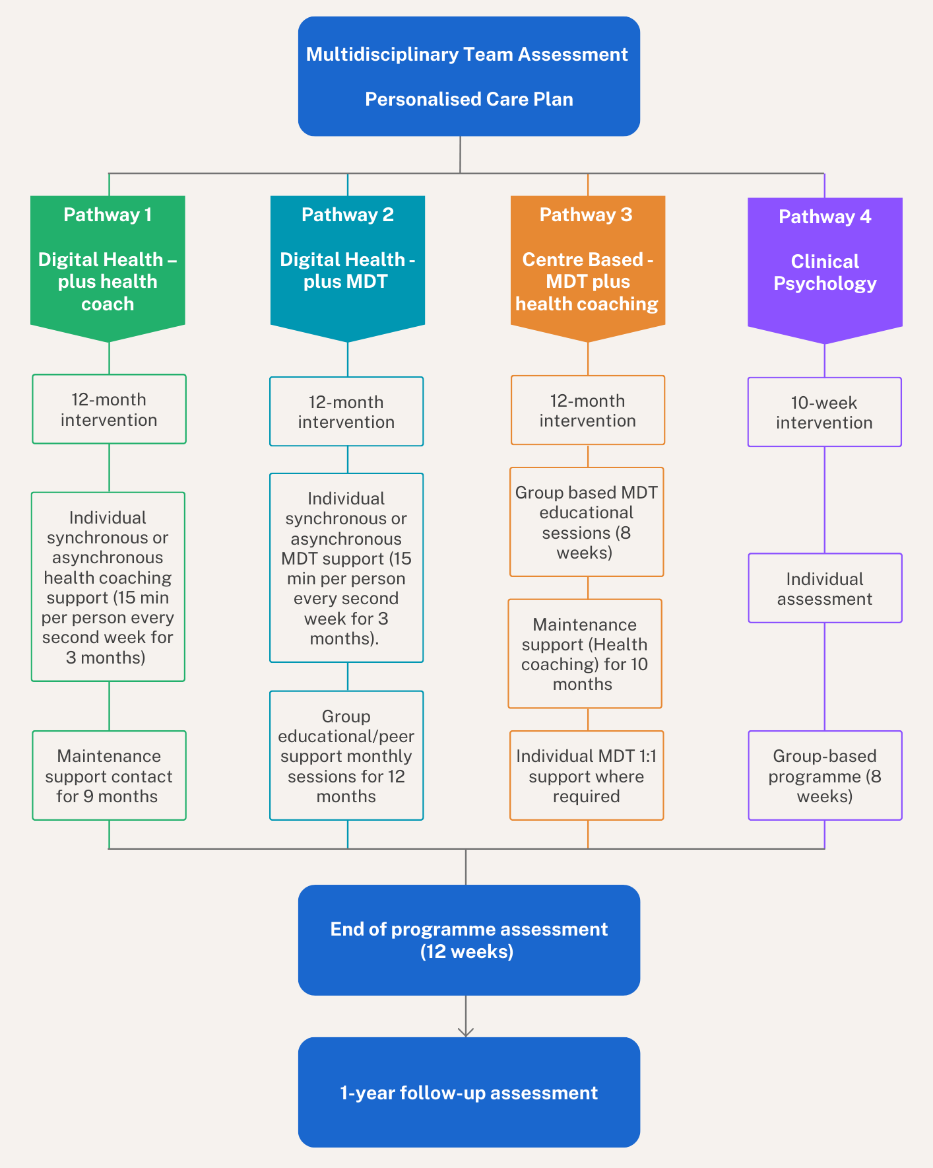

The overarching objectives for the provider are as follows;
- Contribute to the co-design of the clinical programme in Northern Ireland ensuring that the delivery approach, and patient pathways are tailored to local population needs and are aligned with the agreed project outcomes, objectives, and performance measures.
- Improve participants’ physical activity levels and overall health behaviours
- Support sustainable behaviour change through evidence-based coaching methodologies
- Utilise coaching and motivational techniques to help people identify their needs, set goals, and to support sustainable, long-term lifestyle behaviour change
- Through respectful communication and shared decision making, empower people to make informed choices about the management of their condition.
- Ensure a non-judgemental, stigma free environment is provided.
- Facilitate social prescribing by liaising with social prescribing link workers and local voluntary community and social enterprise organisations
- Actively participate in clinical audit and research ensuring efficient collection and management of participant and programme data.
- Under the supervision of the multi-disciplinary team, deliver to a defined protocol, an individual and group-based health coaching & physical activity coaching aligned intervention through in person, digital or hybrid modalities.
- Support prevention and management of long-term conditions with a focus on OBDM
- Deliver measurable health outcomes and social value
- Improve mental wellbeing, resilience, and quality of life
- Provide robust monitoring, reporting, and evaluation mechanisms
- Deliver a high-quality service that demonstrates value for money
- Increase participant engagement and programme adherence

The provider shall provide a comprehensive Health Coaching-aligned support and physical activity support programmes. These interventions will be provided both as (i) one-to-one or group sessions and (ii) in person or online. There is a strong digital health element in the delivery of PEACETIME, so staff will engage with patients through the online digital platform (already procured).

The activities that will be performed include, but not limited to:
- Initial participant assessments
- Individual personalised wellbeing support
- Physical activity coaching and programme planning
- Behaviour changes interventions
- Goal setting and progress tracking
- Group workshops and educational sessions
- Digital engagement and remote coaching
- Monitoring, reporting, and evaluation
- Equality, diversity, and inclusion measure
- Safeguarding and risk management

Digital Health Coaching Platform

The successful provider will be expected to deliver a high-quality, person-centred health coaching service using the PEACETIME digital platform (already procured) as the primary means of communication, documentation and participant engagement.
Providers will be responsible for ensuring that participants are supported to use the platform effectively and that all coaching activity is recorded within the platform in accordance with the study protocol. This will include:

- Conducting an initial face-to-face or virtual start-up coaching session to establish rapport, assess participant readiness for change, agree personalised goals and introduce the digital platform.
- Delivering the allocated coaching intervention (individual, group or asynchronous) in accordance with the agreed protocol and coaching schedule.
- Using the digital platform to document coaching sessions, agreed action plans, SMART goals and participant progress.
- Reviewing participant-entered data and self-monitoring information (e.g. activity, weight, nutrition or other agreed outcomes) to inform coaching conversations.
- Providing timely digital support through secure messaging, behavioural nudges, educational content and motivational feedback as appropriate to the intervention arm.
- Monitoring participant engagement with the platform and taking reasonable steps to re-engage participants who disengage from the intervention.
- Supporting participants with any practical issues relating to use of the platform and escalating technical issues where appropriate.
- Maintaining accurate and contemporaneous records within the platform to facilitate clinical oversight, audit and evaluation of the intervention.
- Participating in multidisciplinary discussions and communicating with the wider PEACETIME team where required to ensure safe, coordinated participant care.
- Delivering ongoing maintenance support following the intensive coaching phase, including scheduled digital contact and facilitating access to ongoing coaching where specified within the protocol.

Providers will be expected to demonstrate competence in behaviour change coaching, digital communication and person-centred care, and to work within all relevant governance, information governance and safeguarding requirements. Training in the PEACETIME intervention protocol and digital platform will be provided prior to commencement, and providers will be expected to adhere to the standardised intervention model to ensure consistency across the programme.

The provider will be expected to respond to participant messages submitted through the platform within two working days, maintain high levels of participant engagement, complete all required documentation contemporaneously, attend mandatory training and supervision sessions, and participate in quality assurance processes, including audit of coaching records and fidelity to the intervention protocol.

The provider will also be expected to deliver a health coaching aligned programme, personalised well-being and behaviour change interventions, that may include but are not limited to:
- Motivational interviewing
- Lifestyle assessment
- Behaviour change techniques
- Goal setting and action planning
- Ongoing progress reviews
- Confidence and self-efficacy building
- Group-based activity sessions where appropriate

The provider shall deliver structured physical activity support including but not limited:
- Baseline activity assessment
- Personalised activity plans
- Safe exercise guidance
- Community and home-based activity options
- Digital fitness support
- Group-based activity sessions where appropriate
- Monitoring of participation and outcomes

An integral part of this project will see the provider work closely as part of the Derry GP Federations PEACETIME multi-disciplinary team (MDT). The provider shall demonstrate ability to:
- Collaborate effectively with project psychologists, dietitians, nurses, GPs and other relevant stakeholders
- Liaise with Ulster University, the Atlantic Technological University and The National Institute for prevention and Cardiovascular health and participate in any necessary training and onboarding sessions to ensure understanding and effective use of their bespoke platform.
- Demonstrate experience and capability in the co-design of health and wellbeing programmes, engaging relevant stakeholders to develop and implement services that achieve agreed outcomes
- Participate in MDT meetings and case discussions where required
- Contribute to the development of care pathways where appropriate
- Escalate participant concerns appropriately in line with defined project governance and safeguarding procedures
- Contribute to shared outcome reporting and service improvement initiatives

The provider will be expected to meet a number of service requirements:
- Be operationally ready to deliver the intervention in the Autumn of 2026
- Employ appropriately qualified and trained and vetted personnel
- Maintain professional indemnity/insurances and public liability insurance
- Provide appropriate space for staff to work from, including one-to-one or group sessions with patients in a variety of settings (i.e. gym/exercise space).
- Ensure all safeguarding procedures are in place.
- Comply with all data protection obligations including GDPR.
- Comply with project reporting requirements
- Operate quality assurance and continuous improvement processes
- Provide the Derry GP Federation with any requested assurances.
- The Provider shall achieve any Key Performance Indicators (KPIs) specified by the Contracting Authority and shall monitor, measure and report performance against these throughout the duration of the Contract.

Providers wishing to be appointed following this tender competition must provide details of the following:
Staffing
- Organisation structure
- Professional and vocational qualifications for those involved in this project*
- Governance arrangements
- Arrangements for training and continuing professional development.
- Staff supervision arrangements
- Capacity and resource availability.
- Arrangements in the event of staff sickness absences.
- Evidence of professional indemnity/insurances and public liability insurances
- Valid Access NI checks for all staff involved in the delivery of the project
The Provider shall ensure that staff sickness, annual leave, vacancies or other planned or unplanned absences do not materially interrupt service delivery. The Provider shall maintain appropriate contingency arrangements and provide suitably qualified replacement staff within agreed timescales to ensure continuity of the Service and achievement of all contractual requirements.
Practitioners delivering the service should possesses appropriate qualifications, professional experience of delivery and competencies relevant to health coaching/behavioural change support/wellbeing improvement and physical activity delivery
Relevant qualifications and experience may include, but are not limited to:
- Behaviour change methodologies
- First Aid
- Motivational interviewing
- Exercise referral
- Community wellbeing delivery
- Long-term condition management
- Safeguarding and risk assessment
- Allied health and rehabilitation experience
- Accredited health coaching, wellbeing, lifestyle, or physical activity qualifications
Providers will be expected to demonstrate robust systems for the following:
- Safeguarding vulnerable adults
- Risk assessment
- Incident reporting
- Health and Safety
Providers must comply with all relevant legislation relating to data protection and information governance and they must demonstrate how they comply with the following:
- Data storage arrangements
- Cyber security measures
- Retention and deletion policies
- Incident response procedures
Provider will be expected to provide the Derry GP Federation with the following information with regards to reporting requirements.
- Monthly operational and performance reports & variance management
- Monthly Strategic meetings
- Weekly implementation updates
- Annual evaluation reports
- Outcome and impact analysis
- Equality and demographic reporting
- Quarterly financial and utilisation reporting in order to process financial claims to SEUPB
- Case studies
- Appropriate participant feedback

