Clarifications
MI-CFT26-036 Call for Tenders for the provision of Seismic Data Processing Services

No. | Date | Questions | Date | Answers
1 | 17/09/26 | You state total line km to be processed will be specified after survey completion but will be about 1500 line km. The document states though that the survey completed on 10/09/26. Can you therefore please state  - Total line km to be processed?  - How many individual lines are in the dataset? | 21/09/26 | - 1409 line km are to be processed  - 67 lines require processing
2 | 17/09/26 | Most of the document, especially tow depths, implies the data is UHRS using sparker. However, the source is described in the table under "Survey Operations Information" as ether sparker or air gun. Can you please be explicit and say how many lines would be using either source if indeed air gun was deployed. | 21/09/26 | All lines were acquired with sparker.
3 | 17/09/26 | From the first paragraph on page 19 starting "2D Multichannel UHRS data were acquired..." there is implication that at least some of this data has already been processed. If so we have some queries on this.  - Would it be possible to see an example of one of the lines as either a QC stack, processed stack or migrated image?  - Will the processed images be available including any velocity model derived from them at the start of the contract?  - Will these lines be included in the processing or subsequent reprocessing? |  | 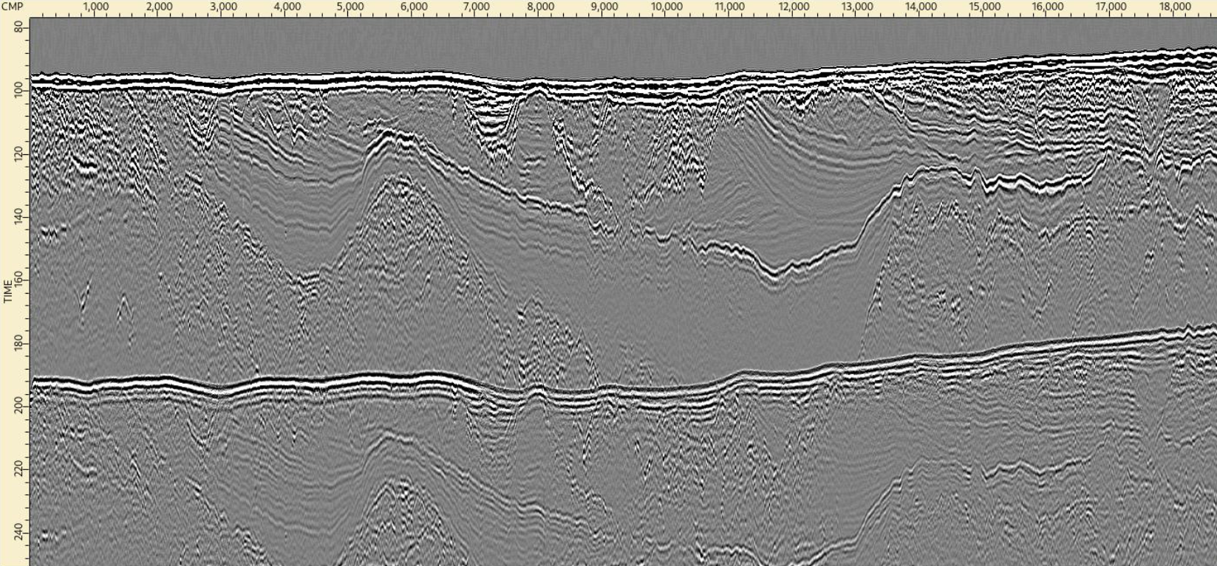  QC Brute Stack
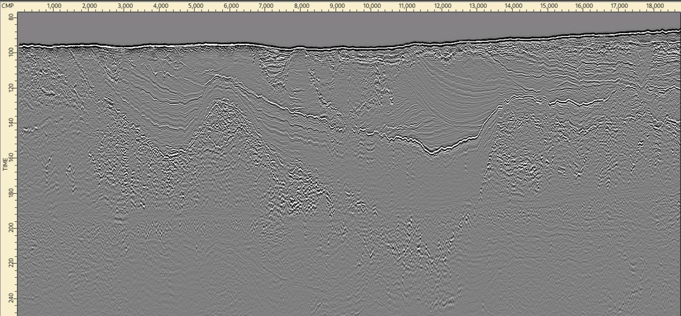
Processed Stack
 |  |  |  | Q2 & Q3 – Data will be provided for the UHRS data that are to be processed. Data, images or velocities will not be made available for lines that do not require processing.
4 | 17/09/2026 | Please expand on the acquisition parameters used for the survey. Specifically advise what was the recording sample rate in ms. |  | The first 25 lines acquired had a record length of 250 ms, which was increased thereafter to 300 ms for all subsequent data acquisition. Trigger rate was set to distance @2m intervals. The streamer channel interval was 2m.  The recorder sampling rate was 0.125 ms.
5
6
7
8
9
10

