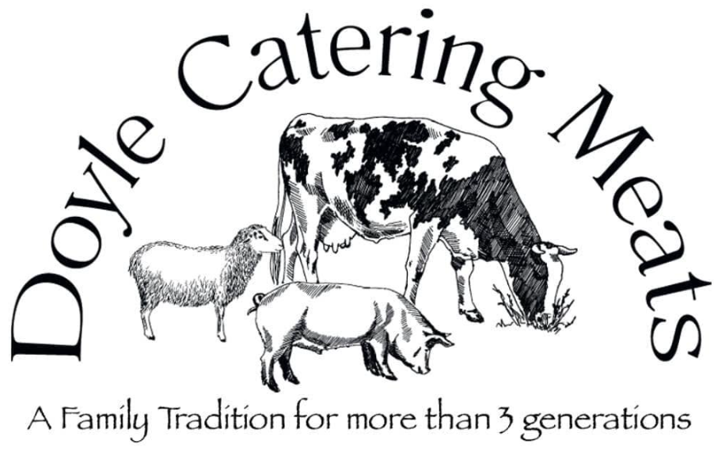

REQUEST FOR QUOTATION

Doyle Catering Meats

LOT 2

Automatic Burger Forming Machine

September 2026

ORGANISATION DETAILS
Doyle Catering Meats is an Irish meat processing business supplying high-quality fresh meat products to the catering, foodservice and retail sectors. The company is committed to producing products that meet the highest standards of food safety, quality, traceability and customer service.
As part of its ongoing investment programme, Doyle Catering Meats is seeking to modernise and improve production efficiency, product consistency and operational performance through the procurement of new equipment.

OUTLINE PROPOSAL
Doyle Catering Meats invites suitably qualified suppliers to submit quotations for the supply, delivery, installation and commissioning of an Automatic Burger Forming Machine for use within its meat processing facility.
We are seeking competitive quotations from suppliers offering equipment that meets the functional and performance requirements specified below. Suppliers may offer equipment from any manufacturer provided it meets or exceeds the minimum specification.
Proposals shall include:
- Supply of all equipment.
- Delivery to site.
- Installation and commissioning.
- Operator training.
- Full technical specification for each item offered.
- Warranty details.
- Delivery lead time.
- Details of after-sales service and maintenance support available in Ireland.
- Availability of spare parts.
- Total purchase price excluding VAT.
- Optional accessories or extended warranties (clearly identified as optional).

TECHNICAL SPECIFICATION: Automatic Burger Forming Machine
Minimum Requirements
- Commercial automatic burger former.
- Minimum production capacity approximately 2,000 burgers per hour.
- Consistent weight and diameter control.
- Stainless steel construction.
- Hopper capacity approximately 75 litres.
- Supplied with forming drum approximately 120 mm diameter (or equivalent).
- Extended discharge conveyor.
- Automatic wire cleaning system.
- Automatic paper interleaving attachment.
- Easy dismantling for cleaning.
- CE certified.
- Installation, commissioning and training included.

General Requirements
All equipment supplied shall:
- Be new and unused.
- Be CE marked.
- Be suitable for commercial food production.
- Comply with all current food hygiene and machinery safety legislation.
- Include operating manuals in English.
- Include installation, commissioning and operator training.
- Include a minimum 12-month warranty.
- State recommended maintenance requirements.
- State availability of spare parts.
- State delivery lead time.

BUDGET
All tenders to be submitted in Euros. Unquantified costs will not be accepted. It is expected that the tender will not exceed €40,000.00 inclusive of any VAT and associated costs.

EVALUATION CRITERIA:
The tender evaluation committee will award the contract to the Most Economically Advantageous Tender (MEAT), based on the following award Criteria:
Criterion | Weighting % | Minimum Required*
Experience of the tenderer including their expertise and qualifications | 20% | 10%
Meeting the technical specification | 35% | 15%
Cost (Incl. VAT, fees, expenses, and incidentals) | 45% | N/A

* Failure to meet the minimum requirement in any category will result in automatic elimination from the competition.
For Full Transparency and clarity, please note the below scoring mechanism and rationale will be operated by the Project Promoter for non-cost criteria.
Score | Interpretation
81% - 100% of the marks | Excellent response that fully meets or exceeds specification and provides comprehensive and convincing assurance that the Tenderer will deliver to an excellent standard.
61% - 80% of the marks | A very good response that demonstrates real understanding of the specification and provides convincing assurance that the Tenderer will deliver to a very good or high standard.
51% - 60% of the marks | A satisfactory response which demonstrates a reasonable understanding of the specification and gives reasonable assurance of delivery to an adequate standard but does not provide sufficiently convincing assurance to award a higher mark.
1% - 50% of the marks | A response where reservations exist. Lacks detail and does not provide confidence that the required services will be successfully delivered.
0 | No response or partial response only and poor evidence provided in support of it, failure to meet the specification.
Cost score | 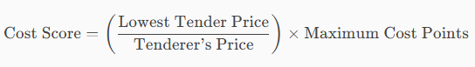

INSTRUCTIONS TO TENDERERS

Tenders must include ALL of the following items as part of their Tender submission:
- Name & contact details of individual/organisation submitting the tender.
- Details of qualifications & experience of the Tenderer.
- Confirmation of ability to provide up-to-date Tax Clearance Cert.
- Confirmation of ability to provide insurance.
- Quote Validity Period (it is assumed that the validity period on Quote prices is six months).
- Access to view site by arrangement only. Please contact Alex at alex@doylecateringmeats.com.
- Queries and clarifications you may have in relation to this Request for Quote can be accepted by email up to 02/10/2026. Please be aware, that we are obliged to share clarification questions and responses with anyone who has expressed an interest in quoting.
- Tenders which are considered to be incomplete will not be evaluated.
- Access to view the site / building by appointment only. Please contact Alex on alex@doylecateringmeats.com, by 02/10/2026
- Closing Date for receipt of Quotes is: 16/10/2026.
- The onus is on the tenderer to ensure that their tender is delivered by the date specified.
- The quote must include the VAT rate, the date and quote number.
- For any other queries, please contact Alex via alex@doylecateringmeats.com.

Non-resident suppliers/contractors must also provide an Irish Tax Clearance Certificate. Further guidance on Tax Clearance for non-residents is available on the Revenue website at Non-resident applications (revenue.ie)

