


Brief For Appointment of Design Team under the Additional Accommodation Scheme
for

Scoil Phobail Sliabh Luachra
Rathmore, Co. Kerry
Roll no. 91504R

IGD-002-v7 Issue 1 Date 13/12/2023

BRIEF FOR APPOINTMENT OF DESIGN TEAM UNDER ADDITIONAL ACCOMMODATION SCHEME
Scoil Phobail Sliabh Luachra
Roll no. 91504R

Primary School  (Put an “X” in the box as appropriate.) |  |  | Post Primary School  (Put an “X” in the box as appropriate) | X
Special School
(Put an “X” in the box as appropriate)

FORM TO BE COMPLETED BY SCHOOL AUTHORITY

Section 1: School Details

1.1 School Details
School Name (As registered on DoE web) : | Scoil Phobail Sliabh Luachra
Address (1): | Rathmore
Town-land: | Rathmore
Town/City:
County: | Kerry
Eircode | P51PR53
Principal: | Denis Kerins
School Phone: | 0647758135
School e-mail: | admin@spslrathmore.ie
Patronage: | KETB and CEIST
School ownership: | Minister of Education

1.2 Enrolment & Staffing Levels
Current Enrolment: | 420
Staffing Levels: |  |  | Date: 6 – 12- 2023
Whole time/Permanent | 33.09
Part-time/Resource [including hrs] | 1.15
Special Education [including hrs] | 2

1.3 Upgrading/refurbishment & rental accommodation records
Details of upgrading/refurbishment work in last 10 years :

Under SWS :  (Scope, expenditure, year completed, etc.) | In the past 10 yrs all prefabricated buildings replaced with 3 phases of devolved grants.  Most recent SWS (2020) finished Feb2023 insulation off flat concrete roof of 1962 building of 6 classrooms. The roof of the 1998 building was redone and insulated as part of a previous SWS grant.  All these improvements to date were in region of €1,500,000.
Other :  (Including Asbestos and Radon remediation) | All school roofs now insulated.
Details of rental accommodation:
Number of teaching spaces and type : | None
Rental started: | N/A

Section 2: Site Details

2.1 Site
Ownership of site: | Minister of Education
Size of Site: | Approx.
Comment:  (e.g. shape- long/narrow/irregular, etc.) | Irregular in two sections.
Is Additional Land Required: | no
Is Additional Land available: | N/A

2.2 School Boundary & Road Frontage Details
General Description: | School off main road no road frontage, boundary fence marks boundary.

2.3 Traffic Management/Parking
Details of existing Traffic system (general commentary): | Traffic busy at start and school finish times. Bus turntable and set down area available.  Parent / car dropping off area available by current entrance.

2.4 Play Areas
Hard play areas (general commentary) | Two outdoor basketball courts.
Is it necessary to locate extension over existing play areas? | Possibly some play area may be required.
Does the School have Playing Pitches (soft)? | Two playing fields.

2.5 Ground Conditions/Topography
General Comment :  (Implications for current Project and in particular restrictions on possible locations for extension) | Sloping site different levels where indicated in appendix B probably on top of the last existing extension which would also bring it out at ground level to existing car park would be more suitable.
Surveys/Sub-soil Investigation | To be procured by the Design Team. The cost of surveys to be funded by DoE

2.6 Site Drainage & Service Utilities
Foul Water Drainage: | Septic Tank? (Yes/No) No
Foul Water Drainage: | Percolation Area? (Yes/No) No
Foul Water Drainage: | Public Foul Sewer? (Yes/No) Yes
Surface Water Drainage | Public Sewer? (Yes/No) Yes
General commentary on main services: | The Design Team to assess capacity of existing main services, e.g. gas, water, electricity, fire main, etc.

2.7 Site Plan
Include School Site Plan showing all buildings (With Number of Storeys) in Appendix B.

Indicate location of all prefabs on the site and also which are to be removed as part of this project.

Indicate the extent of the School site with a red line.

Section 3: Building Fabric Details
(Generally not relevant to Additional Accommodation Scheme.)

Section 4: Building Services

4.1 School Building(s) Building Services: Information as supplied by the School
Existing Heating systems | 1. | Oil | Yes
Existing Heating systems | 2. | Gas | Yes
Existing Heating systems | 3. | Electricity | No

Additional information in relation to building services
The Design Team to assess the capacity of all main services.

Section 5: Summary Technical Recommendations

5.1. Planning, Site & Building Recommendations
    - General Description of School and Site
School building off main road sloping site,

    - The Brief for the Project
The Brief for the project is to design and procure additional accommodation for the school as set out in the Schedule of Accommodation in Appendix A.
Except where the accommodation to be provided is for Special Needs, the accommodation is to be designed as a standalone extension. Where possible the extension should be located in a way that will facilitate a future enclosed link to the existing building.
In the case of Special Needs Accommodation the design should provide for enclosed linkage to the main circulation in the existing building. The accommodation for pupils with Special Educational needs (SEN) should be located, and designed in accordance with the requirements of TGD 026, and its addendums.
Where room for expansion is severely limited a multi-storey option must be considered.
The Design Team shall also
- Review car parking and set down arrangements to incorporate any adjustments necessitated by the new building.
- Where the project includes the replacement of prefabricated buildings with permanent accommodation, include for removal of prefabs and reinstatement of the disturbed area.
- Consider, in consultation with the School Authorities, how further expansion of the school can be accommodated and indicate at Stage 1 how this can be achieved. As part of this process, design teams will be required to provide a masterplan of relevant areas of the school site to indicate where future development could take place. This will be helpful in informing decision-making into the future. A separate masterplan drawing will be required to be submitted as part of the formal Stage 1 submission.
- Ensure that the established development standards (ie; space separation distances, etc) in the relevant county development plan are adhered to.
The project will be developed in full accordance with the following standards and regulations, current at the time of tendering, which will all apply to this project:
- Department of Education Design Team Procedures and associated Practice Notes.
- Department of Education Technical Guidance Documents (available on the Department website at www.education.gov.ie).
- The Building Regulations (including Part L 2017).
    - Purpose of the Brief
- This Brief document is intended to inform the appointment of a full consultancy Design Team including Architect, Civil/Structural Engineer, Building Services Engineer, Quantity Surveyor and Project Supervisor Design Stage.
    - Project Governance and Communication
- A Stage 1 submission to the Department of Education and a project review meeting in Tullamore, attended by the School Authorities and the Design Team, will be required at the end of Stage 1 when the Brief has been analysed and options for the development (including estimated costs) have been considered and prepared. After Stage 1 the responsibility for the delivery of the project within the available funding will rest with the Board of Management/School Authority and the Design Team.
- While the normal project stages detailed in the Design Team Procedures stages apply to this project (i.e. Stages 1, 2a, 2b, 3, 4, and 5) the fee payment stages are based on the milestones described in the Forms of Tender and Schedule B (which is attached to the Standard Conditions of Engagement for Consultancy Services).
- At three points before commencing construction, written approval from the Department to move to the next stage is mandatory. As this is a devolved project, it is the responsibility of the Design Team in consultation with the School Authority to ensure compliance with these stages.
These stages are:
- A Stage 1 – Preliminary Design Stage Report in compliance with the Design Team Procedures must be submitted to the Department. A meeting in Tullamore with the Design Team and the School Authority will be required to discuss the submission and agree any adjustments to the brief and the project budget.
- A Stage 2A Cost Plan, updated to include any cost implications arising from planning conditions, must be submitted within 5 working days of the date of the Notice of Intention to Grant Planning Permission. This Cost Plan must be accompanied by an Architect’s Report with commentary on the planning conditions as it may be necessary to issue an appeal to An Bord Pleanála in relation to any conditions that are considered to be unreasonable or particularly onerous before completing the tender documents and seeking tenders for the project.
- When tenders have been obtained for the construction works a Tender Report must be submitted and approval to proceed obtained in writing from the Department before accepting a tender/placing a contract and commencing construction.
- Apart from the above three mandatory interactions, there is an onus on the Design Team to inform the School Authority of any significant deviation from the approved brief and budget at any stage in the project and a corresponding onus on the School Authority to inform the Department.
- The DT shall develop appropriate architectural options to demonstrate the optimal expansion of the school in accordance with the Schedule of Accommodation. The final composition of the buildings on the site layout shall be developed to ensure coherent legibility of all buildings on the site while delivering a contemporary educational facility.
- The DT shall apply, in consultation with the school authority, the recommendations contained in this Brief within in the target floor area limit stated in the Schedule of Accommodation.
- The schedule may not include a floor area allowance for vertical circulation. Any floor area associated with this will be agreed with the DoE Planning & Building Unit (PBU) at Stage 1 with identification of the preferred design option. Any such floor area, including interface area, is deemed included in the fee proposed.
- A pre-planning meeting with the Planning Department of the Local Authority should take place prior to the Stage 1 meeting.
    - Specialist Surveys
- The coordination, procurement and interpretation of the specialist survey related data and services will be a function of the DT (sponsoring consultant) as will the development of any appropriate design strategy. The tendered cost of the surveys themselves will be paid for separately by the DoE as per the DoE DTPs. Anticipated specialist surveys for this project include:
- Topographical Survey
- Sub-soil Investigation
- Traffic safety audit (Stage 1-3) and mobility Management Plan (only if indicated as a requirement by the Local Authority at the pre-planning meeting)
- Asbestos Survey (if relevant)
- Architectural Heritage Impact Assessment (if relevant)
- Any other surveys shall be defined and justified by the Design Team.
- The DT shall address any design and programme risks arising from the early consultation with the Planning Authority (PA) and the preparation and commissioning of any reports necessary in support of these consultations. These reports should form part of the Stage 1 process, as appropriate, and should be accompanied with recommendations.
    - Maintaining Existing School in Operation
- The DT shall develop an appropriate construction phasing and execution plan during design development to optimise delivery of the project while maintaining the existing school in operation in situ during construction. Additional temporary accommodation shall be avoided, or where shown to be necessary, shall be kept to an absolute minimum.
- Where temporary accommodation is unavoidably required for decant purposes, the DT will be responsible for quantifying the amount needed, in consultation with the school authority and obtaining statutory compliance (Planning Permission, Building Regulations, Health & Safety, BC(A)R including acting as Assigned Certifier) associated with the temporary accommodation element of the project as part of their overall service
- Where the Schedule of Accommodation identifies Interim Temporary Accommodation to be provided ahead of the permanent extension, the DT will be responsible for obtaining statutory compliance (Planning Permission, Building Regulations, Health & Safety, BC(A)R including acting as Assigned Certifier) and the fees for the provision of this accommodation will be calculated as described in the Letter of Invitation to Tender.
    - Specific Requirements with regard to Siteworks
- The DT will be required to review car-parking, set down area and hard play areas. Any parking or hard play areas displaced by the new building shall be replaced.

    - Alternative Options and Optimum Scheme
- The DT will be expected to develop the project in line with the recommendations herein. If, during architectural planning an alternative solution, or solutions, become apparent the DT shall develop such alternatives for comparison purposes, in consultation with the school authority, and present them along with the options herein.
- The DT will be expected to develop design options to Stage 1 of the current DoE Design Team Procedures (DTP-2012), in accordance with DoE Technical Guidance Documents (TGD’s), National Building Regulations, and project norms. Optimum design solution to be agreed at Stage 1 and developed through the remaining DTP stages, in accordance with DoE Technical Guidance Documents (TGD’s), National Building Regulations, Local Authority Planning & Development Guidelines and project norms generally.
    - Visiting the Site
- Tendering Consultants are advised to visit the site and familiarise themselves with the issues before submitting a tender.
    - Specific Requirements – Compliance Pack Submission
- Upon Substantial Completion and at project handover, the DT is required to provide to the Employer/ Client, in duplicate, the following;

- Property Registration Authority compliant Folio & Map of the school site
- Grant of Planning Permission
- Relevant Certificates of Compliance with Planning (Architects & Engineers)
- BCAR Certificate and evidence of registration with Building Control Authority
- Fire Safety Certificate
- Disability Access Certificate
- BER Certificate & Advisory Report
- Substantial Completion Certificate

Please Note: Only original documents will be accepted for all of the above.

In all cases original documents will be issued to the Client/property owner and the duplicate copies issued to the Department of Education (if the minister not the Client/property owner) or School Board of Management (if the School/patron is not the Client/property owner).

Payment of final Stage 4 Professional Fees will be contingent on the provision of all of the above documentation.

5.2 Building Services Recommendations
    - General Brief for Building Services
- M&E building services for the proposed project shall comply in full with the Department’s TGDs and the Building Regulations.
- As part of the Stage 1 report the Building Services Consulting Engineer shall include proposals on options to provide mains services (heat, power, water, etc.) to the new accommodation. Options shall include advantages and disadvantages, and cost implications of (i) extending the existing heating system to service the new accommodation or (ii) providing a standalone heating system to service the new accommodation. Rainwater recovery and cold water storage shall be similarly considered in the context of extending existing systems or providing new.
    - Deviations from TGDs
- Where deviations from the TGDs are proposed they must be identified, commented on together with an indication of any associated costs and justified by both the school authority and the DT at the Stage 1 meeting with the DoE Technical Staff. A decision will be made at this meeting on whether or not to revise the M&E brief to include these works.
    - Daylighting and Overheating
- Responsibility for compliance with the DoE norms for daylighting and overheating as outlined in the DoE TGDs will lie with the Architect on the DT. The Building Services Consulting Engineer will be expected to assist him or her on these matters and should allow for providing any necessary modelling of daylight and overheating calculations
    - Works to Existing Buildings
- No work to be undertaken to the existing M&E services except for
- Linking of life safety and protection systems, PA system and Wi-Fi system to the new building.
- The Building Services Consulting Engineer will be expected to survey the site with a view to identifying any existing underground M&E services.
- Liaise with the local ESB at an early stage in the design process regarding the adequacy of the existing supply to serve the new building.
- Assess the location of the existing ESB meter and main switchboard location in relation to any proposed new buildings and comment on their suitability.
    - Existing ICT equipment in accommodation being demolished, e.g. Prefabs.
- The school authority will be responsible for disconnecting any existing ICT equipment (such as data projectors/interactive whiteboards and other ICT equipment) in accommodation to be demolished (e.g. in prefabs). It will also be responsible for its installation in the new school building. All works associated with this will not form part of the building contract.

Signed on behalf of the Board of Management / Trustees / School Authority | Denis Kerins. Principal | Date: | 30-01-2024

Appendix A
Schedule of Accommodation
Scoil Phobail Sliabh Luachra, Rathmore, Co. Kerry
ROLL NUMBER 91504R
SCHEDULE OF ADDITIONAL ACCOMMODATION
Description of Space | No. of spaces | Area (m²) | Total Area
Special Needs Accommodation
Central Activities Space |  | 80.0 m2
Classroom - Safe Base |  | 70.0 m2
Classroom - Safe Base |  | 70.0 m2
Toilets and Shower Area |  | 20.0 m2
1 x Toilet / Shower for Assisted Users
1 x Independent Use
1 x Ambulant Disabled
Quiet Space 1 |  | 12.0 m2
Quiet Space 2 |  | 12.0 m2
Multi-Activity Room |  | 20.0 m2
Practical Activity Room |  | 50.0 m2
Daily Living Skills |  | 15.0 m2
Staff Toilets |  | 10.0 m2
Storage |  | 25.0 m2
Cleaner Store / Linen / Sluice |  | 5.0 m2
Office |  | 20.0 m2
Sub Total |  | 409.0 m2
Internal Walls & Partitions 7% |  | 28.6 m2
Circulation 21% |  | 85.9 m2
SUB-TOTAL |  |  | 523.5 m2
Staircases  (assume two storey, 25m2 per stairs per floor) | 0 | 50.0 m2 | 0.0 m2
Lift  (assume two storey, 10m2 per stairs per floor) | 0 | 20.0 m2 | 0.0 m2
Vertical Circulation to be agreed at Stage 1 if required.
GROSS FLOOR AREA |  |  | 523.5 m2
GROSS FLOOR AREA (Rounded Off) |  |  | 524.0 m2
External
Secure Soft Play area (accessible from Classroom) 50m² per Class Base | 2 | 50.0 m2 | 100.0 m2
Sensory Garden | 1 | 100.0 m2 | 100.0 m2
Parking spaces |  |  | 6

This schedule of accommodation is considered to be the optimum provision for this project and assumes reasonable building and site conditions. Where the Design Team can demonstrate that these conditions do not exist, a pragmatic, cost optimal approach will have to be taken, which may result in adjustments to the above schedule. Any adjustments proposed must be detailed and explained in the Stage 1 submission. In all cases the Department will have the final say, and where adjustments are required and approved this will be confirmed in the Stage 1 approval. Where the site constraints are so great as to severely compromise the provision of the required additional accommodation, a pre-Stage 1 submission to the Department may be required in order to avoid unnecessary abortive design work.

Please Note: Due to the restricted nature of the site, the DT will be required to explore all possibilities for providing the required additional accommodation on site while also maximising the available play space on site.

Some of these options are (but not limited to);
- Provide the additional accommodation in a single storey attached extension as indicated at Appendix B below.
- Provide the additional accommodation in a first floor extension over the existing single storey section of the existing building to the rear of the school.
- Re-designation of existing mainstream Ground Floor accommodation to provide the SEN Base and construct a first floor extension, over the existing single storey section of the existing building to the rear of the school, to accommodate the all displaced existing accommodation.
- Re-designation of existing mainstream Ground Floor accommodation to provide the SEN Base and construct a standalone 2 storey extension to accommodate the all displaced existing accommodation.

Should the DT select an alternate option to option 1 above as the preferred option, the DT will be expected to provide clear justification for doing so, including detailed estimated costs taking into account site specific abnormal works, within their Stage 1/2a submission.

Any necessary demolition and suggested future use shall be reconciled on the Department of Education standard floor area reconciliation sheet or modified as necessary to track the demolished/ replacement and re-designated spaces accurately and properly.
https://www.education.ie/en/School-Design/Procedures-and-Cost-Plans/

FACTORS TO BE TAKEN INTO ACCOUNT BY THE DESIGN TEAM

Factors to be taken into account by the Design Team in the development of this project and reflected in the Notional Capital Value.
(identified based on a desktop study)
- Single Storey Attached Extension
- New SEN Base setdown area
- SEN Base Parking catered for within confines of existing site
- Existing Ball Court to be relocated elsewhere on site
- Sloping Site

Appendix B
Drawings, Site layout plan, etc.

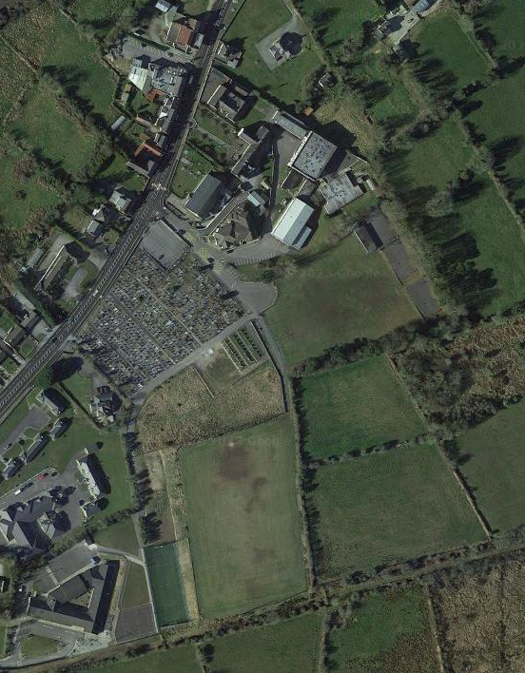
Aerial View – Existing Site Layout (Google Maps extract – December 2023)

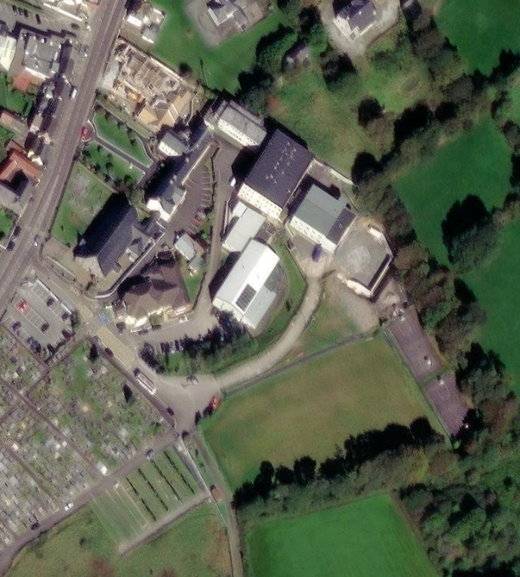
Indicative Existing Extension Location
Aerial View – Existing Site Layout – Close Up (GIS extract – December 2023)

Suggested Extension Location
Indicative Existing Extension Location
Aerial View – Suggested Site Layout – Close Up (GIS extract – December 2023)

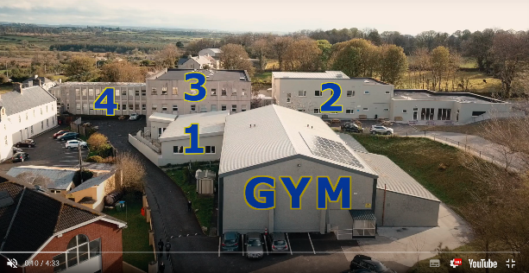
Site Overview – (December 2023 from school website tour video )

[School Authority entry; include indicative floor plans if available,]

END

