Request for Quotation
(Goods & Services less than €50,000 in value)
Grassland assessment & monitoring of NPWS land in the Glengarriff area 2026-2029 project SPU CO XXX
National Parks and Wildlife Service
Glengarriff Woods Nature Reserve, Glengarriff, Co Cork, P75 H638
IRELAND

SECTION 1: Key information
 | - Context  - This Request for Quote (RFQ) is an invitation to suppliers/service providers to submit a quotation for the Grassland assessment & monitoring of NPWS land in the Glengarriff area 2026-2029 project SPU CO XXX contract opportunity.
 | - Our timeline  - Here is our timeline for this RFQ.  All dates and times stated are local time.
  Deadline for Quotes: | Monday, 28 September 2026 by 17:00 hrs
  Deadline for clarifications: | Wednesday, 23 September 2026 by 13:00 hrs
  Anticipated Contract start date: | 01 October 2026
 | - How to contact us  - All enquiries must be directed to the nominated Point of Contact (PoC). We will manage all external communications through this Point of Contact only.  - Our Point of Contact  Name: Mary Coleman  Submit queries through mailbox
 | - Developing and submitting your Quote  - You must use the Response Form provided further below  - You may only include product brochures and appendices that are relevant to your response
 | - Manner for submitting your Quote  Please submit your quotes through e-tenders mailbox
 | - Our RFQ Process, Terms and Conditions  - Offer Validity Period: In submitting a quote the supplier/service provider agrees that their quote will remain open for acceptance by the Contracting Authority for two (2) calendar months from the Deadline for Quotes.  - Payment will be within 30 days from receipt of a valid invoice.
SECTION 2: Our Requirements
  - What we require – Describe the Specific Services Required below

Grassland assessment & monitoring 2026 – 2029
The National Parks and Wildlife Service are looking for suitably qualified ecologist(s) to carry out baseline botanical assessment and monitoring of grasslands and associated habitats at and near Glengarriff Harbour and Woodland (SAC: 000090), over the next three years.
Only very limited initial work is required in 2026 (kick off meeting and desktop study), with the fieldwork (including public engagement), in 2027, 2028 and 2029.
Botanical assessment and monitoring is required. Assessment of other pressures on the habitats at the site, including from native scrub species, may also form part of the work. Outreach with the local community and stakeholders, will be a significant element of the work. Outreach is required in order to highlight the importance of grasslands as a habitat and highlight the issues and potential solutions for managing these habitats.
Local NPWS staff propose that a management plan or strategy for these sites are developed to outline the appropriate care of the grasslands. Deliverables will include the completion of approximately 16 detailed botanical relevés, reporting the data and findings in the requested formats, the creation of a habitat map for management purposes and images and a map and text for an interpretive sign which will be displayed by the Big Meadow.
There is concern that the grassland habitat at these sites will degrade as IAS, rushes and woodland habitat encroaches onto the grassland; and the deer population continues to be unmanaged due to staffing resources in the South West.
The sites:
There are five grassland sites included in this proposal.
Site 1: The most easterly site is the Cluain Cappaughna, a field adjacent to the N71 south and west across the road from the church of the Sacred Heart (See Plate 1), close to Glengarriff village.
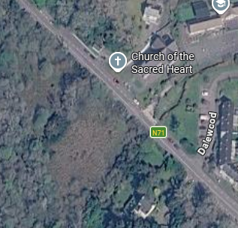
Cappaughna Cluain
Plate 1. Cappaughna Cluain (0.5Ha), is west of the N71 and floods annually. To our knowledge, it has not been grazed in approximately 20 years. The previous owner grazed the site with a horse occasionally. Treatment of the invasive species Chilean Myrtle (Luma apiculata), Rhododendron ponticum and Himalayan Honeysuckle (Leycesteria formosa) has taken place in 2026 and is ongoing into 2027.
Site 2. & 3:
Further West from the Cappaughna Cluain there are two sites either side of the Glengarriff River, which also flood annually. These sites are the lime house field and the Big Meadow (See Plate 2.)
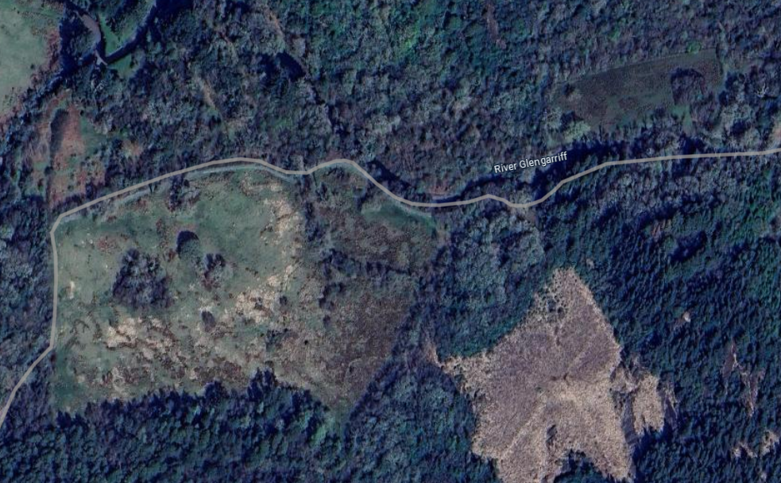
Lime house field
Big Meadow
Plate 2. The Big Meadow (5Ha), south of the Glengarriff River and the locally known Lime House field (0.7Ha), north of the river.
Historically farm animals were grazing the meadow without the consent of NPWS. These trespassing cattle were impounded (approximately 20 years ago). Kerry cattle from Killarney National Park have grazed the Big Meadow and the lime house field for a few months in the winter time. In 2025 due to severe flooding the lime house field was not grazed. Sika deer, smaller herbivores such as hares and potentially feral goats also graze in these areas.
The rare March Fritillary was first discovered in the Big Meadow in 2021. Anthills are present on the site that could be 100 years old. Anthills are a rare site in rural Ireland today due to conventional agriculture practices.
Site 4:
This fourth field is the only site that does not flood and has been grazed occasionally with a horse. It is within the boundary of the Glengarriff Woods Nature Reserve. The other sites are not within the Reserve but they are within the SAC and they are under the stewardship of NPWS.
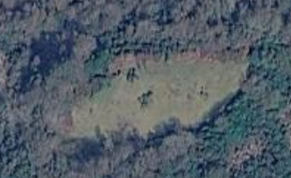
Plate 3. Drum Derrynafulla (0.4Ha), is the only site that does not flood and has historically been grazed by a horse.
Site 5: Approximately three kilometres west of the nature reserve is the fifth site (Gort Derrynafulla); approximately 0.6Ha in size adjacent to the river; which the NPWS acquired recently near Derrynafulla. There are no cattle grazing it and silage bales have been cut from it in Autumn if dry enough for machinery to access the site.
The northern boundary of the Gort Derrynafulla is adjacent to the third class road, L4927 and mature conifer plantation is established on the Coomarkane river side of the boundary to the south.
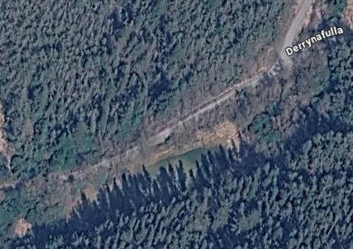
Gort Derrynafulla
Plate 4. Gort Derrynafulla (0.6Ha), is a narrow field and is the most westerly of the sites. It has had the silage cut from it annually except for 2025 when flooding inundated the area.
Key tasks:
- Record botanical relevés in the four sites described above.
- Collection and reporting of monitoring data via repeat relevés in 2028 and 2029 to inform the assessment of the quality and conservation status of these habitats on the sites is required. It is desirable that methodology outlined in the Irish Semi-Natural Grassland Survey and Grassland Monitoring Survey (Irish Wildlife Manuals 78 and 102) is used.
- GIS mapping of the location and conservation status of any Annex habitats identified on the sites.
- GIS mapping of scrub cover will be required, including of native scrub species.
- Recommendations for continued future management of the grasslands and associated habitats both in the treatment of scrub and management of grazing within the four landholdings.
- Input to the production of a long-term management plan for this site will be required, working together with NPWS staff. This plan must involve measures aimed at the prevention of IAS recolonising the SAC from the wider countryside along with grazing and scrub management within the SAC. A 100 year strategy is currently being drafted for the woodland surrounding these grassland sites and there may be scope to get long-term funding for the grassland sites into the future.
- Data entry/data management and review, with GIS mapping and file production, e.g. shapefiles (points and polygons, with attribute fields to be jointly agreed with NPWS, and clearly presented in both the metadata and in an appendix to the main report).
- Outreach and education regarding the importance of grassland habitats (e.g. potentially in Spring and Autumn) for local landowners, gardeners, schools, NPWS staff. This may include production of information leaflets, etc. The Big Meadow is the most suitable site for outreach events.
- Participate in ongoing communications with NPWS staff including: project meetings/discussions; production of drafts of end of year reports; review and response to NPWS comments and feedback; liaison with data management staff in NPWS re. final project/data delivery, and other NPWS staff as needed. A kick off meeting with the data management team will be required.
- Progress report annually with interim deliverables due in early November of each year.
- A detailed final project report will be required before the end of the project in November 2029.
For 2026 the requirements are:
- Project set up meeting
- Preparatory work for other elements of the project, including IAS knowledge share and outreach material discussion
- Desktop study

Potential Cost: The fifth site is 0.4Ha and does not flood. Drum Derrynafulla has been grazed

This would be an 34.5 day project that would cost €17,250 plus VAT.
Deliverables:
1. Dataset containing the results of vegetation relevés carried out at multiple locations across all sites (Plate 4.). In addition, the dataset of the results of monitoring assessments where Annex habitats are present and assessed. Grid references for all relevés will be supplied in ITM. Formats for data collection and submission will be discussed on start-up.
Relevés will be carried out in all of the four sites (See Plate 4). While some desktop review and meetings will be undertaken in 2026, given the time of year, it is envisioned that the fieldwork will not begin until 2027. The same Relevés in 2027 will be repeated in 2028 and 2029.
The total number of annual relevés is likely to be about 16, but exact numbers, locations and how they are spread across the project lifespan will be discussed in more detail at project start-up, and there will be a degree of flexibility available based on initial survey results and data interpretation..
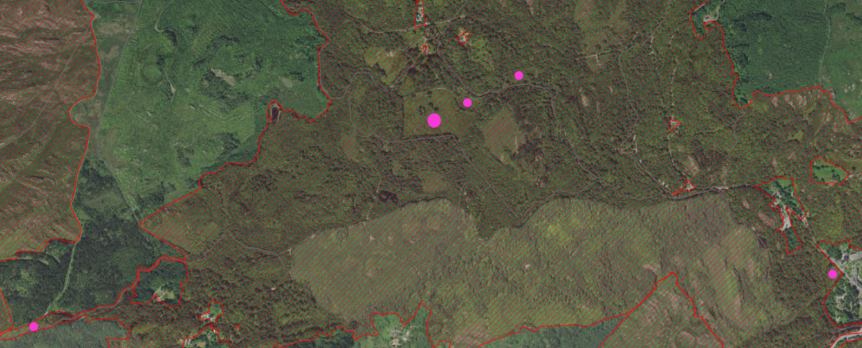
Gort Derrynafulla
Big Meadow
Lime House Field
Cappyaughna Cluain
Drum Derrynafulla
Plate 5. The five sites are marked with pink dots. Red lines indicate designated SAC.
There are three other small areas with grassland by the NPWS offices and in a picnic area by the carpark. We would like to include these areas in a discussion with the successful contractor to get comments on the current management to include improvement and consistency to how the site is managed for grassland species and pollinators. Currently one site is cut once a year and other sites are cut more frequently to accommodate visitors in the picnic area.
Note that all data and reporting must conform in full with the NPWS project delivery and data standards – https://www.npws.ie/maps-and-data/data-standards/npws-project-data-standards. Please take the time to get familiar with these documents and processes – data management and compliance with delivery requirements can take longer than expected.
2. Photographs from each relevé location, labelled, stored and submitted according to NPWS standards and guidelines.
3. GIS habitat mapping of each site, with habitat types clearly assigned to all polygons, as well as each relevé. Maps providing polygons showing the extent of the semi-natural grassland habitats at the sites and scrub distribution are required. All habitats should be assigned a Fossitt code and Annex habitat code if applicable. Note that assignment to IVC plant communities (Irish Vegetation Classification) is desirable as part of this work, and the online ERICA tool can be used: https://biodiversityireland.shinyapps.io/vegetation-classification/
4. Metadata in the NPWS-supplied resource catalogue, as per guidance.
5. Interim reports in 2027 and 2028, and a final report in 2029 summarising work undertaken and findings are to include recommendations for future recording, as well as management and other considerations, and should clearly set out how vegetation is faring post conservation strategies that may be implemented during the course of the three years monitoring period. The report should also outline outreach activities and achievements, and include copies/links to any relevant materials produced, e.g. leaflets, web content.
6. The content of text and photographs of species of interest which may include information on the anthills and pollinators such as the Marsh Fritillary will be created for an interpretive sign. NPWS will be responsible for the translation into Irish, the final design (including department logos etc), printing and installation of the sign.
7. Final deliverables will be due in early November 2029, with progress and interim reports due in early November 2027 and 2028.
Budget
There is a set maximum fee available for the work, €17,250.
General Requirements in response to this RFQ
Quotes should be submitted via email by the deadline of 17.00 Monday 28th September 2026. Any queries relating to this competition should be submitted via email by 13.00 on Wednesday, 23rd September 2026. Quotes/Queries should be sent to NPWS POC: Mary Coleman: mary.coleman@npws.gov.ie and cc. Grassland Ecologist Brian Reidy: brian.reidy@npws.gov.ie
Quotes must include the following:
1. A brief outline of the background, qualifications and relevant experience of the applicant(s), as relevant to the tasks set out in this RFQ. Award criteria (Section 3.1 below) should be addressed.
2. A brief outline of how the work will be approached, with all tasks and deliverables included, including a workplan with timelines.
3. An overall maximum budget for the work is provided above. Based on this, and the listed tasks, applicants are asked to provide:
a. A single figure for total cost (inclusive of VAT if applicable and T&S).
b. A single figure for total cost per year (inclusive of VAT if applicable and T&S).
c. Please also provide a daily rate (inclusive of VAT if applicable and T&S).
d. The quoted costs must be valid for 60 days.

SECTION 3: Our Evaluation Approach
  - Evaluation Model
The evaluation model that will be used in this project is lowest price quoted will be the preferred option. This means that the lowest quote that meets any stated pre-conditions and is capable of full delivery on time will be selected.

Award Criteria
Evaluation Model
Criterion ↓ | % Weighting
Relevant knowledge, expertise and experience; in particular in relation to botanical expertise and the survey and assessment of Annex grassland, semi-natural grassland as well as familiarity with grassland restoration. | 50
Project management and service delivery. Evidence of previous management of projects of this scale and type. | 20
Cost | 30

Request for Quotation
Supplier/Service Provider Response
[Category]

Supplier/Service Provider Details
Name: | [Category]
VAT Number | Click here to enter text.
Postal Address: | Click here to enter text.
Contact Person or Persons: | Click here to enter text.
Telephone: | Click here to enter text.
Email: | Click here to enter text.
Internet address (web address) (if applicable) | Click here to enter text.

Confirmations
I submit the following quote in response to your RFQ. I confirm that [Category] is able to deliver the requirements as follows:
- To the required standard | ☐
- By the delivery date | ☐
- In the quantity requested | ☐
- To the/at the location requested | ☐
- Validity Period | ☐
- T’s & C’s accepted | ☐

How We Meet Your Needs
I believe that my quotation proposal meets or exceeds the award criteria, as follows:
Click here to enter text.
In submitting this quote we have made the following assumptions:
Click here to enter text.

Pricing
Our total price for delivery of the requirements is €Click here to enter text. exclusive of VAT
A breakdown of the price is as follows;
Click here to enter text.

Authorisations & Sign Off
I have been authorised to submit this quote on behalf of [Category]
Signature:
Full name: | Click here to enter text.
Title/Position: | Click here to enter text.
Date: | Click here to enter a date.

