System overview
The high-level architectural table and diagram presented below illustrate the components and apps that constitute the Case Management System (CMS) solution. The solution uses Microsoft's Power Platform, which includes PowerApps, a low-code development approach enabling rapid app creation.

Requirement area | Solution/Technology
Case Management Solution | The solution employs a PowerApps Model-Driven App, and it includes the following created Apps: • Programming Unit App • Secretariat App • Division App • Admin App
Reference Repository | Native SharePoint integration with PowerApps is used for document storage and document management needs.
Applications Forms | Power Page is used for the Customer Facing Portal
Data Migration | Flat file integration with Kingsway soft
Automation | Power Automate is used for all the automation requirements
Approval Request | MS Teams is used for the Program approval request to the Chairman.
Monthly reporting | Power BI is used to generate reports for the Court at regular intervals

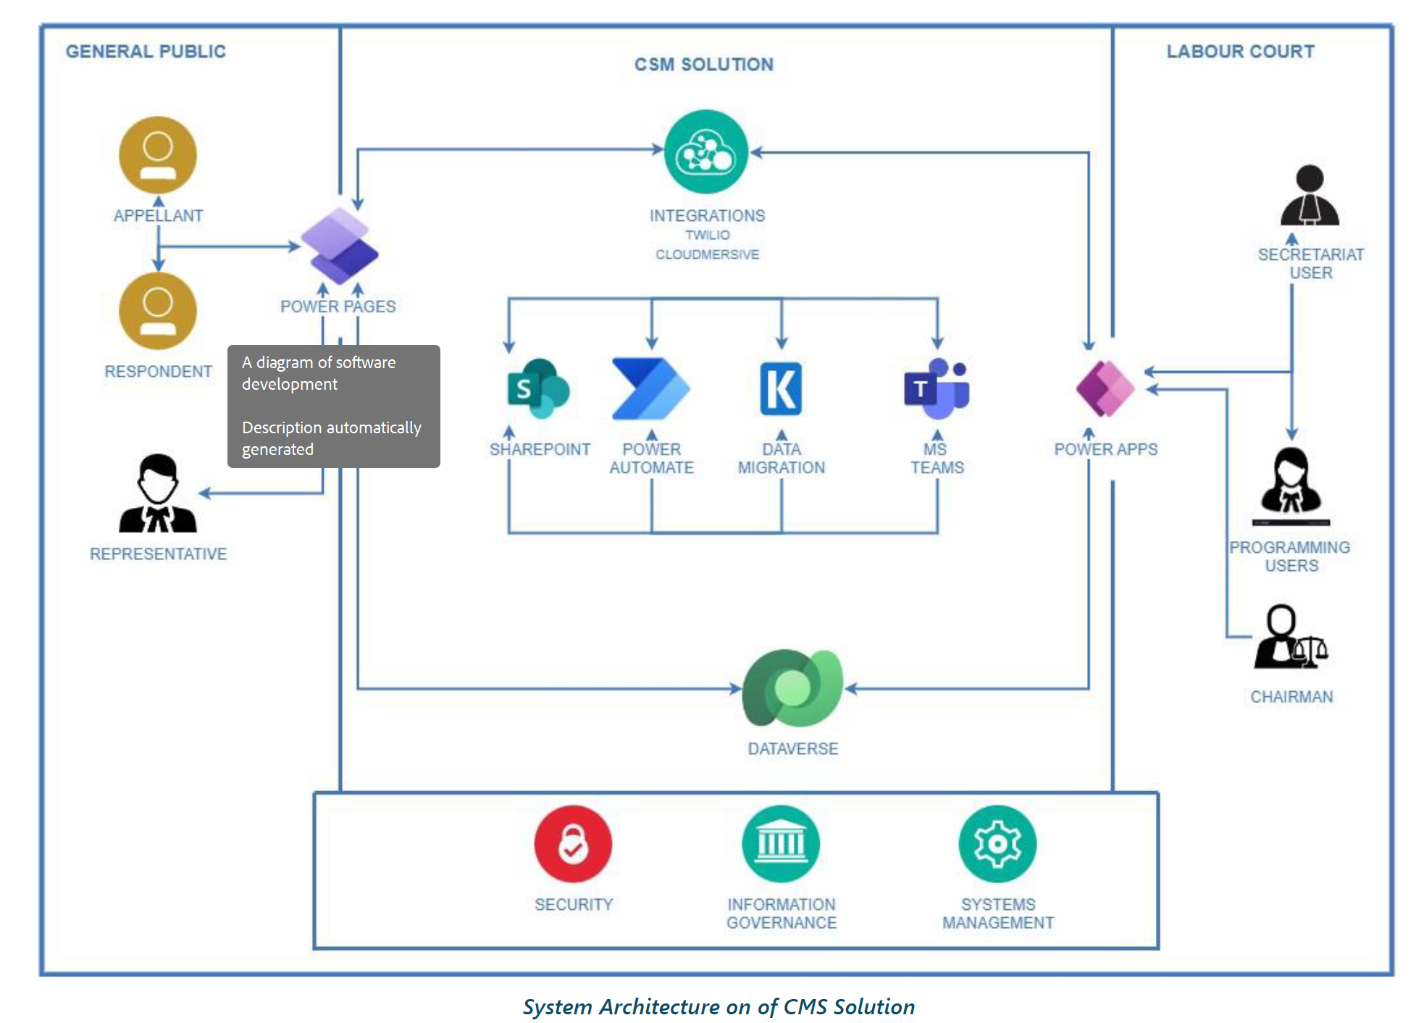

Integrations
The solution comes with two integrations using Power Automate.
These integrations are as follows:
• Twilio – This integration is used to send out SMS for the Portal authentication
• Cloudmersive – This integration was used to scan files for viruses that were uploaded from the Portal by the Public.
In addition, one integration for files to be delivered out of CMS:
• Encodian – This integration is deployed to convert Word files to html for pickup by an external solution

