Request for Tender – Engineering Services – Moyasta GWS
REQUEST FOR TENDER
Subject of Tender
Provision of Consulting Engineer Services to the Moyasta Group Water
Scheme (GWS) to enable Taking in Charge by Uisce Eireann.
Key Dates
Issue Date
26 August 2026

15.00hrs 15 September 2026
15.00hrs 5 October 2026
VIA www.etenders.gov.ie
Closing Date for Queries
Closing Date for Tenders
Contact for Queries
The dates provided above are estimates at the time of publication of the Request for Tender.
Moyasta Group Water Scheme, the Contracting Authority, will endeavour to run the
process to this timetable, but this cannot be guaranteed.
Format for submission of quotations – use the Tender Response Document provided
VIA www.etenders.gov.ie
Page | 1



Request for Tender – Engineering Services – Moyasta GWS
CONTENTS
REQUEST FOR TENDER ....................................................................................................................1
Key Dates................................................................................................................................................1
CONTENTS............................................................................................................................................2
1
.
ABOUT THE CONTRACTING AUTHORITY................................................................4
Introduction ........................................................................................................................4
SCOPE OF REQUIREMENT............................................................................................5
Specification of Requirements............................................................................................5
Deliverables........................................................................................................................6
Stakeholder Engagement..................................................................................................10
Review of Performance................................................................................................... 10
1
.1
2
.
2
2
2
2
.1
.2
.3
.4
2
.4.1 Account Management...................................................................................................... 10
2
.4.2 Invoicing...........................................................................................................................10
2
.5
Award to Runner Up ....................................................................................................... 10
EVALUATION CRITERIA............................................................................................ 11
Suitability .........................................................................................................................11
Award Criteria................................................................................................................. 12
Selection Criteria..............................................................................................................13
FORMAT OF RESPONSE ..............................................................................................15
INSTRUCTIONS FOR ECONOMIC OPERATORS QUOTING.................................. 15
3
.
3
3
3
.1
.2
.3
4
5
.
.
(a) Closing Date..........................................................................................................................15
(b) Submission of Quotations..................................................................................................... 15
(c) Queries...................................................................................................................................16
(d) Currency and Payments........................................................................................................ 16
(e) Confidentiality.......................................................................................................................17
(f) Conflict of Interest.................................................................................................................17
(g) Freedom of Information Acts ............................................................................................... 17
(h) Data Protection..................................................................................................................... 17
Page | 2

Request for Tender – Engineering Services – Moyasta GWS
(i) Tax Clearance Certificate......................................................................................................18
(j) Withholding Tax....................................................................................................................18
(k) Interference and Inducement to Purchase..............................................................................18
(l) Notification of Evaluations................................ ……… ………………………………… 18
(m) Replacement Personnel..........................................................................................................18
(n) Copyright...............................................................................................................................18
(o) Responsibility of Successful Party ........................................................................................18
Appendix A ………………………………………………………………………………………19
Appendix B ………………………………………………………………………………………21
Page | 3

Request for Tender – Engineering Services – Moyasta GWS
1
.
ABOUT THE CONTRACTING AUTHORITY
1
.1
Introduction
The Moyasta Group Water Scheme has been in existence since 1972. It is managed by a
committee. The Scheme provides water services to 50 members with approximately 70 connections.
The scheme has approximately 12.5 kms of distribution network

Page | 4
b
er

Request for Tender – Engineering Services – Moyasta GWS
The Contracting Authority, Moyasta GWS, wish to appoint a suitably qualified
professional/service Engineer (“the Engineer”) with experience in Civil Engineering works in
water distribution systems in Group Water Schemes and Public Water Schemes.
2
.
SCOPE OF REQUIREMENT
2
.1
Specification of Requirements
The Moyasta Group Water Scheme GWS wish to appoint a suitably qualified
engineer with experience in civil engineering works and construction project management in water
distribution systems for group water schemes and public water schemes networks to carry out as
necessary an assessment of the existing watermain infrastructure of the GWS to determine the exact
scope of works required to bring the scheme up to the Minimum Basic Standard for Uisce Eireann
taking in charge consideration (as per Uisce Eireann basic standards). Preparation and submission of
the full Taking in Charge Standard Documents on behalf of the GWS for UE taking in charge
consideration, including:
•
•
•
•
•
Application Form,
Submit Consent Form,
Connection Schedule,
As-Constructed Drawings
Wayleave Agreements.
The scope of works must include the following:
-
Replacement of approximately 6kms of water mains with 101 mm pipe
Various fittings (air, sluice and scour valves) to be replaced
-

The existing mains must be kept live during installations.
Page | 5
Any other works deemed necessary to bring the scheme to a standard for Taking in Charge by
Usice Eireann

Request for Tender – Engineering Services – Moyasta GWS
2
.2 Deliverables
The scope of the anticipated services required under each stage are set out under.
Stage 1 – Preliminary.
1. Carry out as necessary an assessment of existing data and proposed areas for new mains or
upgraded watermain.
2
. Using the existing network mapping, liaise with the local authority and group water
scheme to verify the location of the new water mains and/or upgraded watermain to
identify the need for any additional site investigation works or trial pits.
3
. Survey of Site to allow for Design Process.
. Assess the need and cost of road opening licenses for each project.
. Prepare estimated project costs.
4
5
Stage 2 – Design.
1. Procure and manage the required Site Investigation work such as Excavation,
Inspection and Site Investigation of Trial Holes for inclusion in the contract, if required.
2
. Carry out the detailed design work for capacity expansion and infrastructure rehabilitation.
Produce detailed drawings, specifications, and Bills of Quantities suitable for tendering the
construction phase.
3. Design to be in accordance with the Present Water Code of Practice for Water
Infrastructure.
4. Liaison with Roads Area Engineer to assess ROL requirements and Reinstatement
requirements for inclusion in Contract Documents
5. Acceptance of Role as Designer and PSDP
6
. Fulfil all obligations under current Health & Safety legislation. Carry out role of Project
Supervisor Design Process (PSDP). Prepare a Preliminary Health and Safety Plan and
develop the Safety File in accordance with Safety, Health & Welfare at work Act 2005
and Safety, Health and Welfare at Work (Construction) Regulations 2013 and all other
relevant legislation, regulations and practice codes. Submission of AF1 to HSA.
Page | 6

Request for Tender – Engineering Services – Moyasta GWS
Stage 3 – Tender Activation, Evaluation and Award.
1
. Manage the tender process adhering with the Tendering Procedure and Procurement
legislation. Construction Contract Implementation -The Consulting Engineer (CE)
shall agree on the selection criteria for contractor before commencing the procurement
process with the Client (GWS) with the evaluation criterion used to be “Most
Economically Advantageous Tender”.
2. Preparation of tender documents for construction works for approval by Contracting
Authority and Clare County Council and Publish to E-Tenders.
3
4
5
. Manage process including but not limited to Preparation Notices and Advertisements
respond to all reasonable queries from tenderers.
. Assessment of Tenders including any liaison with any potential contract re
clarifications.
. Ensure the Contract Documents include:
•
•
•
•
Pricing Document.
Design Drawings
Works Requirements
Any further specification needed.
6. Preparation of Tender Report and issue to GWS and CCC with recommendation of
appointment, to include but not limited to:
•
•
•
•
Report procedure
Summary of Tenders
Assessment process
Recommendation
7. Award of Contract to Successful Tender and Issue of Appointments as Contractor and
PSCS
8. Assessment insurance and contract signing.
9. Preparation of Preliminary Safety and Health Plan for GWS
Stage 4 - Construction.
1
. Transfer the role of PSDP to the successful contractor in accordance with Safety, Health &
Welfare at work Act 2005 and Safety, Health & Welfare at Work (Construction) Regulations
2
013 and all other relevant regulations and legislation.
Administration of Construction Contract
Following appointment of Contractor(s) the CE shall be required to act as such for the GWS for
Page | 7

Request for Tender – Engineering Services – Moyasta GWS
the construction and commissioning phases of all the Construction Contracts in relation to the
proposed works.
This will require the administration of the Contract including:
•
•
Obtain permission to start this Stage.
The certification of all payments due to the Contractors in accordance with the Conditions of
Contract.
•
The attendance at meetings (including compiling and circulating minutes of meetings) for the
duration of the scheme including:
Weekly progress meetings,
Any other meetings relevant to the progress scheme, as required by the GWS and CCC
2
. Carry out a supervisory role on behalf of the GWS for the duration of the construction and
commissioning of the works, including administration of the contract, approval of all materials,
site visits and meetings and certification of works.
3
4
5
6
7
8
. Submission of Payment Certificates to GWS
. On Site Supervision includes supervision of pressure testing of mains.
. Allowance for weekly site visit for construction period and any additional visits as required.
. Preparation and submission of weekly report
. Preparation of Snag List and Ensuring all Items are addressed by Contractor
. Submission of Certificate of Substantial Completion and Sign off of Works
. Advise on any claims and settlement thereof.
9
1
0. Representation on behalf of GWS for any Compensation Events / Post Works Meeting / Final
Contract Sum
Stage 5 - Handover and Final Completion and Group Water Scheme TIC Standard Documents
1
. Preparation of As-Constructed Drawings which must include all pipe networks with GPS
coordinates of all valves, meters and customer meters etc. The template to be agreed with Clare
County Council (CCC) and Uisce Eireann and should include but not be limited to.
•
•
Application Form
Consent Form,
Page | 8

Request for Tender – Engineering Services – Moyasta GWS
•
•
•
Connection Schedule,
As-Constructed Drawings (.dxf or .dwg AutoCAD drawings)
Wayleave Agreements.
The following UE TIC Standards represent the minimum standards that are acceptable to UE to consider the
takeover of a network. The network must be fit for purpose and free from significant defects that would impact
on customer service, water quality and/or asset longevity.
Refer to Appendix A for more details
Proposed As Constructed Drawing Standards
The following are UE as constructed drawing standards
•
•
•
Appropriately scaled with Name, North point, Ordnance Grid reference for the centre of
the network.
Line and layouts of water mains (incl. diameter and material of main) hydrants, valves,
etc.
Locations of stop cock or meter box with reference number linked to Connections
Schedule.
•
•
Location of connection to public supply.
Wayleaves should be indicated on layout map and indexed to Wayleave Schedule.
Refer to Appendix B for more details.
2
3
4
. Prepare detailed customer database to be provided to UE, template provided by Local Authority.
. Preparation of Handover Report.
. Preparation of Final Account.
Page | 9
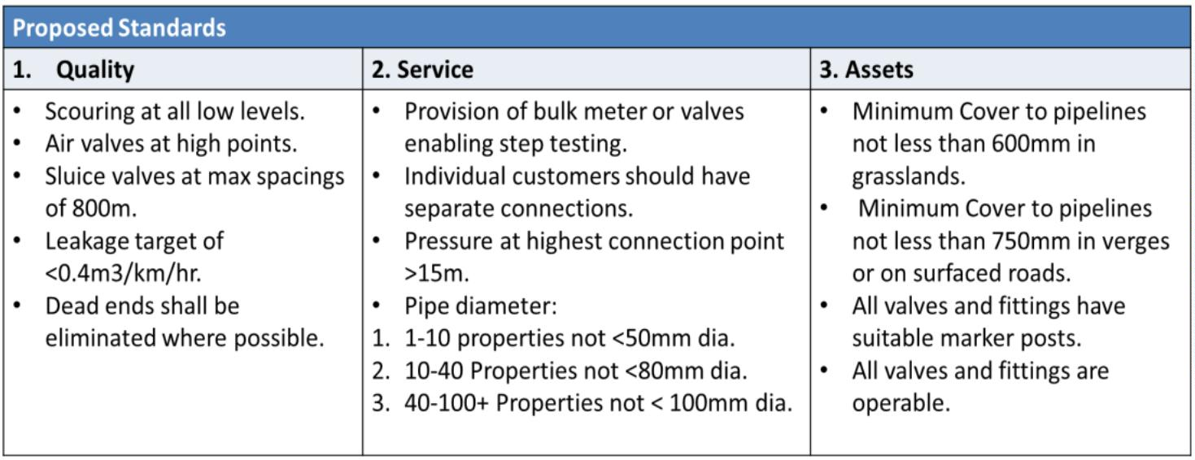

Request for Tender – Engineering Services – Moyasta GWS
The price provided by the Engineer for the project must be given as a Lump Sum Fixed Price.
The Lump Sum Price to include any other item of work or service that the Engineer deems
necessary or desirable for the purposeful delivery of the tender preparation stage for the
relevant works.
The Design work (Stages 1& 2) should be completed within three months from appointment.
Stage 3 should be completed within seven months from appointment to facilitate completion
of the project within the desired timeframe.
2
.3 Stakeholder Engagement
For all stages the Consulting Engineer will be required to engage with the Group Water
Scheme and the Rural Water Section of Clare County Council as necessary for the proper
delivery of the project.
2
.4
Review of Performance
2
.4.1 Account Management
Tenderers submitting a quotation are required to nominate a dedicated account manager who
will act as the main point of contact for the duration of the contract. This person shall have the
authority to deal with all matters in relation to the contract and be responsible for the satisfactory
delivery of the services required.
2
.4.2 Invoicing
Invoices shall be submitted by the awarded contractor on stage basis.
2
.5
Award to Runner Up
3
.
EVALUATION CRITERIA
If for any reason, it is not possible to award the contract to the successful economic operator emerging
from this competitive process, or if having awarded the contract, the Contracting Authority considers
that the successful economic operator has not met its obligations, the Contracting Authority reserves
the right to award the contract to the next highest scoring economic operator on the basis of the terms
advertised, at any time during the quotation validity period of 15 months.
Page | 10

Request for Tender – Engineering Services – Moyasta GWS
3
.1
Suitability
The Contracting Authority will only consider quotations from competent and financially sound
and compliant economic operators. To this end, you are required to confirm the following by
completing a self-declaration in the Economic Operators Tender Response.
(a) General economic operator information.
(b) Confirmation of tax compliance.
(c) Confirmation that the economic operator is appropriately insured.
(d) Confirmation via declaration that the economic operator is not bankrupt, guilty of
corruption, fraud, money laundering, membership of a criminal organisation, not
involved in child labour and/or human trafficking and is fully compliant with all its
statutory obligations.
Page | 11

Request for Tender – Engineering Services – Moyasta GWS
3
.2
Award Criteria
The contract will be awarded on the basis of the Most Economically Advantageous Tender.
The following criteria will apply:
Criterion A
Weighting Maximum
Marks
Qualifications
Description
Criterion B
Pass / Fail
See minimum requirements outlined in Section 3.1
Weighting Maximum
Marks
Qualifications /Expertise of Consultant/Team,
40%
4,000
Proposed Methodology and Project Plan.
Description
Criterion C
See description included in Section 3.3
Weighting Maximum
Marks
Cost of Tender
Description
60%
6,000
Lowest cost achieves highest marks
(a) Tenders will be evaluated against the quality criteria set out below. Any Tender:
•
•
Not passing on a ‘pass / fail’ criterion,
achieving less than 50% of the maximum marks on an individual ‘quality’ criterion
will be excluded from further consideration.
(b) Those Tenderers whose tender submissions have not been excluded following the
evaluation against the criteria at (a) above will then have their tender assessed.
(c) Marks will be awarded for the cost of tender based on the following formulas:
Methodology for Calculating the Cost Score
Page | 12


Request for Tender – Engineering Services – Moyasta GWS
Lowest Cost from a Bona Fide
Tender
A
Cost for the tender being evaluated
Maximum Points available for Cost
Formula employed
B
6000
A x 6000
B
•
Lowest price tendered divided by the Tenderer’s price (net of VAT) multiplied by the
number of marks available for price.
The lowest price offered that also meets all the minimum requirements of the qualitative
award criteria, will receive the maximum score for this criterion and all other prices offered
will be scored relative to this lowest price using the above formula.
Methodology for Calculating Scoring of Qualitative Criteria
Score
Meaning
Interpretation
9
0 – 100% Outstanding
A very comprehensive response demonstrating extensive
understanding offering full assurance to client – fully
supported with no reservations.
8
0 – 89% Excellent
An
excellent
response
demonstrating
excellent
understanding offering assurance to client – strongly
supported.
7
6
5
0 – 79% Very good
0 – 69% Good
A
very good response demonstrating very good
understanding offering assurance to client – fully supported.
A good response demonstrating good understanding offering
assurance to client – well supported.
An acceptable response demonstrating a minimum
understanding offering assurance to client - satisfactorily
supported.
0 – 59% Acceptable
Less than 50% is unacceptable and considered ineligible from further consideration
2
5 – 49% Mediocre
Response demonstrates limited understanding with
insufficient or no detail and a risk of non-delivery. This is
unacceptable and classified as inadmissible.
1
– 24%
Poor
Response demonstrates very limited understanding of the
requirements and has fundamental flaws and lacks
credibility with a significant risk of non-delivery. This is
unacceptable and classified as inadmissible.
Page | 13
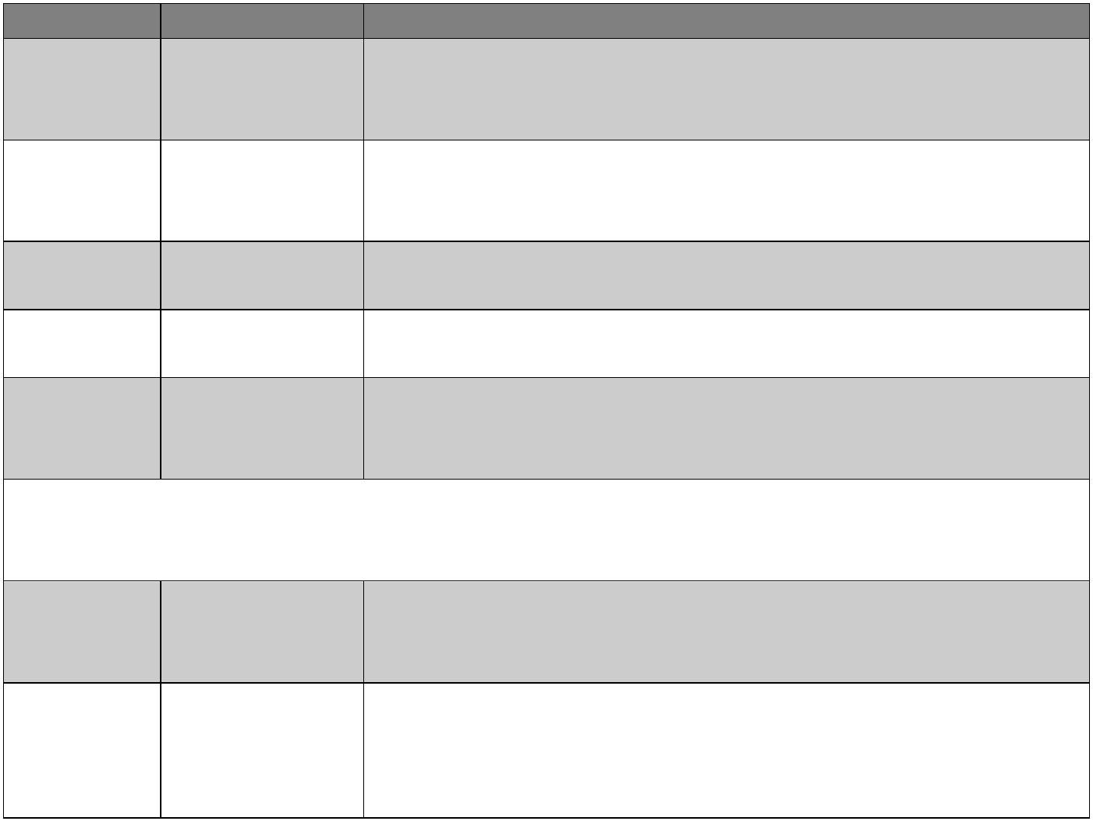


Request for Tender – Engineering Services – Moyasta GWS
Response completely fails to address the criterion under
0
%
No response
consideration. This is unacceptable and classified as
inadmissible.
The Tenderer with the highest final score as determined by the Methodology explained will be
the Most Economically Advantageous Tender. In the event of a tie between Tenderers, the
Tenderer with the highest marks for quality will be the Most Economically Advantageous Tender.
The contract will be awarded on the basis of a quality and cost evaluation as assessed by the
Contracting Authority, who is not obliged to accept the lowest or indeed any quotation.
Tenderers should also complete the Hourly Rates table included on Page 9 of the Tender
Response Document (TRD). Should additional services outside the scope of this tender be
requested from the successful tenderer during the project, the hourly rates specified will apply.
No additional services should proceed prior to a final agreement from each party (i.e. successful
tenderer and Loop Head GWS).
3
.3
Selection Criteria
The qualifications and expertise criteria set out below will apply.
Criterion B – Qualification and Expertise of Consultant/Team Proposed
Tenderers must be suitably qualified. Tenderers must demonstrate in their tender response their
expertise and proven track record among individuals responsible for delivering the project as set out
at Section 4 below and elsewhere in this document.
This should include:
•
CVs of employee personnel involved in the project;

Tenders must demonstrate recent experience of similar projects undertaken in terms of scale
and it is desirable if they can demonstrate experience of working on a project for the successful
Taking in Charge of a GWS to UE.
Methodology and Project Plan
•
Methodology and proposed approach for design of services.
Page | 14

Request for Tender – Engineering Services – Moyasta GWS
•
Programme outlining key milestones and delivery dates.
Criterion C Pricing Schedule (detailed breakdown of fees including reimbursable expenses).
4
.
FORMAT OF RESPONSE
Service Providers are required to complete the Tender Response Document which contains:
(ii)
General Economic Operator Information
(iii)
Information regarding compliance with the Suitability Criteria – tax, insurances and
declarations; and
(iv)
The Quotation Form;
Service Providers are also required to provide a relevant response to the Qualitative Award Criteria. This
should include:
•
CVs of employee personnel involved in the project

•
•
Methodology on how it is proposed to complete the various associated tasks.
Examples of previous relevant projects undertaken by the tenderer in order to
demonstrate the expertise requested in Section 3.3 and with a minimum of 3
comparable projects, preferably demonstrating “Taking-in-Charge Works” and/or
similar works for water/utilities.
Please ensure you read the Instructions to Economic Operators Quoting as detailed in Section 5.
5
.
INSTRUCTIONS FOR ECONOMIC OPERATORS QUOTING
(a) Closing Date
The closing date for receipt of quotations is 15.00hrs 6 October 2026. Tenders that are
received late will not be considered in this competition.
(b) Submission of Quotations
Tenders should be submitted VIA www.etenders.gov.ie ONLY clearly marked Procurement of a
Consulting Engineer for the Loop Head Group Water Scheme.
Page | 15

Request for Tender – Engineering Services – Moyasta GWS
(c) Queries
All queries regarding this quotation should be VIA www.etenders.gov.ie ONLY clearly marked Query
for Procurement of a Consulting Engineer for the Moyasta Group Water
Scheme.
Queries should be raised as soon as possible and in any case before 15.00hrs 13 September 2026.
For the purpose of circulating responses, queries will be edited to avoid disclosing the identity of the
querist, and any sensitive information included in the query should be clearly indicated.

(e) Currency and Payments
The currency and invoices in which all prices and rates shall be quoted, and which payments under the
contract will be paid, shall be Euros (€). All prices and rates quoted should be exclusive of VAT.
A schedule of payments will be agreed with the successful economic operator. The Contracting
Authority operates in accordance with the European Communities (Late Payment in Commercial
Transactions) Regulations 2012.
The standard method of payment used is Electronic Funds Transfer.
(f) Confidentiality
The distribution of the quotation documents is for the sole purpose of obtaining offers. The distribution
does not grant permission or licence to use the documents for any other purpose. Economic operators
are required to treat the details of all documents supplied in connection with the quotation process as
private and confidential.
(g) Conflict of Interest
Any conflict of interest involving an economic operator (or economic operators in the event of a
consortium bid) must be fully disclosed to the Contracting Authority. Any registrable interest involving
the economic operator and The Contracting Authority or employees of the Contracting Authority or
their relatives must be fully disclosed in the quotation submission or should be communicated to the
Contracting Authority immediately upon such information becoming known to the economic operator,
in the event of this information only coming to their notice after the submission of a bid and prior to the
award of the contract. The terms ‘registrable interest' and 'relative' shall be interpreted as per Section 2
of the Ethics in Public Office Act, 1995. Failure to disclose a conflict of interest may disqualify an
economic operator or invalidate an award of contract, depending on when the conflict of interest comes
to light.
Page | 16

Request for Tender – Engineering Services – Moyasta GWS
(h) Freedom of Information Acts
Economic operators should be aware that, under the Freedom of Information Act 2014 and the European
Communities (Access to Information on the Environment) Regulations 2007 to 2014, information
provided by them during this Competition may be liable to be disclosed.
Economic operators are asked to consider if any of the information supplied by them in their Quotation
should not be disclosed because of its confidentiality or commercial sensitivity. If economic operators
consider that certain information is not to be disclosed because of its confidentiality or commercial
sensitivity, economic operators must, when providing such information, clearly identify the specific
sections of their quotation containing such information and specify the reasons for its confidentiality or
commercial sensitivity. For the avoidance of doubt economic operators may not assert confidentiality
or commercial sensitivity over the entire quotation but must clearly identify the specific section
containing such information. If economic operators do not identify information as confidential or
commercially sensitive, it is liable to be released in response to a request under the above legislation
without further notice to or consultation with the economic operator. The Contracting Authority will,
where possible, consult with economic operators about confidential or commercially sensitive
information so identified before making its decision on a request received. The Contracting Authority
accepts no liability whatsoever in respect of any information provided which is subsequently released
(irrespective of notification) or in respect of any consequential damage suffered as a result of such
obligations.
(i) Data Protection
“
Data Protection Laws” means all applicable national and EU data protection laws, regulations and
guidelines including but not limited to Regulation (EU) 2016/679 on the protection of natural persons
with regard to the processing of personal data and on the free movement of such data, and repealing
Directive 95/46/EC (the “General Data Protection Regulation”), the Data Protection Act, 2018 and any
guidelines and codes of practice issued by the Data Protection Commission or other supervisory
authority for data protection in Ireland from time to time.
The Contracting Authority will be a Controller (where Controller has the meaning given under the Data
Protection Laws) in respect of any Personal Data (where Personal Data has the meaning given under
the Data Protection Laws) required to be provided by the Tenderer in response to this Request for
Quotation.
The Tenderer, as Controller in respect of any Personal Data provided by it in its Tender, is required to
confirm by way of statement in the “Declarations” section of the accompanying Quotation Response
Document (QRD) that all Data Subjects (where Data Subject has the meaning given under the Data
Protection Laws) whose Personal Data is provided by the Tenderer have consented to the processing of
such Personal Data by the Tenderer, the Contracting Authority, the Evaluation Team and the supplier
of the etenders.gov.ie website, for the purposes of the participation of the Tenderer in this Competition
or that the Tenderer otherwise has a legal basis for providing such Personal Data to the Contracting
Authority for the purposes of its participation in this Competition.
Page | 17

Request for Tender – Engineering Services – Moyasta GWS
(j) Tax Clearance Certificate
It will be a condition of award of this contract and any subsequent contract that the successful economic
operator(s) comply with all EU and national tax laws. Economic operators are referred to the Irish
Revenue web site http://www.revenue.ie/. Non-resident economic operators should apply to the Office
of the Revenue Commissioners, Non-Resident Tax Clearance Unit, Office of the Collector General,
Sarsfield House, Francis Street, Limerick, Ireland; e-mail: nonrestaxclearance@revenue.ie.
(k) Withholding Tax
Relevant payments shall be subject to Irish ‘Professional Services Withholding Tax’ at the prevailing
rate (currently at 20%) as laid down by the Revenue Commissioners in Ireland. Non-residents may be
able to reclaim such deducted Tax from the Office of the Revenue Commissioners in Ireland,
International Claims Section located currently at Government Buildings, Nenagh, Co. Tipperary,
Ireland (Tel: +353-67-63400).
(l) Interference and Inducement to Purchase
Any effort by the economic operator to unduly influence the Contracting Authority, relevant agency
personnel or any other relevant persons or bodies in the process of examination, clarification, evaluation
and comparison of quotations and in decisions concerning the Award of Contract shall have their
quotation rejected. In accordance with Section 38 of the Ethics in Public Office Act 1995 any money,
gift or other consideration from a person holding or seeking to obtain a contract will be deemed to have
been paid or given corruptly unless the contrary is proved.
(m)Notification of Evaluations
All parties will be informed of the outcome of their proposals following evaluation and any necessary
clarifications.
(n) Replacement Personnel
Notification must be sent in writing (by post or electronic means) as soon as possible to the Contracting
Authority on any proposed change of nominated personnel, such change to be subject to the written
approval of the Contracting Authority. Replacement personnel must be of equal or better standing that
the existing personnel in terms of qualifications and experience.
(o) Copyright
The Contracting Authority will have copyright ownership of any material developed for use by the
Contracting Authority under the terms of this quotation. The service provider may have a non-exclusive
licence to use such material but only for its own purposes (to be agreed with the successful economic
operator).
(p) Responsibility of Successful Party
As a condition of award, it shall be the sole responsibility of the tenderer (in the event of success in this
competition) to fulfill the obligations under the Contract, notwithstanding any changes in circulars,
laws, regulations, taxation, duties or other factors which might arise following the withdrawal of the
United Kingdom from membership of the EU.
Page | 18

Request for Tender – Engineering Services – Moyasta GWS
Appendix A: UE Basic Standards
Page | 19
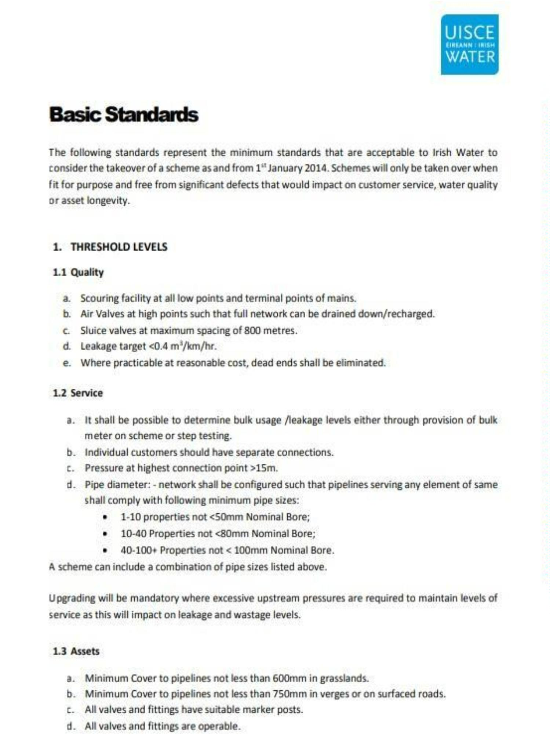

Request for Tender – Engineering Services – Moyasta GWS
Page | 20
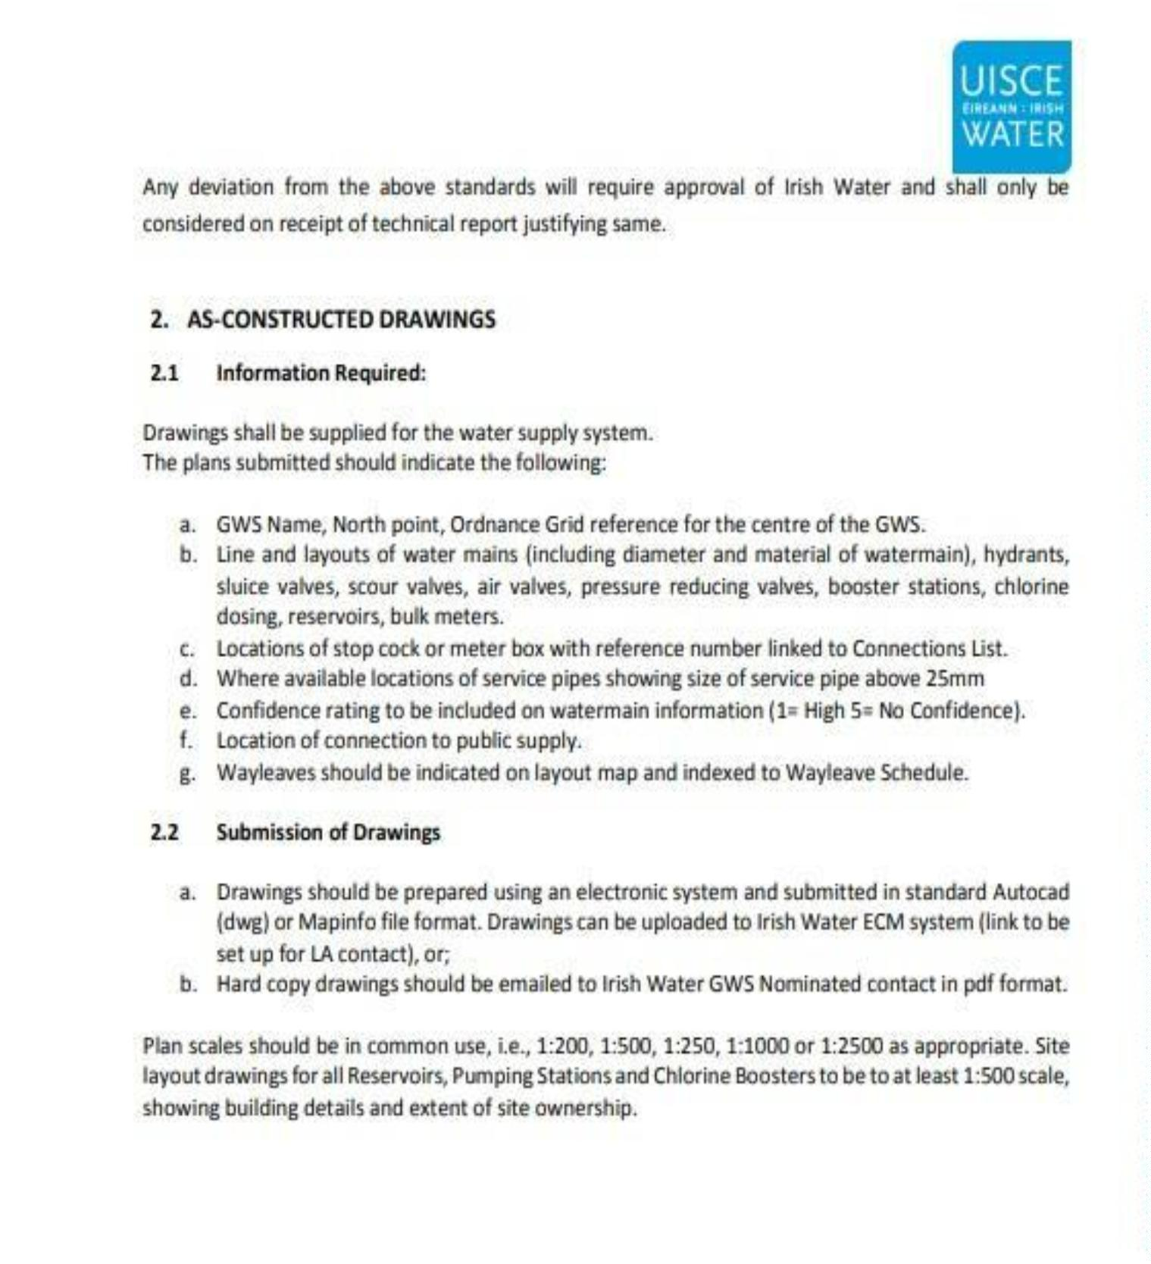

Request for Tender – Engineering Services – Moyasta GWS
Appendix B UE Submission Requirements
The following is a non-exhaustive list of the UE submission requirements as part of the Taking in Charge.
Application Form
•
•
•
•
•
Section 1: Network Summary
Section 2&3: Background & Historical Information.
Section 4&5: Customer and Billing Information.
Section 6: Technical Information.
Section 7: Wayleave and Land Transfer Schedule
Consent forms
Fully completed & signed by not fewer than 2/3 of the members of the network.( already completed and
submitted to CCC in 2021)
Connection Schedule
Listing customer name, address, Eircode and meter ING coordinates.
As Constructed drawings
as per UE Basic Standards.
Wayleave and/or Land Transfer documents,
if applicable, and network layout map referencing the wayleaves.
UFW data
In the form of a 7 – day logger flow graph, minimum requirements as per UE Basic Standards.
Water sample analysis
Confirming compliance with Drinking Water regulations.
Technical report
Outlining if any monies owed by customers, and a statement signed by relevant party proposing that the
network should be TIC by UE.
Page | 21

