

SECTION 3
Technical Appendices for
UHF Antennas at
Woodcock Hill and Aranmore

Tender Doc. 2RN2604-03

Woodcock Hill
1.1 Summary
Replacement spine on top of the mast with a single UHF antenna system. The existing spine hosts one 4H x 2R antenna.

Site Name | Woodcock Hill
Coordinates | 52.71977, -8.692273
Site Height | 254m
Support Structure | 640mm square spine on Tower
Structure Outline Drawing. | As per attached drawing
Total Tower Height | 56m (including existing spine)
Design Wind Speeds Vz (m/s) | 81 m/s (Factored gust wind speed)

1.2 Existing Transmitting System Details

Existing Antenna | 4H x 2R
Existing Channels in use | 44, 47
Antenna Height | 50-56m
Main Feeders Number | 2
Feeder Type | 1 5/8”

1.3 New Antenna Requirements (Tendered Antenna Systems)

Antenna Title | UHF1
Estimated Feeder Length | 90m
Number of Feeders | 2
Estimated Feeder Requirements | 1 5/8”
Fault Conditions | Full power into half stack.
Available Aperture | 50-56m
Configuration (suggested) | 4 x 2
Channel Range | 21 - 48
Optimised Channels | Priority 1 – 44, 47  Priority 2 – 39, 41, 42, 45  Priority 3 – all others from 21 to 37
Polarization | Horizontal
Max ERP | 10kW or more
Number of services (at full power) | 2
Tx Output Power per service | 1 kW
In building losses | 1dB
Beam tilt | 1.5 degrees

1.4 Radiation Pattern Template

Azimuth | Normalised Gain (dB) | Azimuth | Normalised Gain (dB) | Azimuth | Normalised Gain (dB)
0 | -20 | 120 | 0 | 240 | -4
10 | -20 | 130 | 0 | 250 | -7
20 | -20 | 140 | 0 | 260 | -12
30 | -20 | 150 | 0 | 270 | -20
40 | -20 | 160 | 0 | 280 | -20
50 | -12 | 170 | 0 | 290 | -20
60 | -7 | 180 | 0 | 300 | -20
70 | -4 | 190 | 0 | 310 | -20
80 | -2 | 200 | 0 | 320 | -20
90 | -1 | 210 | 0 | 330 | -20
100 | 0 | 220 | -1 | 340 | -20
110 | 0 | 230 | -2 | 350 | -20

1.5 Tower Drawing – existing spine with existing 2R x 4H antenna

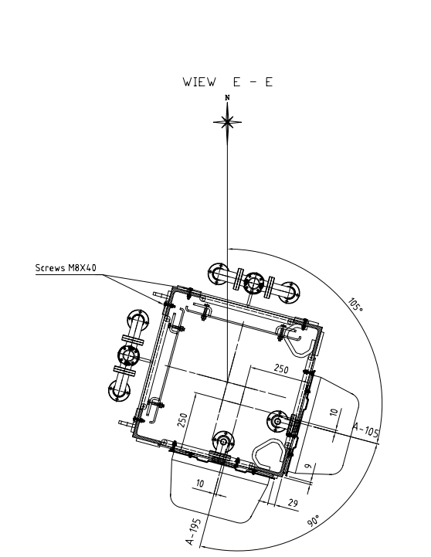

Aranmore

2.1 Summary
Replacement UHF antenna system mounted on a triangular mast. The existing mast hosts one 8H x 2R antenna.

Site Name | Aranmore
Coordinates | 54.983287, -8.508962
Site Height | 120m
Support Structure | Stayed Mast
Structure Outline Drawing. | As per attached drawing
Total Mast Height | 50m
Design Wind Speeds Vz (m/s) | 70 m/s (Factored gust wind speed)

2.2 Existing Transmitting System Details

Existing Antenna | 4H x 2R
Existing Channels in use | 44, 47
Antenna Height | 38m – 47m
Main Feeders Number | 2
Feeder Type | 1 5/8”

2.3 New Antenna Requirements (Tendered Antenna Systems)

Antenna Title | UHF1
Estimated Feeder Length | 70m
Number of Feeders | 2
Estimated Feeder Requirements | 1 5/8”
Fault Conditions | Full power into half stack.
Available Aperture | ~ 38m – 47m
Configuration (suggested) | 8 x 2
Channel Range | 21 - 48
Optimised Channels | Priority 1 – 44, 47  Priority 2 – 32, 34, 35, 40, 41  Priority 3 – all others from 21 to 37
Polarization | Vertical
Max ERP | 5.5kW
Number of services (at full power) | 2
Tx Output Power per service | 250 W
In building losses | 1dB
Beam tilt | 2.5 degrees – with heavy null fill

2.4 Radiation Pattern Template

Azimuth | Normalised Gain (dB) | Azimuth | Normalised Gain (dB) | Azimuth | Normalised Gain (dB)
0 | -12 | 120 | 0 | 240 | -20
10 | -8 | 130 | 0 | 250 | -20
20 | -5 | 140 | 0 | 260 | -20
30 | -3 | 150 | 0 | 270 | -20
40 | -1 | 160 | 0 | 280 | -20
50 | 0 | 170 | -1 | 290 | -20
60 | 0 | 180 | -3 | 300 | -20
70 | 0 | 190 | -5 | 310 | -20
80 | 0 | 200 | -8 | 320 | -20
90 | 0 | 210 | -12 | 330 | -20
100 | 0 | 220 | -20 | 340 | -20
110 | 0 | 230 | -20 | 350 | -20

2.5 Mast Drawing – existing triangular mast (700mm face width)

