Request for Tender
for
Engineering Inspection of Construction of New Car Park



Ballina Stephenites GAA Club, Stephenites Ground, Lord Edward St, Carrowcushlaun West, Ballina, Co. Mayo, F26 E622

Table of Contents
Section 1: Introduction, Background and Summary of Requirements 3
Section 2: Scope of Services 3
Section 3: Reporting and Deliverables 3
Section 4: Engineer Qualifications 4
Section 5: Summary 4
Section 6: Evaluation of Quotations and Suitability 5
Section 7: Information and Format Required from the Tenderer 6
Section 8: Description of the Existing Car Park and Project 7

Section 1: Introduction, Background and Summary of Requirements

Ballina Stephenites GAA Club CLG (the “Contracting Authority”) invites tenders (“Tenders construction work) for the appointment of a suitably qualified and experienced Consulting Engineer to provide periodic inspection, review, and certification services for construction works to the entrance avenue and car park at the James Stephens Park, Lord Edward St, Carrowcushlaun West, Ballina, Co. Mayo, F26 E622.

The relevant CPV codes are:
Engineering inspection services | 71356000-1
Technical inspection services | 71631000-0
Civil engineering consultancy services | 71311000-1
Primary CPV: 71356000-1 — Engineering inspection services
Secondary (optional): 71311000-1 — Civil engineering consultancy services

Section 2: Scope of Services

The appointed engineer will act on behalf of the Contracting Authority to ensure that the works are carried out in accordance with the approved design, specification, and industry standards.

The engineer’s duties will include:

- Reviewing the contractor’s proposed materials and work;
- Visiting the site approximately four to five times during the works to inspect progress and workmanship;
- Preparing concise inspection notes for each visit;
- Preparing 1 interim report;
- Preparing a Final Inspection and Certification Report confirming that the works have been completed to the required standard.

The construction works are expected to last approximately one to two months. The engineer’s commission will extend slightly beyond this to include pre-start review and post-completion certification.

This is a professional services appointment under an open procedure (below EU threshold).

Tender submissions must include:
- Quotation
- TCC and TCAN
- Evidence of insurance cover (Professional Indemnity, Public Liability).

Section 3: Reporting and Deliverables

The deliverables are:
- Pre-Start Review: Assessment of proposed materials and contractor method statements.
- Periodic Inspections: 4–5 site visits during construction.
- Inspection Notes: Short written record of each visit.
- One Interim and a Final Certification Report:
  - Confirmation that the works comply with the contract specification and applicable standards.
  - The interim report is to support a phase payment.

The standard of workmanship and materials shall be judged against:
• Transport Infrastructure Ireland (TII) Specification for Road Works, Series 700 (Road Pavements) & Series 900 (Materials).
• BS EN 13108 – Bituminous mixtures.
• BS 594987:2015 – Asphalt for roads and other paved areas (laying and compaction).
• Health & Safety Legislation and Construction Regulations 2013 (as amended).
• The approved design drawings and specifications for the project.

Section 4: Engineer Qualifications

The engineer must be competent under the Safety, Health and Welfare at Work (Construction) Regulations 2013 (as amended), and act in a supporting capacity to the PSDP/PSCS where appropriate.

The engineer appointed shall have:
- A degree in civil or structural engineering (NFQ Level 8 or equivalent).
- Registration as a Chartered Engineer (CEng) with Engineers Ireland or an equivalent professional body.
- A minimum of five years’ relevant post-qualification experience in civil engineering inspection, pavement or car park surfacing.
- Familiarity with bituminous materials, TII specifications, and quality control procedures for road or car park works.

Section 5: Summary

Tender Type | Open tender for professional engineering services
Contract Form | Public Services Contract
Primary CPV Code | 71356000-1 — Engineering inspection services
Estimated Duration | 1–2 months for construction + certification
Engineer Visits | 4–5 total
Engineer Qualifications | Chartered Civil Engineer or Equivalent
Standards Referenced | TII Specification, BS EN 13108, BS 594987

Deliverables Summary:
Deliverable | Timing
Pre-start review of materials/methods | Before works start
Periodic inspection reports (4–5) | During construction
Final certification report | On completion

All queries relating to any aspect of this should be submitted to ballinastephenitesgrantswork@outlook.com or 086-3086047.

Section 6: Evaluation of Quotations and Suitability

To constitute a suitable and valid bid the following conditions must be adhered to;
- The bid must have been submitted before the advertised deadline.
- The tenderer must be able to deliver all the services.
- The tenderer must be a registered as a Chartered Engineer (CEng) with Engineers Ireland or an equivalent professional body.
- The bidder’s tax clearance form and TCAN must be submitted.
- The bidder must have an office located within 30 minutes travel time by car from the work site.

Failure to adhere to any of these conditions means the tender is immediately invalid. Invalid tenders will not be considered.
Price and technical match for the cervices sought will be used as the evaluation criteria.

The evaluation criteria is the lowest substantially compliant bid.

Section 7: Information and Format Required from the Tenderer

The Form of Tender for this competition shall consist of a written quotation describing and itemising the proposed works. The quotation must clearly show the net cost, the applicable VAT, and the total cost inclusive of VAT. Tenderers are also required to submit valid Tax Clearance details, including a current Tax Clearance Certificate (TCC) and the associated Tax Clearance Access Number (TCAN).

The quotation submitted must comply with the following requirements:

- The document must be clearly titled “Quotation” and must not be described as an order, invoice, proforma, or any other document type. A quotation reference or number should be included where applicable.

- The quotation must clearly state the name, address, and contact details of the individual, organisation, business, or company providing the quotation.

- The quotation must be addressed to Ballina Stephenites GAA Club, James Stephens Park, Lord Edward St, Carrowcushlaun West, Ballina, Co. Mayo, F26 E622.

- The date on which the quotation is issued must be clearly shown.

- The quotation must include clear details of the works proposed.

In relation to pricing, the quotation must:

- Itemise the individual elements or items of the works and add these together to give a total net cost.

- Clearly identify all costs in the Euro (€).

- Clearly state the applicable VAT rate and VAT amount, shown separately.

- Clearly state the total cost inclusive of VAT.

- The quotation must be signed by the person providing it. An electronic signature, including signature by email, is acceptable.

Section 8: Description of the Existing Car Park and Project

The car park is to be built on a green area at the back of the Ballina Stephanites GAA Clubhouse.

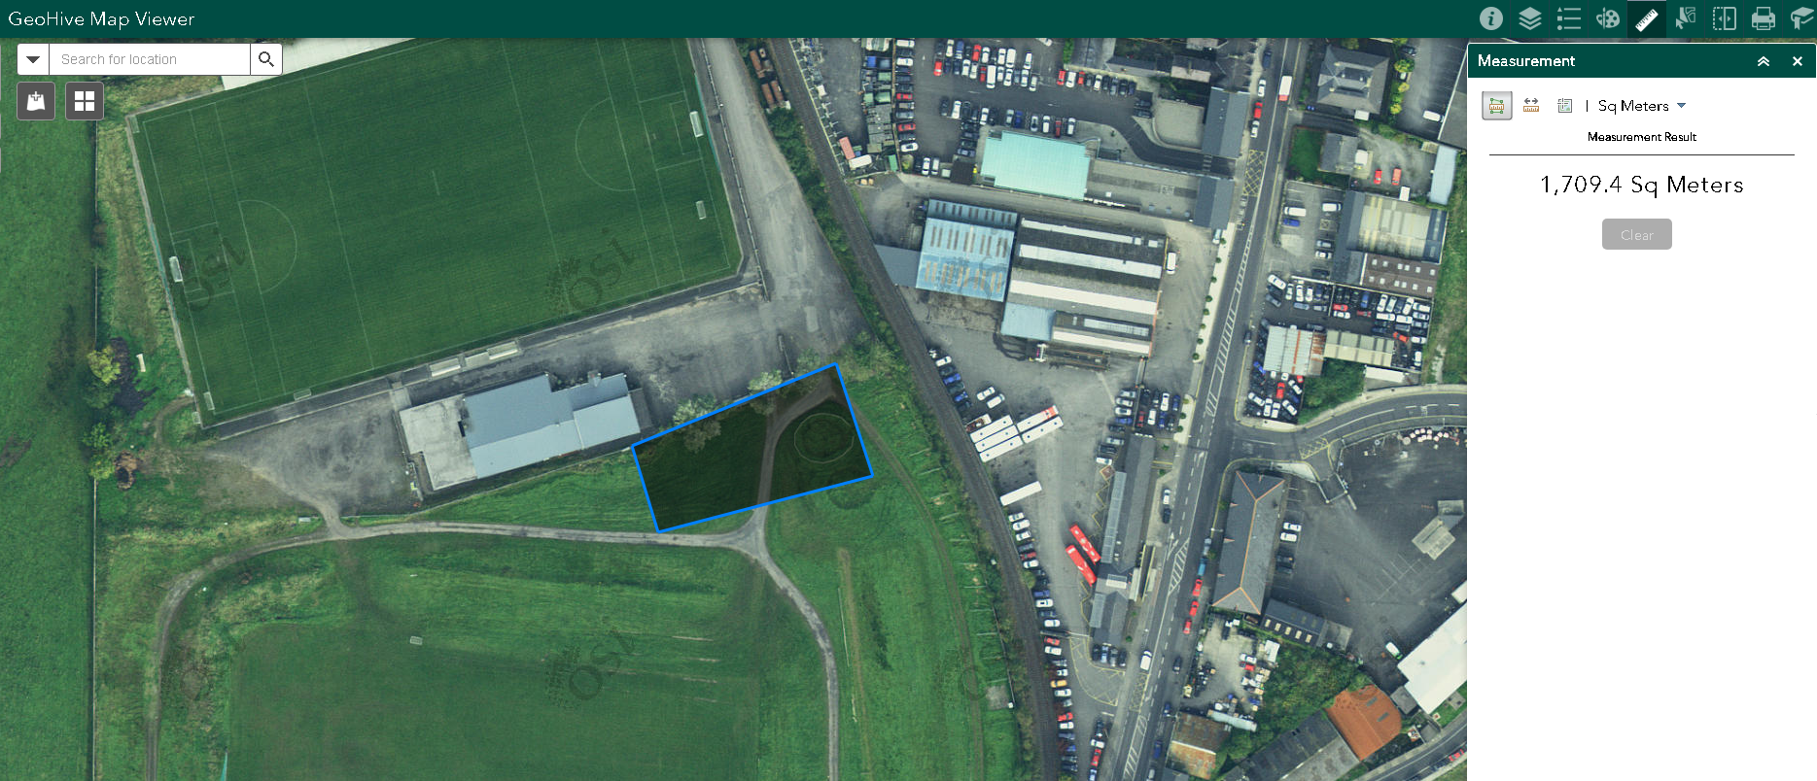
Figure: Size and location of the new car park.

Construction Description
- Strip 1,709.4m² existing stone road and grass back.
- Install 6 rainwater gullies (one from each corner and two from the middle) with 100mm PVC piping to the to an attenuation tank located beside the gate from the existing car park into the showgrounds.
- Connect storm water gullies to new storm drain and allow for all associated pipework, gully pots and steel grates.
- Lay Clause 804 over entire area 1,709.4m² along with kerbing.
- Lay stone mastic asphalt over entire area 1,669.3m².
- Line marking to finished stone mastic asphalt.

Figure: The James Stephens Park, home of Ballina Stephenites GAA

