

Provision, Supply and Delivery of Event Management & Production Services to

South East Technological University

Ref: EVENTSETU202607

Issue Date: | 31st July 2026
Contact Details for Queries: | https://www.etenders.gov.ie
Closing Date for Receipt of Queries: | 7th August 2026 @ 12pm
Deadline for Receipt of Tenders: | 31st August 2026 @ 12pm

Please note that all information relating to this tender, including clarifications and changes, will be published on the Irish Government Procurement Opportunities Portal (www.etenders.gov.ie) only. Registration is free of charge and there is no charge for documents.
South East Technological University will not accept responsibility for information relayed (or not relayed) via third parties.

Table of Contents

Section | Description | Page
 | Introduction, SETU and Contract Objectives | 3
A | Checklist for Tender Submission | 5
B | Qualification Criteria | 6
C | Award Criteria and Tender dates | 8
D | Instructions to Tenderers | 9
E | Specifications/Scope of Requirements | 16
Appendix 1 | Form of Tender | 19
Appendix 2 | Declaration of Bona Fide | 21
Appendix 3 | Certificate relating to Bona Fide Tender | 25
Appendix 4 | Company Information | 26
Appendix 5 | SETU Arena information | 29
Appendix 6 | Photos from previous events | 31

Introduction

On 1st May 2022, the newest university in Ireland, South East Technological University (SETU) was established. SETU is a multi-regional university with campuses in Carlow, Waterford, Wexford and Wicklow with over 18,000 learners and 2,000 staff. The University will graduate over 6,000 students each year.

SETU operates in the context of the south east region which is experiencing an exciting period of significant change through a rapid population increase of over 35% since 1991, an economy that is diversifying in the light of shifting national, European and global environments, and a changing socio-cultural landscape marked by increased diversity, new patterns of population distribution and a changing demographic profile.

SETU will provide leadership and act as a centre of knowledge, research and innovation in the region. Additionally, it will look outward to help the region to capitalise on the broader economic drivers, nationally and internationally. It will educate and nurture future generations of active and engaged citizens across the south east region and will be a driver of social inclusion, social justice and of technological, cultural and artistic activity in the coming decades.

Contract Objectives and Duration

The objective of this Request for Proposal (RFP) is to provide the appropriate infrastructure required for the Waterford Campus Conferring ceremony. This includes, lighting, sound, staging, trussing, drapes, and the associated logistic support (qualified personnel).

This is a procedure leading to a framework agreement between SETU and the supplier(s) for a draw down list of services. The typical requirements would be the provision of staging, trussing, drapes, lighting and other AV equipment for annual conferring events at the SETU Arena Waterford X91 XD96. Conferring ceremonies take place over 2-3 days, generally in late October, early November and may include 3 or 4 ceremonies, of approximately 2hr duration, per day. There is also a set-up period required. The pack down, storage and collection of all equipment will be required, immediately after the close of ceremonies on the last day.

SETU in conjunction with Novus (SETU | Subsidiaries) will manage events. All rigging and construction activities must be approved with the appropriate personnel prior to the commencement of works.

It is envisaged that the main drawdown from this tender will be in support of events held at SETU Arena (SETU Arena). However, services may be required at other locations across SETU as the need arises.

The SETU Arena, the largest conference and events centre in the south east of Ireland, consists of a main hall (2,000m²) which can accommodate 2,000 people for a seated conference or between 2,000 – 5,000 people standing events. The arena also features a catering service with a full range of culinary options. Please see appendix 6 and 7 for further details and pictures from previous events.

Contract is for 3 years with an option to extend for 1 x 12 months.

SECTION A - Checklist for Tender Submissions

In order to allow SETU to evaluate fully completed proposals, tenderers are advised to ensure that their responses include ALL of the following information:

- Response to Qualification Criteria Requirements (Section B of this Tender Document)
- Completed and signed Form of Tender including all relevant information (Appendix 1)
- Completed and signed Declaration of Bona Fides and Declaration re Statutory Obligations (Appendix 2 & 3)
- Completed sections on Company Information, Economic & Financial Standing, Insurances, Previous Relevant Contracts sections (Appendix 4)
- All other responses required in accordance with this Tender Document as required, to be completed by the Tenderer and any proposed subcontractor/partner

The above checklist is for guidance purposes only and the contracting authority will not accept any responsibility for omissions from this checklist. Tenderers are advised to read all tender documentation and appendices in full in order to provide a comprehensive response.

SECTION B – Qualification Criteria

Tenderers will either Pass or Fail each of the Qualification Criteria in this section. In the event of one or more Qualification Criteria achieving a fail, the Tenderer will be excluded from participating in this Competition.

Information outlined below should be submitted in the order requested. Any additional information you feel may be relevant to these sections may also be added.

Economic & Financial Standing

Tenderers must have a minimum turnover of €100,000 (ex VAT) as set out below: per annum in each of the three most recent financial years.

However, where the preferred bidder is unable for a valid reason to provide such documentation, they must inform the Contracting Authority of the valid reason as to why the documentation cannot be supplied. They must also provide other suitable alternative documentation to prove their economic and financial capacity to the satisfaction of the Contracting Authority

Rule: Complete and return Appendix 2 of this tender document.

Insurance Levels

The successful tenderer shall be required to hold for the term of the Contract the following insurance:
Minimum levels of insurance:
- Details of Employers Liability - €13 million Euro any one accident
- Product/Public Liability - €6.4 million
- Professional Indemnity - €1m for any one claim or series of claims arising out of a single occurrence, per insurance year (for each and every claim excluding defence costs)

Rule: Candidates must provide the insurance details required in Appendix for this tender document and include copies of their insurance policies or letter of confirmation from their insurance company. Companies should also complete Appendices 3 & 4.

Professional Ability

Company Information and Previous Contracts:
Rule: Complete and return the relevant details requested in Appendix 4 of this Tender document.

Health & Safety Policy

Rule: Candidates must submit evidence of their Health & Safety Policy and compliance with Safety, Health and Welfare at Work Act 2005, Safety, Health and Welfare at Work (General Application) Regulations 2007 with their tender submission.

Selection Criteria | Max Score
Economic & Financial Standing | Pass/Fail
Insurance Levels | Pass/Fail
Professional Ability:  Previous Contracts  Company Information | Pass/Fail
Health & Safety Policy | Pass/Fail
SECTION C - Award Criteria and Tender dates

The evaluation of tender submissions will be on the basis of the award criteria as set out below.

Award Criteria | Score
Price | 50
Quality of Technical Proposal, including comprehensive plan, method statement and equipment used. | 35
References attesting to the quality of Event services delivery, at a high corporate level and similar services supplied to organisations. Track record of vendor in supplying similar services into the corporate sector, considering size and scale of previous similar contracts. Visual proof of quality of corporate stage services, provided to an organisation, any relevant testimonials of how neat and clean the installation is. | 15

Scoring:

Weighting | Meaning
91% - 100% | An excellent response, with very few or no weaknesses, that demonstrates a complete understanding of requirements and provides comprehensive and convincing assurance that the Tenderer will deliver to an excellent standard.
80% - 90% | A very good response that demonstrates real understanding and fully meets the requirements and assurance that the Tenderer will deliver to high standard.
60% - 79% | A satisfactory response which demonstrates a reasonable understanding of requirements and gives reasonable assurance of delivery to an adequate standard but does not provide sufficiently convincing assurance to award a higher mark.
30% - 59% | A response where reservations exist. Lacks full credibility/convincing detail, and there is a significant risk that the response will not be successful.
1% - 29% | A response where serious reservations exist. This may be because, for example, insufficient detail is provided, and the response has fundamental flaws, or is seriously inadequate or seriously lacks credibility with a high risk of non-delivery.
0% | Response completely fails to address the criterion under consideration

Cost Assessment
The lowest Ultimate Cost tender will receive the maximum score achievable under this criterion.

Cost Score | = | Lowest Eligible Tendered Rate | x | Maximum Number of Marks Available
Cost Score | = | ________________________  Tendered Rate under evaluation | x | Maximum Number of Marks Available

Tender dates

Receipt of Queries | 7th August 2026 @ 12pm
Publication of response to queries | 14th August 2026 @ COB
Receipt of Tender submissions by eTenders | 31st August 2026 @ 12pm

SECTION D - Instructions to Tenderers

DEFINITION "THE CLIENT" - REFERS TO SETU

Tender Documents - Ambiguity, Discrepancy, Error, Omission
If you consider that you are missing any documents that would prevent you from submitting a comprehensive tender please submit your query as soon as possible using the messaging facility on www.etenders.gov.ie. Responses to all such queries will be published through www.etenders.gov.ie on the date set out below. Responses will be issued to all interested parties to ensure that no party has an unfair advantage over any other

Tenderers shall immediately notify the Client should they become aware of any ambiguity, discrepancy, error or omission in the tender documents. The Client shall, upon receipt of such notification, notify all tenderers of its ruling in respect of any such ambiguity, discrepancy, error or omission. Such ruling shall be issued in writing and shall form part of the tender documents.

Closing Date and Time for Receipt of Tenders
The deadline date for receipt of tenders:31st August 2026 at 12.00 noon faxed, emailed or late tenders will not be accepted.

Queries
Queries relating to this tender can be submitted using the messaging facility on www.etenders.gov.ie. Responses to all such queries will be published through www.etenders.gov.ie on the date set out below. Responses will be issued to all interested parties to ensure that no party has an unfair advantage over any other. The details of the person submitting a query will not be disclosed when circulating the responses. Queries should clearly state the tender reference in the subject field. Deadline for receipt of queries is 7th August 2026 @ 12 noon and answers will be published on 14th August 2026 by COB.

Health & Safety
Tenderers must comply fully with Health & Safety regulations. In addition, the successful tenderer will be familiar with the University’s Safety Statement, copy available on website,
SETU | Safety Statements & Risk Assessments and shall comply with its requirements.

Tender Submission
Completed tender submissions should be submitted electronically via the eTenders platform using the online portal on www.etenders.gov.ie

Cost of Preparation of Tender
The Client will not be liable for any costs incurred by tenderers in the preparation of proposals or any associated work effort. It is the responsibility of the tenderer to ensure that they are fully aware and understand the requirements as laid down in this document. Tenderers will be responsible for any costs incurred by them in the event of they being required to attend clarification, other meetings or make a presentation of their proposals or supply samples for evaluation.

Tender Validity Period
To allow sufficient time for eTender assessment, a Tender Validity period of 120 days is required, this period commencing on the closing date by which the tenders are to be returned. If the contract is awarded within the validity period, then the prices must be held firm for the duration of the contract. No price increase during the lifetime of the contract will be accepted.

Pricing
All prices quoted must be inclusive (i.e. including but not limited to shipping, packaging, delivery, ancillary costs and all other costs/expenses), expressed in Euro only and exclusive of VAT. The VAT rates where applicable should be indicated separately.

Confidentiality
The distribution of the tender document is for the sole purpose of obtaining offers and does not grant permission or licence to use the documents for any other purpose.

Tenderers are required to treat the details of all documents supplied in connection with the tender process as private and confidential.

1. The University proposes that the following information relating to this tender competition will be made available.

- Contract price
- Name of successful tenderer and scores awarded
- Reasons for non-acceptance of the enquirer’s tender

2. The University undertakes to hold confidential any information provided by you in this tender subject to:

  - Disclosure of the information specified in 1 above as liable for release to the public
  - The University obligations under law, including Freedom of information Act, which came into force on 21 April 1998.

Conflict of Interest
Any conflict of interest or potential conflict of interest on the part of a tenderer, subcontractor or individual employee(s) or agent(s) of a tenderer or subcontractors(s) must be fully disclosed to the Contracting Authority as soon as the conflict or potential conflict becomes apparent. In the event of any actual or potential conflict of interest, the Contracting Authority may invite tenderers to propose means by which the conflict of interest might be removed. The Contracting Authority will, at its absolute discretion, decide on the appropriate course of action, which may in appropriate circumstances include eliminating a tenderer from this competition or terminating any Goods Contract entered into by a tenderer.

Freedom of Information Act
Tenderers should be aware that, under the Freedom of Information Act 2014, information provided by them during this competition may be liable to be disclosed.

Tenderers are asked to consider if any of the information supplied by them in their tender should not be disclosed because of its confidentiality or commercial sensitivity. If tenderers consider that certain information is not to be disclosed because of its confidentiality or commercial sensitivity, tenderers must, when providing such information, clearly identify and specify the reasons for its confidentiality or commercial sensitivity. If tenderers do not identify information as confidential or commercially sensitive, it is liable to be released in response to a Freedom of Information request without further notice or consultation with the tenderer. The Contracting Authority will, where possible, consult with tenderers about confidentiality or commercially sensitive information identified before making a decision on a request received under the Freedom of Information Act.

Tax Clearance Certificate
In the case of all public sector contacts of a value of €10,000 (inclusive of vat) or more within any 12-month period, the contractor will be required to produce a C2 certificate, a valid Tax Clearance Certificate (Foreign Supplier) or Tax Reference Number (TRN) for verification on the Revenues ETax Clearance system. It will be a condition of award of contact that the successful tenderer must comply with Circular 43/2006 Tax Clearance procedures – Public Sector Contracts. See Irish Revenue web site http://www.revenue.ie.
Prior to the award of any contract arising out of this competition the successful tenderer shall promptly produce a Tax Clearance Certificate or Tax Reference Number (TRN) from the Irish Revenue Commissioners.

Irish Legislation
Tenderers should be aware that national legislation applies in matters such as Employment, Working Hours, Official Secrets, Data Protection, Health and Safety and Waste Management Acts (EEE & WEEE). All relevant aspects of such legislation must be observed at all times by the successful team.

Confidentiality of Evaluation
After the official opening of tenders, information relating to the examination, clarification, evaluation and comparison of tenders and recommendations concerning the award of contract will not be disclosed to tenderers or any other persons save as required by law.

Determination of Responsiveness
After the official opening of tenders, the Client, his staff or agents will determine whether each tender is substantially responsive to the requirements of the tender documents.

If a material deviation exists that limits in any substantial way the Client’s rights or the tenderer’s obligations under the Contract, the tender shall be rejected.

Clarification of Tenders
To assist in the examination and comparison of tenders, the Client may ask tenderers for clarification of their tenders, including breakdowns of unit prices. No change in the price or substance of the tender shall be sought, offered or permitted. To assist in finalising the tender evaluation, selected tenderers may be invited to attend clarification meetings with the Client.

Correction of Errors
    - Where there is a discrepancy between amounts in figures and words, the amount in words shall apply.
    - If applicable where there is a discrepancy between the sum of the prices quoted under Detailed Cost Sheets and the lump sum fee quoted in the Form of Tender, the latter will normally prevail unless, in the opinion of the Purchaser, there is a clear and manifest error in the lump sum fee. In this case, the amount stated in the Form of Tender will be adjusted by the Purchaser, with the agreement of the tenderer, by aggregating the prices quoted under Detailed Cost sheets.
    - The above procedure shall be binding upon the tenderer and a tenderer not accepting the correction of their tender as described above shall have their tender rejected.

Change in the Composition of a Tender
The Client reserves the right, but is not obliged, to disqualify any tenderer that makes any change to its composition after submission of a tender.

Interference
Any effort by the tenderer to unduly influence the Client, relevant agency personnel or any other relevant persons or bodies in the process of examination, clarification, evaluation and comparison of tenders and in decisions concerning the Award of Contract, shall have their tender rejected. In accordance with Section 38 of the Ethics in Public Office Act 1995 any money, gift or other consideration from a person holding or seeking to obtain a contract will be deemed to have been paid or given corruptly unless the contrary is proved.

Inducements to Purchase
The Client shall be entitled to terminate any contract and to recover from the service provider the amount of any loss resulting from such termination in the following circumstances:

- if the service provider has offered, given or agreed to give to any person any gift or consideration of any kind as an inducement or reward for doing or forbearing to do, or for having done or forborne to do, any action in relation to the obtaining or execution of this Agreement or any other contract with the Client, or showing or forbearing to show favour or disfavour to any person in relation to this Agreement or any other contract with the Client, or

- if like acts have been done by any other person employed by the service provider or acting on its behalf (whether with or without the knowledge of the service provider).

Notification of Tender Evaluations
All tenderers will be informed of the outcome of their proposals following tender evaluation. Potential outcomes can be:

- Letter of Regret (including scores under each criteria, plus winning tender score)
- Letter of intent to Award of Contract

Publication
All information relating to this tender, including tender documentation, clarifications and changes, will be published on the eTenders website (www.etenders.gov.ie) only. Registration is free of charge and there is no charge for documents. SETU will not accept responsibility for information relayed (or not relayed) via third parties. If the RFT is in any way altered or edited, the subsequent tender may be deemed inadmissible.

Payment
Payment terms will be in accordance with the Late Payment in Commercial Transactions Regulations (2002) or as agreed with SETU. The University operates a 30-day credit period; however, SETU is committed to reducing the payment period to suppliers for commercial transactions from 30 to 15 calendar days, on receipt of a valid invoice, as a means of easing cash flow difficulties for businesses, as set out by The Department of Education and Skills.
Original invoices should be sent directly to accountspayable@setu.ie

- Cancellation of Tender Process
In the event of cancellation of the competitive process/tender procedure, tenderers will be notified of the cancellation by SETU. Cancellation may occur where:
- The tender procedure has been unsuccessful; i.e. no qualitative or financially worthwhile tender has been received or there is no response at all.
- The economic or technical data of the project has been fundamentally altered.
- Exceptional circumstances of force majeure render normal performance of the contract impossible.
- All technically compliant tenders exceed the financial resources available.
- There have been irregularities in the procedure, in particular where these have prevented fair competition.

In no event shall SETU be liable for any damages whatsoever including, without limitation, damages for loss of profits in any connection with the cancellation of a tender procedure even if SETU has been advised of the possibility of damages. The publication of a procurement notice does not commit SETU to implement the programme or the project announced.

- Standstill Period
In circumstances where Directive 89/665/EEC as amended by Directive 2007/66/EC (the “Remedies Directive”) applies, no contract can or will be executed or take effect until at least fourteen (14) calendar days after the day on which the tenderers have been sent a notice informing them of the result of this competition (the “Standstill Period”) if such notice is sent by electronic means. The Standstill Period shall be sixteen (16) calendar days if such notice is sent by other means. The preferred bidder will be notified of the decision of the Contracting Authority and of the expiry date of the Standstill Period.

Tenderers should note that the Contracting Authority may, when notifying tenderers of the results of this competition, include the scores obtained by the tenderer concerned and obtained by the preferred bidder in respect of each award criterion assessed by the Contracting Authority.

- Employment Law
The successful service provider shall throughout the period of the contract comply with and ensure that its staff (and subcontractors) will comply with all relevant legislation relating to employment.

Under Article 27 of Directive 2004/18/EC as implemented into Irish Law by Regulation 27 of European Communities (Award of Public Contracts) regulations 2006 (S.I 329 of 2006) tenderers must provide a statement that they have taken account of their legal obligations relating to employment protection and working obligations for the provision of services sought under this tender.

27. Procurement of energy services, products, equipment and energy
As per the EUROPEAN UNION (ENERGY EFFICIENT PUBLIC PROCUREMENT) REGULATIONS 2011 known as S.I. 151 of 2011, which states Public bodies, which includes SETU, should only procure equipment or vehicles which are listed on the Triple E register or satisfy the SEAI published energy criteria.
See more at: http://www.seai.ie/Your_Business/Triple_E_Product_Register/#sthash.pRLWkAkI.dpuf
http://www.irishstatutebook.ie/eli/2011/si/151/made/en/pdf.

SECTION E - Specifications

- Provision and rigging of suitable trussing and drapes to form a stage area
- Provision and construction of stage for events
- Provision and rigging of suitable lighting and control equipment
- Provision and rigging of suitable audio equipment
- Provision and rigging of suitable video equipment; cameras, projectors, screens
- Supply of suitably qualified personnel to operate event equipment
- Where necessary, design, specify and implement lighting design for events
- Additional AV equipment to supplement SETU equipment e.g. extra sound equipment
- Supply qualified stage crew to run events
- Supply qualified pyrotechnic and special effects operators
- Attend event planning meetings and draw up a project plan with approved timelines for delivery, construction/rigging and removal of all event equipment
- Provide plan for set-up and takedown
- Directly after final show, breakdown and proper storage of all SETU Trussing and Curtains, boxed and placed back in storage area.

Notes:

Tenderer must factor in any height for hire requirements
Tenderer must factor in any travel time or expenses
Tenderer must factor in any fork-lifting requirements

For larger items, please indicate cost per item, but for smaller items, e.g. staging an overall cost for staging will suffice without the need for an itemised breakdown. The costs are calculated on delivery of an event at SETU Waterford Arena and all costs associated with travel, accommodation or ancillary facilities such as height for hire must be borne by the supplier.

Candidates must complete all parts of this form which should then be signed and returned with the submission. Failure to do so may result in an invalid submission

Qty | Description | Cost €
Lighting and cables
8 | - Full Color LED (RGBAL) ERS-style lighting fixture  - Color Temperature Presets from 2800 K to 6500 K  - Variable beam angle  - Min lumens 3,000
8 | RGBW 37 x 10watt LED Wash fixtures  Min lumens 4,000
6 | Multi-function lamps min 40,000 lumen  Zoom range 5 – 55  2 gobo wheels  Includes frost/colours etc.
32 | RGBW colour mixing LED lamps Min 1,000 lumen
1 | DMX buffer
1 | Lighting console to control above lamps and include memory to record cues
100 | Assorted short and long power cables and dmx
Total for lighting
Staging
52 | 2m x 1m stage deck
220 | 1m legs
3 | 1m x 1m stage deck
2 | 1m high steps
11 | 2m handrail modules
3 | 1m handrail modules
15m | 1m black skirt
Total for staging
Rigging
28 | 3m lightweight truss
20 | 1ton motors
1 | 24-channel motor control
16 | 20m soca
6 | 10m soca
10 | Motor fan outs
14 | 5m motor cable
20 | 2m soft span
35 | RSJ beam clamp 1Ton
75 | 3.25ton shackle
15 | 10ft 1ton steel
15 | 5ft 1ton steel
4 | 9m x 12m black drapes
6 | 9m x 9m black drapes
Total for rigging
AV
4 | Compact line array system capable of 130 db spl totalling 8 half arrays and 4 subwoofers. With mounting poles and tripods
 | Cabling for above
Total for AV
Crew
8 | 2-days fit up
4 | 1-day get out
Total for crew

Rate Card. Per diem rate:

Qty | Detail | Cost €
1 | Designer per day
1 | Rigger per day
1 | Crew per day

APPENDIX 1 – FORM OF TENDER

MUST BE COMPLETED AND RETURNED

Tender for

Event Management & Production Services to

South East Technological University

Candidates must complete all parts of this form which should then be signed and returned with the submission. Failure to do so may result in an invalid submission.

Total Cost € (excl VAT)
Cost of delivery, fitting up and taking down of kit list in specification section. Fit up to take no longer than 2 days and take down no longer than 1 day.

for the sum of €…………………………
plus, Irish VAT €……………………….

I/We the undersigned do offer to provide SETU with …………….. as specified in this document at the rates set out in the Pricing Schedule, and subject to the service requirements and quality standards as set out by SETU in this document.

I/We confirm that all information and commitments contained in or referred to in my/our tender are (i) accurate and correct, and (ii) accurately reflect my/our actual current operational and managerial capability.

I/We confirm that my/our tax affairs are in order and that, if awarded the contract,
I/we will be in a position to provide SETU promptly with a current valid Tax Clearance Certificate or Statement of Suitability from the Irish Revenue Commissioners.

I/We acknowledge that no legally binding agreement exists between us unless and until our tender is accepted and an acceptance letter has been concluded on behalf of the SETU

I/We understand that SETU is not bound to accept the lowest or indeed any tender it may receive and may abandon or terminate the tender process at any time.

Date
Authorised Signatory

name in print or block capitals

Email Address for queries

Rank/Position

Company Address

APPENDIX 2: DECLARATION OF BONA FIDES
As per Article 57 of Public Sector Directive 2014/24/EU as implemented by SI 284 of May 2016

Economic Operators will be excluded from the procurement process if, within the past five (5) years, there is evidence of a conviction relating to a specific criminal offence listed below (see 1.1) or if they have been the subject of a binding legal decision which found a breach of legal obligations to pay tax or social security contributions (see 1.2) (except where this is disproportionate e.g. where only minor amounts are involved).
1.1 Has the Economic Operator or a member of their proposed consortium, (if applicable), Director, or Partner or any other person who has power of representation, decision or control, been convicted of any of the following | Yes | NO
 | Please indicate your answer by marking ‘X’ in the relevant box

1.1.a | Participation in a criminal organization as defined in Article 2 of Council Framework decision 2001/841/JHA;
1.1.b | Corruption, as defined in Article 3 if the Convention of the fight against corruption involving officials of the European Communities or officials of Member States of the European Union and Article 2(1) of the Council Framework Decision 2003/568/JHA as well as corruption as defined in Irish Law or the jurisdiction in which the Economic Operator is established;
1.1.c | Fraud within the meaning of Article 1 of the Convention on the protection of the European Communities’ financial interests;
1.1d | The subject of a conviction for terrorist offences or offences linked to terrorist activities or for inciting or aiding or abetting or attempting to commit an offence
1.1e | The subject of a conviction for money laundering or terrorist financing
1.1f | The subject of a conviction of child labour and other forms of trafficking in human beings
Non-payment of taxes or social security obligations
  - Has it been established by a judicial or administrative decision having final and binding effect in accordance with Irish law or the legal provisions of the country in which the Economic Operator is established (if outside Ireland), that the Economic Operator is in breach of obligations related to the payment of tax and social security contributions?
Note: If the response to 1.2 above is in the affirmative, please provide further information on the decision and the amounts involved.

An Economic Operator who answers ‘YES’ in any of the situations set out in paragraphs 2.1.a to 2.1.i will be excluded

2.1. Please indicate if any of the following situations have applied, within the past three (3) years, or currently apply to your organisation |  | YES | NO
 |  | Please indicate your answer by marking ‘X’ in the relevant box
2.1a | Has, in the performance of any public contract, failed to comply with applicable obligations in the field of environmental, social and labour law applying at the place where the works were carried out of the services provided, as established by EU law, national law, collective agreements or by international, environmental, social and labour law listed in annex x of Directive 22014/24/EU;
2.1b | Is bankrupt or the subject of insolvency or winding-up proceedings, its assets are being administered by a liquidator or by the court, or has entered into an arrangement with creditors, suspended its business activities or is in any analogous situation arising from a similar procedure under national laws and regulations;
2.1.c | Is guilty of grave professional misconduct which renders its integrity questionable;
2.1d | Has entered into agreements with other economic operators aimed at distorting competition;
2.1e | Has a conflict of interest within the meaning of Article 24 of 2014/24/EU that cannot be effectively remedied by other, less intrusive, measures;
2.1f | Confirms that it has had prior involvement in the preparation of the procurement procedure which has resulted in a distortion of competition, as referred to in Article 41 of 2014/24/EU, that cannot be remedied by other, less intrusive, measures;
2.1g | Has shown significant or persistent deficiencies in the performance of a substantive requirement under a prior public contract, a prior contract with a contracting entity, or a prior concession contract, which led to early termination of that prior contract, damages or other comparable sanctions
2.1.h | Is guilty of serious misrepresentation in supplying the information required for the verification of the absence of grounds for exclusion or the fulfilment of the selection criteria;
OR | Has withheld such information or is not able to submit supporting documents required under Article 59 of Directive 2014/24/EU; or
2.1i | Has undertaken to:  - unduly influence the decision-making process of the contracting entity, or  - obtain confidential information that may confer upon the Tenderer undue advantages in the procurement procedure; or negligently provide misleading information that may have a material

DECLARATION RE STATUTORY OBLIGATIONS

We confirm that we are fully compliant with the following legislation: |  |  | YES | NO
(i) | Employment Equality Acts 1998-2011
(ii) | Equal Status Acts 2000-2011
(iii) | National Minimum Wage Act 2000 as amended
(iv) | Organisation of Working Time Act 1997 as amended
(v) | Safety, Health and Welfare at Work Act 2005 and Safety, Health and Welfare at Work (General application) Regulation 2007
(vi) | Disability Act 2005
(vii) | We have procedures in place to ensure that our subcontractors, if any are used for this contract, apply the same standards.
This Declaration is made for the benefit of the Contracting Authority

I certify that the information provided in this declaration is accurate and complete to the best of my knowledge and belief. I understand that the provision of inaccurate or misleading information in this Declaration will lead to my organisation being excluded from participation in this and future tenders and I am signing on behalf of:

Name of Economic Operator

Authorised Signatory

Name in print or block capitals

Rank / Position

NOTE:

The term Economic Operator covers equally the concepts of Contractor, Supplier and Service Provider whether as Candidate, Tenderer or Participant under an award procedure in accordance with the relevant Public Procurement Directive.

APPENDIX 3: CERTIFICATE RELATING TO BONA FIDE TENDER

1. The essence of tendering is that the client shall receive bona fide competitive tenders from all firms tendering. In recognition of this principle, we certify that this is a bona fide tender intended to be competitive, and that we have not fixed or adjusted the amount of the tender by or under or in accordance with any agreemnt or arrangement with any other person.

- We also certify that we have not:

(a) communicated to a person other than the person calling for these, the amount or approximate amount of the proposed tender, except where the disclosure in confidence, or the approximate amount of the tender was necessary to obtain insurance premium quotations required for the preparation of the tender; ?

(b) entered into any agreement, arrangement or understanding with any other person and
that person shall refrain from tendering or as to the amount of any tender to be submitted;

(c) offered paid or given or agreed to pay or give any sum of money or valuable consideration directly or indirectly to any person for doing or having done causing or having caused to be done in relation to any other tender or proposed tender for the said work, any act or thing of the sort described above.

We undertake that we will not do any of the acts mentioned in paragraphs 2(a), 2(b) or 2(c). above at any time before the date and hour specified for the return of this tender.

- In this certificate the word "person" includes any persons, anybody or association, corporate or incorporated and "any agreement or arrangement" includes any such transaction, formal or informal
Signed: |  | Position:
Print Name: |  | Phone no:
Company Name: |  | Date:
Postal Address:
Email Address

Appendix 4: Candidate Information – Please complete and return

4.1 Company Information

Full Company Name

Previous Company Name ( if applicable)

Company Description

Address

Telephone Number

Email address

Website address

Contact name for queries relating to quotation submission

Year established

VAT Number

Company registration Number

Parent Company
Details of any proposed sub-contractors for the delivery of any part of this contract must be completed.

4.2 Economic and Financial Standing

 | 2025 | 2024 | 2023
Overall Financial Turnover | € | € | €

4.3 Insurance levels

 | Employers Liability | Product/Public Liability
Level in Place | € | €
Details of any excess | € | €
Name of Insurance Company

Expiry Date of policy

4.4 Organisation

Core Area of Business

Range of services offered

Markets Served

4.5: Previous Contracts

Candidates must provide evidence of 3 reference projects of similar scale which was completed in the recent past together with the client’s details, name of project, dates, project value and description of project. Candidates may add supplementary information if applicable.
Client Name | Project Description | Contract Value  (Ex. VAT)  € | Completion Date

Appendix 5: SETU Arena information

SETU Arena (Waterford) venue details:
- Flexible, multi-purpose venue
- Main Hall (2,000sq. m); can accommodate 2,000 people for a seated conference or 2,000 to 5,500 for a standing event
- 5 x seminar/training rooms
- Can be configured to meet various requirements
Main layout options:
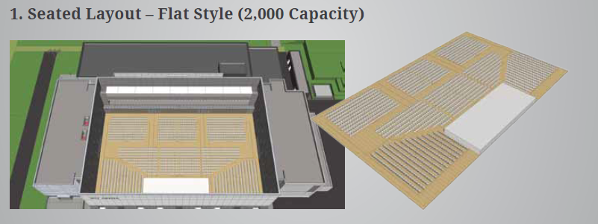
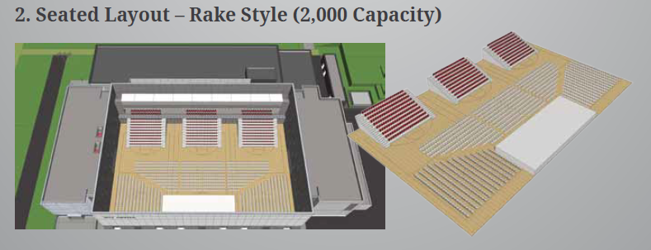
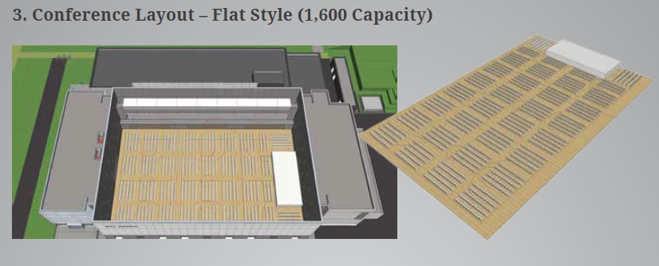
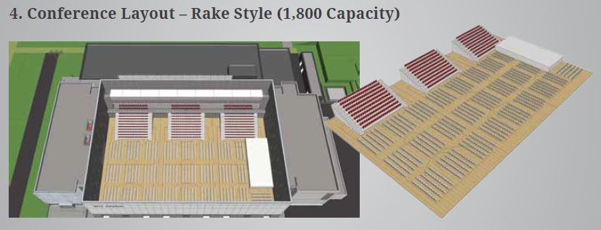
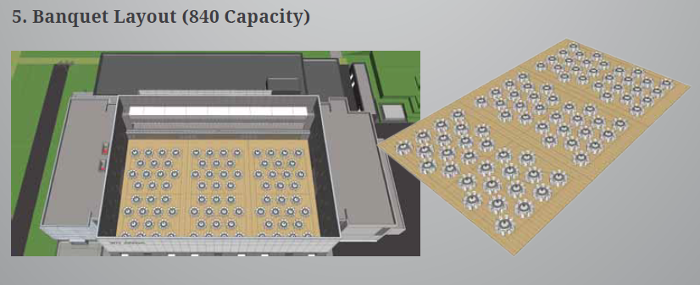

Appendix 6: Photos from previous events

Photos of previous events. All staging, drapes and lighting indicate what is required to be hired, assembled and taken away again.
