
OPEN PROCEDURE
REQUEST FOR TENDER FOR A CONTRACT
Title of Contract | Multi-disciplinary Consultancy Services for EPA Abstraction Licensing Support Services – Waterways Ireland
Open Procedure | OJEU Value
Key Dates
eTenders Ref ID: | 8755969
Issue Date | Friday 31st July 2026
Closing Date for Queries | Friday 14th August 2026 at 12 Noon
Closing Date for Tender Submissions | Monday 31st August 2026 at 12 Noon
Contact for Queries | Via www.etenders.gov.ie ONLY
Format for submission of tenders - use the Tender Response Document (TRD) provided and submit via www.etenders.gov.ie ONLY

Tender Parameters
Description of Parameter | Requirement Applicable
Please state Tender Validity period in months. | 12 months
Currency of the Tender | Euro €
Place of Supply | ROI & NI
In this Request for Tender the processing of Personal Data under GDPR | does not apply to the contract

IMPORTANT NOTES
Please note that information relating to this Request for Tender, including clarifications and changes, will be published on the Procurement Opportunities Portal www.etenders.gov.ie. Registration is free of charge and there is no charge for documents. Please note that the Contracting Authority accepts no responsibility for information relayed (or not relayed) via third parties.
Waterways Ireland have provided a Tender Response Document as a separate document for tenderers to use in preparing their response to this tender. This document and format must be used.

CONTENTS
IMPORTANT NOTES 1
CONTENTS 2
1 ABOUT THE CONTRACTING AUTHORITY 5
1.1 About Waterways Ireland 5
1.2 Small and Medium Enterprise Participation 6
2 SCOPE OF THE CONTRACT 7
2.1 Overview of the Requirement 7
2.2 Details of Options 7
2.3 Anticipated Timeline 7
2.4 Termination of Contract 8
3 DETAILED SPECIFICATION OF REQUIREMENTS 9
3.1 Specification 9
3.1.1 Meetings 9
3.1.2 Project Programme & Risk Register 9
3.1.3 Licence Application Process – Eden portal 9
3.1.4 Existing Site Information 10
3.1.4.1 Longwood Aqueduct 13
3.1.4.2 Whitworth Aqueduct 14
3.1.4.3 The Downs 15
3.1.4.4 Rye Water Supply, Ferns Lock (Lock 17) 16
3.1.4.5 Ballinacarrigy Supply 18
3.1.4.6 Richmond Harbour 20
3.1.4.7 Morell River 20
3.1.4.8 Leinster Aqueduct Abstraction 22
3.1.4.9 The Cush, Derrycooly Abstraction 23
3.1.4.10 Shannon Harbour 24
3.1.4.11 Annanough Supply 25
3.1.4.12 Lough Scur – Summit Abstraction to the Shannon-Erne Waterway 26
3.1.4.13 Back pumping to Lough Scur Summit from Saint John’s Lough 28
3.1.4.14 Lough Allen Canal 28
3.1.5 Proposed Site Information 31
3.1.5.1 Reinstatement of Tullamore River Supply 32
3.1.5.2 New Abstraction from Silver River 34
3.1.6 Data Collection 35
3.1.6.1 Data Collection Deliverable Summary 36
3.1.7 Field Work 36
3.1.7.1 Associated Impoundments 36
3.1.7.2 Barrier Data 37
3.1.7.3 Pump Intake Details 37
3.1.7.4 Field Work Deliverable Summary 37
3.1.8 Hydrological Assessment 37
3.1.8.1 River waterbody assessment 38
3.1.8.2 Lake waterbody Assessment 40
3.1.8.3 Hydrological Assessment Reports Deliverable Summary 40
3.1.9 WFD Assessment 40
3.1.9.1 WFD Supporting Surveys 40
3.1.9.2 WFD Deliverable Summary 41
3.1.10 Reporting to inform Appropriate Assessment (AA) 42
3.1.10.1 AA Screening (AA) 42
3.1.10.2 Supporting Surveys to inform AA Reporting 42
3.1.10.3 AA Deliverable Summary 43
3.1.11 Natura Impacts Study 43
3.1.12 Environmental Impact Assessment - Consideration of Class 43
3.1.12.1 Retrospective Environmental Impact Assessment 43
3.1.12.2 Proposed Abstractions – EIA Class Determination 44
3.1.12.3 Environmental Impact Assessment Report 44
3.1.13 Final Reporting and Handover 44
3.1.14 Deliverable Summary 45
3.1.15 Deliverable Review and Approval Process 45
3.1.16 Deliverable Tracking and KPI Reporting 46
3.2 Duration 46
3.3 Contract Management 46
3.3.1 Waterways Ireland’s Representative/ Project Manager 46
3.3.2 Consultant’s Representative 46
3.4 Compliance with the Terms and Conditions 46
3.5 Award to Runner Up 47
4 SELECTION CRITERIA 48
4.1 Use of the European Single Procurement Document 48
4.2 Relying on the Standing of Other Entities 48
4.3 General, Legal and Financial Requirements 48
4.4 Technical Capacity Requirements 49
4.4.1 Previous Contracts / Experience 49
4.4.2 Health and Safety 49
4.4.3 Quality Assurance 49
5 AWARD CRITERIA 50
5.1 Criteria A – Cost 50
5.2 Criteria B - Methodology 50
5.3 Criteria C – Key Resources & Programme 50
5.4 Criteria D - Demonstrated efforts to reduce project environmental impact 52
5.5 Methodology for Calculating the Cost Score 52
5.6 Methodology for Calculating Scoring of Qualitative Criteria 52
5.7 Clarification / Verification Meetings 53
5.8 Clarification of Abnormally Low Tenders 53
6 INSTRUCTIONS FOR TENDERERS 54
6.1 Closing Date for Tenders 54
6.2 Submission of Tenders 54
6.2.1 Accessing Documents 54
6.2.2 Submitting your Response 54
6.3 Queries 55
6.4 Tender Validity Period 55
6.5 Discrepancy between Documents 55
6.6 Formatting of Tenders / Amending Tender Documents 55
6.7 Collusive Tendering 56
6.8 Confidentiality 56
6.9 Clarification of Tenders 56
6.10 Extension of Tender Deadline 56
6.11 Correction of Errors 56
6.12 Change in the Composition of a Tender 57
6.13 Interference and Inducement to Purchase 57
6.14 Conflict of Interest 57
6.15 Publicity 57
6.16 Right Not to Award 57
6.17 Notification of Tender Evaluations 58
6.18 Award Notices 58
6.19 Policy on Personal Debriefings 58
6.20 Copyright 58
6.21 Brand Names, etc. 58
6.22 Environmental Aspects 59
6.23 Knowledge and Skills Transfer 59
6.24 Currency and Payments 59
6.25 Responsibility of Successful Party 59
6.26 Relevant Legislation 59
6.26.1 General 59
6.26.2 Health & Safety 60
6.26.3 Anti-Competitive Conduct 60
6.26.4 Accessibility 60
6.26.5 Value Added Tax (VAT), Tax Clearance and Relevant Contracts Tax (RCT) 60
6.26.6 Freedom of Information 61
6.26.7 Late Payment 62
6.26.8 Data Protection 62
A. EPA Application Documents 63

ABOUT THE CONTRACTING AUTHORITY

About Waterways Ireland
Waterways Ireland is one of six North-South Implementation Bodies, established under the British-Irish Agreement Act of 1999. We are the cross-border navigational authority responsible for the management, maintenance, development, and restoration of 1,100 km of inland navigable waterways principally for recreational purposes. Our Headquarters are in Enniskillen Co. Fermanagh, with regional offices in Dublin, Carrick-on-Shannon, Co. Leitrim, and Scariff, Co. Clare. We employ 350 permanent staff located at offices and sites close to the inland waterways who are assisted by a team of seasonally recruited staff reflecting the seasonality of the organisation’s remit. Waterways Ireland creates social, economic, and environmental well-being to the value of €600m annually.
Waterways Ireland is the navigation authority for 1,200 km of navigable inland waterways, comprising:
- Lower Bann Navigation
- Erne System
- Shannon-Erne Waterway (SEW)
- Shannon Navigation
- Royal Canal
- Grand Canal
- Barrow Navigation
- Ulster Canal (Upper Lough Erne to Clones)
In July 2007, it was agreed by the North/South Ministerial Council (NSMC) to include responsibility for the reconstruction of the Ulster Canal from Upper Lough Erne to Clones, and following restoration, its management, maintenance, and development, principally for recreational purposes to Waterways Ireland’s remit.
At an operational level, Waterways Ireland is responsible for a vast range of infrastructure assets including navigation channels, embankments, towpaths, adjoining lands, harbours, jetties, fishing stands, bridges, culverts, aqueducts, overflows, locks, sluices, and lock houses along with buildings and archives. The current valuation of the rebuild costs of this infrastructure is estimated at €809 million. Waterways Ireland’s work programs are critical to providing a safe and high-quality recreational environment for customers, whilst preserving the industrial and environmental heritage of the waterways for future generations. Our Purpose is:
To be the custodian of the inland navigations and collaborate to reimagine, maintain, develop and promote them to sustain communities, environment and heritage.
Our Vision is to bring our waterways to life – full of recreational and commercial activities, havens rich in wildlife and biodiversity, and positively transformational both in terms of enriching people's lives and regenerating the many rural and urban communities and regions through which the waterways pass. Our Vision is:
Creating inspirational inland navigations and waterways experiences through conservation and sustainable development for the benefit of all.
To realise our Vision, Waterways Irelands focus remains on achievement of six strategic priorities based on extensive user and stakeholder engagement following the completion of our Long-term Plan:
- Organisation Development & Governance
- Sustainable Funding Model
- Asset Portfolio Management
- Participation & Reputation
- Sustainable Development
- Climate Action, Environment & Heritage
Our Values, as behavioural guidance, are critically important to the organisation as they are essential to the successful implementation of the Long-Term Plan as well as driving cultural change and development in the organisation

Further information is available at our corporate website www.waterwaysireland.org

Small and Medium Enterprise Participation
It is the policy of the Contracting Authority to promote participation by Small and Medium Enterprises (SMEs) on a fair and equal basis.
SMEs are encouraged to explore the possibilities of forming relationships with other SMEs or with larger enterprises to meet the financial, economic or technical capacity requirements of the competition, if required.
Tenderers may include individuals, partnerships, limited companies, groupings or any combination of the foregoing with or without legal personality. However, a grouping if successful will be required to establish legal personality to enter the contract.
Tenderers are reminded that they may rely on the resources of other entities to establish the requirements on condition that they can prove to the satisfaction of the Contracting Authority that they will have these resources at their disposal when necessary.
If the tender is from a consortium / joint venture, Tenderers must ensure that all the relevant information is provided and where necessary, provide the information requested separately for each party. Relevant information relates to where a tenderer is relying on the resources to qualify (e.g. turnover, personnel, previous experience) and/or to deliver the contract. The consortium must appoint a single point of contact who will assume overall responsibility for delivery, and who is authorised to sign the contract on behalf of all consortia members. The Contracting Authority will not act as an arbitrator between members of consortia.

SCOPE OF THE CONTRACT

Overview of the Requirement
Following the enactment of the Water Environment (Abstractions and Associated Impoundments) Act 2022 and the subsequent commencement of the Water Environment (Abstractions and Associated Impoundments) Regulations 2024, Waterways Ireland is seeking technical services to prepare the documentation and data required to support the abstraction licensing process with the Agency (Environment Protection Agency, EPA) for waterways under our statutory remit.
Waterways Ireland manages 1,200 km of navigable inland waterways comprising the Lower Bann Navigation, Erne System, Shannon-Erne Waterway, Shannon Navigation, Royal Canal, Grand Canal, Barrow Navigation and Ulster Canal (Upper Lough Erne to Clones). Our operations include numerous water abstractions and associated impoundments, supporting navigation, pumping stations and operational requirements across these waterways.
This contract scope covers a total of fourteen abstractions of greater than 2,000 m³/day under Waterways Ireland's management, which will require abstraction licensing. In addition to the licensing of existing abstractions, the scope of this contract also includes the assessment of two proposed new and reinstated abstraction sources within Waterways Ireland’s operational network on the Grand Canal in order to explore the potential to use these sources to augment flow in the Grand Canal. The Consultant shall review and assess both current abstraction sites and any new or proposed locations described in this tender.
The licensing framework will focus on the data gathering, modelling and potential environmental impact of each abstraction. Waterways Ireland will be required to submit necessary information to permit consenting of abstraction application assessments by the EPA, ensuring compliance with our statutory obligations under the Water Framework Directive and supporting our strategic water management objectives.

Details of Options
N.A

Anticipated Timeline
The following indicative timeline is envisaged for this procurement:
Issue RFT | as per front page of RFT
Closing date for Queries | Friday 14th August 2026 at 12 Noon
Closing date for Receipt of Tenders | Monday 31st August 2026 at 12 Noon
Clarification meetings (if anticipated) | TBD
Award decision | TBD
Contract Commencement | TBD
The dates provided above are estimates at the time of publication of the Request for Tender. The Contracting Authority will endeavour to run the process to this timetable, but this cannot be guaranteed.

Termination of Contract
The Contracting Authority reserves the right at its sole discretion to terminate any contract where, due to matters outside its control, including but not limited to, increased costs arising from any changes in the Customs Union, which render the commercial arrangement uncompetitive.

DETAILED SPECIFICATION OF REQUIREMENTS
The Contracting Authority invites tenders for the award of a contract as specified hereunder.

Specification
The technical services involve environmental assessment activities for each abstraction, including:
- Field Work
- Hydrological Assessment;
- Appropriate Assessment (AA) Screening;
- Environmental Impact Assessment Consideration of Class and if required EIA Screening Report;
- Water Framework Directive (WFD) Assessment.

Meetings

Please allow for bi-monthly progress update meetings to be held virtually with the Client. An agenda for each bi-monthly progress meeting shall be issued to Waterways Ireland at least three (3) working days in advance of the meeting. Minutes of each meeting shall be prepared and circulated to Waterways Ireland within five (5) working days following the meeting for approval.

Site meetings which could reasonably be expected to be organised to overlap with field work are also excluded from consideration as additional meetings under this Section.

Project Programme & Risk Register

A detailed Project Programme will be developed and maintained for the duration of the contract by the Consultant. The programme will be presented as a Gantt chart, showing all key project phases, milestones, and deliverables. It will outline the sequencing and dependencies of activities. It will be reviewed and updated as appropriate at each progress meeting.

A Project Risk Register will be developed and maintained throughout the contract by the Consultant. The register will identify potential risks, assess their likelihood and impact, and define mitigation measures and responsible parties.
It will be reviewed and updated at each progress meeting.

Licence Application Process – Eden portal
Prior to commencing the consultant shall familiarise themselves with all aspects of the application process and ensure an appropriate level of detail is captured. See Appendix A for sample EPA templates included – form 2.3 Impoundment, form 2.5 Monitoring, form 3.0 Supplementary Information Attachment.
Waterways Ireland will be responsible for the upload and formal submission of the completed license application via the EDEN portal. Waterways Ireland shall advise the Consultant of subsequent Requests for Further Information (RFI). The Consultant shall allow for addressing an RFI from the EPA for each abstraction.

Existing Site Information
This section details the 14 no. existing abstractions which have been registered with the EPA. The peak 24-hour abstractions from each site exceed the 2000 m³/day automatic licensing volume and required abstraction licenses under the Act, see Figure 3-1. This section provides details on the abstractions currently in operation which need to be regularised under the Act.
In general, Waterways Ireland hold little to no abstraction volume information for our gravity supplies. In 2026, Waterways Ireland are undertaking a spot flow study at key sites. This will involve monthly spot flows abstraction measurements. The flow records captured will be provided to the consultant for analysis.
 | No. | Name | Source | Type | 24 hr Volume m³/d
Royal Canal | 1 | Longwood Aqueduct | River | Pumped | 20,000
Royal Canal | 2 | Whitworth Aqueduct | River | Pumped | 20,000
Royal Canal | 3 | The Downs | River | Pumped | 10,000
Royal Canal | 4 | Rye Water Supply, Ferns Lock | River | Gravity | 10,000
Royal Canal | 5 | Ballinacarrigy Supply | River | Gravity | 6,000
Royal Canal | 6 | Richmond Harbour | River | Pumped | 4,000
Grand Canal | 7 | Morell River | River | Gravity | 10,000
Grand Canal | 8 | Leinster Aqueduct | River | Pumped | 21,000
Grand Canal | 9 | The Cush, Derrycooly Abstraction | River | Pumped | 11,000
Grand Canal | 10 | Shannon Harbour | River | Pumped | 13,000
Barrow Line | 11 | Annanough Supply | River | Gravity | 8,500
SEW | 12 | Lough Scur – Summit Abstraction to the Shannon-Erne Waterway | Lake | Gravity | 20,000
SEW | 13 | Saint John’s Lough | Lake | Pumped | 3,500
Lough Allen Canal | 14 | Lough Allen Canal | Lake | Pumped | 10,500
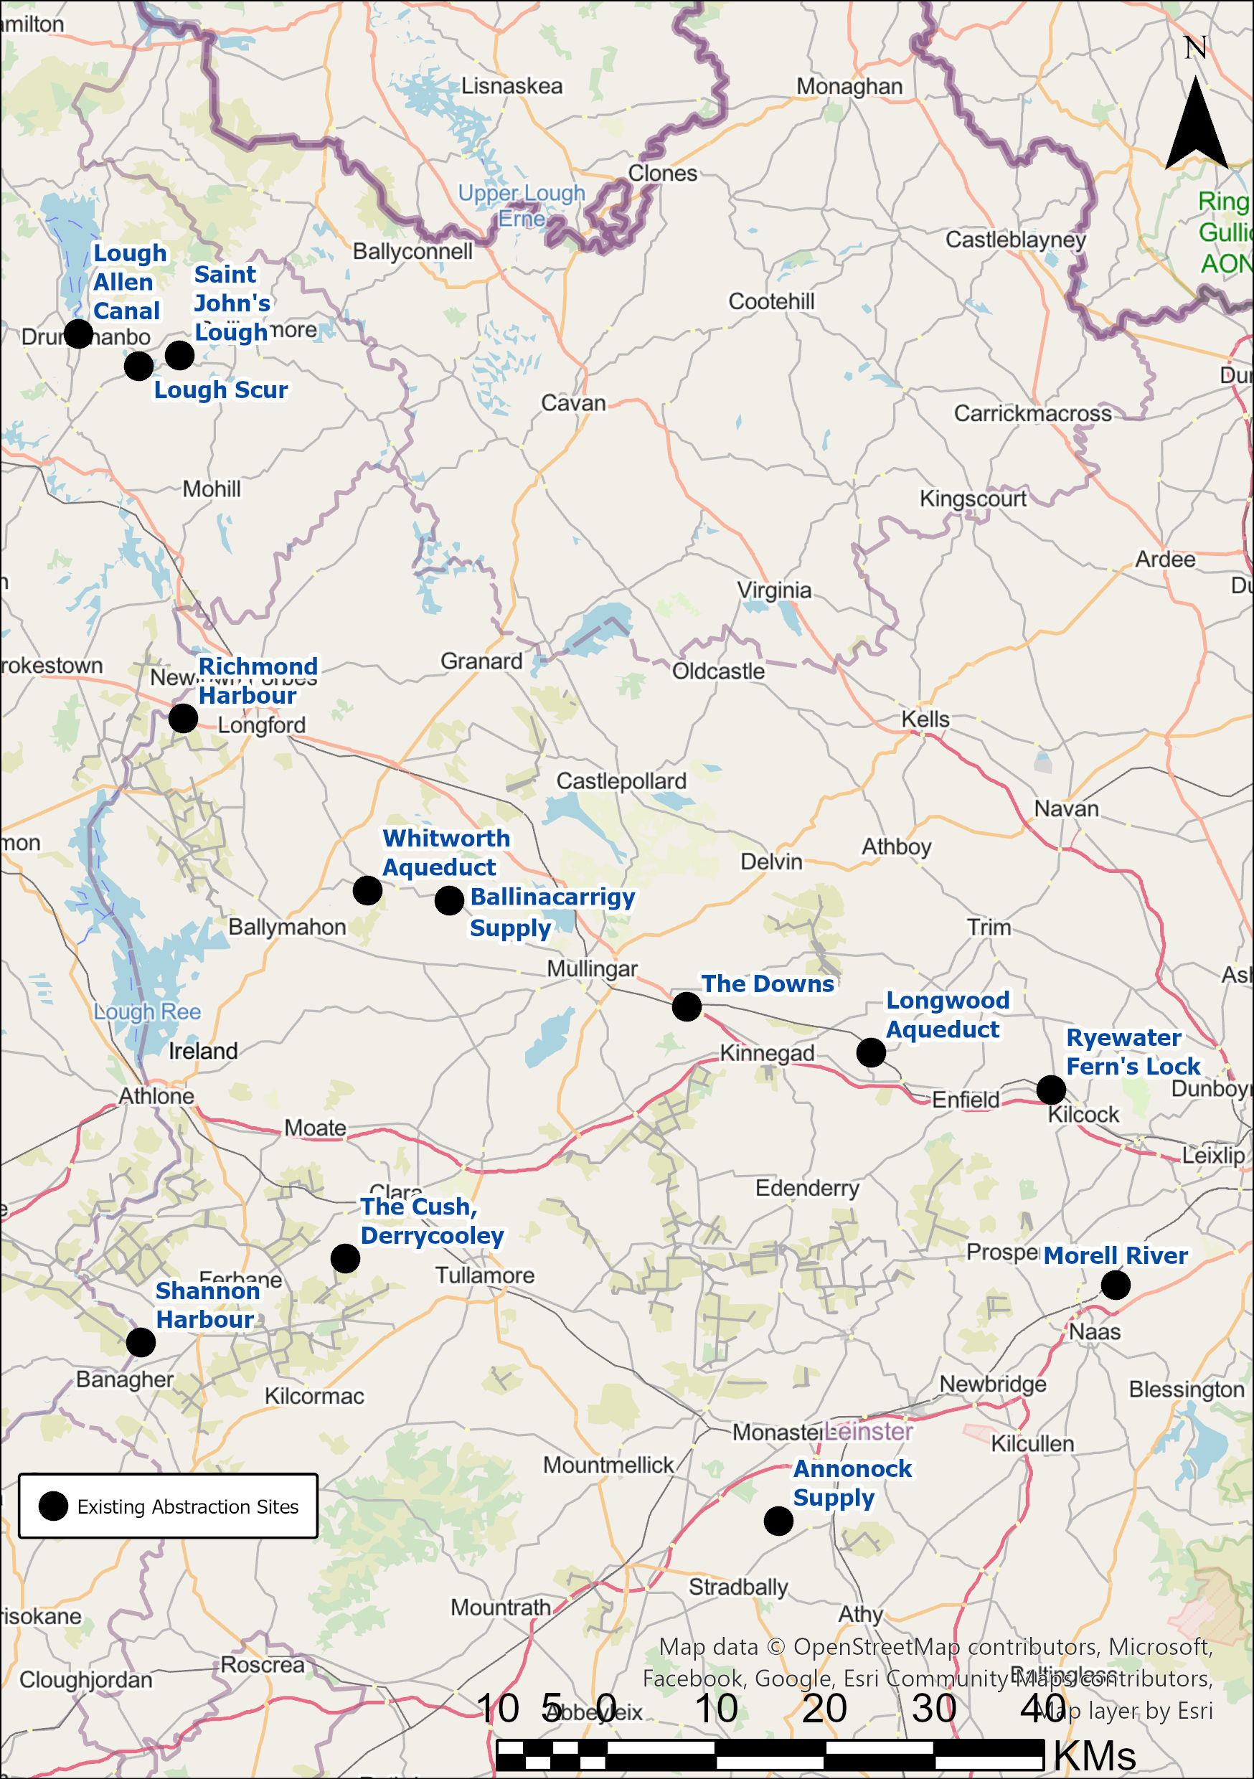

Figure 3-1; Overview of Abstraction Sites identified for Licence Applications within the scope of this Tender.

Longwood Aqueduct
A seasonal pumping arrangement operates from the River Boyne to the Royal Canal at the Longwood Aqueduct (see Figure 3-2). During times of low levels on the Royal Canal, the pumps are used to supplement the gravity-fed supplies to the canal. A typical year may see operation of the pumps during the navigation season from March to October
The abstraction from the River Boyne has been operated annually since the re-opening of the Royal Canal (2010). Pumps are typically operated 24 hours per day. The abstraction has been registered with the EPA annual volume of 3,200,000 m³ and a maximum of 20,000 m³/day, based on pumping rates. There is no known associated impoundment with this abstraction.

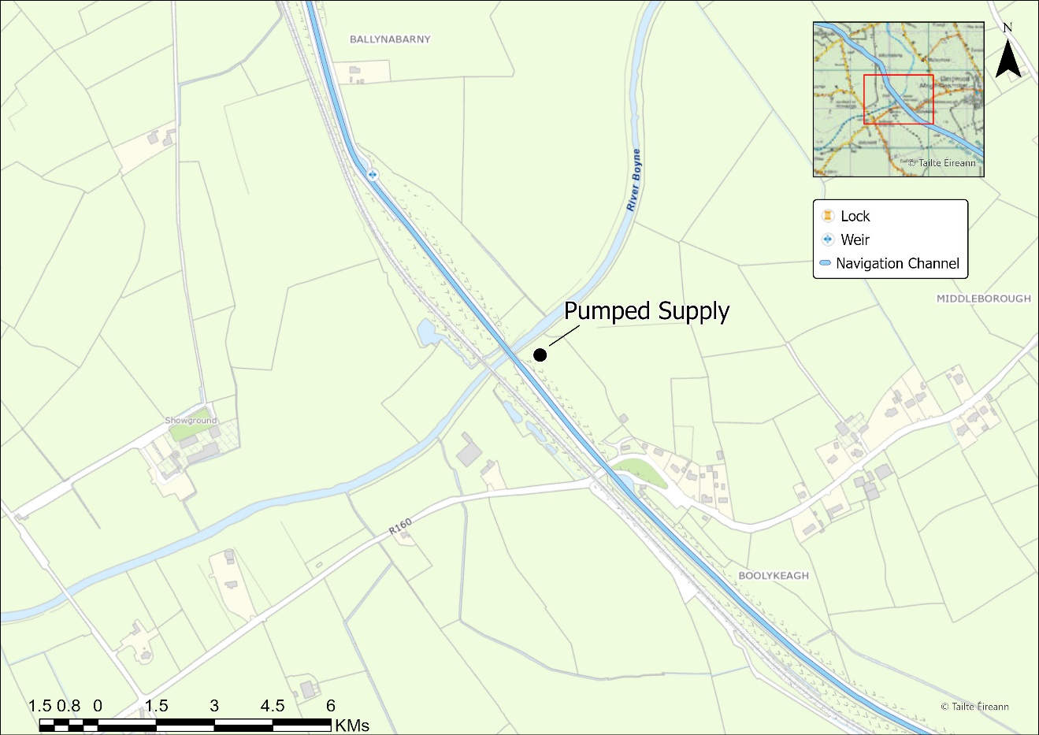
Figure 3-2; Longwood Aqueduct

Whitworth Aqueduct
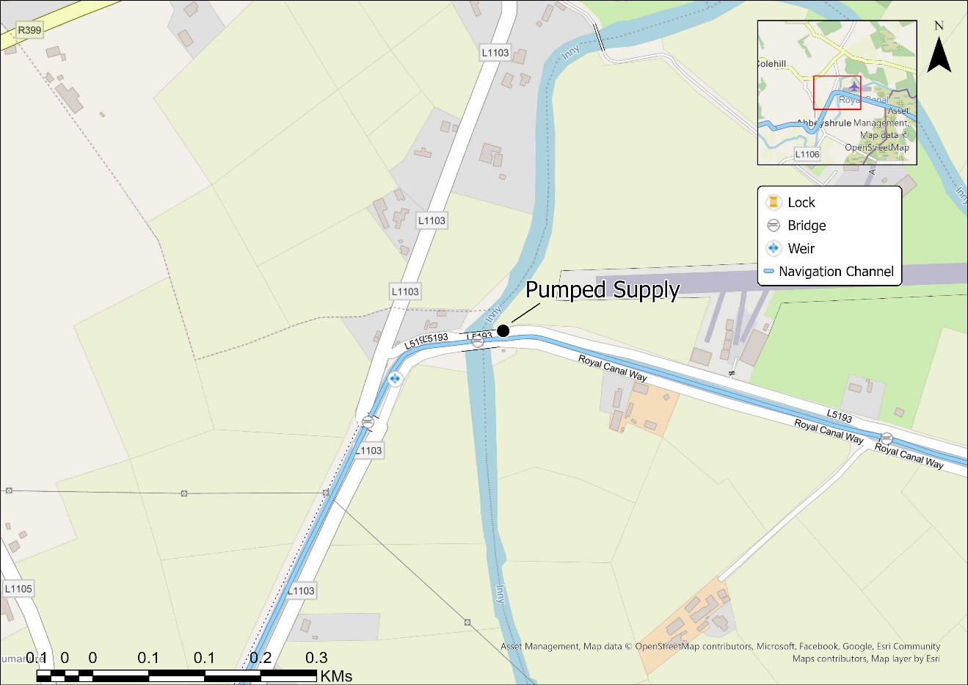
Figure 3-3; Whitworth Aqueduct abstraction from River Inny - Royal Canal

A seasonal pumping arrangement operates from the River Inny to the Royal Canal at the Whitworth Aqueduct near Abbeyshrule, Co Longford (see Figure 3-3). During periods of low water levels on the Royal Canal, the pumps are used to supplement the gravity-fed supplies. In a typical year, the pumps operate during the navigation season, from March to October.
The abstraction from the River Inny has been operated annually since the re-opening of the Royal Canal (2010). Pumps are typically operated 24 hours per day. The abstraction has been registered with the EPA for an annual abstraction volume of 3,200,000 m³ and a maximum of 20,000 m³/day, estimate from pump rates. There is no known associated impoundment with this abstraction. The Consultant should familiarise themselves with the Abbeyshrule Water Treatment Works abstraction licence application documentation (R00588-02), which relates to an abstraction from the River Inny.

The Downs
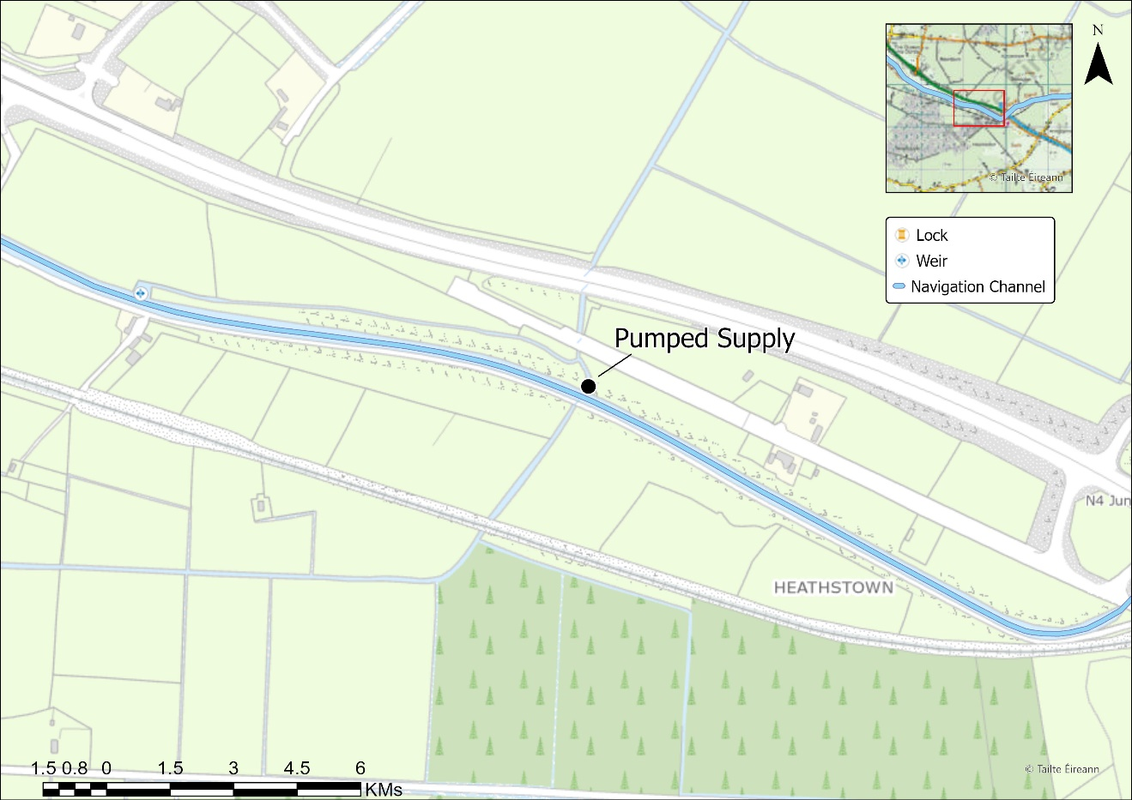
Figure 3-4; The Downs - Pumped Abstraction
A seasonal pumping arrangement operates from a watercourse culverted under the Royal Canal near The Downs, east of Mullingar, Co. Westmeath (see Figure 3-4).
The abstraction can only operate after local rainfall and operates on an ad-hoc basis during the navigation season from March to October. The abstraction is registered with the EPA for an annual volume of 1,200,000 m³ and a maximum of 10,000 m³/day. There is no known associated impoundment with this abstraction. Historically this watercourse was used as the source for the now disused Old Thomastown Supply. This gravity supply is no longer functioning due to changes in the catchment. The Old Thomastown Supply is visible on six-inch mapping from the 1800s.
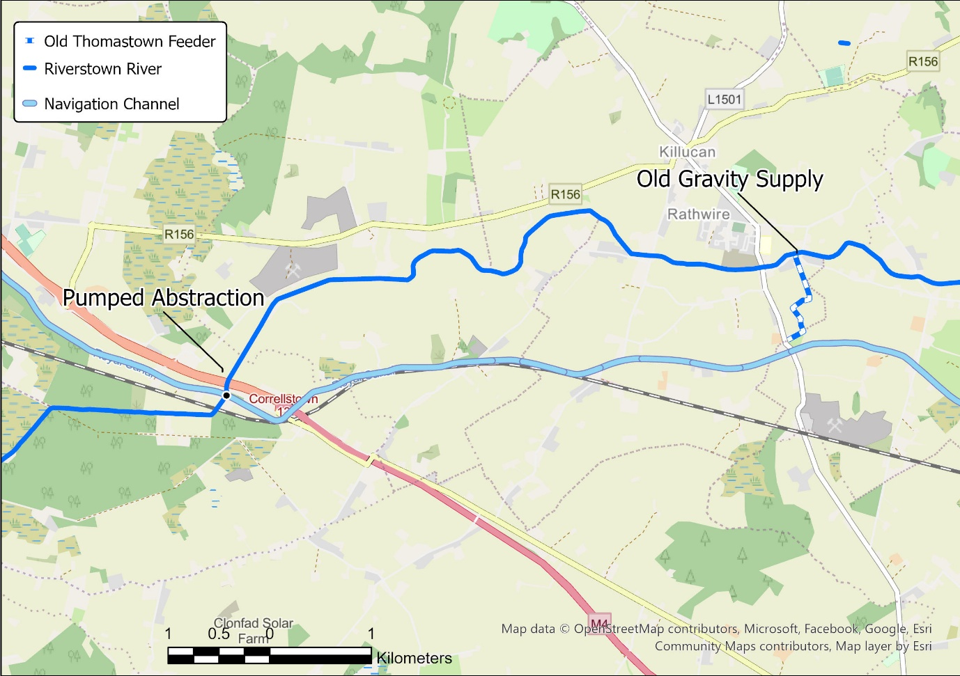
Figure 3-5; Overview of Old Thomastown Supply

Rye Water Supply, Ferns Lock (Lock 17)
The Rye Water supply enters the canal by gravity, just east of Lock 17 near Kilcock, Co. Kildare (see Figure 3-6). A series of stepped weirs raise the levels locally on the Rye Water River, which runs parallel to the Royal Canal. A sluice contained in a sluice house manages the off-take into the canal, being closed when water is not needed and opened when required (see Figure 3-7). This supply has been active since the canal was constructed and is visible on historic 6-inch maps from the 1800s. During periods of low flows, the sluice is closed to ensure sufficient flow remains in the Rye Water downstream.
The abstraction is registered with the EPA for an annual volume of 2,100,000 m³ and a maximum of 10,000 m³/day. Waterways Ireland hold no flow records for this supply and is estimated based on knowledge and experience of Waterways Ireland operations. The supply is shown entering the Royal Canal in Figure 3-8.

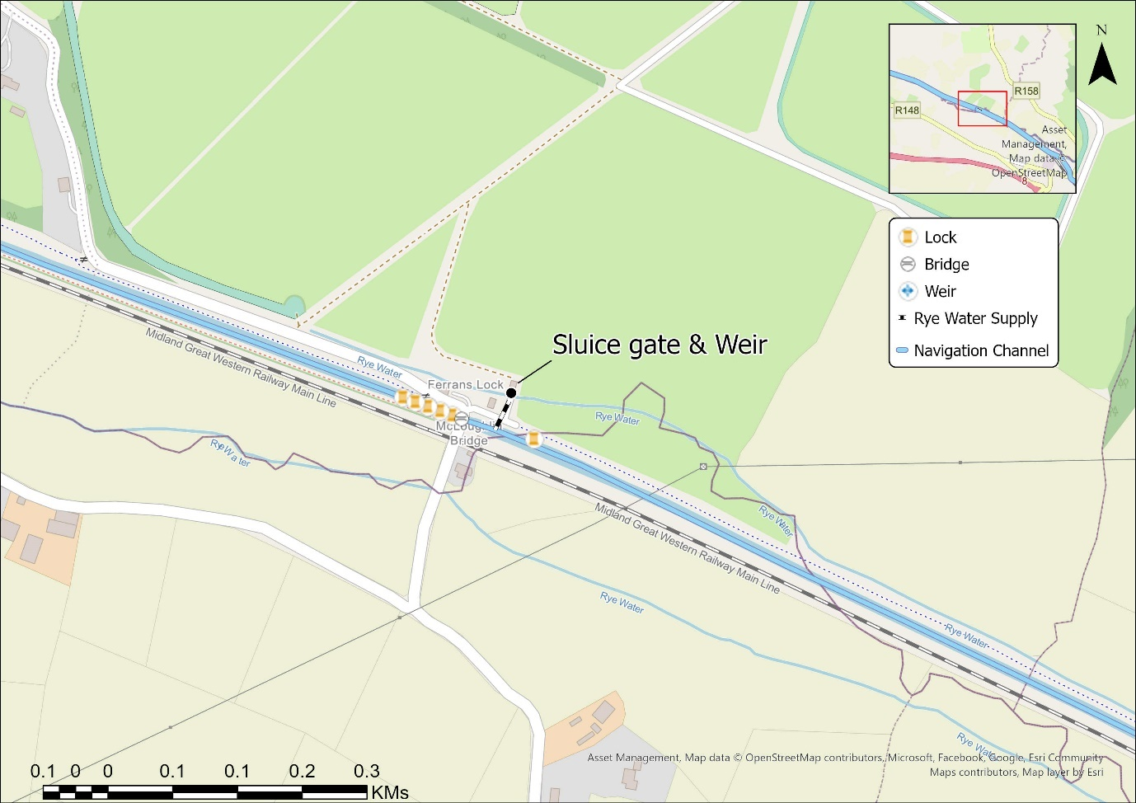

Figure 3-6; Rye Water Supply

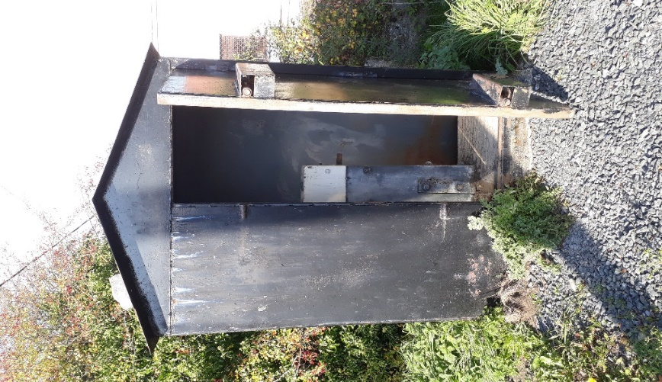
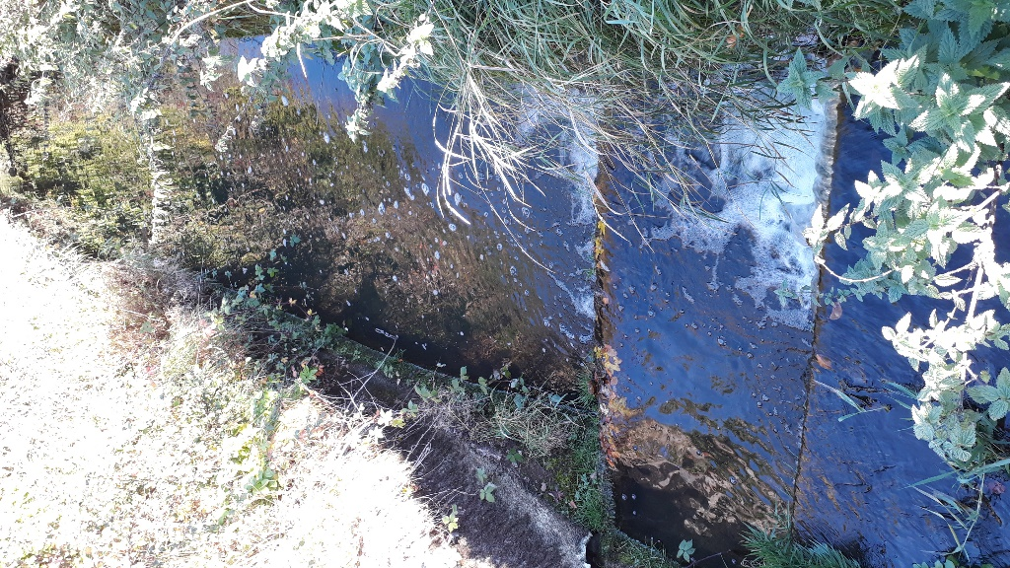
Figure 3-7; Sluice House & Stepped Weir on Rye Water

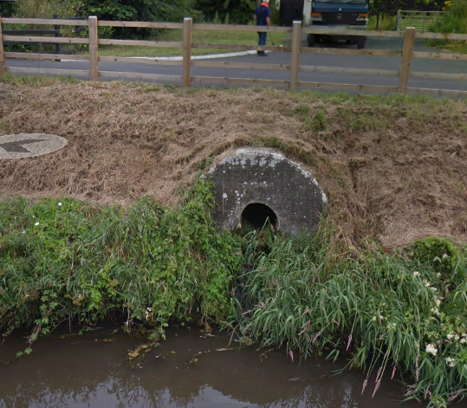
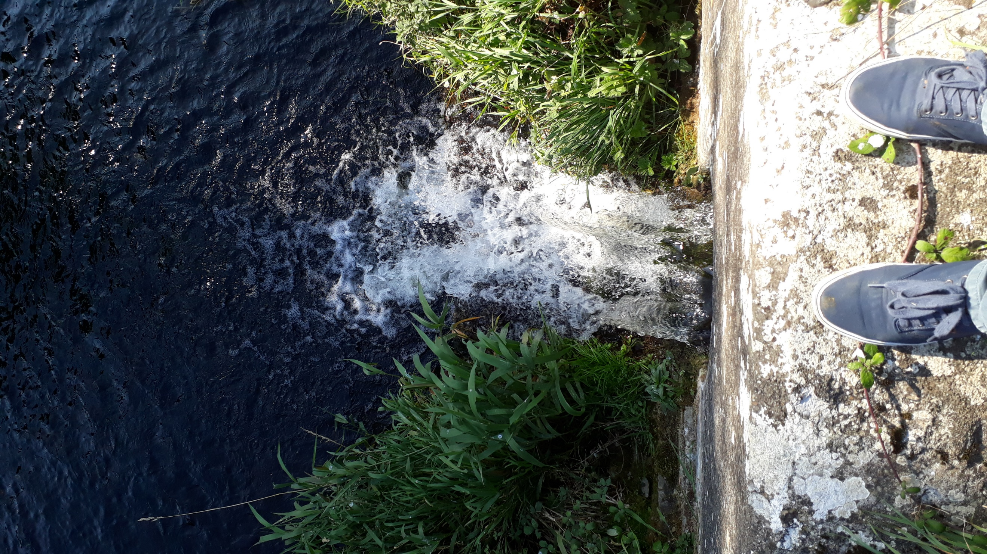
Figure 3-8; Rye Supply Inflow from above and from the Canal (Google Streetview)

Ballinacarrigy Supply
The Ballinacarrigy Supply is taken from a stream which originates along the northern bank of the Royal Canal and enters the Royal Canal just below the 35th lock in Ballinacarrigy, Co Westmeath (see Figure 3-9). The flow in the watercourse is understood to be supplemented by leakage from the canal. It is unclear what proportion of the flow entering the canal from the supply originates from the canal itself.
A sluice controls flow entering the canal from the supply, throttling flow passing downstream and diverting a portion of the flow it into the canal – see Figure 3-10. The abstraction is registered with the EPA for an annual volume 1,300,000 m³ and a maximum of 6,000 m³/day. Flow measurements taken at this supply have informed the registered volume.

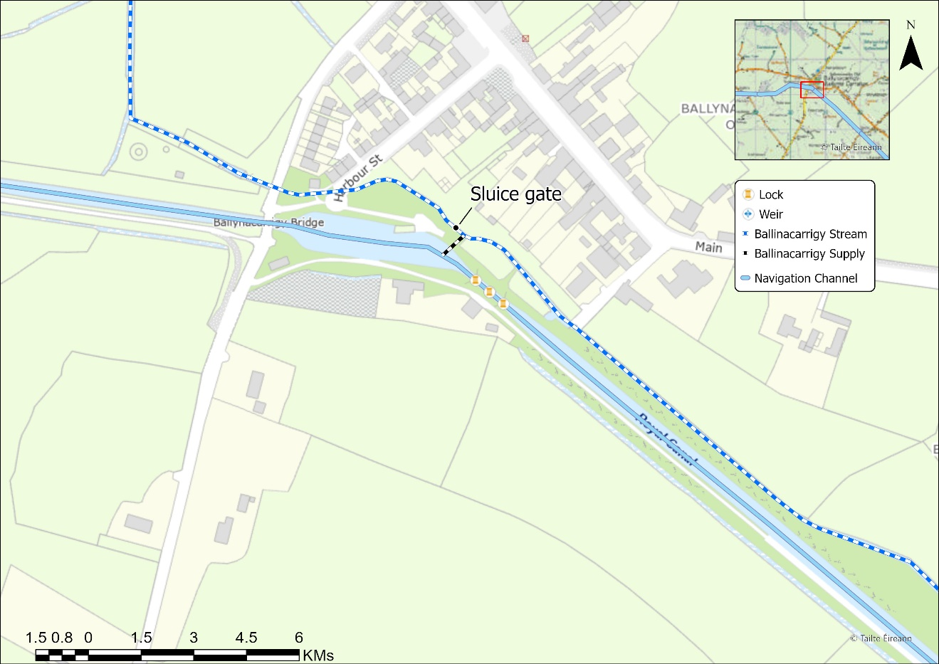
Figure 3-9; Overview of Ballinacarrigy Supply
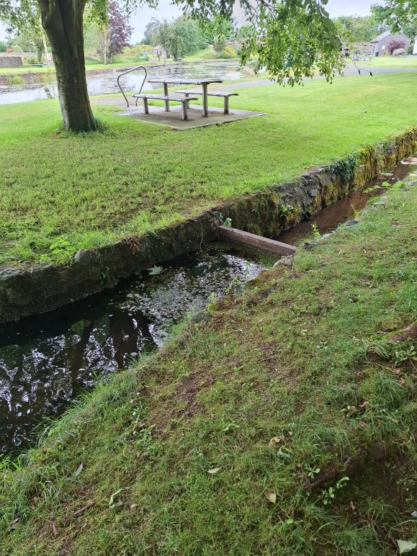
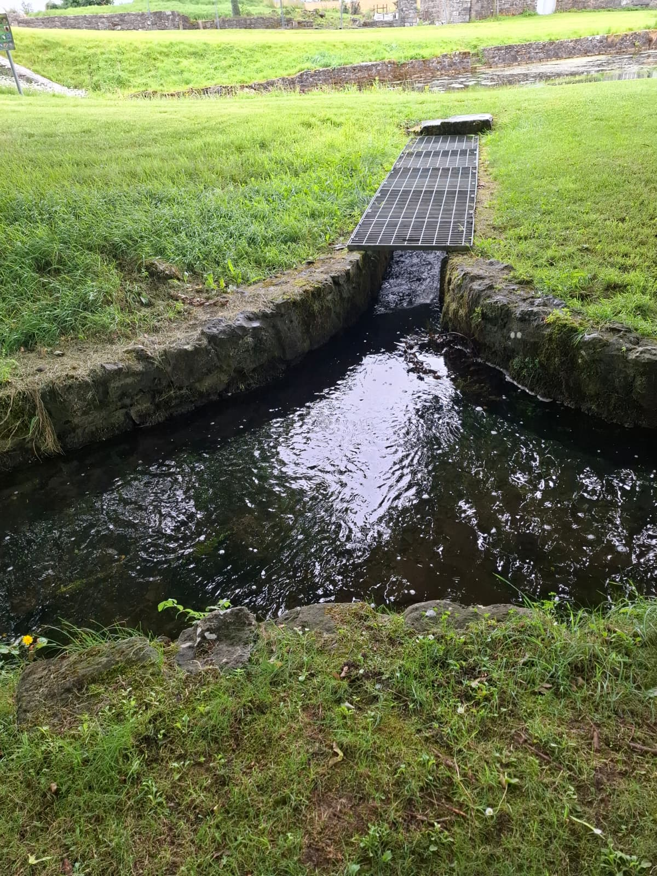
Figure 3-10; Ballinacarrigy Supply Entering Channel (Left) and Weir Board (Right)

Richmond Harbour
A pump operates from the River Camlin to the Royal Canal just upstream of Lock 46 directly into Richmond Harbour, Cloondara, Co Longford. The pumped water is used to maintain levels in Richmond Harbour. The abstracted water is returned to the Camlin River via lockage or lock leakage.
Pumps are typically operated 3-4 hours per day during peak periods during the navigation season. The abstraction has been registered with the EPA annual volume of 800,000 m³ and a maximum of 4,000 m³/day, based on pumped data. A weir is located in the River Camlin immediately downstream of the pump intake. The primary function of the weir is to maintain navigation levels in the River Camlin.

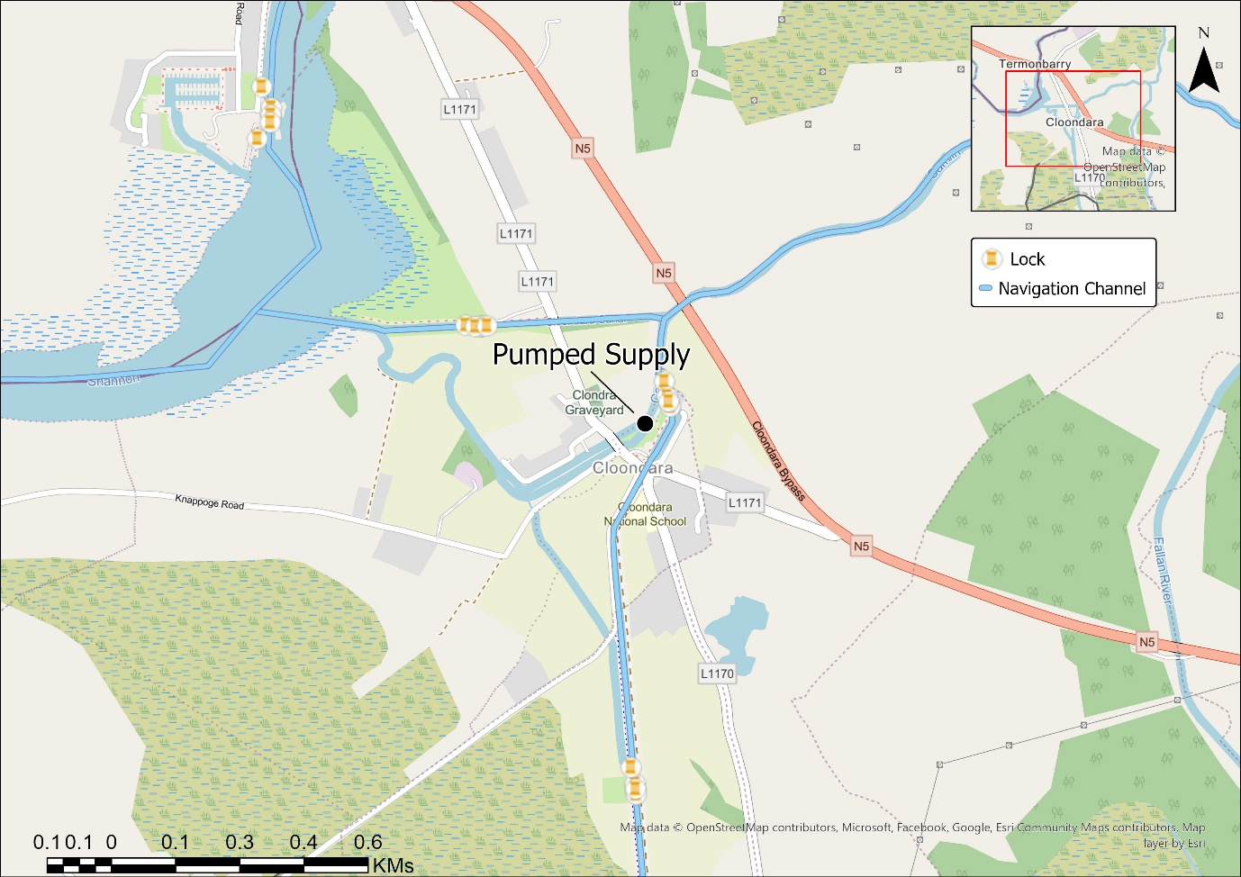
Figure 3-11; Richmond Harbour Overview

Morell River
The River Morell passes under the Grand Canal immediately south-west of the 15th lock, near Sallins Co Kildare, see Figure 3-12. Upstream of this point, a sluice and weir on the River Morell diverts a portion of the river flow into the canal feeder channel. A secondary sluice on the feeder channel regulates the flow entering the canal from the River Morell. Both structures are shown in Figure 3-13. This supply has been active since the canal was constructed and is visible on historic 6-inch maps from the 1800s.
Two overflow weirs discharge into this channel downstream of the secondary sluice; one upstream and one downstream of the 15th Lock. The combined flow from the River Morell diversion and the overflow weirs enters the canal downstream of the 14th Lock.
The abstraction is registered with the EPA annual volume of 2,340,000 m³ and a maximum of 13,000 m³/day. Waterways Ireland holds no flow records for this supply. The registered volumes have been estimated based on experience of Waterways Ireland staff.

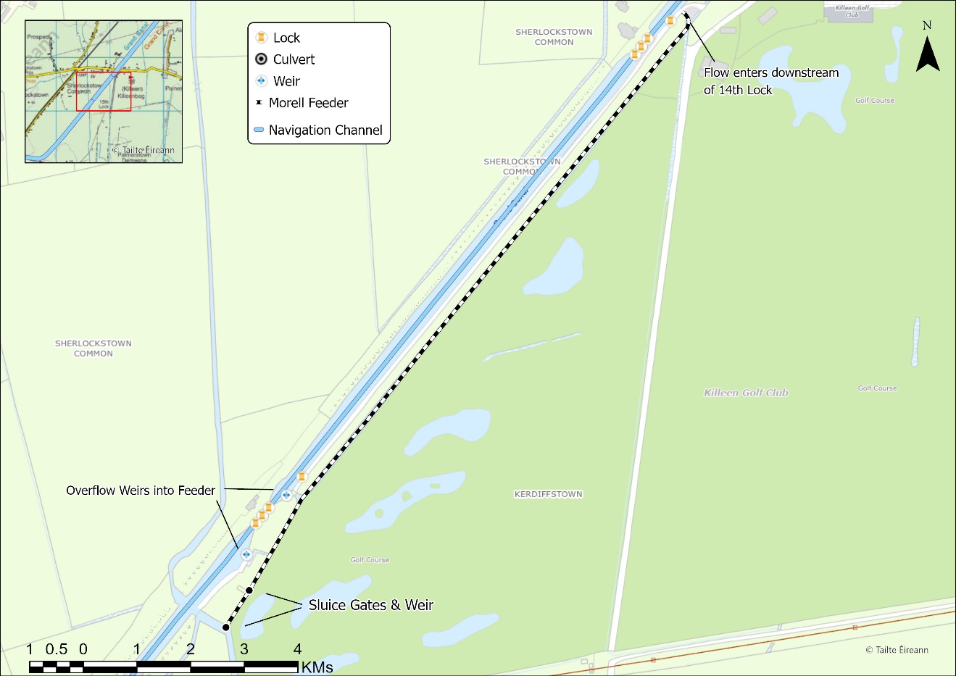
Figure 3-12; Overview of Morell Feeder
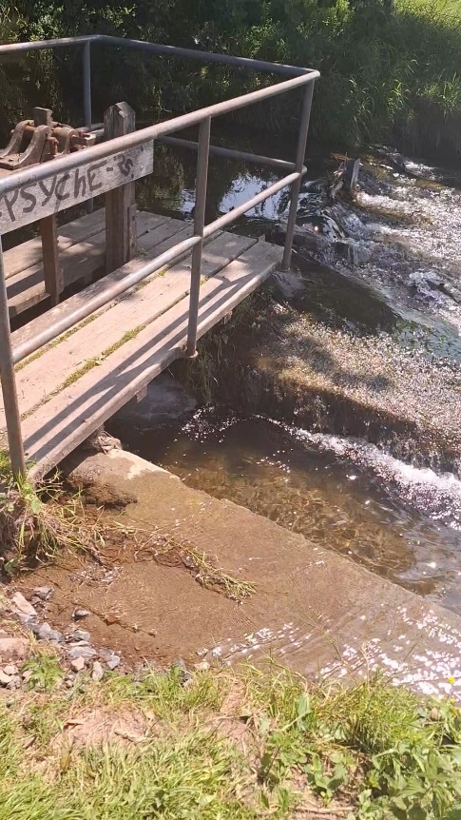
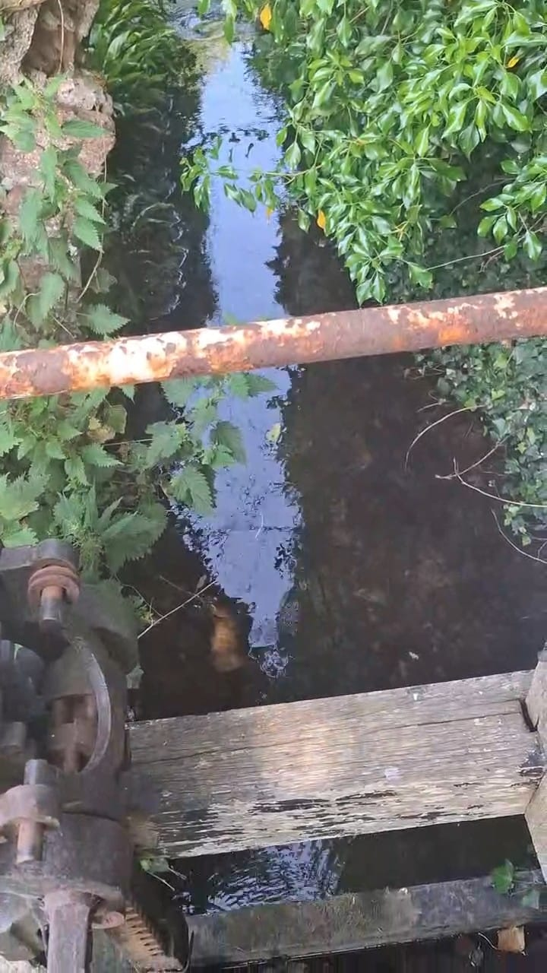
Sluice - Feeder
Sluice & Weir – River

Figure 3-13; Morell Feeder & River Flow controls

Leinster Aqueduct Abstraction
The Allenwood Power Station began generating in 1952 and was decommissioned in 1993. During this period water was drawn from the Grand Canal to supplement cooling requirements. To offset the water drawn from the canal the Liffey pumps were installed by the ESB, to bring water from the Liffey up to the summit level of the Grand Canal and onwards to Allenwood. When the power station was decommissioned in 1993, the operation of the pumps came into ownership of the OPW (since transferred to Waterways Ireland).
The water is abstracted from the Liffey at the Leinster Aqueduct and back pumped up through the various level to the summit level (see Figure 3-14):
- The Leinster Aqueduct Abstraction feeds Level 15
- Water is pumped from below Lock 16 at Digby’s Bridge to immediately upstream of Lock 16 into Level 16
- Water is pumped from below Lock 17 at Landenstown Bridge to immediately upstream of Lock 17 into Level 17
- Water is pumped from below Lock 18 at to immediately upstream of Lock 18 into the Summit Level.
The abstraction is registered with an EPA annual volume of 2,520,000 m³ and a maximum of 21,000 m³/day. The pumps, which operate on duty/duty/standby basis have a capacity of approximately 240l/s. There is no known associated impoundment. The closest significant structure is located in Clane approximately 3 km downstream. The riverbed level at the abstraction site is approximately 2.5m higher than the weir crest so is unlikely to have an effect on water levels at the Leinster Aqueduct.

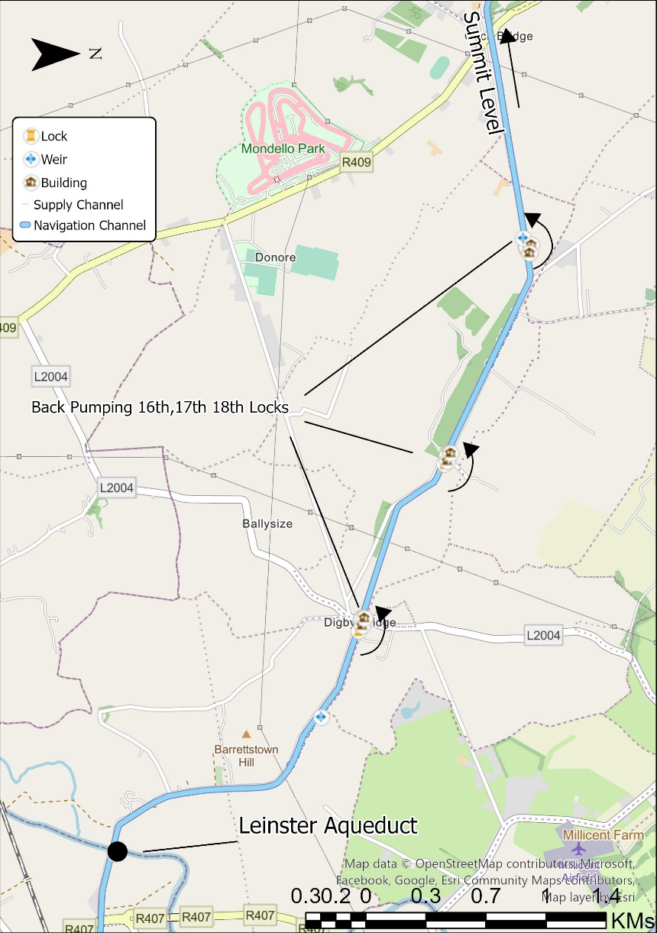
Figure 3-14; Overview of Back Pumping on Grand Canal

The Cush, Derrycooly Abstraction
A seasonal pumping arrangement is in place at The Cush, abstracting water from the Derrycooly Stream. Historically, this supply to the canal operated as a gravity-fed system, with an off-take into a 1.3 km artificial feeder channel. This gravity system is visible on historic six-inch maps from the 1800s. The historic gravity feeder is disused.
The current pumped abstraction effectively utilizes the same source of water, lifted from the Derrycooly stream as it crosses under the canal, see Figure 3-15 . The pump is hired on a temporary basis, installed only when required, and is not a fixed structure. The abstraction has been registered with a maximum of 11,000 m³/day and annual volume of 850,600 m³/year. In a typical year, the pump is operated from May to early October 7 days a week.
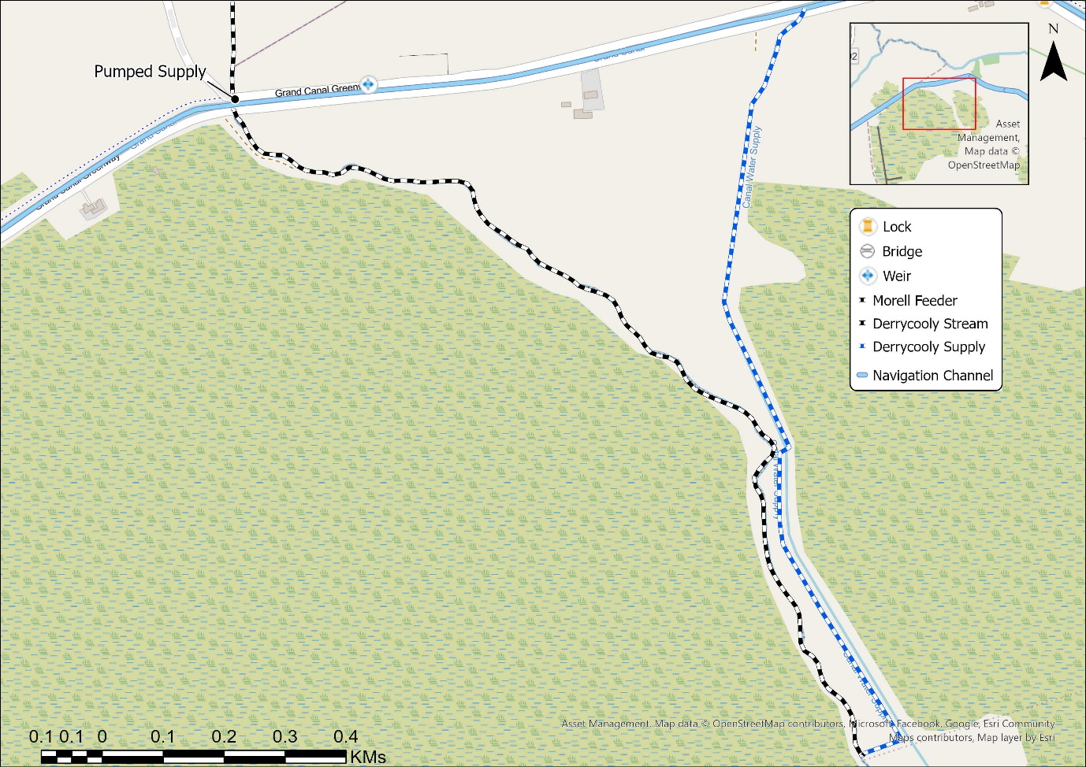
Figure 3-15; Derrycooley Supply

Shannon Harbour
A pump operates from downstream of Lock 36 to the Grand Canal just upstream of Lock 36 directly into Shannon Harbour, see Figure 3-16. The source of the water is the area downstream of Lock 36 where the discharge from the Grand Canal, River Brosna and River Shannon confluence. The water level at this point is defined by the level in the River Shannon. The pump is used to maintain levels in the Grand Canal at Shannon Harbour and is also used in a back pumping chain, where water is further backpumped up through the levels of the Grand Canal. The abstracted water is discharged to the abstraction point via lockage or lock leakage.
Pumps are typically operated 24 hours per day during peak periods. The abstraction has been registered with the EPA annual volume of 3,000,000 m³ and a maximum of 13,000 m³/day.

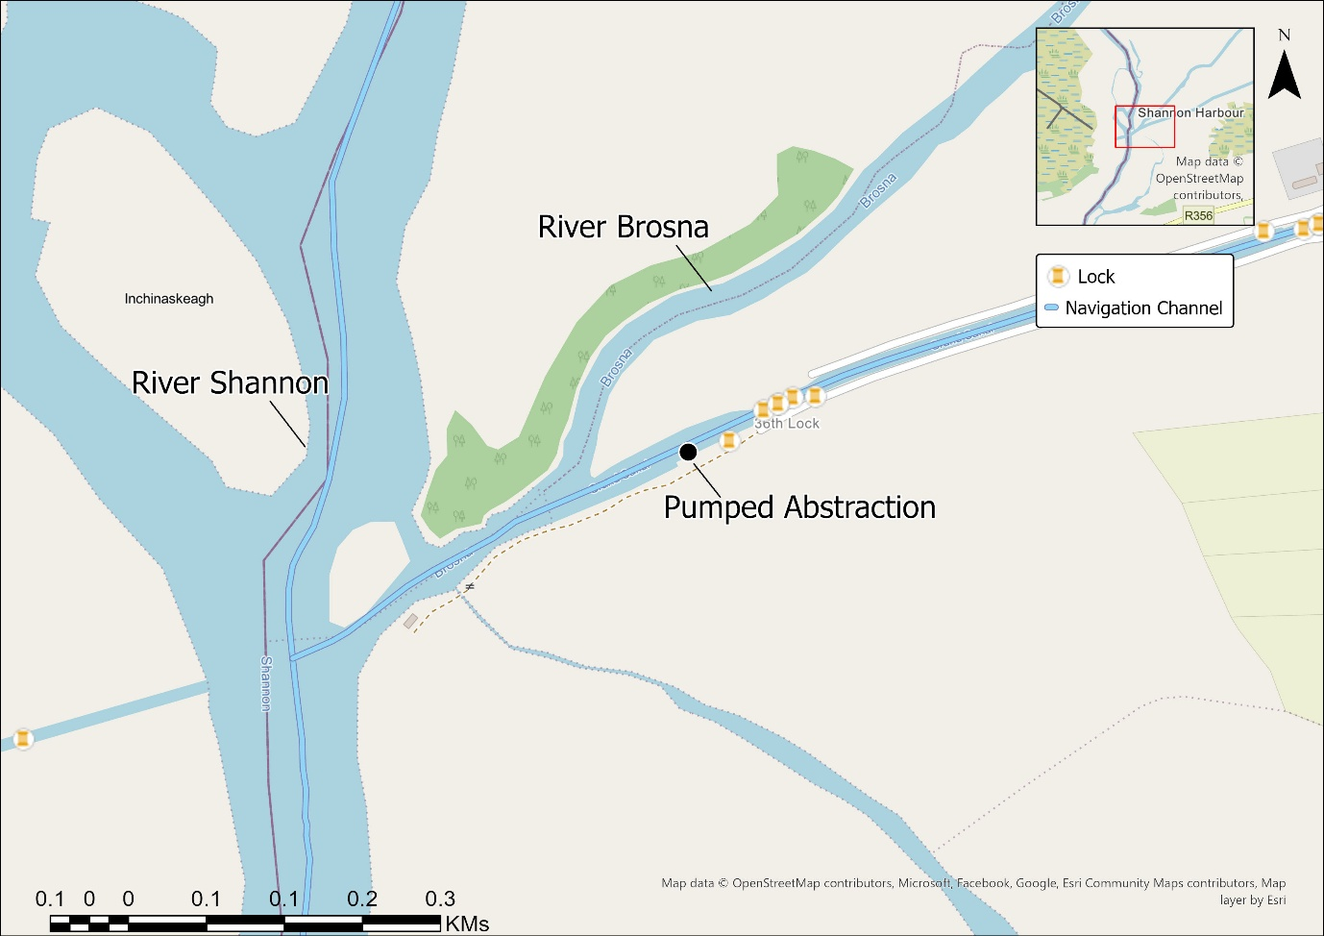
Figure 3-16; Shannon Harbour

Annanough Supply
The Annanough Supply is a surface water feeder providing inflow to the Grand Canal Barrow Line Level 26. It is sourced from the Glasha River shortly before it confluences with River Barrow. Water levels are raised locally via a series of weir boards which raises the hydraulic head locally to allow flow to pass into the 1km long feeder channel, see Figure 3-17. The weir boards are operated seasonally rather than on a day-to-day basis. Two overflow weirs are located along the feeder channel which throttle the flow entering the canal. The supply is “flashy” — responsive to rainfall and quickly diminishing after rainfall. A third arch was added at the main intake for the supply channel when the M8 motorway was constructed as some motorway discharges enter into the Glasha catchment upstream. The abstraction has been registered with a maximum of 8500 m³/day and annual volume of 600,000 m³/year with the EPA.

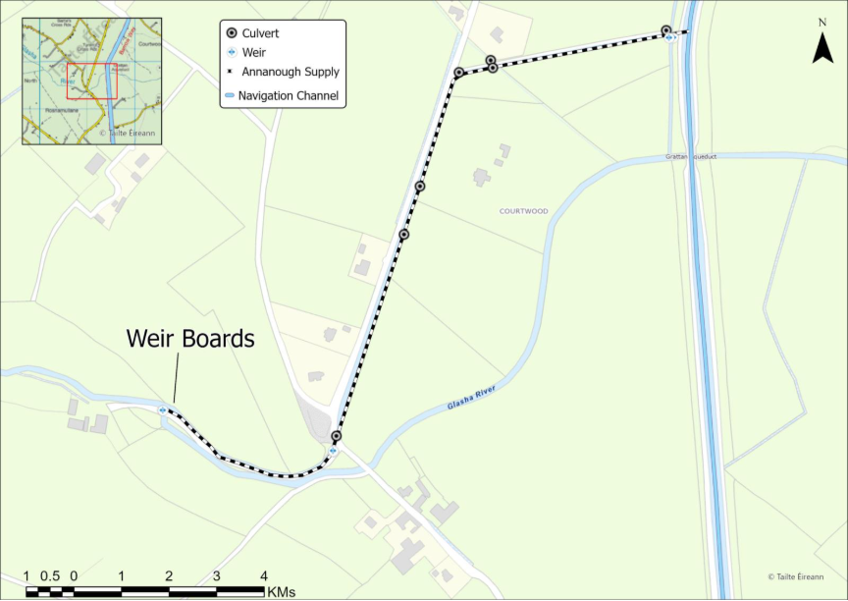
Figure 3-17; Annanough Supply

Lough Scur – Summit Abstraction to the Shannon-Erne Waterway
This waterway runs through the Shannon and Erne catchments. From the River Shannon at Leitrim village the canal section of the Shannon-Erne Waterway rises to the summit at Lough Scur. The waterway then takes the form of a canalised river linking several lakes on its journey towards Upper Lough Erne. The water entering the canal section (flowing west toward Leitrim Village) of the Shannon Erne Waterway is considered an abstraction from Lough Scur (see Figure 3-18).
The flow entering the canal section is controlled by the interaction between Lock 8, Weir 8 and Lock 9 (Figure 3-19). The crest of Weir 8 sets the summer navigation level on Lough Scur. Any storage in the lake system is free to run-off over Weir 8 when the water level in the lake rises above crest level.
The Shannon Erne Waterway was restored in 1990. An Environmental Impact Statement of January 1990 for the “Restoration of the Ballinamore and Ballyconnell Canal” found that 20% of the long-term discharge entered the Shannon via the disused canal at that time, reflecting the condition of the lock gates, which were in disrepair.
During dry periods, there is no discharge from Lough Scur as water is back pumped from the River Shannon and St John’s Lough. No flow measurement is in place for the abstraction from Lough Scur. The EIS noted that the re-instatement of the canal would lead to 6% increase of 0.1m³/s to the long-term average outflow towards the natural outflow to the Woodford River. Prior to the restoration about 20% of the total discharge flows towards the Shannon according to the EIS. This allows an estimate for Annual volume of 7,250,000 m³/year, with a daily estimate of 20,000 m³/day.

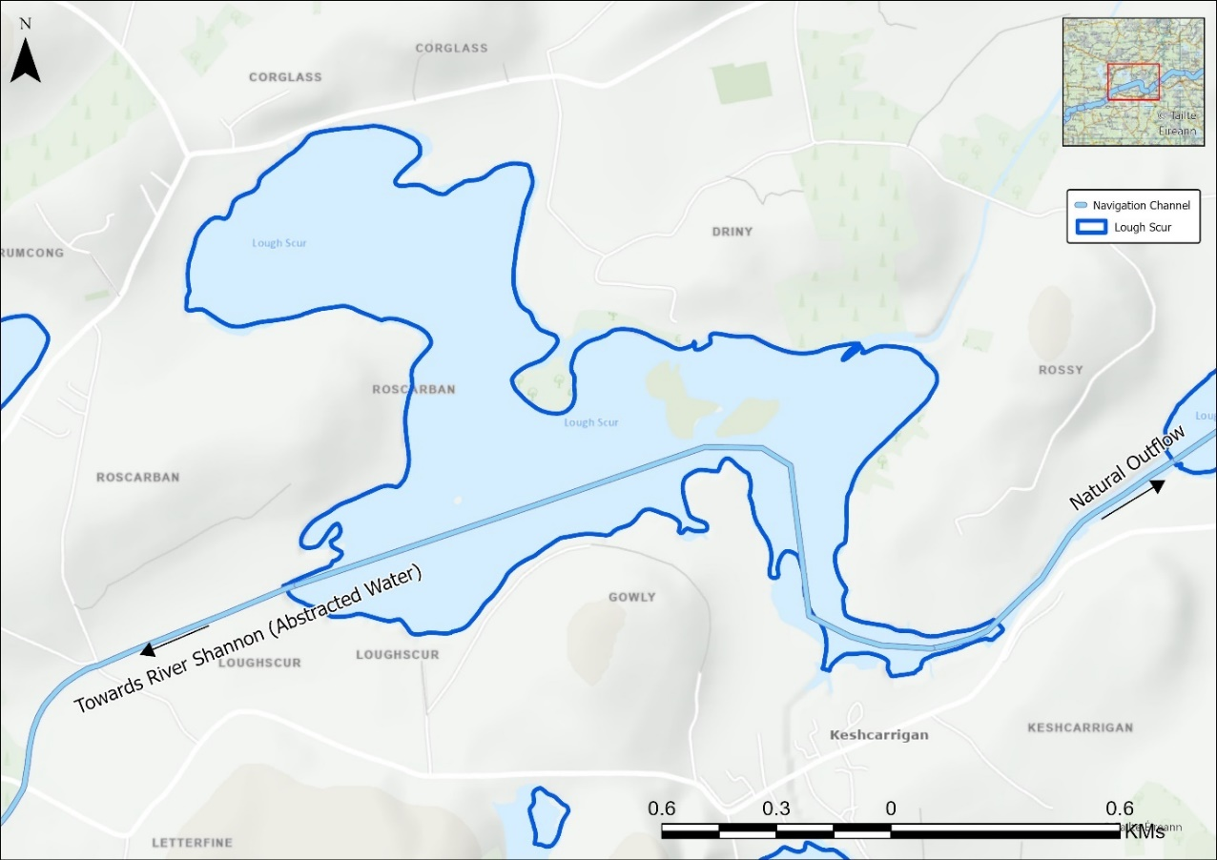
Figure 3-18; Overview of outflows from Lough Scur
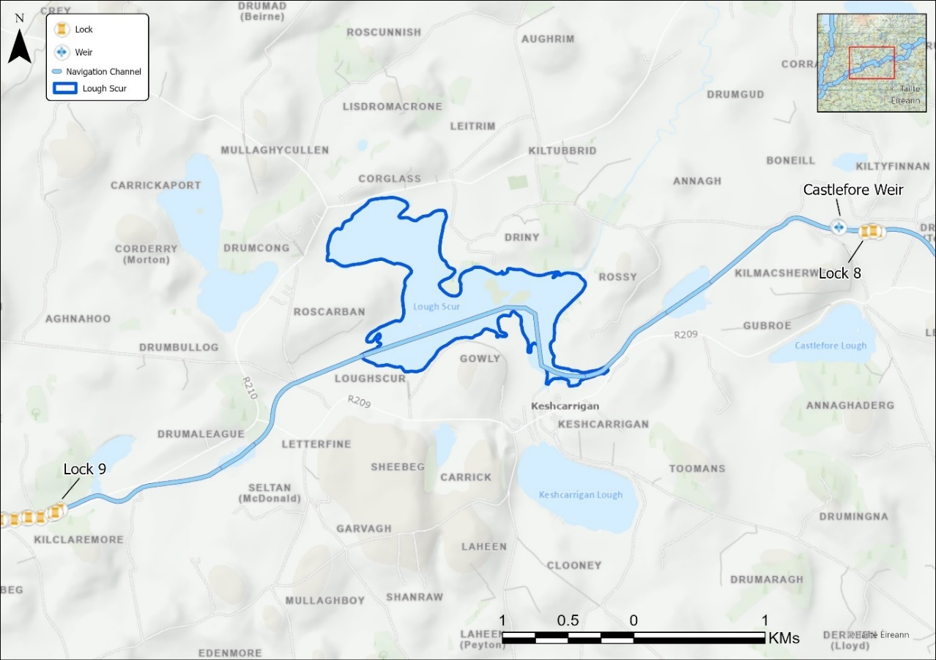
Figure 3-19; Key Controls for Lough Scur

Back pumping to Lough Scur Summit from Saint John’s Lough
A pump operates from downstream of Lock 8 and Castlefore Weir up to Lough Scur on the Shannon-Erne Waterway, see Figure 3-20. The abstraction is from the Saint John Lough level of the Shannon-Erne Waterway.
The pump is used to maintain levels in Lough Scur and in turn, maintain flow entering the canal to the west of the summit. The abstracted water is discharged to the abstraction point via lockage or lock leakage or enters the canal west, eventually discharging to the River Shannon.
Pumps are typically operated 24 hours per day during peak periods. The abstraction has been registered with the EPA annual volume of 400,000 m³ and a maximum of 3,500 m³/day.

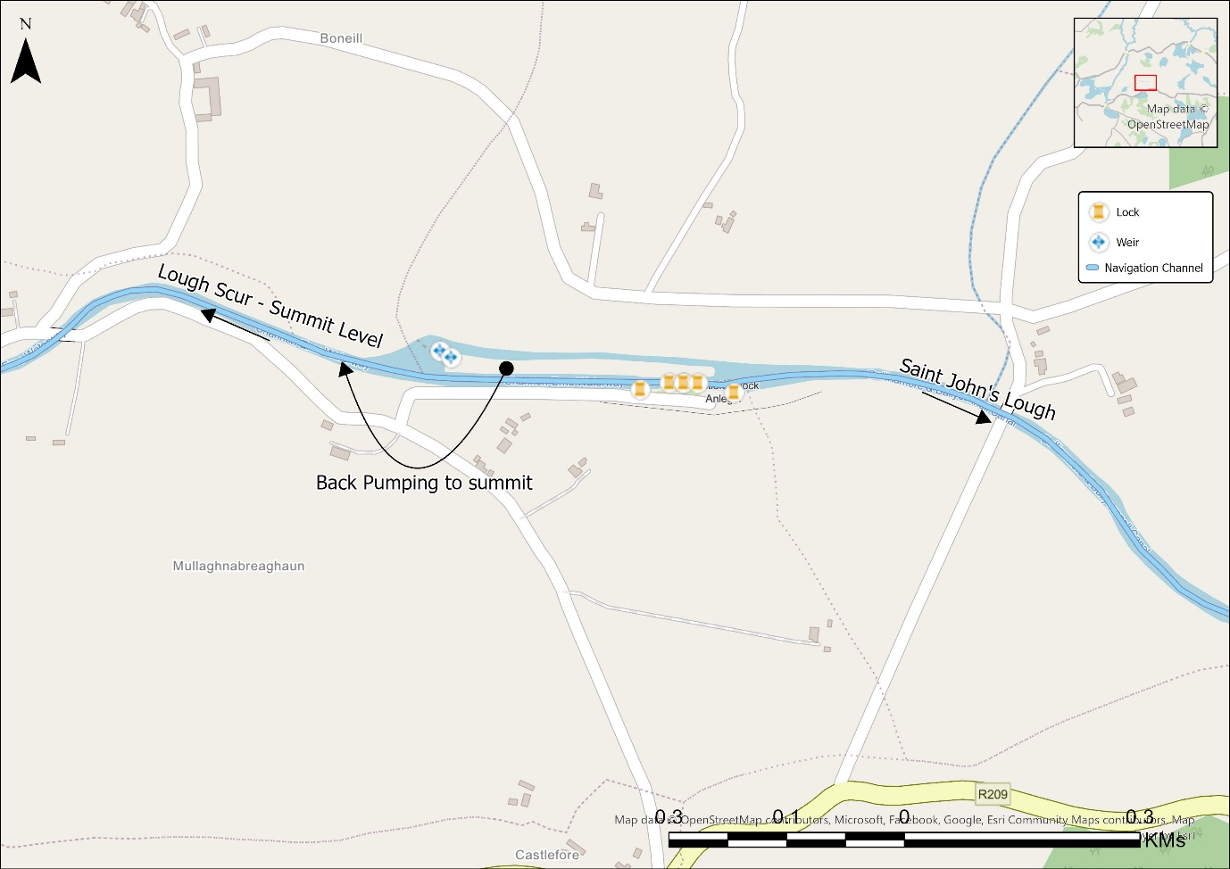
Figure 3-20; Back Pumping to Lough Scur

Lough Allen Canal
The Lough Allen Canal runs from Lough Allen at Drumshanbo before re-joining the River Shannon upstream of Leitrim Village.
The canal is primarily fed by water from Lough Allen. A dual lock allows for the variations in upstream water levels in Lough Allen, during periods of flooding the lake level exceeds the canal level and the lock works in the other direction. The canal is supplied via a pump when gravity flow from Lough Allen is not possible which is the vast majority of the time.
The level in Lough Allen is managed by the ESB who operated the Bellantra Sluices at the southern end of the lake. The ESB operates the sluices to assist with navigation, to ensure minimum navigation levels in the river during dry periods and to ensure that floods are passed safely.

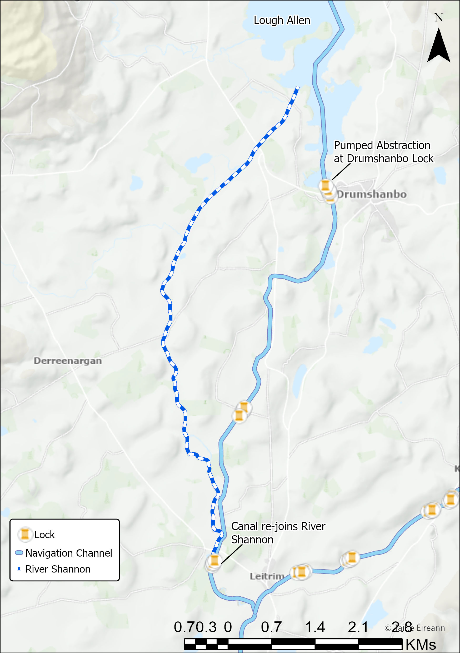
Figure 3-21; Lough Allen Overview

Proposed Site Information
In this section a number of sites are proposed as potential abstraction locations. The consultant shall review the information provided and establish an appropriate abstraction regime. Proposed values are shown in the below table. The Consultant shall recommend a value or tapered regime based on environmental, hydrological constraints. The consultant shall undertake all assessments as described in Sections 3.1.6-3.1.13.
The consultant shall assume that the primary method of abstraction shall be pumped. The Consultant shall not undertake any civil, structural, or mechanical engineering assessments. The consultant shall assume that no additional associated impoundments will be constructed as part of this new abstraction.
 | No. | Name | Source | Type | Proposed m³/day
Grand Canal | 1 | Reinstatement of Tullamore River Supply | River | Pumped | 5,000
Grand Canal | 2 | New Abstraction from Silver River | River | Pumped | 7,500

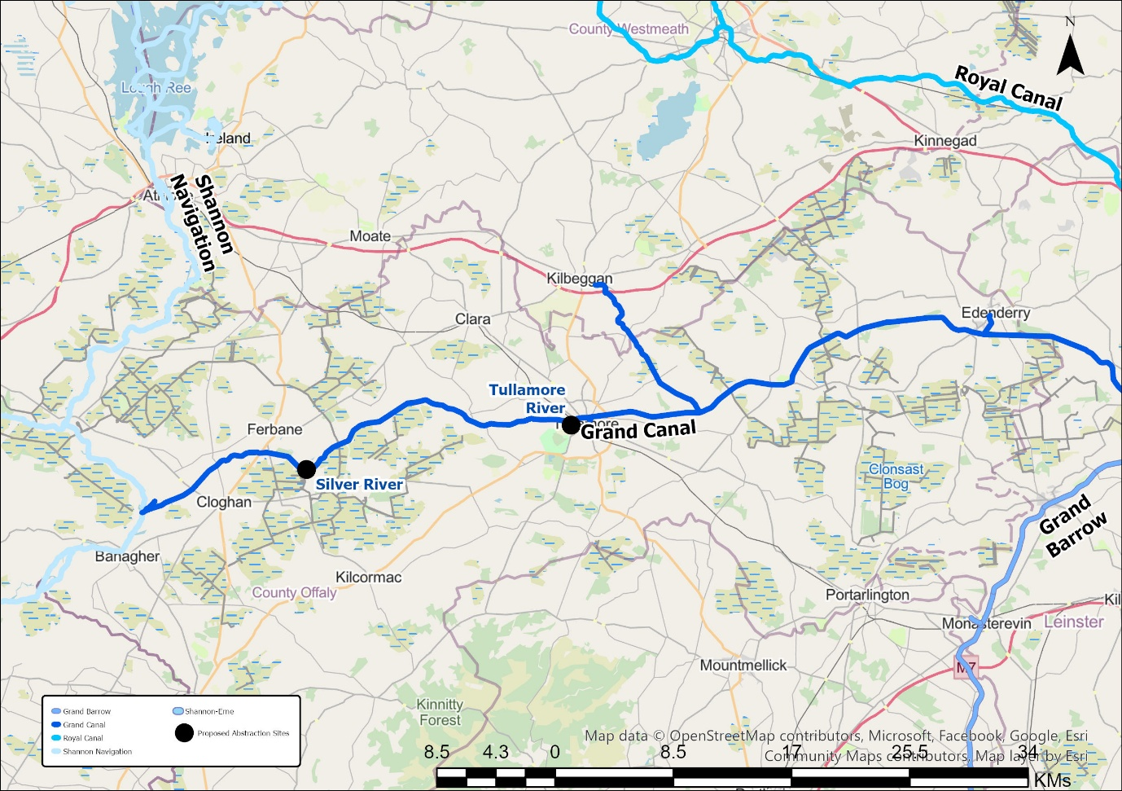
Figure 3-22; Proposed Abstraction locations

Reinstatement of Tullamore River Supply
The Tullamore River is a discontinued supply for the Grand Canal located just west of Tullamore. The supply was a gravity supply which relied on the use of an impoundment to raise levels and direct into a feeder channel, see Figure 3-23. The feeder ran northwards initially before running parallel along the canal for a period before entering the channel. This supply was discontinued to prevent water of poor quality entering the canal in the 1970s. The feeder channel is now in a state of disrepair. If a supply is reinstated here, then it is likely a pumped abstraction will be required.
The Tullamore WWTP had discharged into the river immediately upstream of the gravity offtake which exacerbated water quality issues in the water entering the canal. In recent years Uisce Éireann have improved the treatment process and now discharge downstream of the impoundment.
The consultant shall investigate the potential of re-instating this supply. As the channel is in disrepair, the consultant shall assume a pumped abstraction. The consultant shall also review other potential abstraction locations noted in Figure 3-24:
- The Clodiagh River passes under the Grand Canal approximately 4 km to the west of the old Tullamore feeder location. The Clodiagh River then confluences with the Tullamore River 700m downstream;
- The Tullamore River passes under the Grand Canal around 3.5 km west of the feeder offtake.
The consultant should also examine the potential locations for a pumped abstraction and propose recommendations for the likely hydrological and environmental limits when applying for an abstraction license. The consultant should be cognisant of other proposed new abstractions which share a hydrological connection. (e.g. section 3.1.5.1).
The consultant shall assess the impact of the proposed 5,000 m³/day abstraction. If this exceeds environmental limits, the consultant shall identify the maximum sustainable abstraction at the site. The consultant may propose an abstraction which varies throughout the year based on hydrological conditions.
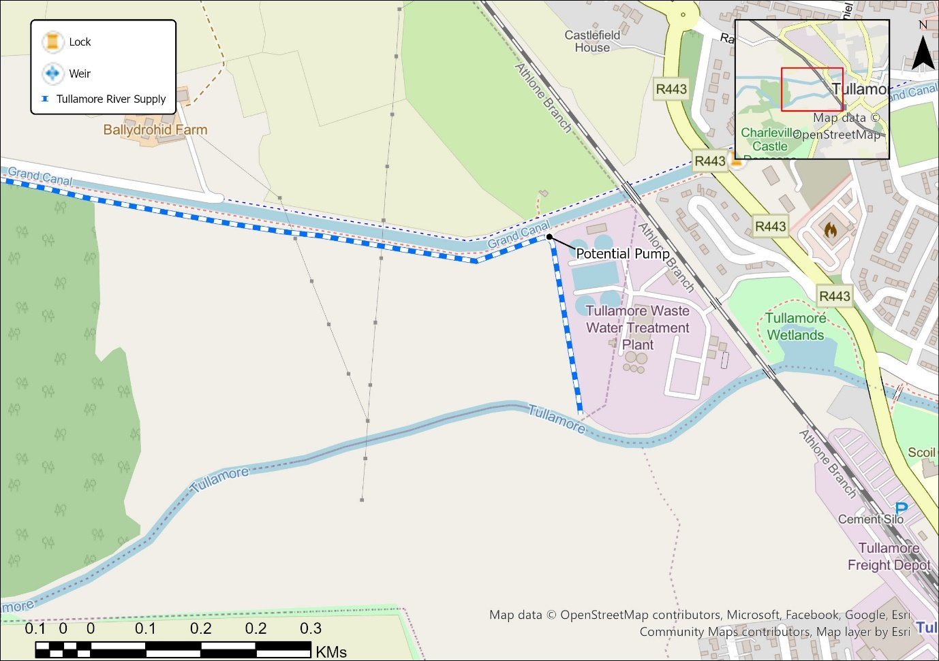
Figure 3-23; Old Tullamore River Feeder Channel

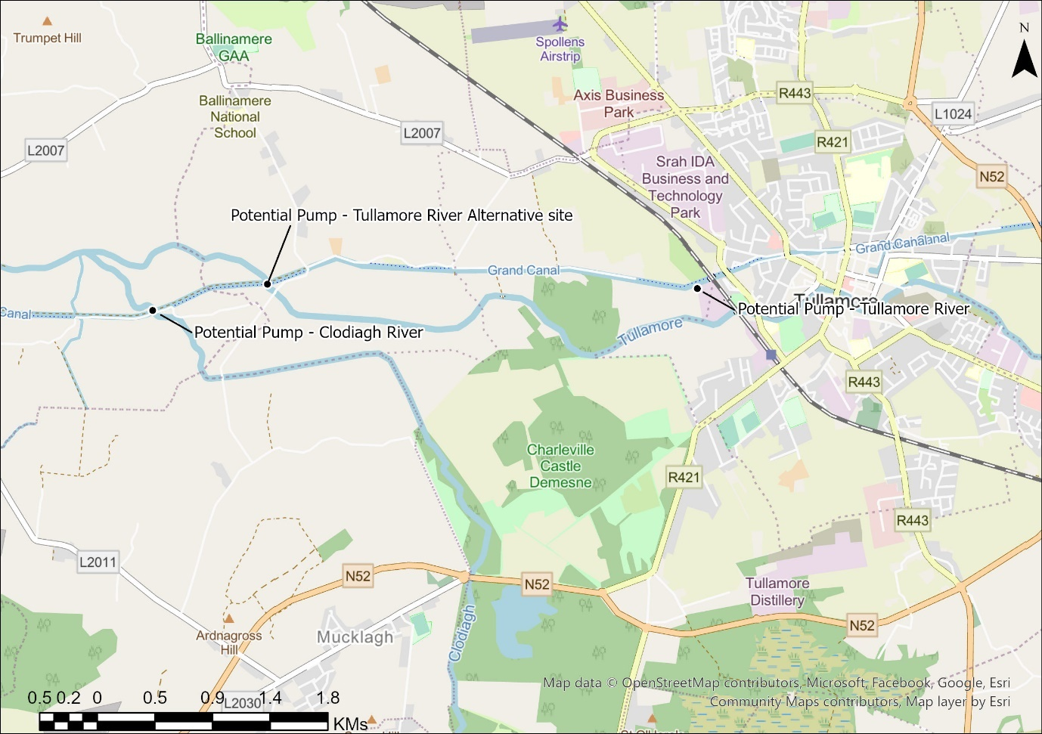
Figure 3-24; Overview of Potential Pumped Abstractions near Tullamore

New Abstraction from Silver River
The Silver River passes under the Grand Canal at the Macartney Aqueduct approximately 4km south-west of Ferbane, Co Offaly. The Silver River confluences with the River Brosna 1 km downstream of the aqueduct.
The consultant shall assess the impact of the proposed 7,500 m³/day abstraction. If this exceeds environmental limits, the consultant shall identify the maximum sustainable abstraction at the site. The consultant may propose an abstraction which varies throughout the year based on hydrological conditions.
The consultant should examine the likely hydrological and environmental limits of a pumped abstraction when applying for an abstraction license and recommend an appropriate abstraction amount and apply this to fulfil all deliverables required under Section 3.1.12.

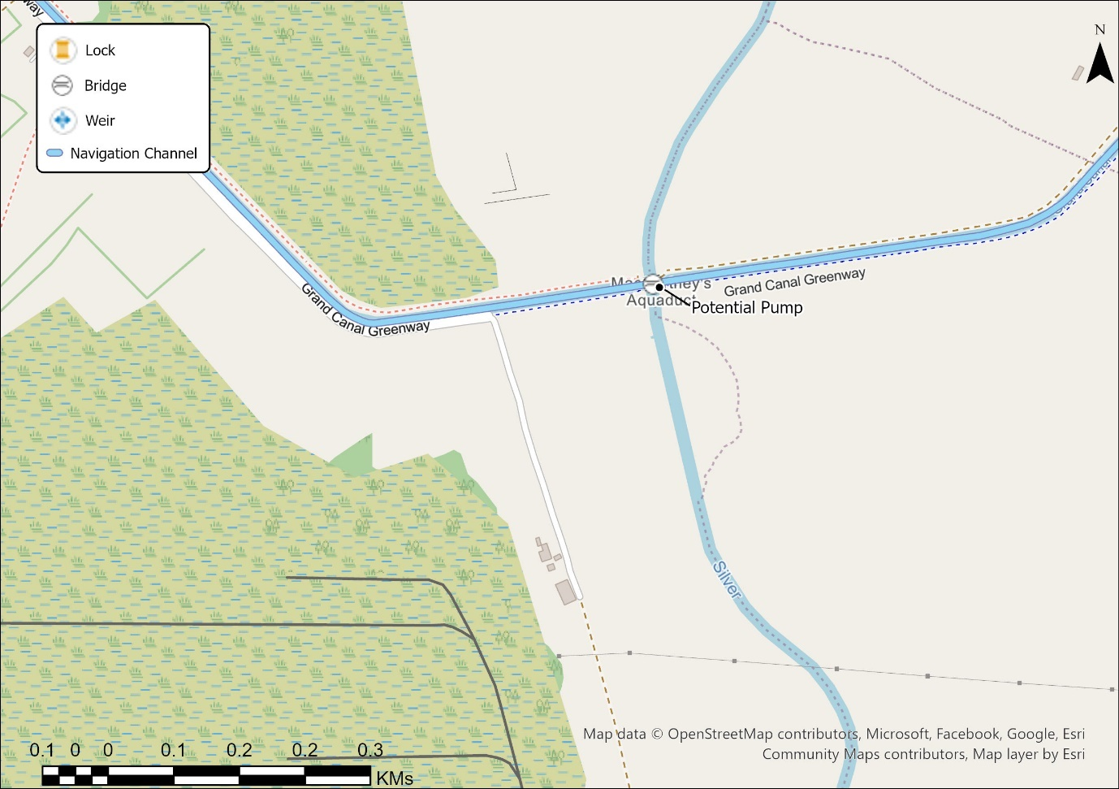

Data Collection
Collate and analyse existing data, including but not limited to:
- EPA and OPW hydrometric monitoring data,
- CFRAM survey data,
- Details of other abstractions,
- NPWS European site data,
- NPWS Article 17 Report data,
- Existing hydrological assessments
- National Hydrometric data
- WFD Module on Eden,
- Catchments.ie WFD Status data, Freshwater monitoring data and Significant Pressures data
- EDEN Abstraction Register,
- LAWPRO -- Priority Areas for Action Reporting
- County Groundwater Protection Reports
- EPA Heavily Modified Waterbody list,
- Met Éireann data,
- IFI's National Barrier Programme (NBP)
- IFI Fisheries Surveys Data and Reports.
- BSBI Database (aquatic vegetation)
- National Biodiversity Data Centre database
- IWEBS Data
- Bathymetric surveys from a variety of sources including, but not limited to EPA, IFI, i-fishing, and GloBathy

Waterways Ireland will provide:
- Co-ordinates of Waterways Ireland abstractions and operational infrastructure;
- Other relevant data as required;
- EPA Canal Water Balance Study for the Royal Canal & Barrow Line;
- Outputs from on-going spot flow measurement monitoring.

The above list of data sources is by no means exhaustive. Further data sources shall be identified by the Consultant.

Data Collection Deliverable Summary
The Consultant shall deliver a short technical note for each existing and proposed abstraction which summarises the following:
- Comprehensive data collation report including all existing hydrometric, environmental and operational data relevant to each abstraction site
- Zone of Influence mapping, defining catchment boundaries and potential impact areas for each abstraction
- Data gap analysis identifying information requirements for successful licence applications and proposals to close data gaps.

Field Work

A site visit is required to collect the following information:
- Photographs of the abstractions:
  - Photographs of the abstraction point at the waterbody,
  - 360-degree videos of the abstraction providing a view of the waterway/navigation,
  - Photographs of the abstraction infrastructure including pumping stations, weirs, stop logs, sluices feeder channels and associated navigation infrastructure as possible.
  - Upstream, downstream, and aerial photos of associated impoundments.
- Preliminary ecological survey as required to prepare Fossitt habitat mapping, undertake relevant mammal and bird surveys, and identify invasive species.

Associated Impoundments
The consultant shall confirm via site visit impoundments that may be associated with an abstraction. Note that proximity to an abstraction would not necessarily confirm an associated impoundment.

- Sufficient information to provide the 2.3 Associated Impoundments Attachment (see Appendix A) as required as part of the license application. This includes vertical height (as measured from the downstream toe of the impoundment structure to the crest, or top of the spillway).
- The consultant shall, noting the requirements of Table 9 of EPA application form 3.1 Supplementary Information Attachment (see Appendix A) to consult with IFI where a fish pass is present or proposed.

Barrier Data
The collection of barrier information is required for Water Framework Directive (WFD) assessments, and effectively liaising with key stakeholders, such as Inland Fisheries Ireland (IFI).
The barrier assessment is mainly a visual assessment and collection of basic dimensions. Experienced teams can undertake an initial assessment in approximately 30 minutes per barrier.

Before any fieldwork, a desk study of the waterway catchment area will be undertaken, focusing on the Zone of Influence (ZoI) of the abstraction (minimum 1 km upstream and downstream). This study should include a review of the National Barriers Programme Dashboard to identify any existing data on barriers. Note these barriers may not be associated impoundments.

Pump Intake Details
Sufficient information should be collected during the site visit and engagement with the operational staff to capture pump intake details. All age classes of all fish species, resident within the area of the abstraction or likely to migrate through that section of the watercourse should be considered.
Details should include the following factors:
- Usage of a screen
- Surface area of the screen (based on bar width and spacing for course screens, and mesh size for fine screens).
- Screen opening and/or intake dimensions
- Potential for screens to become clogged which is likely to increase flow velocities in the vicinity of the screen (Maintenance regimes or clogging history)
- Angle of the screen.
- Fish friendly design or return systems
Evidence may include design or as-constructed drawings, design specifications, photographs, site measurements, as available.

Field Work Deliverable Summary
The consultant shall deliver a Field Work Summary Report per existing or proposed abstraction which shall include the following:
- Site visit Summary with standardised photography requirements: abstraction points, associated infrastructure, and impoundment
- Preliminary Ecological Appraisal summary following CIEEM guidance, confirming abstraction locations, identifying interacting features, invasive species mapping and Fossitt habitat classification
- Barrier Assessment
  - Zone of influence walkover reports (minimum 1km upstream / downstream)
- Pump intake Details Summary
  - Details of pump intakes captured

Hydrological Assessment

The assessment should establish ecology based hydrological limits to sustain waterbody status and protected sites and based on the EPA's document ’Methodology to assess the impact of abstraction on waterbodies and identify significant abstraction in Ireland’. Outputs from the Hydrological Assessment shall feed sequentially into the WFD, AA and EIA screenings using a consistent zone of influence

River waterbody assessment

The purpose of the river waterbody assessment is to establish Naturalised flow duration curves (FDCs). These naturalised FDCs represent the natural flow that would be in each river where all abstractions and discharges are absent. The cumulative impact from headwater to catchment outflow is then modelled by adding in known discharges and subtracting known abstractions.

The following is proposed layout of a hydrological assessment. Please note there is potential for variations to the process for site-specific issues.

- Provide details on the Waterways Ireland abstraction(s) for licensing -- Name/Waterway/Navigation/Co-Ordinates/Abstraction Volumes/Operational Notes

- Provide a description of the catchment characteristics,
  - General description of catchment including WFD waterbody details and protected sites,
  - Physical catchment descriptors at key locations (gauges/abstractions/discharges/structures/significant tributaries) including Area, SAAR, S1085, BFI,
  - Description of the underlying geology and groundwater bodies,
  - Comment on any unusual features which may affect hydrology assessments. This may include (but not limited to) urban centres, tidal extents, attenuation, catchment transfers, legacy mill races, sinking streams, other karst features, incorrect catchment extent mapping, navigation infrastructure impacts, etc.,

- Provide details of available information
  - Meteorological information -- rainfall, evaporation and potential evapotranspiration,
  - Hydrometric gauge assessment (if available):
    - An assessment of the gauge, consistent with guidance from Uisce Éireann’s Technical Guidance for Hydrological Estimation,
    - Comparison of gauged FDC to EPA Hydrotool outputs,
    - Define the extent of the gauged catchment using guidance from Uisce Éireann's Technical Guidance for Hydrological Estimation,
    - Define the extent of ungauged catchment from which it is appropriate to use the above gauged catchment as a donor catchment using guidance from Uisce Éireann’s Technical Guidance for Hydrological Estimation,
    - Provide a clear description of the transposition method (flow per unit catchment area or otherwise),
    - Compare proposed FDC with EPA’s Hydrotool values as appropriate.

- Provide details on potential impounding structures gathered from either desk studies or site visits,
- Assessment Methodology
  - Map and provide details of all known abstractions and discharges in the catchment,
    - For discharges from Wastewater Treatment Plant or similar, the most recent annual reporting values should be used available from the EPA’s ‘LEAP’ portal. Select the lower of the design dry weather flow or the observed daily mean flow when calculating the influenced flow (unless there is a site-specific nuance),
    - Plants under 500PE may be disregarded if the flows are deemed insignificant.
    - Review EPA abstraction register for known abstractions in the catchment area.
  - Follow a risk-based approach to determine the impact of groundwater abstractions on rivers and to identify abstractions that may be depleting river flows as described in EPA guidance on ‘Methodology to Assess and Identify Significant Abstractions in Ireland’
  - Define the naturalised flow and influenced flow along the waterbody's length for Q60, Q70 and Q95. Note that the gauged flow may be influenced -- naturalised flows can be back-calculated using available abstraction and discharge information. Comment on the uncertainty arising from potential variation in abstractions and discharges over the gauged record. In some cases, reliance on present-day abstraction and discharges rates may be misleading as they may have not been in operation in previous years.
  - Define the catchment topology and environmental flows (e-flow); please refer to EPA guidance on ‘Methodology to Assess and Identify Significant Abstractions in Ireland’.
  - Graph the naturalised flow, influenced flow and e-flow at key locations along the waterbody for Q60, Q70 and Q95.
  - Summarise in a table for the Q60, Q70 and Q95, the naturalised flow value, allowable abstraction limit, abstraction rate and the residual flow.
  - The downstream extent of the assessment shall be the waterbody in which there is no further impact where the influenced flow is greater than the e-flow

Provide a commentary on the existing abstraction (or proposed abstraction) and data limitations. Describe any areas which encroach on the e-flows limit with the proposed or existing abstraction amount. Detail the length of the waterbody which encroaches on the e-flows limit and compare to the total length of the waterbody.

Lake waterbody Assessment

Test the environmental standards for lakes as per EPA Guidance ‘Methodology to Assess and Identify Significant Abstractions in Ireland’ via
  - Reduction in the lake habitable zone area
Or
  - % allowable change in natural Q50 lake outflow
And
  - Undertake e-flow assessment for waterbodies downstream of the lake as described in Section 3.1.8.1.

Hydrological Assessment Reports Deliverable Summary
The consultant shall provide a Hydrological Assessment Report for each existing and proposed abstraction location including the following as appropriate:
- River Waterbody Assessment:
  - Naturalised Flow Duration Curves (FDCs) as appropriate along waterbody
  - Physical catchment descriptors (Area, SAAR, S1085, BFI) at key locations
  - Gauge assessment report
  - Cumulative impact modelling
  - Q60, Q70, Q95 flow analysis with e-flow compliance assessment
- Lake Waterbody-Specific Assessment Reports (where required):
  - Description of lake to include Physical catchment descriptors (Area, SAAR, S1085, BFI), water clarity data, littoral zone, available bathymetric data
  - Sensitivity analysis and uncertainty assessment
  - e-flow compliance assessment

WFD Assessment

The Consultant shall undertake a WFD screening and scoping exercise to determine the potential ecological impact of the named abstractions on the linked water bodies for each abstraction location.

WFD Supporting Surveys
Where the abstraction hydrological assessment indicates a potential impact (i.e. below e-flow) -- in the absence of robust AA WFD data, surveys may be required to assess presence/condition of ecological elements subject.

Ecology surveys should be scoped appropriately (see CIEEM 2024), informed by the following guidance below and proportionately focused on significant effects. In line with best practice an initial ecological visit to site must be undertaken to inform WFD assessments and incorporate efficiencies to reduce project costs and delays.

Surveys outside the initial site survey, for specific species and/or licenced surveys must be identified following a robust desktop assessment. Following this the survey need must be justified and agreed with the Client. The fixed price shall include all project management, procurement, and quality assurance time related to potential specific species and/or licenced surveys or other surveys undertaken by third parties. The cost of such 3rd party surveys will be paid by WI.

A comprehensive desktop review of EPA Water Framework Direct Reporting (catchments.ie) should form the basis of the WFD assessment, the following elements of each individual waterbodies (taking account of the characterisation of each waterbody: AWB, HMWB, river, lake, TWB) within the ZOI should be identified and used to inform further assessment.
- WFD 2010-Present Ecological Status or Potential
  - Biological Status or Potential
    - River Invertebrate Status or Potential
    - River Fish Status (If applicable)
    - Lake Macrophyte Status or Potential
    - Lake Phytobenthos Status or Potential (If applicable)
  - Hydromorphological Conditions (If applicable)
    - River Hydromorphology Assessment Technique (RHAT) Condition (Rivers)
    - Lakes Morphological Impact Assessment System (MImAS)
- WFD 2010-Present Supporting Chemistry Condition
- WFD 2010-Present Risk Status
- Significant Pressure (s)
- EPA Significant Pressures List
- Priority Area for Action -- Desktop assessment and updates.
- Heavily Modified Waterbodies Designation

Where the abstraction hydrological assessment indicates a potential impact (i.e. below e-flow) -- Published WFD data will be comprehensibly reviewed to examine evidence as to whether the abstraction;
- Cannot cause a deterioration of WFD status
- Cannot compromise the achievement of Good/ High/ Good Ecological potential Env. Objective
- Cannot compromise the objectives and standards for associated protected areas
- Compromise implementation of measures for significant pressures

In the absence of robust WFD data, further field assessment(s) (of the waterbodies biological, chemical and/or Hydromorphological WFD elements) may be required to investigate if the abstraction is a significant pressure and what mitigation measures are required. This must be communicated to Waterways Ireland following desktop review and prior to completing the assessments.

WFD Deliverable Summary
The consultant shall provide a Water Framework Directive Assessment Reports for each abstraction point. The report shall include the following:
- Summary of Baseline Scoping
- Compliance Assessment
  - Environmental Flow limits
  - Biological Quality Elements
  - Hydrological Regime
  - Morphological conditions
- Assessment of Current Abstraction against Waterbody Measures
- Cumulative Impact Assessment
- Assessment of the abstraction against WFD objectives
- Ecological status/potential impact assessment
- Significant pressure analysis and mitigation recommendations
- Desktop review of EPA catchments.ie data
- Field survey reports (where required for data gaps)

Reporting to inform Appropriate Assessment (AA)

AA Screening (AA)
Conduct AA screening for the existing & proposed abstractions in line with ‘Appropriate Assessment Screening for Development Management’ (Office of Planning Regulator, 2021). The screening shall:
- Provide details of status, classification, objectives, etc. of the respective water bodies/European sites within each of the defined Zones of Influence,
- Consider their likely impacts on relevant European Sites, and
- Conclude with a recommendation statement on whether a full AA and the preparation of an NIS is required

Supporting Surveys to inform AA Reporting

Where the abstraction hydrological assessment indicates a potential impact (i.e. below e-flow) -- in the absence of robust AA data, surveys may be required to assess presence/condition of ecological elements subject.
Ecology surveys should be scoped appropriately following CIEEM guidance (CIEEM 2024), informed by the following guidance below and proportionately focused on significant effects. In line with best practice an initial ecological visit to site must be undertaken to inform AA screening assessments and incorporate efficiencies to reduce project costs and delays.

Surveys outside the initial site survey, for specific species and/or licenced surveys must be identified following a robust desktop assessment. Following this the survey need must be justified and agreed with the Client.

Desktop assessment to inform survey scope review of following sources: Review NPWS data; Conservation Objectives, Article 17 reporting, NBDC database, Primarily Ecological Assessment(s), Abstraction hydrological assessment (used to inform the survey extents).

When desktop assessment indicates potential presence of protected species, where practical the initial site survey should incorporate appropriate survey methodology to adequately inform AA. E.g., if Otter is a QI and potentially within ZOI but records are poor, the initial site survey should record signs of activity and condition of habitat within survey area, similarly if salmon are a QI but records are poor, riverine habitat condition and fish pass potential (see below) should be recorded to inform AA.

If the likely presence of QI species and/or habitats is confirmed at desktop stage and following initial site survey presence is assumed, and no further surveys required for AA.

Where abstraction or changes to the hydrological regime is called out as a potential activity which may impact a QI/SCI of the European Site, in the absence of robust data further hydrological and ecological surveys should be undertaken to inform the assessment.

Where the available data is insufficient and specialist or licenced surveys are required (crayfish searches, electro fishing, FWMP surveys etc) these should be raised following the Primarily Ecological Assessment and communicated to Waterways Ireland.

AA Deliverable Summary
- Appropriate Assessment Screening Reports including:
  - European Site impact assessment within defined zones of influence
  - Cross-border designated site considerations
  - Conservation objectives compliance analysis
  - Natura Impact Statement recommendations (where AA required)
  - Supporting ecological survey reports (where required)

Natura Impacts Study
Where an abstraction cannot be Screened Out with regard to AA and an AA (with accompanying NIS) is required, the Consultant shall not undertake this. The Scope of Services for that specific abstraction shall explicitly end prior to the 'Licence Application' submission stage. Waterways Ireland will determine the next steps (e.g., separate procurement of NIS). The Consultant shall proceed with all other independent deliverables (e.g., WFD Assessment, EIAR Screening) unless otherwise instructed.

Environmental Impact Assessment - Consideration of Class

Retrospective Environmental Impact Assessment
For each existing abstractions, the Consultant shall undertake an initial review to confirm whether the abstraction is subject to Retrospective Environmental Impact Assessment (rEIA) considerations. The consultant shall refer to EPA guidance available on Retrospective Environmental Impact Assessment for existing abstractions.

The consultant shall provide a report to allow the EPA to undertake an rEIA screening including pertinent information to allow EPA to make a determination.

Proposed Abstractions – EIA Class Determination
The Consultant shall conduct a comprehensive Environmental Impact Assessment (EIA) Class Determination and Screening Statement to establish the mandatory or sub-threshold requirements for each proposed water abstraction project and associated impoundment. The consultant shall refer to EPA guidelines on the topic to ensure best practice.

Environmental Impact Assessment Report
If the EIA Screening statement determines a full EIAR is required, the Consultant shall not undertake this. The Scope of Services for that specific abstraction shall explicitly pause prior to the 'Licence Application' submission stage. Waterways Ireland will determine the next steps (e.g., separate procurement of EIAR). The Consultant shall proceed with all other independent deliverables (e.g., WFD Assessment, AA Screening) unless otherwise instructed.

Final Reporting and Handover
For each existing and proposed abstraction, the consultant shall deliver a final report with the following:
- Non-Technical Summary for each abstraction
  - A plain-language report (≤10 pages) for each abstraction summarising operation, monitoring, impoundment details, WFD and AA screening findings, and site location maps, written in non-technical language suitable for regulator and public review

- Technical Appendices containing detailed methodology, calculations, and supporting data
- Recommendations Report for licence application strategy and operational modifications
- Abstraction Licence Application Support Documentation in EPA-compliant formats
  - 2.3 Impoundment Template
  - 2.5 Monitoring
  - 3.1 Supplementary information

All deliverables must be provided in electronic format, with electronic submissions compatible with Waterways Ireland's document management systems and suitable for submission to regulatory authorities.

Deliverable Summary
This section outlines the typical schedule of deliverables required across all project phases, including data collection, field surveys, hydrological assessments, and environmental reporting. Some variation will occur in deliverables (e.g., gravity abstractions vs. pumped abstractions, river abstractions vs. lake abstractions).
Phase / Assessment Category | Required Deliverables
Data Collection | - Comprehensive data collation report  - Zone of Influence mapping  - Data gap analysis
Field Work | - Site visit summary  - Preliminary Ecological Appraisal summary  - Barrier assessment  - Pump intake details summary
Hydrological Assessment | - Hydrological Assessment Reports
Water Framework Directive (WFD) | - Water Framework Directive Assessment Reports
Appropriate Assessment (AA) | - Appropriate Assessment Screening Reports
Environmental Impact Assessment (EIA) | - rEIA screening report  - EIA Class Determination and Screening Statement
Final Reporting and Handover | - Final Reports

Deliverable Review and Approval Process
All deliverables issued by the Consultant shall initially be submitted as a "Draft". The Client will review the Draft and return comments. The Consultant shall update the document to address all Client comments and reissue it as "Draft Final". The deliverable will only achieve "Final" status upon the Client’s written confirmation that all comments have been satisfactorily addressed and the document is approved.
The Client will endeavour to return comments on Draft submissions within two (2) weeks; however, this review period may extend up to four (4) weeks. The Client shall return comments on Draft Final submissions within two (2) weeks of receipt. When programming the works, the Consultant shall be cognizant of these review requirements and build appropriate allowances into the project schedule. Furthermore, should the Consultant issue multiple deliverables simultaneously, the Client reserves the right to extend the aforementioned review periods as necessary to accommodate the concurrent workload.

Deliverable Tracking and KPI Reporting
Based on the Summary of Deliverables outlined in 3.1.14, the Consultant shall develop, maintain, and issue a tracking matrix to monitor the progress of all deliverables across every abstraction.
The tracking matrix shall utilise a Red-Amber-Green (RAG) status indicator for each deliverable heading (e.g., Data Collection, Field Work, Hydrological Assessment) per abstraction. Furthermore, the Consultant shall monitor progress against the baseline project programme. The Consultant must track and report the Schedule Variance as a Key Performance Indicator (KPI), quantifying any delay or acceleration in days (+/-) against the originally agreed programme deadlines.

Duration
The contract will be for a period of twenty-four (24) months from award.
The Contracting Authority reserves the right at its sole discretion to extend the contract, subject to satisfactory performance, budget availability and ongoing business needs. The maximum number and duration of extensions will be three (3) extensions of twelve (12) months each making a possible contract length of five (5) years.

Contract Management

Waterways Ireland’s Representative/ Project Manager
The Waterways Ireland Representative/ Project Manager for the project is Kevin Macken, Senior Hydrologist Waterways Ireland, Ashtown Gate, Navan Road, Dublin 15.

Consultant’s Representative
The Contracting Authority requires tenderers to nominate a dedicated contract manager who will act as the main point of contact for the duration of the contract. This person shall have the authority to deal with all matters in relation to contracts and be responsible for the satisfactory delivery of the supplies/services required including coordination of all deliverables, programme management, stakeholder engagement and regulatory submissions associated with the contract. The duties of the contract manager will include the following:
- Overall responsibility for a good working relationship with the Contracting Authority;
- Provide regular reports on performance as agreed with the Contracting Authority; this may be fulfilled by online progress meeting as defined in Section 3.1.1;
- Meet as and when required, at the discretion of the Contracting Authority, to review and examine performance;
- Handling of disputes, complaints or concerns that cannot be adequately resolved;
- Proactively discuss with the Contracting Authority ways of improving efficiency in respect of service delivery in general and providing suggestions for improvements and cost savings.
NOTE: Tenderers will note that contract management activities shall not be billed separately but instead be included within the tenderer’s rates for the delivery of the phases/deliverables stated above.

Compliance with the Terms and Conditions
Award of contract will be subject to the successful tenderer agreeing to the Contract Terms and Conditions as contained in the appropriate Appendix.

Award to Runner Up
If having awarded a contract, the successful tenderer fails to deliver the contract in accordance with the terms and conditions, the Contracting Authority reserves the right to award the contract to the next highest scoring tenderer by mutual agreement based on the terms advertised at any time during the tender validity period. This shall be without prejudice to the right of the Contracting Authority to cancel this competitive process and/or initiate a new contract award procedure at its sole discretion.

SELECTION CRITERIA
The Contracting Authority is using the Open procedure for the award of this contract, therefore, while all interested parties may submit a tender, only those demonstrating that they have the required level of financial and technical capacity will have their tender considered. In order to demonstrate a tenderers’ qualifications, tenderers are required to provide the information set out below in the Tender Response Document (TRD) which is based on a self-declaration model, however tenderers are required to provide the minimum information required.

Use of the European Single Procurement Document
The Contracting Authority does not currently employ the European Single Procurement Document (ESPD) as part of its tender documentation. However, in accordance with Directive 2014/24/EU, tenderers may have compiled a European Single Procurement Document (ESPD) which will be accepted as evidence of compliance with Sections 4.3 and 4.4 on condition that all information self-declared will be provided promptly on request at any time prior to an award decision.

Relying on the Standing of Other Entities
Tenderers are reminded that they may rely on the resources of other entities to establish the requirements on condition that they can prove to the satisfaction of the Contracting Authority that they will have these resources at their disposal when necessary. Tenderers should provide information on proposed roles and relationships with the sub-contractor or partners.
If the tender is from a consortium / joint venture Tenderers must ensure that all the relevant information is provided and where necessary, provide the information requested separately for each party. The consortium must appoint a single point of contact who will assume overall responsibility for delivery, and who is authorised to sign the contract on behalf of all consortia members. The Contracting Authority will not act as an arbitrator between members of consortia.

General, Legal and Financial Requirements
Tenderers are required to provide information on the following in the Tender Response Document. The criteria and rules outlined below are assessed on a pass/fail basis. Failure to comply with the requirements will result in your tender being considered inadmissible.
General Information
Provide contact and general information on the tendering organisation - company name, address and contact details for individual responsible for this tender and company overview as well as information on sub-contractors and consortium members if applicable.
Declarations
Complete the Declaration of Bona Fides as per Art. 57 of Directive 2014/24/EU as implemented by Regulation 102 of 2015 (UK) and SI 2814 of May 2016 (Irl) and as contained in the Tender Response Document.
Complete the Declaration regarding compliance with relevant statutory obligations as contained in the Tender Response Document. Where tenderers are established and operating outside of the jurisdiction of supply, compliance with equivalent legislation as applicable in the country of establishment / operation is required.

Financial and Economic Standing
Tax | Confirmation that the tenderer / all parties associated with the tenderer are fully tax compliant – please refer to the tax rules contained in the Tender Response Document.
Financial Standing | Confirmation that the tenderer has the financial capacity to pay their debts identified on the current statement of assets and liabilities as being the debts as they fall due. Evidence of independent verification will be provided on request.
Insurance | Confirmation of the following insurances being in place:
 | Insurance Type | Required Value € | Required Value STG£
 | Employer’s Liability | €13 million | £10 million
 | Public Liability | €6.5 million | £5 million
 | Professional Indemnity | €1.5 million | £1 million

Technical Capacity Requirements
Tenderers are required to provide information on the following in the Tender Response Document. The criteria and rules outlined below are assessed on a pass/fail basis. Failure to comply with the requirements will result in your tender being considered inadmissible.

Previous Contracts / Experience
Details of three (3) reference contracts relating to the provision of consultancy services for public or private sector clients which demonstrate, to the satisfaction of the Contracting Authority, the Tenderer’s experience in successfully delivering the services in scope or similar with particular emphasis on projects involving hydrological estimation. Details should be provided of relevant contracts delivered within the 60 months prior to the deadline for submission of Tenders. Reference contracts outside this timeframe will not be considered:
Each reference contract must demonstrate the successful provision of consultancy services aligned with the subject matter of this tender. Individually, contracts must meet at lease one of the criteria below; collectively, the submitted references must cover all three.
The experience demonstrated within these contracts must include at least two (2) of the following:
- One (1) example of undertaking drought hydrological assessment.

- One (1) example of completing Water Framework Directive Assessment Reports

- One (1) example of undertaking Appropriate Assessment Screening / Environmental Impact Assessment – Consideration of Class reports

Health and Safety
Tenderers must provide information which demonstrates operation of health & safety systems and procedures in line with all relevant Safety Health & Welfare at Work legislation. Please complete the TRD. Evidence of compliance will be required as condition of contract award.

Quality Assurance
Tenderers must provide information which demonstrates a commitment to quality assurance and provide details of quality assurance policies and systems and whether 3rd party certified. Please complete the TRD.

AWARD CRITERIA
Only tenderers who meet the Selection Criteria and are confirmed as valid and responsive to the specifications set out in this document will be evaluated against the award criteria. Tenderers should ensure that they have submitted sufficient relevant information to allow their tenders to be assessed under each of the award criteria set out below.
The contract will be awarded on the basis of the most economically advantageous compliant tender taking into account the following award criteria and weightings.

Criteria A – Cost
Only tenders that meet the selection criteria, specification requirements and minimum scores under the Qualitative Criteria (Criterion B,C and D) will be scored under the Cost Criterion.
Title | Cost for the Delivery of the Abstraction Licensing Support Services
Description | Proposed Total Fixed Fee for delivery of the Contract (to include all aspects) as outlined in the Request for Tender document.  (as per details provided in Pricing Document)
Weighing | 30%
Maximum Marks | 3000

Criteria B - Methodology

Criterion B – Methodology for Abstraction Licensing Support Services | Weighting | Max. Marks | Min. Marks Required
 | 30% | 3,000 | 1,500
Description
Tenderers should demonstrate that they have a detailed understanding of the requirements of the tender specification.
Tenderers should outline in a max. of seven no. A4 pages (excluding images/graphs) a methodology, providing details of how the work will be undertaken, including estimated hours, number of staff, etc. Your tender should also show the management and superintendence arrangements proposed together with the role and management of any sub-contractors, if any.

Criteria C – Key Resources & Programme
Criterion C – Key Resources & Programme | Weighting | Max. Marks | Min. Marks Required
Criterion C – Key Resources & Programme | 35% | 3500 | 1750
Description
Tenderers must demonstrate access to suitably qualified staff in the following disciplines. Staff qualifications and experience requirements:

Project Manager:
- Third level qualification in environmental science, engineering, or related discipline
- Minimum 5 years’ experience managing multi-disciplinary environmental assessment projects
- Experience with regulatory submission processes and stakeholder engagement
Hydrologist:
- Third level qualification in hydrology, water resources engineering, or related discipline
- Minimum 5 years’ experience in hydrological modelling and flow assessment
- Experience with EPA methodologies and WFD compliance assessments
Freshwater Ecologist:
- Third level qualification in ecology, environmental science, or related discipline
- Minimum 5 years’ experience in freshwater ecological assessment
- Experience with WFD biological quality element assessment and aquatic survey methodologies
Environmental Assessment Specialist:
- Third level qualification in environmental science or related discipline
- Minimum 5 years’ experience in EIA and AA processes
- Knowledge of Irish and/or UK environmental legislation and assessment procedures

Minimum: Tenderers must demonstrate that they and that their sub-contractors or partners have a suitable level of qualified/experienced personnel to perform the contract. All personnel must have a relevant 3rd level qualification with five years’ experience.

Tenderers must provide a Project Programme, presented in the form of a Gantt chart or equivalent timeline, that clearly sets out:
- The key project phases and milestones (e.g., mobilisation, data review, hydrological modelling, field surveys, environmental assessments, reporting, QA review, and close-out).
- The deployment of each professional discipline across these phases, demonstrating the level and timing of staff input.
- Durations, dependencies, and overlap between tasks to illustrate the coordination of technical and fieldwork activities

Tenderers must showcase the expertise and qualifications of their project team by:
  - Completing the schedule of proposed resources provided, identifying by name the individuals, grades/positions and roles of all staff that will be part of the team delivering the services to Waterways Ireland. The relative percentage of input that these individuals will have in delivering the project should also be identified in the column provided.
  - Providing CVs (two A4 pages max.) detailing the qualifications, employment history, experience and competencies for each individual member of the team who will be engaged in delivering the Services.

NOTE 1: Tenderers should ensure in their tenders that they provide detailed information in respect of all aspects of the contract award criteria as stated above. This will enable the awarding authority to assess fully the extent of their offers.

Criteria D - Demonstrated efforts to reduce project environmental impact
Criterion D – Demonstrated Measures to Minimise Environmental Impact During Delivery of the Services | Weighting | Max. Marks | Min. Marks Required  (50%)
 | 5% | 500 | 250
Description
  - The tenderer shall describe how they intend to ensure that the environmental impact of the project remains as low as possible:
    - Minimising repeat site visits
    - Use of remote surveys/data
    - Sustainable travel arrangements
    - Digital reporting
    - Coordination of field teams
    - Minimising disturbance to habitats

Methodology for Calculating the Cost Score
The following formula will be applied to the cost score:
The lowest cost tender that also meets all the minimum requirements of the qualitative award criteria will receive the maximum score achievable under this criterion. The scores of the other valid tenders will be calculated using the following formula:
Lowest Cost from a Bona Fide Tender | A
Cost for the tender being evaluated | B
Maximum Points available for Cost | 3,000
Formula employed | 3,000 x A  B

Methodology for Calculating Scoring of Qualitative Criteria
Score | Meaning | Interpretation
90 – 100% | Outstanding | A very comprehensive response demonstrating extensive understanding offering full assurance to client – fully supported with no reservations.
80 – 89% | Excellent | An excellent response demonstrating excellent understanding offering assurance to client – strongly supported.
70 – 79% | Very good | A very good response demonstrating very good understanding offering assurance to client – fully supported.
60 – 69% | Good | A good response demonstrating good understanding offering assurance to client – well supported.
50 – 59% | Acceptable | An acceptable response demonstrating a minimum understanding offering assurance to client - satisfactorily supported.
Less than 50% is unacceptable
Marks in the score ranges outlined above can be awarded where responses so merit additional marks.

Clarification / Verification Meetings
Award of contract may be subject to attendance at a clarification and verification meeting. It would be essential that the key personnel assigned to this contract should be available and present at this meeting. If required, tenderers will be notified of the date, time, agenda and format for such meetings as soon as possible.
A visit to the tenderer’s premises may be required to clarify any questions or queries regarding the tender offer.
Tenderers should note that the Contracting Authority reserves the right to confirm that the financial and technical capacity of the tenderer is valid and unchanged prior to the award of any contract.

Clarification of Abnormally Low Tenders
If the Contracting Authority considers the tender submission to be commercially unsustainable or otherwise problematic in light of the tendered price or any other financial matter (including proposed indicative hours), the tenderer shall be invited to provide clarification to the Contracting Authority in respect of all elements of the tender submission that the Contracting Authority deems relevant. Any failure to satisfactorily comply with such a request, or to satisfactorily address the Contracting Authority’s concerns, may, at the discretion of the Contracting Authority, result in the elimination of the tender in question on the basis of it being considered abnormally low.

INSTRUCTIONS FOR TENDERERS

Closing Date for Tenders
The closing date for tender submission is specified on the title page.
It is the responsibility of the tenderers to ensure that their tender is complete and is uploaded by the designated deadline. Tenders that are received late or via other means will not be considered in this public procurement competition.
It is important to note that only persons who have downloaded and accepted a document can upload a submission.

Submission of Tenders
The Contracting Authority is using the post-box facility on eTenders, and tender responses must be submitted electronically via the eTenders postbox facility on www.etenders.gov.ie only. Only tenders submitted to the electronic postbox will be accepted. Tenders submitted by any other means (including but not limited to by email, post or hand delivery) will not be accepted.
Tenderers must ensure that they give themselves enough time to upload and submit all required documentation before the closing date/time noting the use of the new eTenders platform. Tenderers should consider the fact that upload speeds vary. To submit a response to the electronic post-box, please note that you must ensure you have submitted the response completely. It is advisable to familiarise yourself with the new platform prior to the closing date.
Below we provide an overview of the key steps. Please note that the Contracting Authority take no responsibility for these steps being the totality of the steps required as different processes may require different actions.
If in doubt, please ensure you contact the eTenders helpdesk as follows:
Email: irish-eproc-helpdesk@eurodyn.com
Phone: +353-818001459

Accessing Documents
It is important to note that you must ensure you ASSOCIATE your company with this competition in the first instance. To do this you must do the following:
(a) Log-in to the system
(b) Locate the competition using the Advanced Search by Contracting Authority or Resource ID
(c) Click on the hyperlink for the competition which will bring you to the CfT Workspace
(d) In the Show CfT Menu for the competition click on the “Expression of Interest” in the drop-down menu
(e) Complete the “Association with the CfT” tab.
(f) This will then provide you with a link to “Tender” under the Show CfT Menu

Submitting your Response
In responding to a competition without an electronic ESPD, a number of steps are required. The final step involves clicking on a Submit button and receiving the following status:

If you do not receive a message similar to above and a confirmation email directly to the inbox of the person who uploaded and submitted the tender, then you have not submitted your response.
Please note that the screen may say OFFLINE, this is a technical feature of etenders and does not mean you cannot submit. Also please note you may see the percentage field also saying 100% before you submit, this still requires you to go through the submit button.
Please upload your response as a ZIP FILE to protect the integrity of the file names.
It is the responsibility of the Tenderer to ensure that their tender is complete and is uploaded in accordance with the instructions provided on eTenders prior to the deadline as per the front page.

Queries
The closing date for submitting queries is specified on the title page.
All queries regarding this tender should be through the messaging facility on www.etenders.gov.ie, including any omissions which would prevent tenderers from submitting a comprehensive tender. Please submit queries as soon as possible.
In circulating responses, queries will be edited to avoid disclosing the identity of the querist and will be circulated to all parties who have expressed an interest in the procurement on the eTenders website.

Tender Validity Period
To allow sufficient time for tender assessment a tender validity period of [12 months] is required, this period commencing on the closing date by which the tenders are to be returned

Discrepancy between Documents
A pdf version of the Request for Tender has been made available on eTenders. This document will be considered as the primary source document in this procurement process, word versions of documents where they are provided are being made available to assist tenderers in responding to the tender competition. Where there is a discrepancy between a pdf version and a word version, the pdf version will take precedence. Tenderers are requested to notify the Contracting Authority immediately of any anomaly. Where applicable the Contracting Authority will issue amended versions.

Formatting of Tenders / Amending Tender Documents
Tenderers must ensure they use the Tender Response Document (TRD) when preparing their submission.
Tenderers are prohibited from amending any text or content of forms or declarations or templates provided as part of this tender competition in their tender responses. Where amendments have been identified, the Contracting Authority may at its discretion eliminate the tenderer from further consideration. Likewise, failure to use the template documentation provided particularly in relation to costing / pricing may result in tenders being eliminated.

Collusive Tendering
If any tendering Party is found to have, at any time, offered to give or to have agreed to offer or give to any person, any bribe, gift, gratuity, commission or consideration of any kind as an inducement or reward for taking or forbearing to take any action in relation to the obtaining of its tenders, or for showing or forbearing to show any favour or disfavour to any person in relation to its tenders, the bid submitted by such tendering party shall be automatically disqualified and the circumstances surrounding such action shall be referred to the appropriate authority.

Confidentiality
After the official opening of Tenders, information relating to the examination, clarification, evaluation and comparison of Tenders and recommendations will not be disclosed to tenderers or other persons not officially concerned with such process until the award decision with the successful Tenderer has been announced and in conformity with national laws.

Tenderers shall treat the details of all documents supplied to them in connection with this contract as private and confidential and shall not disclose the contents to a third party without the permission of the Contracting Authority.

Any effort by the Tenderer to influence the Contracting Authority or his staff in the process of examination, clarification, evaluation and comparison of Tenders and in decisions concerning the award of the contract may result in the rejection of that Tender.

Clarification of Tenders
The Contracting Authority is entitled, but not obliged, to seek clarification of tenders, including pricing breakdowns in the course of the evaluation process. No change in the price or substance of the Tender shall be sought, offered or permitted. To assist in finalising the tender evaluation, selected tenderers may be invited to attend clarification meetings with the Contracting Authority.

Extension of Tender Deadline
The Contracting Authority reserves the right, at its sole discretion, to extend the closing date for receipt of tenders by giving notice in writing (by post or electronic means) to all parties who have expressed an interest in the notice via eTenders no later than six calendar days before the original closing date.
Tenderers will be responsible for any costs incurred by them if they are required to attend clarification or other meetings or make a presentation of their proposals.

Correction of Errors
Detailed pricing of all tenders will be examined for errors that might alter the tender pricing as determined from the figures on the tender form or as between the hard copy and electronic versions of the tender. In general, the following approach will be applied to manifest errors - where there is a discrepancy between the unit price and the total amount derived from the multiplication of the unit price and the quantity, the unit price as quoted will normally govern.
The amount stated in the tender form will be adjusted by the Contracting Authority in accordance with the above procedure and, with the agreement of the tenderer, shall be considered as binding upon the tenderer. Without prejudice to the above, a tenderer not accepting the correction of their tender as outlined may have their tender rejected.
Where the Total Quote function has been activated on eTenders and a discrepancy arises between the amount in the Total Quote box and the tender submission, the amount in the tender submission shall take precedence.

Change in the Composition of a Tender
Where a change in composition of a tender arises, this must be notified in writing to the Contracting Authority and formally approved by them.
The Contracting Authority reserves the right, but is not obliged, to disqualify any tenderer that makes any change to its composition after submission of a tender.

Interference and Inducement to Purchase
Any effort by the tenderer to unduly influence the Contracting Authority, relevant agency personnel or any other relevant persons or bodies in the process of examination, clarification, evaluation and comparison of tenders and in decisions concerning the Award of Contract shall have their tender rejected. The presumptions (including as to any gift, consideration or advantage) and other provisions under the Bribery Act 2010 (UK) and the Criminal Justice Act 2018 (Ireland), and all other measures for the time being governing the subject-matter in any applicable jurisdiction, shall be applicable.

Conflict of Interest
Any conflict of interest involving a tenderer (or tenderers in the event of a consortium bid) must be fully disclosed to the Contracting Authority. Any registrable interest involving the tenderer and the Contracting Authority or employees of the Contracting Authority or their relatives must be fully disclosed in the tender submission or should be communicated to the Contracting Authority immediately upon such information becoming known to the tenderer, in the event of this information only coming to their notice after the submission of a bid and prior to the award of the contract. Failure to disclose a conflict of interest may disqualify a tenderer or invalidate an award of contract, depending on when the conflict of interest comes to light.

Publicity
Tenderers shall not undertake (or permit to be undertaken) at any time, whether at this stage or after the award of the contract, any publicity activity with any section of the media in relation to this tender/agreement other than with the prior written consent of the Contracting Authority. Such consent shall extend to the content of any publicity. For the purposes of this paragraph, the word “media” includes (but is not limited to) radio, television, newspapers, trade and specialist press, the Internet and e-mail, accessible by the public at large and the representatives of such media.

The Contracting Authority will have the right to publicise or otherwise disclose to any third-party information regarding this process and the agreement.

Right Not to Award
The Contracting Authority does not bind itself to accept the most economically advantageous tender or any tender. It also reserves the right to accept or reject in whole or in part any or all tenders received, and, in particular, to source the requirement with more than one service provider.

The invitation to tender is issued in good faith; however, the Contracting Authority at its sole discretion shall not be obliged to award a contract or proceed to further stages in the procurement process and reserves the right to cancel the procurement process.

Notification of Tender Evaluations
All tenderers will be informed of the outcome of their tenders following tender evaluation and any necessary clarifications. Potential outcomes can be:

- Award of Contract
- Letter of Regret
- Decision not to proceed with the award of Contract

The following information will be provided in the Letter of Regret – name of successful tenderer designate; the applicable standstill period (for EU tenders only); scores of tender and that of successful tender; features and characteristics of successful tender where they scored higher marks in specific criteria.

In the case of EU tenders only, the Contracting Authority will undertake not to award the contract for a period of at least 14 (or whatever period is stated in the notification letters) days from the date of notification of unsuccessful tenderers (‘standstill period’).

Award Notices
Following the award of contract, an award notice will be despatched to the Official Journal of the European Union announcing the results of the competition no later than 30 days after the award of contract. It should be noted that it is standard practice for the Contracting Authority to include the price of the winning tender or the range of prices of tenders received in the publication of the award notice as required under European procurement rules.

Policy on Personal Debriefings
Based on the provision of the information to unsuccessful tenderers as outlined above and due to resourcing constraints, the Contracting Authority will not be offering individual debriefing meetings to unsuccessful bidders.

Copyright
The Contracting Authority will have copyright ownership of any material developed for use by the Contracting Authority under the terms of this tender. The service provider may have a non-exclusive licence to use such material but only for its own purposes (to be agreed with the successful tenderer).

Brand Names, etc.
Please note in relation to this tender document; where reference is made to a particular make, source, process, trademark, type or patent, that this is not to be regarded as a de facto requirement. In all such cases it should be understood that the reference in question is accompanied by the words "or equivalent”.

Environmental Aspects
The Contracting Authority is committed to the principles of environmental management in its activities, and it encourages the implementation of sustainability principles in its procurement practices. Tenderers/contractors should make all reasonable efforts to minimise adverse environmental impact in the methods of services delivery and in materials used.

Knowledge and Skills Transfer
It will be a condition of the contract that opportunities for the transfer of skills and/or knowledge from the Tender/Tender’s staff to the Contracting Authority staff will be availed of during the course of the contract or prior to the handing over of the finished work/product.

Currency and Payments
The currency and invoices in which all prices and rates shall be tendered, and which payments under the contract will be paid, shall be as stated on the cover page of this tender document.
All prices and rates quoted should be on the basis of both VAT exclusive and VAT inclusive costs, clearly identifying the applicable rate of VAT.

A schedule of payments will be agreed with the successful tenderer and invoices shall be submitted in accordance with the terms agreed with the Contracting Authority.

The Contracting Authority require that invoices are submitted electronically, and the following information sets out our requirements with regard to billing the Contracting Authority. Any claim for payment should meet the following minimum format and information requirements:

- Be produced on invoice or headed stationery showing the supplier’s name, address and VAT details (where applicable)
- Be addressed to or otherwise properly identify the Contracting Authority as the client/customer/payee
- Display the invoice/billing date
- Display the relevant contracting authority purchase order number or agreed payment reference
- Display a unique supplier invoice number/billing reference
- Fully itemise the services provided in line with the costs structure set out in the tender
- Subtotal amount
- VAT rates and amount (as applicable)
- Gross Total
The method of payment used by the Contracting Authority is normally Electronic Funds Transfer.

Responsibility of Successful Party
As a condition of award, it shall be the successful tenderer’s sole responsibility to ensure they have taken account of all obligations under the Contract including supply chain and related risk factors.

Relevant Legislation

General
For the contracting authority, the place or places of supply can be in Ireland, Northern Ireland or both. The supplies, services or works which are the subject matter of this tender will be supplied to the contracting authority as stated on the cover of this document.

As a cross border public body, the Contracting Authority must comply with all applicable legislation within its relevant jurisdiction(s) of operation. The place of supply will determine the applicable terms and conditions under which supply will be made and place specific obligations on the Contracting Authority to comply with relevant legislative requirements as follows:

Health & Safety
With respect to the jurisdiction where the supply of goods or services will be provided, the successful Tenderer must comply with the following Health and Safety legislation as applicable;
- The Safety, Health & Welfare at work Act 2005, in Ireland
- The Health and Safety at Work (Northern Ireland) Order 1978 in Northern Ireland and all relevant regulations made thereunder.

Anti-Competitive Conduct
Tenderers attention is drawn to the following legislation:
- Competition Act 2002 (Ireland)
- Competition Act 1998 (Northern Ireland)
- Enterprise and Regulatory Reform Act 2013 (Northern Ireland)
This legislation makes it a criminal offence for Tenderers to collude on prices or terms in a public procurement competition.

Accessibility
The Contracting Authority operate in line with
- The Disability Act 2005 in Ireland and
- The Disability Discrimination Act 1995 in Northern Ireland.
Under the requirements of these Acts the Contracting Authority is required to ensure that both the goods supplied, and services provided to it are accessible to persons with disabilities.

Value Added Tax (VAT), Tax Clearance and Relevant Contracts Tax (RCT)
The nature of the supply to be made under this contract together with the place of supply requires the Contracting Authority to consider specific obligations in relation to the application of Value Added Tax (VAT), Relevant Contracts Tax (RCT) and the requirement to verify tax clearance. These specific obligations which may, depending on the place of supply, affect how purchases and payments are made to suppliers. The table below summarises the taxation rules depending on the place of supply and the place of establishment for the supplier:

Supply to Locations in Ireland
Supplier Based in | VAT | Tax Clearance | RCT
Ireland | Supplier to charge vat in accordance with Irish VAT Rules | Required | The applicability of RCT will be identified on the cover page of this document.  Where RCT applies to contracts (except haulage) Waterways Ireland will self-account for VAT on the reverse charge basis
European Union Country  (other than Ireland) | Waterways Ireland self-account for VAT on the reverse charge basis | Required
Supplier Based Outside European Union | VAT position will be determined prior to award of contract | Required
Supplier Based in the UK (post Brexit special conditions?) | TBC | Required

Supply to Locations in Northern Ireland
Supplier Based in | VAT | Tax Clearance | RCT
Ireland | The supplier will charge VAT in their country of establishment unless the nature or value of the supply requires the supplier to register and account for UK VAT | Waterways Ireland will require tax clearance to ensure that suppliers based in Ireland are tax compliant | Not Required
European Union |  | Not Required | Not Required
Supplier Based Outside European Union |  | Not Required | Not Required
United Kingdom | Supplier to charge VAT in accordance with UK VAT Rules | Not Required | Not Required
Specific information in relation to VAT, Tax Clearance and RCT will be identified in the terms and conditions of the tender and will apply to the subsequent contract(s) formed thereunder.

Freedom of Information
In order to comply with legislation on the Freedom of Information the contracting authority as a North South Body operates a Code of Practice for Freedom of Information. The primary purpose of this code is to facilitate access by members of the public to information held by the body which is not routinely made available.
The objective is to provide:
- Greater openness and accountability and increased public confidence in the workings of North South Bodies, and
- Improvement in the quality of decision making by North South Bodies

Anyone corresponding with the contracting authority through any tender or procurement process should be aware that any information provided in the tender or other correspondence may be made available if requested under the Freedom of Information Code of Practice.

The Contracting Authority will consult with tenderers about sensitive information in their tender or correspondence before making a decision on the disclosure of any such information in response to a request under the relevant Freedom of Information legislation.
A decision on what information can be released under the relevant Freedom of Information legislation is the sole prerogative of the contracting authority.
A copy of the Freedom of Information Code of Practice is available on the contracting authority website www.waterwaysireland.org under Other Information or by writing to:

FOI Liaison Officer
Chief Executives Office
Waterways Ireland
2 Sligo Rd
Enniskillen
Co. Fermanagh
BT74 7JY
Telephone +44 (0)2866 323004

Late Payment
The Contracting Authority operates in accordance with EU Directive 2011/7/EU on combating Late Payment in commercial Transactions transposed into national legislation as
- S.I. 580 of 2012 in Ireland and
- The Late Payment of Commercial Debts (Interest) Act 1998 in Northern Ireland

Data Protection
As a cross border public body, the Contracting Authority must comply with all applicable data protection legislation within its relevant jurisdiction(s) of operation including,
- Data Protection Act 2018 (Ireland)
and
- UK GDPR (General Data Protection Regulation) and the DPA (Data Protection Act) 2018,
Where the contract resulting from this tender competition involves the processing of Personal Data, as defined by the applicable Data Protection legislation in Ireland or Northern Ireland, it will be a requirement that contractors engaged sign and implement an Addendum to contract, in compliance with the data protection legislation and regulations as applicable in Ireland, Northern Ireland or both.

- EPA Application Documents

2.3 Associated Impoundment - Attachment

Organisation Name: | Waterways Ireland
Register No.: | RTEMP000189-01

Complete Table 1 where the impoundment owner/ operator is not the person carrying out the abstraction. If the impoundment owner/ operator is unknown, please state ‘unidentified’.
Table 1: Impoundment owner/operator
Name:
Address:
CRO Number (where applicable):
Tel:
e-mail:
Is there a water abstraction agreement with the impoundment owner/ operator in place?

Check the appropriate box on Table 2 to indicate who is giving notice of an abstraction for entry on the register or making an application for an abstraction licence.
Table 2 – Application/notice
The person carrying out the abstraction, on the person’s own behalf and on behalf of the person operating the associated impoundment
Jointly by both the person carrying out the abstraction and the owner/operator of impoundment

Provide further details of the associated impoundment by completing table 3.
Table 3 Associated Impoundment details
Impoundment name and location (townland)
Where the impoundment is the subject of an existing licence or licence application relating to a different abstraction, give the registration number of the licence or application.
Vertical height (as measured from the downstream toe of the impoundment structure to the crest, or top of the spillway) | m
National barriers programme dataset information (where available) | Barrier: yes/ no  Barrier type:  Survey date:  U28 ID:

Upload upstream, downstream and aerial photos of the associated impoundment with this attachment

2.5 Monitoring - Attachment

Organisation Name:
Register No.: | RTEMP00..

Describe how the volume of water abstracted is or will be measured by completing Table 1. Sample wording is provided to assist in completing the table. This should be removed prior to submitting.

Table 1: Abstraction monitoring
Abstraction Point Code | Unit | Frequency | Method | Record
 | M³/day | Daily/ monthly | Water meter/ estimated using EPA Quick water abstraction volume estimator tool / pump capacity and duration | Maintained on an excel spreadsheet/ record book at the premises of the abstraction/ at the place of residence of the abstractor/ at the address listed on the register/ at the address of the abstractor agent.  Maintained for 3 calendar years

3.0 - Supplementary Information Attachment

Organisation Name:
Reg. No.: | RTEMP00……………… or R00………………

Section 3.1 – Additional Application Details

3.1(i) Application Type
Tick appropriate box.
Table 1: Abstraction type
Type of Abstraction Applied for
Existing abstraction
Proposed abstraction
Revised abstraction

3.1(ii) Application Fees
State the appropriate fee as per Water Environment (Abstractions and Associated Impoundments) (Licensing Fees) Regulations 2024.
Table 2: Fee
Class of abstraction |  |  | Fee accompanying application / review application  (in €)
Abstraction volume | (tick one as appropriate) |  | Fee accompanying application / review application  (in €)
Abstraction volume | Application for new licence | Application for review of conditions | Fee accompanying application / review application  (in €)
- ≥2,000 m³/day |  |  | €___________________
- 25 -1,999 m³/day |  |  | €___________________

3.1(iii) Application Proposal
Provide a summary of the proposal to which the application relates.
Table 3: Application proposal
Provide a summary of the proposal to which the application relates (including any works):
Provide summary of proposal for licensing

Section 3.1 – Additional Organisation Details

3.1(iv) Organisation (Applicant) Details
State whether the applicant is a corporate body or not.
Table 4: Applicant detail
Is the applicant a body corporate? | Yes/ No
Are either of joint applicants a body corporate? | Yes/ No/ Not applicable

Where applicable, upload the following additional information for corporate bodies under section 3.2 Additional Documents of the web form.

Document type | Document name
Copy of Certificate of Incorporation
Copy of Certificate of Incorporation (for joint licence application)
For joint licence application - Copy of agreement between the person carrying out the abstraction and the associated impoundment operator (other than an agreement with ESB)
For unidentified owner of an impoundment - Evidence of searches for owner of impoundment

Section 3.1 – Additional Abstraction Details

3.1(v) Abstraction and associated impoundment controls
It is for the applicant to propose the quantities (limits) and controls you wish the licence to authorise and how you will monitor compliance with proposed limits and controls.
Complete the following tables where appropriate, to identify controls that explain any unusual feature of your water usage, local factors or agreements with other stakeholders (described under operational regime) that are necessary to protect/ restore water quality.
Table 5: Operational regime
Provide a description of the operational regime ^{Note 1}
Describe in summary the operation of the abstraction including timings, water transfers, management plans and agreements, etc. with reference to controls on the water abstraction and any associated impoundment

Note 1: For complex operational regimes provide a description of the operational regime (include supporting diagrams) as an upload attachment under section 3.2 Additional Documents of the web form.

Complete Table 6 if you propose abstraction rates (proposed limits) other than a maximum daily and maximum yearly quantities in cubic metres (provided already in the web form). The proposed quantities must be consistent with the impact assessment under the Water Framework Directive.
Table 6: Additional information on quantities
Abstraction Point Code | Period | Proposed abstraction rate | Conditions | Monitoring Method
 | May to June |  | e.g. monthly average, 95% of all daily average, etc.

Complete Table 7 where fish screens are provided on the intake.
Table 7: Fish screen on intake
Abstraction point code | Screen Type | Maximum gap size

For application that involves an associated impoundment, consider and complete Tables 8 to 10 as appropriate.
Complete Table 8 where measures to protect or restore the surface waterbody are proposed as part of the current or future operational regime. Add rows to the table as needed. Where there are data gaps and a need for further assessment, provide a proposal on measures including a timeframe.

Table 8: Measures to protect/ restore the surface waterbody
Measure | Applicability Yes/No | Location | Period | Flow Volume (m³/s) / Level mAOD | Monitoring Method
Minimum flow downstream |  |  | All year
Minimum level downstream
Freshets |  |  | (Month) to (month)
Spill / flood flows |  |  |  | xxxx (%ile in main river)
Flushing flows

Complete Table 9 where a fish pass is present or proposed.
Table 9: Fish pass
Is the design and proposed operation of the fish pass to the satisfaction of Inland Fisheries Ireland (IFI)? | Yes/No
Confirm that you have uploaded details of the fish pass and your consultation with IFI | Yes/No

Complete Table 10 where sediment management is proposed.
Table 10: Sediment management
Do you implement a sediment management regime? | Yes/No
If yes, is the proposed sediment management regime to the satisfaction of Inland Fisheries Ireland (IFI)? | Yes/No
Confirm that you have uploaded details of sediment management and your consultation with IFI | Yes/No

For abstraction from navigable waters, complete Table 11.
Table 11: Navigation controls
Do you implement navigation controls? | Yes/No
If yes, are the proposed navigation controls to the satisfaction of Waterways Ireland? | Yes/No
Confirm that you have uploaded details of navigation controls and your consultation with Waterways Ireland | Yes/No

Where applicable, upload the following additional information under section 3.2 Additional Documents of the web form.

Document type | Document name
Impoundment controls (e.g. sediment management, fish pass)
Navigation controls
Evidence of consultation with IFI or Waterways Ireland

Section 3.1 – Impact Assessment under Water Framework Directive
3.1(vi) Impact Assessment under Water Framework Directive
The applicant must consider the impact of the abstraction and any associated impoundment and demonstrate that the relevant requirements of the Water Framework Directive (WFD) and implementing Irish regulations are complied with.
Upload the supporting reports under section 3.2 Additional Documents of the web form.
Document type | Document name
Impact assessment reports under WFD

Section 3.2: Additional documents

In addition to the uploads referenced in section 3.1, upload the following documents under section 3.2 Additional Documents of the web form.

Document type | Document name
Evidence of Notices - Newspaper notice
Evidence of Notices - Site notice
Supporting maps
Non-technical summary

Section 3.3: Additional details on Environmental Impact Assessment and Appropriate Assessment
3.3(i) Associated impoundment
For application involving an associated impoundment.
Complete Table 12 for an associated impoundment.
Table 12: Additional details on an associated impoundment
Year of impoundment construction:
Amount of water held back or stored (m³)
Area of water impounded (hectares)
Have any alterations been made since construction that have increased the amount of water being held back or stored (m³), or increased the area of water impounded (hectares)?
If yes:
- state year the alteration was made,
- specify the additional amount of water held back or stored (m³), and
specify the additional area of water impounded (hectares)
3.3 (ii) Planning documentation
For section 21(1) and 37(1) licence applications only.
Where applicable, provide information in respect of an abstraction that involves development or proposed development for which a grant of planning permission is or was required.

Table 13: Relevant development
Does the abstraction involve development or proposed development for which a grant of planning permission is or was required? | Yes/ No

If yes, fill out the relevant tables below

Table 14: Planning Status
Planning Authority name:
Has planning permission been granted? | Yes |  | No

If ‘Yes’ was answered, the following ‘Planning Granted’ table should be completed.
Table 15: Planning granted
Planning File Reference Number:
Planning Appeal Reference Number
(if relevant):
Planning Authority Name /
An Bord Pleanála:
Date of Planning Decision (Final Grant):
Brief description:
EIAR required with Planning Application? | Yes |  | No
NIS required with Planning Application? | Yes |  | No

If ‘No’ was answered in Table 14, the following Planning under Consideration table should be completed.

Table 16: Planning under Consideration
Planning File Reference Number:
Planning Appeal Reference Number (if relevant):
Planning Authority Name /
An Bord Pleanála:
Date of application:
Brief description:
EIAR required with Planning Application? | Yes |  | No
NIS required with Planning Application? | Yes |  | No

Please note that where an EIAR and/ or an NIS accompanies a planning application, these documents are uploaded under section 3.3 EIA/Retrospective EIA and Appropriate Assessment of the web form.
Upload planning documents under section 2.4 Other Authorisations and Assessments or 3.2 Additional Documents of the web form.
Document type | Document name
- letter from planning authority confirming EIA is not required (if relevant)

- a copy of relevant grant of planning permission AND planners report

3.3(iii) EIA and retrospective EIA
Refer to EPA documents ‘Registration and Licence Application Guidance’ and ‘Technical guidelines on the categories of abstraction that are likely to require a retrospective EIA or retrospective screening determination’ for further information to assist in completing this section.
For section 21 licence application.
The applicability of EIA and/ or retrospective EIA must be made clear in the application.

Table 17: EIA Class/ Project Type.
Is the abstraction (and any associated impoundment) of a class specified in Part 1 and Part 2 of the Planning and Development Regulation 2001, as amended? | Yes |  | No

If the answer is ‘yes’, complete table 18. If the answer is ‘no’, provide a statement on the consideration of EIA class. Upload under section 3.2 Additional Documents of the web form.

Table 18: EIA
Is this application subject to an EIA | Yes |  | No

If the answer is ‘Yes’, the EIAR must accompany the application. If the answer is ‘No’, an EIA screening report must accompany the application or evidence that EIA has already been completed and/ or an authorisation from the State is in place.

Please note an EIAR or EIA screening report are uploaded under section 3.3 EIA/Retrospective EIA and Appropriate Assessment of the web form.
Please note that an authorisation is uploaded under section 2.4 Other Authorisations and Assessments.
Upload additional documents under section 3.2 Additional Documents of the web form.

Document type | Document name
- Consideration of EIA class
- Evidence of completed EIA

For section 29 and 37 licence application.
Applications under section 29 and 37 of the Water Environment (Abstractions and Associated Impoundments) Act 2022 are subject to EIA/ retrospective EIA or screening for EIA/ retrospective EIA. The EIAR/ retrospective EIAR or EIA/ rEIA screening report are uploaded under section 3.3 EIA/Retrospective EIA and Appropriate Assessment of the web form. In the case of an application requiring retrospective EIA, the applicant must also provide information for the exceptionality test (Section 30 of the Act).

Upload additional documents under section 3.2 Additional Documents of the web form.

 | Document type |  | Document name
- Exceptionality test information

END

Environmental Protection Agency (EPA). Water Abstractions and Associated Impoundments – Methodology to Assess and Identify Significant Abstractions in Ireland. Version 1.15. Published August 2025. Available at: https://www.epa.ie/publications/licensing--permitting/freshwater--marine/Significant-Abstraction-Guidance-V1.15.pdf
Uisce Éireann . Technical Guidance for Hydrological Estimation. Document Code: IW-AMT-GL-022. Version 1.0. Published February 2022. Available at: https://www.water.ie/sites/default/files/iwstandards/IW-AMT-GL-022.pdf.
Environmental Protection Agency. LEAP Online – Licence & Enforcement Access Portal. Available at: https://www.epa.ie/our-services/compliance--enforcement/whats-happening/leap-online/
Chartered Institute of Ecology and Environmental Management (CIEEM). Guidelines for Ecological Impact Assessment in the UK and Ireland: Terrestrial, Freshwater, Coastal and Marine. Version 1.3. Published September 2024. Available at: https://cieem.net/wp-content/uploads/2018/08/EcIA-Guidelines-v1.3-Sept-2024.pdf.
Office of the Planning Regulator (OPR). Appropriate Assessment Screening for Development Management. Practice Note PN01. Published March 2021. Available at: https://www.opr.ie/wp-content/uploads/2021/03/9729-Office-of-the-Planning-Regulator-Appropriate-Assessment-Screening-booklet-15.pdf.
Chartered Institute of Ecology and Environmental Management (CIEEM). Guidelines for Ecological Impact Assessment in the UK and Ireland: Terrestrial, Freshwater, Coastal and Marine. Version 1.3 – September 2024. Chartered Institute of Ecology and Environmental Management. Available at: https://cieem.net/wp-content/uploads/2018/08/EcIA-Guidelines-v1.3-Sept-2024.pdf.
Environmental Protection Agency (EPA). Technical Guidance on the Categories of Abstraction that are likely to require a Retrospective EIA or a Retrospective Screening Determination. Published February 2025. Available at: https://www.epa.ie/publications/licensing--permitting/freshwater--marine/EPA_TechnicalGuidance_RetrospectiveEIA.pdf. [www.epa.ie]

