
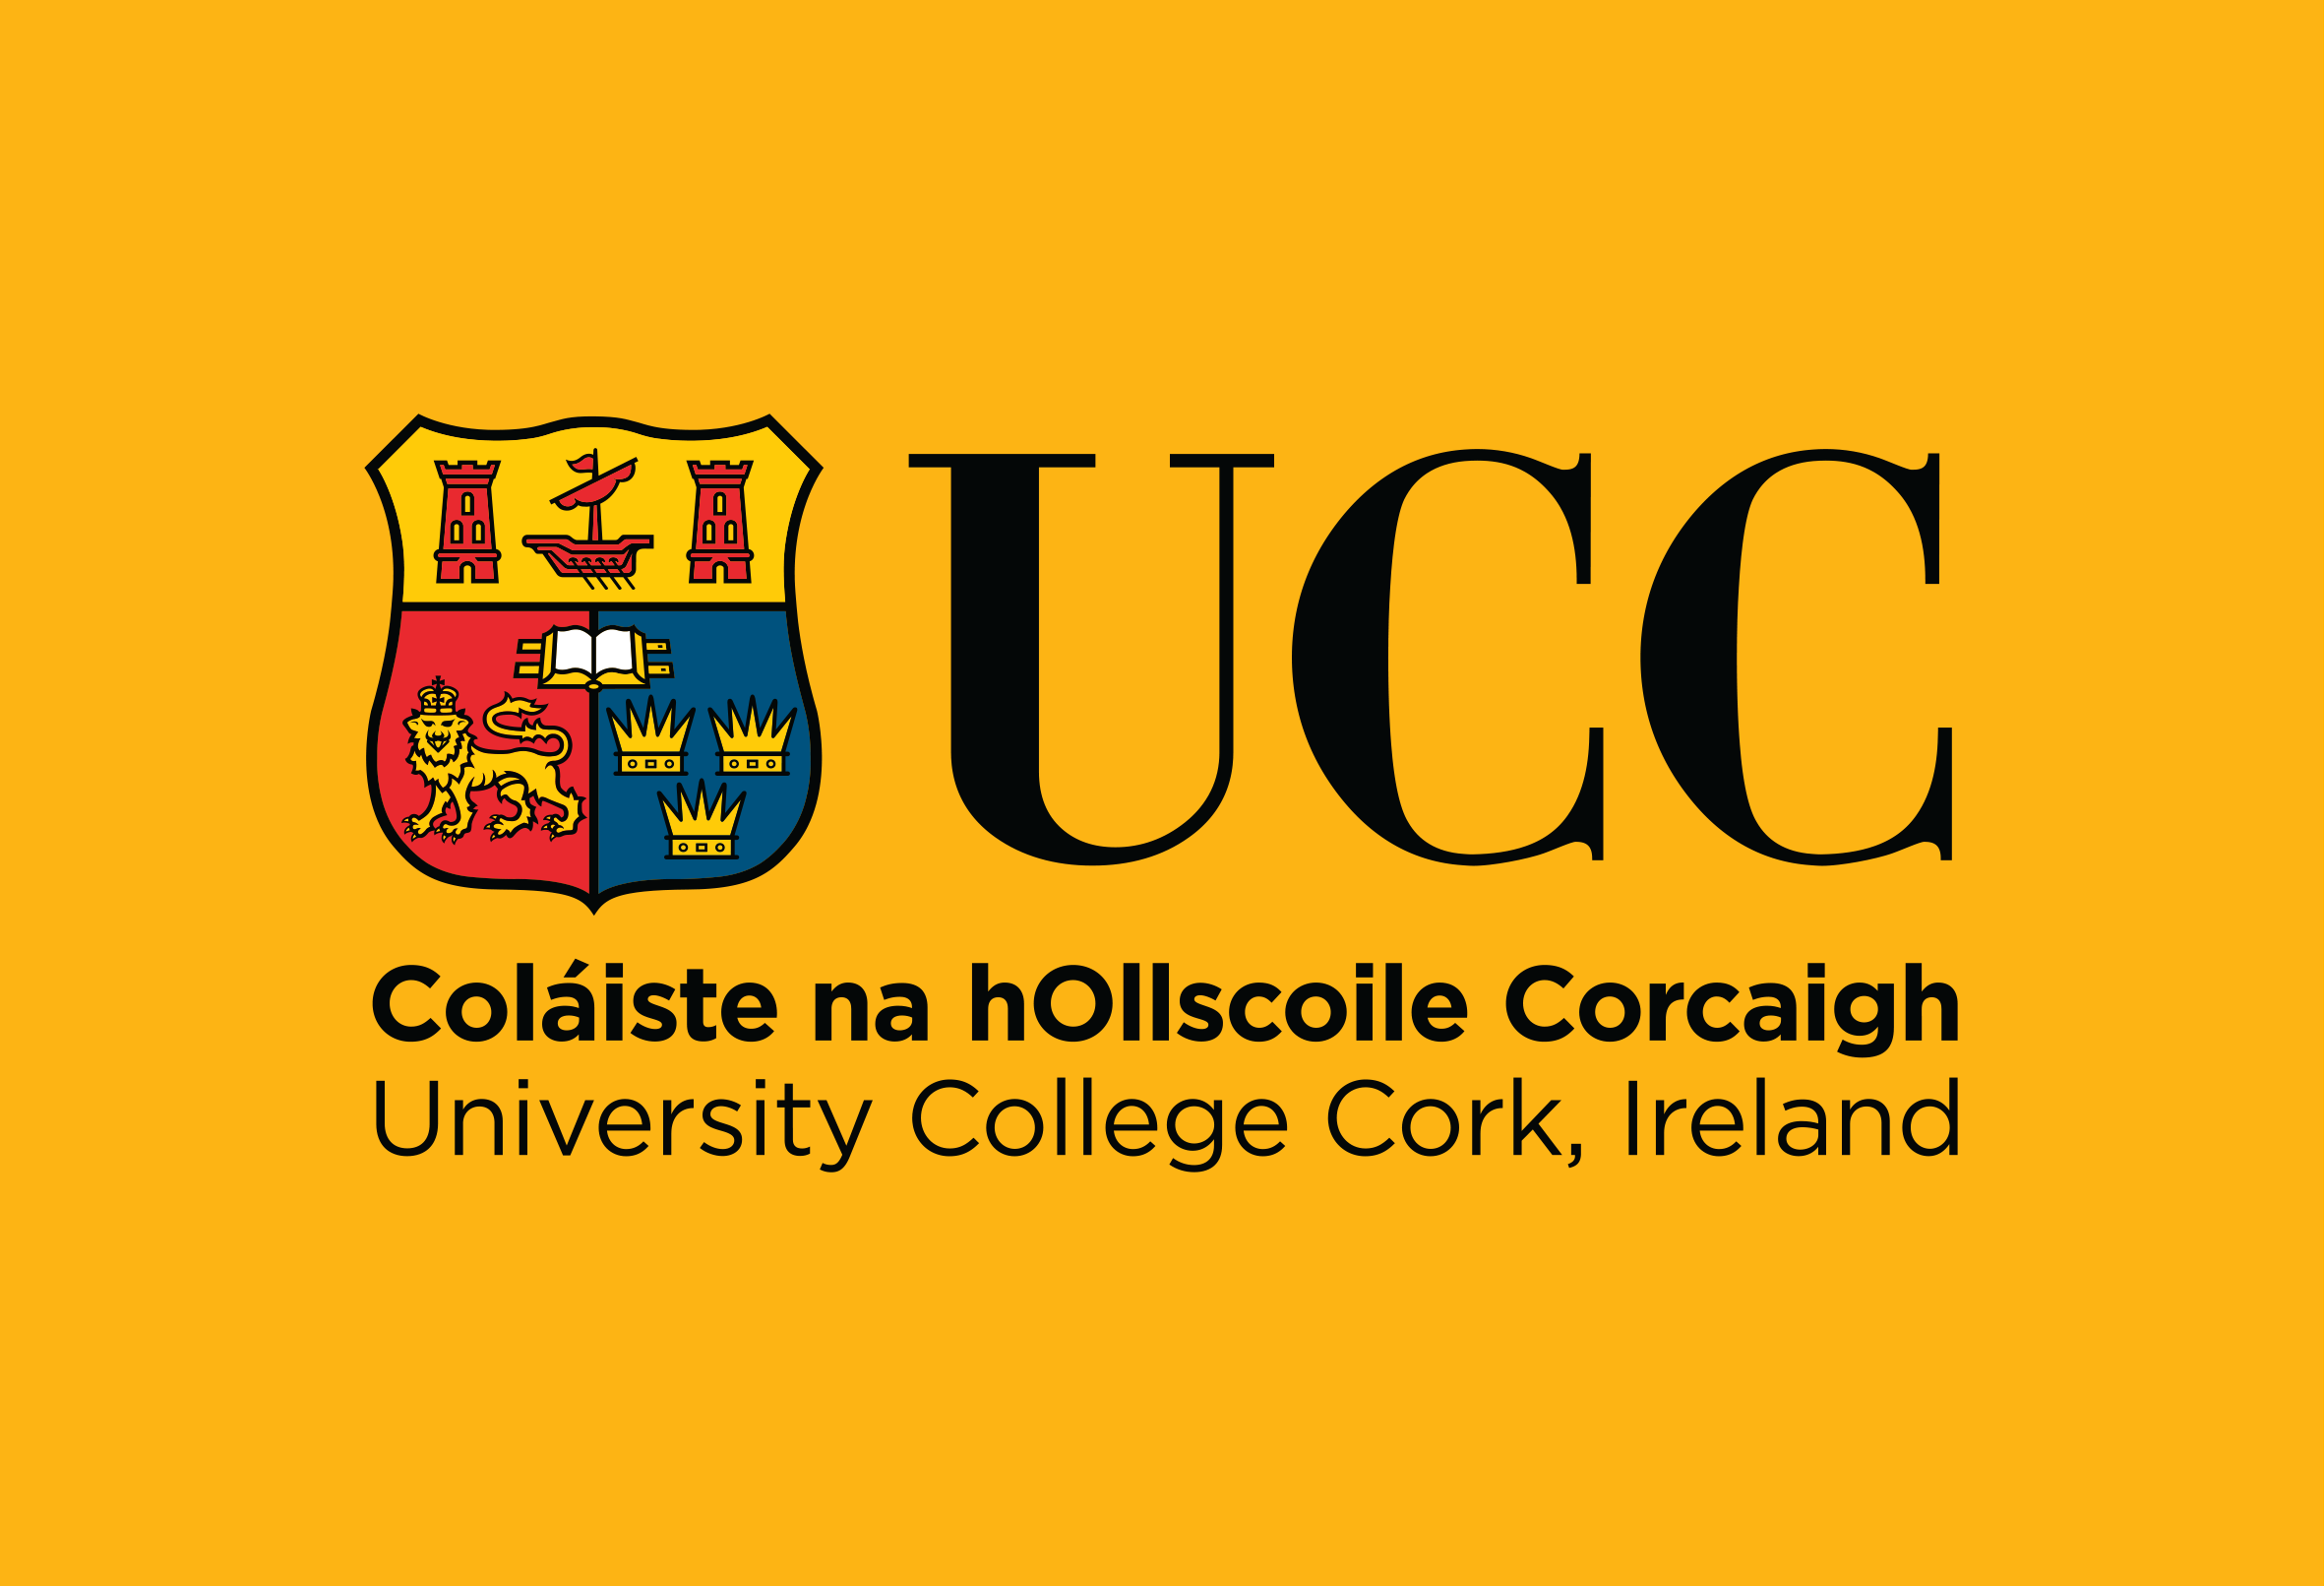
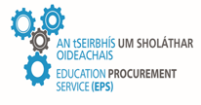

Tender Response Document

Tender Reference: LA3673C
Request-for-Tenders under Open (OJEU) Procedure for the Supply, Delivery, Installation, Commissioning & Calibration of a Fully Integrated Precision Ferroelectric and Piezoelectric Analysis Platform, for Tyndall National Institute, University College Cork (UCC)
Location:
Tyndall National Institute – Cork, Lee Maltings Complex, Dyke Parade, Cork, T12 R5CP, Ireland.

Issue Date: | Wednesday 22nd July 2026
Contact Person for Queries: | Gráinne Quinn
Contact Details for Queries: | E-Tenders Mailbox
Closing Date for Receipt of Queries: | 12.00pm On Thursday 20th August 2026
Deadline For Receipt of Tenders: | 12.00pm On Monday 31st August 2026

