
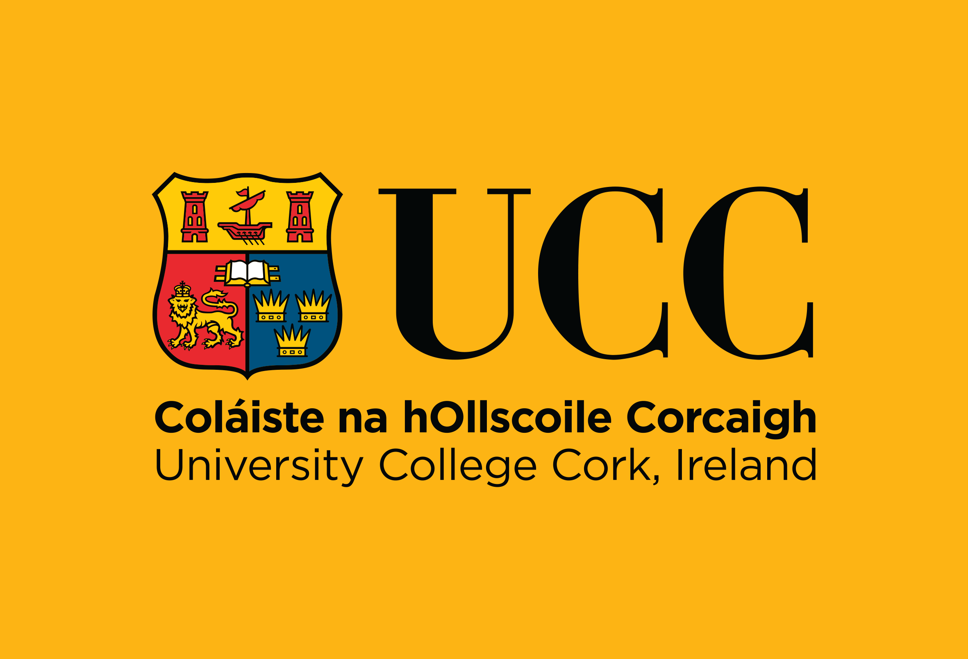
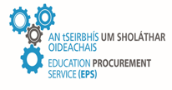

Tender Response Document
Tender Reference: LA3215C
Request for Tenders under Open (OJEU) Procedure for the Supply, Delivery, Installation and Commissioning of a Suite of Plasma Etcher & Plasma Deposition Tools, [4 Lots], for Tyndall National Institute, University College Cork (UCC)

Location:
Tyndall National Institute – Cork, Lee Maltings Complex, Dyke Parade, Cork, T12 R5CP, Ireland.

Issue Date: | Tuesday 16th June 2026
Contact Person for Queries: | Gráinne Quinn
Contact Details for Queries: | E-Tenders Mailbox
Closing Date for Receipt of Queries: | 12 noon on Tuesday 07th July 2026
Deadline For Receipt of Tenders: | 12 noon on Friday 31st July 2026

Suppliers, please refer to the “Clarifications” document within the CFT documents for further information on UCC Responses to Clarifications requested on the Tender Document specifications outlined in the Appendix 1 below.

