REQUEST FOR TENDERS
Design and Delivery of a Grassland Management Programme
Contracting Authority
Macra Agricultural Skillnet
Procedure: Open Procedure
Issue Date: 17th July 2026
Closing Date and Time: 9th August 2026

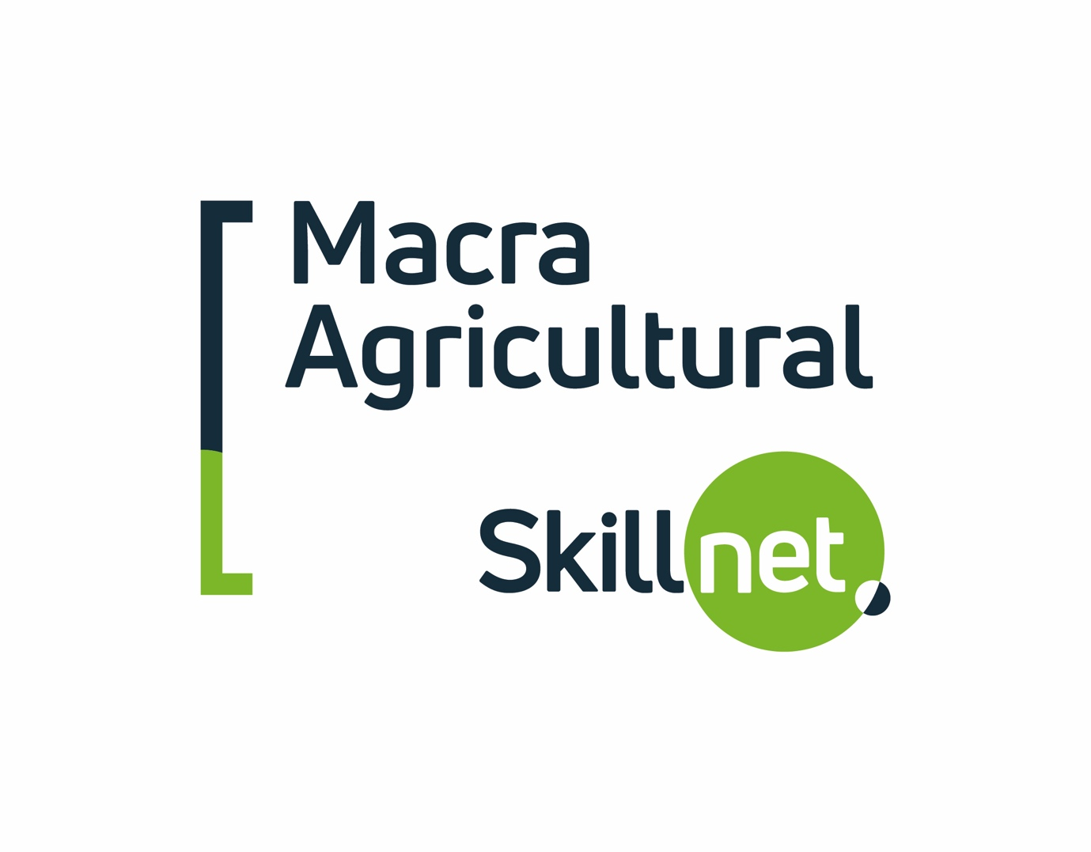

Contents
Part 1 – Introduction
1.1 Invitation to Tender
1.2 Background
1.3 Scope of Services
1.4 Contract Term
1.5 Contract Extension
1.6 Estimated Budget
1.7 Eligible Tenderers
Part 2 – Instructions to Tenderers
2.1 General
2.2 Tender Submission Requirements
2.3 Submission of Tenders
2.4 Clarifications
2.5 Tender Validity
2.6 Insurance Requirements
2.7 Data Protection
2.8 Freedom of Information
2.9 Conflict of Interest
2.10 Costs of Tendering
2.11 Contract Award Process
2.12 Contract Formation
Part 3 – Award Criteria
3.1 Evaluation Methodology
3.2 Award Criteria
Appendix 1 – Programme Requirements and Specification
Appendix 2 – Pricing Schedule
Appendix 3 – Tenderer's Statement

PART 1 – INTRODUCTION

1.1 Invitation to Tender
Macra Agricultural Skillnet ("the Contracting Authority") invites suitably qualified and experienced organisations to submit tenders for the design, coordination and delivery of a practical Grassland Management Programme.
The Contracting Authority seeks a delivery partner with demonstrated expertise in grassland management, grazing systems, agricultural education and practical farmer training to develop and deliver an engaging programme that supports the professional development of young farmers in Ireland.
The procurement will be conducted by way of an Open Procedure in accordance with the principles of transparency, equal treatment, proportionality and non-discrimination.

1.2 Background
Macra Agricultural Skillnet is the national training network dedicated to supporting the continuous professional development of those working in Irish agriculture and the wider agri-food sector.
Through industry-led training initiatives, Macra Agricultural Skillnet works with education providers, industry experts and strategic partners to deliver high-quality programmes that respond to the evolving needs of Irish agriculture.
Macra Agricultural Skillnet aims to deliver a practical Grassland Management Programme designed specifically for young farmers, farm successors, new entrants to farming and those in the early stages of their farming careers.
The programme will focus on developing the practical knowledge, technical skills and confidence required to manage productive grazing systems, improve grass utilisation, enhance farm profitability and support environmentally sustainable farming practices.
The successful tenderer will be expected to work collaboratively with Macra Agricultural Skillnet to ensure the programme reflects current industry best practice and delivers measurable value for participants.

1.3 Scope of Services
The successful tenderer will be responsible for the design, coordination and delivery of a four-day Grassland Management Programme.
The services shall include, but not be limited to:
- Development of programme content and learning materials.
- Delivery of all programme sessions.
- Coordination with Macra Agricultural Skillnet.
- Participant engagement throughout the programme.
- Provision of appropriate learning resources.
- Attendance management.
- Collection and analysis of participant feedback.
- Submission of programme reports.
- Continuous review and improvement of programme content throughout the contract period.
The detailed programme requirements are set out in Appendix 1.

1.4 Contract Term
The initial contract resulting from this competition shall be for a period of one (1) year, covering the delivery of one Grassland Management Programme and all associated reporting requirements.

1.5 Contract Extension
Macra Agricultural Skillnet reserves the right to extend the contract for a further two (2) additional one-year periods, subject to:
- Continued demand for the programme.
- Availability of Skillnet Ireland funding.
- Satisfactory performance by the successful tenderer.
- The ongoing requirements of Macra Agricultural Skillnet.
The maximum potential contract duration shall therefore be three (3) years.
No guarantee is given regarding the exercise of any extension option.

1.6 Estimated Budget
The estimated budget available for the programme is a maximum of €40,000 per annum, exclusive of VAT.
Based on the initial contract term and potential extensions, the estimated maximum contract value is €120,000, exclusive of VAT.
This budget is provided for information purposes only and does not constitute a guarantee of expenditure.
Tenderers shall submit pricing in accordance with Appendix 2 – Pricing Schedule.

1.7 Eligible Tenderers
Macra Agricultural Skillnet welcomes tenders from organisations with demonstrated experience in the design and delivery of agricultural education and training programmes.
This may include:
- Agricultural education providers.
- Agricultural consultants.
- Higher education institutions.
- Industry organisations.
- Specialist agricultural training providers.
- Collaborative partnerships with appropriate expertise.
Tenderers should demonstrate experience in delivering practical programmes that combine technical knowledge with applied learning in agricultural settings.

PART 2 – INSTRUCTIONS TO TENDERERS

2.1 General
Macra Agricultural Skillnet does not bind itself to accept the lowest priced or any tender received.
The Contracting Authority reserves the right to cancel, suspend or discontinue this procurement process at any stage prior to contract award.
Participation in this competition does not create any contractual relationship between Macra Agricultural Skillnet and any tenderer until a formal contract has been executed.

2.2 Tender Submission Requirements
Tenderers shall submit:
- Organisation profile.
- Details of relevant experience delivering agricultural education and training programmes.
- Details of previous grassland management, grazing, livestock or farm management programmes delivered.
- Proposed methodology for programme delivery.
- Proposed programme content and learning outcomes.
- Summary of personnel who will deliver the programme and their relevant expertise.
- Details of two comparable programmes delivered within the previous three years, including client references.
- Completed Pricing Schedule.
- Signed Tenderer's Statement.
Failure to provide the requested information may result in a tender being deemed incomplete.
2.3 Submission of Tenders
Tenders must be submitted electronically through the eTenders platform before the published closing date and time.
Late tenders will not be accepted.
Tenders must be submitted in English.

2.4 Clarifications
Requests for clarification shall be submitted exclusively through the eTenders messaging facility.
Macra Agricultural Skillnet reserves the right to issue clarification responses to all tenderers where appropriate.
Macra Agricultural Skillnet may seek clarification of any aspect of a tender submission during the evaluation process. Such clarification shall not permit material amendments to a tender.

2.5 Tender Validity
Tenderers shall ensure that pricing remains valid for a period of twelve (12) months following the tender closing date.

2.6 Insurance Requirements
The successful tenderer shall maintain, for the duration of the contract, the following minimum levels of insurance:
Insurance | Minimum Cover
Employers Liability | €13,000,000
Public Liability | €6,500,000
Professional Indemnity | €1,500,000
Evidence of insurance shall be provided upon request prior to contract award.

2.7 Data Protection
The successful tenderer shall comply with all applicable Data Protection legislation, including the General Data Protection Regulation (EU) 2016/679 (GDPR), the Data Protection Act 2018 and any subsequent amendments.
Personal data obtained during programme delivery shall be processed solely for the purposes of administering and delivering the programme.

2.8 Freedom of Information
Tenderers should note that information supplied in response to this competition may be subject to disclosure under the Freedom of Information Act 2014.
Tenderers should identify any information considered commercially sensitive and provide reasons supporting such designation.

2.9 Conflict of Interest
Tenderers shall disclose any actual, potential or perceived conflict of interest relating to this procurement.
Macra Agricultural Skillnet reserves the right to request additional information regarding any declared conflict and to determine any appropriate action.

2.10 Costs of Tendering
All costs associated with the preparation and submission of a tender shall be borne solely by the tenderer.
Macra Agricultural Skillnet shall not be liable for any costs incurred by tenderers in connection with this procurement process.

2.11 Contract Award Process
Following evaluation, Macra Agricultural Skillnet reserves the right to:
- Seek written clarification.
- Verify information supplied.
- Contact referees.
- Request additional supporting documentation.
- Invite tenderers to present their proposals where considered appropriate.

2.12 Contract Formation
Following completion of the procurement process, the successful tenderer will be required to enter into Macra Agricultural Skillnet's standard Services Agreement before the commencement of the Services.
The Contracting Authority reserves the right to amend the agreement where necessary to reflect the specific requirements of this procurement, provided that any such amendments are consistent with the terms and conditions set out in this Request for Tenders.
Submission of a tender shall constitute acceptance by the tenderer that, if successful, they will enter into the Contracting Authority's standard Services Agreement.

PART 3 – AWARD CRITERIA

3.1 Evaluation Methodology
The contract will be awarded to the tenderer submitting the Most Economically Advantageous Tender (MEAT).
Each submission will be evaluated against the criteria below. Scores awarded for each criterion will be weighted in accordance with the published percentages to determine the overall ranking.

3.2 Award Criteria
Criterion | Weighting
Proposed Programme Content and Delivery Methodology | 40%
Relevant Experience and Programme Delivery Capability | 30%
Price and Value for Money | 20%
Sustainability and Green Procurement Measures | 10%
Total | 100%

Proposed Programme Content and Delivery Methodology (40%)
Tenderers should demonstrate:
- Understanding of the programme objectives.
- Practical, field-based delivery methods.
- Innovative learning approaches.
- Relevance of proposed content.
- Participant engagement strategies.
- Methods for supporting young farmers and new entrants.

Relevant Experience and Programme Delivery Capability (30%)
Tenderers should demonstrate:
- Experience delivering agricultural education and training.
- Experience in grassland management and grazing systems.
- Capacity to deliver the programme over the contract term.
- Relevant expertise of personnel assigned to the programme.
- Successful delivery of comparable programmes.

Price and Value for Money (20%)
Tenderers shall provide pricing in accordance with Appendix 2, demonstrating transparency, competitiveness and overall value for money.

Sustainability and Green Procurement Measures (10%)
Tenderers should demonstrate how sustainability principles will be incorporated into programme delivery, including environmentally responsible practices, efficient resource use and the promotion of sustainable grassland management.

