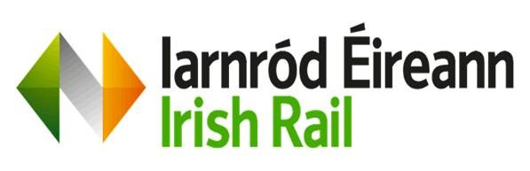
9472 PRE-QUALIFICATION QUESTIONNAIRE - INFORMATION SECURITY
- Information Security Management System

- Does the Applicant have a documented and formally approved Information Security Management System in place with Information security policies covering Incidence Response, Business Continuity & Disaster Recovery, Acceptable Use, Security Awareness, vulnerability management Supply Chain Security, Encryption, Data Protection, End Point and Network Security?
Tick as appropriate YES NO

If YES, are information security policies reviewed and updated at least annually?

Tick as appropriate YES NO

- Standards & Certifications - Certification of an Applicant to a Recognised Industry Information Security Standard

- Is the Applicant’s Security Management System currently certified as compliant with ISO 27001:2022, SOC 2 or an equivalent internationally recognised standard?
Tick as appropriate YES NO
If YES, please state which standard it is certified to and provide a current certificate:
If NO, what equivalent evidence is in place. This may include, but is not limited to, equivalent certification from other national certification bodies

- Data storage and hosting requirements

- Applicants must state if their data hosting / data storage facilities can be provided within EU and EEA areas?
Tick as appropriate YES NO
If YES, please state location:
If NO, please provide brief details to where data is hosted and processed:
Note: If data is hosted outside of EU/UK then please log a request to dpo@irishrail.ie for a data privacy assessment and or a data protection impact assessment.

- Data Protection and Privacy Compliance
- Is the Applicant GDPR compliant or has an equivalent internationally recognised standard?

Tick as appropriate YES NO
If YES, please provide brief details of compliance:
If NO, please provide brief details:

- Have staff received data protection and security awareness training in the last 12 months?
Tick as appropriate YES NO

- Incident Management & Response

- Does applicant have a documented information security Incident Management Policy
Tick as appropriate YES NO

- Has applicant experienced any security breaches in the past 12 months?
Tick as appropriate YES NO

If YES, please provide details and corrective actions taken:

- Are security incidents logged, investigated, and remediated?
Tick as appropriate YES NO
- Can you notify a contracting authority promptly in the event of a security or data breach?
Tick as appropriate YES NO

- ISA/IEC 62443 (If Operational and control systems Technology is included)

- Is Applicant compliant with ISA/IEC 62443 standards?
Tick as appropriate YES NO
If YES, please provide brief details of compliance or any relevant documentation:
If NO, please provide brief details:

- Business Continuity & Resilience
Do you have a documented business continuity and disaster recovery plan?
Tick as appropriate YES NO

Are backups performed regularly and tested periodically? (Yes/No)
Tick as appropriate YES NO

If YES, what is the testing frequency
If NO, what other control is in place?

- Information Security Risk Management
Does Applicant have a formal Risk Management Program to assess cybersecurity risks associated with their own third parties or subcontractors?
Tick as appropriate YES NO
If YES, are security requirements included in contracts with subcontractors where relevant?
If NO, please provide brief details:

Pass: Vendor has strong security ISMS, security policies, follows industry best practices and standards, incident response plans and no significant recent breaches.

Fail: Vendor has inadequate security measures, lack of evidence, lack of industry best practices and standards and\or a history of unresolved breaches.

