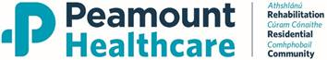

Request to attend Mandatory Site Visit
Window Cleaning Services To [Peamount Healthcare]
Client Reference -RFT 05-2026
Date for Visit:22/07/2026
From: Wednesday 22 July 2026 to Wednesday 8 July 2026
Timings/dates may change depending on Government or client Health and Safety restrictions.
Site visit details
Meeting point:The Education Cemtre at Peamount Healthcare D22Y008
Commences at: [9.00]
Point of contact: Gary Ryan ]

Individual(s) attending Site Visit(s): Maximum 2 persons per Framework Member.
 | Name | Position | Contact Mobile No. | Car Registration
1
2

Standard tenderer information
Registered name of tenderer
Registered company address
Company contact telephone number
Company contact email address

Please complete and return via etenders messaging facility no later than Tuesday 21 July 2026

