TRD Section 1: Selection Criteria - Mandatory Response Requirements

These are mandatory requirements where the Tenderers must submit the information requested. Please ensure supporting documents are clearly named and easily identifiable.

Standard Tenderer Information

Registered Name of Tenderer
Registered Company Address
Company Telephone Number
Company Email Address
Company Registration Number

TENDER LEAD
Contact Name for this Tender
Job Title
Telephone Number incl. Mobile Number
Email Address

1. Economic and Financial Standing

The minimum requirement under this criterion is that the Tenderer has the financial capacity, to the Contracting Authority’s satisfaction, to meet all financial requirements and contingencies that might arise from the contract if awarded to the Tenderer. This assessment will be based on whether the Tenderer has the ability to pay its debts as they fall due. We have reserved the right to assess the financial standing of the tenderer itself (independently of the auditor).

Mandatory Requirement (Pass/Fail) | Tenderer to confirm requested evidence has been provided in their tender submission.
Evidence of a minimum turnover of €150,000 per annum for the past three (3) years (2022-2024 or 2023-2025) by way of Auditor/Accountant’s letter. | Yes/No

2. Technical & Professional Ability

Mandatory Requirement (Pass/Fail)

- Garda Clearance Policy: Details should include assurance that all staff obtain Garda vetting prior to commencing work on CHI’s sites. Please attach policy/statement as a separate document and include in your tender submission.
- Confirm and provide evidence that staff proposed for this contract will hold a current Safe Pass and Manual Handling training certificates.
- Confirm that proposed staff will be suitably trained to carry out proposed works.
- Submit a Risk Assessment and Method Statement associated with the proposed works. These documents must clearly outline the health and safety measures, procedures, and controls to be implemented.

Requirement | Tenderer to Confirm Yes/No
Tenderer to confirm compliance with the requirements in this section (2. Technical & Professional Ability) and that requested evidence is included in the tender response. | Yes/No

3. Insurance
Mandatory Requirement (Pass/Fail) | Tenderer to Confirm Yes/No
Tenderer to confirm that, if awarded a Services Contract under this Competition, they will, from the Effective Date of the Services Contract, obtain and hold the types and levels of insurance specified below.  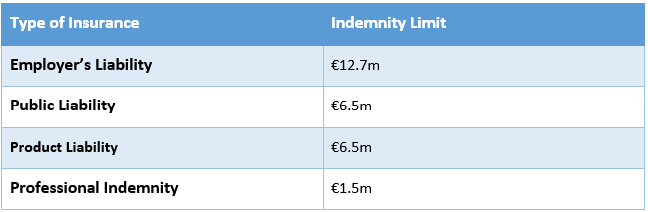 | Yes/No

4. Tenderer’s Statement
Mandatory Requirement (Pass/Fail) | Tenderer to Confirm Yes/No
Tenderers have included the Tenderer’s Statement (refer to RFT document, Appendix 3) signed by an Authorised Person in their Tender Submission. | Yes/No

5. Declaration as to Personal Circumstances of Tenderer
Mandatory Requirement (Pass/Fail) | Tenderer to Confirm Yes/No
Tenderers have included the Declaration as to Personal Circumstances (refer to RFT document, Appendix 4) signed by an Authorised Person in their Tender Submission. | Yes/No

Once mandatory requirements have been met, proceed to Tender Response Document (TRD) 2, and ensure you have carefully read Appendix 1 of the RFT (Requirements and Specifications).
Document checklist for tender submissions:
- Completed TRD 1 and required additional material/evidence
- Completed TRD 2 and permitted additional material
- Completed Pricing Schedule
- Signed Tenderer’s Statement printed on Tenderer’s headed notepaper (see Appendix 3 of the RFT)
- Signed Declaration as to Personal Circumstances of Tenderer (see Appendix 4 of the RFT)

End of document.

