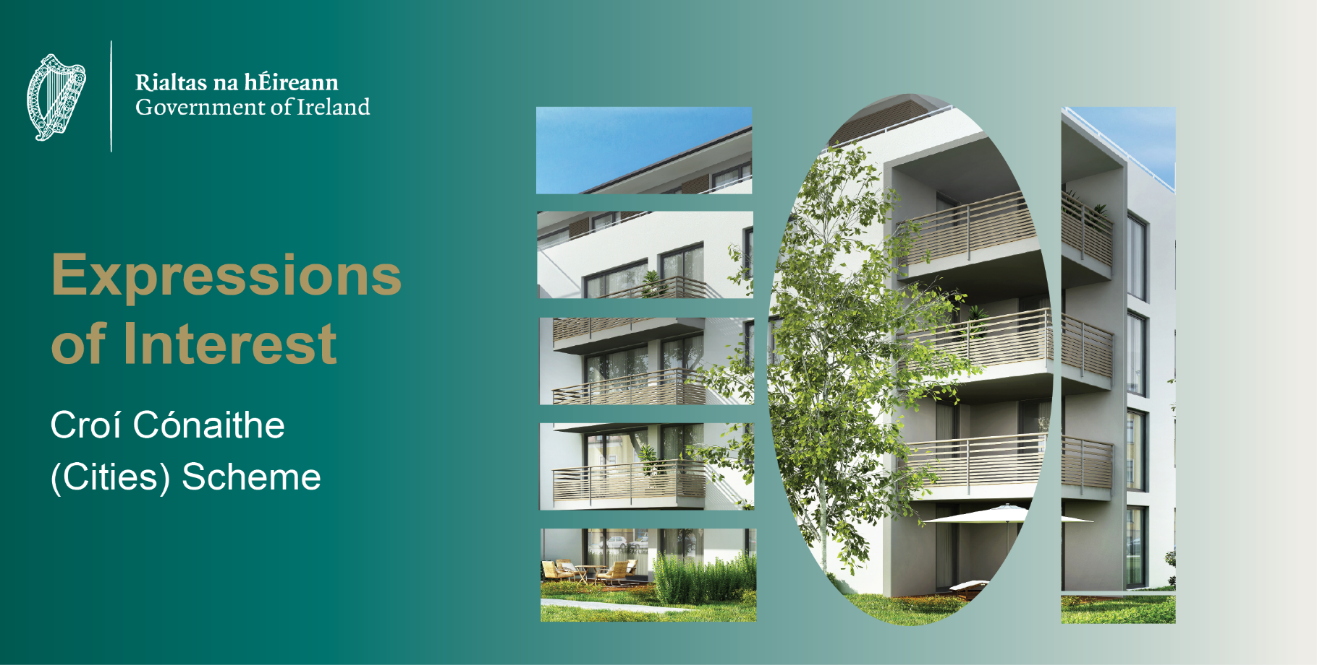
Croí Cónaithe (Cities) Scheme - Expression of Interest Application Form

- Proposers Details

1.1 Contact Name
1.2 Proposer Entity Name
1.3 Legal nature of proposer
including details of any JV
Partners or Subsidiaries
1.4 Name of Parent Company
(if applicable)
1.5 Company VAT Number(s)
1.6 Contact Phone Number
  - Contact Email Address
  - Company Address

- Details of Development

2.1 Site Address and Eircode
and Land Folio Number
(if available) or long/latitude coordinates
2.2 Local Authority Area
2.3 Planning Reference
2.4 Insert link to planning
documents

2.5 Details of any
outstanding pre
commencement criteria
(Including any
outstanding legal issues)

2.6 Proposal Tender Status
(Has the apartment development in the Proposal 1 – not been tendered, 2- partially tendered or 3 – fully tendered, ready to go)

- Details of Apartment Development Proposed for Funding

3.1 Description of overall development
3.2 Number of apartments (and houses or duplexes if applicable) to be constructed in the overall development
Apartments | Houses | Duplexes | Total Dwellings

3.3 Number and type of apartments proposed for inclusion under Croí Cónaithe (Cities)
Studio | 1-Bed | 2-Bed | 3-Bed | Total Apartments

  - Proposed specification and fit-out in relation to apartments proposed for sale that will avail of e.g. Builders finish, white goods, flooring etc.

- Viability Gap

Eligibility for the Croí Cónaithe (Cities) subsidy is subject to a demonstrable viability gap existing between the cost of delivery of an apartment and the open market price for the sale of the apartment to an individual purchaser. The CCC subsidy payable to a proposer will be equal to the viability gap. Measurement of the viability gap will be calculated as follows:

C = A - B

Where C is the viability gap in euros, A is the cost of delivery in euros and B is the market sales price to an individual purchaser in euros.

Please complete the valuations table within the “Costs & Viability Gap” tab in the EOI Excel Document and enter the information below based on the output from that spreadsheet
4.1 Based on the output of the “Costs & Viability Gap” tab within the EOI Excel Document, please state whether the apartments proposed for Croí Cónaithe funding have a viability gap

Yes/No
4.2 Please upload a valuation report confirming the market values for the schedule of average unit values per unit type

- Proposer Track Record
Please outline past development delivery experience and provide details of successfully completed residential developments by the proposer or a parent entity connected to the proposing entity. This should include a description of the developments, location, date constructed or estimated completion date.

- Project Financing
Please outline the intended funding solution for the development. Confirmation of project financing will be the subject of specific due diligence at Stage 3 and will be a condition precedent for entry into a Designation and Development Agreement with the Housing Agency

- Selection Criteria
Viability Gap
  - Do the apartments proposed for funding
under Croí Cónaithe have a
demonstrated viability gap?
Yes/No
Location
Location must be confined to Metropolitan boundaries of the cities of Cork, Limerick, Galway and Waterford and within Dublin County and the metropolitan boundary of Dublin city.
Dublin includes the Metropolitan Boundaries as well as all of County Dublin.
  - Is the proposal located within the designated Croí Cónaithe (Cities) boundaries of Dublin, Cork, Limerick, Galway or Waterford City? Yes/No
Please submit proposals to the relevant ‘Lots’ on eTenders
Residential Density
Developments must be a minimum of four stories with a net density threshold of 35 dwellings per hectare or higher.
  - Are the apartment blocks proposed for funding under Croí Cónaithe four storeys or greater in height?
Yes/No
  - Are the apartment blocks proposed for funding under Croí Cónaithe a minimum of 20 units and upwards (excluding any Part V requirements)?
Yes/No
- Please state the number of storeys of each apartment block
  Block Number | Number of Storeys
  - Is the net density of dwellings per hectare of the overall development, which includes the proposed apartments, 35 dwellings per hectare or greater? Yes/No

Planning Permission
Full grant of planning approval must be in place at the time of submission. Apartment blocks must not have commenced construction at the time of submission. However, un-commenced phases of schemes may be considered particularly if the commenced phases are not apartments.

  - Is there a full grant of planning approval in place for the proposed apartments?
Yes/No
  - Date of grant of planning
  - Is the grant of planning subject to any appeals or judicial review proceedings?
Yes/No
  - Is there a Build to Rent element within your planning permission or proposal?
Yes/No
  - Has construction of the proposed apartments commenced?
Yes/No
  - What is the commencement date of apartments proposed for CCC funding? (This date will be verified as part of Stage One)
Proximity to Transport Infrastructure
Developments must be located within walking distance (1,250m) of high-capacity urban public transport stops (such as DART or Luas) OR from reasonably frequent (i.e. min 15-minute peak hour frequency) urban bus services or where such services can be provided prior to the stated delivery date of the development.

  - Is the development located within 1,250m walking distance from high-capacity urban public transport stops (such as DART or Luas) OR from reasonably frequency (i.e. min 20-minute peak hour frequency) urban bus services or will such services be provided prior to the stated delivery date of the development.
Yes/No
  - Please provide details of the closest high-capacity urban public transport stops (such as DART or Luas) OR the closest reasonably frequency (i.e. min 20 minutes peak hour frequency) urban bus service stop to the development including interactive map link
Sale to Individual Purchasers Only
Every apartment within the proposed development must be sold to an individual purchaser.
  - Can the apartments be sold to individual purchasers?
Yes/No

- Ranking Criteria

8.1 Residential Density (15 Marks)

Schemes will be awarded marks based on the overall density of the development:

- 150 + dwellings per hectare = 15 marks
- 100 up to 149 dwellings per hectare = 12 marks
- 75 up to 99 dwellings per hectare = 9 marks
- 49 up to 74 dwellings per hectare = 6 marks
- 35 up to 49 dwelling per hectare = 3 marks

    - Net residential density
per hectare of overall
development

  - Delivery Timelines (15 Marks)

Subject to agreement being in place, dwellings must have commenced by Q3 2027 and be delivering homes by the end of 2030 or a later timeline outlined and agreed by both parties, please note those proposals which can deliver housing quicker than others will be awarded higher marks.

Marks will be awarded as follows:

- Delivery in Q3 2029 = 15
- Delivery in Q4 2029 = 10
- Delivery in Q1 2030 = 5
- Delivery later than Q1 2030 = 0
Please provide a program of delivery demonstrating delivery timelines for the development

    - Date of delivery of apartments proposed for CCC funding. If delivery is phased, please provide details and timelines for each proposed phase.
    - Please upload a program of delivery demonstrating delivery timelines for the development.
(These dates will be verified as part of Stage One)

  - Quality & Strategic Considerations (25 Marks)

Please provide details of the design of the development with particular reference to the quality, scope, scale, and level of ambition and innovation of the development, as well as the approach to context, location and design (2,000-word limit). If an Architect’s Design Report was prepared for the development, a pdf copy of that report can be submitted in place of a specific written statement below.

The following documents must be submitted in addition to either the written statement below or the
Architect’s Design Report:
- Planning application summary document: A3 pdf
- Site location map (overall site)
- Site layout (with red line identifying CCC apartment blocks)
- Designated floor plans of apartments proposed for funding
- Elevations of apartments proposed for funding
- Sections of apartments proposed for funding

  - Cost Per Apartment (25 Marks)

Cost per apartment will be awarded marks on the basis of the weighted average dwelling cost of the overall proposal.

It is acknowledged that at Stage One Proposers may not have full knowledge of the costs likely to be incurred in the delivery. However, proposers are required to submit an accurate estimate of the delivery costs based on the best available cost information they have available to them at the time of submission rounded to the nearest thousand euro.

Please complete the “Costs & Viability Gap” tab in the EOI Excel Document and enter the information below based on the output from that spreadsheet
    - Anticipated average
development cost
(This will be verified as part of Stage One)
8.4.2 Please confirm that the
“Costs & Viability Gap” tab
in the EOI Excel Document
has been completed.
Yes/No

8.5 Proximity to Core Services and Amenities (20 Marks)

Allocation of marks are based on the distance between the development and each of the core amenities.
Please complete the “Proximity to Amenities” tab in the EOI Excel Document and enter the information below based on the output from that spreadsheet. Proposers should use an interactive mapping product e.g., Google Maps to measure the distance between the relevant boundary of the proposed apartment development and the services and amenities set out in the document.
8.5.1 Please confirm that the “Proximity to Amenities” tab in the EOI Excel Document has been completed.
Yes/No

8.5.2 Marks based on proximity to core services and amenities (as generated by spreadsheet)

- Upload Excel Document

Please confirm that you have completed and uploaded a copy of the EOI Excel Document with the “Costs & Viability Gap” and “Proximity to Amenities” tabs.
Yes/No

Please ensure that all the above is submitted as part of your Expression of Interest. If any of the above fields are omitted or incomplete, it will not be possible to assess your Expression of Interest and your Expression of Interest will be deemed ineligible.

____________________________________________________________________________________

I confirm that I have submitted the required information as requested in the above fields 1-9.

_________________________
Print Name

Proposer name should be the name of the legal entity that would enter a contract with the Housing Agency, subject to contract, due diligence and terms and conditions outlined elsewhere in these documents.
State if entity is a Limited Company, DAC, SPV, Private Equity fund etc.
The valuation report must be prepared by a qualified valuer and must be prepared on the basis of a schedule of average unit values per unit type. The valuation must set out the current open market value of the proposed apartments (setting out each type, 1 bedroom, 2 bedroom etc.) that the valuer estimates the apartments would achieve if sold to individual purchasers if the apartments were completed and ready for sale as of the 28^{th of} August 2026.
The date of grant of planning for non-SHD planning applications is determined in accordance with section 34(11) of the Planning and Development Act 2000 (as amended) and is a date following the expiry of the period for taking an appeal to An Bord Pleanála or in the case of an appeal, is a date after which the appeal has been withdrawn or dismissed or decided by the Board.
Where the public transport link is a DART, Luas or urban Commuter train stop, please provide the name of the stop and the distance from any part of the development. Where the public transport link is an urban bus service, please provide the name and number of the stop, the peak-time frequency of the bus service and the distance from any part of the development. Where the public transport link is not currently in place, please provide details of the planned link and upload documentation demonstrating that the transport link will be operational prior to the proposed delivery date of the apartments.
Residential net density should be calculated in accordance with Appendix A of the Sustainable Residential Developments in Urban Areas Guidelines for Planning Authorities 2009: https://www.gov.ie/en/publication/a8c85- sustainable-residential-developments-in-urban-areas-guidelines-for-planning-authorities-may-09/

