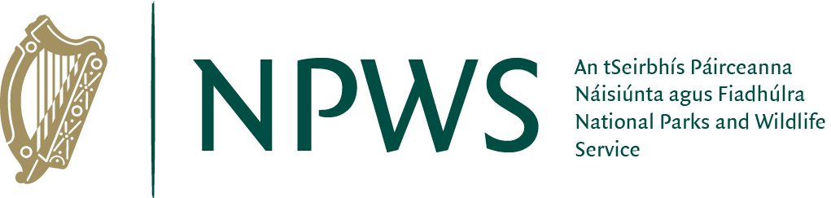

National Parks and Wildlife Service
INVITATION TO TENDER

to provide

Design and Planning Consultancy Services for the preparation of new visitor facilities at Coole Park Nature Reserve

April 2026

Table of Contents
- Introduction 3
1.1 Project Location 3
1.2 Background 4
1.3 Coole Park Nature Reserve 5
1.3.1 Natural Heritage 5
1.3.2 Literary and historic significance 6
1.3.3 Current Infrastructure 6
1.3.4 Visitors to the Reserve 7
2. Project Definition 8
2.1 Objective of the Project 10
2.2 Scope of Requirements 11
2.3 Deliverable/Desired Outcomes 11
2.4 Constraints 12
3. Timescale 13
4. Budget and Costing 17
5. Relevant Qualifications and Experience 17
6. Performance 18

- Introduction
The purpose of this project brief is to:
• detail the plans, procedures and control processes for
- Project design and implementation,
- Monitoring and reporting progress,
- Preparation and submission of planning application.
• define the roles and responsibilities of all project participants to ensure that everyone understands, accepts and completes their responsibilities.
• outline the mechanisms for monitoring, review and feedback by defining reporting and meeting requirements.
This document will provide prospective tenderers with information regarding the scope of service to be provided and invite proposals from architect led design teams with suitable experience of successfully completing similar type projects.
The outcome of this project will be the development and preparation of a planning design for new visitor and staff facilities at Coole Park Nature Reserve which will be brought through planning submission. The final documents should be suitable for pricing, tendering and construction purposes.
It is anticipated that the Architect-led Design Team will be procured for the whole project through construction if funding is secured.

1.1 Project Location
The location for the project is Coole Park Nature Reserve, Coole Demense, Gort, Co. Galway, H91 HF5X.
Grid Reference: 53.09275, -8.83798.
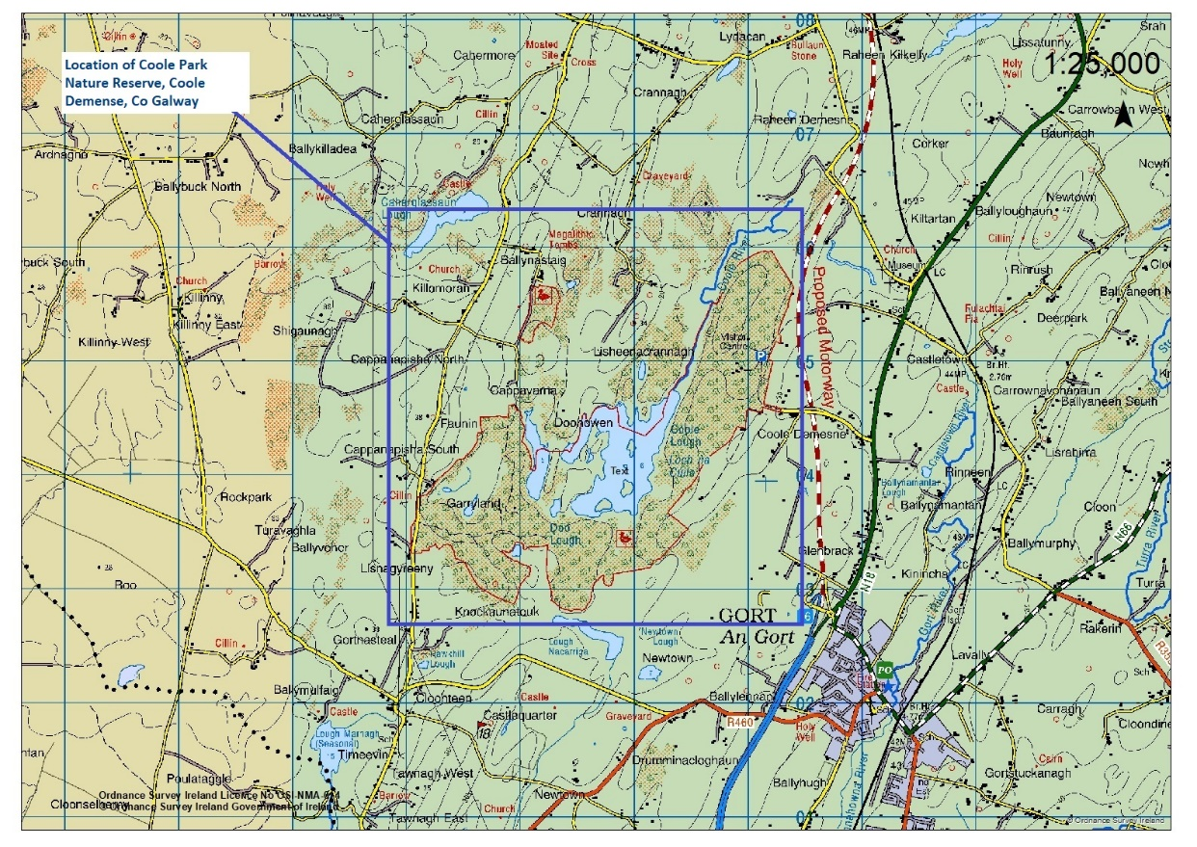
Map 1 showing location of Coole Park Nature Reserve.

1.1.1 Site Visit
It is recommended that tenderers visit Coole Park Nature Reserve in order to assist them in the preparation of their tender response.
Accordingly, an on-site group briefing has been scheduled for all interested parties at Coole Park Nature Reserve on 24th April at 11 am. To confirm please email ronan.kelly@npws .gov.ie

1.2 Background
In January 2017, An Taoiseach, Enda Kenny launched Fáilte Ireland’s new strategic partnership with the National Parks and Wildlife Service (NPWS). The strategic partnership brought together the Department of Arts, Heritage, Regional, Rural and Gaeltacht Affairs, the National Parks and Wildlife Service and Fáilte Ireland to achieve the shared goal of further developing quality visitor experiences at Ireland’s National Parks and Nature Reserves.
The purpose of the partnership is to benefit local communities through growing tourism revenues in the rural areas where the parks are located. It is also to increase Ireland’s appeal as a holiday destination in the international travel market.
In 2018, the Department, as part of the strategic partnership, commissioned a Tourism Interpretative Master Plan (TIMP) for Ireland’s National Parks and Coole Park Nature Reserve. The aim of the partnership was to enhance the tourism experience at these landscapes. The aim of the TIMP was to capture the key stories of these sites and explore ways to bring these stories to life, identify what makes the respective sites unique and how the sites are related to each other, harness international best practice to inform the visitor experience and leverage the collective value of the parks as a whole.
The plan lists a number of key themes and makes a number of recommendations for new projects. The TIMP recommends the realignment of the current visitor centre at Coole to provide sufficient space for clearly articulated interpretation of history and heritage together with the important natural history of the reserve.

1.3 Coole Park Nature Reserve
Coole Park Nature Reserve is situated approximately 3km north of the town of Gort, Co. Galway. The Reserve, designated under the Wildlife Acts (1976-2018), has an approximate area of 400ha. The site is traversed by many walking trails and hosts a Visitor Centre and Tearooms. It is an important recreation amenity for locals and people living in the South Galway and North Clare catchment area. The site is also a significant tourism attraction, attracting approximately 320,000 visitors per annum. The Coole Park Nature Reserve is also included in the Coole-Garryland Complex Special Area of Conservation (SAC site code 000252) and Coole-Garryland Special Protection Area (SPA site code 004017) though it should be noted that the Visitor Centre, associated buildings and structures and immediate adjacent surroundings are excluded from the SAC and SPA designated areas.
The Nature Reserve is managed by the National Parks and Wildlife Service (NPWS) of the Department of Housing, Local Government and Heritage and comes under the overall responsibility of the Divisional Manager for the Mid-West Division.
Coole Park Nature Reserve presents an interesting confluence of natural heritage and cultural history. The current interpretation at the Visitor Centre needs to be updated to allow for the two stories of natural heritage and culture to be articulated independently whilst acknowledging the intrinsic links between the two. At present the important natural heritage of the site is lost behind the cultural significance of the site and the towering figure of Lady Gregory. Additional staff accommodations and facilities are also needed and the steadily increasing visitor numbers and knock-on increases in demand for on-site refreshments means that the Tearooms facilities are now insufficient, in terms of both kitchen and dining space.

1.3.1 Natural Heritage
Coole Park Nature Reserve was designated a Nature Reserve in 1983 and is of exceptionally high conservation significance and a site of global importance. The natural heritage of Coole is centred on the woodlands, as well as the lake, river and turlough system which combined, create a dynamic and beautiful wetland of dramatic rising and falling water levels throughout the seasons of the year. The turloughs, river and lake at Coole Park Nature Reserve are part of an internationally rare, complex and largely hidden underground water system which flows through the karst landscape of South West Galway. In addition, a number of rare plant species, including the fen violet (Viola persicifolia), mudwort (Limosella aquatica) have strongholds for abundance, at the site and large flocks of the beautiful Whooper swan (Cygnus cygnus) grace the turlough and lake in winter months. The site encompasses 400ha of woodland and wetland. It forms part of the Coole-Garryland Complex Special Area of Conservation (SAC) under the EU Habitats Directive and part of the site is also within the Coole-Garryland Special Protection Area (SPA) under the EU Birds Directive.

1.3.2 Literary and Historic Significance
Within the core of the Nature Reserve lies the former home of Augusta Lady Gregory, author and playwright who was a key figure in the Irish literary revival towards the beginning of the 20th Century and prominent in the creation and establishment of the National Abbey Theatre. Many famous writers and poets, including W.B. Yeats, visited Lady Gregory and stayed at Coole House, and carved their initials on the famous autograph tree, located in the walled garden of the estate. The house is no longer in existence, having been demolished after the death of Lady Gregory in 1932, but the walled garden and many of the original outbuildings remain, although many are in a state of disrepair.

1.3.3 Current Infrastructure
Coole Park Nature Reserve has a Visitor Centre which currently contains an interpretative centre, toilets, and Tearooms. The interpretive centre includes an AV room with large screen display for showing video, conferencing and educational uses; interpretative displays, both audio-visual and static, artwork and artefacts related to the Gregory family. The Visitor Centre and its facilities are located in the renovated old stable buildings and barn which originally served the house see Figures 1 and 2 in Appendix A. The two structural elements of the Visitor Centre building also includes a newer connecting extension that links two older buildings together (ca 1990s).
Directly opposite this building and located across a cobbled yard are the remains (ruins) of a coach-house and dove-cote that would have originally mirrored the stable building where the tea rooms now exist see photographs Figure 3, Appendix A.
The adjacent grounds include three car/bus parks, a separate toilet block located a short distance from the Visitor Centre, the site of Coole House, and the old walled garden of the demesne. A further small car park is located at the Garryland side of the reserve. The walled garden has a picnic area and two shelters. A further shelter is located near the river, beside the site of the old horse pump that used to provide water for Coole House and two further shelters are located on the trail network. The old walled orchard of the house now contains a small herd of native red deer that originated in Killarney and a converted apple store which is now a dedicated bat roost.
Other areas that are enclosed by or incorporated into the old walls of the estate include a works yard, a small out-office/canteen and purpose built cabin for storage of educational materials, classroom equipment and a temporary administration space for Coole Park Guide/GO staff use. A further enclosed area is situated immediately behind the visitor centre. This is partly paved but mainly grassed over with a number of trees planted. This area has been fenced in sections with the paved area providing additional outdoor space available for use by customers of the tea rooms, and sections of the grassed areas around the cabin being managed for wildlife in line with the National Pollinator Plan. A wildlife pond has been developed in this area also, see Figures 4 and 5 in Appendix A. The Visitor Centre and associated buildings, including the old demesne walls and walled garden are a Protected Structure (RPS Number 410 in the Record of Protected Structures for Co. Galway) and the building is classified as having Regional Importance under the National Inventory of Architectural Heritage (NIAH) – the NIAH reference is 30412.

1.3.4 Visitors to the Reserve
The Nature Reserve is open to the public throughout the year. The Visitor Centre is open all year round with the exception of a select few days, such as Christmas Day. The Tearooms that are operated under franchise, are open all year round with the exception of a short period in late January/early February, and in line with Visitor Centre opening hours each day. The days the Tearooms opens varies seasonally, with 5-day opening Spring, Autumn and early Winter, and 7-day opening throughout the peak late-Spring and Summer season.
An estimated 310,720 people visited the reserve in 2025, 305,250 in 2024 and 302,700 people visited the reserve in 2023, an increase from approximately 263,600 in 2022. We anticipate numbers in the region of 320,000 for 2026 and that they will continue to rise as visitor numbers over recent years have indicated that the upward trend is set to continue.
The profile of visitors to Coole Park can be seen in the following infographic from research conducted in August 2022:
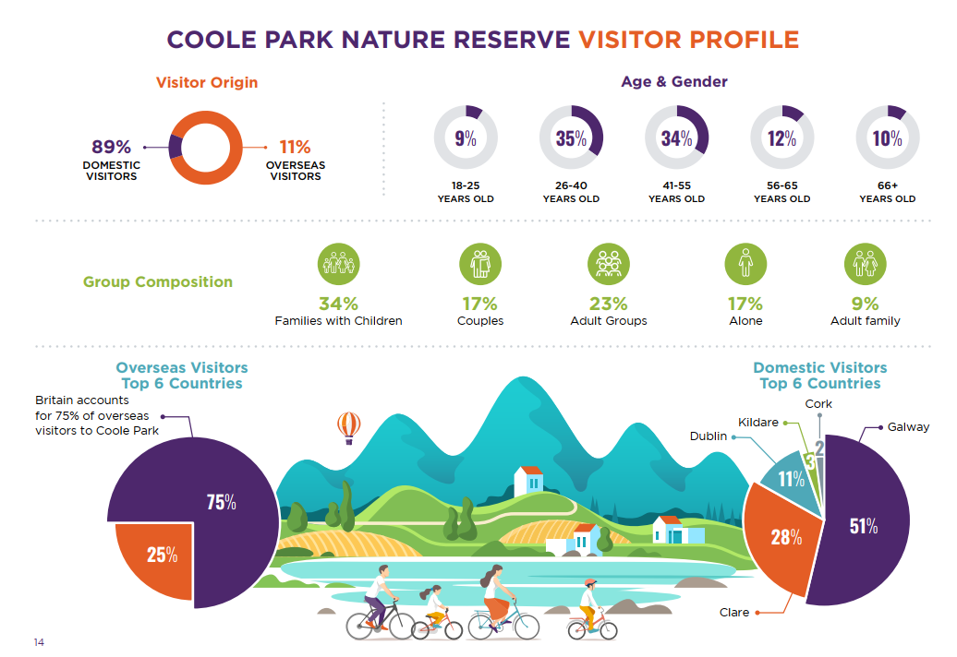

The main attraction of Coole Garryland is the beauty and serenity of the landscape that Yeats captured in his poetry. Information on Lady Gregory and the literary and cultural history of the site is provided in the Visitor Centre, in addition to displays relating to natural heritage. The attraction from a recreational point-of-view is the opportunity for visitors to immerse themselves in the beauty and tranquillity of the various woodlands, turlough and lake. A visit to the Walled Garden is another popular activity for visitors which offers a short ramble from the Visitor Centre, and which takes in the beauty of the walled garden and the famous Autograph Tree. It also has a picnic area with a shelter hosting covered seating for wetter days. Families and other users make good use of both the waymarked and unmarked trail network for walking, running and cycling and the site hosts a popular Park Run and other events (under permit) throughout the year.

2. PROJECT DEFINITION
This element of the study is to comprise a Property Feasibility Study incorporating an assessment of National Park and Wildlife Service user requirements in relation to the Coole Park administrative centre, office, interpretative facilities current and future provision at Coole Park, and a review of current and future uses for all of the existing on site buildings including the footprint of all historic buildings on site in line with the six different elements of the project as outlined below (these elements may be subject to change and NPWS will be guided by the architect-led team):

- The first requirement is to provide a dedicated space for the interpretation of Coole Park natural heritage. This will require the reconfiguration of the existing Visitor Centre and current Tearooms as a new interpretative space where an in-depth and immersive experience in Coole’s rich natural heritage can be created. This interpretation will place an emphasis on the international importance of turloughs and their ecology. The additional space this element of the project will create will mean that interpretation could also include information on climate change, the risk of flooding, global natural systems and the importance of nature conservation. It is envisaged that the existing Visitor Centre will be solely dedicated to natural heritage interpretation.

- The Tearooms will be relocated to the old coach house and dove-cote building and ancillary structures which will require full renovation. It is envisaged that this structure could be reinstated and the layout configured as a new dedicated Tearooms, with modern commercial kitchen, dedicated storage and ample indoor seating, possibly over two levels. (located across the courtyard from the VC structure). See photos and map in Appendix A.

- The provision of an outdoor performing area and a new literary and cultural building incorporating the old dairy and associated storage buildings adjacent to the site of the old Coole House. This should include a workspace/studio with suitable natural lighting as it is envisaged that Coole may host visiting artists-in-residence of various genre so the beauty of Coole and the legacy of Lady Gregory can inspire a new generation of talent in this area. See photos and map in Appendix A.

- Located in the vicinity of the visitor facilities, it is further intended that this project will include additional staff facilities and offices (See Appendix B) which will form part of the overall design for the site. Where possible these designs should consider the reinstatement, restoration and reuse of former buildings. For example, the re-use of the former gate house at the eastern boundary for staff amenities and or office accommodation. It is envisaged that these facilities should meet the requirements of 10-12 staff to be based at Coole. See photos and map in Appendix A.

- The redevelopment of the deer pen adjacent to the Visitor Centre, with a focus on a heritage garden/orchard and amenity areas, and any other recommendations put forward by the architect-led team.

- A review of existing services and infrastructure on site, to include; the provision and treatment of water services, waste management and electricity supply and distribution throughout the site. Furthermore, Coole Park Nature Reserve endeavours that all existing and future facilities will be designed and managed to the highest building and environmental standards. All new builds and building upgrades should embrace green technology and endeavour to be carbon positive as best practice and have a minimum aim to be carbon neutral. Buildings at the Coole Park Nature Reserve should act as an example of green building excellency in Ireland.

2.1 Objective of the Project

The objective is to carry out an initial study to establish the most appropriate form of development for Coole Park. It should be noted that in considering any work in the Nature Reserve, that one of the objectives in the Statement of Strategy is to ensure that our natural heritage is promoted in a manner consistent with the primary function of conservation.
The aim of the initial study is to design an attractive development layout with associated graphics to illustrate the type of development proposals that the National Parks and Wildlife Service would like to see coming forward on this site. It will provide a vision for the future development of the site and provide conceptual drawings of the building(s) on site. It is envisaged that this project will identify a strategy to realign the current visitor facilities while using the heritage buildings/sites/ruins on site in order to enhance the interpretation of Coole Park Nature Reserve as both a site of significant cultural heritage and a unique natural landscape of global conservation importance. It is proposed to keep the two elements of the story of Coole separate, targeting different, albeit overlapping audience segments.

The study will:
- Identify and provide for uses that will expand and enhance the existing NPWS offering in Coole Park.
- Quantify the current and potential level of NPWS provision within Coole Park.
- Formalise the space requirements of the National Parks and Wildlife provision within Coole Park.
- Investigate the potential for redevelopment of onsite vacant / under-utilised buildings and site bringing the potential for the creation of high-quality spaces that could be utilised as National Parks and Wildlife Service’s Natural Heritage and Literary/Cultural interpretation, Tearooms and staff facilities. The study should consider the footprint of all historic buildings at Coole Park including those that do not currently exist.
- Plan and design an attractive design and layout that takes account of the location and nature of the site and its context by giving a clear indication of the key elements that must be integrated into any development proposals.
- It is important to create an orderly space with a distinctive character. The feasibility study must work to create focal points and landmarks to help navigation into and around the space at Coole Park.
- Include associated graphics to illustrate the type of development that the Client would like to see coming forward on this site. The emphasis of this will be to prepare conceptual drawings and 3D images for the site showing building/structure design, pedestrian permeability and linkages with the carparks.
- Contain a written statement outlining the design proposal and key criteria that must be included in development proposals for this site.

2.2 Scope of Requirements

This project requires an architect led design team for the design, planning, environmental assessments.
All consultants should be registered as a professional in the discipline in which they are providing services.
To ensure that the project is completed successfully on time and within budget this consultancy service must be an all-in package and include other professional consultants and specialist services as deemed necessary for example M&E, Civil Engineers, Planning and Environmental Consultants, Health and Safety, Fire Safety, Accessibility Requirements etc.
The successful tenderer will be expected to be familiar with the Capital Works Management Framework available on www.constructionprocurement.gov.ie.

2.3 Deliverable/Desired Outcomes

The appointed consultants will be required to produce the following:

- Through liaison with the NPWS Regional Management, a topographical survey of the Study Focus Area.
- Feasibility study indicating the various options considered and the rationale for selecting the preferred option.
- Conservation Assessment, Condition Report (including building survey and relevant historical information, in line with the DAHG Architectural Heritage Protection: Guidelines for Planning Authorities) & Feasibility Study for the site. These buildings are a Protected Structure (RPS Number 410 in the Record of Protected Structures for Co. Galway) and the building is classified as having Regional Importance under the National Inventory of Architectural Heritage (NIAH) – the NIAH reference is 30412.
- A design statement giving a written overview of the design process and of key elements that must be incorporated into future development on the site.
- A site masterplan showing an indicative overall layout for the site that will provide the client and the public/developers with an example of a development footprint that is desirable and can be accommodated on the site and will fulfill NPWS’s optimum Coole Park Nature Reserve provision.
- ‘Artist’s impression’ type graphics of different areas of the site as they would appear if developed as per the masterplan.
- Indicative designs/sketches/concepts to provide guidance on the following issues:
  - Location/arrangement of uses.
  - Building(s) heights and finishes.
  - Scale and form of building(s).
  - Facades.
  - Relationship of buildings to existing context.
  - Surface treatment.
  - Public realm element i.e. outdoor furniture, exterior lighting.
  - Mobility analysis.
- A timeline / next steps required and associated costings to progress the final option.
- Based on the Final preferred proposal develop a client brief incorporating the NPWS’s future provision in Coole Park Nature Reserve on the site suitable for the procurement and appointment of a Design Team to progress the project to:
  - Stage (ii) Design inclusive of planning permission
  - Stage (iii) Tender
  - Stage (iv) Design
  - Stage (v) Handover

Agreed and finalised graphics to be made available as jpeg files. The design statement to be provided as a Word document. Original graphic files e.g. SketchUp files must also be provided to the Client at the end of the project.

A risk analysis should be prepared to rate the different options.

Order of Magnitude Costing from the quantity surveyor of each option to be provided to guide budgetary decisions or phasing strategy. A Quantity Surveyor is to form part of the design team.

2.4 Constraints

The Design Consultant should respect the following constraints in devising the design solution:

Technological – There are no technological constraints known at this stage.

Environmental - The ultimate implementation and delivery of this project will be subject to environmental assessment. The appointed consultant will be required to undertake at least Screening for Appropriate Assessment and if deemed necessary the preparation of a Natura Impact Statement.

The Coole Park Visitor Centre and associated structures are within the zone of influence of the Coole-Garryland Complex Special Area of Conservation (SAC site code: 000252) and the Coole-Garryland Special Protection Area (SPA site code: 004107). Future development must ensure there are no adverse effects on the European Sites or on the site integrity, or the integrity of any other European site as a result of the proposed Strategy. Accordingly, objectives set out in Volume 1 of County Development Plan 2022-2028 relating to European sites and to appropriate assessment will apply to any future development proposals in this area. The Coole Park Visitor Centre and associated buildings is also within the Coole Park Nature. Nature Reserves are protected from works that would destroy or significantly alter, damage, or interfere with the features for which the Nature Reserve was designated. Therefore, given the location of the Coole Park buildings in the context of European Sites, the Strategy will need to be screened for Appropriate Assessment with a Screening Report prepared as part of the contract. Should it be deemed necessary following Screening for Appropriate Assessment a Natura Impact Statement should also be prepared.

Administrative and managerial ability - There are no constraints in terms of administrative and managerial ability known at this stage.

Distributional, social, spatial, and land use Strategy - There are no constraints in terms of distributional, social, spatial, and land use plan known at this stage.

Co-operation required from other interests – Stakeholders including the local community including specific groups (Friends of Coole, the Yeats Thoor-Ballylee Society, the Burren Lowlands CLG and the Kiltartan Gregory Cultural Society) should be consulted with and engagement with these groups is required.

General policy consideration – There are no known constraints in terms of general policy consideration known at this stage.

3. Timescale
The project will be directed by a working group comprising of NPWS representatives. The working group will review progress on the tasks outlined and provide an overall steer on the direction of the project. Six working group meetings are envisaged: one at the commencement of the project (project inception), three interim meeting to approve the process, a further meeting to approve designs prior to planning, and a final meeting to finalise the outputs.
Where there are significant comments on the work presented at the interim or final meetings, further meetings (no more than three) may be required under the contract.
Day to day engagement with the Department will be facilitated through the assignment of a Departmental liaison person/officer who will be assigned at the project commencement meeting.

The timescale for the project shall be as follows:

June 2026
Project commencement

Meeting | Purpose | Frequency & Timeline  This is a guide and to be agreed upon once Design Team (DT) are appointed | Output | Notes | Stage Payment
Client initial Briefing to Design Team (DT) | Brief DT on requirements & procedures. | On Project Initiation | Minutes and agreed actions issued within 3 days via email.  Minutes by DT | DT to provide estimated program / schedule of work items  DT to link up with all relevant stakeholders i.e. Failte Ireland, Community Stakeholders etc.
Client progress meeting with DT | Synopsis on progress made.  Agree on Agenda template for Public Consultation. | Week 4 | Minutes and agreed actions issued within 3 days via email.  Minutes by DT | Progress to include:  Evaluation of sites potential  Provide research report in relation to sites Planning, physical and historical context.  DT to confirm of Public Consultation date, proposed location, time, method of media promotion.  DT to coordinate hosting / social media awareness of Public Consultation.
Initial Design Public Consultation No. 1 | Meet Coole Park community stakeholders and Tearoom Franchisee | Week 6 | Minutes and agreed actions issued within 3 days via email.  Minutes by DT | Initial agenda to include: Historic backgrounds of Coole Park, possibilities to be reviewed, welcome public input.
Client progress meeting with DT | Report on Public Consultation no.1. | Week 8 | Minutes and agreed actions issued within 3 days via email.  Minutes by DT | Submission of interim report –inclusive of summary of the work to date including assessment of feasibility of various design options, emerging preferred option and initial redevelopment concepts. | 20%
Client progress meeting with DT | Presentation of draft Coole Park Visitor Centre Redevelopment Proposal | Week 10 | Minutes and agreed actions issued within 3 days via email.  Minutes by DT | DT to link up with all relevant stakeholders i.e. Failte Ireland, Community Stakeholders etc.
Public Consultation No. 2 | Presentation of draft Coole Park Visitor Centre Redevelopment Proposal | Week 12 | Minutes and agreed actions issued within 3 days via email.  Minutes by DT | DT to coordinate hosting / social media awareness of Public Consultation.
Client progress meeting with DT | Final Coole Park Visitor Centre Redevelopment Proposal on board comments and discussion topics at Public Consultation no.2 | Week 14 | Minutes and agreed actions issued within 3 days via email.  Minutes by DT | Submission of interim report –inclusive of summary of the work to date including assessment of feasibility of various design options, emerging preferred option and initial redevelopment concepts.
Client Final meeting |  | Week 16 | Minutes and agreed actions issued within 3 days via email.  Minutes by DT | An end of Project Report to be issued including steps taken in the project, synopsis of premises of draft property feasibility study and redevelopment proposal items of work which took place in relation to the Public Consultations, guidance provided for steps required to fulfil brief. | 25%
NPWS Management Board | DT presentation to NPWS Management Board | Week 18 | Minutes and agreed actions issued within 3 days via email.  Minutes by DT | Comments from client meeting to be incorporated into Final document.
Public Consultation No.3 | DT Presentation of Final Coole Park Visitor Centre Redevelopment Proposal | Week 20 | Minutes and agreed actions issued within 3 days via email.  Minutes by DT | Comments from NPWS Management Board / represented stakeholders to be incorporated in Final document. | 25%
Planning Application | DT and Planning Team (PT) present pack with draft planning report and associated planning documents | Week 28 | Minutes and agreed actions issued within 3 days via email.  Minutes by DT/PT | Comments from client to be incorporated into planning document.
Planning Application Submission | PT to submit planning application to Galway County Council | Week 30 | Confirm valid submission of planning applicant and provide planning reference number |  | 30%

Public consultation is an essential element of this project and it is envisaged that consultation will be carried out in two phases. Firstly, the consultants will be required to engage directly with local stakeholders and community groups in the Gort area. Other relevant stakeholders to be consulted include, elected representatives, local authority staff, Tearooms Franchisee etc.

A second consultation phase will take the form of a wider consultation with the general public and Fáilte Ireland, most likely carried out when a draft proposal has been prepared and is available for consultation and comment.

The appointed consultant will be required to attend an inception, interim and final meeting with the Steering Group responsible for the delivery of the Proposal.

4. Budget and Costing

Payments to the appointed consultants shall be made on a stage payment basis, the details of which shall be agreed at the inception meeting.

The overall budget for the Coole Park Visitor Centre Redevelopment Proposal shall not exceed €250,000 Incl. VAT.

The tenderer must provide:
(1) One overall cost for the design team, as a unit, to deliver the requirements specified for this project. Please also provide daily rates and role for each team member. In addition, a detailed breakdown of costs should be provided

(2) The tenderer should give a separate cost in relation to the extra ‘pool’ of days.
The overall cost and cost for extra pool of days must be quoted in euro (€) and be inclusive of any generic overheads (incl. expenses, travel and subsistence, contingency rates).

Prior to the award of any contract, the successful tenderer shall produce a Tax Clearance Certificate from Irish Revenue or any such details required by the Contracting Authority so as to permit them to verify the successful tenderer’s status by means of the Irish Revenue on-line verification facility. All payments under the contract will be conditional on the contractor being in possession of the valid Tax Clearance Certificate at all times.

Relevant Qualifications and Experience

This request for tender seeks to procure a multi-disciplinary team for an architect-led project that will prepare a design for visitor and staff facilities at Coole Park Nature Reserve which will utilise the heritage elements and footprint of the site. It is anticipated that the design team will either be a multi-disciplinary organisation, or a consortium brought together by the lead architect to complete this project. Expressions of Interest from individual consultants who cannot provide all the necessary services will not be considered.
The successful tenderer will be responsible for the preliminary design, detailed design and planning submission. The supplier shall provide complete Architectural, Structural, Mechanical & Electrical designs, all planning documentation (incl. environmental/ecological reports), tender drawings, construction drawings and details, detailed design calculations and complete pricing document. All the documentation will meet current standards and statutory requirements.
The successful tenderer must demonstrate the skills, expertise and experience required for this contract, with the provision of CVs being essential. It will be essential to demonstrate the satisfactory completion of a minimum of two projects of similar scale and requirements.
The successful consultancy must also fulfill the role of PSDP in respect of this project.

Proposals shall contain clear details of the skills and experience of the tenderer and individual team members, including the range of their relevant professional skills and their CVs. Details shall be given of the relevant experience of the firm and personnel proposed, including examples of relevant work.
The design team services to be provided comprise the following principle services / disciplines and specialists as follows:
- Architect
- RIAI Architect Accredited in Conservation at Grade 1 / 2
- Landscape Architect
- Interpretative Planner
- Project Manager
- Civil / Structural Engineer
- Mechanical, Electrical and Plant Engineering
- Ecologist/ Bat Ecologist
- Quantity Surveyor
- Project Supervisor Design Process
- Other consultancy services necessary for the performance of the services described in this brief.

Personnel identified to be part of the project team will only be considered to be so if it is clear that significant time is proposed to be dedicated by them to the project. The tenderer should consider and include costs for supporting consultants.

Performance

The following performance standards are to be considered and refined by the appointed consultant:

Energy Efficiency – Government policy establishes the importance of reducing the energy requirements and greenhouse gas emissions associated with development. Energy efficiency should be embedded in the design proposals for the site e.g. maximising solar gain, proposed use of local materials etc.

Universal Design – Proposals for green infrastructure development should be designed so that the area can be accessed, understood and used to the greatest extent possible by all people regardless of their age, size, ability or disability. It should be designed to meet the needs of all people who may wish to use it. This is not a special requirement, for the benefit of only a minority of the population. It is a fundamental condition of good design. Everyone will benefit if an environment is accessible, usable, convenient and a pleasure to use. By considering the diverse needs and abilities of all throughout the design process, universal design creates products, services and environments that meet peoples' needs.

Safety - The design of the proposals contained in the Coole Park Redevelopment Strategy will have a direct impact on people’s perceptions of safety and their willingness to use a space.
The area should be designed as a safe environment, ensuring that the spaces created do not, in any way, facilitate anti-social behaviour.
Proposals should create a legible space; an ability to find one’s way with ease, contributes to a sense of security and comfort.

Quality – The Contracting Authority seek quality design outcomes in all aspects of this project.

Best Practice Design
Designers shall adopt best practice in terms of design. Proposals should reflect a sense of place, be distinctive, inclusive and well connected.

Best Environmental Standards - Sustainability and Environmental Accreditation – RFT Recommendations

Please consider the below additional/voluntary sustainability, environmental standards and accreditation that should be pursued. It does not list the mandatory, required regulations associated with planning and construction in relation to the environment. It is recommended that RFTs for new buildings should require contractors to meet the criteria listed below in addition to the mandatory environmental requirements in order to ensure maximum energy efficiently and sustainability of new builds whilst considering the impacts of buildings (new and existing) on the environment. As such, new builds should endeavour to be carbon positive as best practice (to offset the carbon negative impacts of existing buildings) and have a minimum aim to be carbon neutral. Buildings should act as an example of green building excellency in Ireland and developments should seek to achieve carbon neutrality at a Park/Nature Reserve level.

In addition to the necessary AA, EIA and SEA sought by planning authorities and in addition to the regulations set out by planning authorities in Ireland, NPWS should seek out contractors who:

- Are construction professional members of the Irish Green Building Council, a branch of the US Green Building Council and are environmentally responsible in their actions.
- Design with a view to provide a building with leadership in green building in an Irish context, backed up with international acclaim.
- Follow the advice of IGBC in relation to best practice in achieving LEED accreditation in all aspects of the awards system: Integrative process, location and transport, sustainable sites, water efficiency, energy and atmosphere, materials and resources, indoor environmental quality, innovation; and regional priority.
- Aim for Building Research Establishment Environmental Assessment Method (BREEAM) certification and have completed projects which have achieved LEED and BREEAM awards.
- Use the Embodied Carbon in Construction Calculator (EC3) developed by Shanska and the Carbon Leadership Forum to calculate the carbon emissions of all materials to be used in construction at the design phase; and where appropriate, use materials which are repurposed, recycled or ideally, recovered from waste.
- Back up the use of EC3 with the RICS method to achieve an accurate carbon calculation for the building and present this to NPWS management for each of the three proposed designs. Note: The embodied carbon calculated should be a weighted score within the RFT process.
- nZEB - The European Energy Performance of Buildings Directive Recast 2010 (EPBD) requires all new buildings to be nearly Zero Energy Buildings (nZEB) by 31st December 2020 (from website https://www.igbc.ie/nzeb/).
- Endeavor to reach the highest standard in the BER system (A2 as standard in new public building construction). Note: BER is an arbitrary energy rating and does not account for the embodied carbon of construction materials or indeed, the continued sustainability of the building following the construction phase. This should not be viewed as a suitable measure of sustainability.
- Are aware that Coole Park aims to achieve ISO14001 and additional green building and environmental awards following construction and that the building should continue to remain carbon positive over a set number of years (to be decided in consultation with potential contractors) during the operation of the building to ensure that the highest standards in sustainable energy/natural resource consumption are considered and met within the design phase using the most up-to-date technologies available at the time.
- Work with NPWS management to secure SEAI EXCEED grant scheme for public buildings (up to the value of €500,000) e.g. installation of photovoltaics, hydroponics and smart glass.
- Consider the impacts on natural resources such as air and water quality through the installation of living walls, environmentally sensitive waste treatment facilities (reed beds), use of existing hydroelectric infrastructure, amongst others.
- Avoid unnecessary destruction of habitat by working around habitat where appropriate e.g. incorporation and retention of older native tree species and shaping building around habitat
- Aim to achieve the Living Building Challenge certification, enabling the building to become self-sufficient as a minimum and carbon positive at best.
- Comply with all new laws pertaining to Climate at both an EU and national level.
- Provide solutions in retrofitting existing buildings to ensure maximum efficiency of the site.

Note: ISO 14001, LEED, BREEAM, HPI, nZEB and use of EC3 are all voluntary opt-in schemes to achieve high standards in sustainability, energy efficiency, decarbonisation and low environmental impact. All mentioned greatly add to CNPs contribution in actively aiming to hit Climate Action Plan targets, Paris Agreement targets and work towards achieving the Sustainable Development Goals.

Some examples of key buildings which have achieved LEED platinum accreditation:
- Miesian Plaza, Baggot Street, Dublin 2 secured LEED Platinum v4 in 2019 (highest possible accreditation by the USGBC) and is the 179th building globally to achieve this standard.
- Excellence in green building: Phipps Conservatory & Botanical Gardens in Pittsburgh. World’s only platinum-certified greenhouse and platinum and net-zero energy certified Centre for Sustainable Landscapes (carbon positive).

- Living Building Challenge: The Kendeda Building at Georgia Institute of Technology, Atlanta (goal of 105% energy production).

Abbreviations and additional info.
BREEAM – Building Research Establishment Environmental Assessment Method.
EC3 – A tool developed by Shanska, the Carbon Leadership Forum, C Change Labs, Microsoft and other supporters to enable construction professionals to calculate embodied carbon emissions of a wide selection of building materials (over 16,000). This is an open-source tool and was developed with the view of reaching the carbon targets of the Paris Climate Agreement.
IGBC/USGBC – Irish Green Building Council/US Green Building Council
ISO 14001 – International standard which provides a framework and requirements of an environmental management system (EMS) by helping organisations to be more efficient in the use of resources, reduction of waste and improves overall performance of the organisation. An appointee within the organisation takes on the responsibility of putting in places changes to meet the ISO.
LEED – Leadership in Energy and Environmental Design
RICs Method – https://www.igbc.ie/wp-content/uploads/2015/02/RICS-Methodology_embodied_carbon_materials_final-1st-edition.pd

APPENDICES

Appendix A Images and Site Layout Maps
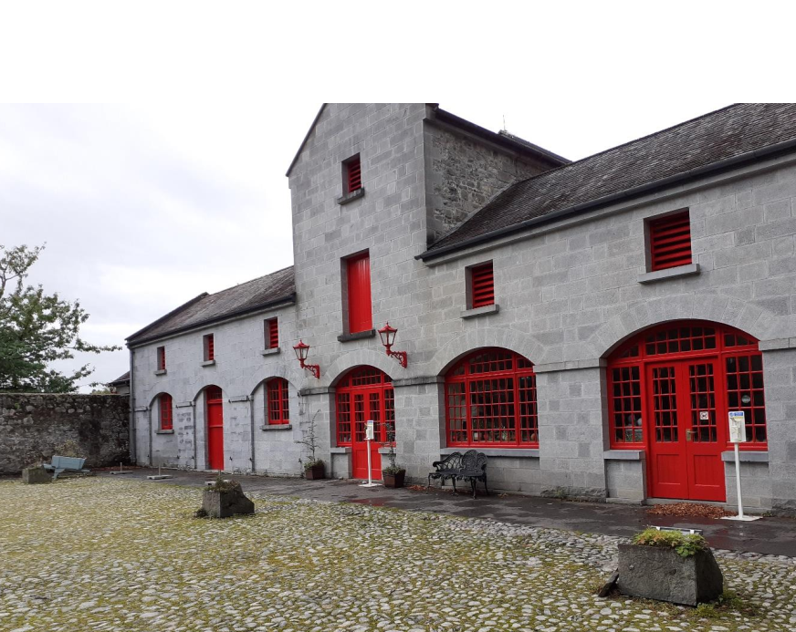
Fig 1. Courtyard – East Elevation of Tea Room

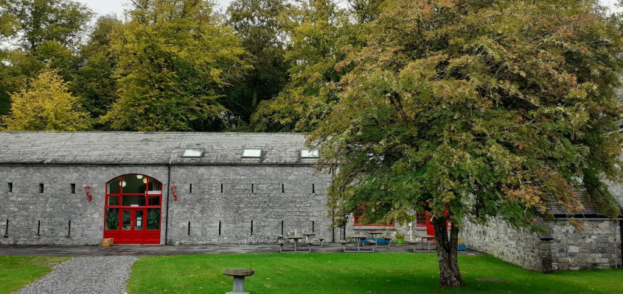
Fig 2 Visitor Centre – view from South

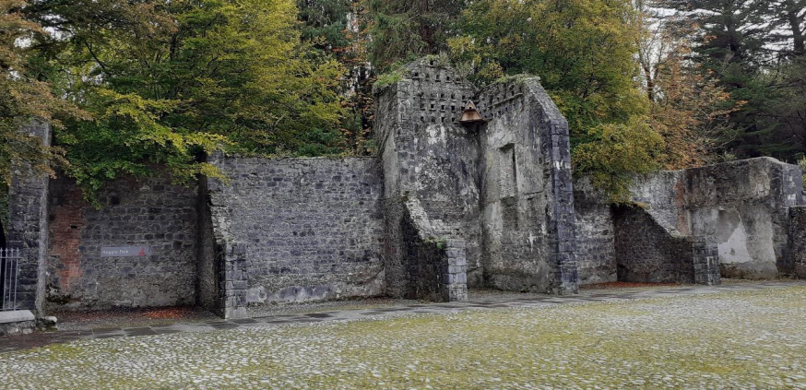
Fig 3 Courtyard – Ruins along Eastern Boundary

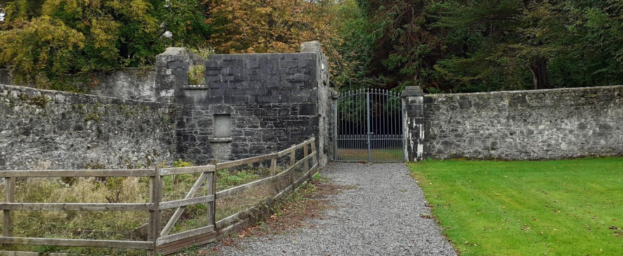
Fig 4 Gate Lodge – Ruins along Eastern Boundary
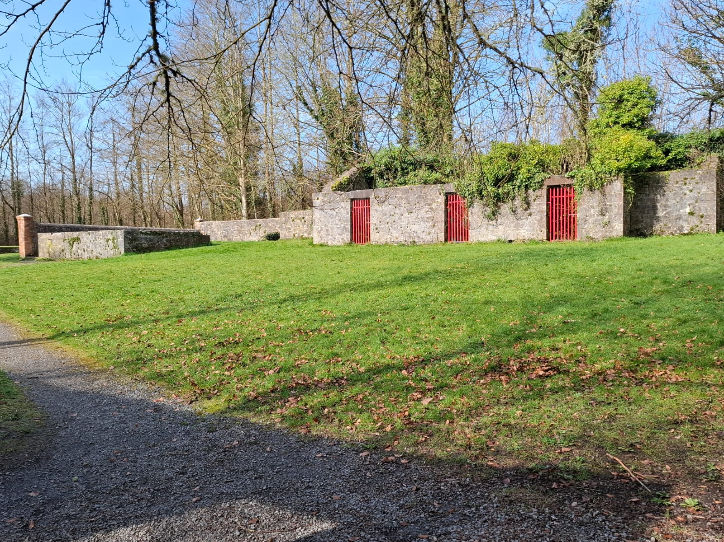
Fig 5 Old dairy buildings
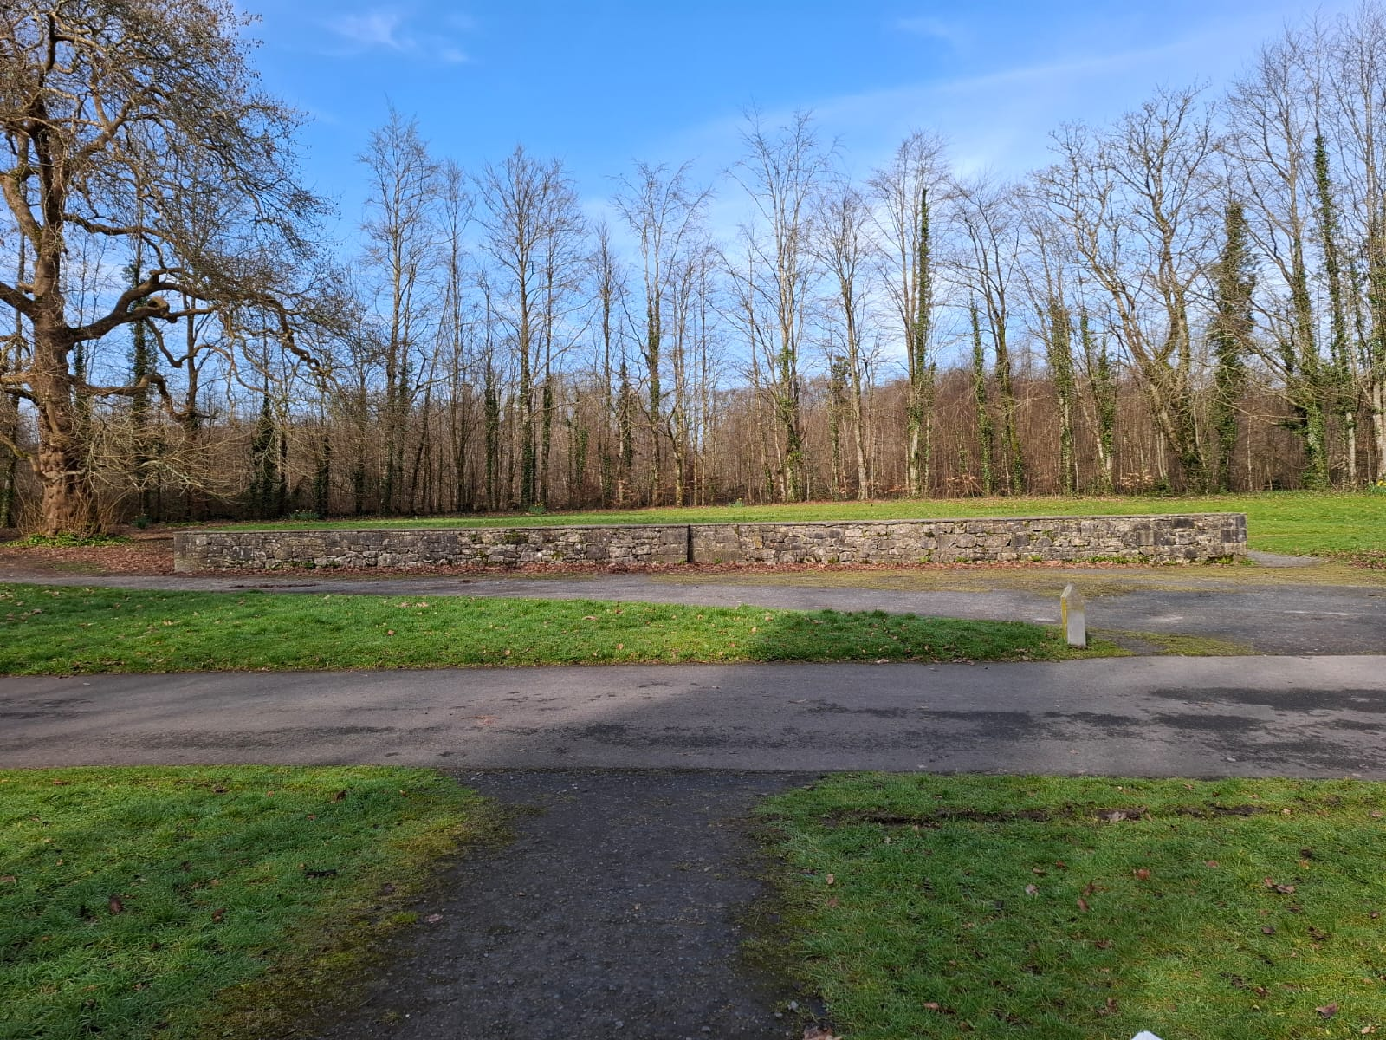
Fig 6 Site of Coole House

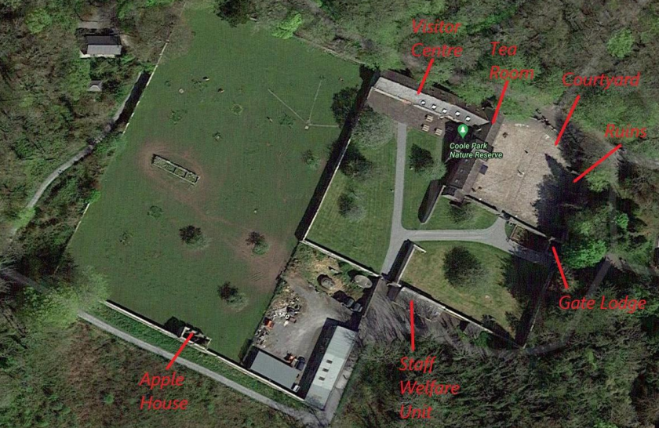
Fig 7 Location of Coole Park Visitor Centre and surrounding buildings
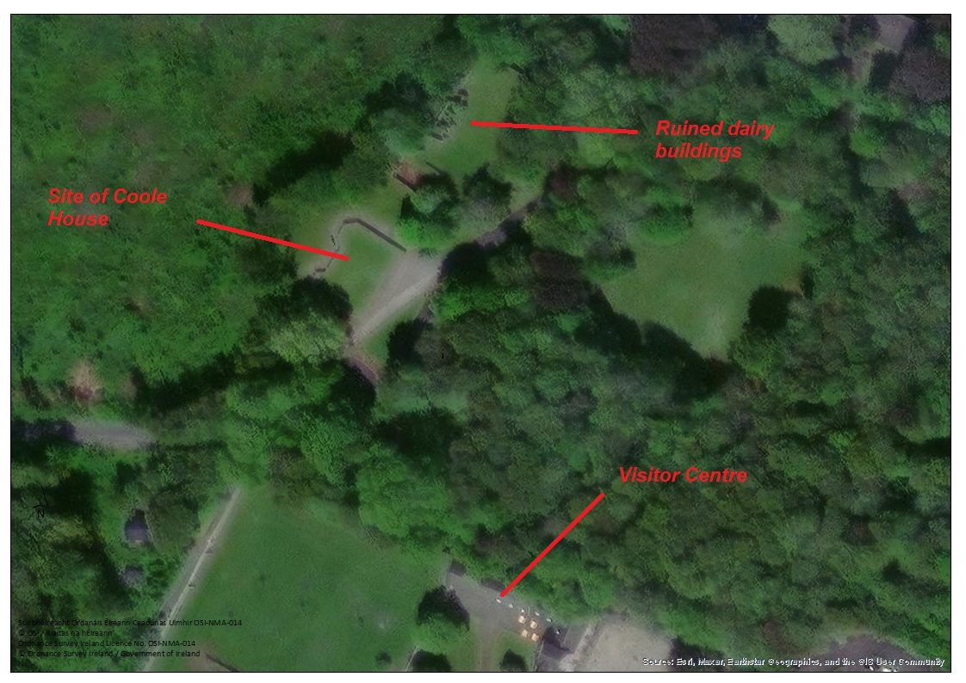
Fig 8 Location of Coole House and ruined dairy buildings in relation to Coole Visitor Centre
Appendix B
Requirements for NPWS Staff Office Accommodation and Coole Park Administrative Facilities.

  - • Office Accommodation for:
    - 1 of Regional Manager
    - 1 of District Conservation Officer
  - 2 of Conservation Ranger (hot desk)
  - 1 of Store Keeper clerk
  - 1 of Supervisor Guide
  - 1 of Head guide (This could be in visitor centre).
  - 4 of Visitor/Education Guides
  - 1 of Foreman
  - 5 of GO hotdesks

  - • 1 Field Studies Room/Laboratory. This space should be reasonably spacious an capable of accommodating a minimum of two persons with adequate desk/table/bench space for microscopes, PCs, and other items for Park research
  - • 1 reception area
  - • 1 Meeting Room capable of holding regional/district meetings
  - • 1 adequate room to accommodate map cases –including table for laying out of maps - photocopier, shredder and other in-common items.
  - • 1 Dry Store room to accommodate stationary and publications
• 1 Kitchen/canteen room capable of accommodating up to 12 persons (higher in summer)
  - • 2 Toilets
  - • Disabled access toilet
  - • 1 shower
  - • 1 Locker room - this could be incorporated into the toilet\shower block – with adequate locker storage for each member of field staff for secure storage of field equipment, telescopes tripods etc.
  - • 1 wet room for storage of wet suits, dry suits, wellies and personal boat equipment
  - • Evidence room for secure storage of evidence. (This need not be large).

