
Fire Station Developments
Planning & Design Guidelines and Financial Procedures for
Fire Station Development Projects
WORKING DRAFT

2026
Prepared by the Department of
Housing, Local Government and Heritage
gov.ie

Table of Contents
Prepared by the Department of
Housing, Local Government and Heritage
gov.ie
Part 1: Project Stages 5
1.1 Strategic Assessment and Preliminary Business Case 6
1.1.1 Preliminary Appraisal (Establishment of Needs) 6
1.1.2 Detailed Appraisal 8
1.1.3 Project Design Brief 8
1.1.4 Site Selection 9
1.1.5 Application for approval-in-principle 11
1.2 Project Design, Planning and Procurement Strategy Stage 11
1.2.1 Appointment of Professional Consultants 11
1.2.2 Preliminary Design 13
1.2.3 Planning Permission 14
1.2.4 Fire Safety Certificate 14
1.2.5 Disabled Access Certificate 14
1.2.6 Nearly-zero energy buildings 15
1.2.7 Utilities 15
1.2.8 Specialist works and equipment 15
1.2.9 Preliminary Cost Plan 15
1.2.10 Detailed Design 16
1.2.11 Building Information Modelling 16
1.2.12 Detailed cost plan 17
1.2.13 Tender documents 17
1.2.14 Approval to proceed to final business case stage 18
1.3 Final Business Case Stage 18
1.3.1 Tender Advertisement 18
1.3.2 Tender Evaluation 18
1.3.3 Planning Permission 19
1.3.4 Fire Safety Certificate 19
1.3.5 Disabled Access Certificate 19
1.3.6 Tender recommendation to NDFEM 19
1.3.7 Approval from NDFEM to accept tender 20
1.4 Implementation Stage 20
1.4.1 Appointment of Main Contractor 20
1.4.2 Commencement Notice 20
1.4.3 Construction supervision 20
1.4.4 Abnormal conditions 21
1.4.5 Variations 21
1.4.6 Interim claims for payment 21
1.4.7 Project Completion 22
1.5 Final account 22
1.5.1 Final Account 22
Part 2: Fire Station Design 24
2.1 Functional Requirements of Fire Stations 24
2.2 Fire Station Accommodation and Facilities 25
2.3 Fire Station Layout and Zones 25
2.4 Appliance Bays 27
2.5 Watch Room 30
2.6 Muster Bay 31
2.7 Washing and Drying Facilities 32
2.8 Sanitary Conveniences and Washing Facilities 32
2.9 Multi-purpose room 33
2.10 Cleaning Store 34
2.11 Corridors and Lobby 34
2.12 Plant Room 34
2.13 Electrical Services 35
2.14 Heating 35
2.15 Communications Facilities 35
2.16 Drill Yard 36
2.17 Drill Tower 37
2.18 Forecourt 38
2.19 Car Parking 38
2.20 Landscaping 39
2.21 Station Sign and Artistic Feature 39
2.22 Station Furnishings 39
2.23 Additional Requirements for Headquarter Stations 39
2.23.1 Site Size 39
2.23.2 Office Accommodation 39
2.23.3 Appliance Bays 40
2.23.4 Multi-purpose Room 40
2.23.5 Kitchenette 40
2.23.6 Storage Areas 41
2.23.7 BA Servicing Room 41
2.23.8 BA Compressor Room 41
2.23.9 Drill Tower 41
2.23.10 Drill Yard 42
2.23.11 Car Parking 42
2.23.12 Workshops 42
2.24 Additional Requirements for Full-time Stations 42
2.24.1 Site Size 42
2.24.2 Individual Study Pods 42
Appendix 1 – Capital Grant Aid Funding Forms 44
Appendix 1.1 FSC 1 Application for Approval in Principle Form 45
Appendix 1.2 FSC 2 Detailed Cost Plan Form 47
Appendix 1.3 FSC 3 Tender Cost Analysis 48
Appendix 1.4 FSC 4 Forecast of Expenditure Form 49
Appendix 1.5 FSC 5 - Certificate of Expenditure and Payments Form 50
Appendix 1.6 FSC 6 Form - Final Account 51
Appendix 1.7 FSC 7 Fire Station Upgrading / Improvements Capital Grants Claim 63
Appendix 2 – Station Schematic Layout Templates 65
Appendix 3 – Fire Station Generators & Ancillary Equipment 69
A3.1 Introduction 69
A3.2 Generator Specification 69
A3.2.1 Electrical Requirements 69
A3.2.2 Location and Plinth Requirements 70
A3.2.3 Weatherproofing, Guarding and Acoustic Requirements 70
A3.2.4 Engine 71
A3.2.5 Fuel Tank 71
A3.2.6 Cooling System 72
A3.2.7 Exhaust System 72
A3.2.8 Lubrication & Filters 72
A3.2.9 Alternator & Automatic Voltage Regulator 72
A3.2.10 Generator Control Panel 73
A3.2.11 Identification & Rating Labels 73
A3.3 Auto Changeover Switch & Panel 73
A3.4 Cables & Containment 74
A3.5 Commissioning 75
A3.6 Training 75
A3.7 Warranty 75
A3.8 Standards and Codes 75

Part 1: Project Stages
These guidelines are provided for individual fire station projects. However, fire authorities may also wish to consider a number of projects as part of an overall strategic improvement programme. In particular, the appraisal stage could involve a review of all the fire stations in an authority's area and consider a programme of projects to be implemented over a number of years, depending on established priorities.
This guidance considers, the Department of Public Expenditure NDP Delivery and Reform’s, prevailing Infrastructure Guidelines, which were published in December 2023 and can be accessed through the following link https://assets.gov.ie/static/documents/infrastructure-guidelines.pdf .The guidelines provide a high degree of confidence that projects will be delivered on time and in a manner that ensures value for money. Fire authorities and design teams should familiarise themselves with these guidelines at the early stages of any fire station development project.
The elements of the various project stages are set out in the following 2 schematics and each stage is considered in detail in Part 1 of this document.
A 3D model of a typical fire station layout is available on the NDFEM Sherpoint.
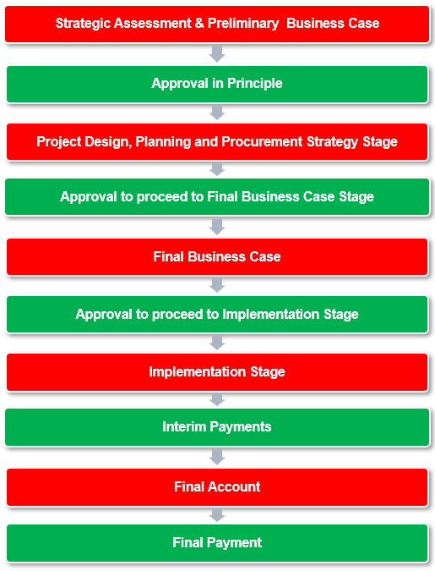

1.1 Strategic Assessment and Preliminary Business Case
The objective of the strategic assessment and preliminary business case stage is to establish the need for a particular fire station project and to prepare a case for submission to the National Directorate for Fire and Emergency Management (NDFEM) for "approval-in-principle" to grant-aid the project from the fire services capital allocation funds.

1.1.1 Preliminary Appraisal (Establishment of Needs)
Projects will be considered on a case-by-case basis and fire authorities may wish to consider these in the context of an overall improvement programme. The objectives of such a programme should be set out in terms of statutory and risk-based service delivery requirements. The needs for a particular project should be linked to these overall objectives.
In general fire brigades should have established and sustainable crewing levels, operating satisfactorily for a number of years, before applications for grant-aid will be considered. Preference will generally be given to upgrading and replacing the higher activity fire stations, and it is expected that fire authorities would prioritise projects on this basis.
It may be feasible to provide adequate facilities by upgrading and/or extending an existing fire station. Where possible, this option should be thoroughly explored and could provide a cost-effective solution. The suitability and adequacy of the existing building and site/location will be an important factor in this regard. Any improvement works could include the provision of universal toilet / shower facilities, additional muster bay positions, training facilities etc. The option of a new station should only be considered when upgrading works has been shown to be neither viable nor adequate.
Modern methods of construction should be considered to reduce costs where a new station is required. Consideration may also be given to the acquisition of suitable industrial or other types of buildings that can be modified to meet the operational requirements of a fire station. Each proposal will be assessed on a case-by-case basis, with a strong emphasis on demonstrating value for money, operational suitability, and long-term sustainability.
The fire authority should assess the long-term need for a new or upgraded fire station including carrying out a risk assessment that considers any significant risk to project delivery. There are a number of factors which should be considered in this context, including:
- Characteristics of the area and any special risks within the brigade's functional area;
- Annual number of brigade turnouts and recent trends;
- Number of fire fighters in the brigade;
- Location relative to other fire stations in the authority's functional area and in adjoining authority functional areas; and
- General operational requirements.
The NDFEM considers that a 2-bay station will generally be sufficient, other than headquarter and appropriate full-time stations.

1.1.2 Detailed Appraisal
Having completed the preliminary appraisal, the options available to the fire authority include:
- Existing facilities are adequate, and no new works are required;
- Upgrade existing facilities by extension/renovation, etc.;
- New station with two bays is required; and
- New station with greater than two bays is required.
The range of options must be fully explored before deciding on the needs in a particular case. The detailed appraisal should include an estimate of costs for the preferred option. This should be based on best available data and realistically reflect construction and other costs at the time of application. If it is deemed appropriate to apply for capital grant aid funding to upgrade or construct a new fire station, the fire authority may consider contacting the NDFEM’s advisory staff at this stage to discuss the application process.

1.1.3 Project Design Brief
The design brief should be prepared by the Fire Authority and effectively describe the project as determined by the detailed appraisal and set out the objectives and parameters for the consideration of the design team. All the fire authority’s requirements should be set out in appropriate detail, including a schedule of accommodation and room sizes etc. These should be based, in so far as is practicable, on Part 2 of this guidance.
The design brief aim is to provide a functional fire station, appropriate to the needs of the authority and sympathetic to its’ location, without the need for over-elaborate designs and/or specifications exceeding the minimum necessary.
Cost limits for the project must be included in the design brief. Estimated costs for the project will have been included in the detailed appraisal and these should be used as the permitted expenditure limits.
Once design has commenced, changes in the scope or objectives of the project should not be made unless absolutely necessary, or unless the proposed change could reduce the overall cost of the project. If changes are required, the cost implications and timing for the project should be fully appraised. Approval for any such changes to the design brief must be obtained from the NDFEM.

1.1.4 Site Selection
In the case of a new station, the main priority is to secure a suitable site. Advice on the site selection may be included in the design brief, or alternatively the fire authority may have carried out this exercise and secured a suitable site for development. In the case of upgrading an existing station, the suitability of the existing site for expansion should be similarly assessed. There are two factors in site selection, namely suitability of the location, and secondly the suitability of the site for development.

Site location is a critical factor in enabling the fire service to fulfil its emergency response role. The key influencing factors are:

- Fire stations should ideally be located in areas not liable to traffic congestion. Ideal parameter is proximity to a major road network, balanced with convenience for crew mobilisation, which provides effective access to the station's operational area. It should ideally have direct access to a major road and in this regard, traffic considerations and any proposed road developments should be considered;
- For a retained brigade, proximity to the crew's living and work places is important. It may be appropriate to conduct a series of trials to test the turnout times for sites under consideration;
- Proximity to specific risks where the brigade's response-time may be critical; and
- Town planning issues.

Site suitability, other than location, relate to the impact on the functionality of the station and on the potential for development without excessive construction costs. Factors to be considered include:
- The site should be capable of meeting all the functional requirements of a fire station, including the building, accommodation for appliances, car-parking, training etc (refer to Part 2 of this guidance for detailed requirements). A site for a 2-bay retained fire station should typically not exceed 2,000 m²;
- The nature of the site itself and its suitability for building purposes will affect the design of building substructure and structure. This should include local historical flood water data and any potential impact on the site. The existing ground levels should be such that the site development works will not require excessive retaining structures and/or excessive cut and fill operations;
- The selected site should be subjected to a comprehensive investigation to establish the full extent of necessary development works and the design of the structure and sub-structure. The investigation should also establish that the site grounds are free of any contamination materials. The ground conditions should be such that will enable a cost-efficient design for the works. A site that requires piled foundations, or where removal and replacement of considerable amounts of unsuitable materials are involved, should generally be avoided;
- The site should be capable of being serviced with electricity, water and main drainage (foul and storm water). These services should be available from a public roadway adjacent to the site. If services need to be extended to the site boundaries, the cost implications should be identified and where possible shared with other proposed or future development. This principle should also be extended to any access roadway needed to service the site; and
- It should be possible to establish suitable communication links to and from the site for mobilisation purposes. Checks should be made to establish that there are no inherent difficulties with the site selection in this regard.
It may be necessary to engage a level of appropriate professional consultancy services at this stage of the process to assist with the initial site selection process. It is acknowledged that unforeseen site issues may arise during the detailed Project Design, Planning, and Procurement Strategy phase, which may necessitate consideration of an alternative site.

It should be noted that costs associated with the acquisition of a new site will not be capital grant aid funded.

In some cases, consideration may have to be given to relocating the current fire brigade to an alternative location while development works are taking place. It should be noted that costs associated with relocation will not be capital grant aid funded.

1.1.5 Application for approval-in-principle
An application for an approval-in-principle, signed by the Director of Services with responsibility for Fire Services following a recommendation from the Chief Fire Officer, should be made using the standard application form FSC 1 (see Appendix 1), accompanied by the following documents:
- Preliminary appraisal report and detailed appraisal as part of a strategic assessment and preliminary business case;
- Project design brief;
- Site location map; and
- Site suitability report.
Once approval-in-principle is granted the project can then proceed to the project design, planning and procurement strategy stage. It is important that the terms of the design brief are strictly adhered to, particularly in relation to meeting the required functionality and cost parameters.

1.2 Project Design, Planning and Procurement Strategy Stage
The purpose of the project design, planning and procurement strategy stage is to specify the output requirements accurately, precisely and comprehensively at the start or as early as possible in a project.

1.2.1 Appointment of Professional Consultants

Fire authorities should ensure that, as far as possible, professional consultant's fees are kept to a minimum. It is expected that significant development project will necessitate the engagement of the following professional consultants:
- Architects
- Mechanical and Electrical Engineers
- Civil and Structural Engineers
- Quantity Surveyors
In the first instance, the fire authority shall determine the most appropriate professional consultant discipline to lead the design them. This will be dependent on the pre-dominant nature of the works. Fire station development projects will generally be architect led.
Fire authorities shall comply with procurement guidance, procedures and other arrangements within their Local Authority when engaging professional consultants. This may require bespoke tendering to engage appropriate professional consultants or carrying out a mini-tender competition where frameworks are already in place.
The tender documentation should provide a detailed scope of works for the professional consultant’s team and clarification as to the arrangements and costs on areas including list of specialist surveys, reports and works will be dealt with:
- Production of Building Information Modelling (BIM) for the project
- Carrying out the role of Project Supervisor Design Process;
- Carrying out the role of design and assigned certifier including the certificate of compliance on completion;
- Carrying out the role of Project Supervisor Construction Stage;
- Obtaining a fire safety certificate including the application fee;
- Obtaining a disabled access building certificate including the application fee;
- Submitting a commencement notice including fees;
- Nearly-zero energy building design;
- Screening for appropriate assessment;
- Environmental impact screening assessment;
- Shadow analysis;
- Asbestos surveys;
- Archaeology Services;
- Costs associated with planning permission including purchasing of relevant maps, newspaper advertisements and application fee;
- Trial holes;
- Erection of building profiles;
- Utility Surveys;
- Attendance at meetings and site visits including travel and subsistence costs; and
- A schedule of how fees for the different stages of the project will be processed.
The tender documentation should also request details of how fees relating to abnormal conditions and project variations will be dealt with.
Where there are a number of fire station projects there is scope for a model fire station design, which could be applied to different locations, and to negotiate fees on this basis.

1.2.2 Preliminary Design
The preliminary design is based on the design brief for the project, established in the detailed appraisal. Part 2 provides detailed guidance on the different types of accommodation requirements and may be influenced by particular requirements and site constraints, but a fire station should be standardised to a large extent. For this purpose, a schematic layout of a typical two-appliance bay fire station is included in Appendix 2. It is not intended to impose undue restriction on the architectural treatment or other options open to a designer and consideration must be given to intellectual copyright of a design. However, a certain degree of standardisation should lead to other benefits. It is essential that the users of the building are fully involved in the development of the design and are satisfied that the building will meet all the functional requirements, within the parameters set out in these guidelines.
The preliminary design would normally include a schedule of finishes and outline specification, including the following drawings:
- Floor plans;
- Elevations;
- Sections;
- Site survey; and
- Site layout.
A detailed site investigation should have been carried out during the strategic assessment and preliminary business case stage. If not, it is essential that this is done at the earliest possible stage.

1.2.3 Planning Permission
Requirements for planning under the Local Government (Planning and Development) Act will need to be met and the necessary procedures should be carried out, as part of the preliminary design process. These will normally include traffic considerations and provision of services such as water supplies. Planning considerations may influence the design of a fire station and advice from the relevant planning authority through a pre-planning application meeting should be sought at the earliest possible stage.

1.2.4 Fire Safety Certificate
A Fire Safety Certificate will be required for all new fire stations and for modifications / extensions to existing fire stations, in accordance with Article 11 of the Building Control Regulations 1997 to 2024. Fire Safety Certificate considerations may influence the design of a fire station and advice from the relevant fire authority should be sought at the earliest possible stage.

1.2.5 Disabled Access Certificate
A Disabled Access Certificate will be required for all new fire stations, and for modifications / extensions to existing fire stations requiring a Fire Safety Certificate in accordance with the Building Control Regulations. Disabled Access Certificate considerations may influence the design of a fire station and advice from the relevant building control authority should be sought at the earliest possible stage.

1.2.6 Nearly-zero energy buildings
Since 2020, the Energy Performance of Buildings Directive EU/31/2010 (revised in 2018) requires that all new buildings are to be nearly-zero energy buildings, hence all new buildings must have a high energy performance and very low energy needs. On 28 May 2024, the revised Energy Performance of Buildings Directive (Revised EPBD) entered into force in all EU Countries, requiring all new publicly owned buildings to be zero-emission by 2028. Zero-emission buildings will have low energy demand and no on-site carbon emissions from fossil fuels. The design will take into consideration the provision of renewable energy sources such as photovoltaic panels.

1.2.7 Utilities
It is recommended that the professional consultants should engage with relevant utility companies during the preliminary design phase to discuss connections to gas, electricity, telephone and wastewater systems. Costs associated with relocating and new connections to utilities should be provided in the preliminary cost plan.
When extending or redeveloping an existing fire station the professional consultants may require a utilities survey to be carried out.

1.2.8 Specialist works and equipment
There may be some limited specialist works where a main contractor would not be expected to have available the necessary expertise or experience to carry out these works. This could include the supply, installation and commissioning of an appliance exhaust extraction system or a drying room de-humidifier in a station. It may also include the supply, installation and commissioning of a breathing apparatus compressor. Estimated costs for specialist works and equipment should be included in the preliminary cost plan.

1.2.9 Preliminary Cost Plan
Once the preliminary design is completed, a preliminary cost plan should be compared with the cost plan contained in the design brief. It should include for all costs highlighted above including those relating to various planning authority requests and surveys. Significant variation will require reassessment of proposals to bring costs in line with the design brief. Any significant variation should be referred to the NDFEM before proceeding.

1.2.10 Detailed Design
Once the preliminary design is completed, including the cost plan is in line with the design brief, the detailed design can then proceed. This involves detailed drawings and specifications in the following principal areas:
- Architectural design, including schedules of materials and finishes;
- Civil design including arrangements for site services;
- Structural design including structural arrangements and details;
- Mechanical services design and detailed drawings;
- Electrical services and detailed drawings; and
- Detailed specifications: architectural, civil, structural, mechanical and electrical services.

1.2.11 Building Information Modelling
Building Information Modelling (BIM) is a collaborative process that enables the structured creation, management, and exchange of information throughout the lifecycle of a built asset - from design and construction through to operation and maintenance. It is a core component of Ireland's digital construction strategy and is increasingly a requirement in both private and public sector projects, including strategic housing delivery.
BIM allows project teams to work with shared, coordinated information, improving accuracy, reducing duplication, and enabling better decision-making. The data handling capacity of BIM is vital to accurately measure the embodied carbon of construction projects. It can also drive significant efficiencies from the point of view of time, and cost and enables a better-quality outcome.
BIM requirements were introduced into the Capital Works Management Framework in January 2024. It initially applied to higher value projects – over €100 million – and cascades down to projects below €1 million over a 4 year period. Further details on the requirements for BIM may be found at the following link - BIM requirements in the CWMF from January 2024 | Capital Works Management Framework.

1.2.12 Detailed cost plan
When the design is sufficiently advanced to enable accurate measurements of the works involved to be made, the detailed cost plan for the project should take into consideration all items listed above. This will be provided on the format outlined in the standard form FSC 2 (see Appendix 1). The overall cost of the project should be in line with those indicated in the approval-in-principle. Costs may be adjusted for normal inflation in construction costs since the date of the approval. Any other variations must be fully explained and justified before completion of the tender documentation. If necessary, the design should be modified to meet these cost objectives and within the terms of the project brief. It is envisaged that the NDFEM’s advisory staff would review the detailed design and other relevant issues, with a view towards approval of the project cost. On completion of this cost control exercise, the tender documentation can be completed.

1.2.13 Tender documents
The tender documentation should be sufficient to fully detail and quantify the works involved and to enable tender submissions from suitable contractors. All works should be capable of measurement from the drawings, whether or not a bill of quantities is required.
Provisional sum costs should be minimised and considered only for specialist parts of the work, where a main contractor would not be expected to have available the necessary expertise or experience as outlined in 1.2.8 above. Tender documents should be prepared for any provisional sum cost items, with a view to obtaining tenders for these elements at the same time as the main contract. Provisional sums included in the contract documents should be itemised and should not include any amounts for unspecified contingencies.

1.2.14 Approval to proceed to final business case stage
On completion of the project design, planning and procurement strategy stage, approval should be sought from the NDFEM to proceed to the final business case stage. When requesting approval to proceed to the final business stage, confirmation of the detailed cost plan should be made, subject only to the outcome of the tendering process.
The formal request for approval to proceed to the final business case should be signed by the Director of Services with responsibility for Fire Services following a recommendation from the Chief Fire Officer.

1.3 Final Business Case Stage
The final business case stage is the last and final approval stage in the project lifecycle.

1.3.1 Tender Advertisement
Following approval from the NDFEM to proceed to Final Business Case Stage, Fire Authorities should make arrangements to publish the tender, in accordance with the procurement procedures and arrangements in place in their Local Authority. This will include responding to tender queries from interested parties. Depending on the nature and estimated cost of the works required, a framework may exist within the Local Authority allowing for a mini-tender competition, or a pre-qualification of suitable tenderers may take place. Other projects will necessitate advertisement of the project as a stand-alone tender. This process may be supported by the Local Authority procurement section and the project design consultants.

1.3.2 Tender Evaluation
Tender submissions should be evaluated in accordance with Local Authority procurement procedures and guidance. The evaluation process will consider the validity of tender submissions along with assessing qualitative and quantitative criteria of valid tenders where relevant. This will result in a pre-standstill ranking of successful tenders. The results of the tender process should then be announced followed by the appropriate standstill period. The successful companies will be ranked post-standstill period, dependent on any review of observations or objections received during the standstill period.

1.3.3 Planning Permission
A formal application for planning permission should be made to the relevant planning authority in parallel with the running of the tender process. Planning permission should be granted for the development works prior to any works being carried out. The necessary public-notice procedure must also be met.

1.3.4 Fire Safety Certificate
A formal fire safety certificate application to proceed with the proposed works should be lodged with the relevant fire authority in parallel with the running of the tender process. A fire safety certificate shall be granted before proceeding with any works.

1.3.5 Disabled Access Certificate
A formal disabled access certificate application to proceed with the proposed works should be lodged with the relevant building control authority in parallel with the running of the tender process in accordance with the Building Control Regulations. A disabled access certificate shall be granted before proceeding with any works.

1.3.6 Tender recommendation to NDFEM
Following the post-standstill period ranking of contractors, a final business case shall be sent to the NDFEM for consideration. The business case shall provide an overview of the tender process and details of the recommended main contractor for the project. Details should be provided of all costs and fees associated with the project, including professional consultant services, and any items of note and confirm an anticipated start and completion date for the contract. The recommendation should include confirmation that planning permission, a fire safety certificate and a disabled access certificate in accordance with the Building Control Regulations have been granted for the works. The recommendation should include Forms FSC 3 and FSC 4 (see Appendix 1) and be signed by the Director of Services with responsibility for Fire Services following a recommendation from the Chief Fire Officer.

1.3.7 Approval from NDFEM to accept tender
The NDFEM will carry out a review of the final business case before deciding on approval (with or without conditions) to approve the project to proceed to the implementation stage.

1.4 Implementation Stage
The Implementation Stage of a project begins once final approval for the award of a contract has been secured. The critical tasks at this stage are to award the contract, manage and monitor the project to ensure that it is executed satisfactorily, within budget, to standard and on time.

1.4.1 Appointment of Main Contractor
Following receipt of approval to proceed to implementation stage, the Fire Authority should appoint the Main Contractor in accordance with the Local Authority procedures. Purchase orders should be generated for any specialist works and equipment.

1.4.2 Commencement Notice
A full documentation Commencement Notice submission will be required for all new fire stations and for modifications / extensions to existing fire stations requiring a Fire Safety Certificate. A Design Certifier, Assigned Certifier and a Builder must be appointed/assigned roles in advance of the Commencement Notice submission. The appropriate notice period shall be provided prior to any works commencing.

1.4.3 Construction supervision
The project supervisor construction phase will make arrangements, in consultation with the Fire Authority, for ongoing supervision of the construction phase of the project. This will include regular site visits and project meetings with the main contractor, the design team and the fire authority. Minutes should be available for all meetings.

1.4.4 Abnormal conditions
Additional costs may arise during the construction phase of the project relating to unforeseen circumstances or unexpected unique site conditions, which will require additional expense beyond what was initially budgeted. In such circumstances, the professional consultants should review all options and agree costs for potential solutions with the main contractor. The fire authority should make the NDFEM aware of, and where appropriate seek formal approval for any such additional costs, before approving any additional works with the main contractor.

1.4.5 Variations
Variations, sometimes referred to as a change, include alterations to the scope of work originally specified in the contract, whether by way of an addition, omission or substitution to the works, or through a change in the way the works are to be carried out. The fire authority should make the NDFEM aware of, and where appropriate seek formal approval for any additional costs associated with variations before approving any variations with the main contractor. All variations should be documented by the professional consultants.

1.4.6 Interim claims for payment
Fire Authorities should submit a recoupment claim for expenditure associated with a project at the earliest opportunity. The submission should include the following documentation:
- Completed FSC 5 Form (see Appendix 1);
- Completed FSC 7 Form (see Appendix 1);
- Copies of all invoices;
- Certificate of stage payments from the design consultants; and
- Proof of payments (generally a screenshot from the financial management software used by the Fire Authority).

1.4.7 Project Completion
The professional consultants, in conjunction with the fire authority and main contractor should complete a report, commonly known as a ‘snag list’, prior to handover of the completed building to the fire authority. The report should identify any gaps between the builder’s finish and an acceptable industry standard for handover. The report shall take cognisance of the building drawings and specifications. Any training required on building installations shall be provided to the fire authority by the main contractor or their agents.
A certificate of compliance on completion shall be issued by the professional consultants upon completion of the project certifying that the works were practically completed in accordance with the project drawings and specifications.
A health and safety file shall be provided to the fire authority which will provide details of the complete building and will include documentation but not limited to as built drawings, certificates for all mechanical and electrical installations along with operational and maintenance manuals for all installations.
The Fire Authority should submit a post project evaluation report to the NDFEM identifying lessons learned and driving the process of continuous improvement in how public bodies evaluate, plan and manage public investment projects. This translates the lessons learned from an individual project or programme back into the bank of learning to inform sectoral and national guidance and future projects.

1.5 Final account

1.5.1 Final Account
The project final account will be agreed following issue of the certificate of practical completion. Following agreement on the Final Account, payment of the last stage payment should take place. Many projects will have a retention payment, typically 5%, withheld for a period of 12 months to allow for any issues that may arise with the building during the initial operational period.
An FSC 6 form (see Appendix 1) should be submitted to the NDFEM following agreement on the final account along with the recoupment claim for the final payment. Recoupment of the retention payment, where applicable, can take place later when the retention money has been paid.

Part 2: Fire Station Design

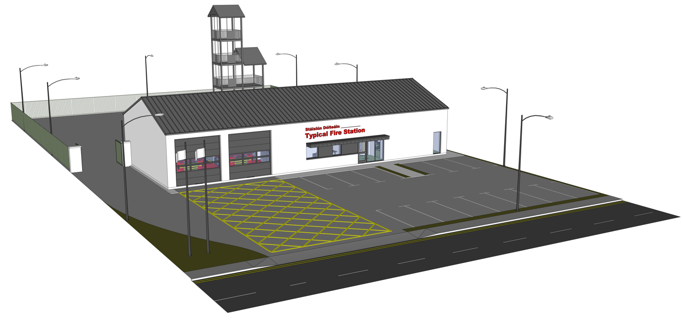

2.1 Functional Requirements of Fire Stations
The primary function of a fire station is to facilitate the speedy response of a fire brigade to incidents. The facilities required will largely depend on the type (whether retained or full-time) and activity of the brigade in terms of the operational requirements identified in the strategic assessment and preliminary business case stage for the project. The functional requirements of a fire station can be summarised as follows to:
- Facilitate the emergency turn-out of the fire brigade;
- Accommodate fire brigade appliances and equipment, in a state of permanent readiness for use;
- Provide appropriate facilities for fire brigade personnel, commensurate with the level of fire brigade activity;
- Facilitate routine testing and maintenance of appliances and equipment; and
- Facilitate ongoing training of fire brigade personnel.

2.2 Fire Station Accommodation and Facilities
The principal elements of a fire station are the following:
- Appliance bays;
- Crew muster area;
- Equipment cleaning/servicing/testing;
- Sanitary/washing area;
- Storage areas; and
- Training areas.
There is considerable scope in arranging these elements and the layout should, where possible and within the constraints of a particular site, be standardised in line with these guidelines. Ideally the internal layout of the station should separate the appliance bays, storage and crew muster facilities from areas such as the training room and any office accommodation.
The project brief, prepared by the fire authority during the strategic assessment and preliminary business case stage, should identify the extent of the accommodation required, including a schedule of accommodation and areas, in line with these guidelines and any other constraints or considerations which are necessary to meet the functional requirements of the fire brigade. The entrance lobby and corridors should be kept to the minimum size required for the functional operation of the station.
The specification of materials and finishes should be appropriate to the intended uses and should provide where possible, and without excessive cost implications, for minimum maintenance and operating costs during the life of the station. Fair faced blocks or painted block finish is considered adequate for most fire stations.
The fire station should be designed to facilitate a safe and healthy working environment for fire brigade personnel. In this regard, requirements under the Building Control Act, 1990 and Safety, Health and Welfare at Work Act, 2005 should be taken into account.

2.3 Fire Station Layout and Zones
Fire station design and layout can assist with reducing exposure to lingering contaminants from the products of combustion following attendance at an incident involving carbonaceous burning. Designating different zones within fire stations is good practice, to help reduce exposure when working in fire stations. This is best achieved by moving personnel from zones of higher contamination to zones of low to no contamination.
Red zones, also called hot zones, have the highest level of contaminants. These are the areas firefighters first enter when they return to the station after an incident, and where dirty undergarments and equipment are washed and cleaned, and where contaminated PPE is stored. It is assumed that contaminated PPE will be appropriately bagged at the incident site in a manner that prevents exposure to contaminants upon return to the station. Appliance bays are considered a red zone. The layout of the fire station should be clearly delineated with appropriate signage, as much as practicable, for the areas where dirty or contaminated equipment or PPE is permitted.
Yellow zones are transition zones that firefighters enter after the red zone. They offer a buffer between red zones and green zones, and a second chance to ensure no contaminants enter a green zone. Yellow zones will include the muster bay and drying room.
Remaining areas within the station are considered green zones. They have the lowest level of contaminants and can be free of all contaminants and carcinogens when part of a zoned approach to the station’s design.
Design features ensure that each zone remains isolated from the others. Figure 2.3.1 provides a recommended flow path between these zones. However, the specific rooms assigned to each zone may vary based on local risk assessments and the measures in place to manage products of combustion. As a result, both the flow path shown in the flowchart and the colour coding of the zones may be subject to change.
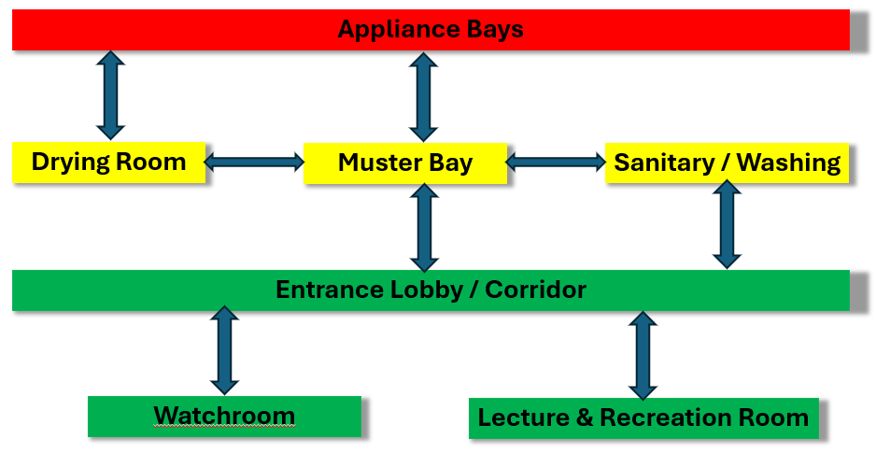

Figure 2.3.1 Recommended flow paths in Fire Station Designs

The zones can be identified within the building in a variety of different ways, e.g. by the floor colouring in a particular zone or by running a line of colour tiles through the middle of a white tiled room, door colours etc.
It is expected that a 2-bay retained station will typically not exceed 300 m². A schematic layout of a typical two-appliance bay fire station is included in Appendix 2. This layout is included for exemplar purposes and is not intended to be prescriptive.

2.4 Appliance Bays

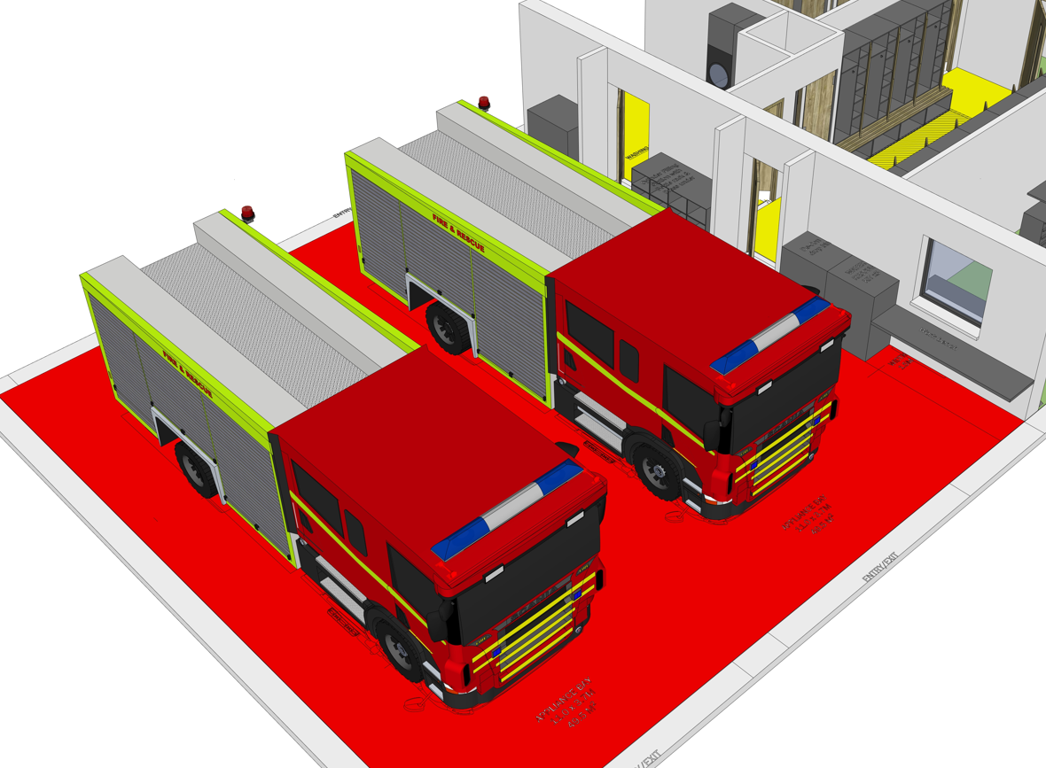
Appliance room requirements should be defined in the project brief, but as a general rule, other than headquarter and certain full-time stations, fire stations will have two appliance bays. Various combinations of appliance may be required, depending on local circumstances.
The minimum recommended appliance bay dimensions are 11 m long x 4.5 m wide per bay x 3.7 m high. Where it is proposed to house any special appliances; care should be taken to ensure that the door/ roof height at 3.7m is sufficient. Hydraulic platforms and turntable-ladder appliances need also to be considered, for some stations.
It is recommended that an additional 1.5m of width is allowed at the side of one of the appliance bays to accommodate the following:
- A bench incorporating appropriate sink layout for frontline servicing of breathing apparatus sets;
- A suitable bench incorporating a vice for light maintenance;
- Shelving, presses and racking for storage of materials, cleaning equipment, spare parts, etc.; and
- Suitable storage for contaminated PPE.
- Suitable storage and charging arrangements for Lithium Ion and other Batteries.
To maintain flexibility for the use of appliance accommodation and to avoid the danger of collision, damage or impeding movement of personnel, internal piers or columns should, wherever possible, be avoided.
The appliance room should be sited to enable the appliance to be moved straight out from the station until it is clear of the building. The driver should be afforded maximum visibility of the road/ footpath onto which the vehicle is emerging.
Exit doors from appliance bays should be a minimum of 3.8m wide and should be capable of withstanding frequent usage without losing their smooth action and reliable operation. The use of doors designed specifically for fire stations is recommended. Doors may be electrically or manually operated. In addition to the front doors, where site arrangements permit, a minimum of one appliance door should be provided at the rear of the appliance accommodation to facilitate appliance movement, but ideally at the rear of all appliance bays.
The floors of the appliance bay should be capable of carrying the imposed wheel loads of fully laden fire appliances, but not less than 10 tonnes per axle. The type of floor finish should be consistent with the degree of usage of the fire station. In most retained stations, a sealed concrete floor is generally adequate. In exceptional circumstances a floor finish to a higher specification may be considered necessary. Floors should be slip-resistant and falls in floor level and drainage facilities should be provided for any water spillage.
The walls of the appliance bays should be finished to a standard consistent with the level of use of the station. Fair faced blocks or painted block finish is considered adequate for most fire stations.
The appliance bays should be provided with an adequate level of artificial lighting for safe working and to illuminate the areas between appliances for access to equipment lockers. Switches should be arranged so that relevant lighting can be operated immediately on entry to the station via the normal personnel entrance.
A level of heating should be provided in the appliance bays to prevent freezing of water, damage to pumps, electrical and electronics in appliances and to reduce the risk of condensation on building surfaces. For these purposes the appliance bays should be fitted with thermostatically controlled heating to ensure that the air temperature does not fall below 12º C.
Electrical facilities are required to ensure continuous charging of batteries and air brakes on appliances. The appliance bays should be provided with an exhaust extraction system capable of extracting all exhaust fumes from vehicles when started and whilst idling. The connections to the appliances for these services should disconnect automatically when the appliance is driven forward.

2.5 Watch Room

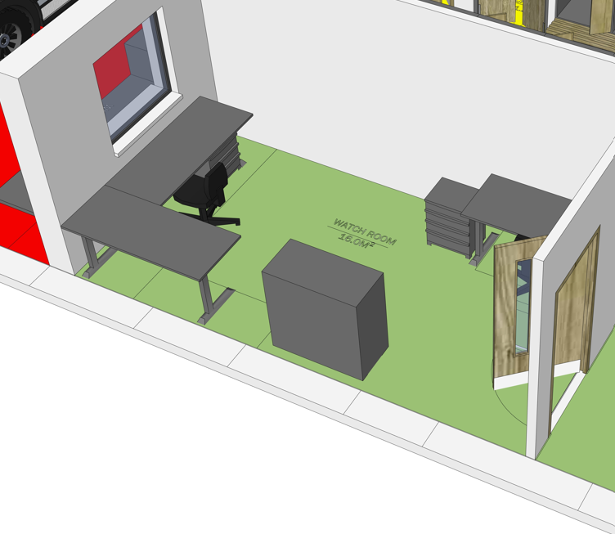
The function of the watch room is to accommodate the mobilisation and communications equipment and to provide an office space for the station officer. It should be located close to the muster bay, where mobilising messages can be readily picked up by crews responding to incidents. Consideration may also be given to locating the mobilisation message printer in the entrance lobby for ease of access for responding fire-fighters. It is desirable that the watch room should have a clear view of the forecourt and the appliance bays. The watch room should typically not exceed 16 m².
In stations where there is a full-time station officer, a separate office should normally be provided which should typically not exceed 16 m².

2.6 Muster Bay
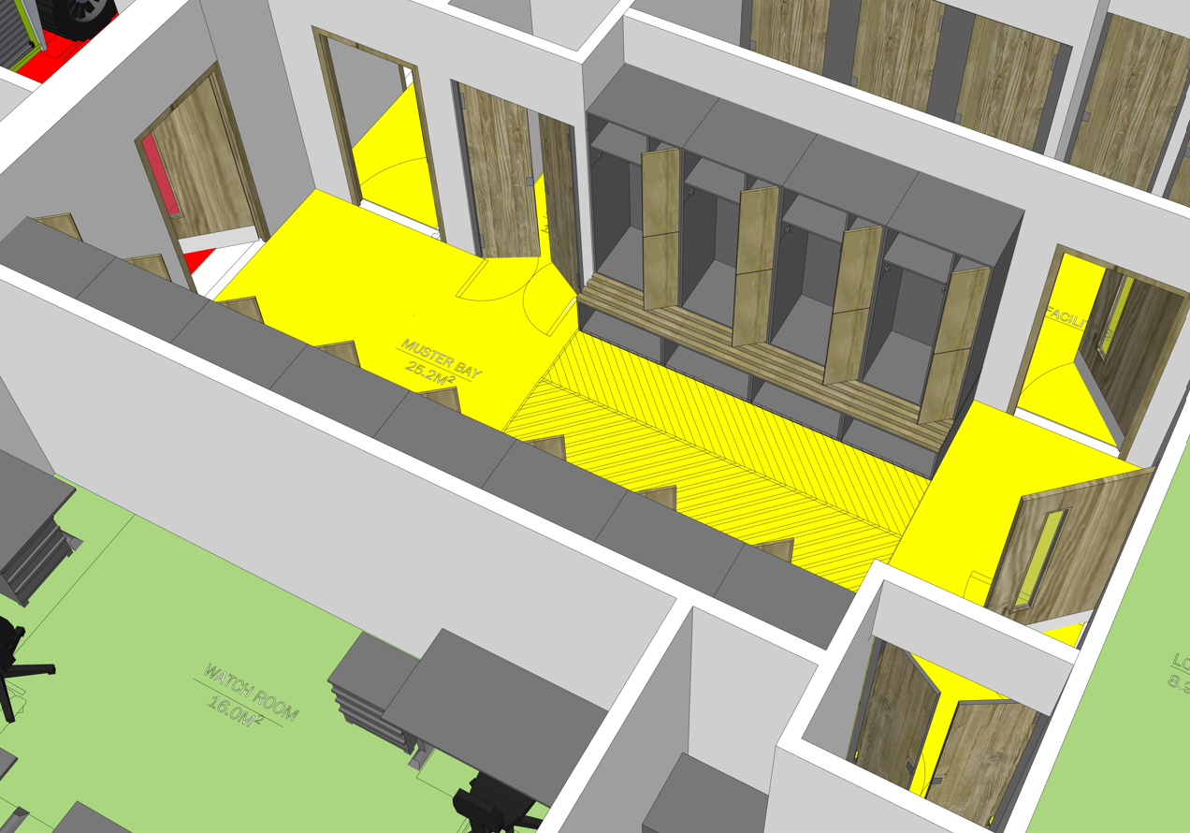

The muster bay should be adjacent to the appliance bay(s) and directly accessible to fire fighters on entry to the station via the normal entrance. The muster bay should be large enough to accommodate the fire kit for 12 personnel and to allow fire fighters to don and doff fire kit and undergarments in a comfortable manner. Each fire fighter should ideally have individual combined seating space and suitably sized built-in locker / storage rack accommodation to hold 2 sets of fire kit, other essential items of PPE and undergarments when not in use and for storage of personal effects. Generally, the seating spaces will be set up in an arrangement with 6 to 8 spaces facing the remaining spaces opposite them with a distance of 2.2m between them. The individual spaces should have a typical width and depth (including the seating portion) of 0.8m and 0.9m respectively.
Floor finishes in the muster area should be slip-resistant and easy to clean. The muster area should incorporate a system, such as a sentinel tile, for removing airborne contaminants such as volatile organic compounds (VOCs), carcinogens, and particulates, in order to enhance indoor air quality. Consideration should be given to providing appropriate electrical and water connections within the Muster Bay to accommodate a suitable hydration station. The muster bay should typically not exceed 25 m².

2.7 Washing and Drying Facilities
Facilities are required for drying wet fire kit. This will normally comprise of a dedicated drying room. The drying space should be accessible from the appliance bays and the muster bay to enable crews to pick up and drop off fire kit and other items of PPE on mobilisation and return to station. The drying room should have suitable ventilation and simple racking to dry clothes over a slow heat. Provision of a washing machine should be made for washing undergarments and smaller items of PPE. De-humidifiers should be installed in preference to heaters to dry PPE quicker. The drying room should also incorporate a system, such as a sentinel tile, for removing airborne contaminants such as volatile organic compounds (VOCs), carcinogens, and particulates, in order to enhance indoor air quality The drying room should typically not exceed 10 m².
In addition, the Fire Services may consider incorporating a lean-to structure along the side of the station, equipped with appropriate rails and hangers to facilitate the off-gassing of PPE.

2.8 Sanitary Conveniences and Washing Facilities

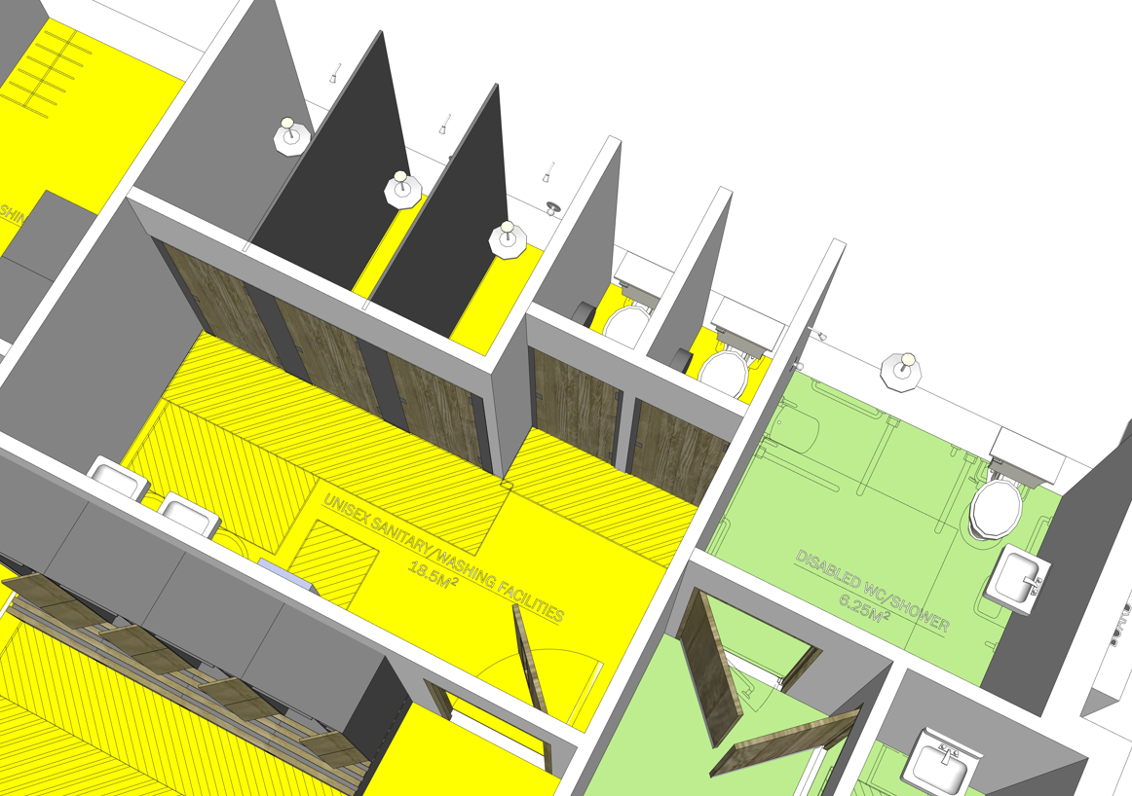

Adequate sanitary, hygiene and washing facilities are required in fire stations. Facilities should be provided in non-gender specific individual units, rather than in communal units. The individual unit partitions and doors should run from floor to ceiling. Individual shower units should include a fold down bench style seat, clothes hooks, hair dryer and a shower door. It is recommended that sanitary facilities for retained fire crews should be provided based on one WC / washbasin / shower per 4 fire fighters. A wheelchair accessible unit will be included and will count as one of the units to be provided for fire-fighters.
Guidance on the scale of provisions, selection, installation and special requirements is contained in BS 6465 Part 2 Sanitary installations. The sanitary conveniences and washing facilities, including the disabled access facilities, should typically not exceed 22 m².

2.9 Multi-purpose room

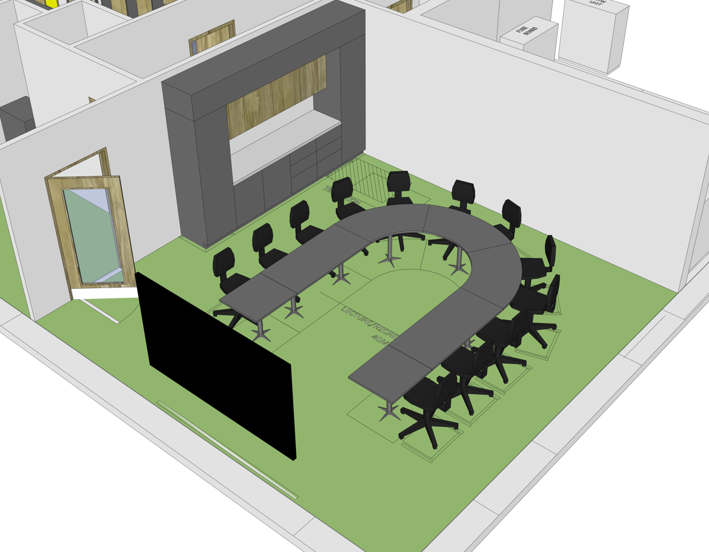

Fire stations should include a suitable multi-purpose room to support activities such as training, recreation, refreshment, rest and recovery, and Equality, Diversity & Inclusion (EDI) initiatives. The floor area of this room should accommodate 12 individual desks and chairs in a U shape orientation. The front wall of the multi-purpose room should have a display screen capable of displaying presentations from a remote laptop on a presentation desk. A wall mounted whiteboard should also be provided.
Facilities should be provided to make light refreshments available to retained fire fighters after protracted incidents or training periods. Such facilities normally include a sink and draining board, small worktop, cooker hob, presses, space for a dishwasher and fridge and electrical sockets. These facilities will normally be provided along the back / side wall of the room and will also incorporate a cleaning cupboard. It is recommended that there is no separation / dividing walls between the multi-purpose room and the refreshment area in order to maximise circulation space in this room. The multi-purpose room should typically not exceed 40 m².

2.10 Cleaning Store
A small store for accommodating cleaning items and equipment, typically no larger than 3m², may be incorporated into the corridor / lobby areas.

2.11 Corridors and Lobby
Corridor and lobby arrangements will vary depending on the overall layout of each fire station and should be tailored to the specific design of each station. Corridor dimensions should be kept to a minimum, however, all corridor widths must comply fully with the relevant provisions of the Building Regulations. Consideration should be given to providing appropriate electrical and water connections within a corridor to accommodate a suitable hydration station(s).

2.12 Plant Room
A room should be provided to accommodate the following typical plant:
- a generator and ancillary equipment to provide secondary power supply to the station – the size of the generator shall be determined by the Mechanical and Electrical professional consultant – note guidance and specifications for tendering for fire station generators is provided in Appendix 3, this guidance is also suitable for retrofitting generators to existing stations;
- main electricty fuseboard;
- plant relating to heating of the station;
- water storage tanks; and
- powerwasher etc.
Ventilation requirements for the plant room should be considered. Access for maintenance to the various items of plant should also be considered during the design stage. The plant room should typically not exceed 20m².

2.13 Electrical Services
It is important that the requirements in relation to electrical services are fully covered at the design stage. Consideration should be given to the location of switches, the number and types of lighting fittings (internally and externally), socket locations, electrical heaters (where provided) and communication and mobilisation equipment requirements. Where possible, lighting should be energy-efficient, activated by motion sensors, and programmed to switch off after a predetermined time delay.

2.14 Heating
A low level of heating is required in the appliance bays. Conditions should be sufficient to maintain equipment and appliances without excessive humidity and at a temperature generally not less than 12^{O}C. This general requirement extends to other areas of the fire station also. However specific areas need to be capable of being raised to a temperature of 19^{O}C. The choice of system used to achieve this will depend on the level of usage.
To achieve maximum economy, it is important that the heating system operates only when required and switches are located in the optimum location for ease of use. The use of timer-controlled switches and thermostats is recommended.

2.15 Communications Facilities
Modern mobilisation and communication facilities are essential components of the fire station. Much of the associated equipment will be in the watch room and provision should be made for power and communication connections. The number and location of antennas will vary and the requirements in this regard should be established at the earliest possible stage. The loss of signal strength in radio communications is directly related to the length of cable between the transmitter/receiver and the antenna, and this distance should be minimised. Adequate internal and external ducting for all services including electrical, telephone, antennae leads, etc. should be provided.
Arrangements should be put in place to have connectivity to relevant local authority IT infrastructure. Wi-Fi should be provided in the accommodation block of the fire station.

2.16 Drill Yard

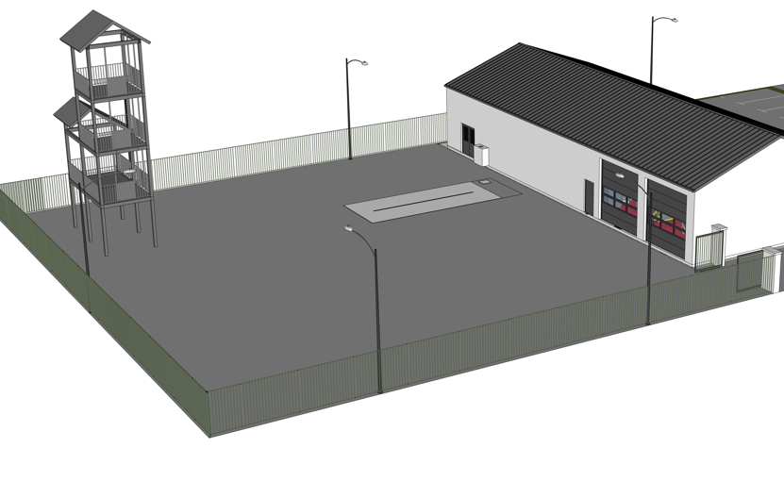

A drill yard to the rear of the station should be provided to enable on-station training, to facilitate appliance movement in and out of the appliance bays, and for testing of equipment and appliances. The surface of the yard will generally be tarmacked, other than concrete pads for an RTC exercise area and the vicinity of the Drill Tower, to a standard suitable for manoeuvring of fire appliances and for carrying out exercises. Suitably located hydrants supplied from the public water mains should be provided in the drill yard. Where possible, a 3.7m wide entrance gate should be provided for access to and egress directly from the yard. Adequate surface water drainage and crossfall sloping should be provided to drain away from the building and yard. Areas designated for vehicle washing should be provided with a dished concrete area draining to a suitable interceptor trap, preferably near the plant room where a power-washer can be stored.
Where considered appropriate, a 9,000-litre capacity underground tank with a controlled feed from the mains, complete with suitable manhole cover, should be sited near the hydrant for pump-testing/drill purposes. It should also be possible to fill this tank through rainwater harvesting from the complete site. An appropriate design should be included allowing the power-washer to be fed from the underground tank, to minimise mains water utilisation.
Suitable lighting can be located on the drill tower or on the fire station to provide illumination of the drill yard during hours of darkness.
A boot wash station should be located at the entrance to the fire station in a suitable location.
The drill yard should be designed, where site arrangements permit, to allow appliances to be driven directly from the drill yard into the appliance bays. In general, unless specific local requirements dictate otherwise, drill yard should be secured using metal palisade fencing. The drill yard should typically not exceed 1,000 m².

2.17 Drill Tower

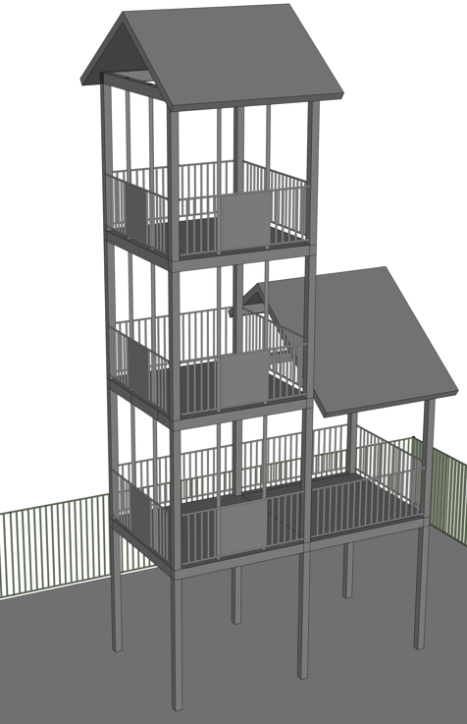
Drill towers are provided at fire stations to enable ladder drills and testing to be carried out, but may not be required at all stations, depending on local circumstances and arrangements for training. The design should be functional and economical and be constructed with a structural steel frame. Lighting should be provided at all levels. Access from floor to floor of the tower should be by means of staggered fixed ladders with suitable protective caging. Although only one drill tower face is required for normal training, additional openings may be provided as considered appropriate. It is recommended that the area of the tower that ladders are pitched to is differentiated from the rest of the tower by a contrasting colour or other means to assist crews with pitching ladders.

2.18 Forecourt
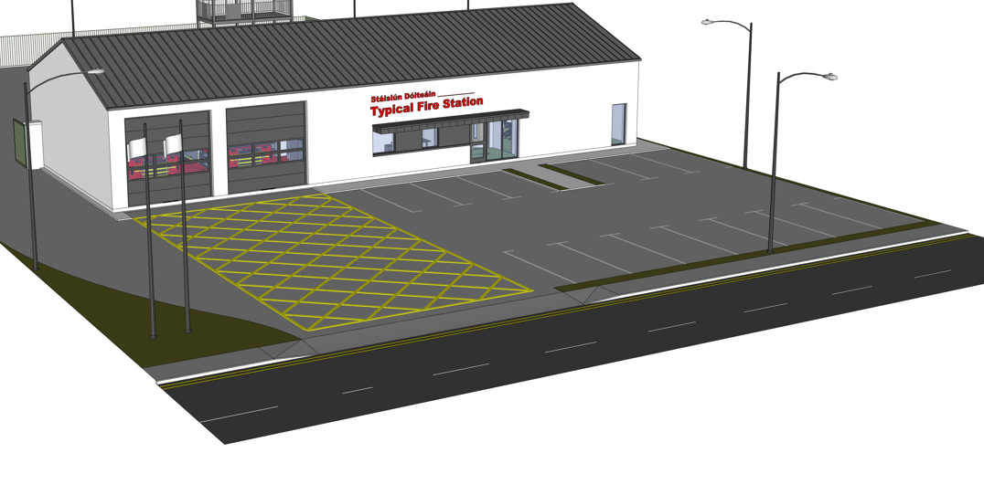
Fire stations should generally have a tarmacked forecourt between the appliance bay front doors and the road. The depth of the forecourt should be designed to accommodate the largest appliance comfortably and should not be less than 10m deep. The forecourt should not slope more than 1 in 25. Clear lines of sight should be provided to offer safe egress onto the public roadway.

2.19 Car Parking
Adequate car parking should be available for fire fighters reporting to the station. This should be located to facilitate rapid entry to the muster bay area of the station.

2.20 Landscaping
Landscaping should be designed to minimise ongoing maintenance. Planted shrubbery should generally be of the evergreen dwarf variety. Grassed areas should be avoided or kept to a minimum.

2.21 Station Sign and Artistic Feature
Fire stations are important civic buildings and should generally be marked with a suitable sign to the front of the fire station and include the authority’s crest. All text on signs should be bilingual in Irish and English.
The provision of an artistic feature can enhance the visual impact of the building in the built environment. It is important that the artistic feature is planned as an integral part of the design and landscaping of the scheme. Further details on the scheme for grant-aiding of artistic features are available in Circular Letter No. LS 1/97.

2.22 Station Furnishings
Station furnishings will not normally be included in an application for capital grant aid funding.

2.23 Additional Requirements for Headquarter Stations

2.23.1 Site Size
A larger site will be required to accommodate the additional items detailed below. It is expected that the site for a headquarter station should typically not exceed 8,000 m².

2.23.2 Office Accommodation
Headquarters stations require office accommodation for operational, technical and administrative staff. The scale will depend on the scale of local technical and administrative arrangements. Office accommodation should be separate and located such as not to interfere with the operational activity of the station. The office accommodation should generally be open plan with each cubicle typically not exceeding 5m². Consideration may be given to providing individual offices, typically not exceeding 15m² each, due to the nature of the work carried out for the following roles:
- Chief Fire Officer
- Senior Assistant Chief Fire Officers
- Lead administration person
A meeting room is normally also provided. The meeting room should typically not exceed 22 m².

2.23.3 Appliance Bays
The number of bays in a headquarter station will be determined on a case-by-case basis, considering the fleet size and operational requirements of the station. While it is normal for appliance bays to be located side-by-side, in headquarter stations where four or more bays are provided, site constraints may determine that bays are located behind each other. This will require double-length bays, where key response appliances can be parked to the front. Note, the additional 1.5m width along the length of the appliance bay to incorporate workbench space, as described in 2.4 above, will not be required in Headquarter stations due to the provision of dedicated rooms for these activities.

2.23.4 Multi-purpose Room
A multi-purpose room in headquarter stations will be larger in size to accommodate fire service training courses. This room will typically be 85 m² to deliver a training course to 18 learners and should comfortably accommodate 18 individual desks and chairs in a U shape orientation.

2.23.5 Kitchenette
In headquarter stations a kitchenette can be provided for facilities as described in 2.9 above along with appropriate seating and tables for personnel using the facility. The room should typically not exceed 50 m².

2.23.6 Storage Areas
Headquarters will accommodate the fire authority’s central stock, equipment and PPE. These are usually provided in secure, separate storage rooms. The extent of the storage required should be carefully considered at the design stage of the project and should typically not exceed 40 m². The room should include appropriate shelving, racking and presses.

2.23.7 BA Servicing Room
BA facilities should be provided at each headquarters station for testing, maintaining and keeping records on breathing apparatus equipment. Facilities required in the BA servicing room usually include an appropriate sink unit with a carbon filter trap, tool rack, storage drawers, racks for full and empty cylinders and a rack for breathing apparatus sets. The room should have a control panel to allow for filling BA cylinders. A dedicated BA room should typically not exceed 20 m².

2.23.8 BA Compressor Room
A compressor should be provided in a separate adjoining room, plumbed through to the BA servicing area. It should be possible to turn the compressor on and off from within the BA servicing room without accessing the BA compressor room. Consideration should be given during the design process to having sufficient air circulation around the compressor to keep the room cool during operation. The room should have access to an external wall for ventilation purposes. Access for maintenance of the compressor will also be required. The BA compressor room should typically not exceed 10 m².

2.23.9 Drill Tower
The drill tower may require additional functionality to assist with the delivery of a range of specialist or particular fire service courses. This may necessitate simultaneous access to at least 3 sides of the drill tower, a central staircase, working at heights rigging etc.

2.23.10 Drill Yard
A drill yard that is utilised in the delivery of fire service training courses will require additional drill yard space to accommodate the delivery of fire-fighting skills courses and the simultaneous running of courses. The drill yard should typically not exceed 2,000 m².

2.23.11 Car Parking
Additional car spaces should be provided to accommodate operational, technical and administrative personnel as appropriate. Electric Vehicle charging facilities should be considered at headquarter stations in accordance with relevant guidelines for electrical vehicle charging infrastructure.

2.23.12 Workshops
Fleet and equipment maintenance will be carried out in some fire authorities, while other fire authorities will choose to outsource this work. Applications for new workshops or upgrade / extension works to existing workshops should follow the project steps in Part 1 above.

2.24 Additional Requirements for Full-time Stations

2.24.1 Site Size
It is expected that the site for a non-headquarter full-time station should typically not exceed 6,000 m².
All items included in 2.20 above should be considered in addition to the following;

2.24.2 Individual Study Pods
Consideration should be given to the inclusion of an individual study pod room for each operational personnel on duty. The number of study pods should not exceed the maximum number of personnel on duty at a time. These study pods will be shared between personnel on different shifts / watches. In as far as practicable, individual study pods should have access to natural light and appropriate air circulation. The pods should include appropriate furnishings to allow for study and for storage of personal clothing and items. The typical size for individual pods will be 10 m².

Appendix 1 – Capital Grant Aid Funding Forms
Form FSC 1 Application for Approval in Principle
Form FSC 2 Detailed Cost Plan
Form FSC 3 Tender Cost Analysis
Form FSC 4 Forecast of expenditure
Form FSC 5 Certificate of Expenditure and Payments
Form FSC 6 Final Account
Form FSC 7 Fire Station Upgrading / Improvements Capital Grants Claim Form
Note: The latest revisions of the above forms should be downloaded from the NDFEM SharePoint site

Appendix 1.1 FSC 1 Application for Approval in Principle Form
 | FIRE STATION CONSTRUCTION -  APPROVAL IN PRINCIPLE  Return completed form to:  fscapital@housing.gov.ie | FORM FS C1
FIRE AUTHORITY: ____________________________

Please attach a report on the need and justification for the proposed station
- See Circular Fire 6/87 Paragraph 2.

Station Name: _______________________________________________________________

Station Address: _______________________________________________________________

_______________________________________________________________

Attach 6” O/S Sheet or Tracing showing location and block layout of station.

STATION INFORMATION

Retained |  | Site Area Sq. Metres |  | If extension/improvement project give details of existing station

Day Manned |  | Station Floor Area  (sq. metres) |  | Station Floor Area  (Sq. metres)

Full Time |  | No. of Bays |  | No. of Bays

H.Q.

TRAINING FACILITIES PROPOSED

Drill Yard |  | Other (Specify)

Drill Tower |  | Size in sq. metres.

ESTIMATED COSTINGS EXISTING STATION (if applicable)

 | €
Site |  |  | Proposed Use:
Construction
Fees |  |  | Estimated Value:
Other | ___________
Total

Signed: __________________________  County Secretary/Town Clerk | Contact Person: _________________________

Appendix 1.2 FSC 2 Detailed Cost Plan Form

Appendix 1.3 FSC 3 Tender Cost Analysis

Appendix 1.4 FSC 4 Forecast of Expenditure Form

Appendix 1.5 FSC 5 - Certificate of Expenditure and Payments Form

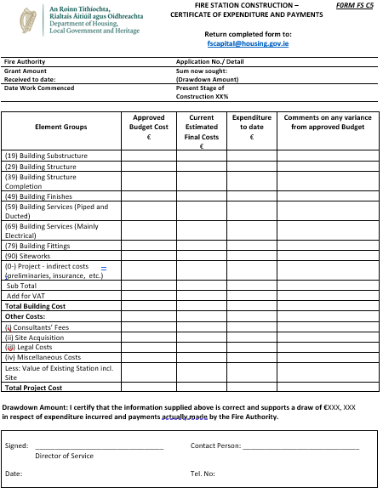

Appendix 1.6 FSC 6 Form - Final Account
(Page 1 / 12)
Appendix 1.6 FSC 6 - Final Account Form (Page 2 / 12)

Appendix 1.6 FSC 6 - Final Account Form (Page 3 / 12)

Appendix 1.6 FSC 6 - Final Account Form (Page 4 / 12)

Appendix 1.6 FSC 6 - Final Account Form (Page 5 / 12)

Appendix 1.6 FSC 6 - Final Account Form (Page 6 / 12)

Appendix 1.6 FSC 6 - Final Account Form (Page 7 / 12)

Appendix 1.6 FSC 6 - Final Account Form (Page 8 / 12)

Appendix 1.6 FSC 6 - Final Account Form (Page 9 / 12)

Appendix 1.6 FSC 6 - Final Account Form (Page 10 / 12)

Appendix 1.6 FSC 6 - Final Account Form (Page 11 / 12)

Appendix 1.6 FSC 6 - Final Account Form (Page 12 / 12)

Appendix 1.7 FSC 7 Fire Station Upgrading / Improvements Capital Grants Claim

Appendix 2 – Station Schematic Layout Templates
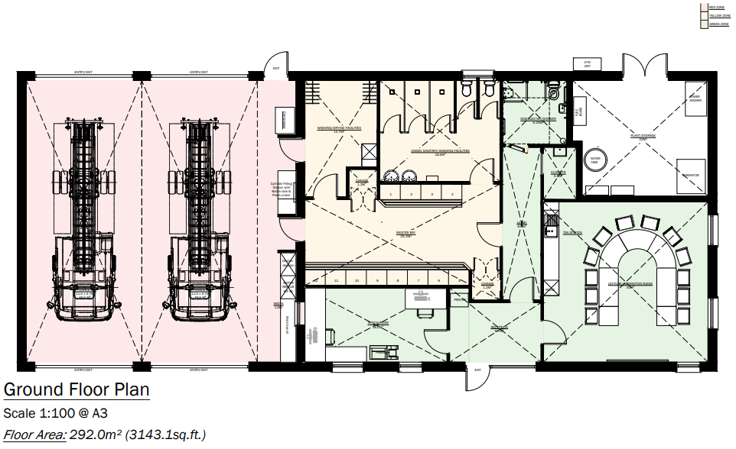
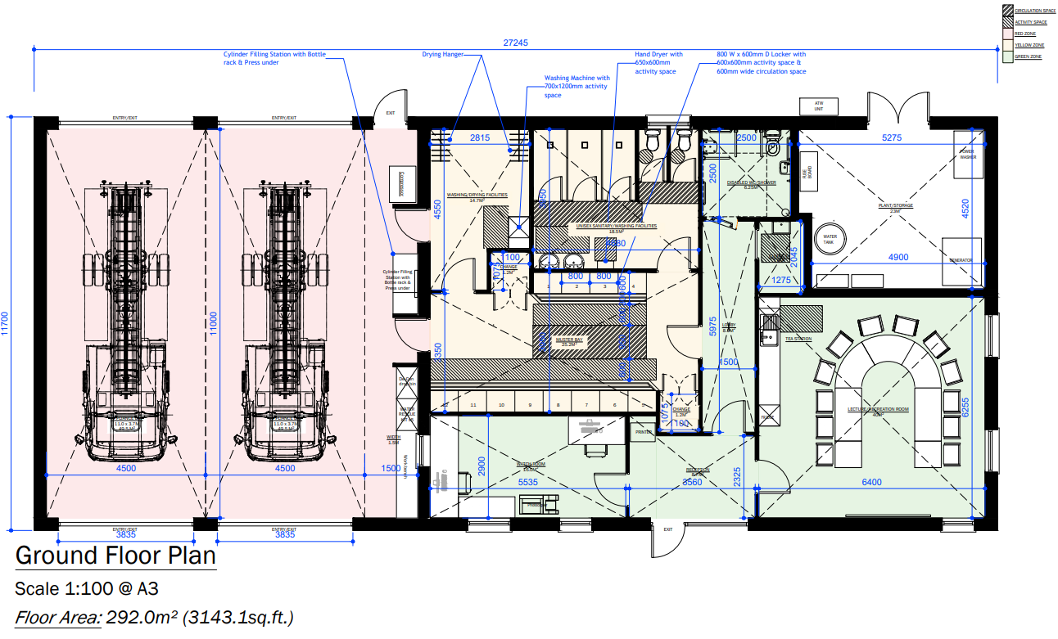
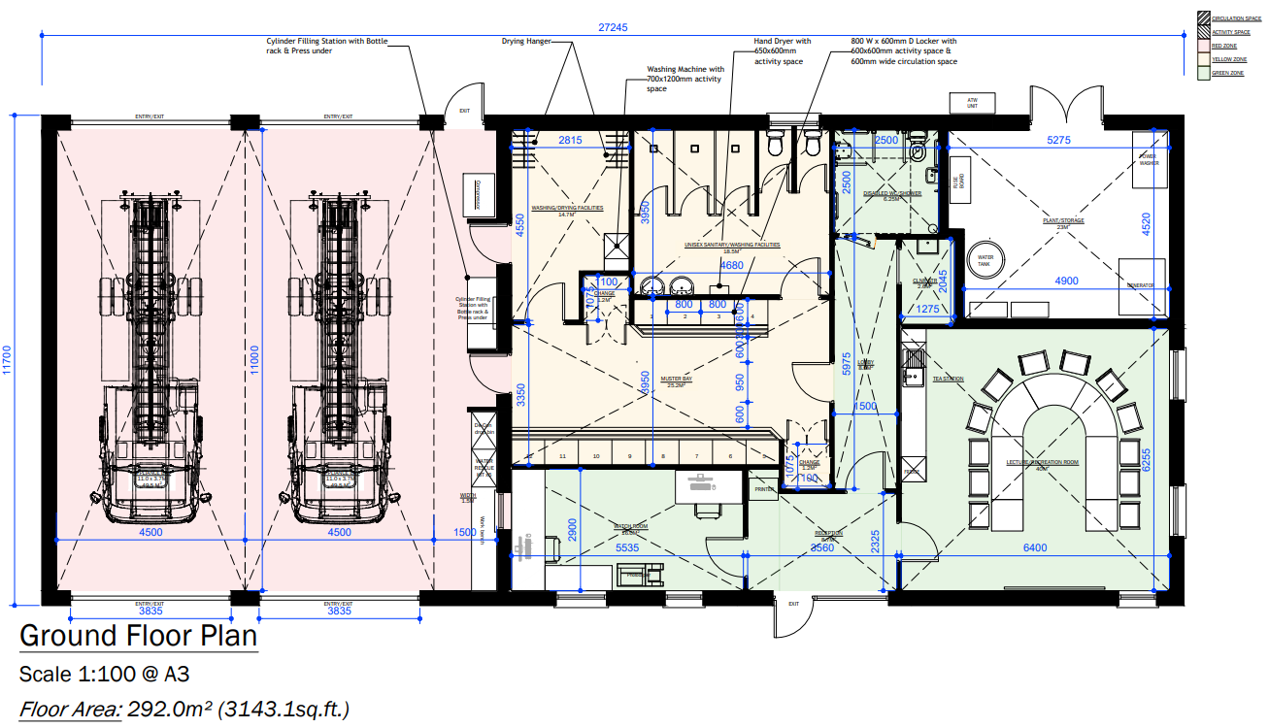
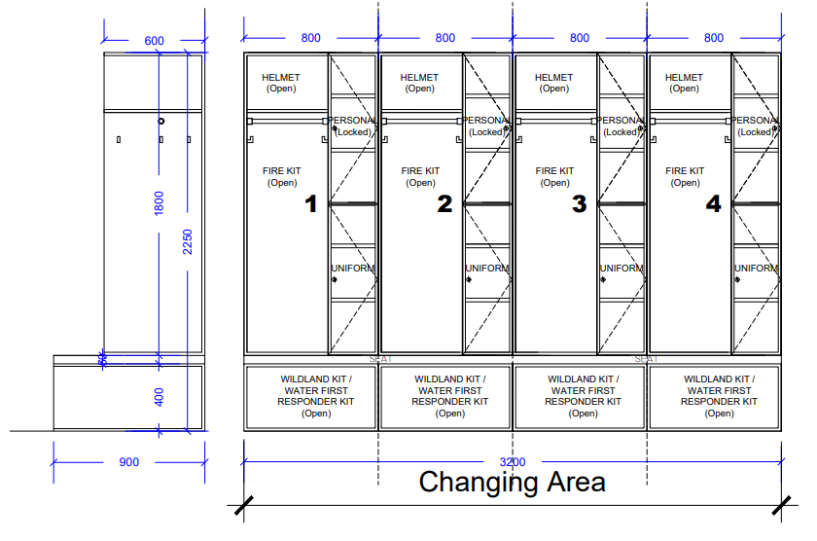

Appendix 3 – Fire Station Generators & Ancillary Equipment

A3.1 Introduction
The purpose of this appendix is to outline the considerations when procuring an emergency backup generator (skid) that will operate in the event of a power outage at a Fire Station and provide full load redundancy. In addition to the generator, it considers auto-changeover switching, design, supply, installation, cabling, containment and commissioning. This guidance relates to both new and existing fire stations. The following sections can be considered when preparing a request for tender document for a fire station generator. Note, it is expected that when procuring fire station generators, a Fire Authority would procure electrical engineering / contractor specialist services independently from the generator procurement.

A3.2 Generator Specification

A3.2.1 Electrical Requirements
An electrical engineer / contractor will complete a survey of the electrical requirements of a station (either new or existing). The engineer / contractor must specify which genset is most suitable for the station and size a generator for the full load operation of the site. The engineer / contractor shall be aware that the Genset to be supplied is intended for use primarily for emergencies only and will remain off for extended periods at this site; thus, a separate permanent power supply shall be provided for the battery charger, coolant heater, and anti-condensation heaters (where it is deemed these are required for a cold start).
Accordingly, the units are expected to have low operational usage and may have durations at low operational load. They will be situated in the plant room of new stations and externally in existing fire stations - connected directly to an auto changeover panel.
This specification will include the kVA and the phasing - single (230V) or three-phase (400V). Typically, generators for fire stations will be either 30kVA single-phase or 60kVA three-phase. Generators will be suitable for 50Hz and must be sized to match the incoming ESB supply.

A3.2.2 Location and Plinth Requirements
The generator will be located in the plant room in new fire stations. For existing fire stations, a concrete plinth will be required. The electrical engineer / contractor shall specify the size of the plinth required. The location shall be agreed with the Fire Services in advance. The generator location should allow access for refuelling, along with the provision of spill kits, and should be considerate of any noise implications for running the genset.
The generator shall be installed on anti-vibration mountings to suit the assembly to avoid transfer of any vibration internally on the skid to ancillary equipment or externally from the skid.

A3.2.3 Weatherproofing, Guarding and Acoustic Requirements
Generators that are being installed externally in existing fire stations without a suitable plantroom must be suitable for external conditions. A suitable lean-to structure, provided by the Fire Authority, shall prevent the generator from exposure to rain ingress that could cause damage to the generator or ancillary equipment.
The generator and ancillary equipment shall be located within an acoustic weatherproof canopy to achieve sound proofing of 75dB (A) at 7m to ISO 3744/3766/8528-10. Any further upgrade on acoustic requirements shall be agreed with the Fire Service prior to order. This enclosure shall be protected by a corrosion protection coating with a minimum of a C3 corrosion classification to ISO 12944 or equal and equivalent material to similar durability.
All moving or hot parts shall be guarded for operator safety. Guards shall be readily removable to allow inspection and maintenance. Signage should be included as required. Removable and hinged panels shall provide all the required access to ensure maintenance can be carried out.
The entire skid, including all equipment and pipework, shall be fully equipotential bonded back to the main site earth bar.

A3.2.4 Engine
A four-stroke, multi cylinder diesel compression-ignition, water-based coolant, engine rated in accordance with ISO 3046 shall form the basis of the skid. The complete generating set shall comply with ISO 8528 (Parts 1 and 5 as applicable). The fuel direct injection system shall have individual or centralised fuel pump(s) for the cylinders driven by the engine power.
The engine may be fitted with either a mechanical or electronic governor. The starting motor shall be supplied from heavy-duty 12/24 Volt lead-acid batteries. The battery set shall have sufficient capacity for at least five successive starts of the genset, without re-charging. The engine driven, self-regulating dynamo/alternator shall charge the batteries when the engine is running. The batteries shall be capable of being charged whilst the generator is off via a 230V auxiliary connection from the main distribution board.
The engine shall run on diesel oil with a specific gravity of 0.85 conforming to EN 590 (ULSD). Where diesel oil is described as BS 2869 Class A2, it shall also meet EN 590 quality.
Fuel shall be supplied from an integral fuel-oil storage tank located underneath the generator with a minimum fuel capacity to allow for a minimum of 7 hours run time at full load. The tank shall have a visual fuel level indicator.

A3.2.5 Fuel Tank
The fuel tank shall be a bunded (double-skinned) unit with leak-detection, which shall be wired to visual and audible alarms in the generator control panel. The tank shall be provided with a level sensor to relay fuel level back to the controller. The fuel tank shall be provided with a vent. All pipework & fittings from the tank to the engine should be completed by the Supplier. Valves should be provided to allow for isolation of the tank from the engine. Drain valves shall be allowed for to drain down the system and tank entirely.

A3.2.6 Cooling System
A cooling system (water-based with suitable antifreeze) shall be included that utilises radiator (air) cooling with an integral fan unit to dissipate the thermal energy at the maximum design ambient temperature. An integral engine-powered cooling pump shall circulate the cooling water within the engine. The system shall be provided with coolant fill & drain points. A coolant (water jacket) heater shall be allowed for on the coolant system (where required for a cold start), and this shall be powered from a 230V mains supply.

A3.2.7 Exhaust System
The generator shall be supplied with an integral exhaust system complete with all pipework, fittings, flexible connections, silencer to achieve the required noise reduction and a flue that terminates above the canopy of the skid. It should be suitably rated for the maximum temperatures that will be produced by the unit. The exhaust-silencers shall be mounted internally. The hot surfaces of the exhaust pipework shall be fitted with non-combustible insulated material to render it fully rust and corrosion proof, and for touch protection. The exhaust system shall be treated to render it rust and corrosion proof. The exhaust pipework shall be arranged such that condensation or rainwater cannot run back into the engine. A drain cock shall be fitted at the lowest point of the system for periodic drain down.

A3.2.8 Lubrication & Filters
Circulation of lubrication oil shall be by an engine-driven pump. A lubrication visual pressure gauge shall be fitted on the system and should also have a sensor for low oil pressure protection back to the control panel. Replaceable filters for the air intake, lubricating oil, and fuel oil systems must be readily available off the shelf.

A3.2.9 Alternator & Automatic Voltage Regulator
The alternator shall comply with EN 60034, ISO 8528-3 and EN/IEC 60034-1. The alternator shall be IP23, brushless, self-excited, salient pole with a rectifier. The alternator shall be capable of establishing full load at full stable voltage within a short duration. No Permanent Magnet Generator (PMG) /independent excitation is required.
The alternator winding insulation shall be Class H in accordance with EN 60085. The Supplier shall allow for sealed bearings suitable for heavy-duty and the operating temperatures. The alternator shall be equipped with a digital Automatic Voltage Regulator (AVR). Voltage performance shall comply with ISO 8528-5, Class G3. An anti-condensation thermostatic heater to allow for protection during long-term storage with a connection available to the mains 230V power supply shall be provided.

A3.2.10 Generator Control Panel
A control panel, with minimum enclosure protection IP54, shall be provided in a sheet-steel cubicle with hinged, key-lockable doors mounted within the skid enclosure. The control panel shall contain a backlit digital graphical HMI screen to allow control of the panel and to monitor the health of the system and all alarms. This shall also allow the user to carry out diagnostic checks on the panel. Navigation shall be via buttons on the digital display.
The control panel shall include all the necessary control equipment, including a genset controller with PLC logic for manual/automatic start-up, shutdown and alarms. An emergency button stop shall be located on the control panel and another shall be located externally to the enclosure on the skid to allow emergency stop of the generator. Both emergency stop buttons shall be hard-wired to the safety circuit.
The generator controller shall be able to accept a remote start from an auto changeover switch and declare the generator available when V/Hz are within limits. No mains–generator paralleling is required. The generator automatic transfer switch shall monitor the mains voltage and initiate automatic start up when a ‘power failure’ is detected on the ‘mains’ side of the switch.

A3.2.11 Identification & Rating Labels
CE compliance labelling in accordance with EU Directives shall be displayed on the generator. Rating plates to the relevant standards shall also be provided.

A3.3 Auto Changeover Switch & Panel
The Automatic Transfer Switch (ATS) shall consist of mechanically and electrically interlocked circuit-breakers with a break-before-make operation to prevent back feed to the ESB supply - note, that the generator will not be required to synchronise with the ESB supply. It will be linked to the main board (housed within a separate changeover panel or integrated into MDB). The ATS and the associated control and monitoring devices shall be housed in a sheet-steel cubicle-type free-standing IP42 enclosure with hinged, key-lockable doors. The busbars shall be solid copper and insulated. Cable connection plates and adequate glanding space shall be provided for the termination of the cables.
The automatic transfer system shall include the following minimum controls:
- Voltage sensing for all three phases of the normal supply;
- Time delay to override momentary mains outages;
- Restoration of the mains supply during the starting period shall not interrupt the generator starting sequence, but shall prevent operation of the load transfer;
- Time delay on re-transfer to mains supply, which shall be adjustable;
- An unloaded running time delay for generator cool down (adjustable) followed by automatic generator shutdown;
- LED lamps for Mains and Generator Operation and Mains Available; and
- Test Switch so it can be tested on an annual basis for maintenance.
- Design an Automatic Transfer Switch (ATS) that is linked to the main board (housed within a separate changeover panel or integrated into MDB). install & commission

A3.4 Cables & Containment
The electrical engineer / contractor shall survey the route between the auto changeover panel and the generator, and size the cable appropriately. Ancillary cables shall be provided to the generator for the batteries and the heaters.
Cables and containment shall be installed and tested in accordance with IS 10101:2020 National Rules for Electrical Installations. Cables shall be correctly sized based on the distance and loading of the generator. Auxiliary cables are required to be permanently fed from the Main Distribution Board for battery charging and the ancillary heaters. All main cables shall be XLPE/SWA/PVC LSZH & CPC.
The supplier shall install a system of medium-duty, galvanised steel cable tray and ladder (where appropriate) in accordance with IS EN 61537:2007 to distribute all cabling. All cable containment shall be bonded.
The generator skid and the automatic-transfer-switch panel shall be individually connected to the local earthing busbars. All cables shall be labelled for identification.

A3.5 Commissioning
After delivery and installation, the generator and ancillary equipment shall be fully commissioned and ready for use by the fire authority. The supplier shall provide a complete set of handover documentation, including:
- Full Operations & Maintenance (O&M) file for the genset skid (including factory Acceptance Tests);
- Schedule of Spares Required;
- As Installed Cable Schedules & Wiring Diagrams for the installation;
- Testing and Commissioning Certificates; and
- Contact Details for all personnel.
All documents shall also be handed over in electronic format.

A3.6 Training
The supplier shall allow for full training on-site for 6 personnel on the operation and maintenance of the generator and ancillary equipment, and the annual testing required.

A3.7 Warranty
A minimum 12-month warranty shall be provided with the generator and all ancillary equipment from the date the generator is commissioned.

A3.8 Standards and Codes
The installation and commissioning shall be in accordance with the most recent edition of the following standards and codes: -
- I.S. 10101:2020 National Rules for Electrical Installations (Ireland)
- Harmonised European Standards
- IEC Publications
- Machinery Directive 2006/42/EC
- EMC Directive 2014/30/EU
- Low Voltage Directive 2014/35/EU
- Outdoor Noise Directive 2000/14/EC
- Radio Equipment Directive 2014/53/EU
- Trailers Regulation (EU) 2018/858
- ISO 8528 Reciprocating internal combustion engine-driven alternating current generating sets
- ISO 3046 Reciprocating internal combustion engines — Performance
- EN/IEC 61439 Low-voltage Switchgear and Control Gear Assemblies
- EN/IEC 60204-1 Safety of machinery - Electrical equipment of machines
- EN/IEC 60034 Rotating electrical machines
- EN/IEC 60085 Electrical Insulation - Thermal evaluation and designation
- EN/IEC 60309-1/-2 Industrial plugs, socket-outlets & couplers
- BS EN
- ISO 3744 / ISO 3746 Sound power/pressure test methods
- BS 5000 Vibration resistance of generators, together with their exciters, to be driven by reciprocating internal combustion (RIC) engines

The above list is not exhaustive, and the Supplier must comply with all relevant Irish & EU regulations. The Supplier shall furnish copies of internationally recognised test certificates covering the equipment, as specified herein, as part of the handover package. The generator shall comply with EU Directives and be CE marked and labelled. An EU declaration of conformity (DoC) shall be provided as part of the handover pack.



gov.ie/housing
The Department of
Housing, Local Government and Heritage

