

National Orthopaedic Hospital Cappagh

Works Requirements

NOHC Energy Improvement Works

AC Replacement Programme

Deadline:
Proposals should be submitted via E-Tenders portal as per instruction with the Tender documents.

COMPETITIVE QUOTE PROCESS – AC Replacement Programme for NOHC

Project | NOHC Energy Improvements works – AC Replacement Programme
Prepared By | MH | Date Prepared | May 2026
Lead (s) | MH/SR
1.0 Site Location

The National Orthopaedic Hospital Cappagh (“NOHC” or the “Hospital”) is located in west Finglas in Dublin 11. The Hospital benefits from being strategically positioned in close proximity to a comprehensive network of motorways, national primary routes, and well managed regional roads. Being positioned just 400 metres inside the M50 Motorway facilitates easy connection to the City Centre, Greater Dublin, and the rest of Ireland.
The Hospital campus is located adjacent to the Cappagh Road and immediately south of the M50 Motorway. Please see Figure 1.1 below. The Cappagh Road crosses over the M50 to the northwest of the site. The site is within the Fingal County Council administrative area and close to the boundary of the Dublin City Council administrative area.
The site overlooks the closed and capped Dunsink landfill site to the southwest. Residential properties (of 2 to 3 storey) exist at the southeast boundary of the site. A Residential Traveller Accommodation site is located to the northwest of the site close to the M50.

The existing Elective Hospital provides a full range of Orthopaedic Services, with 159 beds, 6 surgical theatres, advanced diagnostic facilities, a High Dependency Unit, a Central Decontamination Unit, an Outpatients Department, and ancillary supporting infrastructure.

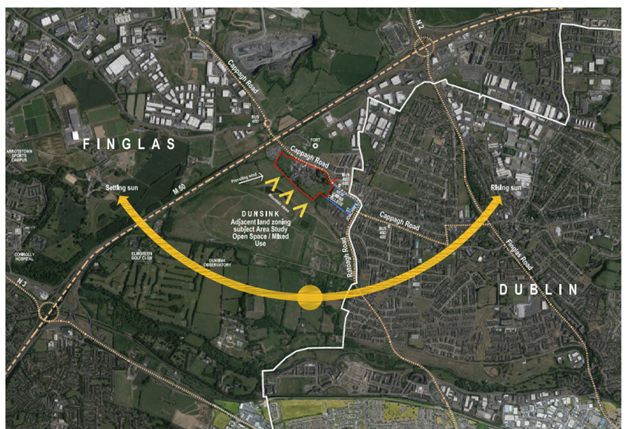

Fig 1.1 shows the location of the NOHC Campus (Highlighted by Red Boundary) in relation to the M50, N2 and N3.

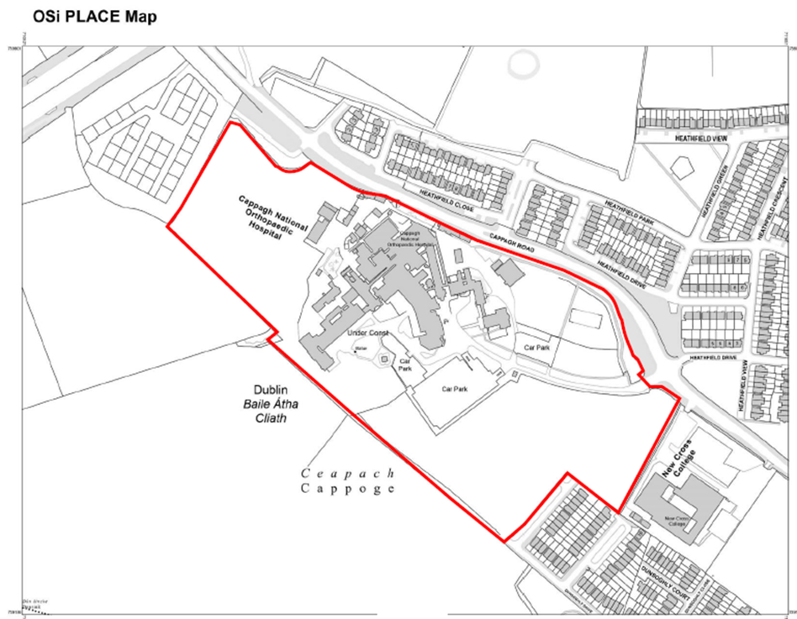

Fig 1.2 shows the existing NOHC Campus and its landownership boundary in Red.

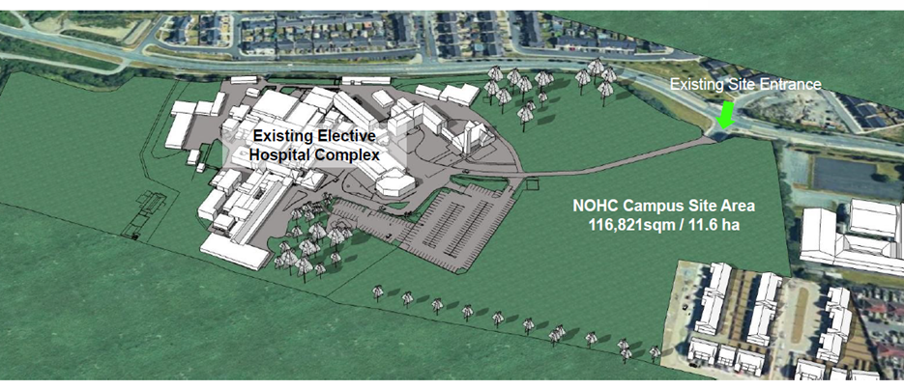

Fig 1.3 shows a Rendered 3D Model of the existing NOHC Campus.

2.0 Design Development

NOHC has a long tradition of providing quality care since its establishment in 1908, consistently ranking in the top hospitals nationally in HIQA’s National Patient Experience Survey. The Hospital’s existing elective care system is a paragon of efficiency and highly flexible in response to increased demand. The Hospital’s activity has grown substantially over the past five years. The Hospital has huge potential for further expansion and sits on an 11.6-hectare site. As illustrated in Figure 1.2 and 1.3 above, most of this landholding is undeveloped.
There is a need to address deficits in the Hospital’s infrastructure in order to support and sustain this growth in activity, to provide a better patient experience, and to improve the working environment for staff.

NOHC Facilities Dept have identified an opportunity to install new Energy Efficient and appropriately sized AC systems across the hospital to assist us on our decarbonisation journey with a view to achieving our 2030 Climate Action Targets.

A number of the existing AC units are end of life, inefficient, poorly programmed or incorrectly sized. There are also units containing R22 or R401A gas which need to be decommissioned and removed.

The appointed contractor shall supply, install and commission new energy efficient units in accordance with the asset list supplied within this Tender. The installation works will include any builders work required, any additional mounting frames, brackets, panels, fixings etc. as well as all wiring, electrical protection, containment and isolators.

The scope of the Project as described in all documents and drawings forming part of the Contract Conditions, Working Requirements, Drawings and Specifications is for the replacement of existing AC units with new high efficiency units. The works listed below and shall include all associated builders works, attendances and making good as required.

A total of 38 AC units are required to be replaced. The AC asset register for the site and requirements are broken down as follows (refer to the enclosed Asset Survey spreadsheet for more detail):
- 35 nr. AC units across the whole hospital campus are end of life – to be replaced
- 3 nr. AC units are undersized – to be reviewed by the Contractor
Note: This list above is subject to addition or omission throughout the Contract at the decision of NOHC.
The Contractor shall be responsible for all site works which shall include for safe and clean installation and handover of the Works. Pre tender site visit is mandatory and the Contractor is wholly responsible for all measurements and calculations. The Contractor shall liaise with NOHC Facilities Dept regarding freeing up work spaces to carry out the works. This will be agreed with NOHC on a room-by-room basis in advance of any work commencing. Permits for Infection Control Prevention may be required in advance of the works subject to a review of RAMS submitted by the Contractor.

The Contract used for this project is the Public Works Short Form of Contract PW-CF6.

Note: The Contractor must be a specialist mechanical/electrical contractor who specialises in installations of a similar nature.

3.0 Description of Works

In general, the Works will consist of but not limited to the following:
- The Contractor shall allow for a site manager on site for the duration of the works
- Initial Survey to ensure AC units as per Volume C - Pricing Schedule are appropriately sized for each associated space. Before starting work the Contractor shall take site dimensions, record on shop drawings, and use to ensure accurate installation.
- Preconstruction Asbestos RDAS Survey: Before starting work, the Contractor must complete the survey to ensure there is no risk of asbestos in each location. (refer to site asbestos register as a starting point).
- The Contractor must allow for all internal & external builders works and allow for making good of each location.
- Strip out of existing AC units including removal and safe disposal of each unit in accordance with EPA guidelines. The contractor shall pay particular attention to units containing potent greenhouse gases including R22 and R410A.
- Strip out, removal and disposal of ancillary items including controllers, any redundant cabling, containment etc.
- All enabling / builders works required.
- Install necessary brackets and supports and fixings (as required).
- Installation of new AC units in agreed locations with NOHC.
- Install pipework (as required).
- Pressure Testing of all pipework.
- Installation of all electrical containment, protective devices, isolators and cabling.
- Commissioning of new AC units and control systems.
- Making good of each work space.
- Demonstration and Training to NOHC maintenance team on the AC control systems.
- Measurement and Verification of energy use and energy savings post installation.
- Submission of all drawings, installation as builts, certification, O&M’s and Safety File.
- Provide after sales service SLA / maintenance requirements and warranty information as per template provided.

The Contractor shall provide a price for each AC unit (supply, install, commission) as well as separate price per unit for bracketry and fixings, and a separate price for pipework. It may be possible to reuse existing supports and pipework depending on condition / suitability.

3.1 Key Development Requirements

Key requirements include the following:
- The Energy Improvement works must be carried out in accordance with current Health & Safety Regulatory requirements.
- AC systems shall comply with HTM 03-01 as applicable.
- The works are being undertaken within a live hospital, which will remain open through-out the works. The tenderer/contractor must plan the works to ensure the works do not impact the operation of the hospital activity. The tenderer/contractor must provide a detailed programme detailing how they will mitigate the impact on NOHC users during the works.
- The specialist manufacturer must provide shop drawings and details which meet the performance criteria set out in the drawings and specification and must be compliant with the Irish Building Regulations.
- All works must be compliant with current Building Regulations including Technical Guidance Document F – Ventilation.
- AC systems shall comply with the Energy Efficiency Directive (2012/27/EU), I.S. 399:2021 Energy Efficient Design (EED) Standard, S.I. No. 376 Energy Performance of Buildings Regulations 2022, EU Motor Directive 2006/40/EC F-Gas Regulation (517/2014), Energy Labelling Regulation (2017/1369) and Building Automation and Control Systems Regulations (BACS). Compliance with IEC 60335-2-40:2024 CMV is also required.
- Where applicable, the Contractor shall use the SEAI Tripple E register for selection of equipment.
- Completed installations shall comply with I.S.10101 National Rules for Electrical Installations including latest amendments.
Note: NOHC shall provide a storage area for all new units that are delivered to site

3.2 Design and Quality
- The works must be compliant with current Irish Building Regulations Standards and HBN 00-03 technical documents for clinical areas, ISO standards and relevant local authority & utilities provider technical guidance standards. The Health Technical Memorandum sets out recommendations and guidance for the management of fire safety in healthcare buildings.
3.3 Construction Constraints

There are a number of constraints, including:
- When undertaking Energy Improvement works in each works location (area), these works must be agreed with NOHC Site Representative – Electrical Project Manager, Shane Robinson.
- Detailed RAMS shall be submitted by the Contractor. Works shall be subject to IPC and Electrical permits and potentially other permits (Work at height, general) issued by NOHC, subject to RAMS review.
- The proposed works will take place on the site of a busy ‘live’ hospital. Noise and vibration will have to be carefully managed by the successful tenderer/contractor and in accordance with best practice. Clinical activities in adjacent / surrounding buildings cannot be interrupted. It is paramount that the works are planned and orchestrated to protect the continuation of existing Hospital activities in a safe manner. Access to all office’s, clinic areas etc. to facilitate the works may not be permitted at once. It will be on a room-by-room basis. NOHC Clinics and operations will remain live with patient activity during the works. The tenderer must provide a detailed programme of works providing a sequence of access required to undertake the AC installations.
- The client will not accept any liability for not providing access into the rooms to facilitate works without a detailed programme from the tenderer. The programme must be completed in Microsoft Programme or similar construction programme software package. Patients/staff access routes & areas must remain in use during the construction works. Works to be undertaken in a phased basis as agreed with Employers Representative.
- The tenderer will need to familiarise themselves with the requirements set out in the HSE’s ‘Procedure for Control of Aspergillosis during the Energy Improvement works. In advance of undertaking construction works, the tenderer must provide details how they intend to segregate access into construction work site and implement measures to mitigate construction dust entering a live hospital & clinic’s environment. Execute work by methods to minimise dust generation from construction or renovation activities.
- NOHC maintain an asbestos register for the site. The Contractor shall familiarise themselves with this to ensure any risk of asbestos is mitigated. The Contractor shall also carry out an independent RDAS survey to ensure any risk of asbestos is mitigated in advance of commencing the works.
- On completion of the works, the tenderer must provide handover documentation and associated as built drawing information (in digital format) to the NOHC representative.
- Records shall be included in the Project O&M Manuals and Safety File documentation.

- All Tenderer’s/Contractor’s must attend the mandatory site visit that will be held on Tuesday 23 June 2026

Project Supervisor Construction Stage (PSCS)
- On successful completion of the PSCS Competency assessment the Contractor will be appointed as PSCS or any successor duly appointed by the Employer as the PSCS pursuant to the Safety Health and Welfare at Work (Construction) Regulations 2013.

- Co-ordinate the implementation of the construction regulations by contractors;
- Organise co-operation between contractors and the provision of information;
- Co-ordinate the reporting of accidents to the Authority;
- Notify the Authority before construction commences where construction is likely to take more than
- 500 person days or 30 working days;
- Provide information to the site safety representative;
- Co-ordinate the checking of safe working procedures;
- Co-ordinate measures to restrict entry on to the site;
- Co-ordinate the provision and maintenance of welfare facilities;
- Co-ordinate arrangements to ensure that craft, general construction workers, and security workers
have a Safety Awareness card, e.g. Safe Pass and a Construction Skills card where required;
- Co-ordinate the appointment of a site safety representative where there are more than 20 persons
on site;
- Appoint a safety adviser where there are more than 100 on site;
- Provide all necessary safety file information to the PSDP;
- Monitor the compliance of contractors and others and take corrective action where necessary;
- Notify the Authority and the client of non-compliance with any written directions issued;
- The PSCS may issue directions to designers or contractors.
Waste Management Plan
On appointment, the Contractor shall provide a waste management plan in accordance with the Waste Management Act 1996, supplemented by EU directives and national regulations as well as EPA guidelines, to incorporate how they propose to dispose of AC units containing potent greenhouse gases as well as all other waste disposal.

Tender Submission
The Contractor shall provide the following additional information with their Tender Submission:
- Project Programme (Microsoft Project Ghant (A3) style
- 3 Previous Project examples in a healthcare environment of a similar nature incl references
- Equipment Proposals including data sheets and specifications demonstrating compliance with the standards outlined herein, as well as high energy efficiency.
- Green Procurement Strategy – refer to enclosed document (EPA_GPP_Criteria_Energy_2022_03)
- Company Turnover – previous 3 years

4.0 General Design Parameters

The works define shall take account of the standards/requirements of the relevant and applicable Health Building Notes (in particular, HBN-23) and Health Technical Memoranda (HTM) guidance.
Health Building Notes were developed by the NHS in the UK and give “best practice” guidance on the design and planning of new healthcare buildings and on the adaptation/extension of existing facilities. These Health Building Notes can be found via the link below:

https://www.england.nhs.uk/estates/health-building-notes/

Health Technical Memoranda were developed by the NHS in the UK and give comprehensive advice and guidance on the design, installation and operation of specialised building and engineering technology used in the delivery of healthcare (for example medical gas pipeline systems, and ventilation systems). They are applicable to new and existing sites, and are for use at various stages during the inception, design, construction, refurbishment, and maintenance of a building. These Health Technical Memoranda can be found via the link below:

https://www.england.nhs.uk/estates/health-technical-memoranda/

ISO EN Standards.

ISO Standards are about making a product, managing a process, delivering a service, or supplying materials – standards cover a huge range of activities.

ISO EN Standards – ISO EN 14901, ISO 391-2020,

British Standards/Euro Codes.

British Standards (BS) are the standards produced by the BSI Group which is incorporated under a royal charter and which is formally designated as the national standards body (NSB) for the UK. The BSI Group produces British Standards under the authority of the charter, which lays down as one of the BSI's objectives to:

Set up standards of quality for goods and services, and prepare and promote the general adoption of British Standards and schedules in connection therewith and from time to time to revise, alter, and amend such standards and schedules as experience and circumstances require.

British Standard 7413/BSEN 12608:2003.

Other design documents may be considered by the appointed Consultant in the preparation of the report on findings and recommendations to compile with current standards.

4.1 Engineering Requirements

This section of the Project Brief gives a high-level view of the engineering requirements for the proposed development. Its purpose is not to inhibit the design solution but to communicate some of the key functional requirements expected. Please note that the following is not an exhaustive list of requirements.

Item | Comments
Building Materials | All building materials that are used in the window Replacement works must comply with current standards.
Environmental Aspects | The works on the AC replacement works shall be formulated in the light of the requirements of current legislation and statutory requirements, including the Waste Management Act 1996 and associated Regulations, requirements of the Environmental Protection Agency and Fingal County Council.  The generation, management, packaging, handling and disposal of solid waste shall be in accordance with the Hospital’s existing operational polices.  Systems dealing with wastes to be discharged to sewer shall comply with local authority requirements and be developed in consultation with the Hospital and the Fingal County Council’s environmental services department. All discharges to the atmosphere shall comply with statutory requirements and established codes of practice to minimise their negative impact on the environment.
Maintenance | The engineering services shall be designed and installed to ensure ease of routine inspection and maintenance and the minimum interruption of services while maintenance works are being carried out.  The design should, as far as possible, minimise the need for routine maintenance. However, where future maintenance needs can be reasonably foreseen, safe access and working space must be carefully considered and provided at the design stage.

4.2 Contact Details

NOHC Site Representative for the Project.

- Electrical Project Manager – Shane Robinson – Electrical Project Manager for the works.
- PSDP – Ashview Consultants.
- PSCS – Main Contractor.

4.3 Cancellation of Works.

The works are being funded by HSE Capital and Estates Energy Bureau; the amount of works will be determined depending if the value of works does not exceed the funds allocated from HSE Capital and Estates 2025 Funding allocation. The Employer may need to cancel some areas of the propose Energy improvements works due to funding constraints, the cancellation of these works ares will be determined on receipt of returning tenders.

Ref: | Form of Submission Required
Volume A – Works Requirements | Project Brief  Drawings
Volume B - Form of Tender and Schedule | Tenderers must complete the Form of Tender (in ink) by inserting the date, lump sum amount tendered, signed, and witnessed
Volume C – Pricing Document | Tenderers must complete (in ink) the Pricing Document in full inclusive of both the mechanical and electrical appendices.
Volume D – Supporting Documentation | H&S Compliance Declaration by PSCS
Additional Information | Project Programme (Ghant A3), 3 Project Examples of similar nature showing healthcare experience including references, Company Turnover for previous 3 years, Green Procurement Strategy, Equipment Proposals.

Performance Periods and Stages
STAGE: | STAGE DECRIPTION: | DURATION: | REQUIRED:
1 | Tendering Period and return date Issue. | 20 days | YES
2 | Evaluation and Award of Tender | 5 days | Yes
3 | Commencement date. | July 2026 | YES
4 | Works Completion | September 2026 | YES

