TECHNOLOGICAL UNIVERSITY OF THE SHANNON - MIDLANDS MIDWEST (TUS)

Athlone Campus

RFT for the supply of electrical materials to the TUS - Athlone campus

Appendix 1 Requirements and Specification
Document ref; 25-010-01-PD-Appendix 1-na

December 2025

Table of Contents
1.0 Standards
2.0 Materials
3.0 Warranties
4.0 Returns
5.0 Equipment- General
6.0 Equipment- Lighting
7.0 Equipment- Cables
8.0 Delivery to Site
9.0 Non-Schedule Material

1.0 | Standards
1.1 | All goods, products and materials shall be in accordance with the latest revision of Irish and EU Standards. All installations shall be in accordance with latest Electro Technical Council of Ireland and Department of the Environment Building Regulations and Technical Guidance Documents.
1.2 | All devices and components shall be compliant with the following and shall bare the CE mark of conformity. Any devices found to be non-compliant shall be replaced at the contractor’s expense.  -European Union (EU)  -EMC Directive 89/336/EEC  -Electromagnetic Compatibility Requirements - CENELEC
1.3 | All components and materials supplied, shall comply with the latest codes of practice and any other legal requirements applicable to any element of materials, equipment and services provided under this contract, even if an applicable code or legal requirement is not specifically referenced in the contract documents.
1.4 | The Contract for supply of electrical materials, consumables and equipment includes for the supply and delivery. Note delivery shall be expected to be weekly, as AIT will not retain any large stocks of materials on-site.
2.0 | Materials
2.1 All products, materials and equipment shall comply with referenced standards and all applicable regulatory requirements.
2.2 Similar items of equipment and individual materials shall be selected from one manufacturer’s range to standardise appearance, maintenance and replacement.
2.3 Unless otherwise indicated, standard manufacturer’s finishes and colours are to be provided.
2.4 All materials, products and equipment are to be transported, handled, lifted, hoisted and stored in accordance with the manufacturer’s guidelines to prevent damage to equipment and injury to persons.
2.5 The manufacturer’s installation recommendations shall be followed and adhered to in full including any requirements for additional or ancillary components not explicitly specified but recommended to complete the installations, ensuring suitability for purpose. In this regard the supplier will be expected to include all necessary components that may be required to complete the installation, unless otherwise expressly notified by AIT that such ancillary components are not required in a particular instance.

3.0 | Warranties
3.1 | All products and materials supplied under this contract shall be expected to be provided with a comprehensive manufacturer supported warranty, to provide full replacement of any defective product within the following time periods;  - Electrical Accessories (sockets, switches, fused connection units etc) – min 10 years  - General Lighting Luminaires – min 5 years  - Emergency Lighting Luminaires – min 3 years
3.2 | The term defect in shall be interpreted as: 'any item of plant, equipment or component thereof, accessory or fitting that shall be found defective, show signs of mechanical or electrical weakness or undue wear in consequence of faulty design, workmanship or material'.
3.3 | In the event of the supplier refusing to rectify such defects within a reasonable period, any charges arising there from, shall be at the expense of the supplier and deducted from retention monies.
4.0 | Returns
4.1 | The supply contract shall include a “returns policy”, whereby materials not used, or ordered incorrectly shall be returnable by TUS -Athlone estates dept, with full credit of costs applied to the account.
4.2 | Only in instances where specialist, or non-standard components or equipment has been returned shall a re-stocking charge be accepted. Re-stocking charges shall not exceed 20% of the value of the goods.
5.0 | Equipment- General

5.1 Ladder Rack
Ladder rack shall have a load capacity of 600kg/linear metre when supported at 2500mm centres. Ladder Rack shall be hot-dipped, galvanized steel per BS 729. Standard fittings are to be provided for slopes bends etc.
Ladder rack shall be supported on proprietary support systems at 1000mm centres.

5.2 Cable Tray
Cable Tray shall be in accordance with IEC61084 BS 61537 :2007
Cable Tray shall be heavy-duty, hot-dipped, galvanized steel with perforated tray base suitable for fixing cables. Heavy duty gauge with returned flanges to BS 61537:2007 shall be utilised.
Constructed from mild steel and hot dipped galvanised to BS EN 10346:2009 For external installations cable tray shall be post galvanised BS EN ISO 1461:1999
Cable Tray shall have return flange at side tops for maximum strength.
Provide proprietary fittings bends, tees, crossovers, reducers and risers to fit.

5.3 Cable Trunking
Cable Trunking shall be in accordance with IEC61084. EN 50085-1 , EN10346
Interior trunking shall galvanised sheet steel per EN 50085-2-1:2006+A1:2011, EN 500851:2005+A1:2013.
Trunking shall be manufactured from heavy gauge, hot-dipped galvanised sheet steel per EN10346
All accessories - including lids, couplings, offsets, elbows, expansion joints, adapters, end caps, attachment assemblies, hold down straps and suspension brackets shall be provided to form a complete system. The complete system shall be selected from manufacturer’s standard components.

5.4 Cable Basket

The entire steel wire cable tray system shall be hot dipped galvanised steel with 60 – 80 microns of zinc. All welds shall be manufactured to a tensile strength of 700kg per weld.

5.5 Conduit and fittings shall be in accordance with IEC 61038
Conduit shall be Heavy gauge, seem welded, Class 4, hot-dipped galvanised steel, zinccoated screw threads and zinc bichromate outer coating to comply with BS 4568.
Fittings shall be threaded, zinc-coated malleable iron or steel.
Expansion couplings for rigid steel conduit shall have earth jumper or internal bonding assembly.
Rigid steel conduit and fixings shall be corrosion-resistant and must not be in contact with dissimilar metals likely to set up electrolytic action.
All fittings shall conform to BS4568.

5.6 General Services

5.6.1 General Services socket outlets shall conform to BS 1363. Pt 2

5.6.2 Connection units shall conform to BS 1363. Pt 4

5.6.3 General power socket outlets (PVC) shall be switched of 13 Amp rating, to BS 1363, and suitable for flush mounting. Outlets shall be high gloss thermoset material with inherent antimicrobial properties. Outlets shall be resistant to chemical spills or tarnish. Outlets shall be as MK Logic Plus range or equal and approved.

5.6.4 General Service socket outlets (metal) generally shall be twin outlet switched with neon indication and of 13 Amp rating, to BS 1363, and suitable for surface or flush mounting and shall be as MK MCO Metalclad range or equal and approved.

5.6.5 Connection units shall be switched or un-switched as may be required. All devices shall be in accordance with BS 1363 and fused in accordance with BS 1362. All connection Units shall be complete with neon indication. Connection units shall be selected from the same manufacturers range as other electrical accessories.

5.6.6 Connection units to commercial / industrial portable devices shall be 16A SP&N and 32A TP&N shall be IP44 rated, angled type, suitable for surface mounting. All devices shall be in accordance with BS EN 60309.

5.6.7 Light switches shall be 20 Amp, inductively rated grid switch type as MK Metal clad range or equal and approved. Light switches where indicated as external or weatherproof shall be IP54 surface mounted as MK Master Seal or equal and approved. Switches are to surface mounted, MCO finish.

5.6.8 Mains rated PIR’s shall be capable of switching the circuit load. Mains rated PIR’s are to be suitable for recessed or surface mounting as appropriate and shall have a minimum range of 6 meters.

The PIR’s shall be multisensory ultrasonic with the ability to hold the lights off in effective ambient conditions. PIRs shall have an inbuilt time delay adjustable to suit the zone.

Mains PIR’s shall have a maximum power consumption of 2 Watts per device.

All Mains PIR’s shall have a minimum 3 years manufacturer’s warranty.

5.6.9 PVC dado trunking shall be of pure white 3 – compartment type;
170mm (H) x 57mm (D) as, MK -Prestige or equal and approved. The dado trunking system shall provide correct segregation and space for CAT 6 cable standards. The dado trunking shall be supplied complete with proprietary tee’s bends and connection pieces with internal flanges to joints to provide a smooth finish to avoid dust traps and simplify cleaning. Outlets shall be disguisable from the dado with the use of charcoal straight covers behind devices.

05.6.10 Handryer type one shall be of the air blade type [ dyson hu02n or better]
Type two shall be straight down blower [ act panther or better]
The maximum dry time shall be 12 to 15 seconds.
The hand dryer shall have a minimum 5 year manufacturer’s warranty.
It shall be vandal proof and of an anti tamper design

6.0 | Equipment- Lighting
6.1 Luminaire manufacturers shall be as indicated on the Luminaire Schedule contained within this specification. Luminaires listed have been selected on the basis of technical and aesthetic performance. Substitutions or alterations to any of the luminaries listed shall only be permitted on an equal or approved basis.
6.2 The supplier should note the criteria for offering alternative luminaires are as follows:
- Proof of Optical performance i.e. light distribution, glare control etc.
- Physical dimensions of alternate luminaires i.e. cut-out size, trim/flange detail, finish and quality.
- Construction material of alternate luminaires i.e. Extruded aluminium, pressed steel, Die cast etc.
- Details of lamp i.e. lumen output, colour temperature, lamp life.
- Control gear/transformer specification must be electronic and compatible with dimming sensors.

Ref | Description | Output | Illustration
A | An IP65 rated LED luminaire for high quality low energy lighting in wet, dusty environments. High quality opal polycarbonate (UV stabilised) diffuser ensures uniform lighting without visible spots. High efficacy, up to 60% energy saving compared with T8 fluorescent. Body: polycarbonate Diffuser: opal polycarbonate (UV stabilised)  Brackets: stainless steel  Weight: 1.95 kg  Colour temp; 4000  Kelvin  Length; circa 1500mm  Type used on site; Thorn Julie (or similar or equal approved) | Luminaire input power: 60  W Power factor = 0.9  Luminaire luminous flux:  6000 lm  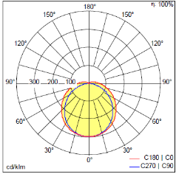 | 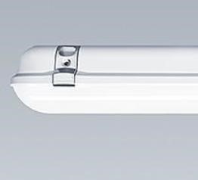
B | Recessed flat panel LEDs Replacement for conventional 4x18W or 4x14W fluorescent lamps  luminaires  For use in recessed  ceiling with grid system 600x600  Slim aluminum housing  (circa 10.5mm) | Input voltage 230v  Nominal 30 Watt LED  Colour temp; 4000K | 

 | Polystyrene diffuser (PS)  IP20 rated  Lifetime (L70/B50):  50000h  5-years guarantee required  Certification: CE, CB,  TUEV SUED  Type used on site; Osram Ledvance (or similar or equal approved) |  | 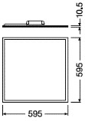
C | Recessed flat panel LEDs Replacement for conventional 4x18W or 4x14W fluorescent lamps  luminaires  For use in recessed  ceiling with grid system 600x600  Slim aluminum housing  (circa 10.5mm)  Polystyrene diffuser (PS)  IP20 rated  Lifetime (L70/B50):  50000h  5-years guarantee required  Certification: CE, CB,  TUEV SUED  Type used on site; Osram Ledvance (or similar or equal approved) | Input voltage 230v  Nominal 30 Watt LED  Colour temp; 3000K |   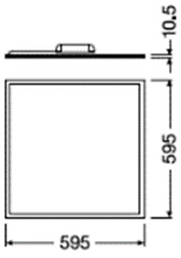
D | A high performance, surface mounted, LED luminaire. Electronic, DALI dimmable control gear. Class I electrical, IP44. Body: white painted steel. End caps: white Polycarbonate (PC) with a curved, precision extruded clear prismatic Polycarbonate (PC) diffuser. | 64W LED 4650 lumens  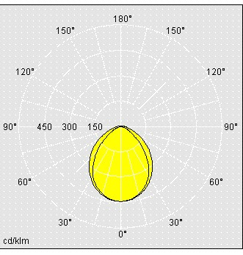 | 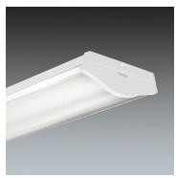
F | Wall Mount , surface circular luminaire for 1200lm LED, 9W with polycarbonate body, ‘flat’ opal and prismatic diffuser with attachments in colour mounted on to an injection moulded polycarbonate body with lamp, electronic and integral emergency gear A compact, round bulkhead luminaire with 1200lm LED package. | Luminaire luminous flux*:1200 lm  Luminaire efficacy*:77 lm/W  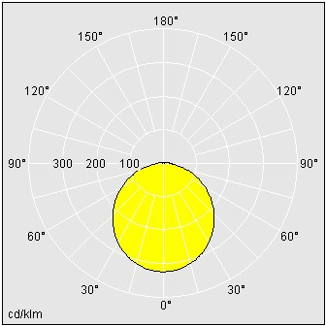 | 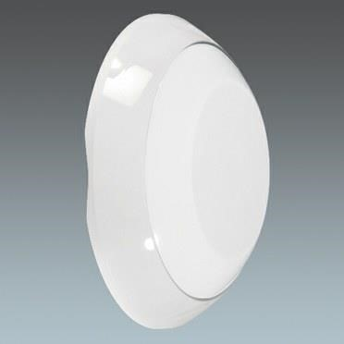

Electronic, fixed output control gear with 3 hour, manual test, emergency lighting circuit. Base: die-cast Aluminium.
Diffuser: opal
Polycarbonate (PC). Bezel: white
Polycarbonate (PC).
Class I electrical, IP65

Type used on site; Robus 10w and 15W (or similar or equal approved)
Em-1 | Semi- Recessed discreet interior escape route and open plan emergency luminaire for selfcontained nonmaintained operation with LED luminaire. Luminaire to be constructed of Flame retardant ABS body to provide a degree of protection of IP20. LED’s to be long life CREE LEDs as standard. Luminaire batteries shall be high temperature NiCd or Ni-Mh to give a duration of 3 hours in emergency mode . Dali Control required for incorporation on  addressable emergency  lighting test systems Also required to be available in surface  mounted type | High Intensity 3 No. 1 Watt LED 300 Lumen  Output | 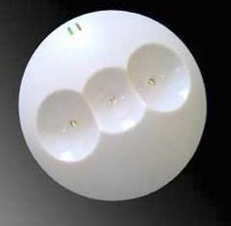
Em-2 | Self-contained – High performance LED emergency luminaire with 3 x 3 watt LEDs to give minimum 950 lumen output, minimum  3 year warranty and 30,000hrs. lamp life. Dali Control required for incorporation on  addressable emergency  lighting test systems  IP 65 Version also required | High Intensity 3 No. 1 Watt LED 300 Lumen  Output | 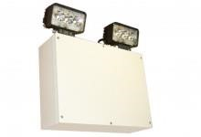

Em-3 | IP-rated robust Surface mounted 1Watt LED maintained exit sign with large downlight panel and internally printed legend, Luminaire to be constructed of ABS. Dali Control required for incorporation on  addressable emergency  lighting test systems  IP 65 Version also required |  | 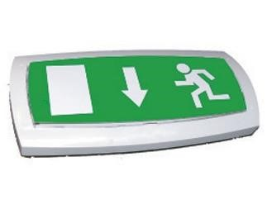
Em-4 | IP20 wall mounted Single sided 3-Hour maintained exit sign. Wall or ceiling mounted.  Powder Coated Sheet Steel body, 850⁰C glow wire approved plastic. 3 hour emergency duration.  Each luminaire to be complete with integrated communications module for connection to ATS.  Dali Communications protocol to be verified to be suitable for connection to the Addressable Emergency  Lighting Test and  Monitoring System | Min 2 x 1 Watt  LED | 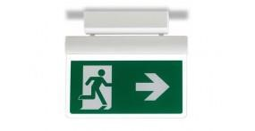
Em-5 | IP20 Suspended double sided 3-Hour maintained exit sign.. Powder Coated Sheet Steel body, 850⁰C glow wire approved plastic. 3 hour emergency duration.  Each luminaire to be complete with integrated communications module for connection to ATS.  Dali Communications protocol to be verified to be suitable for connection to the Addressable Emergency Lighting Test and Monitoring System. | Min 2 x 1 Watt  LED

Em-6 | IP40 1x3W High Power  LED , recessed/Surface 3 Hour non maintained emergency luminaire , complete with “Open Plan” or “Escape route”  optic  Each luminaire to be complete with integrated communications module for connection to ATS.  Dali Communications protocol to be verified to be suitable for connection to the Addressable Emergency  Lighting Test and  Monitoring System | 1 x 3 Watt LED  180 Lumen Output | 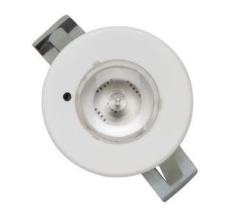
EM-7 | All-weather prismatic bulk-head, IP65 rated. Polycarbonate cover and base, c/w 27x0.05W LEDs (1W output) high brightness strip. Complete with tridonic EmpowerLED 1W pro driver, TALEXXstrip and 55ºC high temp.  NiMH battery. | 27x0.05W LED | 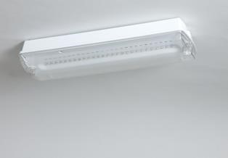
EX-1 | Surface mounted bulkhead with die-cast black/silver grey/anthracite/white aluminium body and opal polycarbonate diffuser. IP65,. Round large/small with bezel/cross/halovisor/visor. With 1000lm (12W) amnd LED. With 3hr emergency pack and presence sensor | High Intensity 12 Watt  LED 1000 Lumen Output | 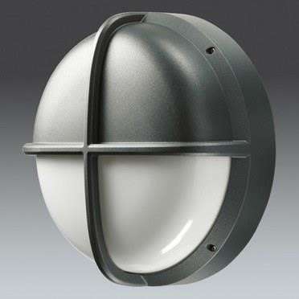
EX-2 | Die-cast aluminium construction with tamperproof stainless steel allen key screws retain opal polycarbonate diffuser and frame, , Removable gear tray for ease of installation,  Optional mounting frame for photocell location and/or surface conduit entry, 50,000 hours With 3hr emergency pack and presence sensor | High Intensity 20 Watt  LED 2100 Lumen Output | 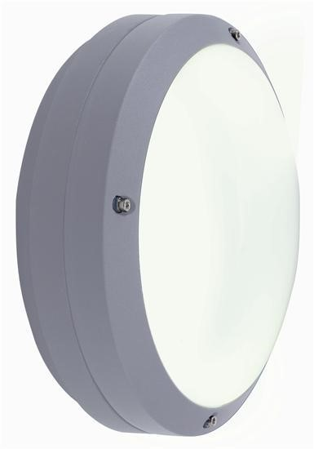
EX-3 | Die cast aluminum housing • Tool-less entry • Luminaire is designed to mount to 60mm outer dimension poles, Luminaire will also mount to 42mm outer dimension tenon or pole with XA-XSPFTRKIT accessory • Fitter is capable of mounting to both vertical and horizontal tenons and can be tilted + / - 5˚ •  Designed with 1–10V dimming capabilities. •finish, epoxy primer with an ultra-durable powder topcoat, providing high resistance to corrosion, ultraviolet degradation and abrasion. Standard colours to be  provided silver. Black,  103 Watt LED  Min 10 year product warranty, 50,000 hrs lamp life |  | 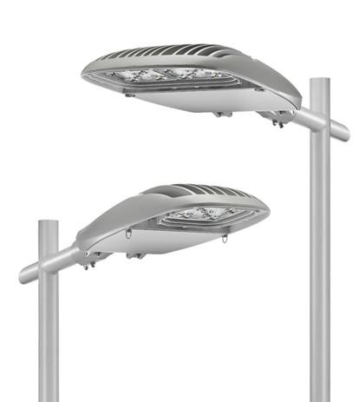

  - Luminaire Replacement components and Lamps shall be selected from leading OEM manufacturers with proven record in product development, product testing and provision of warranties to support their products. Performance data shall be provided for all lamps proposed for approval of TUS.
  - The following is the minimum expected life duration for replacement lamps. Products offering lesser durations will not be accepted.

Lamp Type |  | Min Hours
T8 Fluorescent 36W  Luminous Efficacy (rated) (Nom)  Luminous Flux (Rated) (Nom) | 90 lm/W  3250 lm | 10000 to 10 %  Failures  15000 to 50 %  Failures
T5 Fluorescent 28W  Luminous Efficacy (rated) (Nom)  Luminous Flux (Rated) (Nom) | 104 lm/W  2900 lm | 24000 to 50 %  Failures
T5 Fluorescent 35W  Luminous Efficacy (rated) (Nom)  Luminous Flux (Rated) (Nom) | 105 lm/W  3650 lm | 24000 to 50 %  Failures
T5 Fluorescent 49W  Luminous Efficacy (rated) (Nom)  Luminous Flux (Rated) (Nom) | 99 lm/W  4900 lm | 30000 to 50 %  Failures
T5 Fluorescent 54W  Luminous Efficacy (rated) (Nom)  Luminous Flux (Rated) (Nom) | 93 lm/W  5000 lm | 30000 to 50 %  Failures
PL Fluorescent 18W  Luminous Flux (Rated) (Nom) | 1200 lm | 33000 to 50 %  Failures
PL Fluorescent 26W  Luminous Flux (Rated) (Nom) | 1800 lm | 33000 to 50 %  Failures
PL-C Fluorescent 26W |  | 13000 to 50 %  Failures
Luminous Efficacy (rated) (Nom) | 67 lm/W
Luminous Flux (Rated) (Nom) | 1800 lm
2-D Fluorescent 28W  Luminous Efficacy (rated) (Nom)  Luminous Flux (Rated) (Nom) | 73 lm/W  2050 lm | 13000 to 50 %  Failures
Discharge Son t 100W  Luminous Efficacy (rated) (Nom)  Luminous Flux (Rated) (Nom) | 48000 lm | 30000 to 50 %  Failures
Discharge Mercury Vapour 250W |  | 16000 to 50 %  Failures
Luminous Efficacy (rated) (Nom) | 51 lm/W
Luminous Flux (Rated) (Nom) | 12700 lm

7.0 | Equipment - Cables
  - All cabling supplied shall be Low Smoke Zero Halogen type throughout.

  - The Fire Alarm System cabling shall be a two-wire system with detection loops cable size not less than 1.5 sq.mm PH120 enhanced fire retardant cable with LSF sheathing. All fire alarm cable shall comply with requirements of IS3218:2013.

Data cabling shall of a Cat6 unshielded twisted pair (UTP) system. All cables supplied shall be compliant to ANSI/TIA/EIA 568B, draft ISO 11801 2nd Edition, and prEN50173. The system shall also be compliant with the electromagnetic compatibility requirements of EN55105, EN50081 and EN50082.
In addition to the above, all system components shall be fully compliant to IEEE 802.3 and TIA/EIA 854.
All products proposed must be provided with a 3rd party compliance certificates for panels, jacks, cable and patch leads showing fully compliance to TIA 568B and ISO 11801. The manufacturer may be requested to provide evidence that random audits on manufacturer are preformed from a 3rd part test house during the recent past.

  - The patch panels shall be 24 port UTP Cat6 compliant. They shall be 110-style punch down and wired to TIA/EIA 568B as above. 1u cable management shall be provided every 48 ports.

  - Fibre Optic cabling shall be for use in high speed LAN, mAN, WAN data and telecom networks. All cables are to manufactured to comply with the international standards ISO/IEC 11801, EN50173-1 and ANSI/TIA/ETA 568C

  - Fibre Optic cabling for use within the building shall be 24 core single-mode Fibre Single Mode to connect OS1 and OS2 cables.
  - Fibre Optic cabling for externally shall be duct grade , rodent resistant, 24 core single mode Fibre

8.0 | Delivery to Site
8.1 | The Contracting Authority does not have a large storage facility available for long term storage of materials.
8.2 | Deliveries of materials is required on a weekly basis.
8.3 | The Contracting Authorities personnel will issue order the week in advance of due deliveries.
8.4 | The cost of deliveries must be accounted for in the rates on materials submitted in the Pricing Schedule.
9.0 | Non Specified Materials

9.1 The Contracting Authority reserves the right to procure non-scheduled materials from alternative suppliers throughout the Contract Term.

