Appendix 11: Factory Disclosure Form
Tenderers should note that Appendix 11: Factory Disclosure Form is applicable for Lots 1 and Lot 2 only.
Tenderers should note that Appendix 11 has been included with the suite of Tender Documents as an excel document titled “Appendix 11: Factory Disclosure form”
Tenderers should pay particular attention to clause 7.3.1.of Appendix 10: Electronics Watch Contract Conditions, specifically:
“7.3.1. Provide data requested by the Client to assess compliance with the Conditions, including a list of the Production Sites in supply chain tiers 1 (final assembly) and 2 (strategic component manufacturing) linked to the top 10 product models (by spend volume) provided by the Contractor on the Contract. Data provided in the list may be shared confidentially with Monitors. If the Contractor is unable to fulfil this obligation in part or in full, a written explanation shall be provided to the Client describing the measures taken and obstacles to compliance. The list of Production Sites shall:
a. be provided in the format requested by the Client;
b. include the legal names and complete physical addresses of the identified Production Sites; and
c. indicate the specific product model or component produced at each site.”
Instructions for completing Appendix 11
In Section II, please provide the contact details of the person within the Contractor who will be primarily responsible for monitoring and ensuring compliance with the Electronics Watch Contract Conditions. This will be the Contractor's primary point of contact with the Contracting or Framework Authority.

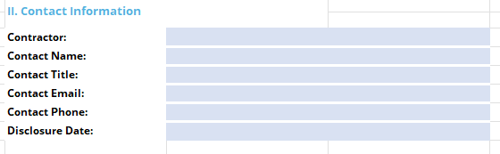
In Section III, please enter the names and complete addresses for each factory that will be assembling the products (first tier) and making the components (second tier) for the goods that will be purchased under the agreement or contract. Please associate each product or component with a specific factory and brand. When entering information for a product leave the components column blank and vise versa. For each factory listed, also indicate if a social audit has been conducted within the most recent 36 months and who conducted the audit, if known. The contractor is responsible for making enquries to discover and obtain the audits and using its leverage to obtain any necessary legal consents to share the audits with Electronics Watch and the Contracting Authority or Framework Authority.

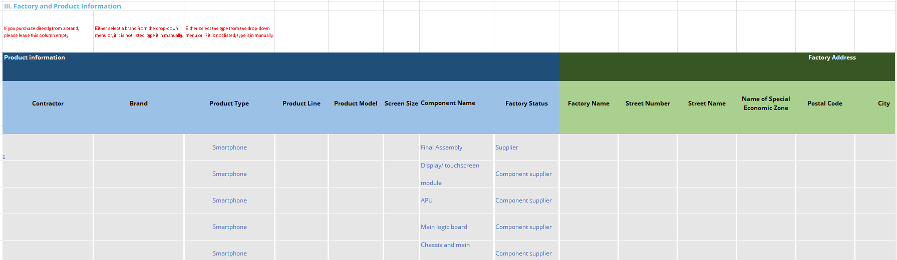

Tenderers should note the following:
General: Only disclose factory names and locations that perform final assembly or component manufacturing. Headquarters, offices, reasearch and development sites, and similar are not within the scope of this form.
Product model: If two different generations of same product model have been procured, e.g. HP Elitedesk 800 G8 and HP Elitedesk 800 G6, please include both versions as separate product models in their own rows. Similarly, different versions of same product model, e.g. HP Elitedesk 800 G8 Small Form Factor (SFF) and HP Elitedesk 800 G8 Desktop Mini (DM) should be listed separately.
Factory name: Please enter name of the factory, such as - Quanta, Pegatron, Jabil, LG, Intel, Samsung, Elek & Eltec.
Regarding chip suppliers: Do not list fabless chip suppliers. Include only the manufacturing site where the front-end or back-end chip manufacturing operations occurs. You are welcome to list both front-end and back-end chip operations by adding an additional row.
For BRAND COMPANIES only: If you think that components other than those listed are of greater strategic importance, please feel free to replace one of the pre-populated components (Component Name) with that component complete the remaining columns with the relevant factory information.

For further information please visit https://electronicswatch.org/en/companies-common-questions_2548590.

