
Responses to Queries

Tender: provision and maintenance of tourist information kiosks and screens
Reference: VE/2025/03

Q1. Could you please confirm whether you require us to construct the overall unit for this panel, or if it will be supplied fully assembled?

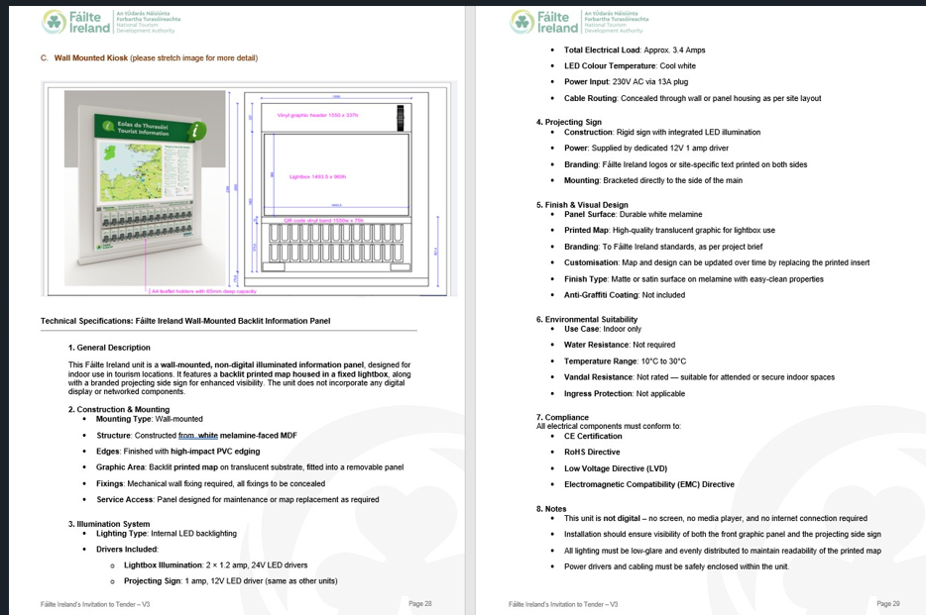

A1. For new locations you will need to construct the overall unit.

Q2. Can you please clarify what media player is currently in situ: Manufacturer: Model:
A2. Giada DS02s.

Q3. Who is the current digital signage licence/provider?
A3. The current service provider.

Q4. Can you please clarify what digital screens are currently in situ: 55” Kiosk Screen Manufacturer: Model: 55” TIC Screen: Manufacturer: Model: 65” TIC Screen: Manufacturer: Model: 65” TIC Videowall Screen: (If different to above) Manufacturer: Model
A4. Vestel VL55 Commercial Displays /Dahua CM55 Commercial Displays.

Q5. Should replacement parts be costed within a maintenance agreement or will replacement parts be charged on an ad- hoc basis?
A5. Ad hoc basis. Note: For budgetary purposes we work of a 5-year life span.

Q6. Do you have a service history log indicating the typical number of callouts in a year and the typical works carried out?
A6. Calls are for Screen and Unit fixes. Please see Table 2 Variable Costs – Number of Days over 4 years. And Table 3 Annual Costs.

Q7. Should the new players be 4K or is HD sufficient?
A7. We require 4K

Q8. What brand and model numbers are your current screens that are not EOL?
A8. Vestel VL55 commercial displays /Dahua CM55 Commercial Displays

Q9. What is the required Nit value of the new screens for the kiosks and TIC's.
A9. 500 nit

Q10. What is the name of the current CMS?
A10. It is a proprietary system – provided by our Service Provider.

Q11. Is MS Windows or Android the preferred Operating System for a new Digital Signage system?
A 11. Android. As our media players are android compatible.

Q12. Under tech specs where a 4G Router with SIM is needed on site do you provide this or do you expect the supplier to do so?
A12. We expect the service provider to provide it. Who in turn will re-charge us. See ‘Connectivity of Kiosks’ and Table of Costs
Q13. Regarding existing android media players, what brand and spec are they please?
A13. Giada DS02s
Q14. Section 3 Scope of Requirements Maintenance and Servicing of New and Existing Kiosks: For existing kiosks - what are the bands and specs of the screens installed and how old are each? Are they near end of life?
A14. Please See P31 of ITT. Proactive Maintenance Programme.
Q15. Content Management System (CMS) Requirement - Are you interested in hearing additional services beyond the scope?
A15. We cannot evaluate additional services not included in the Invitation to Tender.
Q16. Section A6 Human Resources Note 1 the purpose of this section is to identify whether the Tenderer has at its disposal the appropriate number of suitably qualified and experienced human resources to fulfil this contract. Can you confirm that this relates to qualified installer staff only?
A16. This relates to all resources required to fulfil all elements of this contract.
Q17. Finally do you anticipate many new stands will be rolled out in the future?
A17. We estimate 5 Large, 5 Small and 5 Wall Mounted new Kiosks over the lifetime of the contract. We also anticipate removal and re-installation of existing Kiosks to more productive location. See Table 2 Variable Costs.

