Q1. | A1.
Can the Contracting Authority confirm the exact areas and surfaces to be treated (e.g., modular paving, medians, traffic islands)? | Please refer to the RFT Control of Weeds Rev A. (below Figure 1) & Criterion D
Q2. | A2.
Are there any restrictions on the types of alternative weed control methods (e.g., thermal, mechanical, organic) beyond the exclusion of Glyphosate? | This is a matter for the Applicant to comply with the Tender Documents
Q3. | A3.
Is there a preferred format or template for the Traffic Management Plan and Risk Assessment? | This is a matter for the Applicant
Q4. | A4.
What is the expected start date and duration of the initial contract phase? | Please refer to 2.3 of the RFT Control of Weeds Rev A.
Q5. | A5.
Are there seasonal or time-of-day restrictions for weed control operations, especially in high-traffic areas like O’Connell Street? | Please see revised document 2.3 of the RFT Control of Weeds Rev A .(extract below) and Appendix A and Appendix B 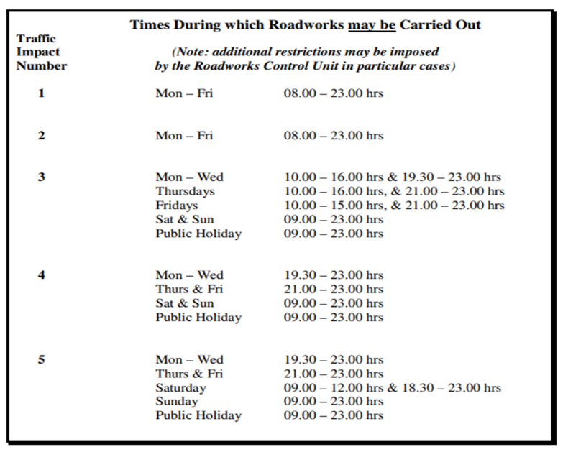
Q6. | A6.
Will the Council provide any logistical support, such as access to water sources or waste disposal? | Any licencing or Permits required as part of your methodology is a matter wholly for the Applicant as per 2.3 of the ‘RFT Control of Weeds Rev A. ‘
Q7. | A7.
Is there a penalty or incentive structure tied to performance levels (Stage 1 and Stage 2)? | Refer to 3.9 of the RFT
Q8. | A8.
Are inflation adjustments allowed over the contract term (2026–2029)? | Refer to 3.8 of the RFT
Q9. | A9.
Is there a cap on the total contract value or annual spend? | Please refer to the Tender Notice and RFT 2.2
Q10. | A10.
Are there any anticipated changes to the scope or service areas during the framework period? | Refer to RFT 2.2
Q11. | A11.
Is Tupe applicable? | Refer to Instruction For Tenderers in the RFT (y)
Q12. | Q12.
Reference 480KM and 408KM can you clarify what the actual roads distances again. | Typo corrected should read 480km see 2.3 ‘RFT Control of Weeds Rev A’
Q13. | A13.
Alternative weeds control methods and TM are only required at De Courney Square and O Connell St to Abbey Street to O Connell Bridge.  Can this work be completed at night to minimise disruption. | As per 2.2 of the RFT ‘Dublin City Council are seeking tenders for alternative methods for the control of weeds other than the use of glyphosate’  See Answer 5 Above
Q14. | A14.
Are all other districts okay with the use Glyphosates. | As per 2.2 of the RFT ‘Dublin City Council are seeking tenders for alternative methods for the control of weeds other than the use of glyphosate’ ‘

‘

