Form of Tender – Cost for Evaluation Purposes (Criterion D)
To: | IDA Ireland
From:
Subject: | Videography Tendered Pricing

I/We have examined the tender documentation and hereby offer to provide the services in accordance with the details contained within the Request for Tender (RFT) document.
Signed:
Name (in Capital Letters):
On behalf of:

For the purpose of tender evaluation Tenderers must complete Table 1 in the Excel sheet labelled Appendix 2 Pricing Entry Sheet. It is reproduced below for illustration purposes only.
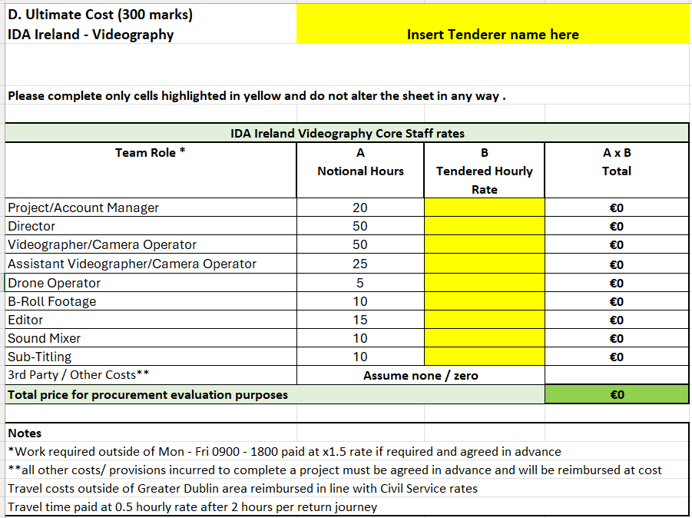

Note:
- Please complete the following table for information purposes only and include a Rate Card for your services, this will not be evaluated but will be referred to during the contract if appropriate.

For Information Purposes only | €
Full Crew Daily Rate (7.5 hours)
Full Crew Half Day Rate (4 hours)
B-Roll Footage Daily Rate (7.5 hours)
B-Roll Footage Half Day Rate (4 hours)
Rate Card to be supplied for all other service provisions

- Please note all rates quoted are inclusive of all out-of-pocket expenses (i.e. mileage, subsistence, phone, postage, etc.) and account / contract management related costs within Greater Dublin area.

- For work delivered outside of the Greater Dublin Area, pre-agreed expenses such as mileage, subsistence, if payable will be payable at published Civil Service rates.

- Rates submitted are maximum prices for the first two (2) years of the framework agreement thereafter rates may be increased by reference to CPI / agreed independent inflation index

- Your company commits, if awarded a contract to employ labour in a manner that is discriminatory in relation to gender, civil/family status, sexual orientation, religion, age, disability or race.

