How to Complete the Tender Response Document

See below some guidance on completing the Tender Response document

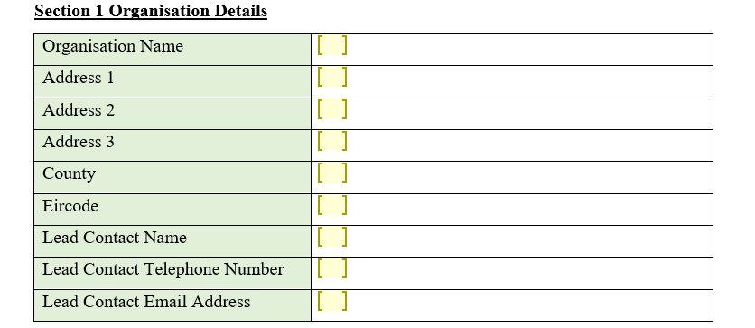
Where you see a “Yellow Box” you can free type in the box.
Region I wish to Apply For | Please Confirm
West Region(Galway/Roscommon) | Choose an item.
Clare Region | Choose an item.
Limerick Region | Choose an item.
Southern Region | Choose an item.
South East Region | Choose an item.

Where you see “Choose and Item” Click on it and a down arrow will appear. Click on the down option and click on “Yes” or “No”
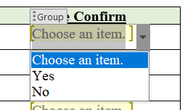

Where you see a “Box” simply click on the box and an “X” will appear
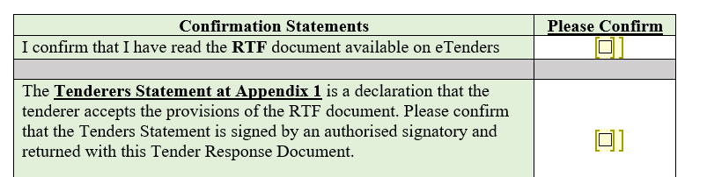

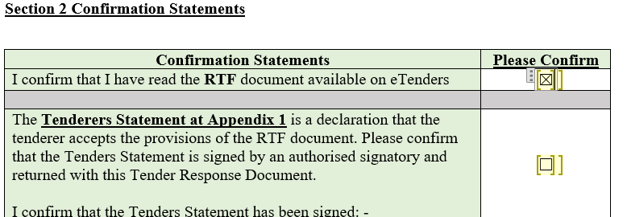

I hope this assists you in completing your response.

