eTENDERS Help Document



February 2025
Veterinary Support Co-ordination Unit (VSCU)
Veterinary Public Health, Food Safety, Pig and Poultry Health Policy Division

This new DPS - reference 5034559, is being utilised by the Veterinary Support Co-ordination Unit (VSCU) in the Veterinary Public Health, Food Safety, Pig & Poultry Health Policy Division of the Department of Agriculture, Food and the Marine. Its purpose is for the procurement of suitably qualified veterinary surgeons/practitioners to undertake short-term contracted Veterinary Services on behalf of the Department.

This guide has been produced to assist you in gathering information and applying to the process if you so choose. As such it is intended to act as an aid when accessing the DPS and participating in the application process. It is not intended to cover every aspect of this process or any other process such as a mini competition held under this DPS. The Department of Agriculture, Food and the Marine (DAFM) cannot be held responsible for any unintended errors or omissions in this guide.

What is a DPS?
A Dynamic Purchasing System (DPS) is a completely electronic system used by a Contracting Authority (buyer) to purchase goods, works or services. It is hosted on the eTenders platform. Unlike a traditional framework, suppliers can apply to join (qualify) at any time.

DPS are not contracts in themselves but are in effect agreements for the award of contracts where the vendors that may participate in the award of a specific contract, are limited to those appointed (or qualified) to the DPS under the main framework agreement. The Dynamic Purchasing System has two Stages:

- Request to participate (RTP) in the DPS (Qualifying stage). Suppliers submit a qualification request to be evaluated; those suppliers who meet the qualification criteria will be added to the pool(s) of suppliers that may participate in a mini competition. Suppliers will be added to the lots for all that are applied for and meet criteria.
- Mini Competitions – contain detail of the contracts that may available. Qualified/appointed suppliers will be offered an opportunity to apply to participate in the award of a specific contract(s).

PLEASE NOTE:
While you can access eTenders from an iPhone, iPad. Tablet or Mac there may be issues downloading documents via these devices. Etenders therefore recommends using a laptop or desktop PC instead.

If you experience any technical issues when registering, accessing, downloading or submitting documentation, at STAGE 1 or STAGE 2 of the process, please contact eTenders Support directly quoting the DPS reference 5034559 at;
Email irish-eproc-helpdesk@eurodyn.com
Phone 0818 001459 (Ireland) or +353 818001459 (International)
For queries not relating to the above, please contact: vetcontractors@agriculture.gov.ie

There are 5 Grouping or ‘Lots’ that are available under this DPS 5034559 and you can apply to any or all of those that are relevant to the services that you can provide.
The Groupings/Lots are as follows:
Groupings Number | Description
1 | Locum Tenens Services – Veterinary Public Health (Meat Plants)
2 | Locum Tenens Services - Animal Health and Welfare (Regional Veterinary Offices and Associated Locations including Assembly Centres)
3 | Locum Tenens Services – Other (including areas such as policy, laboratory services etc)
4 | Veterinary Services - Border Control Posts
5 | Veterinary Services – Other

Please Note: There are no guarantees that there will be any contracts for any groupings over the lifetime of the DPS.
Stage 1 - Request to participate (RTP) in the DPS (Qualifying stage)
Login or Register as a New Supplier / Company Registration
In order to access or apply to the DPS, you will either need to login or set yourself up as a user on eTenders if you have not previously done so.
eTenders can be accessed via this link: European Dynamics - Welcome to eTenders

Accessing the Short-Term Contracted Veterinary Services DPS
- Once you have created your registered supplier details or if already registered, you can then find tenders that you are interested in applying to.
- On the top right of the screen click on the search icon and enter key words, eg “Dynamic Purchasing System” to find the DPS you wish to apply for.

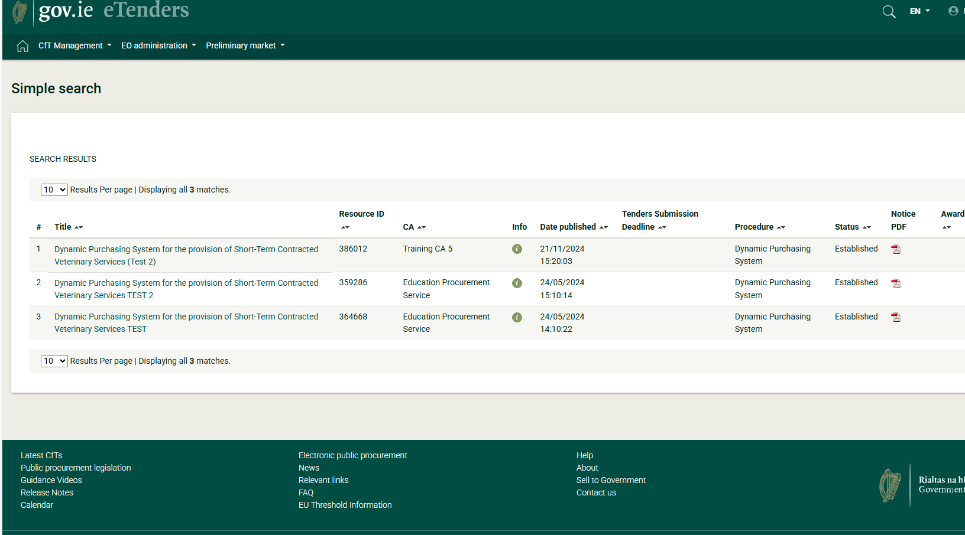

- The returned results will appear below and you can then click on the Tender name to open a screen containing general information relating to the tender.

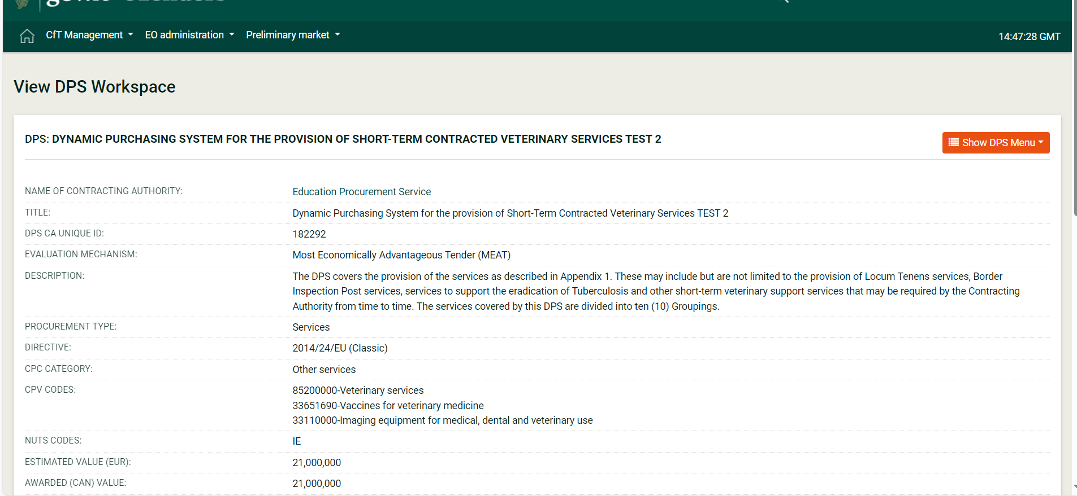

The DPS documents can be accessed via the Show DPS Menu dropdown – DPS documents;

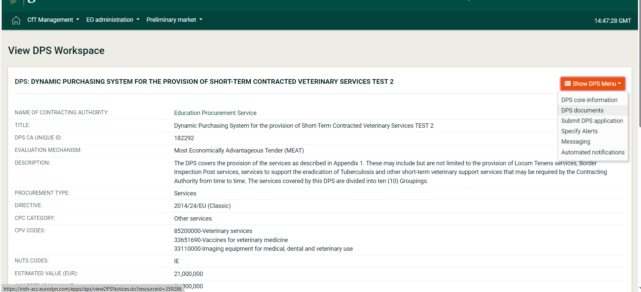
On the next screen that opens up click on ‘Tender Documents’ tab

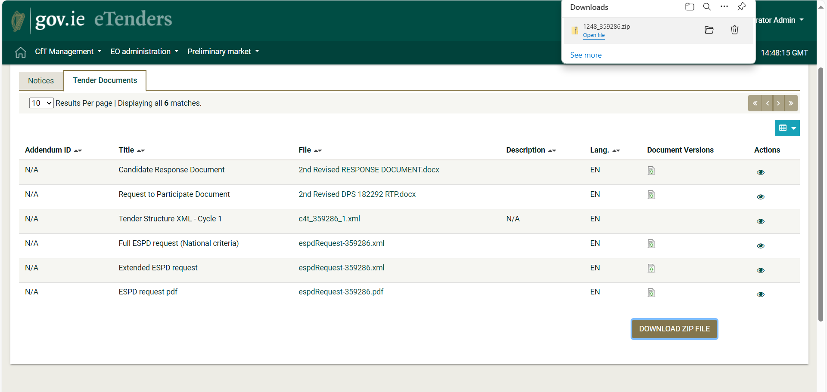

You can download the documents by either clicking on the document name(s), or by clicking the ‘download all (zip)’ option at the bottom of the page
The documents will download into your download folder on your PC/Tablet/Mobile Device
Once you have completed these forms you can then begin your DPS application:
In order to begin the application process, go to the Show DPS Menu – Submit DPS application

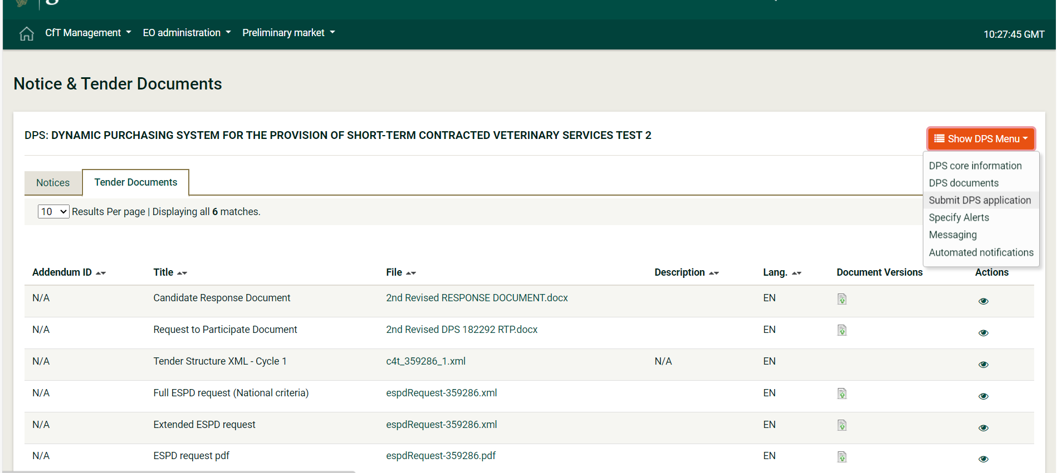

Click Create Tender Online green button
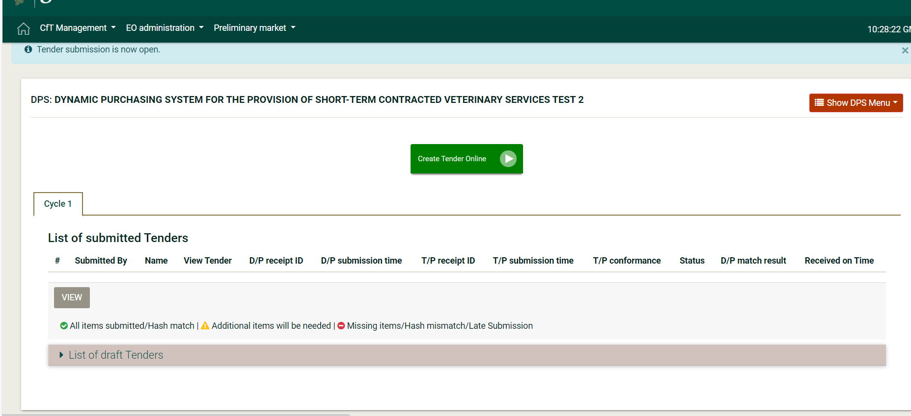

Choose the Lots you wish to apply for
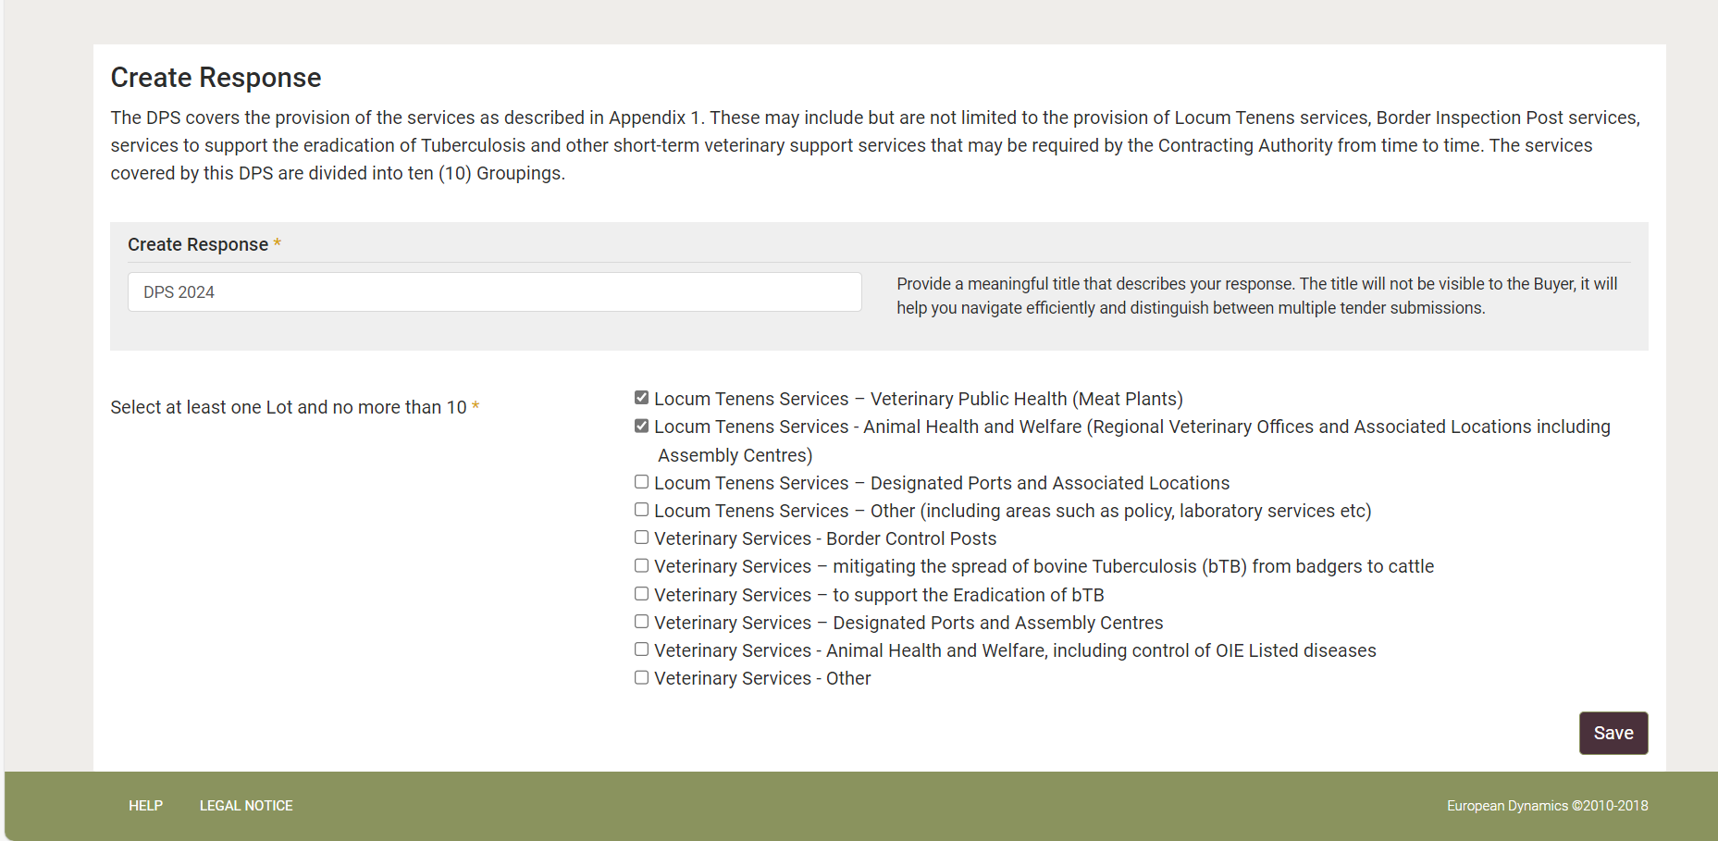

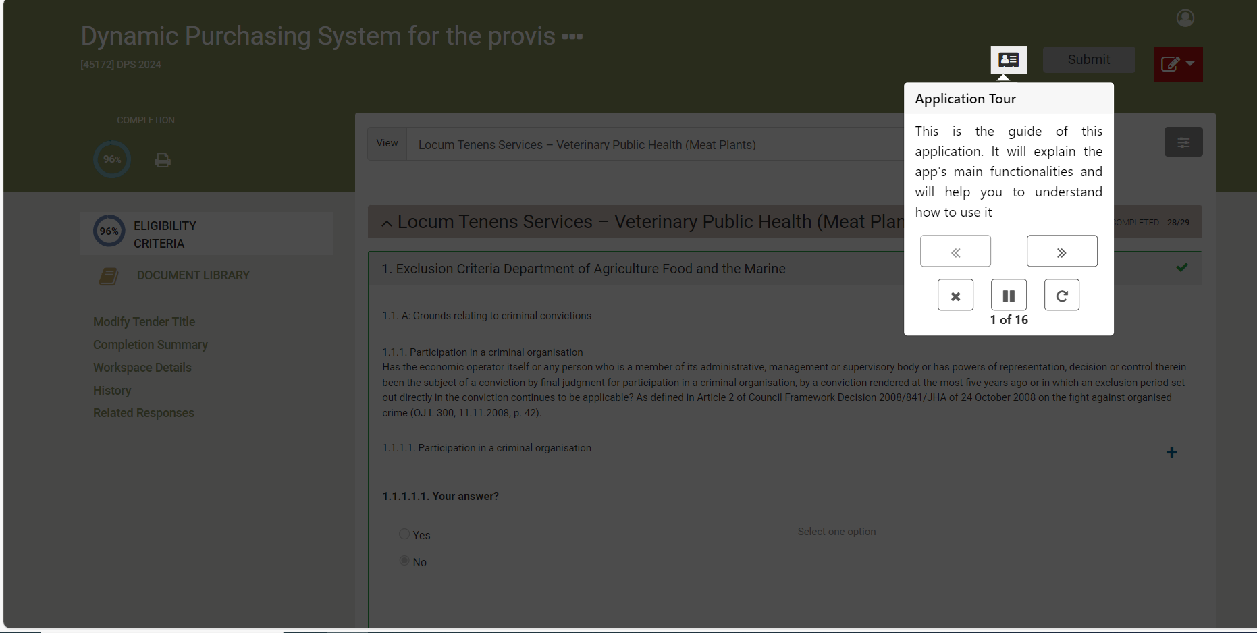
To answer all questions, click on the edit button and select edit from the dropdown menu

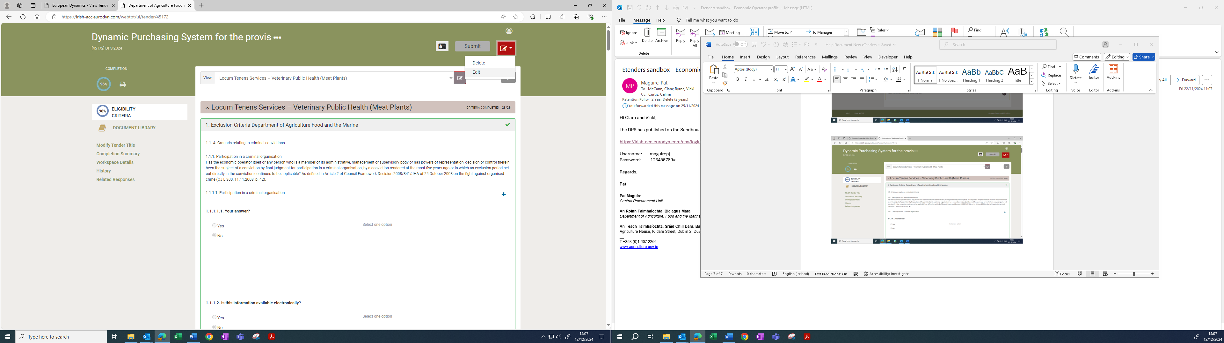

To upload your completed documents, click on the button on the bottom right of the screen
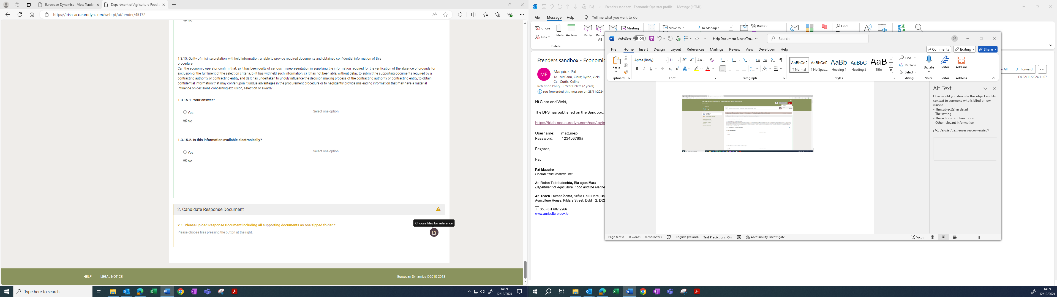

The pop up will appear to prompt you to upload a new file
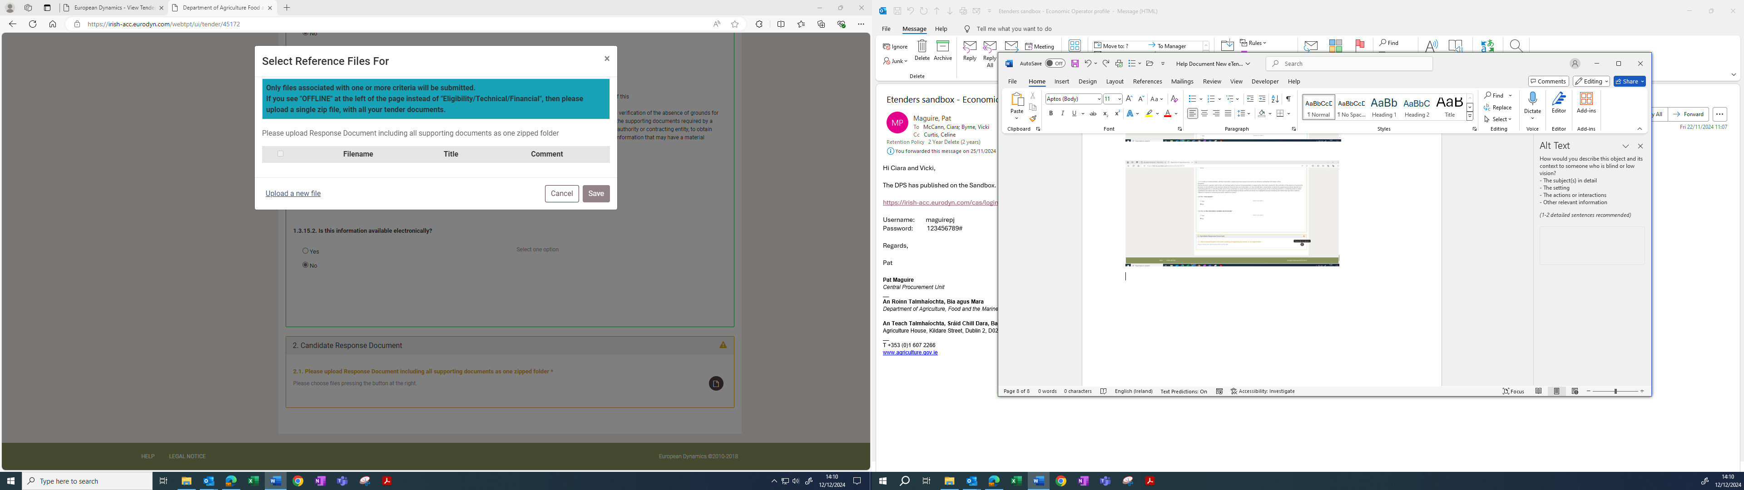

Follow instructions on screen to upload documents
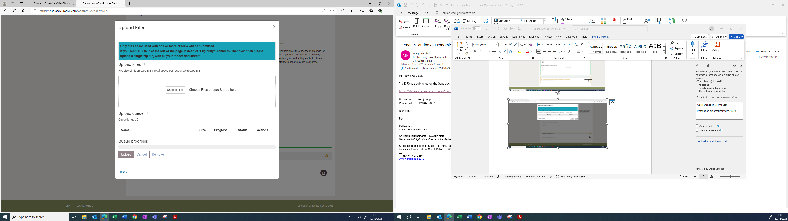
Once successfully uploaded you will receive a notification pop up
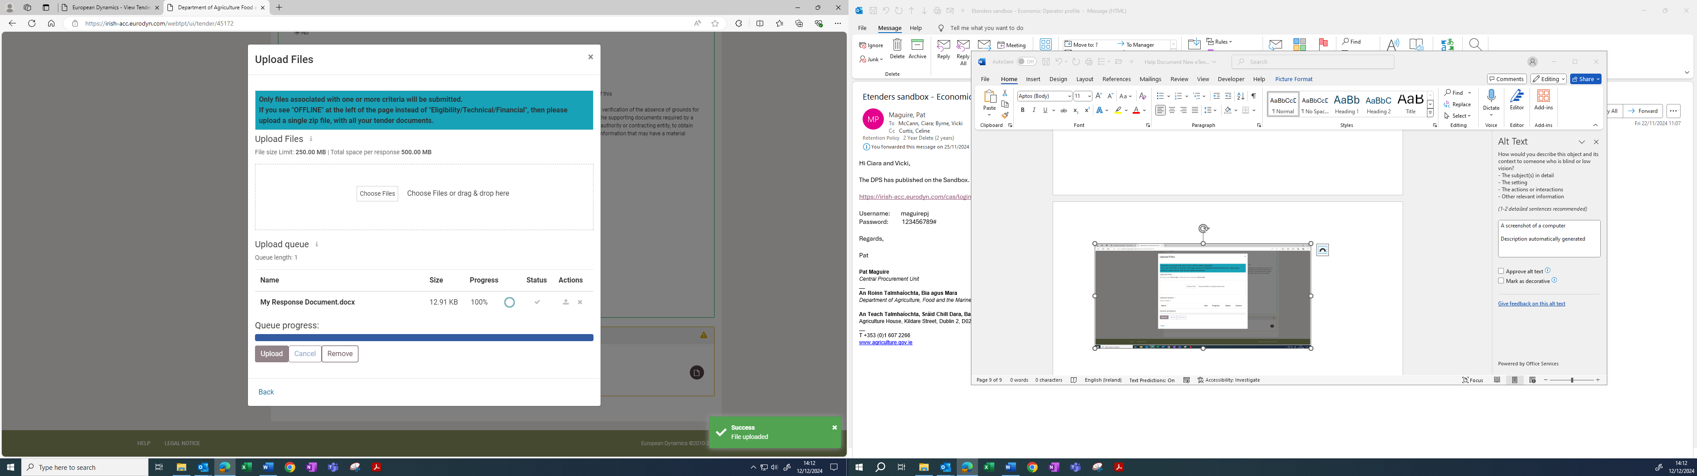

These steps must be completed for each Grouping/Lot being applied for.
Failure to upload documents for each Grouping/Lot will result in an incomplete submission for that Grouping/ Lot.

