Go to European Dynamics - Welcome to eTenders

Click on Register a Supplier
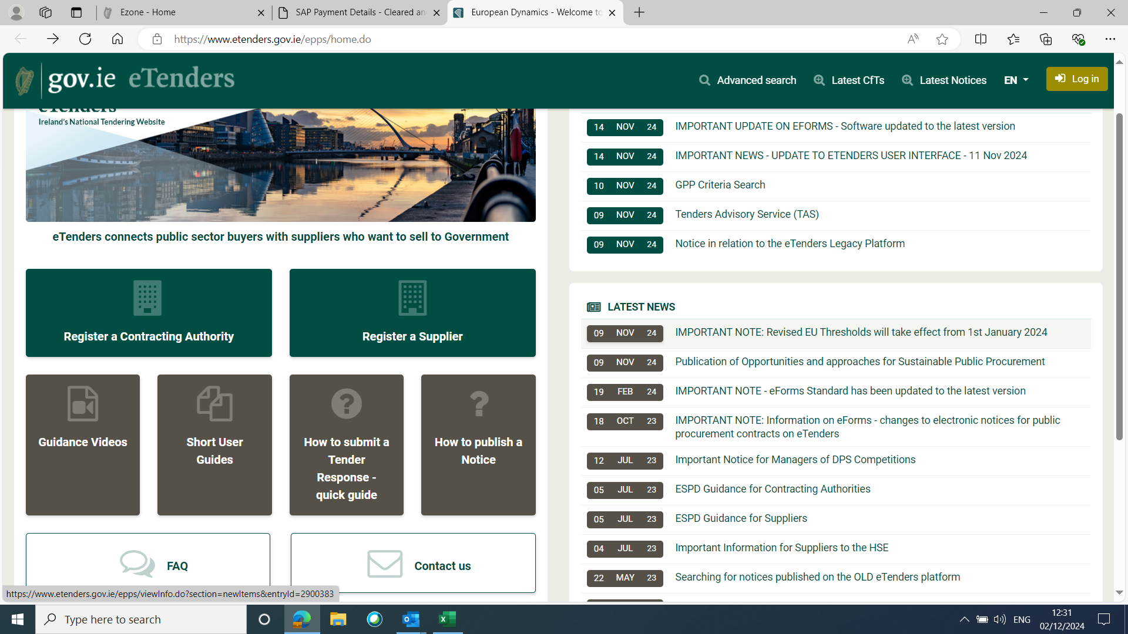

Complete the details required as requested (see screenshot 2 & 3 below)

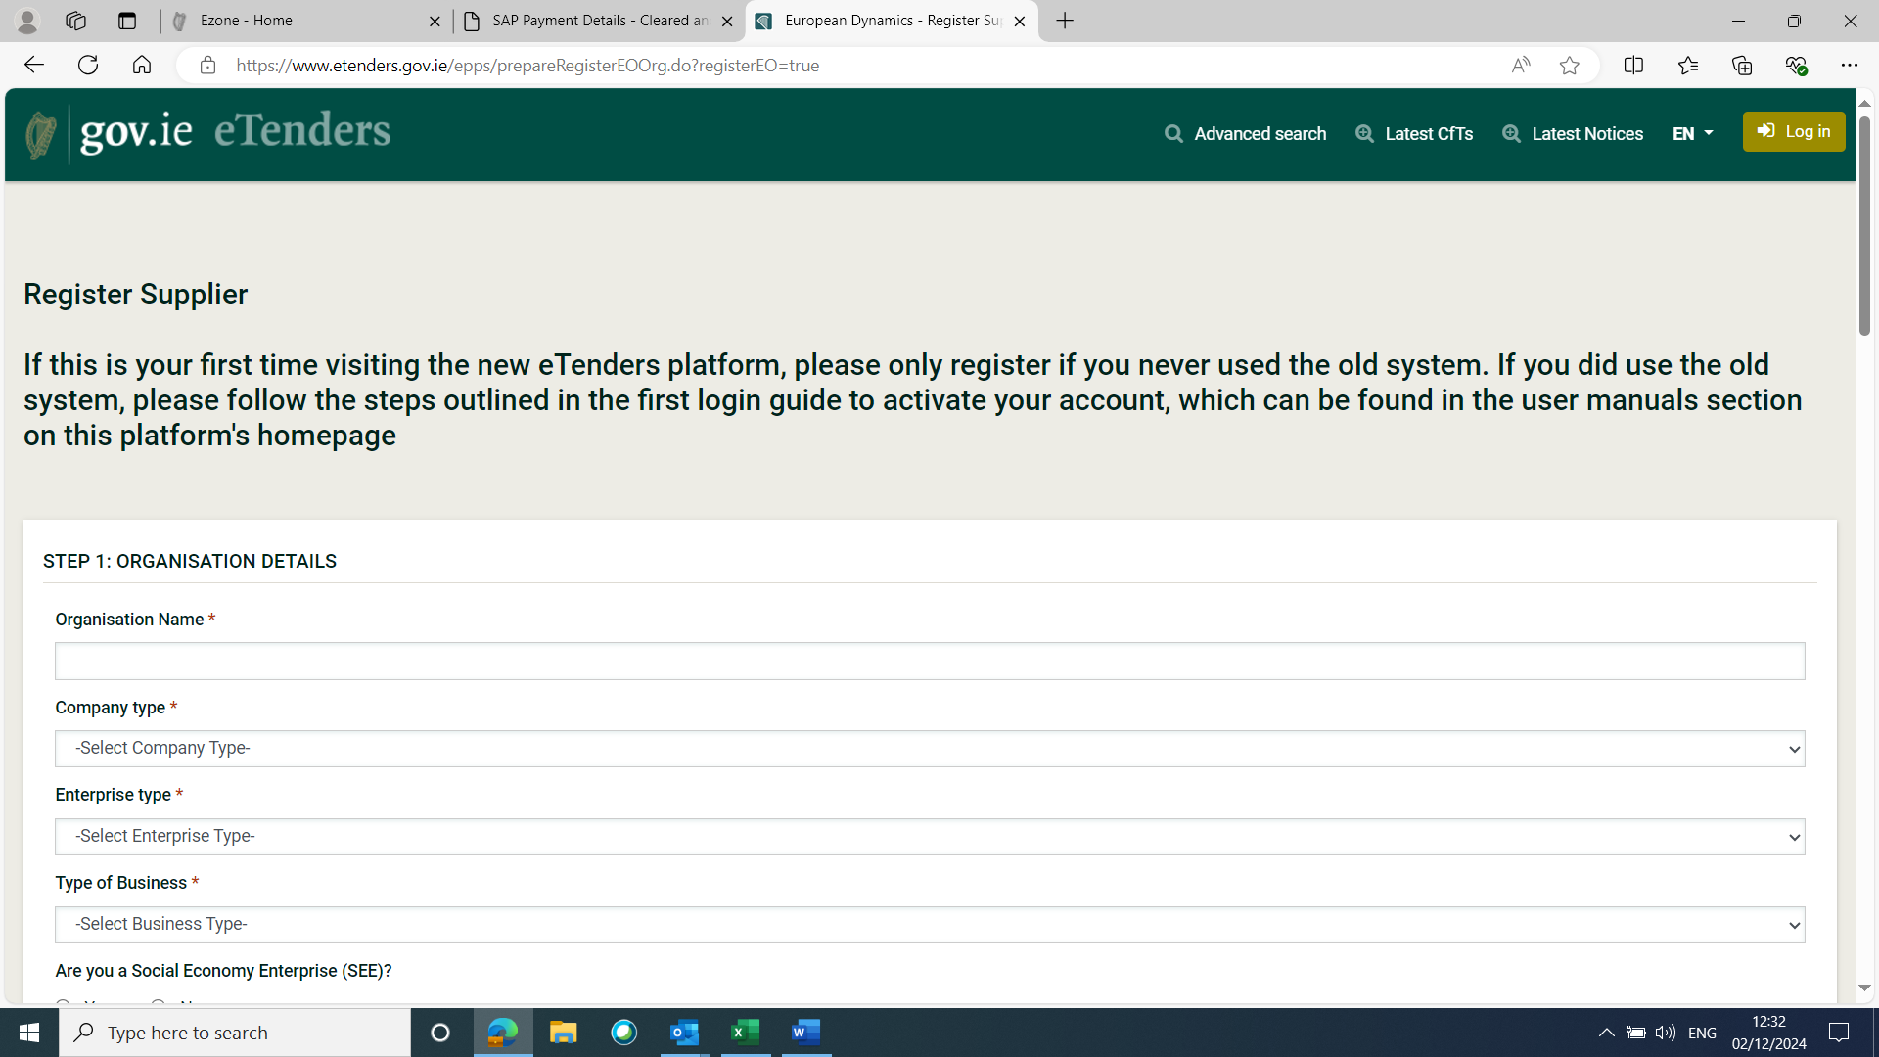

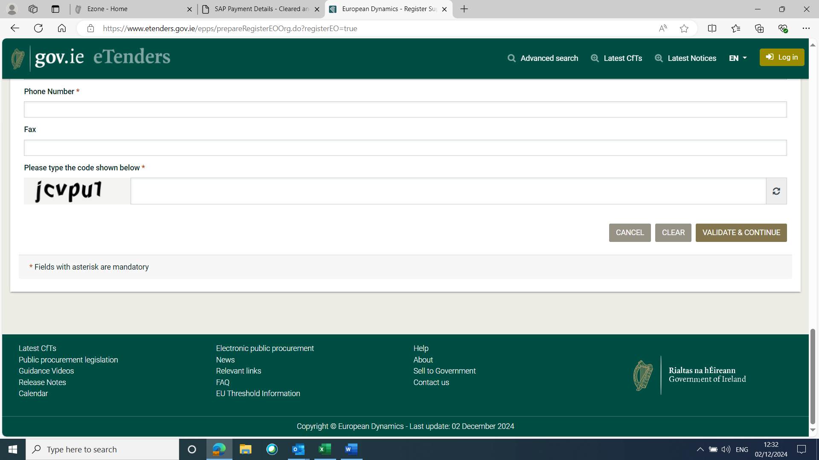

When all details are completed click Validate & Continue.

